

Performance and Accountability for Grants in Energy (PAGE)

Excerpts from Davis Bacon Reporting Functional Requirements (Version 2.0)

March 1, 2012

Prepared by:

U.S. Department of Energy
Office of Energy Efficiency and Renewable Energy
Office of Weatherization and Intergovernmental Programs
1000 Independence Ave., SW
Washington, DC 20585-0121

Table of Contents
1.1. Sample Page Layout: Davis Bacon Reporting Page 3
1.2. Sample Page Layout: Semi-Annual Davis Bacon Enforcement Report 4
1.3. Sample Page Layout: Semi-Annual Davis Bacon Enforcement Report – Expanded Burden Disclosure Statement 5
1.4. Sample Page Layout: Semi-Annual Davis Bacon Enforcement Report – Expanded Instructions 6
1.5. Sample Page Layout: Semi-Annual Davis Bacon Enforcement Report 7
1.6. Sample Report Format: Semi-Annual Davis Bacon Enforcement Report 8
1.7. Sample Page Layout: Davis Bacon Reports Data Export 9
1.8. Sample Page Layout: Davis Bacon Reports Not Submitted Data Export 10

Sample Page Layout: Davis Bacon Reporting Page
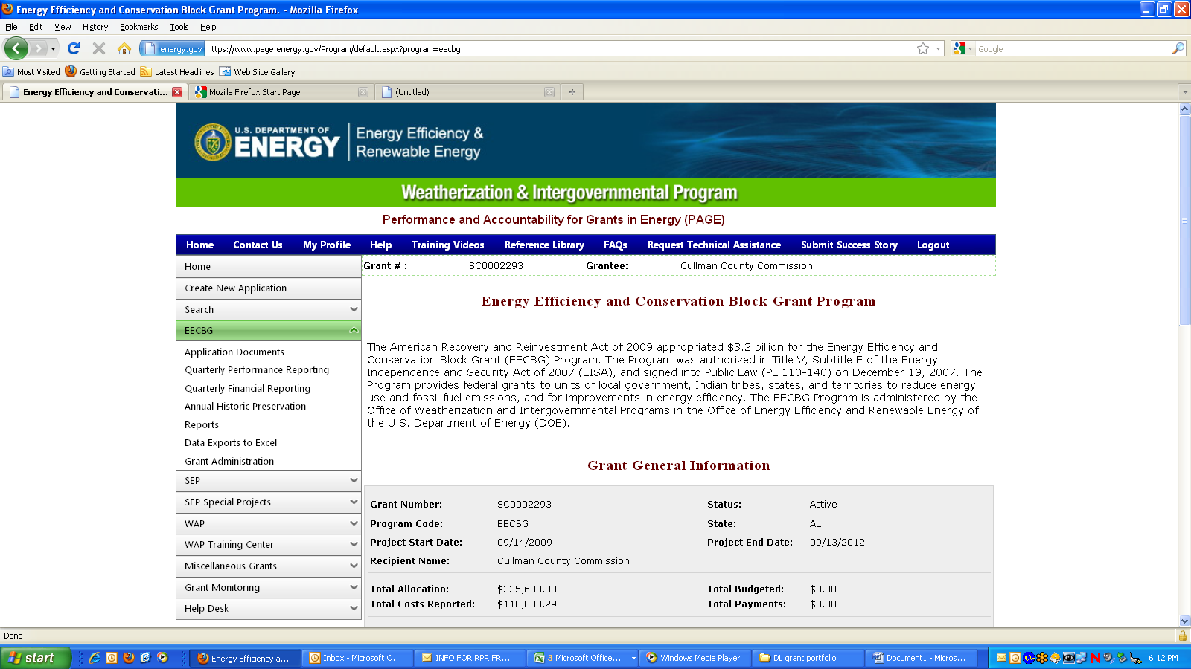
Semi-Annual Davis Bacon Reporting

DOE financial assistance Recipients must comply with the Davis-Bacon and Related Acts as a condition of spending DOE funds. Among other Davis-Bacon requirements, Recipients must report semi-annually to DOE regarding their oversight of Davis-Bacon compliance and enforcement. These reports are due within 20 calendar days following the end of the semi-annual reporting period.
The semi-annual report is submitted to DOE via this webpage. After a Recipient enters the information, simply click on the "submit" button below to submit the report to DOE.

Sample Page Layout: Semi-Annual Davis Bacon Enforcement Report

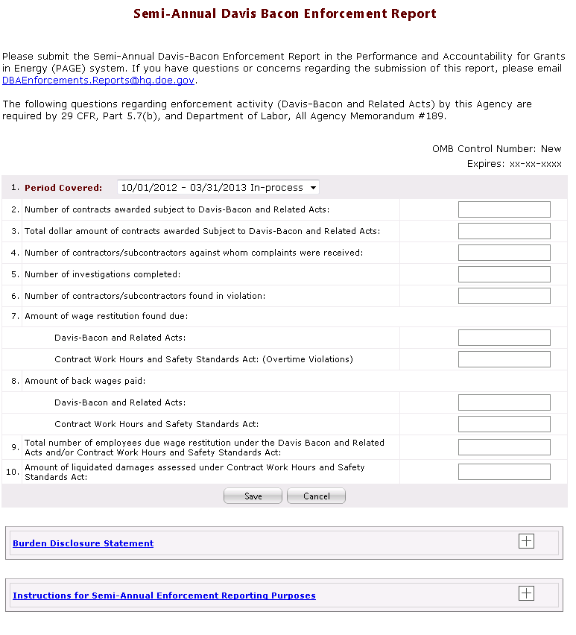

Sample Page Layout: Semi-Annual Davis Bacon Enforcement Report – Expanded Burden Disclosure Statement
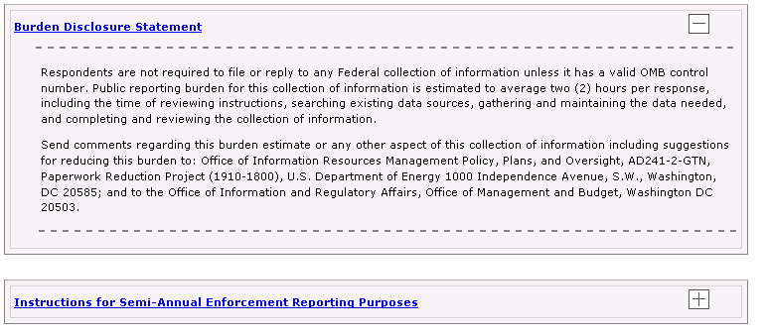
Top of the screen is unchanged
Expands (+) and contracts (-) when users clicks here.

Sample Page Layout: Semi-Annual Davis Bacon Enforcement Report – Expanded Instructions
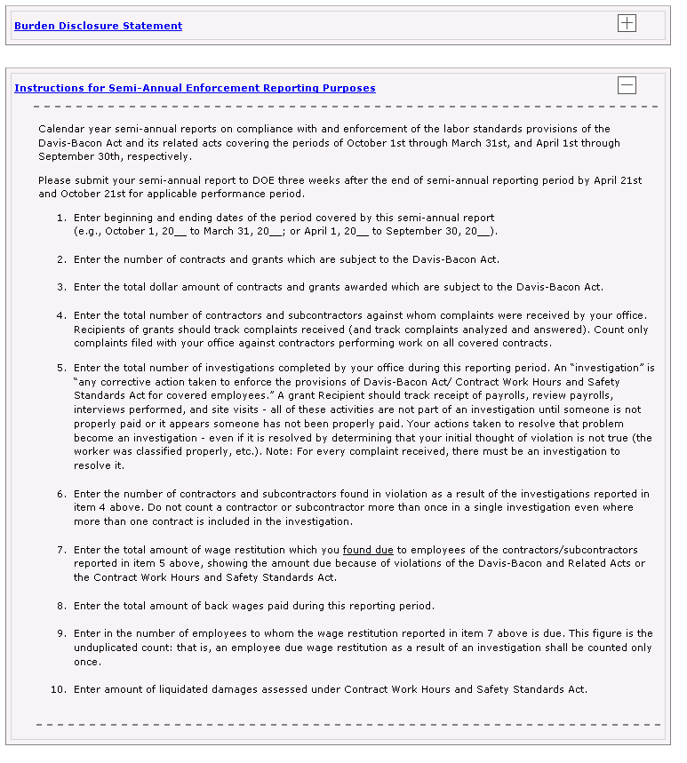
Top of the screen is unchanged
Expands (+) and contracts (-) when users clicks here.

Sample Page Layout: Semi-Annual Davis Bacon Enforcement Report

Semi Annual Davis Bacon Enforcement Report

Sample Report Format: Semi-Annual Davis Bacon Enforcement Report

PAGE, MM/DD/YYYY  HH:MM:SS | U.S. Department of Energy  SEMI-ANNUAL DAVIS BACON  ENFORCEMENT REPORT |  | OMB Control Number: New  Expires: xx-xx-xxxx
Please submit the Semi-Annual Davis-Bacon Enforcement Report in the Performance and Accountability for Grants in Energy (PAGE) system. If you do not have access to the PAGE system, please submit this form to DBAEnforcements.Reports@hq.doe.gov. If you have questions or concerns regarding the submission of this report, please email DBAEnforcements.Reports@hq.doe.gov.

The following questions regarding enforcement activity (Davis-Bacon and Related Acts) by this Agency are required by 29 CFR, Part 5.7(b), and Department of Labor, All Agency Memorandum #189.
Grant Number: XXXXXXXXX |  | Grantee: XXXXXXXXXXXXXXXXXXXXXXXXXXXXXXXXXXXXXXXX
1. Reporting Period: MM/DD/YYYY-MM/DD/YYYY
2. Number of contracts awarded subject to Davis-Bacon and Related Acts: |  |  |  | 999,999
3. Total dollar amount of contracts awarded subject to Davis-Bacon and Related Acts: |  |  |  | $999,999,999.99
4. Number of contractors/subcontractors against whom complaints were received: |  |  |  | 999,999
5. Number of investigations completed: |  |  |  | 999,999
6. Number of contractors/subcontractors found in violation: |  |  |  | 999,999
7. Amount of wage restitution found due:
Davis-Bacon and Related Acts: |  |  |  | $999,999,999.99
Contract Work Hours and Safety Standards Act (Overtime Violations): |  |  |  | $999,999,999.99
8. Amount of back wages paid
Davis-Bacon and Related Acts: |  |  |  | $999,999,999.99
Contract Work Hours and Safety Standards Act (Overtime Violations): |  |  |  | $999,999,999.99
9. Total number of employees due wage restitution under the Davis Bacon and Related Acts and/or Contract Work Hours and Safety Standards Act: |  |  |  | 999,999
10. Amount of liquidated damages assessed under Contract Work Hours and Safety Standards Act: |  |  |  | $999,999,999.99

Sample Page Layout: Davis Bacon Reports Data Export
Davis Bacon Reports Data Export

Sample Page Layout: Davis Bacon Reports Not Submitted Data Export
Davis Bacon Reports Not Submitted Data Export

