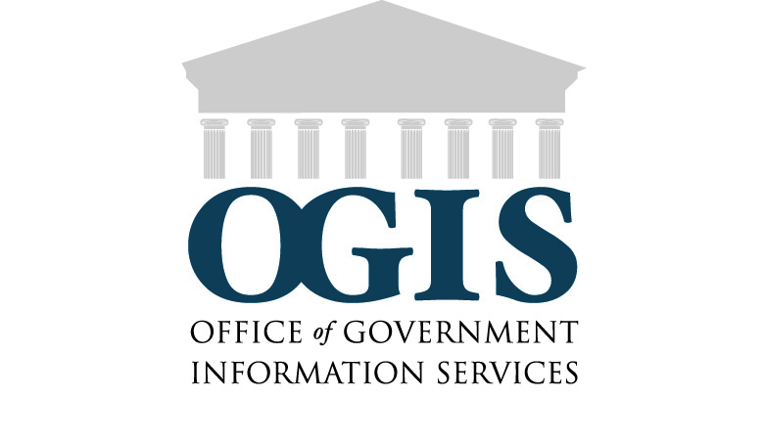

OGIS Customer Service Assessment – DRAFT
- I came to OGIS for assistance with (choose one):
[drop down]
- Filing a FOIA request
- Information about a Privacy Act request
- Resolving a dispute over my FOIA delay
- Resolving a dispute over my FOIA denial
- Resolving a dispute over FOIA fees
- Something else ___________________

- The OGIS staff member I worked with:
[check as many as apply]
  - Was courteous
  - Answered my questions fully
  - Offered additional information
  - Provided satisfactory customer service
  - Responded to my inquiries in a timely manner
  - Other. Please explain:__________________________

- Prior to coming to OGIS, did you visit the OGIS web site?
  - Yes
What was most useful about the OGIS site? __________________________________
What could be improved upon on the OGIS site? ______________________________________
  - No

- Overall, my experience with OGIS was (choose one):
[drop down]
  - Satisfactory
  - Neither satisfactory or unsatisfactory
  - Unsatisfactory

- Please describe your experience with OGIS. [Free form box]
_________________________________________________________________

- How did you learn about OGIS? [Free form box]
_________________________________________________________________
If you would like OGIS to contact you, please include your name and contact information. [box]

Thank you for providing your feedback. To contact OGIS, you may write or call us at:
Office of Government Information Services
National Archives and Records Administration
8601 Adelphi Road, Room 2510
College Park, MD 20740-6001
E-mail: ogis@nara.gov
Phone: 301-837-1996
Fax: 301-837-0348
Toll-free: 1-877-684-6448

