Community Development Revolving Loan Fund

Loan Application

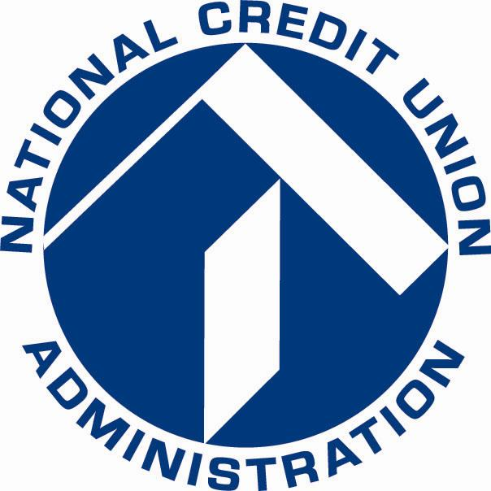

National Credit Union Administration
Community Development Revolving Loan Fund
Loan Application
Checklist

NOTE: Read all instructions, guidelines, and the Notice of Funding Opportunity thoroughly before completing this application. Failure to submit a complete application may result in the application being declined without substantive review.

All Applicants

APPLICATION REQUIREMENTS: Each applicant must complete and submit the following application sections.
- Loan Application Checklist
- Part A: Applicant Information
- Part B: Funding Request
- Part D: Certifications
No additional application materials are required for federally-insured credit unions requesting a loan amount of $300,000 or less.

Applicants for a Large Loan

APPLICATION REQUIREMENTS: In addition to the items listed under the heading, “All Applicants”, a credit union requesting a loan in excess of $300,000 must complete and submit the following sections of the application.
- Part C: Narrative Comments

National Credit Union Administration
Community Development Revolving Loan Fund
Loan Application
Part A: Applicant Information

Credit Union Name
Credit Union Charter Number
Credit Union Employer Tax ID Number
Credit Union Dun and Bradstreet Universal Numbering System (DUNS) Number
Mailing Address
Mailing Address, cont’d
City, State, ZIP
Credit Union Fax Number
Name/Title
Phone Number of Contact Person
Loan Amount Requested | $
Email Address of Contact Person
Name and Title of Authorized Representative
By signing below, the credit union representative (1) certifies that the credit union remains low-income designated, as defined in NCUA’s Rules and Regulations; and (2) commits the credit union to working toward the objectives of the CDRLF as described in the application.
Signature |  | Date

National Credit Union Administration
Community Development Revolving Loan Fund
Loan Application
Part A: Applicant Information (Continued)

Is the applicant credit union federally-insured?
- Yes. No additional information needed, proceed to Part B.
- No. You must submit the following, with the application, in order for it to be considered complete:
  - A copy of the credit union’s most recent external audit report;
  - Proof of deposit and surety bond insurance which states the maximum insurance levels permitted by the policies;
  - The credit union’s balance sheet, income and expense statement, and schedule of delinquent loans, as of the four most recent quarter-ends; and
  - Documentation of the credit union’s status as a low-income credit union by the appropriate state supervisory agency consistent with NCUA Rules and Regulations 701.34(a) and 741.204(b).

National Credit Union Administration
Community Development Revolving Loan Fund
Loan Application
Part B: Funding Request

Principal repayment plan requested (check one). Semi-annual interest payments are required for all loans.

- Semi-annual principal payments beginning Year 2 of loan | - Principal payment due at maturity

Proposed use of funds (check all that apply). If multiple uses are proposed, indicate the dollar amount of requested funds to be allocated for each use.
 | Use | Amount requested
 | Development of new products or services for members (e.g., new or expanded electronic banking facilities, share draft program, credit card program, security and disaster recovery program). | $ ____________
 | Partnership arrangements with community based service organizations or government agencies. | $ ____________
 | Loan programs, including micro business, payday alternative, education, and real estate. | $ ____________
 | Acquisition, expansion or improvement of office space or equipment, including branch facilities and ATMs. | $ ____________
 | Other (explain) | $ ____________

Credit unions requesting < $300,000 only: In the space below, explain how you propose to use the requested loan funds.

Matching funds narrative: Submit a narrative not more than ½ page articulating the credit union’s ability to raise matching funds from non-federal sources if it were required to do so.
National Credit Union Administration
Community Development Revolving Loan Fund
Loan Application
Part C: Narrative Comments

INSTRUCTION: Complete this Part only if your request is for a loan in excess of $300,000. Read all instructions, guidelines, and the Notice of Funding Opportunity thoroughly before completing the application.

- Submit a narrative not more than 3 pages, describing the credit union’s proposed use of the CDRLF loan amount requested. If multiple uses are proposed, indicate the dollar amount of requested funds to be allocated for each use. If loan products are to be generated, specify the type of loan (e.g., mortgage, auto, credit card).

- Submit a narrative not more than 10 pages, describing the credit union’s business plan. The plan should:
  - describe the community’s need for financial products and services
  - summarize the existing community services, and financial products and services provided by the credit union
  - describe the credit union’s involvement/partnership with community based organizations, state or government community development programs
  - explain the credit union’s need for CDRLF loan funding
  - describe the credit union’s marketing strategy to reach members and the community
  - include 18-month balance sheet and income statement projections with assumptions for the credit union’s financial growth and/or development (e.g., capital, assets, deposits, and loans) and membership/community services growth. Examples include growth in:
    - unsecured (alternatives to predatory lending), auto, business, or real estate loans;
    - regular shares; drafts, Individual Development Accounts, Health Savings Accounts, certificates of deposit;
    - financial education classes held; and
    - new services (e.g., ATM, home banking).

National Credit Union Administration
Community Development Revolving Loan Fund
Loan Application
Part D: Certifications

By signing below the authorized representative certifies that:

- The credit union is currently a low-income designated credit union, as defined in Section 701.34 of NCUA’s Rules and Regulations; and will comply with the program objectives as described in the Program Guidance and in the application.

- The board of directors will report on the progress of providing needed community services to the credit union members and NCUA as specified in Section 705.6 of the NCUA Rules and Regulations.

- The credit union conducts its activities such that no person is excluded from participation in, is denied the benefits of, or is subject to discrimination on the basis of race, color, national origin, sex, age or disability in the distribution of services and/or benefits provided under this loan program. The credit union agrees to provide evidence of its compliance as required by NCUA.

By signing this form, I certify that the statements herein are true, complete and accurate to the best of my knowledge. I also agree to comply with any resulting terms if I accept a loan through the CDRLF Program.
Signature of Authorized Individual | Date

