Screenshot 1: Initial log-in screen for the electronic version of the Peace Corps Volunteer application off of the Peace Corps website. This is not included in the hard copy version of the Peace Corps Volunteer application.
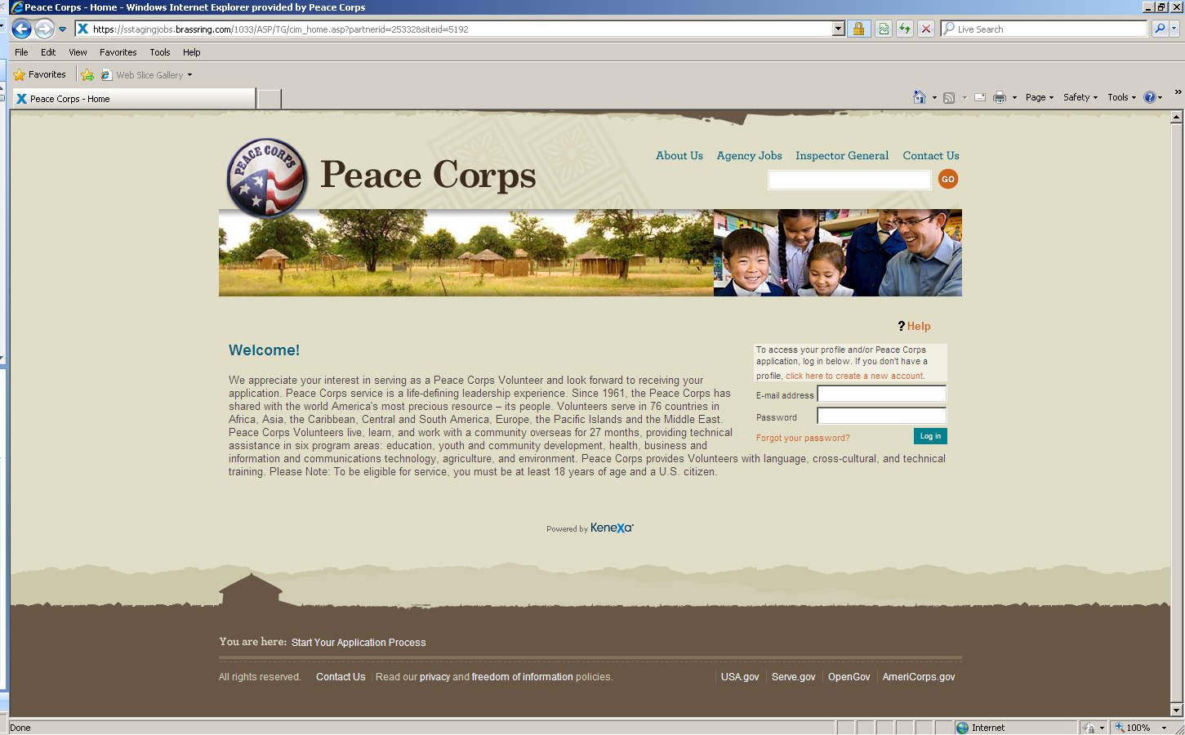

Screenshot 2: “Landing” page for candidates where they may “Click here to become a Peace Corps Volunteer” (which directs them to the first page of the electronic version of the Peace Corps Volunteer application). This is not included in the hard copy version of the Peace Corps Volunteer application.
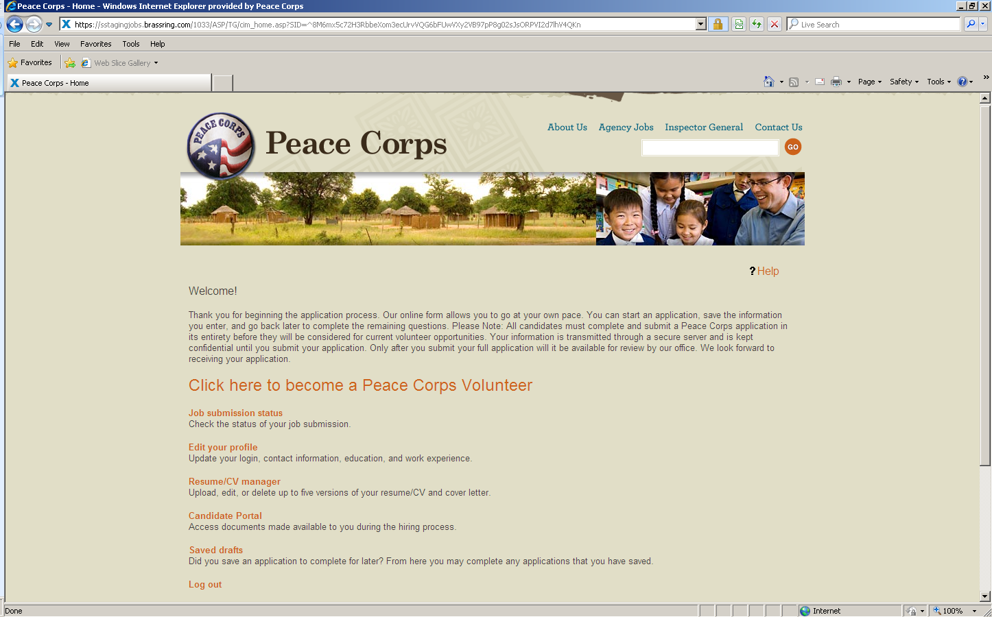

Screenshot 3: General Instructions on how to complete the electronic version of the Peace Corps Volunteer application. This is not included in the hard copy version of the Peace Corps Volunteer application.
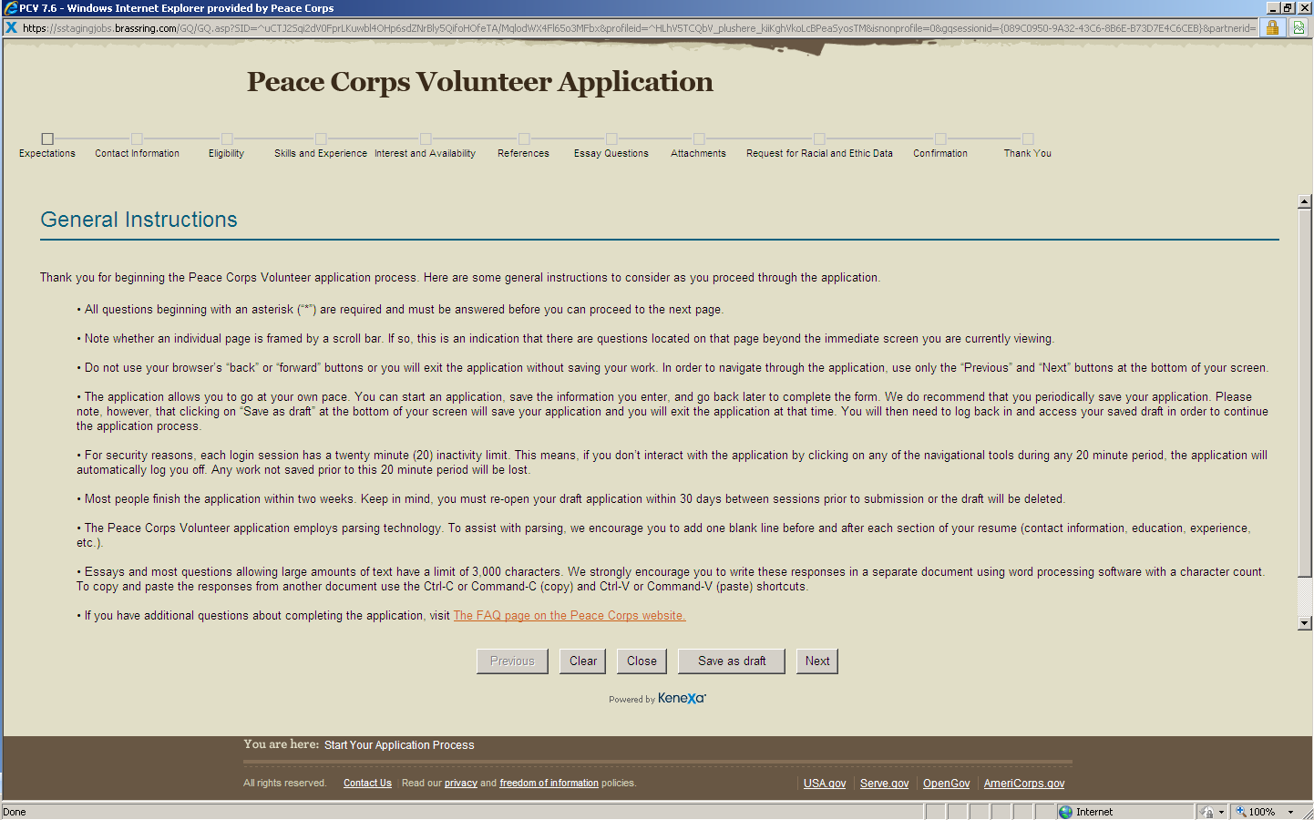

Screenshot 4: The “What You’ll Need” page is the first “page” of the electronic version of the Peace Corps Volunteer application that mirrors the same page in the hard copy of the Peace Corps Volunteer application. All subsequent pages in the electronic version match those in the hard copy.
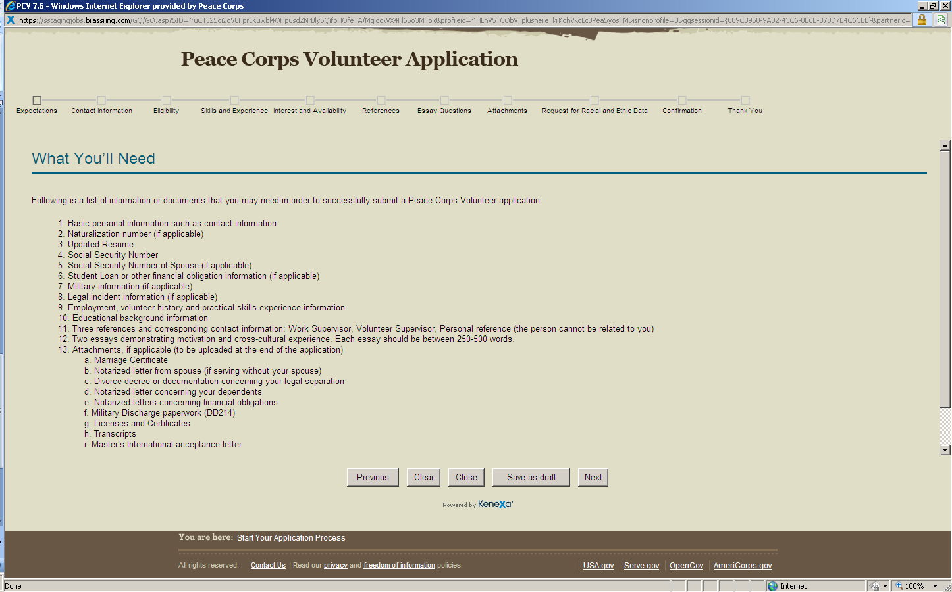

Note 1: The preceding “What You’ll Need” screenshot matches the wording and overall formatting of the same page of the hard copy of the Peace Corps Volunteer application. All subsequent pages of the hard copy of the application match those of the electronic version page for page and question for question. The only exception are that we’ve omitted from the hard copy all references to uploading, electronic parsing, electronic attachments, etc. because that is meaningless in the hard copy (in which case we state “please attach” the same documents).
**Note 2 is on the following page**

Note 2: The following screenshot is of the PRA notice, burden statement, and OMB Control Number and Expiration Date. This is currently included at the end of the electronic and paper copies of the Peace Corps Volunteer application but we can ask the vendor to configure it elsewhere, per OMB guidance.
