National Institute of Standards and Technology (NIST)
Information Technology Laboratory (ITL), Information Access Division (IAD)
Fingerprint Directional Symbols Study Task Evaluation Post-Task Questionnaire

Part 1 - Based on your experience from the tasks with the fingerprint scanner, please answer the following questions.

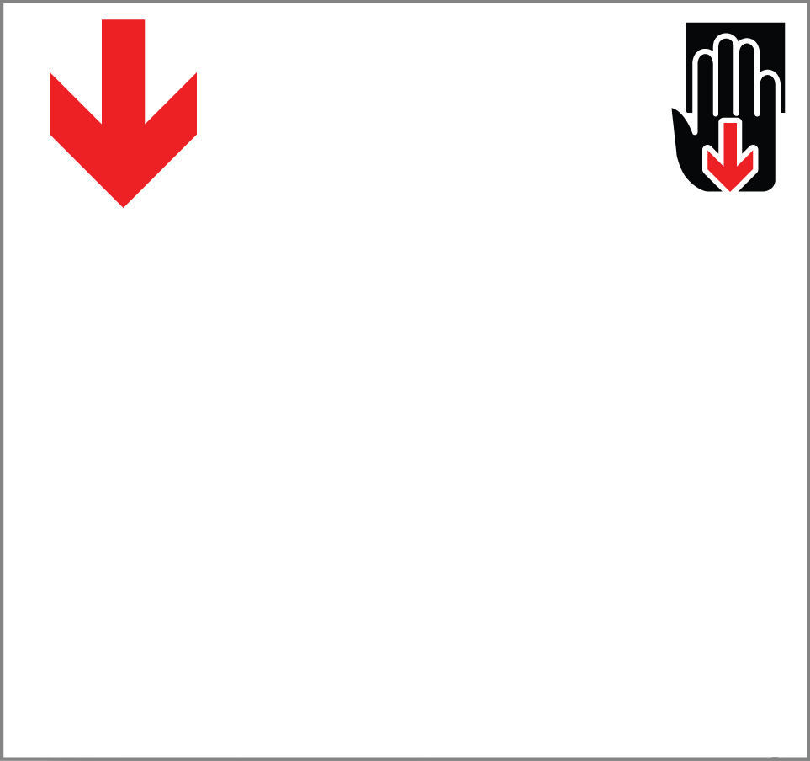 | - What does the picture mean?
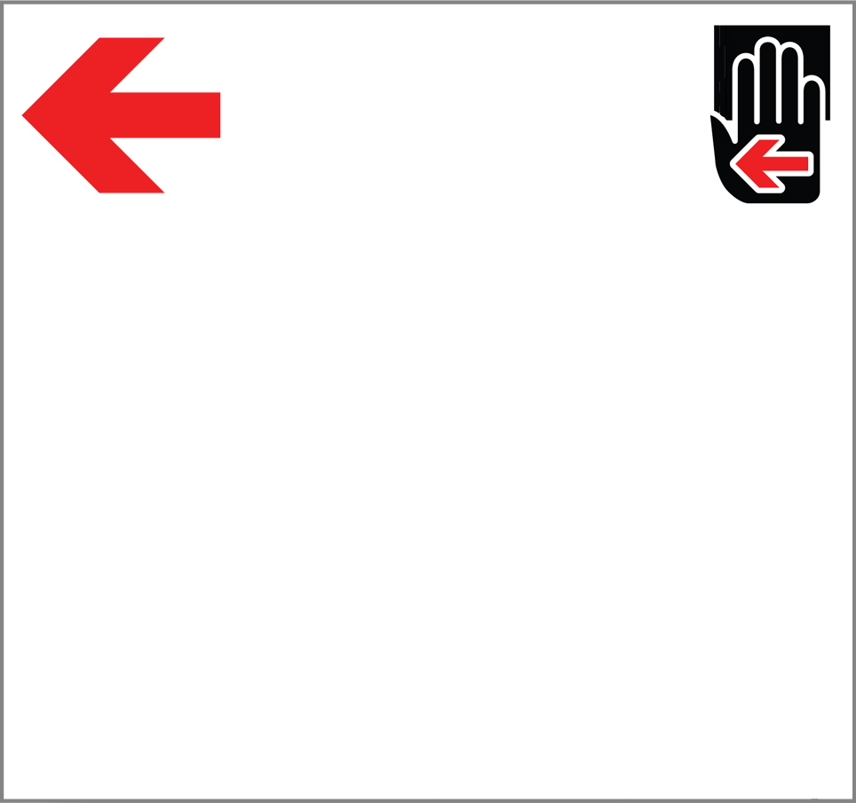 | - What does the picture mean?
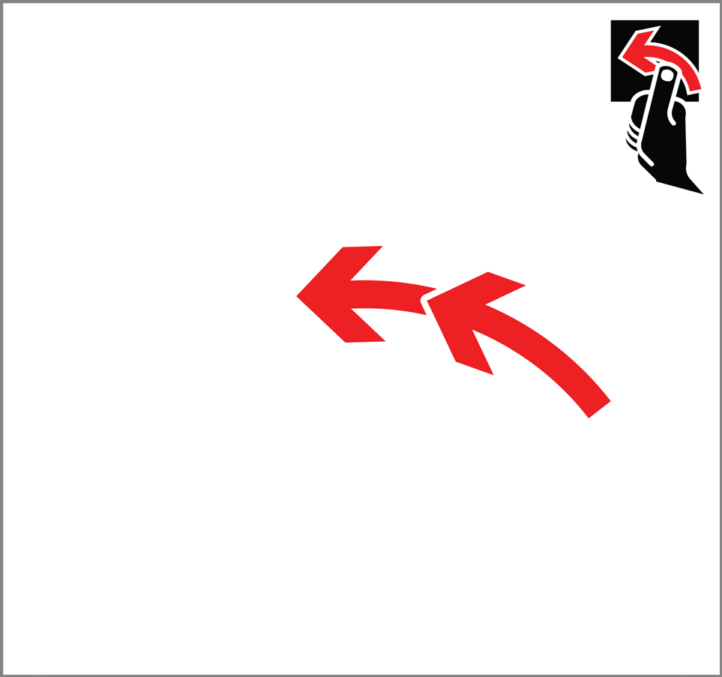 | - What does the picture mean?
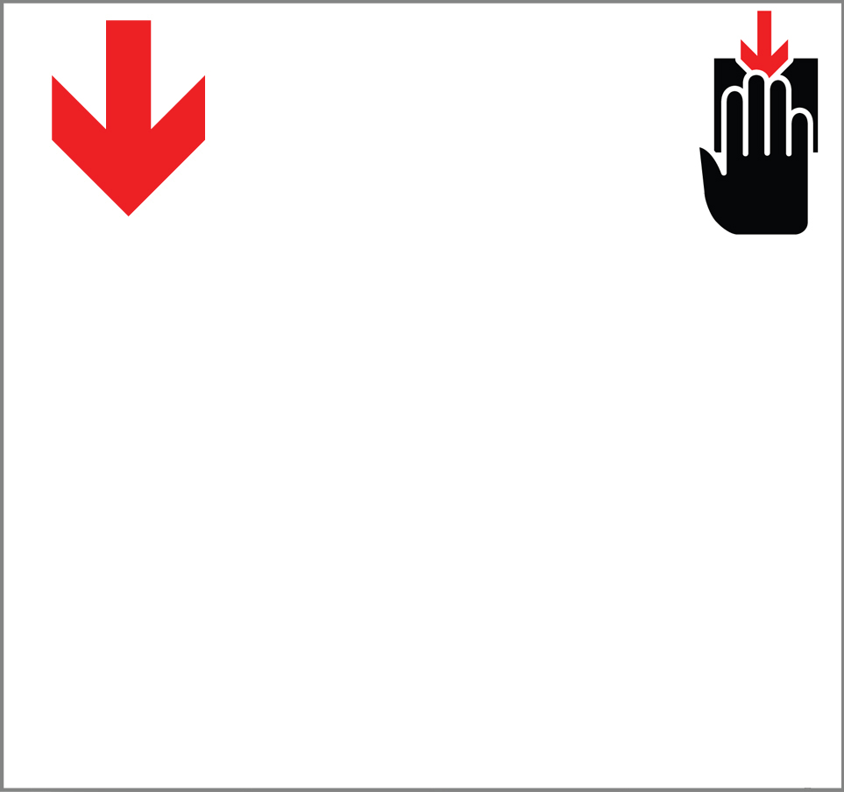 | - What does the picture mean?
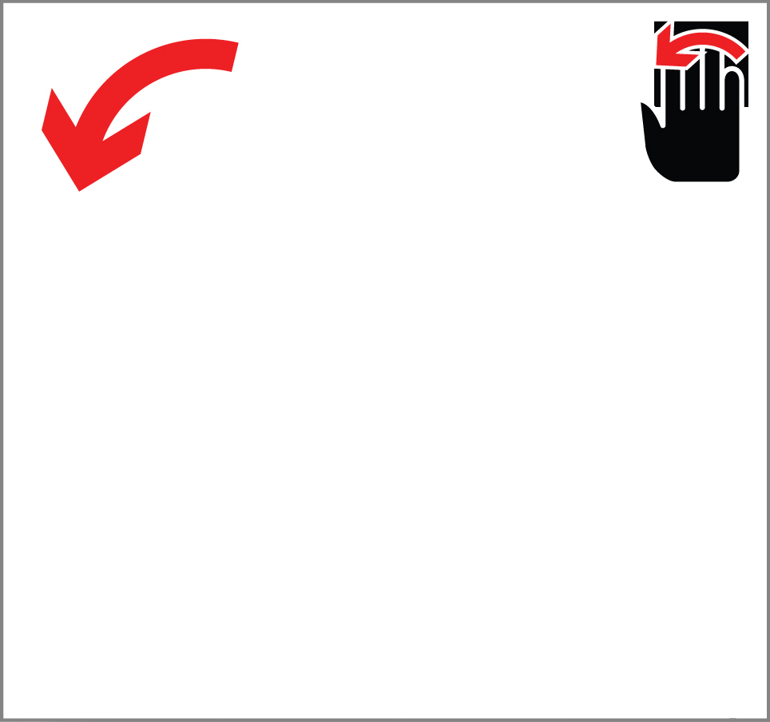 | - What does the picture mean?
 | - What does the picture mean?
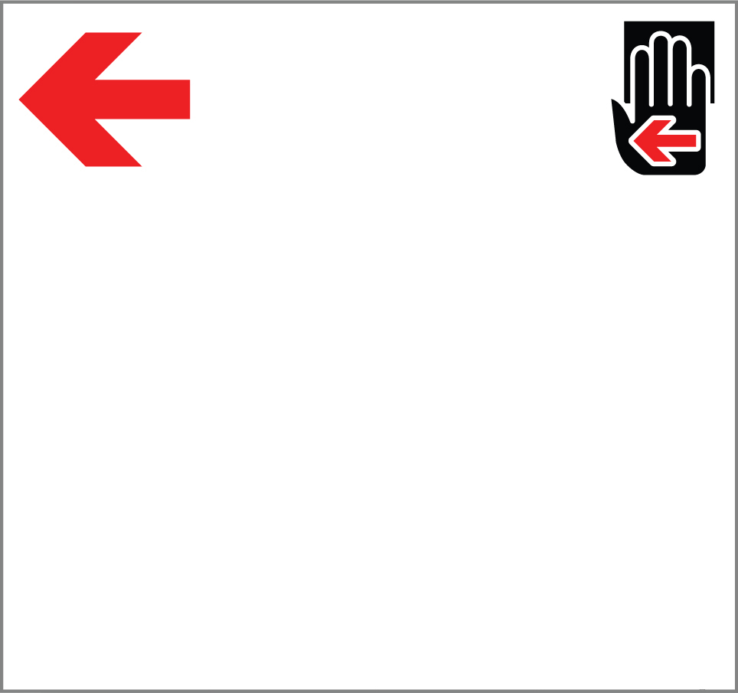 | - What does the picture mean?
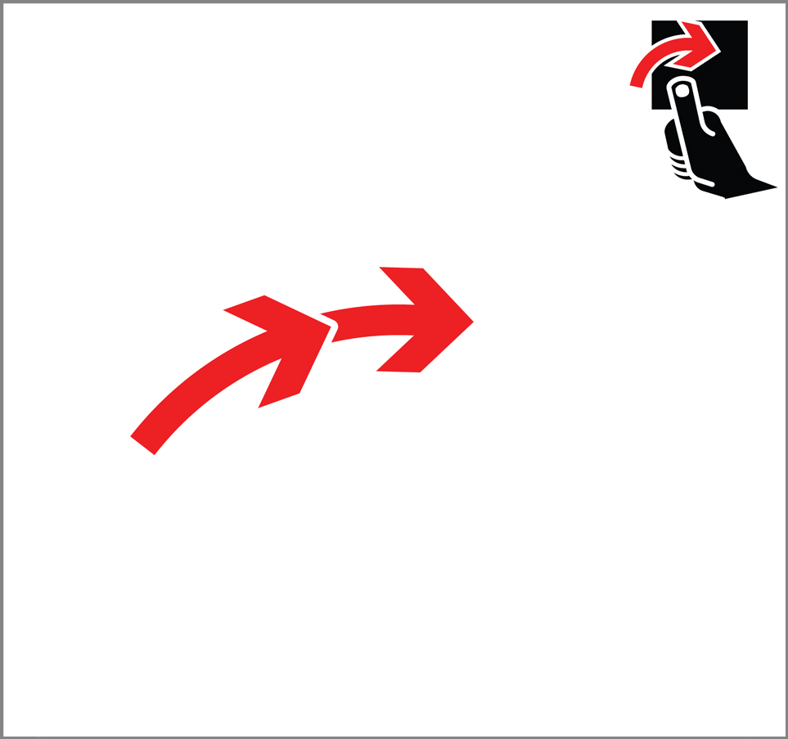 | - What does the picture mean?
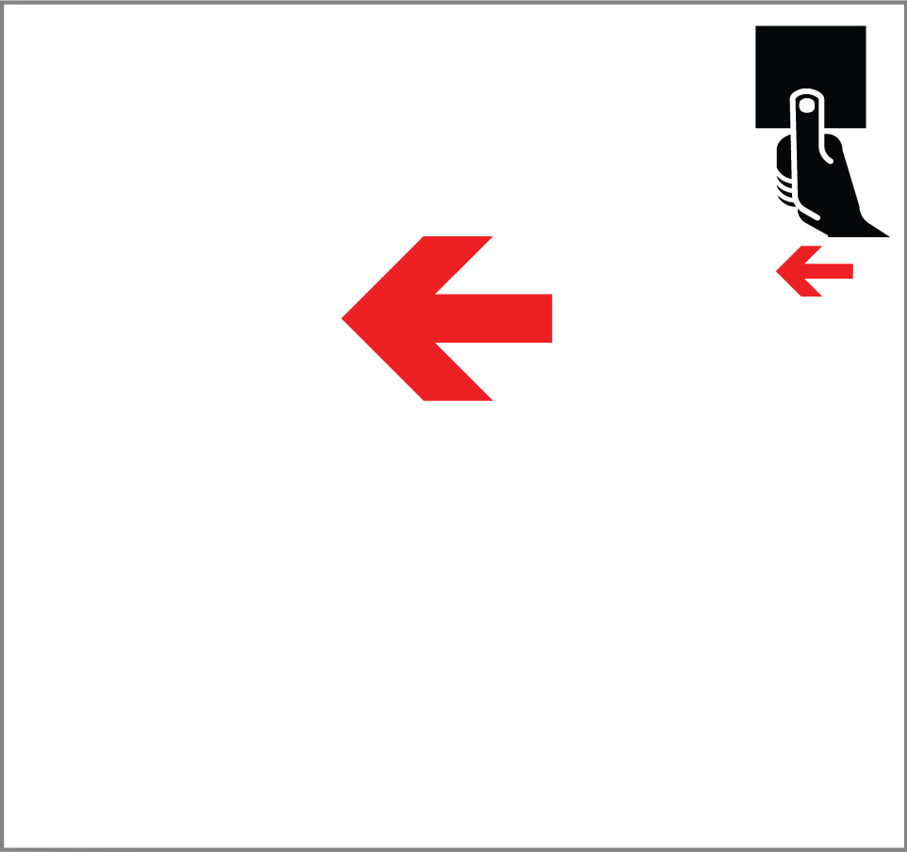 | - What does the picture mean?
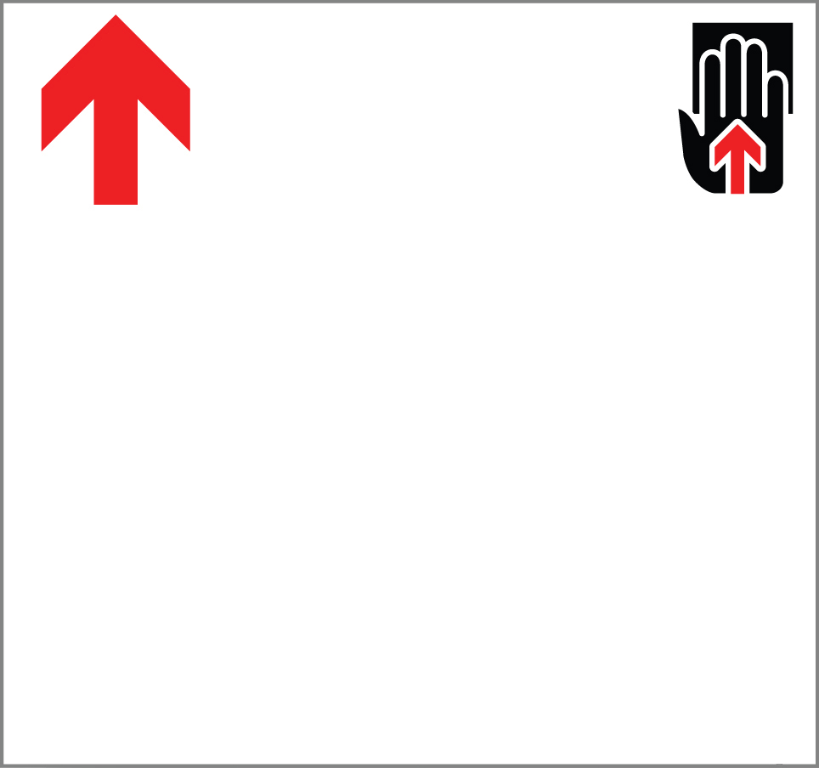 | - What does the picture mean?
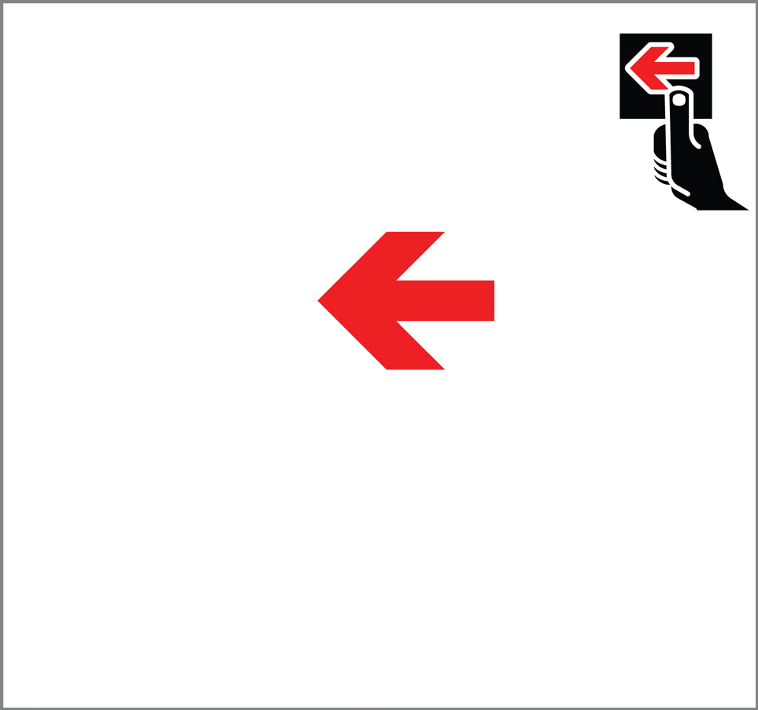 | - What does the picture mean?
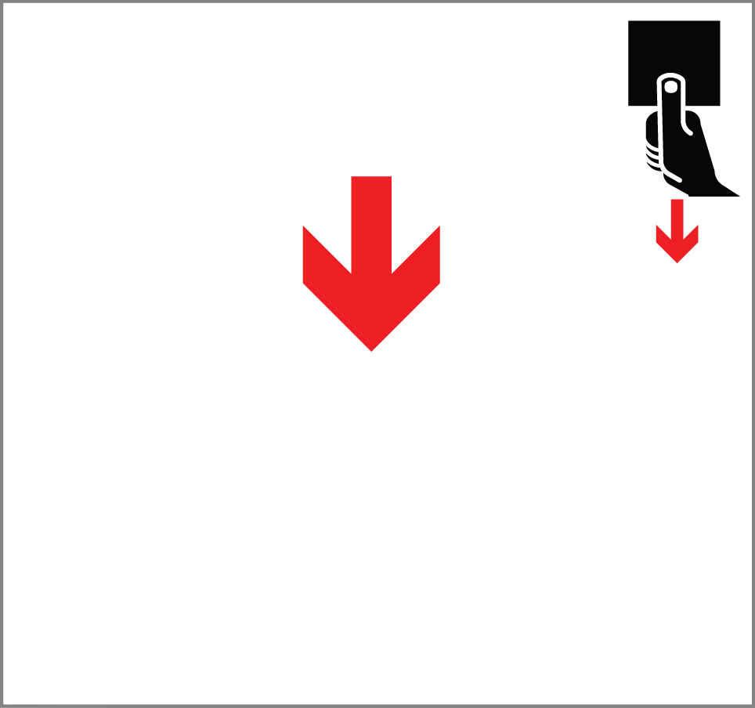 | - What does the picture mean?
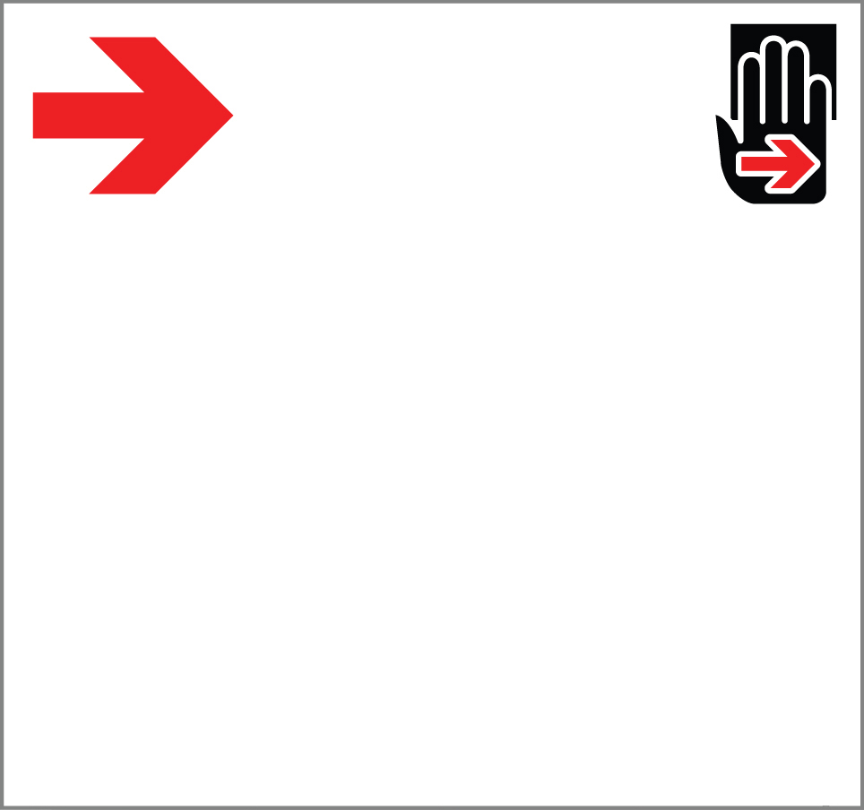 | - What does the picture mean?
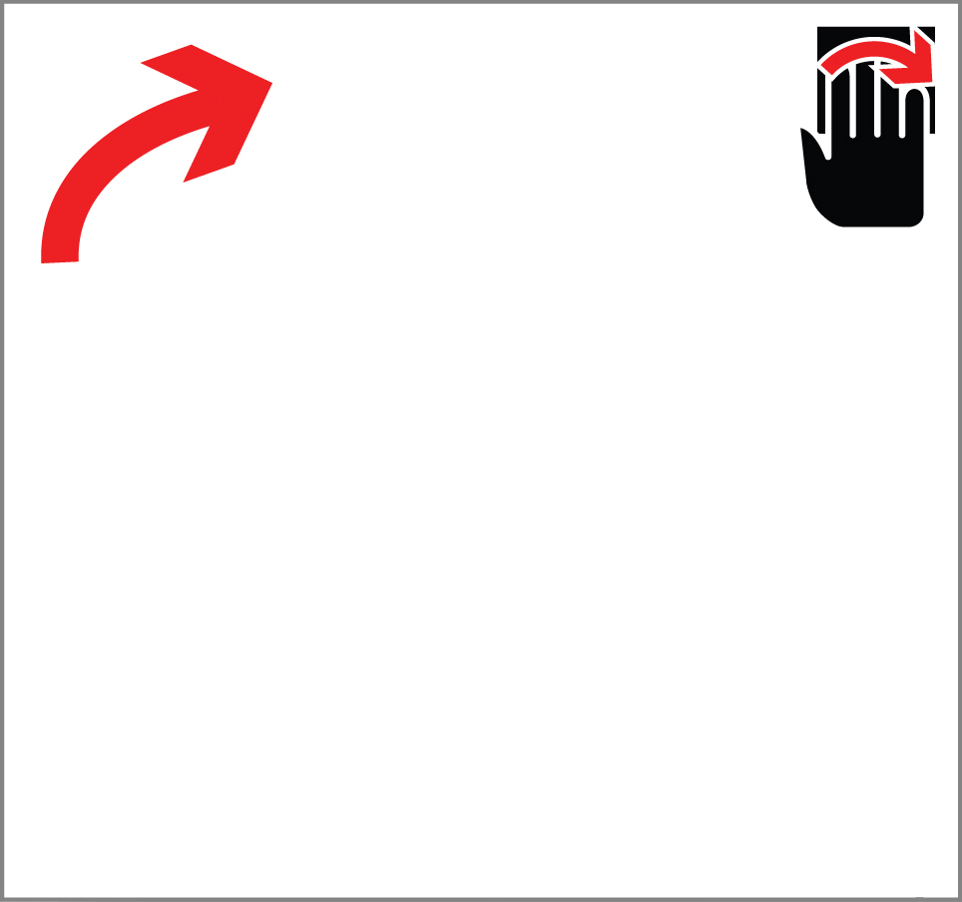 | - What does the picture mean?
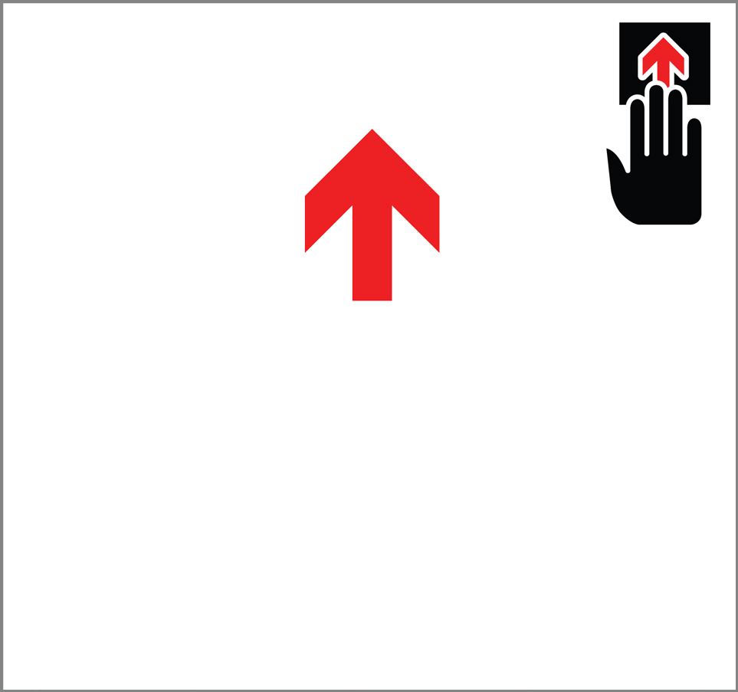 | - What does the picture mean?
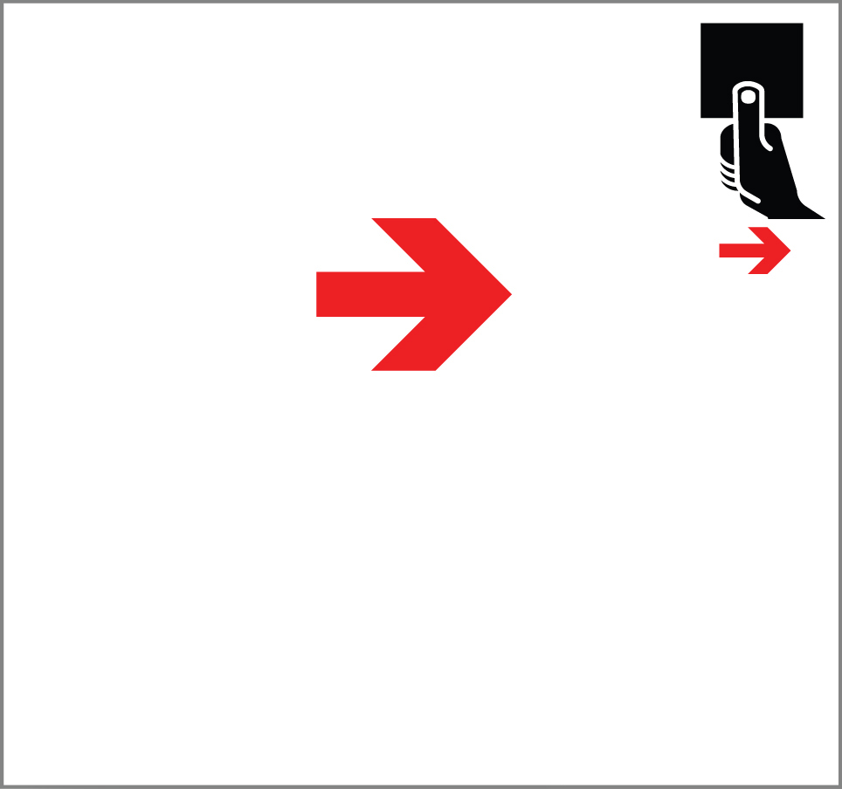 | - What does the picture mean?
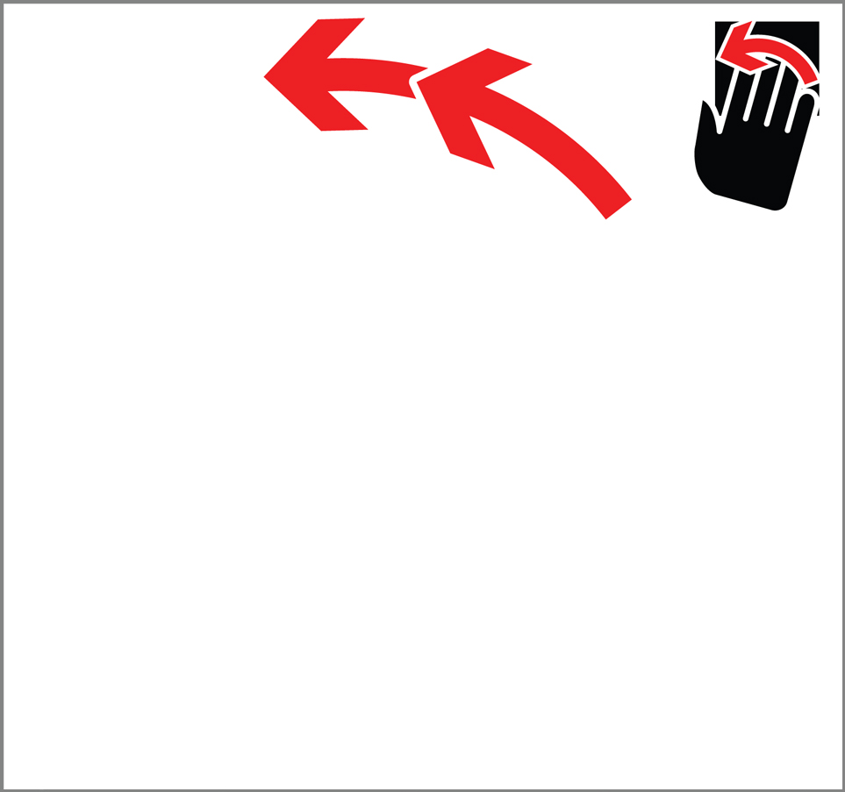 | - What does the picture mean?
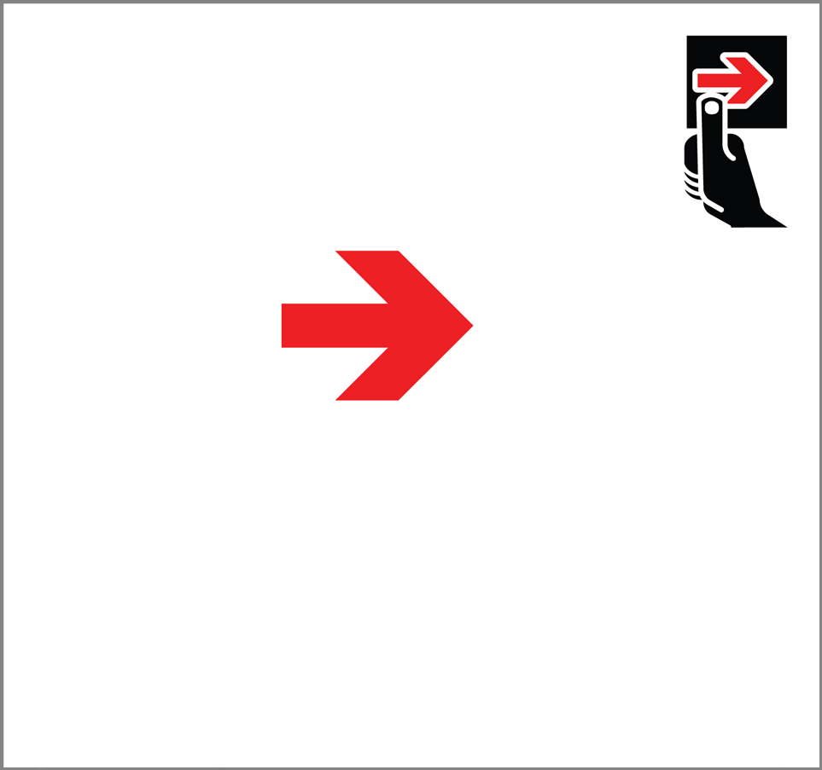 | - What does the picture mean?
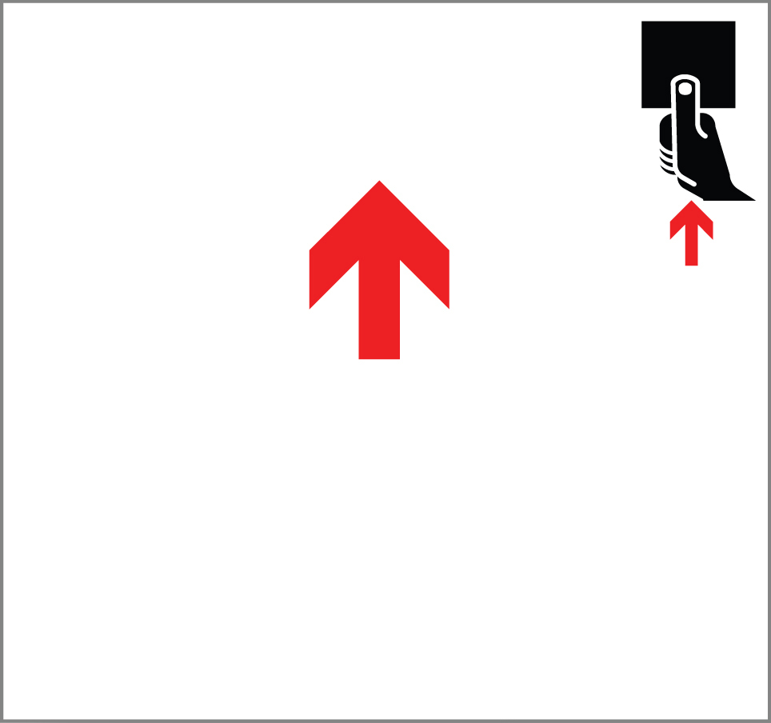 | - What does the picture mean?
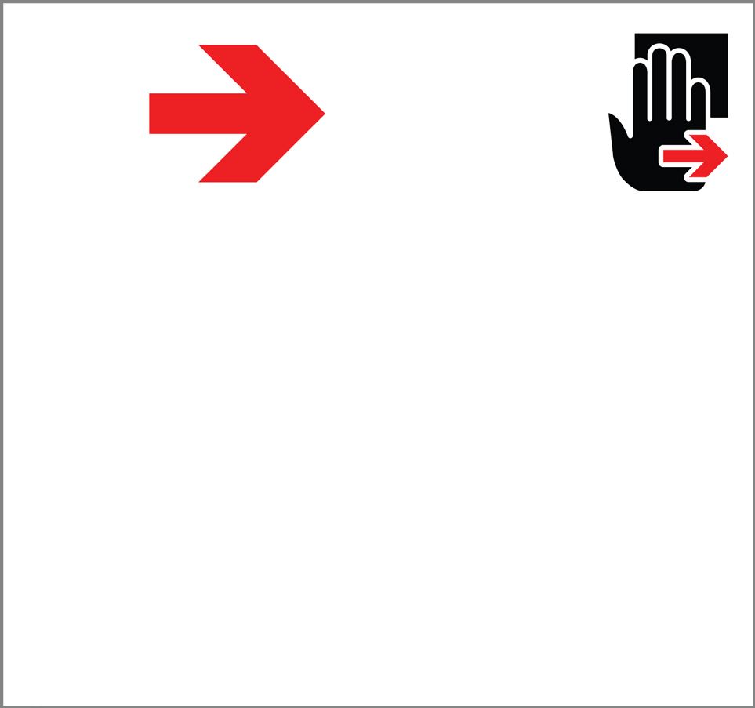 | - What does the picture mean?
 | - What does the picture mean?
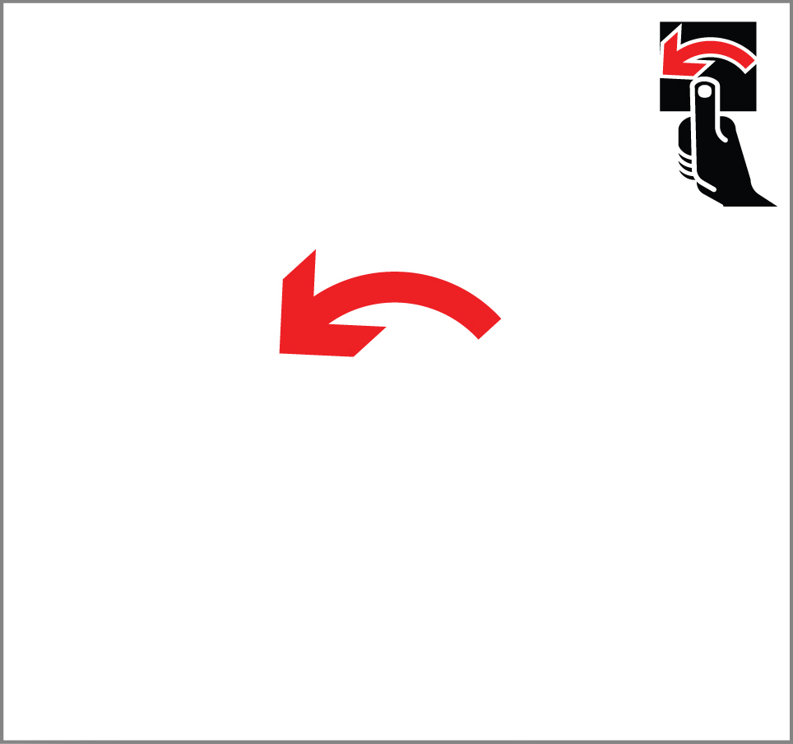 | - What does the picture mean?
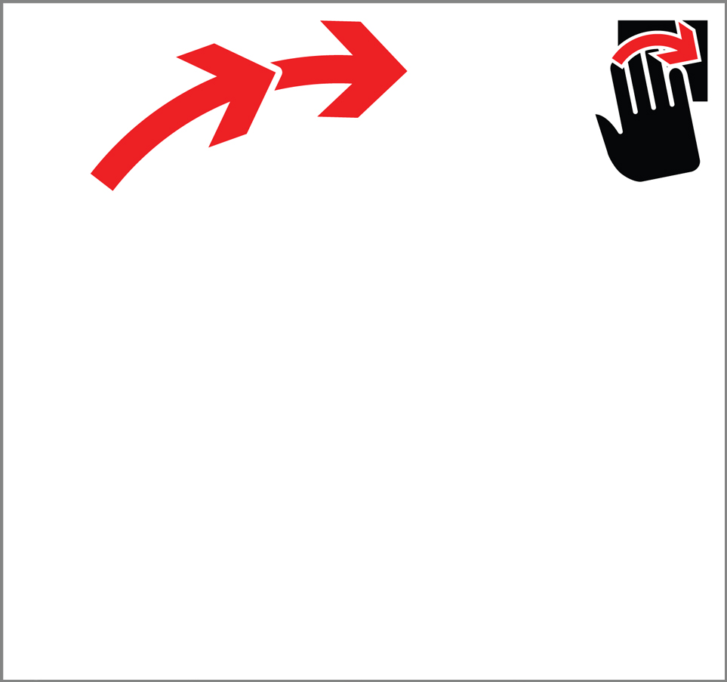 | - What does the picture mean?
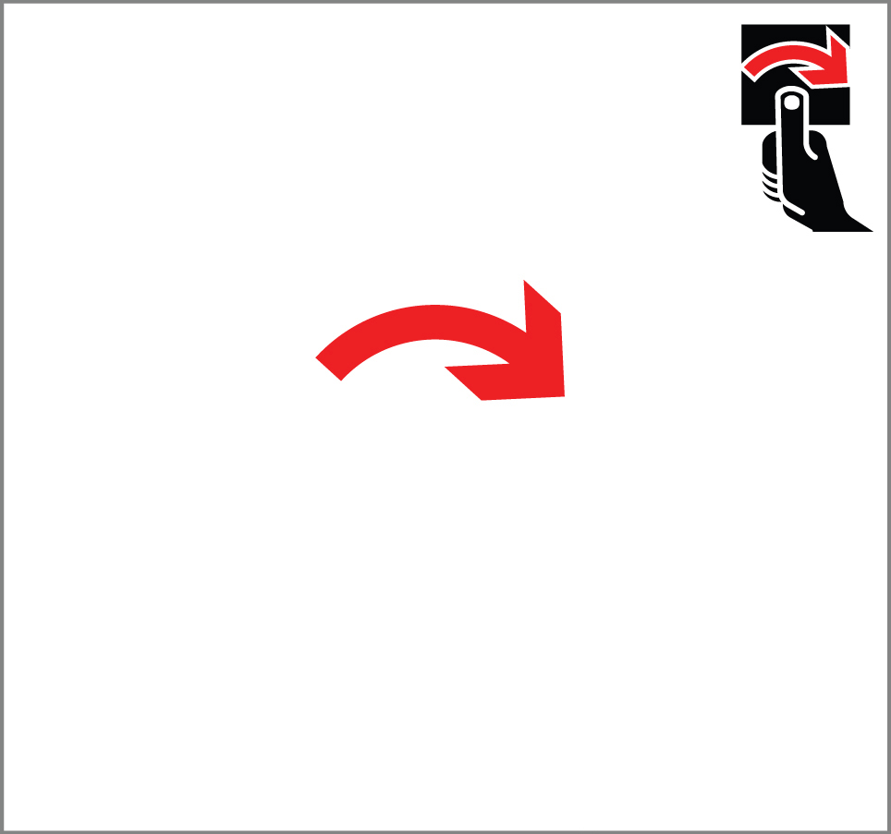 | - What does the picture mean?

Part 2 – If we would use pictures to tell people to move their hand/thumb on the fingerprint scanner, please circle the best representing picture for each movement.

- Right Hand - Move up
A | B | None of them
- Right Hand - Move left
 | 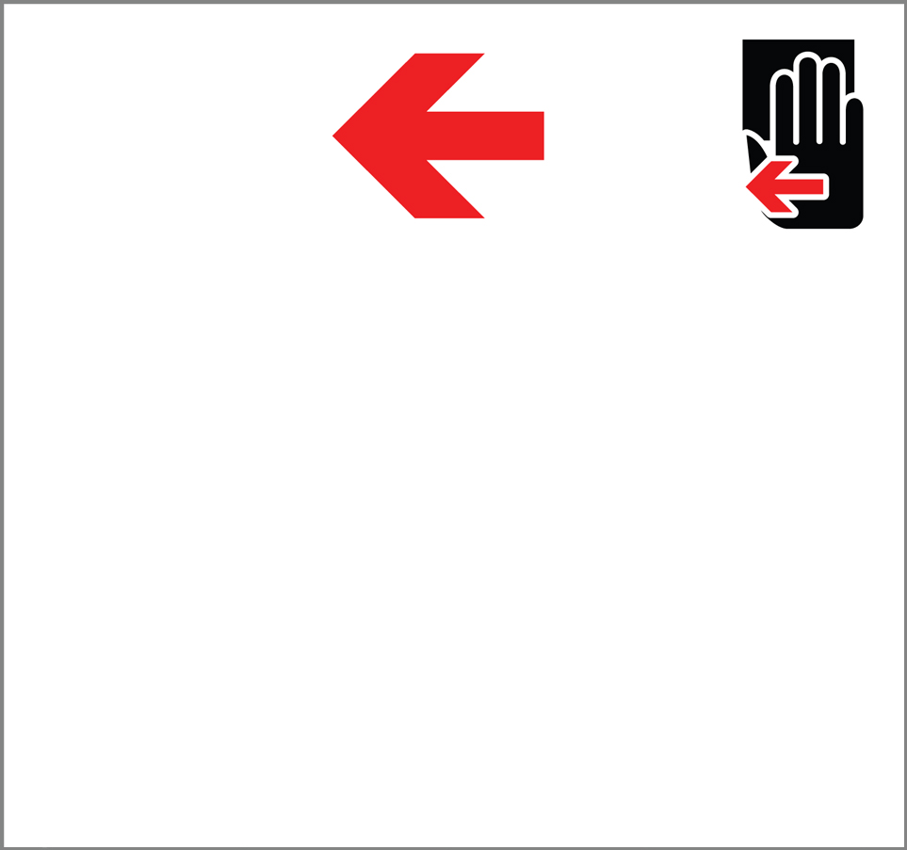
A | B | None of them
- Right Hand - Move down
 | 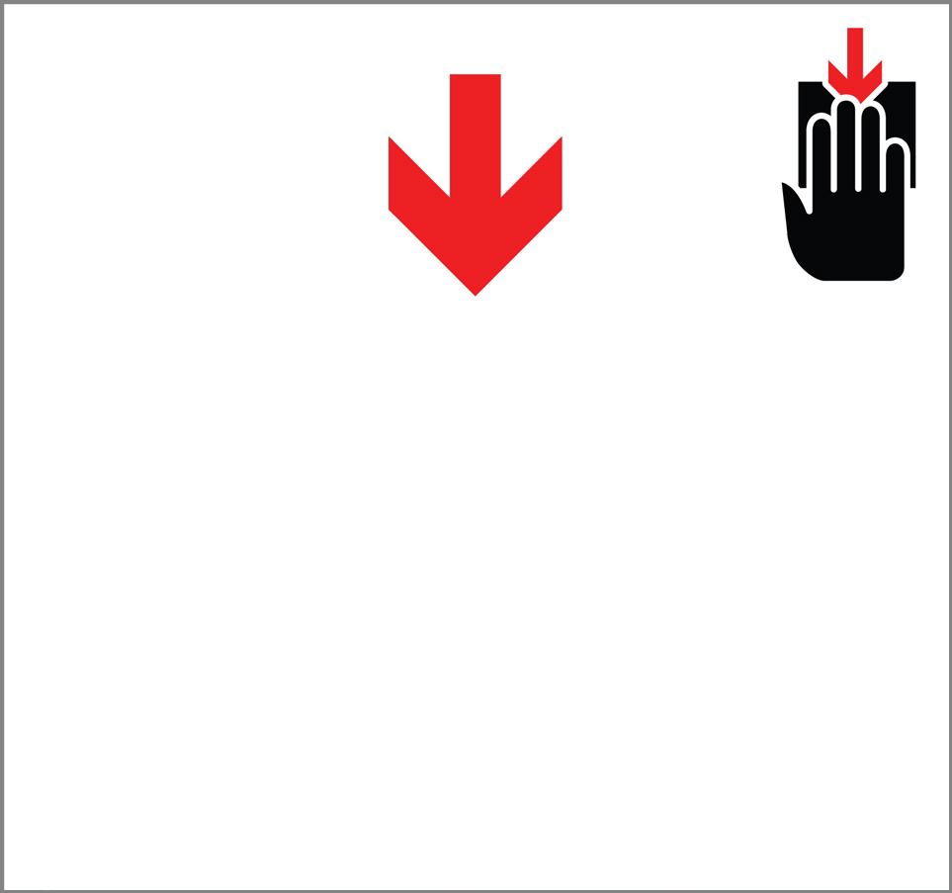
A | B | None of them
- Right Hand - Move right
A | B | None of them
- Right Thumb - Move up
A | B | None of them
- Right Thumb - Move left
A | B | None of them
- Right Thumb - Move down
A | B | None of them
- Right Thumb - Move right
A | B | None of them

- Right Hand – Rotate clockwise
A | B | None of them
- Right Hand – Rotate counterclockwise
A | B | None of them
- Right Thumb – Rotate clockwise
A | B | None of them
- Right Thumb – Rotate counterclockwise
A | B | None of them

Do you have any additional comments?

NOTE: This collection of information contains Paperwork Reduction Act (PRA) requirements approved by the Office of Management and Budget (OMB). Notwithstanding any other provisions of the law, no person is required to respond to, nor shall any person be subject to penalty for failure to comply with, a collection of information subject to the requirements of the PRA unless that collection of information displays a currently valid OMB control number. Public reporting burden for this collection is estimated to be 27 minutes per response, including the response time for reviewing instructions, searching existing data sources, gathering and maintaining the data needed, and completing and reviewing the collection of information. Send comments regarding this burden estimate or any other aspects of this collection of information, including suggestions for reducing this burden, to the National Institute of Standards and Technology, Attn., Mary Theofanos, at mary.theofanos@nist.gov .

OMB Control No.0693-0043,
Expiration Date: 10/31/2012.

