ATTACHMENT F
Permission, Consent, Assent Forms and Scripts

ATTACHMENT F1
Consent for Parent/Guardian and Child Permission for Participation

CONSENT FOR PARENT/GUARDIAN AND CHILD PERMISSION FOR PARTICIPATION

Children’s Health after the Storms (CHATS)
Baseline Feasibility Consent for Parent/Guardian and Child Permission for Participation

Your child has been invited to take part in a research study for the Centers for Disease Control and Prevention (CDC). This study is called Children’s Health after the Storms (CHATS). As a parent or guardian of the child, you will be asked to participate in certain parts of the study as well. The purpose of this research is to find out about the health of children in the Gulf Coast after Hurricanes Katrina and Rita. This is so that we can better understand the effects of the living conditions—such as storm damaged housing, FEMA-supplied trailers, and housing unaffected by the storms—on children in this area.
Who is doing the CHATS Study? RTI International, a not-for-profit research company, is conducting the study on behalf of CDC. Local Louisiana and Mississippi partners, including the Louisiana State University (LSU) Health Sciences Center, the Coastal Family Health Center, and the Louisiana Public Health Institute (LPHI) are also on the study team. Section 301 of the Public Health Service Act permits the Centers for Disease Control and Prevention to collect this information, including your Social Security Number.
How was my child chosen? We used lists from the United States Postal Service and the Federal Emergency Management Agency (FEMA). Your household was picked randomly from one of these lists. Your child was selected from among the 701 eligible households we are contacting.
What will my child and I have to do during the survey? If you agree, today I would like to start what we call the Baseline assessment with you and your child. The Baseline assessment is broken into 2 separate sessions. Today we will complete Session 1. Five to 9 days from now, I will return along with a nurse to complete Session 2.
During Session 1 (Today):
- I will ask you, the parent or guardian of the child, some general questions about the makeup of those who live in your household and about your home itself, including your residential history since the Storms hit. For example, there may be questions about how you heat and cool your home and if any damage has been done to your home since the Hurricanes. I will also ask you some questions about your child’s current and past health conditions, including any history of breathing problems or skin allergies your child or other family members may have.
- If your child is at least 7 years old, I will show him/her a small tool, or personal exposure measuring (PEM) device, your child will wear until I return for Session 2. This PEM measures the quality of the air your child breathes. It is about the size of a cell phone and can be worn on a vest or shoulder strap that I will provide. I will demonstrate for you and your child how the PEM works.
- I will ask both you and your child some questions on his/her feelings about events going on in your child’s life. For example, I may ask about your child’s feelings towards school, their relationships with others, and any physical activities they are involved in.
- I will teach you and your child how to complete the daily Time-Activity Diary to keep track of your child’s location and activities between Session 1 and Session 2.
- I will set up some devices, which will take samples of air in and around your home, and I will do a quick visual check of your home.
- I may also ask your permission for the Study’s staff to review your child’s medical records.
- I will set up an appointment to return to your home for the Session 2, which will be 5 to 9 days from today.
During Session 2:
- I, or another interviewer if I am unable to return, will come back to your home along with a nurse.
- I will ask you and your child about the kinds of activities he/she took part in, both inside and outside of the home, during the previous week. I will also ask you some general questions about your child’s health that will be similar to those asked during Session 1.
- I will pack up the air devices from Session 1 and vacuum some dust from around your home.
- Finally, I will get a GPS reading for your home so we can link the results to the neighborhood where you live.
- The nurse will ask your permission to complete a health assessment with your child. During the health assessment, the nurse will:
  - Ask you and your child some general questions about his/her current and past health conditions, including any history of breathing problems or skin allergies your child or other family members may have
  - Take a look at your child’s face, neck, arms, and legs to see if he/she has any rashes or skin problems
  - Measure your child’s height and weight
  - Ask your child to do some breathing tests to see if he/she has difficulty breathing
  - Collect a urine and blood sample to see if your child is exposed to harmful chemicals or has blood problems or allergies
How long will this take? Today for Session 1, I will only need about 15 minutes of your child’s time and about 1 hour of your time for a total of 1 hour and 15 minutes. During Session 2, the nurse will need about 45 minutes to complete the health assessment with your child, and I will need about 15 more minutes of your child’s time to talk about the activities he/she took part in over the last week between sessions for a total of about 1 hour. I may need to ask you some questions during the 45 minute health assessment.
Is there anything we need to do between Session 1 and 2? If your child was asked to wear the PEM device during Session 1, we ask that he/she continue wearing the device until Session 2. We ask that you keep the air devices in the place where I leave it for the whole week. Lastly, we will also ask that you (or your child) fill out the Time-Activity Diary every day between sessions.
Do we have to do this study? No, your family’s participation in this study is completely voluntary. If you or your child do not want to take part in our study, you do not have to. If you or your child only want to do part of the study, that is okay too.
- You and your child may skip any questions that you do not wish to answer. .
- You may ask us to not leave the environmental devices in your home or on your property. .
- Your child does not have to do any test(s) that he/she does not want to do, or to get weighed or measured.
- If you or your child decides not to take part in the study, you and your family will not lose any benefits or services you may be receiving. There is no penalty for withdrawal.
- You and your child can decide to leave the study at any time. To withdraw from the study, please call us at 1-877-834-7088 and let us know. Please note:
  - CHATS will not be able to remove samples and information that have already been tested.
  - We cannot get back sample data or information that has already been combined with data from other assessments.
  - CHATS may still use or share for research purposes only the health information that was already collected before your child withdrew from the study. This is so we can protect the validity of the study results.
However, your child’s participation in this study is very important to us because he/she plays a critical part in helping us understand the health effects of children living in this area after Hurricanes Katrina and Rita. You and your child may choose not to take part in this study, but because your household was chosen based on scientific method, and your child was chosen at random to participate, no other child or household can take your place. If there is another parent or guardian in the home who is available, we are more than happy to speak with him or her if you prefer.
What type of testing will be done at the laboratories? The blood and urine samples will be sent to the Interim Louisiana State University (LSU) Public Hospital, and the air samples from the PEM and dust samples from your home will be sent to RTI’s laboratory. Some of the tests we will do can identify unusual levels of chemicals and other pollutants such as mold in the air and dust that could cause skin allergies or breathing problems for your child. The blood, urine, air and dust samples will not be used for any purposes other than this study and will be destroyed in accordance with CDC’s records control schedules. You have the right to have these samples destroyed at any time prior to the end of the study as well. To do this, you would only need to call us at 1-877-834-7088 and let us know.
Will we receive anything for taking part in the study? By joining this study, you are helping us to gain a better understanding about the overall health of Gulf Coast children. This will help in making better plans for future natural disasters like hurricanes. As a token of our sincere thanks for your time, you and your child will be given the following at the end of each session:
- Session 1.
  - Parent/Guardian Token of Thanks: $40 for completing the 1st parent interview and consent to set up the air devices

- Session 2.
  - Parent/Guardian Token of Thanks: $65 for completing the 2nd parent interview, permission for your child to take part in the health assessment, and permission to collect the air and dust samples. If your child is 7 to 12 years of age, you will also receive $20 for your time and assistance in working with the child and the PEM.
  - Child Token of Thanks: If Age 13 or older - $30 for wearing the PEM. If Age 8 through 12- $10 for wearing the PEM. . We will ask you to sign a receipt for your child’s cash payment. If Age 7 or younger - activity book or coloring book instead of cash.
If both you and your child fully participate in the study, and depending on the age of your child, your household could receive up to a total of $135.
- Within about 5 months, we will send you some information about the air quality in your home along with the results from your child’s personal air measurements, blood and urine test results if he or she participates. These letters will give you valuable information about your child’s health related mainly to skin allergies and breathing problems. If any test results show that your child should be seen by a doctor, while we cannot refer you to a specific doctor for further care, we will provide you with a list of clinics or doctors in your area who may be able to help.
The letters will also include some information about how to understand what the test results mean. If the air quality results indicate improvements can be made in the home, the letter will provide suggestions for how to do that
If any of the test results for blood or urine are critical, we will notify you within 24 hours after processing by the lab. Lab processing will be finished in 1 to 2 weeks.
Are there any risks to taking part in this study? Some questions in this study are of a personal nature. Some people might find them embarrassing or distressing. If you are upset or uncomfortable you can skip any question, or you can stop the interview at any time.
There are no risks for your child to wear the PEM. Your child should also not feel any physical pain from having the nurse look at their face and skin for allergies, measure their height and weight, or collect their urine sample. When the breathing tests are done, some children may cough or say that they are light-headed. These usually go away quickly. The nurse will be there to help your child if they feel this way.
Your child may find the blood draw a little uncomfortable as described below:
- Your child may feel a slight pinch when the blood is drawn and this could leave a small bruise. We will use the same methods that most doctors use in their office, and we will not make more than two tries to draw your child’s blood.
- There is a small chance of getting germs in the spot where the blood was taken. If the area around the spot gets red and sore or infected, you will need to take your child to a health clinic or your doctor.
- Some people get a little dizzy or feel uncomfortable before or after the blood collection, but the nurse will be there to help them if they feel this way.
- To help lessen the discomfort your child may experience during the blood draw, with your permission, the nurse may be able to apply a small amount of numbing cream to the needle stick area before collecting the blood sample. Some people experience a reaction, such as a mild skin irritation, on the spot where the numbing cream is applied.
During the home visit or health assessment, while we do not anticipate this to be likely, we are required by law to report any child abuse or neglect we may see or hear. More information on this issue is provided in the privacy section below.
As mentioned above, if the letter you receive with your child’s CHATS test results shows there may be areas of concern regarding your child’s health, the study will provide a resource list of clinics and doctors to contact for help. It will then be your choice to decide whether or not to contact a clinic or doctor for further examination or treatment. The CHATS study will not provide any follow up care needed based on the results found during the CHATS assessments.
Will we be contacted again? To help us understand how the health of your child changes between seasons and as they grow older, we would like to return for a follow-up visit, with your permission. The follow-up visit will occur 6 months after Session 2. We will repeat the assessments (both sessions); only we would not collect blood from your child during the 6-month follow-up.
CHATS will follow families for one year and then possibly for another six years. In all, we may ask to visit your child up to 7 times over the course of our study, with each visit being 6 to 9 months apart.
- You and your child will be given the same tokens of appreciation at the end of each session.
- Each of these additional visits will be completely voluntary. You and your child will have the option to say no if either of you do not want to do the study or any part of the study.
Also, you may get a telephone call or a letter from RTI to make sure our field personnel were professional and courteous when visiting you.
Will our information be kept private? Your family’s privacy is protected by law, and all responses and samples collected will be kept strictly private. . The nurse will label your child’s samples with a special number instead of his/her name as a further safeguarding measure.. No DNA or any other biological test that might yield identifiable information will be done. We will not give your family’s personal data or results to anyone who does not work on the study. There is an important exception: If the nurse or I feel that your child’s life or health is in danger or if you or your child tells us that either of you are planning to cause serious harm to yourself or others, we will inform the appropriate county or state agency. We will not use any names of parents or children in our study reports. All answers and data collected for CHATS will be combined with other interviews and all published information about the study will be in summary form only.
In addition, all RTI staff involved in the project have signed a Privacy Pledge saying they will protect the privacy and security of the data they collect and the privacy of the respondents. For added protection, the study also has a Certificate of Confidentiality which helps us protect the privacy of people in the study. Having this Certificate means that we cannot be forced to give your or your child’s name or other identifying characteristics to anyone not connected with the CHATS study, even if in a court of law, unless you say it’s okay. Please note that a Certificate of Confidentiality protects the researchers from being forced to disclose your personal data but it will not protect you if you decide to tell others about your family’s involvement in the CHATS study. You should consider protecting your own privacy when talking to others.
Who do I call if I have questions? If you have any questions about the survey you may call the [Insert project title], [Insert name]. [Her/His] toll free number is 1-xxx-xxx-xxxx, ext xxxx. You may also contact the CDC [Insert title]. [Her/His] toll free number is 1-xxx-xxx-xxxx. When you call, tell [him/her] the protocol number for this survey is xxxx-xxxx. If you have any questions about your rights as a study participant or you feel you have been harmed, you can call RTI’s Office of Research Protection at 1-xxx-xxx-xxxx (a toll-free number).
Do you have any questions that might help you decide whether or not you want both you and your child to participate in the study?
Parent/Guardian’s Participation Agreement. You will be given a copy of this consent form to keep. When you indicate your choices and sign below, it shows that you give consent for both you and your child to participate in Children’s Health after the Storms. It also shows that you have read the information in the previous pages and that you have received answers to all of your questions. If there is a part of this form that is unclear to you, be sure to ask questions about it. If you agree for you and your child to be a part of this survey, you are not giving up any of your legal rights.
Parent/Guardian’s Sample Collection Agreement. Please write your initials next to your choice for each of the samples below. You may make different decisions for each sample if you desire.
Urine Sample
- I DO consent for my child to provide a urine sample.
- I do NOT consent for my child to provide a urine sample.
Blood Sample
- I DO consent for my child to provide a blood sample.
- I do NOT consent for my child to provide a blood sample.

Printed Name of Child

Printed Name of Parent/Guardian Printed Name of Interviewer

Signature of Parent/Guardian Date Signature of Interviewer Date

Recordings. We are using a special quality control system on this project. The system runs on the computer and will record what we say to each other during several different parts of the interview. Neither of us will know when the computer is recording what we say. The recording will be reviewed by people at RTI to monitor my work. The files will be destroyed after they have been used to review my work. The recordings will be kept private just like all the other information you provide. You may participate in the interview even if you do not consent to the recordings. May we use this quality control system during your interview?
By signing below, you are agreeing to allow the computer recordings for quality control.

Signature of Parent/Guardian Date
□ CHECK BOX IF PARENT AGREES TO HAVE
PORTIONS OF THE INTERVIEW RECORDED Signature of Interviewer Date

□ CHECK BOX IF PARENT DOES NOT WANT
ANY PORTIONS OF THE INTERVIEW RECORDED

ATTACHMENT F2
Child Assent Form – 8 - 12 Years of Age
CHILD ASSENT FORM 8 - 12 YEARS OF AGE

Children’s Health after the Storms (CHATS)
Child Assent Form (Age 8-12)

You have been invited to take part in a study called Children’s Health after the Storms (CHATS). The company I work for, called RTI International, is doing this study for the U.S. Government. Your parent/guardian said it was okay for me to talk to you about this special health study. After I tell you about the study, I will ask if you would like to be in it.
What is the study about? We are talking to kids just like you all across Louisiana and Mississippi to find out how you are doing after Hurricanes Katrina and Rita. Section 301 of the Public Health Service Act permits the Centers for Disease Control and Prevention to collect this information.
What will happen to me in this study? There are a number of things we need you to help us with.
Air Measuring Device. Today, I would like to talk to you for about 15 minutes to teach you how to wear a small device called a PEM. It’s easy to wear and just checks the air you breathe.
- We will want you to wear it all day long, from morning until bedtime, until I return in 5 to 9 days.
- The PEM can be worn on a vest or shoulder strap I will give you today. At night, you will place it next to your bed while you sleep.
Time Activity Diary. Today, I will also teach you how to fill out the daily Time Activity Diary to keep track of your activities each day until I return about a week from now.
Health Assessment. Next week, you will meet a nurse who will ask you some questions about your health, such as if you have any breathing problems or skin allergies, and do a short health assessment with you that will take about 45 minutes. The nurse will:
- Look at your face, neck, arms, and legs to see if you have any rashes or skin problems
- See how tall you are and how much you weigh
- Ask you to do some easy breathing tests
- Collect a small amount of urine (pee) and blood. This means that the nurse will use a needle to take a little bit of blood from your arm.
Will anything about the study hurt? You may start coughing or feel light-headed when you do the breathing test. But this usually goes away quickly and the nurse will be there to help you. When the nurse takes the little sample of blood, you may feel a little pinch or sting at first. Some people get a little dizzy before or after, but the nurse will be there to help you if you get dizzy.
Do I get anything for taking part in the study? To thank you for helping us with our study, we will give you $10 for wearing the PEM.
Are you going to come back? If you and your parent/guardian agree, we will return at least one more time and may return up to 6 more times to visit you. It will be about 6 to 9 months in between each visit. You will be able to say no if you don’t want to be in the study anymore.
What about my privacy? We will do our best to protect your privacy, using all of the laws available to us. It was so important that we have obtained a Certificate of Confidentiality for this study. This means that those of us doing the study cannot be forced to give out anything you or your parents/guardians tell us (even in a court of law), unless you say it’s okay. There is one exception to this rule about privacy: The only time I have to tell someone is if we feel that your life or health is in danger or if you tell the nurse or me that you are planning to seriously hurt yourself or others.
When we are finished with this study, we will combine your information with what we learned from other kids like you but we won’t ever use anyone’s names.
Do I have to be in the study? You do not have to do the study if you don’t want to, and no one will be upset with you. If you only want to do part of the study, that is okay too. If you start the study then change your mind, you can stop. Just tell us or your parent/guardian and they will contact us to let us know. You can also take a break at any time. Just tell me when you don’t want to do something or want a break.
What if I have questions? I will answer any questions you have now. If you have questions later, I left telephone numbers for your parent/guardian to call.
Do you have any questions for me now?
If you would like to take part in the study, please tell me and I will write your name on this paper to show that you want to be in the study. Also, please tell me if you agree to have the nurse complete a health assessment. In addition, you can agree to give both the urine and blood sample, only one sample, or none of the samples. I will mark your choice below.
Health Assessment
- I do agree to complete the health assessment with the CHATS nurse.
- I do not agree to complete the health assessment with the CHATS nurse.

Urine Sample
- I do agree to give a urine sample.
- I do not agree to give a urine sample.

Blood Sample
- I do agree to give a blood sample.
- I do not agree to give a blood sample.

Printed Name of Child 8-12 years old Printed Name of Interviewer

□ CHECK BOX IF CHILD DOES NOT AGREE TO PARTICIPATE
Signature of Interviewer Date
□ CHECK BOX IF CHILD AGREES TO PARTICIPATE
Recordings. We are using a recording system on the computer. The system may record what you and I or the nurse say to each other during parts of the interview. Neither of us will know when the computer is recording what we say. The recording will be listened to by people at RTI to check on my work. The files will be destroyed after they have been used to review my work. The people who listen to the recording will know who I am, but will not know who you are. You may participate in the interview even if you do not consent to the recordings. Is it all right with you if the recording system runs during this interview?
□ CHECK BOX IF CHILD AGREES TO HAVE
PORTIONS OF THE INTERVIEW RECORDED Signature of Interviewer Date

□ CHECK BOX IF CHILD DOES NOT WANT
ANY PORTIONS OF THE INTERVIEW RECORDED

ATTACHMENT F3
Child Assent Form – 13 - 15 Years of Age
CHILD ASSENT FORM 13 - 15 YEARS OF AGE

Children’s Health after the Storms (CHATS)
Child Assent Form (Age 13 - 15)

You have been invited to take part in a study called Children’s Health after the Storms (CHATS). The company I work for, called RTI International, is doing this study for the Centers for Disease Control and Prevention. I would like to talk to you about this special health study we are conducting.
What is CHATS all about? Children’s Health after the Storms is a special research study trying to find out about kids health after Hurricanes Katrina and Rita. This is so that we can better understand the effects that the living conditions after the Storms may have had on the children in the area. Your parent/guardian has given permission for you to join the study.
But what if I didn’t live in a temporary home during the Hurricanes? Do you still want to talk to me? Yes. It is very important to the success of our study that we also speak with kids and teens who did not move into temporary housing after Hurricanes Katrina and Rita. This is so that we can compare the overall health of the two groups. Section 301 of the Public Health Service Act permits the Centers for Disease Control and Prevention to collect this information.
What would I do if I participate? There are a number of things we need you to help us with so the study can be a success.
Air Measuring Device. Today, I would like to talk to you for about 15 minutes to teach you how to wear a small device, called the PEM. This device is about the size of a cell phone and will check the air that you breathe.
- We will want you to wear this small device all day long, from morning until bedtime, until I return in 5 to 9 days
- The PEM can be worn on a vest or shoulder strap I will give you today. At night, you will place it next to your bed while you sleep.
Time Activity Diary. Today, I will also teach you and your parent/guardian how to fill out the daily Time Activity Diary to keep track of your location and activities each day until I return in about a week’s time.
Medical Records Release. I may also ask your parent/guardian permission for the Study to review your medical records to confirm your health status.
Health Assessment. Next week, I will come back with a nurse who will ask you some general questions about your health, such as if you have any breathing problems or skin allergies, and complete a health assessment with you. This will take about 45 minutes. During the health assessment the nurse will:
- Take a look at your face, neck, arms, and legs to see if you have any rashes or skin problems
- See how tall you are and how much you weigh
- Ask you to do some easy breathing tests to see if you have any signs of breathing difficulties
- Collect a small urine and a small blood sample to run some health tests
What will happen to the samples I give the nurse? The nurse will label your samples with a special number instead of your name. The samples will be sent to a laboratory where they will run tests. In about 5 months, we will send your parent/guardian a letter with important information about your current health based on the tests run on these samples. One of the tests run on the urine sample identifies if you have been exposed to tobacco smoke.
Are there any risks or dangers to participating? There are very few risks to taking part in the CHATS study.
- There are no risks to wearing the small PEM strapped to your shoulder or vest.
- You should also not feel any physical pain from having the nurse check your skin for allergies, or measure your height and weight. You will take the urine sample privately in the bathroom while the nurse waits outside—just like in a doctor’s office or clinic.
- You may feel a slight pinch when the blood is drawn and this could leave a small bruise. Some people get a little dizzy before or after the blood is taken but the nurse will be there to help you if you get dizzy.
- You may start coughing or feel light-headed when you do the breathing test. But this usually goes away quickly and the nurse will be there to help you.
Do I get anything for participating? To thank you for helping us with our study, we will give you $30 for wearing the Personal Exposure Measuring (PEM).
How often will I take the survey? With both your and your parent’s/guardian’s permission, we will return at least one more time and up to 7 total times to repeat this process with you.
- Each visit will be 6 to 9 months apart.
- You will be given the same tokens of appreciation at the end of each health assessment.
- You will have the option to say no if you do not want to do the study or any part of the study.
What about my privacy? We will do our best to protect your privacy, using all of the laws available to us. It was so important that we have obtained a Certificate of Confidentiality for this study. This means that those of us doing the study cannot be forced to give out anything you tell or your parents/guardians tell us (even in a court of law), unless you say it’s okay. There is one exception to this rule about privacy: The only time I have to tell someone is if we feel that your life or health is in danger or if you tell the nurse or me that you are planning to seriously hurt yourself or others.
When we are finished with this study, we will combine your information with what we learned from other kids like you. We will then write a report about what we learned, but we will not use your name in our report.
Do I have to participate? If you do not want to take part in our study, that is okay, and no one will be upset with you. If you only want to do part of the study, that is okay too. Just tell your parent/guardian and they will contact us to let us know. Or, you can call and tell us directly at 1-877-834-7088. Please note if you decide to leave the study, we will not be able to remove any data that was previously collected and already been analyzed. If you want to take a break at any time, just tell me.
What if I have questions? If you have any questions for me, I will answer them now. If you have questions later, I left telephone numbers for your parent/guardian to call.
Do you have any questions for me now?
If you would like to take part in the study, please write and sign your name below, and then add today’s date.

Printed Name of Child 13-15 years old Printed Name of Interviewer

Signature of Child Date Signature of Interviewer Date

Below, we ask that you also tell us if you agree to have the nurse complete a health assessment with you for the CHATS study. In addition, you can agree to give both the urine and blood sample, only one sample, or none of the samples. Please write your initials next to your choice for each of the tasks below.
Health Assessment
- I do agree to complete the health assessment with the CHATS nurse.
- I do not agree to complete the health assessment with the CHATS nurse.

Urine Sample
- I do agree to give a urine sample.
- I do not agree to give a urine sample.

Blood Sample
- I do agree to give a blood sample.
- I do not agree to give a blood sample.

□ CHECK BOX IF CHILD DOES NOT AGREE TO PARTICIPATE
□ CHECK BOX IF CHILD AGREES TO PARTICIPATE

Recordings. We are using a recording system on the computer. The system may record what you and I or the nurse say to each other during parts of the interview. Neither of us will know when the computer is recording what we say. The recording will be listened to by people at RTI to check on my work. The files will be destroyed after they have been used to review my work. The people who listen to the recording will know who I am, but will not know who you are. You may participate in the interview even if you do not consent to the recordings. Is it all right with you if the recording system runs during this interview?
By signing below, you are agreeing to allow the computer to record parts of the interview.

Signature of Child Date
□ CHECK BOX IF CHILD AGREES TO HAVE PORTIONS OF THE INTERVIEW RECORDED

□ CHECK BOX IF CHILD DOES NOT WANT ANY PORTION OF THE INTERVIEW RECORDED

ATTACHMENT F4

Consent for Parent/Guardian and Child Permission
for Participation Script

CONSENT FOR PARENT/GUARDIAN AND CHILD PERMISSION FOR
PARTICIPATION SCRIPT

Intro 1:
HAND THE “CONSENT FOR PARENT/GUARDIAN AND CHILD PERMISSION FOR PARTICIPATION” CONSENT FORM. I’d like to go over the main points of this form that describes the study and gets your permission for participation. You can follow along. I’ll answer any questions you have.
Intro 2:
Your child, [CHILD’S NAME], has been invited to take part in the Children’s Health after the Storms study, or CHATS. We are speaking to about 500 children to find out about the health of Gulf Coast children after Hurricanes Katrina and Rita. This is so we can better understand the effects of the living conditions - such as storm damaged housing, FEMA-supplied trailers, and housing unaffected by the storms - on children in this area. I’d like to take a few minutes to explain what is involved before asking if you agree to allow both yourself and your child to participate in this study. The institute I work for, called RTI International, is doing this study for the U.S. Government.
Consent 1:
Your family was chosen randomly from lists that we have from the United States Postal Service and the Federal Emergency Management Agency (FEMA). The study starts with a Baseline assessment that involves you and your child. The Baseline assessment is split into 2 separate sessions. Today we will complete Session 1, and then in about a week, I will return along with a nurse to complete Session 2
Session 1 takes about 15 minutes of your child’s time and an hour of your time for a total of 1 hour and 15 minutes:
- First I will ask you, as [CHILD]’s parent/guardian, some general questions about the household, your home itself and other places you lived since the Storms hit. I will also ask you about your child’s health, including any breathing problems or skin allergies your child or other family members may have.
- If your child is age 7 or older, [he/she] will be asked to wear a small device, called the PEM, to measure the quality of air [he/she] breathes.
- I will ask both of you some questions about how things in your child’s life are going. For example, I’ll ask about your child’s feelings towards school, their relationships with others, and any physical activities they are involved in.
- I will also teach you and your child how to fill out a Diary to keep track of your child’s location and activities this week until I come back.
- Next, I will set up some devices, which will take samples of the air in and around your home, and I will do a quick visual check of your home.
- Lastly, I may also ask your permission for the Study’s staff to review your child’s medical records.
About a week from now, I will come back along with a nurse to complete Session 2.
- During Session 2, I will ask you and your child about the activities your child took part in during the previous week and some more questions about [his/her] health.
- Next, I’ll collect the PEM, pack up the air monitoring devices from Session 1 and vacuum some dust from around the home.
- And, finally, I will get a GPS reading for your home so we can link the results to the neighborhood where you live.
- For Session 2, I will need about 45 minutes of your time.
- While we are talking and with your permission, the nurse, who comes with me, will give your child a health assessment, which will take about 45 minutes. During this assessment, the nurse will:
- Ask you and your child some general questions about [his/her] health and the health of other family members
- Look at your child’s face, neck, arms, and legs for signs of rashes or skin problems
- Measure your child’s height and weight
- Do some breathing tests to see if [he/she] has difficulty breathing
And finally, the nurse will collect a small urine sample and, if the child is 5 or older, a small blood sample to see if your child is exposed to harmful chemicals or has blood problems or allergies. If any of the test results for blood or urine are critical, we will notify you within 24 hours after processing by the lab. Lab processing will be finished in 1 to 2 weeks.
So, Session 1 will take about 1 hour and 15 minutes and Session 2 will be about an hour. In between these Sessions, the air monitoring equipment will just quietly stay in place and work and, if your child is given a PEM, we ask them to wear it all the time.
Consent 2: This study is completely voluntary. Your child may choose not to take part in this study, but no one else can take [HIS/HER] place. If there is another parent or guardian in the home who is available, we are more than happy to speak with him or her if you prefer.
- Some of the questions we ask may seem personal. If you or your child feels uncomfortable, you can skip the question or stop the interview. You may ask us not to leave the air devices in your home. Your child does not have to do all the tests.
- Both you and your child can decide to leave the study, quit the interview or health assessment at any time. There is no penalty of withdrawal. We give you a number to call if you later decide to withdraw.
However, your child’s participation is very important to us because [he/she] helps us understand the health effects of children after the Storms. This will help in making better plans for future natural disasters like hurricanes.
Consent 3:
As a token of thanks for participating in the CHATS study, we would like to give both you and your child the following:
- At the end of Session 1, you will receive $40 for completing the interview and providing consent to set up the air devices.
- At the end of Session 2, you will receive $65 for completing the second interview, permitting your child to take part in the health assessment, and letting us collect the air and dust samples. [IF THE CHILD IS AGE 7 - 12] You will also receive $20 for your time helping [CHILD’S NAME} when [he/she] is wearing the PEM.

- [IF THE CHILD IS AGE 13 OR OLDER] Also at the end of Session 2, [CHILD] will receive $30 for wearing the PEM.
- [IF THE CHILD IS AGE 8 -12] Also at the end of Session 2, we will ask you to sign a receipt for your child to receive $10 for [HIS/HER] wearing the PEM.
- [IF THE CHILD IS AGE 7 OR YOUNGER] Also at the end of Session 2, [CHILD] will receive an activity book or coloring book as thanks for participating.
- [IF THE CHILD IS AGE 8 OR OLDER] That means that, if both you and your child fully participate in the study and depending on the age of your child, your household could receive up to a total of $135.
- In about 5 months, we will also send you some information about the air quality in your home and a letter with your child’s health assessment test results.
Consent 4:
There are no risks for your child to wear the PEM. Your child should not feel any pain from having the nurse look at their face and skin for rashes or skin problems, measure their height and weight, or collect the urine sample. Your child may start coughing or feel dizzy when they do the breathing tests. This usually goes away quickly. Your child may find the blood draw a little uncomfortable, but we will use the same methods doctors’ use and only trained nurses will collect the blood. The nurse will help them if they feel dizzy or uncomfortable. The nurse can apply a numbing cream to the blood draw area to help decrease this discomfort. We will contact you again in 6 months to ask if we can repeat the visit. This is voluntary. It is possible that the study would continue for another six years with visits 9 months apart.
Consent 5:
Before agreeing to allow both yourself and your child to participate in the CHATS study, it is important that you know:
- Both your and your child's participation in this study is completely voluntary. The blood, urine, air and dust samples will not be used for any other purpose and they will be destroyed in accordance with CDC’s records control schedules. You have the right to have these samples destroyed at any time prior to the end of the study as well. To do this, or to withdraw from the study completely, you would only need to call us at the number listed below on the consent form and let us know.
- Your family’s privacy is protected by law. All the answers you and your child provide, as well as any samples collected, will be kept strictly private and used only for research purposes. We will not use any names of parents or children in our study reports, and we will not give our participants’ names to anyone who does not work on the study. There is an important exception: If the nurse or I feel that your child’s life or health is in danger, or if you or your child tells us that either of you are planning to cause serious harm to yourself or others, we will inform the appropriate county or state agency.
- All CHATS staff have signed a Privacy Pledge. For added protection, the study also has a Certificate of Confidentiality which helps us protect the privacy of people in the study. Having this Certificate means that we cannot be forced to give your or your child’s name or other identifying characteristics to anyone not connected with the CHATS study, even if in a court of law, unless you say it’s okay. But, the Certificate will not protect you if you decide to tell others about your family’s involvement in the CHATS study. You should consider protecting your own privacy when talking to others.
Consent 7:
If you have any questions please feel free to ask me now. If questions come up after I have left, please call the number listed in the consent form I have given you.
Do you have any questions before signing the consent form?
Consent 8:
If you would like to take another few minutes to read the consent form, go ahead and do that now. Once you put your initials next to your choice for each of the samples, please print your child’s name, print and sign your own name, and finally add today’s date to the form. I will then sign and date the form, give you a copy of the form to keep.
Do you agree to allow both yourself and your child to be in our study?
INTERVIEWER: DOES PARENT/GUARDIAN AGREE TALLOW CHILD AND PARENT/GUARDIAN TO BE IN THE STUDY?
1=YES
2=NO
IF PARENT/GUARDIAN SAYS YES, HAVE THEM SIGN/INITIAL THE APPROPRIATE CONSENT FORM
[IF PARENT/GUARDIAN SAYS NO] Can you tell me why you do not want you and your child to participate in this study?
INTERVIEWER: ADDRESS CONCERN
REASK IF PARENT/GUARDIAN IS NOW WILLING TO ALLOW CHILD AND PARENT TO BE IN THE STUDY. IF PARENT/GUARDIAN STILL SAYS NO, THANK HIM/HER FOR THEIR TIME AND DEPART THE HOME. WE WILL FOLLOW UP WITH A REFUSAL LETTER.
Consent 9:
Do you agree to allow your child to provide a urine sample?
INTERVIEWER: DOES PARENT/GUARDIAN AGREE TALLOW CHILD TO PROVIDE A URINE SAMPLE?
1=YES
2=NO
IF PARENT/GUARDIAN SAYS YES, HAVE THEM INITIAL THE APPROPRIATE CONSENT FORM
[IF PARENT/GUARDIAN SAYS NO] Can you tell me why you do not want your child to provide a urine sample?
INTERVIEWER: ADDRESS CONCERN
REASK IF PARENT/GUARDIAN IS NOW WILLING TO ALLOW CHILD TO PROVIDE A URINE SAMPLE.
Consent 10:
Do you agree to allow your child to provide a blood sample?
INTERVIEWER: DOES PARENT/GUARDIAN AGREE TALLOW CHILD TO PROVIDE A BLOOD SAMPLE?
1=YES
2=NO
IF PARENT/GUARDIAN SAYS YES, HAVE THEM INITIAL THE APPROPRIATE CONSENT FORM.
[IF PARENT/GUARDIAN SAYS NO] Can you tell me why you do not want your child to provide a blood sample?
INTERVIEWER: ADDRESS CONCERN
REASK IF PARENT/GUARDIAN IS NOW WILLING TO ALLOW CHILD TO PROVIDE A BLOOD SAMPLE.
Consent 11:
We are using a special quality control system on this project. The system runs on the computer and will record what we say to each other during several different parts of the interview. Neither of us will know when the computer is recording what we say. The recording will be reviewed by people at RTI to monitor my work. The files will be destroyed after they have been used to review my work. The recordings will be kept private just like all the other information you provide. You may participate in the interview even if you do not consent to the recordings. May we use this quality control system during your interview? If you agree, please sign and date the bottom of the consent form. If you do not agree, simply leave the space blank.
INTERVIEWER: DID PARENT/GUARDIAN AGREE TO RECORDING?
1=Yes
2=No
IF PARENT/GUARDIAN SAYS YES, HAVE THEM CHECK APPROPRIATE BOX ON CONSENT FORM AND SIGN/DATE FORM. YOU WILL ALSO SIGN AND DATE THE FORM
[IF PARENT/GUARDIAN SAYS NO] Can you tell me why you do not want allow us to record portions of the interview?
INTERVIEWER: ADDRESS CONCERN
REASK IF PARENT/GUARDIAN IS NOW WILLING TO ALLOW RECORDINGS.
IF PARENT/GUARDIAN STILL SAYS NO, HAVE THEM CHECK APPROPRIATE BOX ON CONSENT FORM. YOU WILL SIGN/DATE THE FORM.

Consent 12:
Thank you for agreeing to allow both you and your child to participate in this study. I would now like to talk to your child about their role in the CHATS study and to find out if they would like to participate. Is [INSERT CHILD NAME] here right now?
INTERVIEWER: IS THE SELECTED CHILD AVAILABLE TO SPEAK TO YOU?
1=YES
2=NO
IF YES, BEGIN APPROPRIATE AGE CHILD ASSENT SCRIPT
IF NO, SCHEDULE TIME TO RETURN WHEN THE CHILD IS AVAILABLE, CONTINUE WITH PARENT INTERVIEW.
Consent 13:
Thank you for scheduling a time for me to return to speak to your child about participating in the CHATS study. If it is all right with you, we can get started with your interview. (Can we find a private place to complete the interview.

ATTACHMENT F5
Child Assent Script – 8 - 12 Years of Age

CHILD ASSENT SCRIPT (AGE 8-12)

After Parent Participation Script
Consent 26:
Your parent/guardian said it was okay for me to talk to you about a special health study we are doing. [HAND 8-12 YEAR OLD CHILD “CHILD ASSENT FORM (8-12)”] This form describes the study and asks if you agree to participate. I will tell you the main points and you can follow along. After we talk, I will ask if you have any questions and if you would like to be in the study. Our study is called Children’s Health after the Storms (CHATS). The company I work for, called RTI International, is doing this study for the U.S. Government. We are talking to kids just like you all across Louisiana and Mississippi to find out how you are doing after Hurricane’s Katrina and Rita.
Consent 27:
If you choose to be in the study, there are a few things we will want you to do.
- Today, I will show you how to wear a little device called a PEM. It is easy to wear and just checks the air you breathe. We will want you to wear it all day until it is time to go to bed. In about a week, I will come back and get the device from you.
- I will also teach you how to fill out a daily Diary to keep track of your activities and the time you spend each day until I return.
- Next week, I will return with a nurse who will ask you some questions about your health, such as if you have any breathing problems or skin allergies, and give you a short health check-up.
  - The nurse will look at your face, neck, arms and legs to see if you have any rashes or skin problems.
  - The nurse will also see how much you weigh, how tall you are, and ask you to do some easy breathing tests.
  - The last thing the nurse will do is collect a small amount of pee, which is sometimes called urine, and blood from you. This means that the nurse will use a needle to take a little bit of blood from your arm.
Consent 28:
You might feel dizzy or start coughing when you take the breathing test. This usually goes away quickly. When the nurse takes a little bit of your blood, you may feel a little pinch or sting at first. The nurse can use a cream before hand to make it numb. Some people get a little dizzy before or after, but the nurse will be there to help you if you get dizzy.
Consent 29:
To thank you for helping us with our study, we will give you $10 for wearing the PEM.
Consent 30:
One thing that makes our study special is that we will ask you and your parent if we can come back in about 6months to see how you are doing. After that visit and if the study goes on, we may ask to return up to 6 more times to see you. We would also ask if you want to be in the study again. If you don’t want to be in the study anymore, you will be able to say no.
Consent 31:
Before going any further, I want to make sure you understand some important points:
- We will do our best to protect you privacy, using all the laws available to us. This is so important that we have a paper from the government, called a Federal Certificate of Confidentiality, that says we cannot be forced to give out anything you or your parents/guardians tell us, even in a court of law, unless you or your parents/guardians say it’s okay.
- There is one exception to this rule about privacy: If the nurse or I learn, during our time with you, about something that could seriously hurt you or someone else, we must tell someone whose job it is to see that the person in danger is safe and protected.
- When we are finished with this study, we will combine your information with what we learned from other kids like you but we will not use anyone’s names.
- You do not have to do the study if you don’t want to, and no one will be upset with you. If you only want to do part of the study, that is okay too. If you start the study then change your mind or want to take a break, you can stop. Just tell me when you don’t want to do something or want a break.
Consent 32:
You can ask questions at any time. You can ask me now, or you can ask me later. Do you have any questions for me right now?
Would you like to be in our study?
INTERVIEWER: DOES CHILD AGREE TO BE IN THE STUDY?
1=YES
2=NO
IF CHILD SAYS YES, MARK THE APPROPRIATE BOX, PRINT THE CHILD’S NAME, YOUR NAME, AND SIGN AND DATE THE APPROPRIATE AGE ASSENT FORM FOR THE CHILD. NEXT PRINT AND SIGN YOUR NAME AND ADD TODAY’S DATE.
[IF CHILD SAYS NO] Can you tell me why you do not want to participate in this study?
INTERVIEWER: ADDRESS CONCERN
REASK IF CHILD IS NOW WILLING TO BE IN THE STUDY. IF THE CHILD IS STILL UNWILLING TO BE IN THE STUDY, MARK THE APPROPRIATE BOX, DATE, AND PRINT AND SIGN YOUR NAME ON THE APPROPRIATE ASSENT FORM FOR THE CHILD. STOP THE INTERVIEW PROCESS AT THIS POINT. INFORM THE PARENT YOU WILL CALL BACK IN A WEEK TO SEE IF THE CHILD HAS CHANGED THEIR MIND.
Consent 33:
I also want to ask how you feel about meeting with the nurse next week and doing some tests with her/him. You can agree or not agree to do these tests with the nurse. If you do not want to do something, you can say no and no one will be upset with you.
Do you agree to have the CHATS nurse complete the health assessment with you?
INTERVIEWER: DOES CHILD AGREE TO COMPLETE HEALTH ASSESSMENT?
1=YES
2=NO
IF CHILD SAYS YES, PLACE FI INITIALS IN THE APPROPRIATE PLACE ON ASSENT FORM FOR THE CHILD
[IF CHILD SAYS NO] Can you tell me why you do not want to participate in the health assessment?
INTERVIEWER: ADDRESS CONCERN
REASK IF CHILD IS NOW WILLING TO COMPLETE HEALTH ASSESSMENT. IF NO, MARK FORM THAT CHILD REFUSES AND DO NOT PERFORM THE HEALTH ASSESSMENT. CONTINUE WITH REMAINDER OF CONSENT PROCESS. IF CHILD AGREES TO COMPLETE ANY OTHER PORTIONS OF THE STUDY, THEY CAN STILL PARTICIPATE.
Consent 34:
Do you agree to give a pee sample?
INTERVIEWER: DOES CHILD AGREE TO PROVIDE A PEE SAMPLE?
1=YES
2=NO
IF CHILD SAYS YES, PLACE FI INITIALS IN THE APPROPRIATE PLACE ON ASSENT FORM FOR THE CHILD
[IF CHILD SAYS NO] Can you tell me why you do not want to provide a pee sample?
INTERVIEWER: ADDRESS CONCERN
REASK IF CHILD IS NOW WILLING TO PROVIDE A PEE SAMPLE.
Consent 35:
Do you agree to give a blood sample?
INTERVIEWER: DOES CHILD AGREE TO PROVIDE A BLOOD SAMPLE?
1=YES
2=NO
IF CHILD SAYS YES, PLACE FI INITIALS IN THE APPROPRIATE PLACE ON ASSENT FORM FOR THE CHILD
[IF CHILD SAYS NO] Can you tell me why you do not want to provide a blood sample?
INTERVIEWER: ADDRESS CONCERN
REASK IF CHILD IS NOW WILLING TO PROVIDE A BLOOD SAMPLE.
Consent 36:
Recordings. We are using a recording system on the computer. The system may record what you and I or the nurse say to each other during parts of the interview. Neither of us will know when the computer is recording what we say. The recording will be listened to by people at RTI to check on my work. The files will be destroyed after they have been used to review my work. The people who listen to the recording will know who I am, but will not know who you are. You may participate in the interview even if you do not consent to the recordings. Is it all right with you if the recording system runs during this interview?
INTERVIEWER: DID CHILD AGREE TO RECORDING?
1=Yes
2=No
IF CHILD SAYS YES, CHECK APPROPRIATE BOX ON ASSENT FORM FOR THE CHILD AND SIGN/DATE FORM
[IF CHILD SAYS NO] Can you tell me why you do not want allow us to record portions of the interview?
INTERVIEWER: ADDRESS CONCERN
REASK IF CHILD IS NOW WILLING TO ALLOW RECORDINGS.
IF CHILD STILL SAYS NO, CHECK APPROPRIATE BOX ON ASSENT FORM FOR THE CHILD AND SIGN/DATE FORM.

ATTACHMENT F6
Child Assent Script ─ 13 - 15 Years of Age

CHILD ASSENT SCRIPT (AGE 13-15)

After Parent Participation Script
Consent 33:
Your parent/guardian said it was okay for me to talk to you about a special health study we are doing. [HAND 13-15 YEAR OLD CHILD “CHILD ASSENT FORM (13-15)”] This form describes the study and asks if you would like to participate. I’d like to take a few minutes to go over the main points. You can follow along while I cover the major points in this form. After we talk I’ll ask you whether you have any questions and if you agree to participate.
You have been invited to take part in a study called Children’s Health after the Storms (CHATS). The company I work for, called RTI International, is doing this study for the U.S. Government. We are talking to kids just like you all across Louisiana and Mississippi to find out about the health of children in the Gulf Coast after Hurricanes Katrina and Rita. This is so that we can better understand the effects of the living conditions after the Storms on children living in the area.
Consent 34:
If you choose to be in the study, there are a few things we will want you to do.
Today, I would like to talk to you for about 15 minutes to teach you how to wear a PEM device.
- This device is about the size of a cell phone and measures the quality of air you are breathing. We will want you to wear the device all day until it is time to go to bed. In about a week, I will come back and get the device from you.
- I will also teach you and your parent/guardian how to fill out a daily Diary to keep track of your location and activities each day until I return.
- I may also ask your parent/guardian permission for the Study to review your medical records to confirm your health status.
Next week, I will return with a nurse who will ask you some questions about your health, such as if you have any breathing problems or skin allergies, and give you a health assessment, which will take about 45 minutes. During the health assessment the nurse will:
- Take a look at your face, neck, arms, and legs to see if you have any rashes or skin problems
- See how tall you are and how much you weigh
- Ask you to do some easy breathing tests to see if you have any signs of breathing difficulties
- Collect a small urine and a small blood sample to run some health tests. The nurse can put some cream on the skin to numb it. We will send you the test results in about 5 months. One of the tests run on the urine sample identifies if you have been exposed to tobacco smoke.
Consent 35:
There are no risks to wearing the small PEM. You should also not feel any pain from having the nurse look at your face and skin for allergies, measure your height and weight, or collect your urine sample (this will be done privately in the bathroom while the nurse waits outside). You may find the blood draw a little uncomfortable, or feel a little pinch or sting at first. Some people get a little dizzy before or after the blood is taken, but the nurse will be there to help you if you get dizzy. The nurse can apply cream to numb the skin. You might also feel dizzy or start coughing when you take the breathing test. This usually goes away quickly.
Consent 36:
To thank you for helping us with our study, we will give you $30 for wearing the PEM device.
Consent 37:
One thing that makes our study special is that we will ask you and your parent if we can come back in about 6 months to see how you are doing. After that visit and if the study continues, we may ask to return up to 6 more times to see you. We would also ask if you want to be in the study again, and you would be given the same tokens of appreciation at the end of each health assessment. If you don’t want to be in the study anymore, you will be able to say no.
Consent 38:
Before going any further, I want to make sure you understand some important points:
- We will do our best to protect your privacy, using all of the laws available to us. This is so important that we have obtained a paper called a Certificate of Confidentiality for this study. This means that those of us doing the study cannot be forced to give out anything you or your parents/guardians tell us (even in a court of law), unless you say it’s okay. The only time I have to tell someone is if we feel that your life or health is in danger or if you tell the nurse or me that you are planning to seriously hurt yourself or others.
- When we are finished with this study, we will combine your information with what we learned from other kids like you. We will then write a report about what we learned, but we will not use your names in our report.
- You do not have to do the study if you don’t want to, and no one will be upset with you. If you only want to do part of the study, that is okay too. If you start the study then change your mind or want to take a break, you can stop. Just tell me when you don’t want to do something or want a break.
Consent 39:
You can ask questions at any time. If you have any questions for me, I will answer them now. If you have questions later, I left telephone numbers for your parent/guardian to call. Do you have any questions for me right now?
Would you like to be in our study?
INTERVIEWER: DOES CHILD AGREE TO BE IN THE STUDY?
1=YES
2=NO
IF CHILD SAYS YES, CHECK APPROPRIATE BOX ON ASSENT FORM FOR THE CHILD, HAVE HIM/HER PRINT AND SIGN THEIR NAME, AND ADD TODAY’S DATE TO THE APPROPRIATE AGE ASSENT FORM
[IF CHILD SAYS NO] Can you tell me why you do not want to participate in this study?
INTERVIEWER: ADDRESS CONCERN
REASK IF CHILD IS NOW WILLING TO BE IN THE STUDY.
IF CHILD STILL SAYS NO, CHECK APPROPRIATE BOX ON ASSENT FORM FOR THE CHILD AND SIGN/DATE FORM. STOP THE INTERVIEW PROCESS AT THIS POINT. INFORM THE PARENT AND CHILD YOU WILL CALL BACK IN A WEEK TO SEE IF THE CHILD HAS CHANGED THEIR MIND.
Consent 33:
I also want to ask how you feel about meeting with the nurse next week and doing some tests with her/him. You can agree or not agree to do these tests with the nurse. If you do not want to do something, you can say no and no one will be upset with you.
Do you agree to have the CHATS nurse complete the health assessment with you?
INTERVIEWER: DOES CHILD AGREE TO COMPLETE HEALTH ASSESSMENT?
1=YES
2=NO
IF CHILD SAYS YES, ASK CHILD TO PLACE INITIALS IN THE APPROPRIATE PLACE ON ASSENT FORM
[IF CHILD SAYS NO] Can you tell me why you do not want to participate in the health assessment?
INTERVIEWER: ADDRESS CONCERN
REASK IF CHILD IS NOW WILLING TO COMPLETE HEALTH ASSESSMENT. IF STILL NO, MARK FORM THAT CHILD REFUSES AND DO NOT PERFORM THE HEALTH ASSESSMENT. IF CHILD AGREES TO COMPLETE ANY OTHER PORTIONS OF THE STUDY, THEY CAN STILL PARTICIPATE.
Consent 34:
Do you agree to give a urine sample?
INTERVIEWER: DOES CHILD AGREE TO PROVIDE A URINE SAMPLE?
1=YES
2=NO
IF CHILD SAYS YES, ASK CHILD TO PLACE INITIALS IN THE APPROPRIATE PLACE ON ASSENT FORM
[IF CHILD SAYS NO] Can you tell me why you do not want to provide a urine sample?
INTERVIEWER: ADDRESS CONCERN
REASK IF CHILD IS NOW WILLING TO PROVIDE A URINE SAMPLE.
Consent 35:
Do you agree to give a blood sample?
INTERVIEWER: DOES CHILD AGREE TO PROVIDE A BLOOD SAMPLE?
1=YES
2=NO
IF CHILD SAYS YES, ASK CHILD TO PLACE INITIALS IN THE APPROPRIATE PLACE ON ASSENT FORM
[IF CHILD SAYS NO] Can you tell me why you do not want to provide a blood sample?
INTERVIEWER: ADDRESS CONCERN
REASK IF CHILD IS NOW WILLING TO PROVIDE A BLOOD SAMPLE.
Consent 36:
Recordings. We are using a recording system on the computer. The system may record what you and I or the nurse say to each other during parts of the interview. Neither of us will know when the computer is recording what we say. The recording will be listened to by people at RTI to check on my work. The files will be destroyed after they have been used to review my work. The people who listen to the recording will know who I am, but will not know who you are. You may participate in the interview even if you do not consent to the recordings. Is it all right with you if the recording system runs during this interview?
INTERVIEWER: DID CHILD AGREE TO RECORDING?
1=Yes
2=No
IF CHILD SAYS YES, ASK CHILD TO CHECK APPROPRIATE BOX ON ASSENT FORM AND SIGN/DATE FORM UNDER RECORDING HEADER
[IF CHILD SAYS NO] Can you tell me why you do not want to allow us to record portions of the interview?
INTERVIEWER: ADDRESS CONCERN
REASK IF CHILD IS NOW WILLING TO ALLOW RECORDINGS.
IF CHILD STILL SAYS NO, ASK CHILD TO CHECK APPROPRIATE BOX ON ASSENT FORM.

ATTACHMENT F7
Child Assent Script – 6 and 7 Years Old

CHILD ASSENT SCRIPT (AGE 6 – 7 YEARS OLD – NO FORM)

After Parent Participation Script
Consent 19:
Your parent/guardian said it was okay for me to talk to you about a special health study we are doing. After I tell you about the study, I will ask if you would like to be in it. Our study is called Children’s Health after the Storms (CHATS). We are talking to kids just like you all across Louisiana and Mississippi to find out how you are doing after Hurricane’s Katrina and Rita.
Consent 20:
If you choose to be in the study, there are a few things we will want you to do.
- Today, [IF CHILD IS AGE 7] I will show you how to wear a little device about the size of a cell phone that will check the air you breathe. We will want you to wear the device all day until it is time to go to bed. In about a week, I will come back and get the device from you.
- Next week, you will meet a nurse who will give you a short health check up.
  - The nurse will take a look at your face, neck, arms and legs.
  - The nurse will also see how much you weigh, how tall you are, and ask you to do some easy breathing tests.
  - The last thing the nurse will do is collect a small amount of pee and blood from you. This means that the nurse will use a needle to take a little bit of blood from your arm. The nurse can use some cream to make the skin numb.
Consent 21:
When you do the breathing tests, some time children start coughing or get dizzy. These usually go away quickly. When the nurse takes a little bit of your blood, you may feel a little pinch or sting at first. Some people get a little dizzy before or after the blood is taken, but the nurse will be there to help you if you get dizzy.
Consent 22:
Because we want to thank you for helping us and taking part in our study, we will give you an activity book/coloring book next week after you meet with the nurse.
Consent 23:
One thing that makes our study special is that we will ask you and your parent if we can come back many months from now to see how you are doing. We would also ask if you want to be in the study again. If you don’t want to be in the study anymore, you will be able to say no.
Consent 24:
Before going any further, I want to make sure you understand:
You do not have to do the study if you don’t want to, and no one will be upset with you. If you only want to do part of the study, that is okay too. If you start the study then change your mind or want to take a break, you can stop. Just tell me when you don’t want to do something or want a break.
We have a piece of paper called a Federal Certificate of Confidentiality that promises I will keep everything you tell me during our time together private, unless you say it’s okay. The only time I have to tell someone is if we feel that your life or health is in danger or if you tell the nurse or me that you are planning to seriously hurt yourself or others.
Consent 25:
You can ask questions at any time. You can ask me now, or you can ask me later. Do you have any questions for me right now?
Would you like to be in our study?
INTERVIEWER: DOES CHILD AGREE TO BE IN THE STUDY?
1=YES
2=NO
[IF CHILD SAYS NO] Can you tell me why you do not want to participate in this study?
INTERVIEWER: ADDRESS CONCERN.
REASK IF CHILD IS NOW WILLING TO BE IN THE STUDY. IF THE CHILD IS STILL UNWILLING TO BE IN THE STUDY, STOP THE INTERVIEW PROCESS AT THIS POINT. INFORM THE PARENT YOU WILL CALL BACK IN A WEEK TO SEE IF THE CHILD HAS CHANGED THEIR MIND.
Consent 33:
I also want to ask how you feel about meeting with the nurse next week and doing some tests with her/him. You can agree or not agree to do these tests with the nurse. If you do not want to do something, you can say no and no one will be upset with you.
Do you agree to have the CHATS nurse complete the health assessment with you?
INTERVIEWER: DOES CHILD AGREE TO COMPLETE HEALTH ASSESSMENT?
1=YES
2=NO
[IF CHILD SAYS NO] Can you tell me why you do not want to participate in the health assessment?
INTERVIEWER: ADDRESS CONCERN
REASK IF CHILD IS NOW WILLING TO COMPLETE HEALTH ASSESSMENT. IF STILL NO, THE NURSE WILL NOT PERFORM THE HEALTH ASSESSMENT. IF CHILD AGREES TO COMPLETE ANY OTHER PORTIONS OF THE STUDY, THEY CAN STILL PARTICIPATE.
Consent 34:
Do you agree to give a pee sample?
INTERVIEWER: DOES CHILD AGREE TO PROVIDE A URINE SAMPLE?
1=YES
2=NO
[IF CHILD SAYS NO] Can you tell me why you do not want to provide a pee sample?
INTERVIEWER: ADDRESS CONCERN
REASK IF CHILD IS NOW WILLING TO PROVIDE A URINE SAMPLE.
Consent 35:
Do you agree to give a blood sample?
INTERVIEWER: DOES CHILD AGREE TO PROVIDE A BLOOD SAMPLE?
1=YES
2=NO
[IF CHILD SAYS NO] Can you tell me why you do not want to provide a blood sample?
INTERVIEWER: ADDRESS CONCERN
REASK IF CHILD IS NOW WILLING TO PROVIDE A BLOOD SAMPLE.

ATTACHMENT F8
Parental/Guardian Authorization to Obtain Information from Medical Records

PARENTAL/GUARDIAN AUTHORIZATION
TO OBTAIN INFORMATION FROM MEDICAL RECORDS

Children’s Health after the Storms (CHATS)

1. | Provider Name: _____________________________________________________________________________  Provider Street Address: _____________________________________________________________________  City: ____________________________________ State: ____________________ Zip: __________________  Provider Telephone: (_______) - _______ - _________ Provider Email Address: ______________________
2. | I am voluntarily allowing both myself and my child to take part in a research study for the Centers of Disease Control and Prevention (CDC), called Children’s Health after the Storms (CHATS). The purpose of this research is to find out about the health of children in the Gulf Coast after Hurricanes Katrina and Rita. This is so that we can better understand the effects of the living conditions after the storms on children living in the area. In order to meet this goal, the CHATS study is requesting to review my child’s medical records to obtain a better picture of his/her overall health, including any reported problems.  I authorize and request that you provide RTI International (RTI) and its contractors listed below with the medical information they request about all health services your facility provided to my child since August of 2003. RTI’s contractors include:  - ATEN Solutions medical records staff contracted by RTI International  - Louisiana State University (LSU) Health Sciences Center  - Coastal Family Health Center  - Interim Louisiana State University (LSU) Public Hospital  - Louisiana Public Health Institute (LPHI)  This authorization form covers any care my child received at your facility. It also covers care my child received during this period from any medical provider associated with your facility or who provided care to my child in your facility. I authorize and request you release my child’s medical records to the CHATS researchers, including the following:  - My child’s entire medical chart since August of 2003, including notes on office visits  - My child’s complete medical history, including any diagnoses and prescription data  - Reports from other procedures my child has had  I have signed this form voluntarily, with the understanding that:  - The Health Insurance Portability and Accountability Act of 1996 (HIPAA) prohibits you from releasing my child’s information without my authorization.  - This signed form (or a photocopy of this form) gives you my authorization.  - My decision to sign or not to sign the form will have no effect on my family’s or my eligibility for treatment, payment, enrollment, or eligibility for any benefits or services to which we are entitled.  - I will not receive any special treatment for allowing the release of these medical records.  - RTI and its contractors will use this information to supplement the information I have already given for CHATS research on the status of my child’s health. I also understand that once my information is released to the study, it is no longer covered by HIPAA but is covered by the Public Health Service Act.  - For added protection, the study also has a Certificate of Confidentiality which helps RTI to protect the privacy of people in the study. Having this Certificate means that researchers working on this study cannot be forced to give my name or other identifying characteristics to anyone not connected with the CHATS study, even if in a court of law. In addition, it prohibits the release of information that would identify me, my child, or my medical providers outside RTI and its contractors without my permission or that of my medical providers.  - I am authorizing the study to use information I have given in the survey to help you identify my child’s records.  - I am authorizing the CHATS medical records staff to release (for research purposes only) the health information from these records to RTI and it contractors.  - I can change my mind and not allow this authorization at any time by contacting a study representative by telephone at 1-877-834-7088. CHATS may still use or share for research purposes only the medical records that were already obtained before I withdrew this authorization. This is so CHATS can protect the validity of the study results. Otherwise, this authorization expires at the end of the research study.  - I do not have to sign this authorization form.
3. | Patient Name: ____________________________________________________________________________  Patient Date of Birth: ______ / ______ / ______ ___________________________________________  Month Day Year Other Names Under Which the Records May be Filed
4. | _____ _______  Printed Name of Parent/Guardian (CIRCLE ONE) Printed Name of Interviewer  _  Signature of Parent/Guardian Date Signature of Interviewer Date
□ CHECK BOX IF PARENT/GUARDIAN AGREES TO RELEASE MEDICAL RECORDS TO CHATS

□ CHECK BOX IF PARENT/GUARDIAN DOES NOT AGREE TO RELEASE MEDICAL RECORDS TO CHATS

ATTACHMENT F9
Parental/Guardian Authorization to Obtain Information from Medical Records Script

PARENTAL PERMISSION AUTHORIZATION TO OBTAIN INFORMATION FROM MEDICAL RECORDS SCRIPT
Children’s Health after the Storms (CHATS)

Consent 40:
HAND PARENT/GUARDIAN THE “Parental/Guardian Authorization to Obtain Information from Medical Records” FORM. I’ll go over the main points of the medical records release process with you and answer any questions you may have.
The Children’s Health after the Storms study would like to obtain copies of your child’s medical records. We are requesting your consent to allow RTI International researchers and its contractors, which includes the CHATS medical records staff working on the study, to access and review [INSERT CHILD’S NAME]’s medical records to obtain a better picture of his/her overall health, including any reported medical problems.
A federal law called the Health Information Portability and Accountability Act, or HIPAA, requires that you sign an Authorization form before any of your child’s health providers can release information for the CHATS study. We will also need your permission to allow the CHATS medical records staff to release to RTI the info from the medical records they receive from your child’s health providers.
Consent 41:
We will be asking that you choose up to 3 doctors or clinics your child has visited since August of 2003. We will then ask the doctors or clinics to release different types of information about your child’s health, using this signed form as your written permission for them to release information to us. The information we will request will include:
- Your child’s entire medical chart since August of 2003, including notes on office visits
- Your child’s complete medical history, including any diagnoses and prescription data
- And reports from other procedures your child has had
Consent 42:
I want to make sure you understand some important points before signing this form:
- All staff working on Children’s Health after the Storms are required by federal law to keep all information collected about your child strictly private. The Certificate of Confidentiality further helps to protect the privacy of you and the information from your records.
- You and your family will not lose any benefits or services you may be receiving from these doctors or clinics and you will not get any special treatment if you sign this form.
- You are agreeing to allow the 3 doctors or clinics you identify to release your child’s medical records to CHATS medical records staff. These CHATS medical records staff will then be allowed to release the health info from these records to RTI International researchers working on the study.
- You can change your mind and not allow RTI International to view your child’s medical records. You can do this at any time during the study period, even after signing this form, by calling us to let us know.
- This authorization expires at the end of the research study.
- You do not have to sign this authorization form.
Consent 43:
If you have any questions, please feel free to ask me now. If any questions come up after I have left, please call a CHATS study representative at the toll free number provided on the consent form.
Consent 44:
If you need to take a few minutes to read the consent form, please feel free to do so now. If you agree to sign this authorization:
- I will provide you with 3 copies of this authorization form to complete on your own before I return for session 2.
- On each form please do the following. In Section 1, please write the contact info for one doctor or clinic your child has seen since the Storms made landfall in August of 2005.
- In Section 3, please print your child’s first, middle, and last name and date of birth, and any other names the records may be filed under.
- Next in Section 4, print and sign your own name, circle if you are the child’s parent or guardian, and finally add today’s date to the form. I will then sign and date the form, give you a copy to keep and then we will move on to the next part of the interview.
- When I return, we will review the completed forms together and I will record the information into the laptop.

INTERVIEWER: DOES PARENT/GUARDIAN AGREE TO ALLOW CHATS TO OBTAIN THE CHILDS MEDICAL RECORDS?
1=YES
2=NO
IF PARENT/GUARDIAN SAYS YES, HAVE HIM/HER COMPLETE SECTIONS 1, 3, AND 4 FOR EACH DOCTOR/CLINIC, AND MARK ON FORM THAT PARENT AGREES. THEY CAN COMPLETE UP TO 3 FORMS FOR 3 SEPARATE DOCTORS/CLINICS.
[IF PARENT/GUARDIAN SAYS NO] Can you tell me why you do not want CHATS researchers to obtain your child’s medical records?
INTERVIEWER: ADDRESS CONCERN
REASK IF PARENT/GUARDIAN IS NOW WILLING TO ALLOW CHATS RESEARCHERS TO OBTAIN THE CHILD’S MEDICAL RECORDS. IF NO, MARK FORM THAT PARENT REFUSES.

ATTACHMENT F10
Parental/Guardian Authorization for Release of
Health Assessment Results
PARENTAL/GUARDIAN AUTHORIZATION FOR RELEASE OF HEALTH ASSESSMENT RESULTS

Children’s Health after the Storms (CHATS)
Baseline Feasibility Parental/Guardian Authorization for Release of Health Assessment Results

Thank you for agreeing to allow your child to take part in the Children’s Health after the Storms (CHATS) study. The purpose of this research is to find out about the health of children in the Gulf Coast after Hurricanes Katrina and Rita. This is so that we can better understand the effects of the living conditions - such as storm damaged housing, FEMA-supplied trailers, and housing unaffected by the storms - on children living in the area.
Before we can begin the health assessment with your child, we have one final step to complete. The nurses hired to work on this study are employees of RTI International’s (RTI) contractors, Louisiana State University (LSU) Health Sciences Center and Coastal Family Health Center (CFHC). The Health Insurance Portability and Accountability Act of 1996 (HIPAA) prohibits these nurses from releasing your child’s information without your authorization. As a result, we will also need your permission to allow the nurse working with your child today to release the results of your child’s health assessment to the CHATS researchers. These researchers include the Centers for Disease Control and Prevention (CDC) who is sponsoring the study, RTI international who is conducting the study, and the Interim Louisiana State University (LSU) Public Hospital who will be conducting tests on the samples collected during your child’s health assessment.
We will also need your permission to allow employees of RTI’s contractor LSU Hospital, working on CHATS, to release to RTI the results from tests they will conduct on your child’s health assessment samples.
What information will the nurse and the LSU Hospital release to the CHATS researchers? If you sign this form, the nurse will release all the information he/she collected during the health assessment of your child to CHATS researchers. This includes: Your responses to questions about your child’s health; your child’s height and weight; results from looking at your child’s skin and breathing tests; and both the urine and blood samples collected during the assessment.
The LSU Hospital will release to CHATS researchers the results from tests they will conduct on your child’s blood and urine samples.
Do I have to sign this authorization form? No. You do not have to sign this authorization form. If you choose not to sign this form, the nurse will not do the health assessment, but you and your child are eligible to remain in the study. In addition:
- Your decision to sign or not to sign the form for this study will have no effect on any benefits or services which you or your child may be receiving at Louisiana State University (LSU) Health Sciences Center, Coastal Family Health Center (CFHC), and the Interim Louisiana State University (LSU) Public Hospital.
- Once your child’s information is released to the study, it is no longer covered by HIPAA but is covered by the Public Health Service Act. The Certificate of Confidentiality prohibits the release of information that would identify you or your child outside of the CHATS researchers without your permission.
- You can change your mind and not allow this authorization at any time by contacting a study representative by telephone at 1-877-834-7088. Please note:
  - CHATS will not be able to remove samples and information that have already been tested.
  - We cannot get back sample data or information that has already been combined with data from other assessments.
  - CHATS may still use or share for research purposes only the health information that was already collected before you withdrew your authorization. This is so we can protect the validity of the study results.
Do you have any questions for me now?

You will be given a copy of this authorization form to keep. When you sign below, it shows that you give consent for the nurse who completes a health assessment with your child today to release the health information he/she collects to RTI International‘s CHATS’ researchers. It also shows that you agree to allow the LSU Hospital to release to CHATS researchers the results from tests conducted on your child’s health assessment samples. You will be asked to sign a new copy of this authorization form prior to each health assessment. This authorization expires at the end of the research study.

Printed Name of Parent/Guardian Printed Name of Interviewer

Signature of Parent/Guardian Date Signature of Interviewer Date

□ CHECK BOX IF PARENT DOES AUTHORIZE THE RELEASE OF HEALTH ASSESSMENT DATA

□ CHECK BOX IF PARENT DOES NOT AUTHORIZE THE RELEASE OF HEALTH ASSESSMENT DATA

ATTACHMENT F11
Parental/Guardian Authorization for Release of
Health Assessment Results Script

PARENTAL/GUARDIAN AUTHORIZATION FOR RELEASE OF HEALTH ASSESSMENT RESULTS SCRIPT

Children’s Health after the Storms (CHATS)

Intro 1:
First, we thank you for your support and participation in the CHATS study. I am here today to complete the CHATS health assessment with your child. Before we can begin this assessment, we have one final step to complete.
HAND THE “PARENTAL/GUARDIAN AUTHORIZATION FOR RELEASE OF HEALTH ASSESSMENT RESULTS” CONSENT FORM. Please look over this form as I will go over the main points with you and answer any questions you may have.
I am an employee of [LSU/CFHC], which has partnered with RTI International to conduct the CHATS study. Because RTI is a separate research organization, the Health Insurance Portability and Accountability Act of 1996, or HIPAA, prevents me from releasing your child’s information without your written approval. This means I need your permission to share with RTI and the CHATS researchers the samples and information I collect today during the health assessment with your child.
These researchers include the Centers for Disease Control and Prevention (CDC) who is sponsoring the study, RTI international who is conducting the study, and the Interim Louisiana State University (LSU) Public Hospital who will be conducting tests on the samples collected during your child’s health assessment.
We are also asking your permission to allow the LSU Hospital staff working on CHATS to release to RTI the results from tests they will conduct on your child’s health assessment samples.
Consent 1:
By signing this form, you are giving me approval to share with the LSU Hospital and CHATS researchers the results from today’s health assessment. These include:
- Your responses to my questions about your child’s health
- Your child’s height and weight
- The results from my assessing your child’s skin
- The results from the breathing tests I will ask your child to do
I will be sending your child’s blood and urine samples directly to the LSU Hospital for testing. The LSU Hospital will then release to CHATS researchers the results from the tests they conduct on these samples.
Consent 2:
Before signing this authorization form, it is important that you know:
- You do not have to sign this form. If you choose not to sign this form you and your child are eligible to remain in the study. But, I will not conduct the health assessment with your child.
- You are giving your consent for me to share the health information I collect today during your child’s health assessment with RTI and the CHATS’ researchers.
- You are also giving your consent for the LSU Hospital to release to RTI and the CHATS’ researchers the results from tests conducted on your child blood and urine samples.
- You and your child will not lose any benefits or services you may be receiving from LSU or Coastal Family Health if you sign this form.
- I am required by Federal law to keep all information collected about your child strictly private.
- You can change your mind and not allow this authorization at any time by contacting a study representative by telephone at 1-877-834-7088.
Consent 3:
If you have any questions please feel free to ask me now. If questions come up after I have left, please call the number listed in the consent form the interviewer have given you.
Do you have any questions before signing the authorization form?
Consent 4:
If you would like to take another few minutes to read the authorization form, go ahead and do that now. If you agree, please print and sign your name, and add today’s date to the form. I will then sign and date the form, give you a copy of the form to keep, and then we will be ready to begin your child’s health assessment. This authorization expires at the end of the research study.
Do you agree to allow me and the LSU Hospital to share your child’s health assessment results with RTI and the CHATS researchers?
NURSE: DOES PARENT/GUARDIAN AGREE TO ALLOW HEALTH ASSESSMENT DATA TO BE SHARED WITH CHATS RESEARCHERS?
1=YES
2=NO
IF PARENT/GUARDIAN SAYS YES, HAVE HIM/HER CHECK APPROPRIATE BOX ON CONSENT FORM AND SIGN AND DATE THE APPROPRIATE CONSENT FORM
[IF PARENT/GUARDIAN SAYS NO] Can you tell me why you do not want your child’s health assessment results to be shared with CHATS researchers?
INTERVIEWER: ADDRESS CONCERN
REASK IF PARENT/GUARDIAN IS NOW WILLING TO ALLOW HEALTH ASSESSMENT DATA TO BE SHARED WITH CHATS RESEARCHERS. IF NO, MARK FORM THAT PARENT REFUSES AND DO NOT PERFORM THE HEALTH ASSESSMENT.

ATTACHMENT F12

Consent for Parent/Guardian and Child Permission for
Participation – Session 2

CONSENT FOR PARENT/GUARDIAN AND CHILD PERMISSION
FOR PARTICIPATION – SESSION 2

Children’s Health after the Storms (CHATS)
Baseline Feasibility Consent for Parent/Guardian and Child Permission for Participation – Session 2
To Be Used if Parent/Guardian from Session 1 Unable to be Present

Your child has been invited to take part in a research study for the Centers for Disease Control and Prevention (CDC). This study is called Children’s Health after the Storms (CHATS). As a parent or guardian of the child, you will be asked to participate in certain parts of the study as well. The purpose of this research is to find out about the health of children in the Gulf Coast after Hurricanes Katrina and Rita. This is so that we can better understand the effects of the living conditions – such as storm damaged housing, FEMA-supplied trailers, and housing unaffected by the storms – on children in this area.
Who is doing the CHATS Study? RTI International, a not-for-profit research company, is conducting the study on behalf of CDC. Local Louisiana and Mississippi partners, including the Louisiana State University (LSU) Health Sciences Center, the Coastal Family Health Center, and the Louisiana Public Health Institute (LPHI) are also on the study team. Section 301 of the Public Health Service Act permits the Centers for Disease Control and Prevention to collect this information, including your Social Security Number.
How was my child chosen? We used lists from the United States Postal Service and the Federal Emergency Management Agency (FEMA). Your household was picked randomly from one of these lists. Your child was selected from among the 701 eligible households we are contacting.
What will my child and I have to do during the survey? If you agree, today I would like to complete what we call the Baseline assessment with you and your child. The Baseline assessment is broken into 2 separate sessions. Five to 9 days ago, I completed Session 1 with your child and their other parent/guardian. Today, I have returned along with a nurse to complete Session 2.
During Session 1 (5 to 9 days ago):
- I asked your child’s other parent or guardian some general questions about the makeup of those who live in your household and about your home itself, including your residential history since the Storms hit. For example, there may have been questions about how you heat and cool your home and if any damage was done to your home since the Hurricanes. I also asked some questions about your child’s current and past health conditions, including any history of breathing problems or skin allergies your child or other family members may have.
- If your child is at least 7 years old, I showed him/her a small tool, or personal exposure measuring (PEM) device, and asked your child to wear it until I returned for Session 2. This PEM measures the quality of the air your child breathes. It is about the size of a cell phone and can be worn on a vest or shoulder strap that I provided. I gave a demonstration on how the PEM works.
- I asked both your child and the other parent/guardian some questions on his/her feelings about events going on in your child’s life. For example, these questions may have been about your child’s feelings towards school, their relationships with others, and any physical activities they are involved in.
- I taught your child and the other parent/guardian how to complete the daily Time-Activity Diary to keep track of your child’s location and activities between Session 1 and Session 2.
- I set up some devices, which took samples of air in and around your home, and I did a quick visual check of your home.
- I may have also asked the other parent/guardian’s permission for the Study’s staff to review your child’s medical records.
- Lastly, I set up an appointment to return to your home along with a nurse for Session 2.
Today, during Session 2:
- I will ask you and your child about the kinds of activities he/she took part in, both inside and outside of the home, during the previous week. I will also ask you some general questions about your child’s health that will be similar to those asked of the other parent/guardian during Session 1.
- I will pack up the air devices from Session 1 and vacuum some dust from around your home.
- Finally, I will get a GPS reading for your home so we can link the results to the neighborhood where you live.
- The nurse will ask your permission to complete a health assessment with your child. During the health assessment, the nurse will:
  - Ask you and your child some general questions about his/her current and past health conditions, including any history of breathing problems or skin allergies your child or other family members may have
  - Take a look at your child’s face, neck, arms, and legs to see if he/she has any rashes or skin problems
  - Measure your child’s height and weight
  - Ask your child to do some breathing tests to see if he/she has difficulty breathing
  - Collect a urine and blood sample to see if your child is exposed to harmful chemicals or has blood problems or allergies
How long will this take? Today for Session 2, the nurse will need about 45 minutes to complete the health assessment with your child, and I will need about 15 more minutes of your child’s time to talk about the activities he/she took part in over the last week between sessions for a total of about 1 hour. I may need to ask you some questions during the 45 minute health assessment.
Do we have to do this study? No, your family’s participation in this study is completely voluntary. If you or your child do not want to take part in our study, you do not have to. If you or your child only want to do part of the study, that is okay too.
- You and your child may skip any questions that you do not wish to answer.
- You may ask us to not leave the environmental devices in your home or on your property..
- Your child does not have to do any test(s) that he/she does not want to do, or to get weighed or measured.
- If you or your child decides not to take part in the study, you and your family will not lose any benefits or services you may be receiving. There is no penalty for withdrawal.
- You and your child can decide to leave the study at any time. To withdraw from the study, please call us at 1-877-834-7088 and let us know. Please note:
  - CHATS will not be able to remove samples and information that have already been tested.
  - We cannot get back sample data or information that has already been combined with data from other assessments.
  - CHATS may still use or share for research purposes only the health information that was already collected before your child withdrew from the study. This is so we can protect the validity of the study results.
However, your child’s participation in this study is very important to us because he/she plays a critical part in helping us understand the health effects of children living in this area after Hurricanes Katrina and Rita. You and your child may choose not to take part in this study, but because your household was chosen based on scientific method, and your child was chosen at random to participate, no other child or household can take your place. If there is another parent or guardian in the home who is available, we are more than happy to speak with him or her if you prefer.
What type of testing will be done at the laboratories? The blood and urine samples will be sent to the Interim Louisiana State University (LSU) Public Hospital, and the air samples from the PEM and dust samples from your home will be sent to RTI’s laboratory. Some of the tests we will do can identify unusual levels of chemicals and other pollutants such as mold in the air and dust that could cause skin allergies or breathing problems for your child. The blood, urine, air and dust samples will not be used for any purposes other than this study and will be destroyed in accordance with CDC’s records control schedules. You have the right to have these samples destroyed at any time prior to the end of the study as well. To do this, you would only need to call us at 1-877-834-7088 and let us know.
Will we receive anything for taking part in the study? By joining this study, you are helping us to gain a better understanding about the overall health of Gulf Coast children. This will help in making better plans for future natural disasters like hurricanes. As a token of our sincere thanks for your time, you and your child will be given the following at the end of each session:
- Session 1 (Given 5 to 9 days ago to the other parent/guardian).
  - Parent/Guardian Token of Thanks: $40 for completing the 1st parent interview and consent to set up the air devices

- Session 2 (Today).
  - Parent/Guardian Token of Thanks: $65 for completing the 2nd parent interview, permission for your child to take part in the health assessment, and permission to collect the air and dust samples. If your child is 12 years of age or younger, you will also receive $20 for your time and assistance in working with the child while he/she is wearing the PEM.
  - Child Token of Thanks: If Age 13 or older- $30 for wearing the PEM. If Age 8 through 12-$10 for wearing the PEM. We will ask you to sign a receipt for your child’s cash payment. If Age 7 or younger - activity book or coloring book instead of cash.
If both you and your child fully participate in the study, and depending on the age of your child, your household could receive up to a total of $135.
- Within about 5 months, we will send you some information about the air quality in your home along with the results from your child’s personal air measurements, blood and urine test results if he or she participates. These letters will give you valuable information about your child’s health related mainly to skin allergies and breathing problems. If any test results show that your child should be seen by a doctor, while we cannot refer you to a specific doctor for further care, we will provide you with a list of clinics or doctors in your area who may be able to help.
The letters will also include some information about how to understand what the test results mean. If the air quality results indicate improvements can be made in the home, the letter will provide suggestions for how to do that
If any of the test results for blood or urine are critical, we will notify you within 24 hours after processing by the lab. . Lab processing will be finished in 1 to 2 weeks.
Are there any risks to taking part in this study? Some questions in this study are of a personal nature. Some people might find them embarrassing or distressing. If you are upset or uncomfortable you can skip any question, or you can stop the interview at any time.
Your child should not feel any physical pain from having the nurse look at their face and skin for allergies, measure their height and weight, or collect their urine sample. When the breathing tests are done, some children may cough or say that they are light-headed. These usually go away quickly. The nurse will be there to help your child if they feel this way.
Your child may find the blood draw a little uncomfortable as described below:
- Your child may feel a slight pinch when the blood is drawn and this could leave a small bruise. We will use the same methods that most doctors use in their office, and we will not make more than two tries to draw your child’s blood.
- There is a small chance of getting germs in the spot where the blood was taken. If the area around the spot gets red and sore or infected, you will need to take your child to a health clinic or your doctor.
- Some people get a little dizzy or feel uncomfortable before or after the blood collection, but the nurse will be there to help them if they feel this way.
- To help lessen the discomfort your child may experience during the blood draw, with your permission, the nurse may be able to apply a small amount of numbing cream to the needle stick area before collecting the blood sample. Some people experience a reaction, such as a mild skin irritation, on the spot where the numbing cream is applied.
During the home visit or health assessment, while we do not anticipate this to be likely, we are required by law to report any child abuse or neglect we may see or hear. More information on this issue is provided in the privacy section below.
As mentioned above, if the letter you receive with your child’s CHATS test results shows there may be areas of concern regarding your child’s health, the study will provide a resource list of clinics and doctors to contact for help. It will then be your choice to decide whether or not to contact a clinic or doctor for further examination or treatment. The CHATS study will not provide any follow up care needed based on the results found during the CHATS assessments.
Will we be contacted again? To help us understand how the health of your child changes between seasons and as they grow older, we would like to return for a follow-up visit, with your permission. The follow-up visit will occur 6 months after today’s Session. We will repeat the assessments (both sessions); only we would not collect blood from your child during the 6-month follow-up.
CHATS will follow families for one year and then possibly for another six years. In all, we may ask to visit your child up to 7 times over the course of our study, with each visit being 6 to 9 months apart.
- You and your child will be given the same tokens of appreciation at the end of each session.
- Each of these additional visits will be completely voluntary. You and your child will have the option to say no if either of you do not want to do the study or any part of the study.
Also, you may get a telephone call or a letter from RTI to make sure our field personnel were professional and courteous when visiting you.
Will our information be kept private? Your family’s privacy is protected by law, and all responses and samples collected will be kept strictly private. The nurse will label your child’s samples with a special number instead of his/her name as a further safeguarding measure. No DNA or any other biological test that might yield identifiable information will be done. We will not give your family’s personal data or results to anyone who does not work on the study. There is an important exception: If the nurse or I feel that your child’s life or health is in danger or if you or your child tells us that either of you are planning to cause serious harm to yourself or others, we will inform the appropriate county or state agency. We will not use any names of parents or children in our study reports. All answers and data collected for CHATS will be combined with other interviews and all published information about the study will be in summary form only.
In addition, all RTI staff involved in the project have signed a Privacy Pledge saying they will protect the privacy and security of the data they collect and the privacy of the respondents. For added protection, the study also has a Certificate of Confidentiality which helps us protect the privacy of people in the study. Having this Certificate means that we cannot be forced to give your or your child’s name or other identifying characteristics to anyone not connected with the CHATS study, even if in a court of law, unless you say it’s okay. Please note that a Certificate of Confidentiality protects the researchers from being forced to disclose your personal data but it will not protect you if you decide to tell others about your family’s involvement in the CHATS study. You should consider protecting your own privacy when talking to others.
Who do I call if I have questions? If you have any questions about the survey you may call the [Insert project title], [Insert name]. [Her/His] toll free number is 1-xxx-xxx-xxxx, ext xxxx. You may also contact the CDC [Insert title]. [Her/His] toll free number is 1-xxx-xxx-xxxx. When you call, tell [him/her] the protocol number for this survey is xxxx-xxxx. If you have any questions about your rights as a study participant or you feel you have been harmed, you can call RTI’s Office of Research Protection at 1-xxx-xxx-xxxx (a toll-free number).
Do you have any questions that might help you decide whether or not you want both you and your child to participate in Session 2 of the study?
Parent/Guardian’s Participation Agreement. You will be given a copy of this consent form to keep. When you indicate your choices and sign below, it shows that you give consent for both you and your child to participate in Session 2 of Children’s Health after the Storms. It also shows that you have read the information in the previous pages and that you have received answers to all of your questions. If there is a part of this form that is unclear to you, be sure to ask questions about it. If you agree for you and your child to be a part of Session 2 of this survey, you are not giving up any of your legal rights.
Parent/Guardian’s Sample Collection Agreement. Please write your initials next to your choice for each of the samples below. You may make different decisions for each sample if you desire.
Urine Sample
- I DO consent for my child to provide a urine sample.
- I do NOT consent for my child to provide a urine sample.

Blood Sample
- I DO consent for my child to provide a blood sample.
- I do NOT consent for my child to provide a blood sample.

Printed Name of Child

Printed Name of Parent/Guardian Printed Name of Interviewer

Signature of Parent/Guardian Date Signature of Interviewer Date

Recordings. We are using a special quality control system on this project. The system runs on the computer and will record what we say to each other during several different parts of the interview. Neither of us will know when the computer is recording what we say. The recording will be reviewed by people at RTI to monitor my work. The files will be destroyed after they have been used to review my work. The recordings will be kept private just like all the other information you provide. You may participate in the interview even if you do not consent to the recordings. May we use this quality control system during your interview?
By signing below, you are agreeing to allow the computer recordings for quality control.

Signature of Parent/Guardian Date

□ CHECK BOX IF PARENT AGREES TO HAVE
PORTIONS OF THE INTERVIEW RECORDED Signature of Interviewer Date

□ CHECK BOX IF PARENT DOES NOT WANT
ANY PORTIONS OF THE INTERVIEW RECORDED

ATTACHMENT F13

Consent for Parent/Guardian and Child Permission for
Participation – Session 2 Script

CONSENT FOR PARENT/GUARDIAN AND CHILD PERMISSION FOR
PARTICIPATION ─ SESSION 2 SCRIPT
To Be Used if Parent/Guardian from Session 1 Unable to be Present

Intro 1:
HAND THE “CONSENT FOR PARENT/GUARDIAN AND CHILD PERMISSION FOR PARTICIPATION – SESSION 2” CONSENT FORM. I’d like to go over the main points of this form that describes the study and gets your permission for this second session of the study. I will answer any questions you may have.
Intro 2:
Your child, [CHILD’S NAME], has been invited to take part in the Children’s Health after the Storms study, or CHATS. We are speaking to about 500 children to find out about the health of Gulf Coast children after Hurricanes Katrina and Rita. This is so we can better understand the effects of the living conditions – such as storm damaged housing, FEMA-supplied trailers, and housing unaffected by the storms – on children in this area. I’d like to take a few minutes to explain what is involved before asking if you agree to allow both yourself and your child to participate in this study. The institute I work for, called RTI International, is doing this study for the U.S. Government.
Consent 1:
Your family was chosen randomly from lists that we have from the United States Postal Service and the Federal Emergency Management Agency (FEMA). Today I would like to complete the Baseline assessment with you and your child. The Baseline assessment is split into 2 separate sessions. On [INSERT SESSION 1 DATE] I was here and completed Session 1 with your child and [HIS/HER] other parent/guardian. Today I have returned along with a nurse to complete Session 2. Let me tell you about what we have already done during Session 1 and what we would like to do today during Session 2.
During Session 1:
- I asked [CHILD]’s other parent/guardian, some general questions about the household, your home itself, and other places the child lived since the Storms hit. I also asked about your child’s health, including any breathing problems or skin allergies your child or other family members may have.
- If your child is age 7 or older, [he/she] was asked to wear a small device, called the PEM, to measure the quality of air [he/she] is breathing.
- I asked both your child and [HIS/HER] other parent/guardian some questions on how things in your child’s life are going. For example, depending on their age, these questions were about your child’s feelings towards school, their relationships with others, and any physical activities they are involved in.
- I also taught your child and their other parent/guardian how to fill out a Diary to keep track of your child’s location and activities each day during the past week.
- Next, I set up some devices, which took samples of the air in and around your home, and I did a quick visual check of your home.
- (Lastly, I also asked your child’s other parent/guardian’s permission for the Study’s staff to review your child’s medical records.)
Today I have come back along with a nurse to complete Session 2. If you agree, in Session 2 we will do the following:
- I will also ask you and your child about the activities your child took part in during the previous week and some more questions about your child’s health
- Next, I will collect the PEM, pack up the air devices from Session 1 and vacuum some dust from around the home.
- And, finally, I will get a GPS reading for your home so we can link the results to the neighborhood where you live.
- I will need about 45 minutes of your time.
- While we are talking and with your permission, the nurse, who came with me, will give your child a health assessment, which will take about 45 minutes. During this assessment, the nurse will:
- Ask you and your child some general questions about [his/her] health and the health of other family members
- Look at your child’s face, neck, arms, and legs for signs of allergies
- Measure your child’s height and weight
- Do some breathing tests to see if [he/she] has difficulty breathing
And finally, the nurse will collect a small urine sample and, if the child is 5 or older, blood sample to see if your child is exposed to harmful chemicals or has blood problems or allergies. If any of the test results for blood or urine are critical, we will notify you within 24 hours after processing by the lab. Lab processing will be finished in 1 to 2 weeks.
So, Session 2 will take about an hour.
Consent 2:
This study is completely voluntary. Your child may choose not to take part in this study, but no one else can take [HIS/HER] place. If there is another parent or guardian in the home who is available, we are more than happy to speak with him or her if you prefer.
- Some of the questions we ask may seem personal. If you or your child feels uncomfortable, you can skip the question or stop the interview. You may ask us not to leave the air devices in your home. Your child does not have to do all the tests.
- Both you and your child can decide to leave the study, quit the interview or health assessment at any time. There is no penalty of withdrawal. We give you a number to call if you later decide to withdraw.
However, your child’s participation is very important to us because [he/she] helps us understand the health effects of children after the Storms. This will help in making better plans for future natural disasters like hurricanes.
Consent 3:
As a token of thanks for participating in the CHATS study, we would like to give both you and your child the following:
- At the end of Session 1, [CHILD]’s other parent/guardian received $40 for completing the interview and providing consent to set up the air devices.
- At the end of Session 2, you will receive $65 for completing the second interview, permitting your child to take part in the health assessment, and letting us collect the air and dust samples. [IF THE CHILD IS AGE 7 - 12] You will also receive $20 for your time helping [CHILD’S NAME]when he/she was wearing the PEM.
- [IF THE CHILD IS AGE 13 OR OLDER] Also at the end of Session 2, [CHILD] will receive $30 for wearing the PEM.
- [IF THE CHILD IS AGE 8-12] Also at the end of Session 2, we will ask you to sign a receipt for your child to receive $10 for [HIS/HER] wearing the PEM.
- [IF THE CHILD IS AGE 7 OR YOUNGER] Also at the end of Session 2, [CHILD] will receive an activity book or coloring book as thanks for participating.
- [IF THE CHILD IS AGE 8 OR OLDER] That means that, if both you and your child fully participate in the study, and depending on the age of your child, your household could receive up to a total of $135.
- In about 5 months, we will also send you some information about the air quality in your home and a letter with your child’s health assessment test results.
Consent 4:
There are no risks for your child to wear the PEM. Your child should not feel any pain from having the nurse look at their face and skin for rashes or skin problems, measure their height and weight, or collect the urine sample. Your child may start coughing or feel dizzy when they do the breathing tests. This usually goes away quickly. Your child may find the blood draw a little uncomfortable, but we will use the same methods doctors’ use and only trained nurses will collect the blood. The nurse will help them if they feel dizzy or uncomfortable. The nurse can apply a numbing cream to the blood draw area to help decrease this discomfort.
We will contact you again in 6 months to ask if we can repeat the visit. This is voluntary. It is possible that the study would continue for another six years with visits 9 months apart.
Consent 5:
Before agreeing to allow both yourself and your child to participate in Session 2 of the CHATS study, it is important that you know:
- Both you and your child's participation in this study is completely voluntary.
- The blood, urine, air and dust samples will not be used for any other purpose and they will be destroyed in accordance with CDC’s records control schedules. You have the right to have these samples destroyed at any time prior to the end of the study as well. To do this, or to withdraw from the study completely, you would only need to call us at the number listed on the consent form and let us know.
- Your family’s privacy is protected by law. All the answers you and your child provide, as well as any samples collected, will be kept strictly private and used only for research purposes. We will not use any names of parents or children in our study reports, and we will not give our participants’ names to anyone who does not work on the study. There is an important exception: If the nurse or I feel that your child’s life or health is in danger, or if you or your child tells us that either of you are planning to cause serious harm to yourself or others, we will inform the appropriate county or state agency. Also, all answers and data collected for CHATS will be combined with other interviews, and all published information about the study will be in summary form only.
- For added protection, the study also has a Certificate of Confidentiality which helps us protect the privacy of people in the study. Having this Certificate means that we cannot be forced to give your or your child’s name or other identifying characteristics to anyone not connected with the CHATS study, even if in a court of law, unless you say it’s okay.
- But, the Certificate of Confidentiality will not protect you if you decide to tell others about your family’s involvement in the CHATS study. You should consider protecting your own privacy when talking to others.
Consent 7:
If you have any questions please feel free to ask me now. If questions come up after I have left, please call the number listed in the consent form I have given you.
Do you have any questions before signing the consent form?
Consent 8:
If you would like to take another few minutes to read the consent form, go ahead and do that now. Once you put your initials next to your choice for each of the samples, please print your child’s name, print and sign your own name, and finally add today’s date to the form. I will then sign and date the form, give you a copy of the form to keep.
Do you agree to allow both yourself and your child to be in Session 2 of our study?
INTERVIEWER: DOES PARENT/GUARDIAN AGREE TALLOW CHILD AND PARENT/GUARDIAN TO BE IN THE STUDY?
1=YES
2=NO
IF PARENT/GUARDIAN SAYS YES, HAVE THEM SIGN/INITIAL THE APPROPRIATE CONSENT FORM
[IF PARENT/GUARDIAN SAYS NO] Can you tell me why you do not want you and your child to participate in Session 2 of this study?
INTERVIEWER: ADDRESS CONCERN
REASK IF PARENT/GUARDIAN IS NOW WILLING TO ALLOW CHILD AND PARENT TO BE IN THE STUDY. IF PARENT/GUARDIAN STILL SAYS NO, THANK HIM/HER FOR THEIR TIME AND COLLECT ALL EQUIPMENT BEFORE LEAVING THE HOME. .
Consent 9:
Do you agree to allow your child to provide a urine sample?
INTERVIEWER: DOES PARENT/GUARDIAN AGREE TALLOW CHILD TO PROVIDE A URINE SAMPLE?

1=YES
2=NO
IF PARENT/GUARDIAN SAYS YES, HAVE THEM INITIAL THE APPROPRIATE CONSENT FORM
[IF PARENT/GUARDIAN SAYS NO] Can you tell me why you do not want your child to provide a urine sample?
INTERVIEWER: ADDRESS CONCERN
REASK IF PARENT/GUARDIAN IS NOW WILLING TO ALLOW CHILD TO PROVIDE A URINE SAMPLE.
Consent 10:
Do you agree to allow your child to provide a blood sample?
INTERVIEWER: DOES PARENT/GUARDIAN AGREE TALLOW CHILD TO PROVIDE A BLOOD SAMPLE?
1=YES
2=NO
IF PARENT/GUARDIAN SAYS YES, HAVE THEM INITIAL THE APPROPRIATE CONSENT FORM.
[IF PARENT/GUARDIAN SAYS NO] Can you tell me why you do not want your child to provide a blood sample?
INTERVIEWER: ADDRESS CONCERN
REASK IF PARENT/GUARDIAN IS NOW WILLING TO ALLOW CHILD TO PROVIDE A BLOOD SAMPLE.
Consent 11:
We are using a special quality control system on this project. The system runs on the computer and will record what we say to each other during several different parts of the interview. Neither of us will know when the computer is recording what we say. The recording will be reviewed by people at RTI to monitor my work. The files will be destroyed after they have been used to review my work. The recordings will be kept private just like all the other information you provide. You may participate in the interview even if you do not consent to the recordings. May we use this quality control system during your interview? If you agree, please sign and date the bottom of the consent form. If you do not agree, simply leave the space blank.
INTERVIEWER: DID PARENT/GUARDIAN AGREE TO RECORDING?
1=Yes
2=No
IF PARENT/GUARDIAN SAYS YES, HAVE THEM CHECK APPROPRIATE BOX ON CONSENT FORM AND SIGN/DATE FORM. YOU WILL ALSO SIGN AND DATE THE FORM
[IF PARENT/GUARDIAN SAYS NO] Can you tell me why you do not want allow us to record portions of the interview?
INTERVIEWER: ADDRESS CONCERN
REASK IF PARENT/GUARDIAN IS NOW WILLING TO ALLOW RECORDINGS.
IF PARENT/GUARDIAN STILL SAYS NO, HAVE THEM CHECK APPROPRIATE BOX ON CONSENT FORM. YOU WILL SIGN/DATE THE FORM.
Consent 12:
Thank you for agreeing to allow both you and your child to participate in Session 2 of the CHATS study. We would now like to talk to your child to ask them about the activities they took part in since Session 1 and to begin the health assessment. Is [INSERT CHILD NAME] here right now?
INTERVIEWER: IS THE SELECTED CHILD AVAILABLE TO SPEAK TO YOU?
1=YES
2=NO
IF YES, BEGIN COLLECTING TIME ACTIVITY DIARY DOCUMENTS
IF NO, SCHEDULE TIME TO RETURN WHEN THE CHILD IS AVAILABLE, CONTINUE WITH PARENT INTERVIEW.
Consent 18:
Thank you for scheduling a time for me to return to speak to your child about their activities since I was last here. If it is all right with you, we can get started with your interview. (Can we find a private place to complete the interview?)

ATTACHMENT F14
LSU HIPAA Form

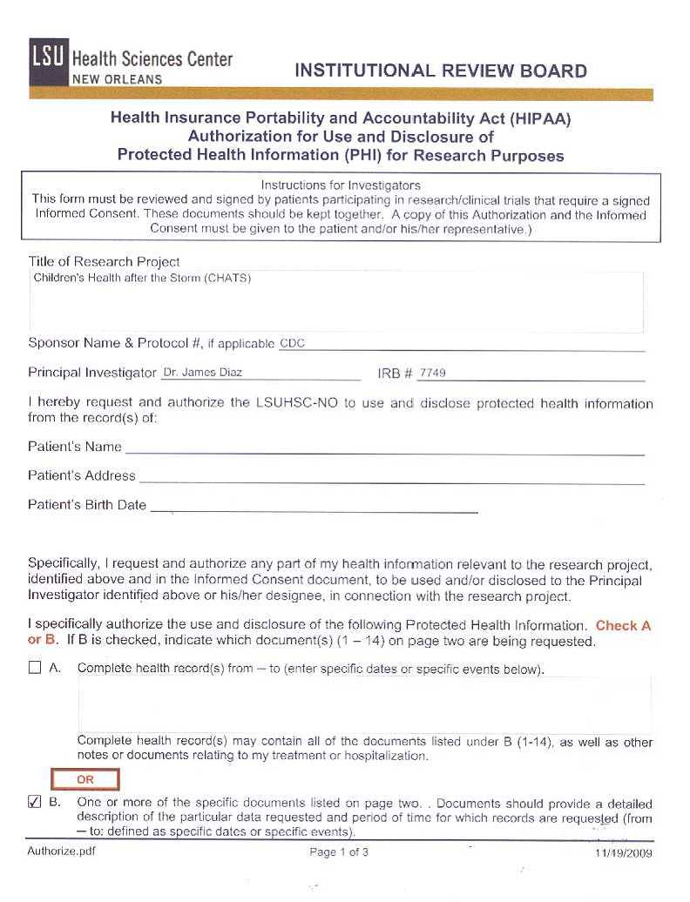

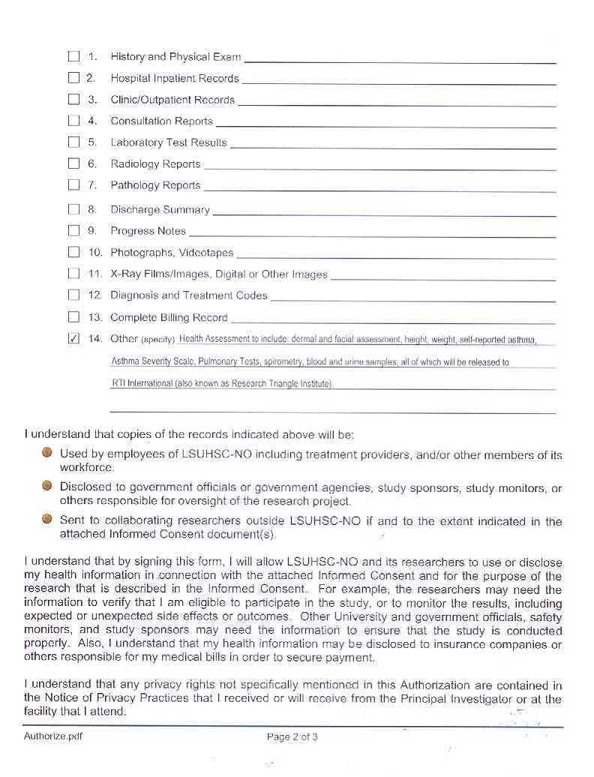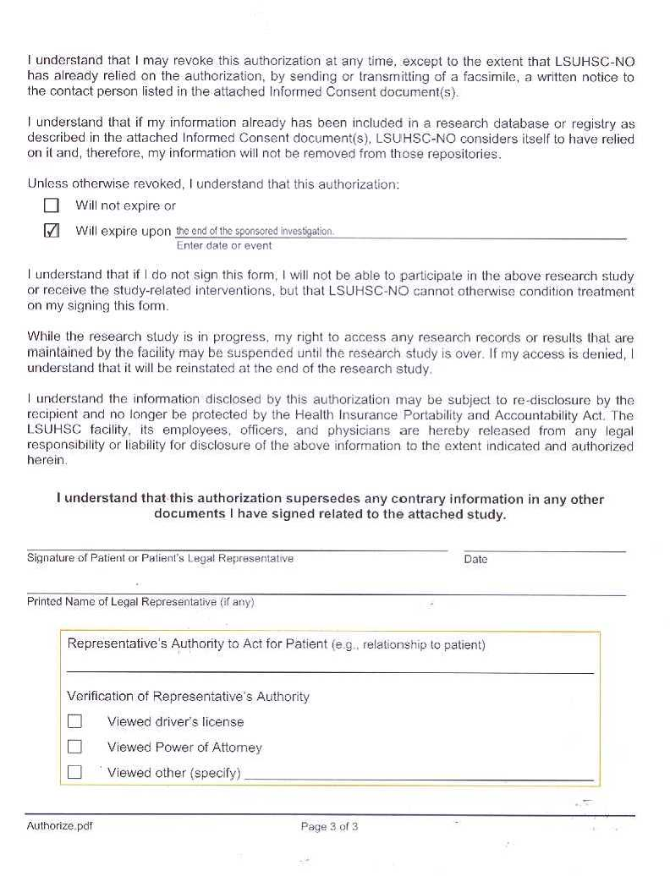

ATTACHMENT F15
LSU Notice of Privacy Practices

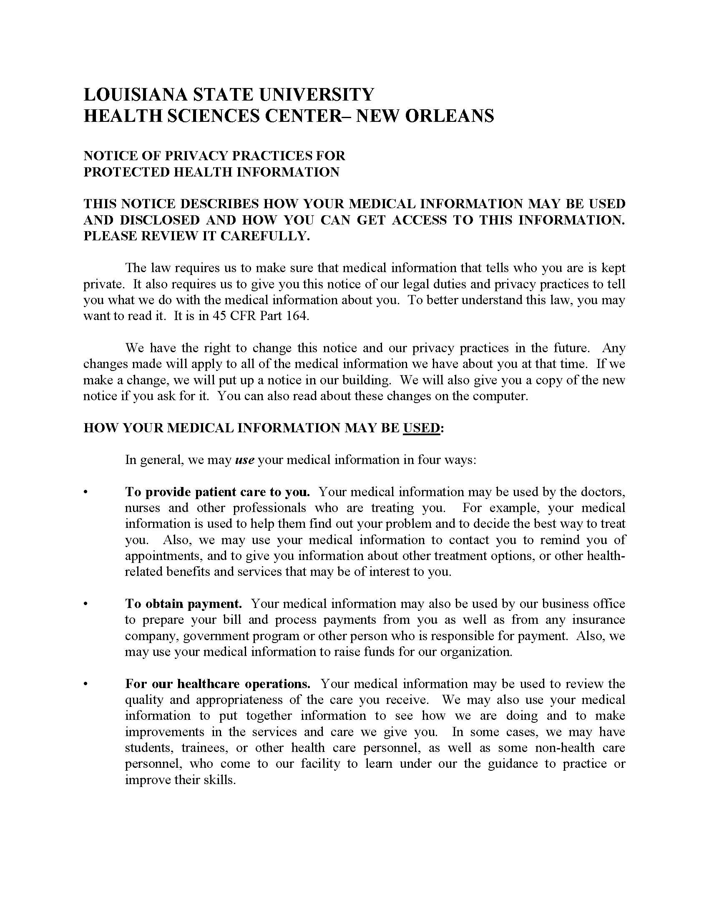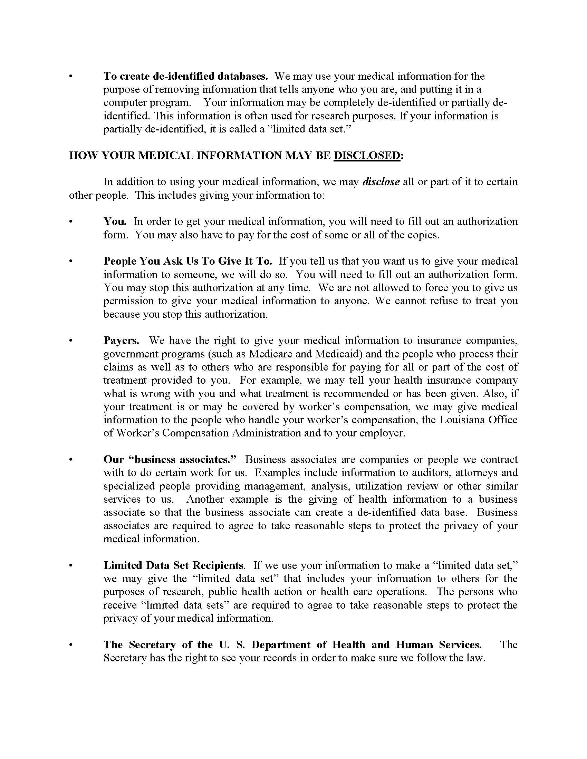

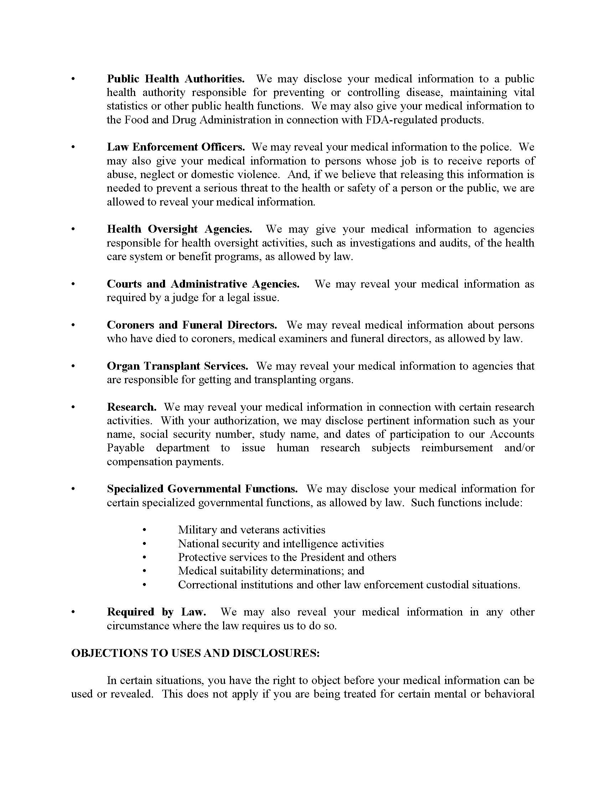

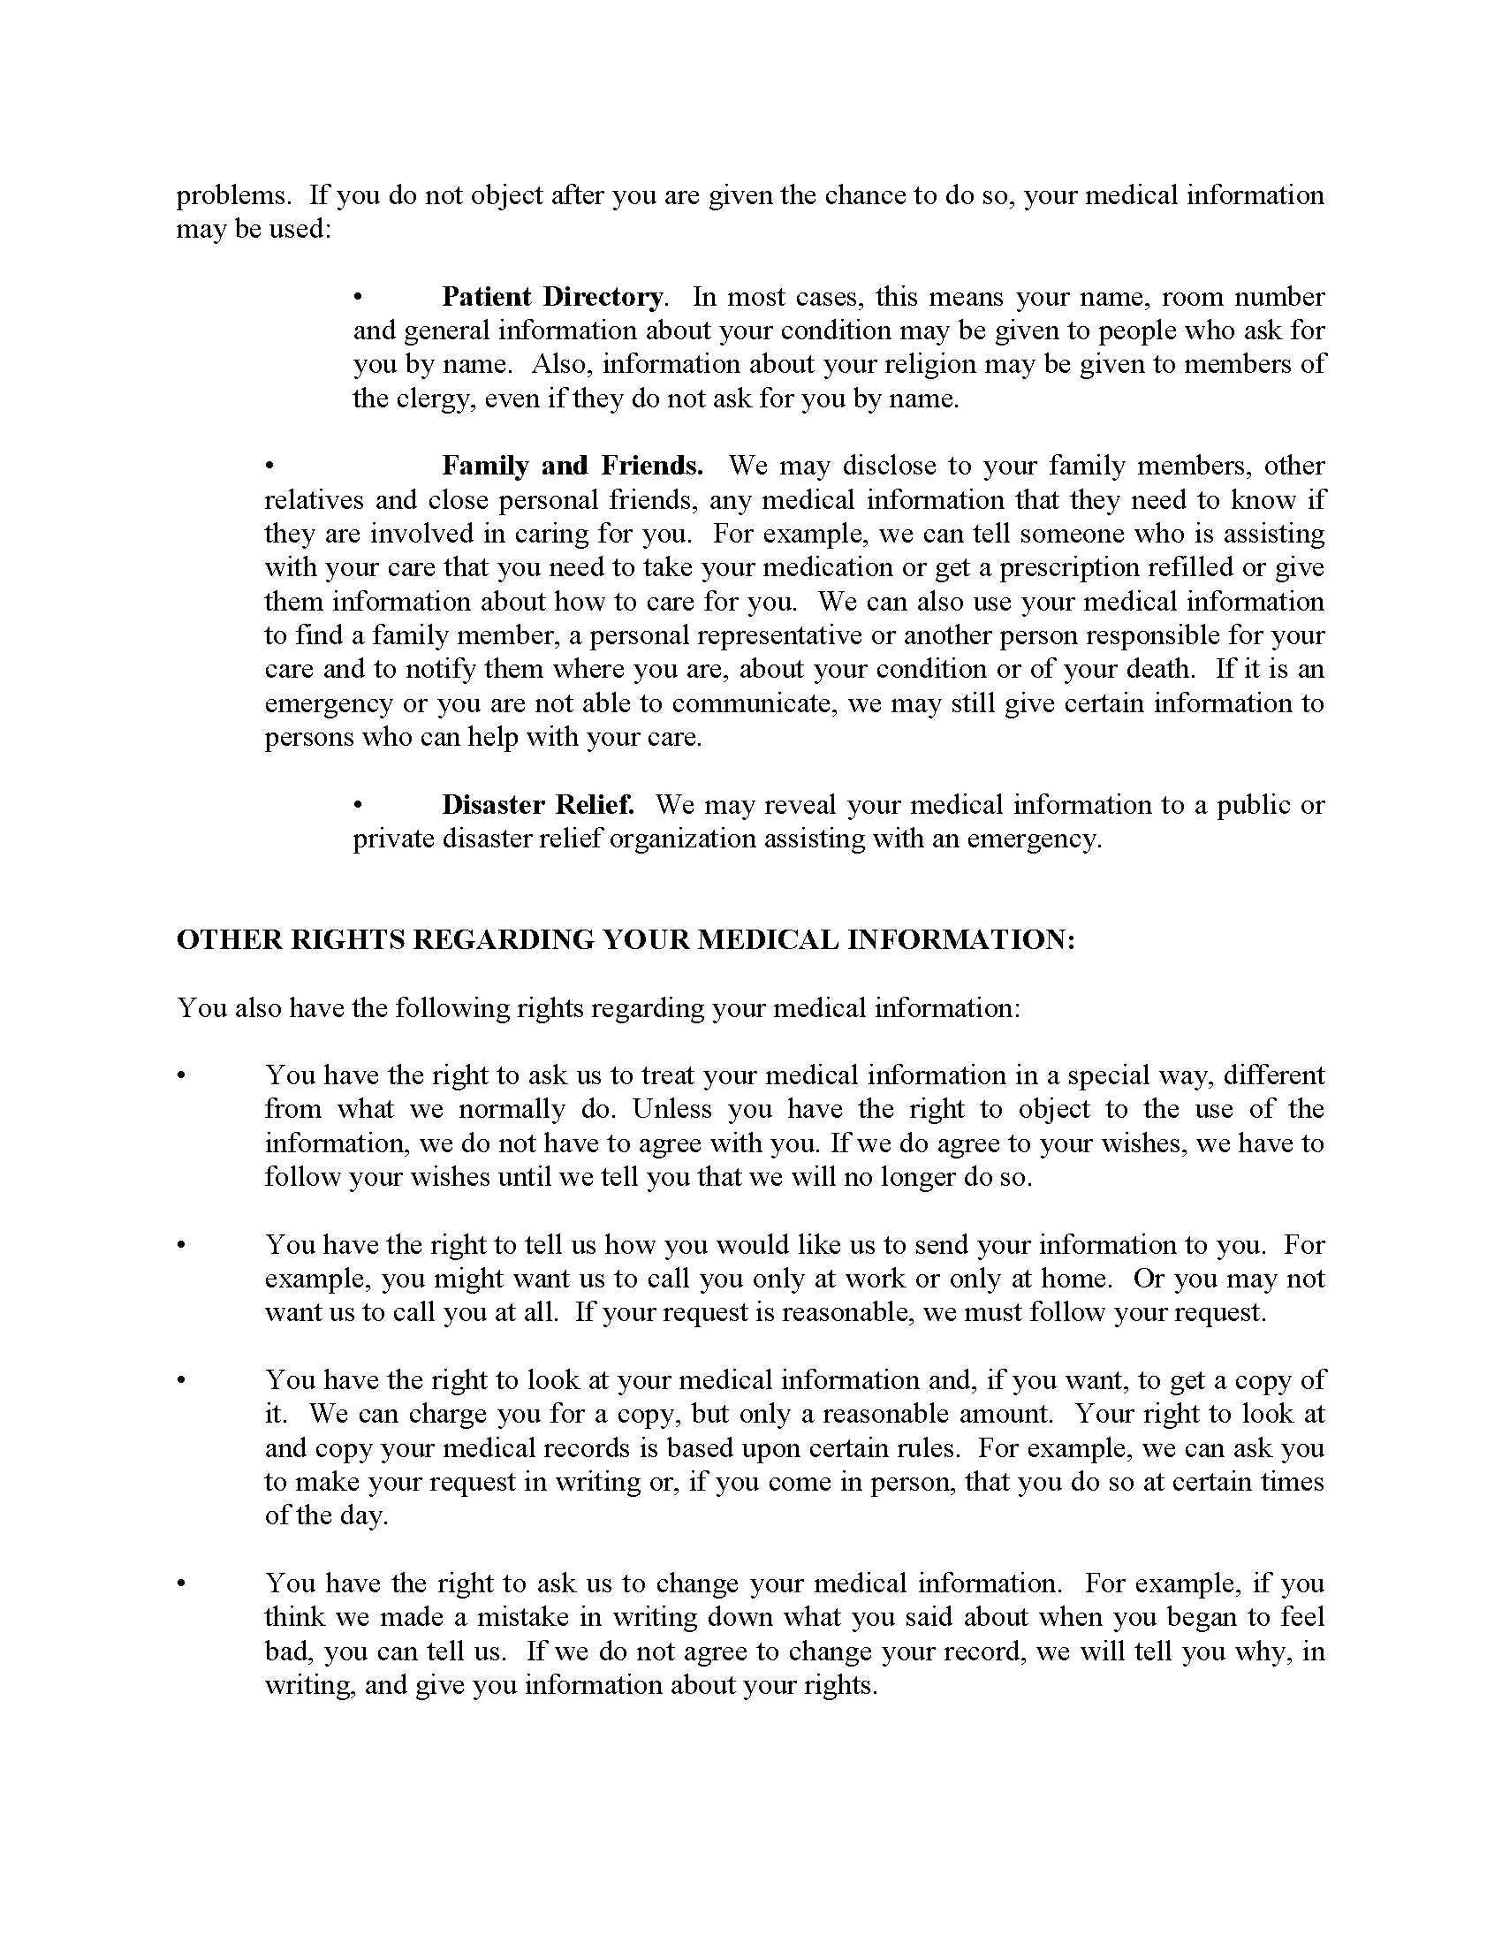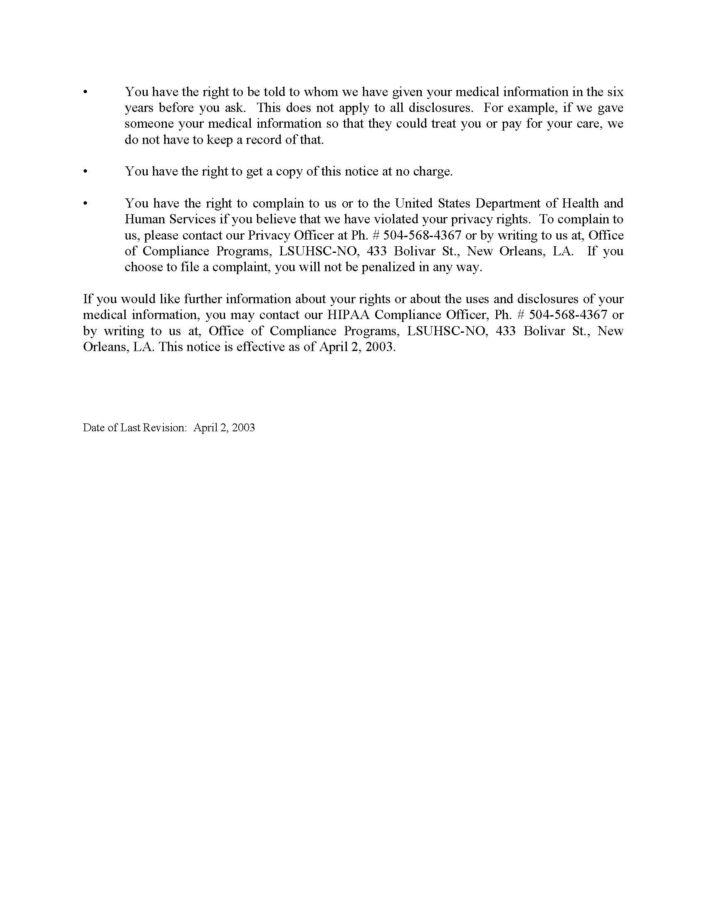

ATTACHMENT F16
LSU Acknowledgment of Privacy Practices

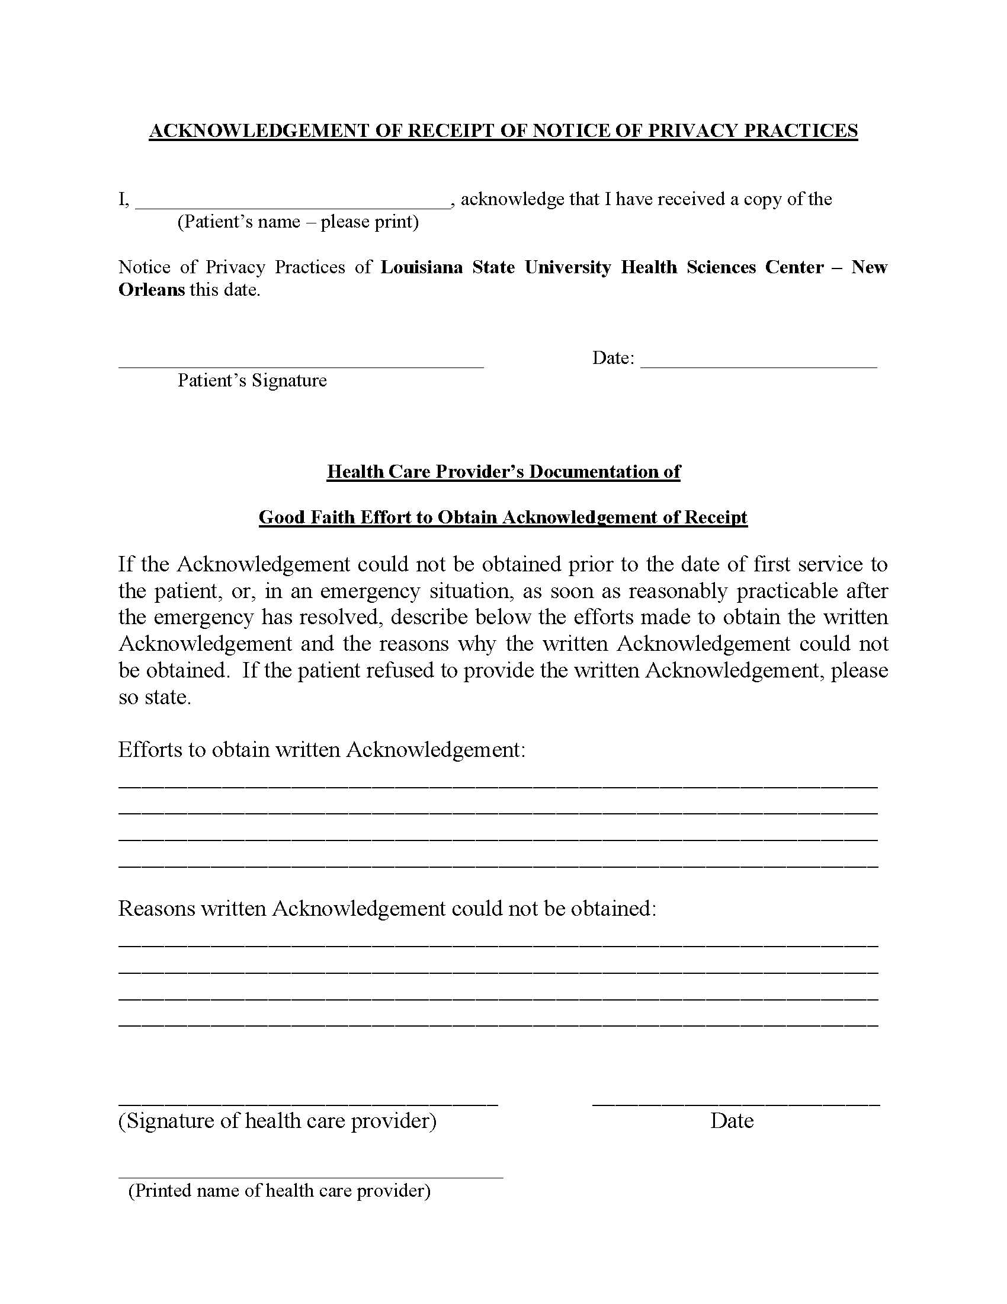
ATTACHMENT F17
LSU Privacy Notice Script

HEALTH INSURANCE PORTABILITY AND ACCOUNTABILITY ACT (HIPAA)
AUTHORIZATION FOR USE AND DISCLOSURE OF
PROTECTED HEALTH INFORMATION (PHI) FOR RESEARCH PURPOSES

SCRIPT
LSU NURSES ONLY

LSUHIPAA [IF LSU NURSE] HAND THE HIPAA FORM TO PARENT/GUARDIAN AND READ THE FORM OUT LOUD, THEN READ THE CLARIFICATION STATEMENT BELOW.
Before I ask you to sign, I’d like to clarify one statement I just read from the form on page 3. POINT TO STATEMENT: “I understand that if I do not sign this form, I will not be able to participate in the above research study…”
This statement only applies to the health assessment that I am here to do today. If you do not sign, you can remain in the CHATS study. It just means that I will not conduct the health assessment with your child.
Do you have any questions about this? [ANSWER QUESTIONS]
ASK THE PARENT TO SIGN.
DID PARENT SIGN THE FORM?
- YES
- NO

LSUPRIV [IF LSU NURSE] HAND THE LSU “NOTICE OF PRIVACY PRACTICES” AND THE “ACKNOWLEDGEMENT OF RECEIPT OF NOTICE OF PRIVACY PRACTICES” TO THE PARENT/GUARDIAN. READ THE “NOTICE OF PRIVACY PRACTICES”. IF HE/SHE AGREES THEN COLLECT A SIGNATURE AND DATE ON THE TOP OF THE ACKNOWLEDGEMENT FORM
DID PARENT SIGN THE FORM?
- YES
- NO

LSUREFUSAL [IF LSUHIPAA=NO OR LSUPRIV=NO] Thank you for your time. Since you have declined to sign this form, I will end this interview now.
PRESS 1 TO CONTINUE
PROGRAMMER: IF LSUREFUSAL=1 THEN SEND USER TO EXIT SCREEN.

