ATTACHMENT V
Unable to Contact Letter
UNABLE TO CONTACT LETTER - SCREENING
[DATE]

Resident
[STREET ADDRESS]
[CITY], [STATE] [ZIPCODE]

Dear Community Member:

Recently, an interviewer from RTI International attempted to contact your household about taking part in the Children’s Health after the Storms (CHATS) study. This study is supported by the Centers for Disease Control and Prevention (CDC). So far, we have been unable to speak with anyone in your household. Your participation in this study is important—this is why we continue to try and reach you.

Some people are careful about speaking to a stranger at their door, and this is understandable. Please know that we are not selling anything. We just have a few general questions to ask that will take about 10 minutes of your time. You do not even need to let the interviewer into your home. You can answer the questions right at your door.

Based on your answers, a child in your home may be selected to take part in our study. It is also possible that no one will be selected to participate. As a thank you for your time, your household could receive up to $135 in cash depending on the age of our child, and the study parts in which your family qualifies.
The purpose of the Children’s Health after the Storms Study is to find out about the health of children in the Gulf Coast after Hurricanes Katrina and Rita. This is so that we can better understand the effects of the living conditions—such as storm damaged housing, FEMA-supplied trailers, and housing unaffected by the storms—on children in this area. A limited number of households were randomly selected to represent this large population of Gulf Coast children, and as a result, we cannot invite another household to participate.
I have included with this letter a brochure with more information about CHATS. I hope that after reading it you will agree to take part in this important study. One of our interviewers will call on you again soon. If you have any questions or concerns, or would like to set up an appointment, please call me toll-free at 1-800-334-8571, extension 5628 from 9 am - 5 pm CST. Thank you very much for your time.

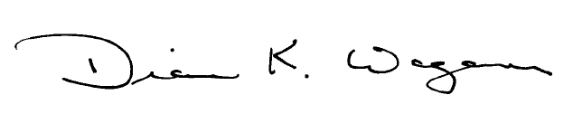
Sincerely,

Diane Wagener, PhD
Project Director
Children’s Health after the Storms

