Health Hazard Evaluation Program

Site Visit Followback Survey

The National Institute for Occupational Safety and Health (NIOSH) surveys those who were involved with NIOSH health hazard evaluations. We would like to learn your thoughts about our evaluation thus far. Your survey responses will help us prevent work-related illnesses at your workplace and across the nation. Your responses will be kept in a secure manner according to applicable laws. Our reports will include only summary information and will not identify you in any way. We will send you similar surveys after the health hazard evaluation has been completed.

Public reporting burden of this collection of information is estimated to average 15 minutes per response, including the time for reviewing instructions, searching existing data sources, gathering and maintaining the data needed, and completing and reviewing the collection of information. An agency may not conduct or sponsor, and a person is not required to respond to a collection of information unless it displays a currently valid OMB control number. Send comments regarding this burden estimate or any other aspect of this collection of information, including suggestions for reducing this burden to CDC/ATSDR Reports Clearance Officer, 1600 Clifton Road NE, MS E-11, Atlanta, Georgia 30333; ATTN: PRA (0920-0260).

STATEMENT OF AUTHORITY:
Sections 20(a)(3–6) of the Occupational Safety and Health Act (29 USC 669(a)(6–9), and Section 501(a)(11) of the Federal Mine Safety and Health Act (30 USC 951(a)(11). The identity of the participant will be protected under provisions of the Privacy Act (5 USC). The voluntary cooperation of the participant is required.

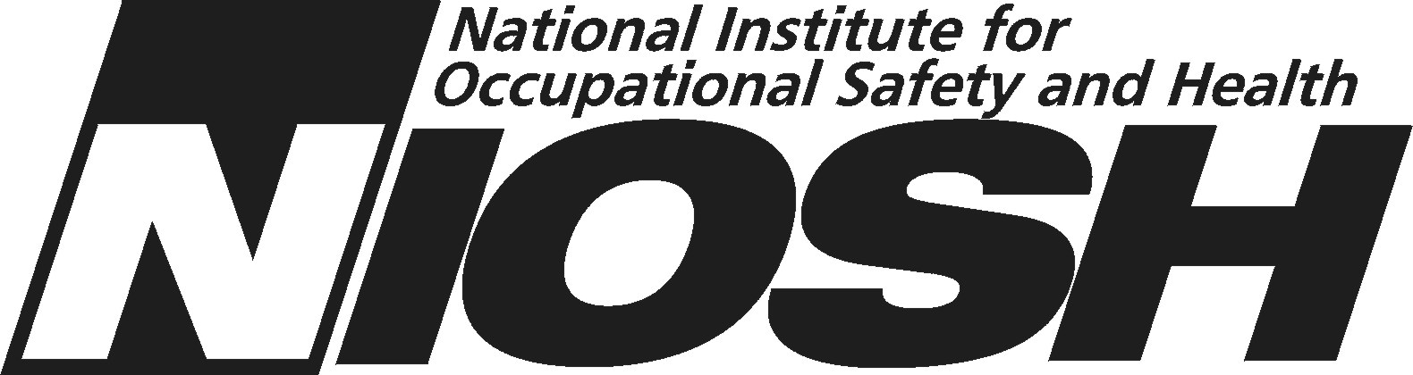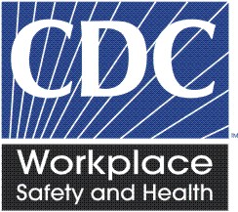

NIOSH Health Hazard Evaluation Survey: Site Visit
This survey asks your thoughts about the NIOSH health hazard evaluation thus far. Please fill in circles completely like this:
- Do you think there is a health hazard at the work place now? |  | - No hazard  - Yes, a mild hazard  - Yes, a moderate hazard  - Yes, a severe hazard  - I do not know
- Before the site visit, did NIOSH keep you well informed of the health hazard evaluation plans? |  | - Yes  - No, I wanted to know more  - No, but I did not need to know
- Did NIOSH visit the workplace in a reasonable time after the health hazard evaluation request? |  | - Yes  - No  - I do not know
- During the site visit, were you fully able to express the issues as you see them? |  | - Yes  - No  - I was not part of the site visit
- At the end of the site visit, did NIOSH give a satisfactory summary of what they did? |  | - Yes  - No  - I do not know
6. At the end of the site visit, how well did NIOSH describe the future plans for the health hazard evaluation? |  |  | - Well  - Not well  - I do not know
7. Do you think the NIOSH evaluation is objective thus far? |  |  | - Yes  - No
8. Do you think the NIOSH evaluation is thorough thus far? |  |  | - Yes  - No
9. How well do the recommendations made thus far address the workplace concerns? |  |  | - Well  - Not well  - NIOSH did not make recommendations
10. Are the recommendations practical? |  |  | - Yes  - No  - NIOSH did not make recommendations
11. What is your impression of the NIOSH health hazard evaluation thus far? |  |  | - Excellent  - Good  - Fair  - Poor
12. Please write any comments you have about the NIOSH health hazard evaluation thus far.

13. Are you still associated with the workplace that NIOSH is evaluating? | - Yes  O No
- Would you prefer to get our future surveys by email? | O Yes  O No
If yes, please print your email address here:

_____________________________

Please make any corrections to this label:

_ _ _ _ _ _ _ _ _ _ _ _ _ _ _ _ _ _ _ _ _ _ _ _ _ _ _ _
□ Administrative area □
Thank you for completing this survey.

Please mail the completed survey to NIOSH in the enclosed postage paid envelope.

Call Barbara Jenkins at 513-458-7132 if you have questions about the survey.

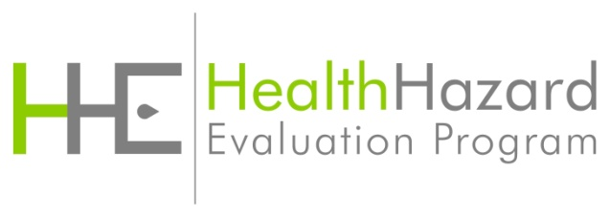

Followback Survey Form 1A

