Attachment J:
Closeout for HHEs without an On-site Evaluation-Followback Survey Cover Letter and Form

Health Hazard Evaluation Program
Final Report Followback Survey

The National Institute for Occupational Safety and Health (NIOSH) surveys people who were involved with NIOSH health hazard evaluations. We would like to learn your thoughts about how we responded to the health hazard evaluation request. Your survey information will help we prevent work-related illness and injury at workplaces across the nation. Your responses will be kept in a secure manner according to applicable laws. Our reports will include only summary information and will not identify you in any way. If we made specific workplace recommendations, we will send you one more survey, approximately one year from now.

Public reporting burden of this collection of information is estimated to average 10 minutes per response, including the time for reviewing instructions, searching existing data sources, gathering and maintaining the data needed, and completing and reviewing the collection of information. An agency may not conduct or sponsor, and a person is not required to respond to a collection of information unless it displays a currently valid OMB control number. Send comments regarding this burden estimate or any other aspect of this collection of information, including suggestions for reducing this burden to CDC/ATSDR Reports Clearance Officer, 1600 Clifton Road NE, MS E-11, Atlanta, Georgia 30333; ATTN: PRA (0920-0260).

STATEMENT OF AUTHORITY:
Sections 20(a)(3–6) of the Occupational Safety and Health Act (29 USC 669(a)(6–9), and Section 501(a)(11) of the Federal Mine Safety and Health Act (30 USC 951(a)(11). The identity of the participant will be protected under provisions of the Privacy Act (5 USC). The voluntary cooperation of the participant is required.

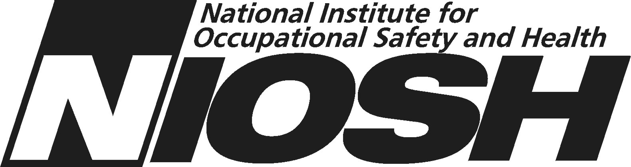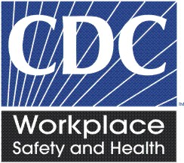

NIOSH Health Hazard Evaluation Survey: Final Report
This survey asks your thoughts about the health hazard evaluation NIOSH recently completed. Please fill in circles completely like this:
- Do you think there is a health hazard at the work place now? | - No hazard  - Yes, a mild hazard  - Yes, a moderate hazard  - Yes, a severe hazard  - I do not know
2. Did you talk with a NIOSH investigator about your request for a health hazard evaluation? | - Yes  - No
3. Did the investigator explain to your satisfaction why NIOSH would not do an onsite evaluation? | - Yes  - No  O I did not talk to a NIOSH investigator
4. Did NIOSH issue the final report in a reasonable time after you requested the health hazard evaluation? | - Yes  - No
5. Did you read the final report? | - Yes  - No – Skip to question 14
6. What is your overall impression of the quality of the final report? | - Excellent  - Good  - Fair  O Poor
7. Is the final report helpful? | - Yes, very helpful  - Yes, somewhat helpful  - No, not very helpful  - No, not at all helpful
NIOSH Health Hazard Evaluation Survey: Final Report
8. Do you understand the technical information in the final report? | - Yes  - Yes, somewhat  - No, not really  - No, not at all
9. How well do the NIOSH recommendations address the workplace concerns? | - Well  - Not well  - NIOSH did not make recommendations
10. Overall, do you think that the NIOSH recommendations are practical? | - Yes  - No  - NIOSH did not make recommendations
11. Has management posted the final report at the workplace? | - Yes  - No  - NIOSH did not send management the final report
12. Have you personally shared the final report with others at the workplace? | - Yes  - No
13. If NIOSH suggested contacting another agency or organization for assistance, have you or has anyone else done this? | - Yes  - No  - I do not know  - NIOSH did not suggest this
14. What is your overall impression of the NIOSH health hazard evaluation? | - Excellent  - Good  - Fair  - Poor
NIOSH Health Hazard Evaluation Survey: Final Report
15. Would you request another NIOSH health hazard evaluation if you were concerned about a possible health hazard at your workplace? |  | - Yes  - No
16. Please write any comments you have about the NIOSH health hazard evaluation thus far.

17. Will you be part of decision making related to the NIOSH recommendations? | - Yes, I have final authority  - Yes, somewhat  - No  O NIOSH did not make recommendations
18. Are you still associated with the workplace that NIOSH evaluated? | - Yes  - No
- Would you prefer to get our final survey by email?
O Yes
O No

If yes, please print your email address here:

_____________________________

_ _ _ _ _ _ _ _ _ _ _ _ _ _ _ _ _ _ _ _ _ _ _ _ _ _ _ _
□ Administrative area □
Please make any corrections to this label:

Thank you for completing this survey.

Please mail the completed survey to NIOSH in the enclosed postage paid envelope.

Call Barbara Jenkins at 513-458-7132 if you have questions about the survey.

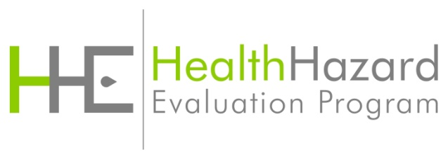

Followback Survey Form 2A

