Attachment K:
One Year Later for HHEs without an On-site Evaluation-Followback Survey Cover Letter and Form

Form Approved
OMB No.: 0920-0260
Expiration Date:

Health Hazard Evaluation Program
One-Year Later Followback Survey
Health Hazard Evaluation Survey
One Year Later
Health Hazard Evaluation Survey
One Year Later
Health Hazard Evaluation Survey
One Year Later
Health Hazard Evaluation Survey
One Year Later
Health Hazard Evaluation Survey
One Year Later
Health Hazard Evaluation Survey
The National Institute for Occupational Safety and Health (NIOSH) surveys those who were involved with NIOSH health hazard evaluations. Now, one year after the close of the evaluation, we would like to know whether action was taken at the workplace and if there have been positive changes. Please give your candid answer to each question. Your survey responses will help us prevent and reduce work-related illnesses and injuries at workplaces across the nation.

Your responses will be kept in a secure manner according to applicable laws.
Our reports will include only summary information and will not identify you in any way.

Thank you for taking the time to fill out this survey.

Please mail the completed survey to NIOSH in the enclosed postage paid envelope.
Call Barbara Jenkins at 513-458-7132 if you have questions about the survey.

Public reporting burden of this collection of information is estimated to average 15 minutes per response, including the time for reviewing instructions, searching existing data sources, gathering and maintaining the data needed, and completing and reviewing the collection of information. An agency may not conduct or sponsor, and a person is not required to respond to a collection of information unless it displays a currently valid OMB control number. Send comments regarding this burden estimate or any other aspect of this collection of information, including suggestions for reducing this burden to CDC/ATSDR Reports Clearance Officer, 1600 Clifton Road NE, MS E-11, Atlanta, Georgia 30333; ATTN: PRA (0920-0260).

STATEMENT OF AUTHORITY:
Sections 20(a)(3–6) of the Occupational Safety and Health Act (29 USC 669(a)(6–9), and Section 501(a)(11) of the Federal Mine Safety and Health Act (30 USC 951(a)(11). The identity of the participant will be protected under provisions of the Privacy Act (5 USC). The voluntary cooperation of the participant is required.

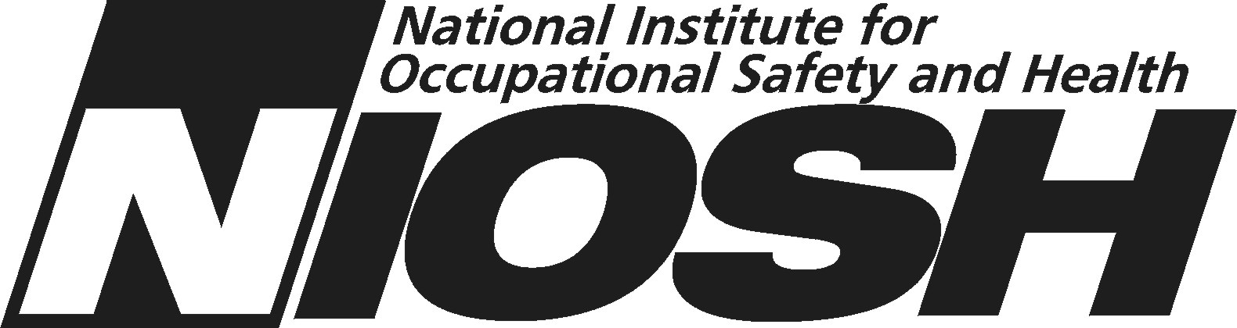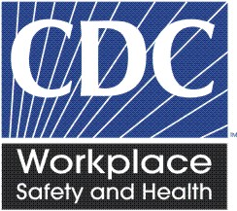

NIOSH Health Hazard Evaluation Survey: One Year Later
This survey asks what has happened at the work place in the year since NIOSH completed the health hazard evaluation. Please fill in circles completely like this:
1. Do you think there is a health hazard at the workplace now? | - No hazard  - Yes, a mild hazard  - Yes, a moderate hazard  - Yes, a severe hazard  - I don’t know
- Do you think NIOSH helped make things better at the work place? | - Yes  - No  - Nothing needed to change
- If yes to Question 2, please describe the positive changes.

4. What is your overall impression of the NIOSH health hazard evaluation? | - Excellent  - Good  - Fair  - Poor

NIOSH Health Hazard Evaluation Survey: One Year Later
Recommendations NIOSH made are printed in the left column below. First we ask about recommendations made to Managers, then about recommendations made to Employees.
Please answer all of these questions. Please only mark one response for each question.
Recommendations to Managers | Was Action Taken?
5A. | - Yes  - No  O I don’t know  O Not applicable now – the process ceased
5B. | - Yes  - No  O I don’t know  O Not applicable now – the process ceased
5C. | - Yes  - No  O I don’t know  O Not applicable now – the process ceased
5D. | - Yes  - No  O I don’t know  O Not applicable now – the process ceased
5E. | - Yes  - No  O I don’t know  O Not applicable now – the process ceased
5F. | - Yes  - No  O I don’t know  O Not applicable now – the process ceased

NIOSH Health Hazard Evaluation Survey: One Year Later
Recommendations to Managers | Was Action Taken?
5G. | - Yes  - No  O I don’t know  O Not applicable now – the process ceased
5H. | - Yes  - No  O I don’t know  O Not applicable now – the process ceased
5I. | - Yes  - No  O I don’t know  O Not applicable now – the process ceased
5J. | - Yes  - No  O I don’t know  O Not applicable now – the process ceased
5K. | - Yes  - No  O Don’t know  O Not applicable now – the process ceased
5L. | - Yes  - No  - I don’t know  - Not applicable now – the process ceased
5M. | - Yes  - No  O I don’t know  O Not applicable now – the process ceased

NIOSH Health Hazard Evaluation Survey: One Year Later
Recommendations to Managers | Was Action Taken?
5N. | - Yes  - No  O I don’t know  O Not applicable now – the process ceased
5O. | - Yes  - No  O I don’t know  O Not applicable now – the process ceased
5P. | - Yes  - No  O I don’t know  O Not applicable now – the process ceased
5Q. | - Yes  - No  O I don’t know  O Not applicable now – the process ceased
5R. | - Yes  - No  O I don’t know  O Not applicable now – the process ceased
5S. | - Yes  - No  O I don’t know  O Not applicable now – the process ceased
5T. | - Yes  - No  O I don’t know  O Not applicable now – the process ceased

NIOSH Health Hazard Evaluation Survey: One Year Later
Recommendations to Employees | Was Action taken?
6A. | - Yes  - No  - I don’t know  O Not applicable now – the process ceased
6B. | - Yes  - No  - I don’t know  O Not applicable now – the process ceased
6C. | - Yes  - No  - I don’t know  O Not applicable now – the process ceased
6D. | - Yes  - No  - I don’t know  O Not applicable now – the process ceased
6E. | - Yes  - No  - I don’t know  O Not applicable now – the process ceased
6F. | - Yes  - No  - I don’t know  O Not applicable now – the process ceased

NIOSH Health Hazard Evaluation Survey: One Year Later
Recommendations to Employees | Was Action taken?
6G. | - Yes  - No  - Don’t know  O Not applicable now – the process ceased
6H. | - Yes  - No  - Don’t know  - Not applicable now – the process ceased
6I. | - Yes  - No  - Don’t know  - Not applicable now – the process ceased
6J. | - Yes  - No  - Don’t know  - Not applicable now – the process ceased
6K. | - Yes  - No  - Don’t know  O Not applicable now – the process ceased
6L. | - Yes  - No  - Don’t know  O Not applicable now – the process ceased

NIOSH Health Hazard Evaluation Survey: One Year Later
7. Please provide details about actions taken or not taken regarding the NIOSH recommendations.

8. Please provide any comments you have about the NIOSH health hazard evaluation.

- Are you still associated with the workplace that NIOSH evaluated? | - Yes  - No
□ Administrative area □

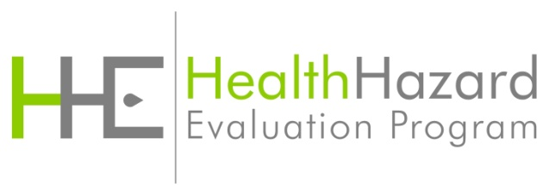
Followback survey Form 3B

