Attachment I:
Year Later for HHEs with an On-site Evaluation-Followback Survey Cover Letter and Form

Health Hazard Evaluation Program
One Year Later Survey

The National Institute for Occupational Safety and Health (NIOSH) surveys those who were involved with NIOSH health hazard evaluations. Now, one year after the close of the evaluation, we would like to know whether action was taken at the workplace and if there have been positive changes.

Your responses will be kept in a secure manner according to applicable laws.
Our reports will include only summary information and will not identify you in any way.

Thank you for taking the time to fill out this survey.

Please mail the completed survey to NIOSH in the enclosed postage paid envelope.
Call Barbara Jenkins at 513-458-7132 if you have questions or concerns about the survey.

Public reporting burden of this collection of information is estimated to average 15 minutes per response, including the time for reviewing instructions, searching existing data sources, gathering and maintaining the data needed, and completing and reviewing the collection of information. An agency may not conduct or sponsor, and a person is not required to respond to a collection of information unless it displays a currently valid OMB control number. Send comments regarding this burden estimate or any other aspect of this collection of information, including suggestions for reducing this burden to CDC/ATSDR Reports Clearance Officer, 1600 Clifton Road NE, MS E-11, Atlanta, Georgia 30333; ATTN: PRA (0920-0260).

STATEMENT OF AUTHORITY:
Sections 20(a)(3–6) of the Occupational Safety and Health Act (29 USC 669(a)(6–9), and Section 501(a)(11) of the Federal Mine Safety and Health Act (30 USC 951(a)(11). The identity of the participant will be protected under provisions of the Privacy Act (5 USC). The voluntary cooperation of the participant is required.

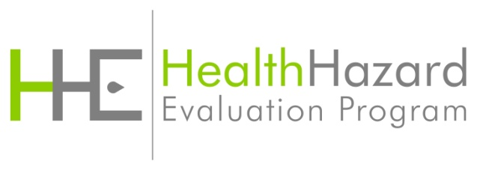
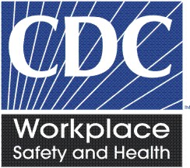
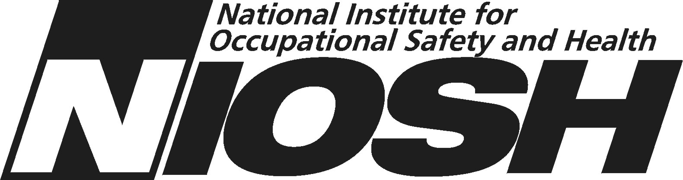
NIOSH Health Hazard Evaluation Survey: One Year Later
This survey asks what has happened at the work place in the year since NIOSH completed the health hazard evaluation. Please fill in circles completely like this:
- Do you think there is a health hazard at the work place now? | - No hazard  - Yes, a mild hazard  - Yes, a moderate hazard  - Yes, a severe hazard  - I do not know
- Do you think NIOSH helped make things better at the work place? | - Yes  - No  - Nothing needed to change
- If yes to Question 2, please describe the positive changes.

- If NIOSH suggested contacting another agency or organization for assistance, did you or anyone else do this? | - Yes  - No  - I do not know  - NIOSH did not suggest this
5. What is your overall impression of the NIOSH  health hazard evaluation? | - Excellent  - Good  - Fair  O Poor
6. Are you still associated with the workplace that  NIOSH evaluated? | O Yes  O No

NIOSH Health Hazard Evaluation Survey: One Year Later
Recommendations NIOSH made are printed in the left column below.
Please mark one response for each item.
Recommendation | Was Action Taken?
7A. | - Yes  - No  - I do not know  - Not applicable now – the process ceased
7B. | - Yes  - No  O I do not know  O Not applicable now – the process ceased
7C. | - Yes  - No  - I do not know  - Not applicable now – the process ceased
7D. | - Yes  - No  - I do not know  O Not applicable now – the process ceased
7E. | - Yes  - No  - I do not know  O Not applicable now – the process ceased
7F. | - Yes  - No  - I do not know  - Not applicable now – the process ceased

NIOSH Health Hazard Evaluation Survey: One Year Later
Recommendation | Was Action Taken?
7G. | - Yes  - No  - I do not know  - Not applicable now – the process ceased
7H. | - Yes  - No  - I do not know  O Not applicable now – the process ceased
7I. | - Yes  - No  - I do not know  O Not applicable now – the process ceased
7J. | - Yes  - No  - I do not know  O Not applicable now – the process ceased
8. Please provide details about actions taken or not taken regarding the NIOSH recommendations.

9. Please provide any comments you have about the NIOSH health hazard evaluation.

□ Administrative area □

Followback Survey Form 3A

