Attachment H:
Closeout for HHEs with an On-site Evaluation-Followback Survey Cover Letter and Form

Health Hazard Evaluation Program
Final Report Followback Survey
Final Report

The National Institute for Occupational Safety and Health (NIOSH) surveys people who were involved in workplace health hazard evaluations. We would like to learn your thoughts about our evaluation. The information you provide will help us prevent work-related illness and injury at your workplace and across the nation. Your responses will be kept in a secure manner according to applicable laws. Our reports will include only summary information and will not identify you in any way. Approximately one year from now, we will send you one last survey, asking about implementation of the recommendations that we made.

Thank you for completing this survey

Please mail the completed survey to NIOSH in the enclosed postage paid envelope.
Call Barbara Jenkins at 513-458-7132 if you have questions about the survey.

Public reporting burden of this collection of information is estimated to average 15 minutes per response, including the time for reviewing instructions, searching existing data sources, gathering and maintaining the data needed, and completing and reviewing the collection of information. An agency may not conduct or sponsor, and a person is not required to respond to a collection of information unless it displays a currently valid OMB control number. Send comments regarding this burden estimate or any other aspect of this collection of information, including suggestions for reducing this burden to CDC/ATSDR Reports Clearance Officer, 1600 Clifton Road NE, MS E-11, Atlanta, Georgia 30333; ATTN: PRA (0920-0260).

STATEMENT OF AUTHORITY:
Sections 20(a)(3–6) of the Occupational Safety and Health Act (29 USC 669(a)(6–9), and Section 501(a)(11) of the Federal Mine Safety and Health Act (30 USC 951(a)(11). The identity of the participant will be protected under provisions of the Privacy Act (5 USC). The voluntary cooperation of the participant is required.

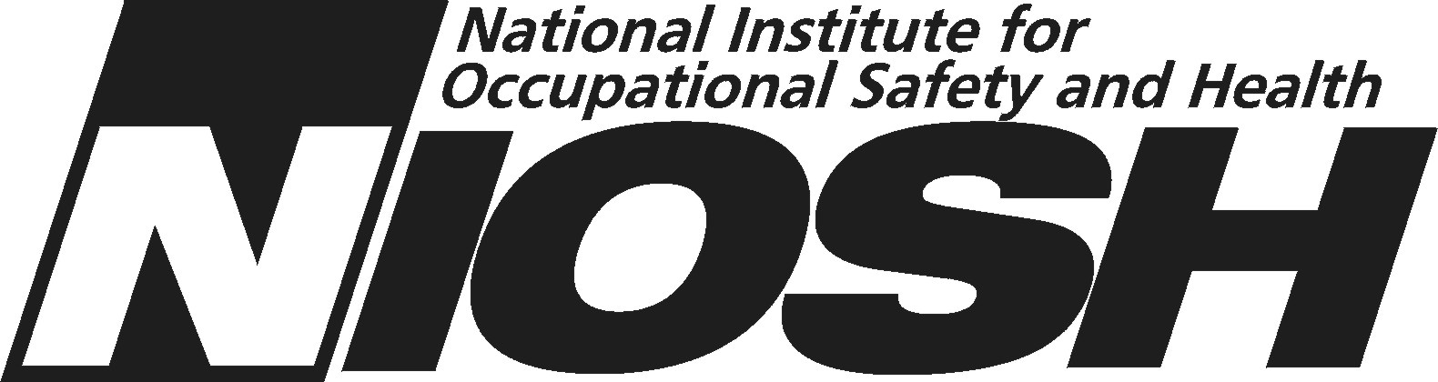

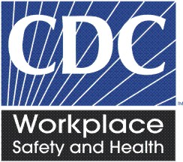
NIOSH Health Hazard Evaluation Survey: Final Report
This survey asks your thoughts about the health hazard evaluation NIOSH recently completed concerning your workplace. Please fill in circles completely like this:
- Do you think there is a health hazard at the workplace now? | - No hazard  - Yes, a mild hazard  - Yes, a moderate hazard  - Yes, a severe hazard  - I do not know
- Have any of the recommendations that NIOSH made been implemented? | - Yes  - No  - I do not know
- Do you think NIOSH helped make things better at the workplace? | - Yes  - No  - Changes were not needed
- If “Yes” to Question 3 above, please describe the positive changes.
- After the site visit(s), did NIOSH keep you well enough informed? | - Yes  - No
- Did NIOSH issue the final report in a reasonable amount of time? | - Yes  - No  - I do not know
- Did management post the final report so employees could see it? | - Yes  - No  - I do not know
- Did you read the final report? | - Yes  - No – Skip to question 21
- Did the final report fully address the issues raised in the health hazard evaluation request? | - Yes  - No  - I do not know because I did not see the request
- What is your overall impression of the quality of the final report? | - Excellent  - Good  - Fair  O Poor
- Do you think the final report is helpful? | - Yes, definitely  - Yes, probably  - Probably not  - Definitely not
- Do you understand the technical information in the final report? | - Yes, thoroughly  - Yes, somewhat  - Mostly not  O I did not understand it
- How useful is the Highlights section of the final report? | - Very useful  - Somewhat useful  - Not useful
- How useful is the Summary section of the final report? | - Very useful  - Somewhat useful  - Not useful
- How useful is the Occupational Exposure Limits and Health Effects section of the final report? | - Very useful  - Somewhat useful  - Not useful
- Which best describes what you think NIOSH found? | - NIOSH found a health hazard  - NIOSH did not find a health hazard  - NIOSH did not decide whether there was a health hazard  - The NIOSH findings were not clear to me
- Overall, do you agree with the NIOSH findings? | - Yes  - No  - I do not know – the NIOSH findings were not clear to me
- Overall, do you think the NIOSH recommendations address the workplace concerns well? | - Yes  - No
- Overall, do you think the NIOSH recommendations are practical? | - Yes  - No
- What is your overall impression of the NIOSH health hazard evaluation? | - Excellent  - Good  - Fair  - Poor
- Would you request another NIOSH health hazard evaluation if you were concerned about a possible workplace health hazard? | - Yes  - No
- Please write any comments you have about the NIOSH health hazard evaluation.

- Are you still associated with the workplace that NIOSH evaluated? |  | - Yes  O No
- Will you be part of decision making related to the NIOSH recommendations? |  | - Yes, I have final authority  - Yes, somewhat  - No, I will not be part of decision making
- Would you like to get our final survey by email? |  | O Yes  O No
If yes, please print your email address here: ____________________________________

_ _ _ _ _ _ _ _ _ _ _ _ _ _ _ _ _ _ _ _ _ _ _ _ _ _ _ _ _ _ _ _ _ _ _ _ _ _ _ _ _ _ _ _ _ _ _ _ __ _ _ _ _ _ _ _ _ _ _ _ _ _ _ _ _ _ _
□ Administrative area □
Please make any corrections to this label.

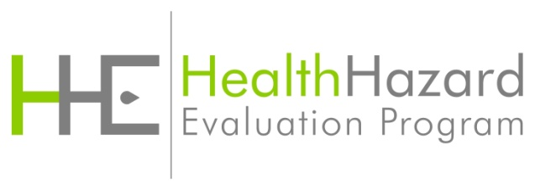

Followback Survey Form 2B

