Form Approved

OMB No. 0920-0910

Exp. Date 01/31/2015

**National Tobacco Prevention and Control Public Education Campaign:**

**Digital Media Testing and Copy Testing for**

**Terrie Hall Rough Cuts**

**Main Questionnaire**

Public reporting burden of this collection of information is estimated to average **15** minutes per response, including the time for reviewing instructions, searching existing data sources, gathering and maintaining the data needed, and completing and reviewing the collection of information. An agency may not conduct or sponsor, and a person is not required to respond to a collection of information unless it displays a currently valid OMB control number. Send comments regarding this burden estimate or any other aspect of this collection of information, including suggestions for reducing this burden to CDC/ATSDR Information Collection Review Office, 1600 Clifton Road NE, MS D-74, Atlanta, Georgia 30333; ATTN: PRA (0920-0910).

{PREAMBLE SHOWN DURING SCREENER}

On behalf of the Centers for Disease Control and Prevention (CDC), we're conducting a study about different health and smoking-specific advertising that you see in the media. Your opinions are very important to us! Please be assured that the purpose of this survey is to gather feedback regarding specific health-related advertising. We do not plan to report your answers individually. We plan to report results from this survey for the group as a whole. Thank you for taking the time to help us!

Your participation in this survey is voluntary.

# Section: Attitudes and Behaviors

## Smoking Behavior

*{Base = all qualified smokers}*

### TS1. On a typical day, how many cigarettes do you usually smoke?

[1 PACK = 20 CIGARETTES]

[RANGE 1-100]

NUMBER __________

*{Base = Smokers who SMOKE EVERY DAY (IF TS2 = 1 or 2)}*

### TS2. How soon after you wake up do you usually have your first cigarette?

SINGLE RESPONSE.

1. Within 5 minutes
2. From 6 to 30 minutes
3. From more than 30 minutes to 1 hour
4. After more than 1 hour

*{Base = all qualified smokers}*

### TS4. Where do you smoke most often?

1. At home
2. At work
3. Friend’s or family’s house
4. In my car
5. Someone else’s car
6. At a party
7. At a restaurant or a bar
8. Outdoors
9. Somewhere else (other specify)

## Other forms of tobacco/nicotine use

*{Base = all qualified respondents}*

### E1. Have you ever used electronic cigarettes or e-cigarettes, such as Smoking Everywhere, NJOY, Blu, or Vapor King, even one time?

1. YES
2. NO

## Quit Attempts

*{Base = Smokers}*

### QA1. How many times have you tried to quit smoking completely during the past 12 months, or have you not tried at all?

1. All the time
2. Very often
3. Occasionally
4. Rarely
5. Have not tried at all

*{Base = Smokers AND answers 1-4 to QA1)}*

### QA2 Thinking back to the last time you tried to quit smoking in the past 12 months, did you use any of the following products to help you quit: (select all that apply)

1. A nicotine patch
2. A nicotine gum or nicotine lozenge
3. A nicotine nasal spray or nicotine inhaler
4. A prescription pill, called Chantix or Varenicline
5. A prescription pill, called Zyban, Bupropion, or Wellbutrin
6. Electronic or e-cigarettes
7. Another product, please specify
8. None of these

*{Base = Smokers AND answers 1-4 to QA1)}*

### QA3. Thinking back to the last time you tried to quit smoking in the past 12 months, did you use any of the following strategies to help you quit: (select all that apply)

1. Try to quit by gradually cutting back on cigarettes
2. Try to quit by switching to using only smokeless tobacco products
3. Try to quit by switching to regular cigars, cigarillos, little filtered cigars or pipes filled with tobacco
4. Switch to a “lighter” cigarette
5. Try to quit by using electronic or e-cigarettes
6. None of these

*{Base = Smokers}*

### QA4. How seriously are you considering quitting smoking within the next 3 months, or are you not considering it at all?

1. Considering it extremely seriously
2. Considering it very seriously
3. Considering it somewhat seriously
4. Considering it slightly seriously
5. Not considering it at all

## Psychographic/Attitudinal

*{Base = All qualified respondents}*

### PA2. How dangerous or safe do you believe tobacco is?

1. Extremely dangerous
2. Very dangerous
3. Somewhat dangerous
4. Neither dangerous nor safe
5. Somewhat safe
6. Very safe
7. Extremely safe

*{Base = Smokers only}*

### PA4. How much does tobacco relieve or not relieve stress?

1. Extremely stress-relieving
2. Very stress-relieving
3. Somewhat stress-relieving
4. Slightly stress-relieving
5. Not at all stress-relieving

*{Base = All qualified respondents}*

### PA7. Would you say your health in general is excellent, very good, good, fair, or poor?

1. Excellent
2. Very Good
3. Good
4. Fair
5. Poor

*{Base = All qualified respondents}*

### PA8. Thinking about the last time you had a health issue or experienced any change in your physical health, where did you first look to get information?

1. Friends or family
2. Your doctor or healthcare professional
3. Internet
4. Pharmacy
5. Other

## Demographic Information

*{BASE for this section is all QUALIFIED RESPONDENTS }*

### DEMO1. What is your gender?

1. Male
2. Female

### DEMO2. How many children (under age 18) live in your household:

1. None
2. 1-2 children
3. 3-4 children
4. 5 or more children

### DEMO3. What is your marital status?

1. Now married
2. Widowed
3. Divorced
4. Separated
5. Never married
6. Prefer not to answer

### DEMO8. Do you consider yourself to be (Select all that apply):

01 Heterosexual / Straight

02 Lesbian

03 Gay (male)

04 Bisexual

05 Transgender

06 Something else – please specify ______________

07 Prefer not to answer

Please indicate your race or ethnic background. Are you….?

SELECT ONE

### DEMO6. Ethnicity

1. Hispanic or Latino
2. Not Hispanic or Latino

SELECT ONE OR MORE

### DEMO7. Race:

1. White
2. Black or African American
3. American Indian or Alaska Native
4. Native Hawaiian or Other Pacific Islander
5. Asian

### SES1. What is the highest level of education you have completed or the highest degree you have received? If you received your education in another country, please indicate the equivalent level below.

1. Less than high school
2. Completed high school or equivalent
3. Job-specific training program(s) after high school
4. Some college, but no degree
5. Associate Degree
6. College (such as B.A., B.S.)
7. Some graduate school, but no degree
8. Graduate degree (such as MBA, MS, M.D., Ph.D.)
9. Prefer not to answer

### DEMO8. Which of the following income categories best describes your total 2012 household income before taxes?

1. Less than $15,000
2. $15,000 to $19,999
3. $20,000 to $24,999
4. $25,000 to $29,999
5. $30,000 to $34,999
6. $35,000 to $49,999
7. $50,000 to $74,999
8. $75,000 to $99,999
9. $100,000 or more
10. Prefer not to answer

### DEMO9. Which statement best describes your current employment status?

01 Working – as a paid employee

02 Working – self-employed

03 Not working – on temporary layoff from a job

04 Not working – looking for work

05 Not working – retired

06 Not working – disabled

07 Not working – other

08 Prefer not to answer

## Technology/Media

*{BASE for this section is all QUALIFIED RESPONDENTS}*

### T1. Think about the last time you went online to look for information...How did you begin looking?

Did you start at a search engine such as Google, Bing or Yahoo, at a site that specializes in topical information, like WebMD, at a more general site like Wikipedia, that contains information on all kinds of topics, or at a social network site like Facebook?

01 At a search engine such as Google, Bing or Yahoo

02 At a site that specializes in information, like WebMD

03 At a more general site like Wikipedia, that contains information on all kinds of topics

04 At a social network site like Facebook

05 Other

### T2. Do you currently own a cell phone?

1. Yes
2. No
3. Don’t Know/Not Sure

### T3. Some cell phones are called "smartphones" because of certain features they have. Is your cell phone a smartphone, such as an iPhone, Android, Blackberry or Windows phone?

1. Yes, I own a smartphone
2. I do not own a smartphone

### T4. How often do you access the Internet on a cell phone, tablet or other mobile handheld device?

1. More than once per day
2. Once per day
3. A few times per week
4. Once per week
5. Less than once per week
6. Rarely
7. Never

# Section: Overall Awareness of anti-smoking campaign and other campaign

*{BASE = QUALIFIED RESPONDENTS}*

### OAS1. How often do you see ads or promotions for electronic cigarettes or e-cigarettes, for example when you are watching television, using the internet, reading magazines, or shopping in stores?

1. Never
2. Rarely
3. Sometimes
4. Most of the time
5. Always

### OAS2. Are you aware of any advertising or tobacco education campaigns against smoking, tobacco products, or tobacco companies that are now taking place?

*[SINGLE RESPONSE]*

1. Yes
2. No

{BASE = recall anti-smoking advertising (OAS1/1)}

### OAS3. Please comment on any other features of these advertisements or campaigns that you are aware of.

*[OPEN END]*

# Section: Rough Cut Test

*{Base in this section = Qualified respondents or as indicated}*

**SHOW (first ad):** We would now like to show you a television ad and then gather your reactions to that ad. Please make sure the volume on your computer is turned up, so that you can both see and hear the video. *Please click “Next” to continue.*

**SHOW (second ad):** We would now like to show one more television ad and then gather your reactions to that ad. This is a reminder to please make sure the volume on your computer is turned up, so that you can both see and hear the video. *Please click “Next” to continue.*

*[Each respondent will review two ads. Ads will be randomly assigned to the respondents. Each of four ads has two different end cards. Please document the end card version, yet summarize the ad randomly assigned to the ads listed.]*

*{Questions RC1 – RC18 to be shown right after each ad. Image of ad should be at top of page when RC1-RC18 are asked}*

### RC1. What do you believe is the main message of this ad?

*[OPEN END]*

### RC2a. Have you seen the person portrayed in the ad, before this survey?

1. Yes
2. No

*{Base = ask only if RC2a.02}*

### RC2b. Since you have not seen the person portrayed in the ad, what would you say are the circumstances of her message, based on what you heard and saw in the ad?

1. {OPEN END}

### RC5. How believable or unbelievable was the person in the ad?

* + 1. Extremely believable
    2. Moderately believable
    3. Slightly believable
    4. Neither believable nor unbelievable
    5. Slightly unbelievable
    6. Moderately unbelievable
    7. Extremely unbelievable

### RC3. People sometimes have different emotional reactions when they see or hear advertisements.

On a scale from 1 to 5, where 1 indicates not feeling any emotion, and 5 indicates feeling emotion extremely intensely, please indicate how much this advertisement made you feel:

1. Angry
2. Afraid
3. Ashamed
4. Sad
5. Hopeful
6. Understood
7. Surprised
8. Trusting
9. Motivated
10. Regretful

Scale for items RC3.A-J:

1. Extreme and intense emotion
2. Very intense emotion
3. Moderate emotion
4. Slight emotion
5. I did not feel this emotion

### RC4. On a scale from 1 to 5, where 1 indicates that you strongly disagree, and 5 indicates that you strongly agree, please indicate how much you disagree or agree with the following statements.

1. This ad is convincing
2. This ad grabbed my attention
3. This ad was easy to understand
4. I learned something new by viewing or hearing this ad
5. I trust the information in this ad
6. This ad is believable
7. I would talk to someone else about this ad
8. This ad is annoying
9. The people in this ad are believable
10. This ad is worth remembering
11. This ad is powerful
12. This ad is informative
13. This ad is meaningful
14. I can identify with what the ad says

*Scale for items RC4.A-N:*

1. Strongly agree
2. Somewhat agree
3. Neither agree or disagree
4. Somewhat disagree
5. Strongly disagree

### RC5. Is there anything about the ad that is confusing, unclear, or hard to understand? (Select all that apply)

1. Confusing
2. Unclear
3. Hard to understand
4. None of the above

*[Base = IF RC5 is any of 1, 2, or 3]*

### RC6. What was confusing, unclear or hard to understand? Please be as specific as possible.

*{Open End}*

### RC7. Was there anything about the ad that you liked?

1. Yes
2. No

*{Base = ask only if Rc7.01}*

### RC8. What do you like about this ad? Please be as specific as possible.

*{Open End}*

### RC9. Was there anything about the ad that you disliked?

1. Yes
2. No

*{Base = ask only if Rc9.01}*

### RC10. What do you dislike about this ad? Please be as specific as possible.

*{Open End}*

**{SMOKERS ONLY}**

{Base = Smokers}

### RC11. Does this ad make you want to quit smoking?

1. Yes
2. No

*{Base = ask only if Rc11.02}*

### RC12. Why doesn’t the ad make you want to quit smoking? Please be as specific as possible.

*{Open End}*

*{Base = ask only if Rc11.01}*

### RC13. What about the ad made you want to quit smoking? Please be as specific as possible.

*{Open End}*

### RC14. In the future, if you saw or heard this ad on television, on a scale from 1 to 5, where 1 indicates not at all likely and 5 is extremely likely, how likely would you be to take the following actions in the next 6 months?

1. Call 1-800-QUIT-NOW for assistance in quitting smoking
2. Visit an informational government website, such as www.cdc.gov/tips for information on quitting
3. Talk with your doctor about quitting smoking
4. Not smoke around others
5. Visit the Twitter site for the campaign.
6. Try to quit on your own
7. Use an e-cigarette to help quit smoking
8. Support smoke-free laws in your community
9. Do nothing

*Scale for items RC14.A-H:*

1. Extremely likely
2. Very likely
3. Moderately likely
4. A little likely
5. Not at all likely

**{NON-SMOKERS ONLY}**

This question is about the possibility of encouraging someone you care about to quit smoking, based on the message you just saw or heard in the ad.

### RC15. Does the ad make you want to quit smoking?

1. Yes
2. No

*{Base = ask only if Rc15.02}*

### RC16. Why doesn’t the ad make you want to encourage someone to quit smoking? Please be as specific as possible.

*{Open End}*

*{Base = ask only if Rc15.01}*

### RC17. What about the ad makes you want to encourage someone to quit smoking? Please be as specific as possible.

*{Open End}*

### RC18. In the future, if you saw or heard this ad on television, on a scale from 1 to 5, where 1 indicates not at all likely and 5 is extremely likely, how likely would you be to take the following actions in the next 6 months?

1. Call 1-800-QUIT-NOW for information to help someone you care about quit smoking
2. Visit an informational government website, such as www.cdc.gov/tips for information to help someone you care about quit smoking
3. Talk to your doctor about helping someone you care about quit smoking
4. Ask someone to not smoke around you or others
5. Encourage someone you care about to use e-cigarettes to help quit smoking
6. Visit the Twitter site for the campaign
7. Support smoke-free laws in your community
8. Encourage someone you care about to quit smoking
9. Do nothing

*Scale for items RC18.A-H:*

1. Extremely likely
2. Very likely
3. Moderately likely
4. A little likely
5. Not at all likely

***{UNAIDED}***

**{All respondents}**

### U2. What do you remember of the URL (web address) listed (even if you remember only parts of the URL, list those parts)

*[OPEN END]*

**{All respondents}**

### U3. Imagine you are at a search engine site, like Google, Yahoo or Bing. Please type in the words or phrases you would use to get more information on quitting smoking, given the ad that you just saw.

{OPEN-END – make the open-end box look like Google’s Search Engine}

**{All respondents}**

### U1. How memorable was the URL or web address given during the last 3 seconds of the ad?

1. Extremely memorable
2. Very memorable
3. Somewhat memorable
4. Slightly memorable
5. Not at all memorable

**{AIDED}**

This is a snapshot of the same ad that you saw a few moments ago. Feel free to read the ad as you answer the next set of questions.

*{Show ad snippet and end card next to each other for next set of questions}*

*{Show only one end card to respondent, corresponding with treatment}*

*{If respondent saw* BeTobaccoFree.gov/tips*, ask}*

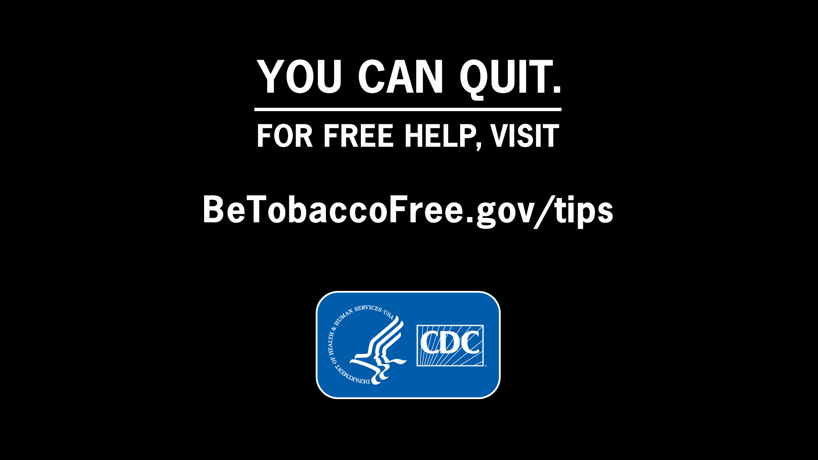

### A1. If you saw this advertisement on TV how likely would you be to visit BeTobaccoFree.gov/tips for information on quitting

1. Definitely would
2. Probably would
3. Might or might not
4. Probably would not
5. Definitely would not

*{If respondent saw* CDC.gov/tips*, ask}*

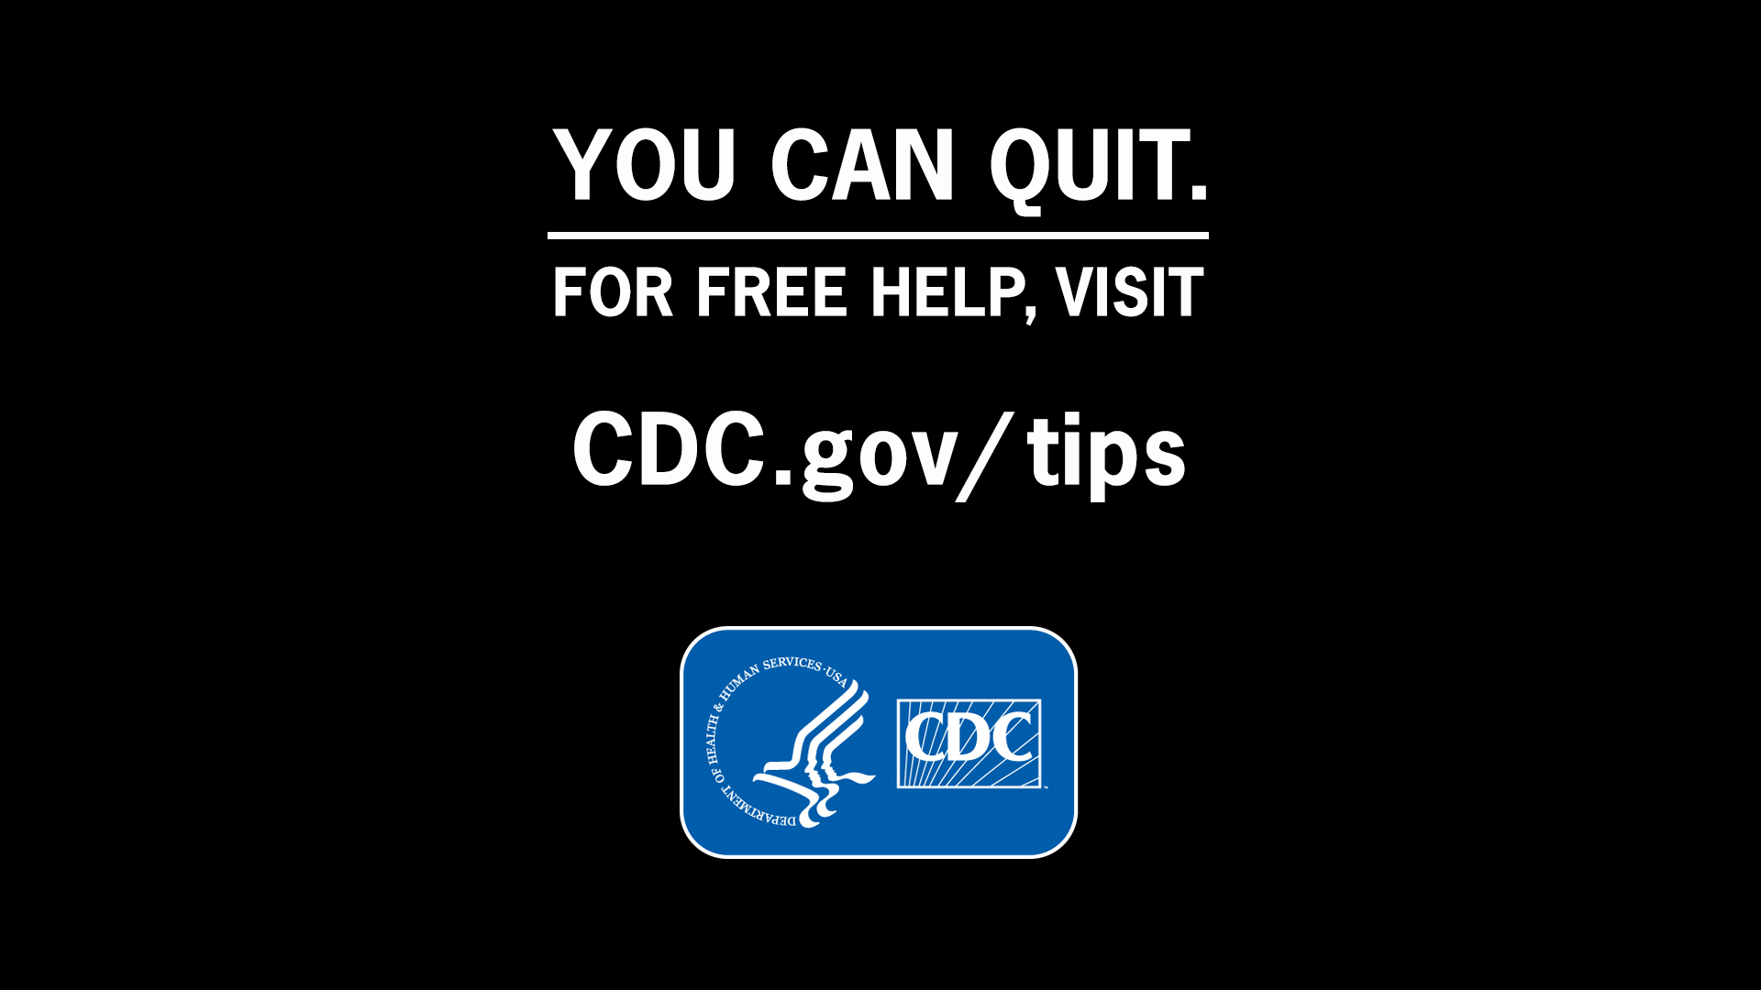

### A2. If you saw this advertisement on TV how likely would you be to visit CDC.gov/tips for information on quitting

1. Definitely would
2. Probably would
3. Might or might not
4. Probably would not
5. Definitely would not

### A3. Which of the following websites would you find more useful if you want additional information on smoking-related health conditions, facts about smoking, dangers of secondhand smoke, or resources on how to quit smoking?”

1. [CDC.gov/tips](http://www.cdc.gov/tips)
2. BeTobaccoFree.gov/tips
3. Neither URL

]