**Information Collection #6:**

**National Tobacco Prevention and Control Public Education Campaign:**

**Digital Media Testing and Copy Testing for**

**Terrie Hall Rough Cuts**

Submitted for approval under CDC generic approval #**0920-0910**

*Message Testing for Tobacco Communication Activities*

**Submission of this GenIC has been approved by**

**HHS/Assistant Secretary for Planning and Evaluation (ASPE)**

November 20, 2013

**Supporting Statement: Part A**

­­­­__________________________________________

**Data Collection Instruments**

##### Attachment 1a. Screener for Terrie Hall Digital Media Testing

##### Attachment 1b. Main Questionnaire for Terrie Hall Digital Media Testing

**Other Attachments**

##### Attachment 2. Email to Potential Respondents (Initial Email Invitation) - English

##### Attachment 3. Toluna Panelist Privacy Policies

##### Attachment 4. Toluna Panelist Terms and Conditions

##### Attachment 5. Statement by Tom Frieden, M.D., M.P.H., Director, Centers for Disease Control and Prevention

**Notes on Excluded Attachments**

##### In this GenIC, CDC outlines a plan to test five draft creative ads with content that may be considered sensitive. The draft materials are not included in the attachments for this GenIC because:

##### The ads have not been approved for public distribution by HHS/Assistant Secretary for Public Affairs (ASPA).

##### The untested ads could be perceived by the public as ineffective or offensive (testing is designed to identify potential problems).

##### Release of the ads must be coordinated with the launch of a comprehensive HHS/CDC campaign. Unauthorized release could jeopardize the evaluation strategy for the campaign.

To support adequate review of this GenIC by OMB, CDC requests permission to provide OMB with a secure link to the draft materials.

­­­­__________________________________________

# Section A: Justification for Information Collection

## A.1 Circumstances Making the Collection of Information Necessary

In winter of 2012, HHS/CDC launched the highly successful “TIPS From Former Smokers” campaign. The “TIPS” campaign was authorized by the Prevention and Public Health Fund of the Affordable Care Act. The third phase, “Tips 3,” is currently being developed and will continue to expand on the theme of health consequences of tobacco use. Ads planned for Tips 3 will feature real people who have suffered as a result of their smoking and exposure to secondhand smoke. The campaign will encourage smokers to quit smoking and to seek information about smoking cessation support from informed sources, such as 1-800-QUIT-NOW, government Websites and health care providers. The campaign will also provide information about the harmful effects of secondhand smoke and encourage non-smokers to seek smoke-free environments and encourage their loved ones to quit smoking. CDC’s Office on Smoking and Health (OSH) has lead responsibility for a number of components of the tobacco education campaign, including the production of effective campaign messages that may be disseminated through a variety of channels, including television, print and/or radio communication channels.

As part of campaign development and planning, CDC conducts rough-cut testing of draft ads and messages to ensure that they are believable, convincing and resonate with the target audiences. The goal of the testing is to optimize the credibility and persuasiveness of the ads. Message testing activities are not designed to provide findings that contribute to generalizable knowledge for the general population, but rather are used to gather specific insight for campaign planning. Such testing activities are conducted during campaign development to help describe a target audience, understand the factors that influence their behavior, and determine the best messages and communication channels. In testing possible advertising messages, CDC also collects information about audience demographics and tobacco-related behaviors in order to segment the audience into more homogeneous subgroups that may share certain beliefs, knowledge and behaviors related to tobacco use. Messages can then be customized and targeted to specific audience segments, thus improving ad effectiveness and efficient use of public resources.  The objective of the test is not to measure likeability of the advertisement. (Likeability, per se, does not necessarily lead directly to changes in consumer behavior, as a disliked but memorable ad may still affect consumer behavior in a positive manner.) There is a growing evidence base of empirical research that is showing fairly conclusively that the approach of arousing strong negative emotions (with graphic images, emotional testimonials, or combinations of the two) is the most effective way to generate the type of real desire to quit smoking cigarettes. Davis et al. outline some of this prior empirical work. This evidence also notes that desire to quit manifests in different belief and attitude constructs, such as a combination of changes in the target audience’s values attached to a behavioral outcome, behavioral beliefs, normative beliefs, attitudes toward existing behaviors, and motivation to comply. Segmenting audiences based on these constructs is critical to optimizing the message.

In this GenIC, CDC requests OMB approval to collect information for rough cut testing of five ads featuring Ms. Terrie Hall. Since 2012, Terrie Hall has been a spokesman for the Tips Campaign. Terrie had two types of cancer as a result of smoking. In 2001, at the age of 40, Terrie was diagnosed with oral cancer, and later that same year, with throat cancer. Terrie spoke with the aid of an artificial voice box that was inserted in her throat. She continued to battle cancer with a strong, positive spirit. In 2012, Terrie showed the American public how she got ready for her day in a “Tips from Former Smokers TV commercial”. The video was posted on YouTube where it received more than three million views, resulting in over three times the viewership of any other CDC Tips video on YouTube. Terrie also served as an advocate for the campaign, speaking to schools and community groups around the country about the dangers of smoking. Terrie died on September 16, 2013, from smoking-related cancer. She was 53. (See Attachment 5, a statement about Terrie’s life and contributions by Tom Frieden, M.D., M.P.H., Director, Centers for Disease Control and Prevention). Since Terrie’s death, five ads have been created that focus on Terrie and the campaign’s overall message and are ready for testing.

The ads that will undergo rough cut testing are:

1. Ad named “Teenager”
2. Ad named “Tips Don’t Smoke”
3. Ad named “I Wish”
4. Ad named “Surgeon General”
5. Ad named “Dana”

To test the draft ads, we will ask individuals about their opinions of the advertising messages emphasizing the negative health effects of cigarette smoking. The target audiences are smokers and non-smokers who are ages 18-54. We will segment by smoking status because smokers and non-smokers may have different beliefs and behaviors related to tobacco use and secondhand smoke exposure, and thus may respond differently to certain types of messages. Ads emphasizing the negative health effects of cigarette smoking may resonate more with smokers, whereas non-smokers may respond more strongly to ads emphasizing the harms of secondhand smoke. Therefore, in addition to collecting information about respondents’ reactions to the draft ads, we will also request basic demographic and tobacco use information in order to understand whether and how these factors may influence individuals’ responses to these messages. We will not specifically screen for low socioeconomic status (SES), but we anticipate that many of the respondents who are smokers will be of low SES. Individuals of low socioeconomic status are known to experience higher rates of smoking and resulting smoking‐related diseases than the general population. Approximately 29% of smokers in the U.S. today are of low SES, compared to 21% of the general population.

The five draft creative ads are in the process of being approved by HHS/CDC for public distribution. Thus, they are considered embargoed until approved. Additionally, unauthorized release prior to testing could inadvertently offend the public and could jeopardize the testing/assessment strategy. As a result this information collection request does not include copies of the materials to be tested in order to preserve the orderly release of campaign materials. A secure link to review the draft ads will be provided to OMB under separate cover.

### Privacy Impact Assessment Information

#### Overview of the Information Collection

The proposed information collection will involve testing of five TV ads among smokers and non-smokers who are ages 18-54. The target number of respondents is 3,700. All Information will be collected electronically through a self-administered online survey instrument. The Web-based system is ideal because of the ease of presenting visual stimuli (the ads) to respondents and recording their feedback. Respondents will be recruited through an existing Web-based panel system, and screened for eligibility and interest prior to administration of the main information collection instrument. Each of the eligible individuals will then view two of the five advertisements under test, complete the on-line survey and then submit the data electronically through a secure Internet environment. Approximately 1,480 respondents will view each ad. This will allow us to assess the ad’s persuasiveness with smokers and non-smokers who also vary in terms of other demographic characteristics such as education, income, gender, age group, region of the United States, amongst others.

#### Items of Information to be Collected

Information about respondent demographics and smoking behavior will be collected through a screening process (Attachment 1a) to verify the respondent characteristics needed for audience segmentation. This information is needed to assess whether the ads are likely to have comparable effects across population sub-groups. In addition, the screener will ask questions about tobacco use behavior. This information is needed to assign each respondent to the appropriate questions in the main questionnaire. For example, smokers will be asked if the ads would make them want to quit, while non-smokers will be asked if the ads would make them want to encourage someone to quit.

The main questionnaire (Attachment 1b) will ask respondents to provide opinions about each ad’s main message, feelings of relatability, impact, clarity, believability, memorability, persuasiveness, and anticipated effects on respondent behavior. Respondents will report on their reactions to the ads, such as whether the ad is convincing, comprehensible, would generate conversation with friends and family, and provides trustworthy and credible information. These topics are critical for message testing, as they have been shown to be strong predictors of message effectiveness. We will also ask respondents if the advertisement would affect their behavioral intentions regarding tobacco use, such as whether the ad would make a smoker want to quit smoking. The main questionnaire is summarized below.

* Screening items to ascertain respondents who meet the qualifying criteria;
* Smoking behavior items, such as TS1, TS2, TS3 and TS4, and quitting behavior items, as these groups may have dissimilar receptivity to advertisements;
* Attitudes toward smoking and health, as those respondents who have shared behavior may have similar or dissimilar receptivity to advertisements;
* Demographic (questions #DEMO1, DEMO2, DEMO3, DEMO6, DEMO7, DEMO8, DEMO9) items to determine, for example, socio-economic status and other specific demographic information about the respondents;
* Technology/Media (questions #T1, T2, T3, T4) and Awareness of Other Campaign (#OAS1, OAS2, OAS3). These questions are needed to inform choices of communication channels for messages
* Items regarding awareness of other campaigns, as awareness of those campaigns may impact receptivity of the ads under test
* The rest of the items are determining receptivity of the ads under test

Each respondent will also view one of two end cards that may be used in conjunction with the Tips ads as a call to action, and memorability of the end card will also be tested. Finally, the questionnaire probes for issues regarding clarity and anything hard to understand. The number of questions will be held to the absolute minimum required for the intended use of the data.

The two end card options are

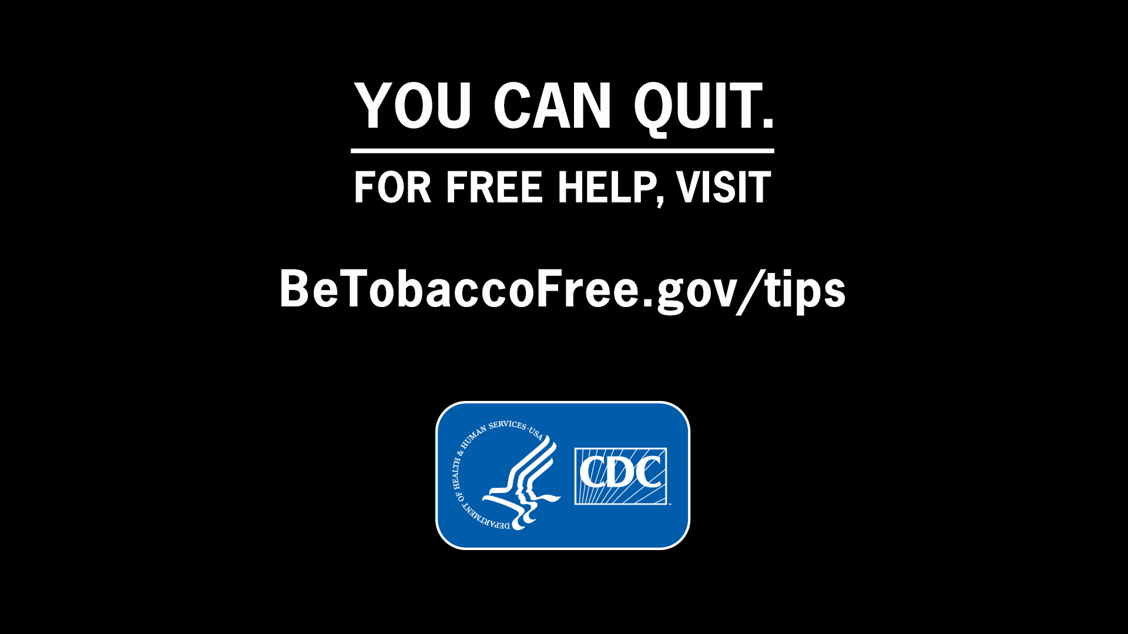 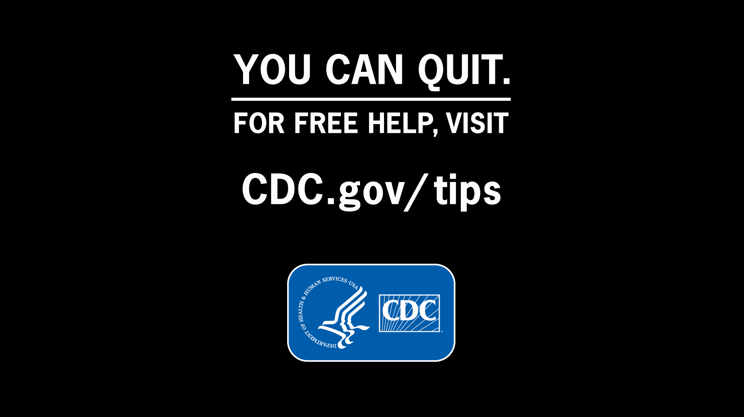

#### Identification of Website(s) and Website Content Directed at Children Under 13 Years of Age

All respondents will be 18 years of age or older. There is no Website content directed at children younger than 13 years of age.

## A.2 Purpose and Use of Information Collection

The information to be collected will allow CDC/OSH to assess whether the creative materials under test are likely to be perceived as credible, comprehensible, and persuasive by target audience members as well as whether the ad elicits negative emotions, which is considered to be an important factor in overall impact of tobacco control messages (Davis 2012, Durkin 2012, Emery 2012, NCI 2008, Wakefield 2011). The information will also allow CDC/OSH to determine whether the creative materials motivate respondents to take certain actions, such as calling for assistance in quitting smoking or whether they would visit an informational government Website, speak to their doctor or take other similar actions. If this data collection is not performed, CDC/OSH will not know whether these ads communicate intended messages credibly and effectively across audience segments and whether they motivate the audiences to take actions based on the messages.

These creative materials under test, where appropriate, will be finalized for production after analysis of results from the copy testing. CDC/OSH will use the information collected through rough cut testing to inform decisions about whether these creative materials under development must be changed in order to be more effective, or whether to omit one or more ads from the upcoming launch of the campaign.

## A.3 Use of Improved Information Technology and Burden Reduction

Information will be collected electronically through an online, Web-based panel system. Respondents have the option of completing the survey in one session.

A Web-enabled panel approach uses online technology to collect data from households that participate in an ongoing panel. The Toluna panel will be used for all subpopulations under test. The panels used for this testing are very large, allowing quick selection from the overall pool and rapid identification of several potential respondents from extremely small subgroups of the population. Samples from these panels are not designed to generate nationally representative samples or precise population parameters but rather are used as a highly efficient, low cost, and low burden method of data collection for formative copy testing. Web-based surveys are an especially convenient option for eliciting feedback on visual stimuli.

## A.4 Efforts to Identify Duplication and Use of Similar Information

Prior to conducting any data collection, CDC reviews existing published literature and unpublished qualitative pretesting reports when they are available, and also consults with outside experts to identify information that could facilitate message development. Health messages developed by OSH/HCB are unique in their mix of intended audience, health behavior, concept, and execution. Therefore, there are no similar data available.

The Centers for Disease Control and Prevention’s Office on Smoking and Health collaborates with other U.S. government agencies that sponsor or endorse health communication projects, such as the FDA’s Center for Tobacco Products, NIH, NCI and SAMHSA. These affiliations serve as information channels, help prevent redundancy, and promote use of consistent measures of effectiveness. Coordination activities include questionnaire review and item standardization where at all possible.

CDC and FDA are developing complementary but distinct communication campaigns. Staff in OSH’s Health Communications Branch are thus working closely with staff in FDA’s Health Communication and Education unit. Conference calls are held as needed to review plans. The message testing proposed in this GenIC does not duplicate FDA efforts. Points of contact for this coordination are

CDC: Diane Beistle, Chief, Health Communication Branch, telephone (770)488-5066, email [zgv1@cdc.gov](mailto:zgv1@cdc.gov)

CDC: Michelle O’Hegarty, Health Communication Specialist, Health Communication Branch, telephone (770)488-5582, izr0@cdc.gov

FDA: Tesfa Alexander, Health Communication Specialist, Office of Health Communication and Education, telephone (301)796-9335, email [Tesfa.Alexander@fda.hhs.gov](mailto:Tesfa.Alexander@fda.hhs.gov)

FDA: Erica Schlosser, Health Communication Specialist, Office of Health Communication and Education, telephone (301)796-9352, email [Erica.Schlosser@fda.hhs.gov](mailto:Erica.Schlosser@fda.hhs.gov)

## A.5 Impact on Small Business or Other Small Entities

There will be no impact on small businesses or other small entities.

## A.6 Consequences of Collecting the Information Less Frequently

Without the proposed information collection, CDC/OSH will have only limited and anecdotal information to guide ad development and consequently risks developing a campaign that will not be effective in achieving its goals of getting smokers to quit. Given the large investment of US government funds in the Tips campaign, an ineffective campaign would result in poor use of limited government resources. Finally, the Tips campaign is a critical prevention component of larger efforts of health reform for our nation under the Affordable Care Act.

## A.7 Special Circumstances Relating to the Guidelines of 5 CFR 1320.5

The testing activities fully comply with the regulation and guidelines in 5 **CFR 1320.5.** There are no special circumstances.

## A.8 Comments in Response to the Federal Register Notice and Efforts to Consult Outside the Agency

Not applicable.

## A.9 Explanation of Any Payments or Gift to Respondents

Health message development and testing occur in a highly dynamic, fast-paced environment. Utilization of existing respondent panels allows CDC/OSH to obtain information quickly so that adjustments can be made, as needed, and health messages and campaigns can progress rapidly from the planning stage to the implementation stage. Similar rapid turnaround techniques are used in the private sector.

The panels from which respondents will be drawn are established Toluna panels that provide points as a reward for participation. Immediately upon completion of the survey, each respondent will be provided with a certain number of points that are equivalent to $.50. Those points are accrued with other points when the panelist takes part in other surveys. At any time, the panelist is able to redeem their points for different products, such as gift cards.

Toluna manages the rewards programs for its panel and follows a strict privacy policy and safeguards the privacy of panel members at all times. For Toluna’s Privacy Policy and Terms and Conditions, please see Attachment 3 and Attachment 4.

## A.10 Assurance of Confidentiality Provided to Respondents

#### Privacy Act Determination

All respondents will be recruited from an existing panel maintained by CDC’s data collection contractor, Toluna. Although demographic information (e.g., gender, age, and race) will be gathered, no direct personal identifiers (e.g., full name, phone number, social security number, etc.) will be collected or maintained as part of the Screener (see Attachment 1a), or Main Questionnaire (see Attachment 1b). No directly identifying information will be transmitted to CDC/OSH. The Privacy Act does not apply.

#### Safeguards

While Toluna has access to personally identifiable information (PII) on panel subscribers, no PII will be shared with CDC or any agencies outside of Toluna. All data will be reported in the aggregate. All data will be stored on password-protected databases to which only Toluna employees working on this project have access. Toluna is firmly committed to protecting the privacy of its panel members. Their policies ensure that PII is not released without panel member permission. In support of its privacy policies, Toluna has been awarded TRUSTe's Privacy Seal signifying that this privacy policy and practices have been reviewed for requirements including transparency, accountability and choice regarding the collection and use of panel member personal information. Toluna also participates in and adheres to the U.S.‐EU Safe Harbor Framework as set forth by the U.S. Department of Commerce regarding the collection, use, and retention of data. Toluna’s data collection conforms to the Council of American Survey Research Organizations (CASRO) Code of Standards and Ethics for Survey Research, the European Society of Opinion and Marketing Research (ESOMAR) Codes and Guidelines for Survey Research, the European Commission Directive on Data Protection, SNYTEC in France, the French law on "Informatique et Libertés", CNIL, the American Association for Public Opinion Research (AAPOR) Code of Professional Ethics and Practices, the Federal Trade Commission (FTC) Fair Information Practice Principles, the FTC’s Children’s Online Privacy Protection Act (COPPA) Final Rule, the Children’s Advertising Review Unit (CARU) Guidelines for Advertising on the Internet and Online Services, the Health Insurance Portability and Accountability Act (HIPAA), the Graham-Leach Bliley Act (GLB), and the CAN-SPAM Act. (See Attachment 3 for further details on privacy policy.)

Respondent Advisements and Consent

Respondents will be advised of the nature of the activity, the length of time it will require, and that participation is purely voluntary. They are also provided with the Privacy Policy. The appropriate advisements are included in the Screener as well as the initial page of the Main Questionnaire. Respondents will be assured that they will incur no penalties if they wish not to respond to the information collection as a whole or to any specific questions. These procedures conform to ethical practices for collecting data from human participants.

CDC’s National Center for Chronic Disease Prevention and Health Promotion (NCCDPHP) has reviewed this submission and determined that it does not involve research with human subjects and does not require review and approval by CDC’s IRB.

## A.11 Justification for Sensitive Questions

The majority of questions asked will not be of a sensitive nature.  There will be no requests for a respondent’s Social Security Number (SSN).

It will be necessary to ask some questions considered to be of a sensitive nature in order to assess individuals’ attitudes and behaviors or to test messages about the specific health behavior of cigarette smoking in order to understand respondent motivation toward behavior change. The theory of planned behavior, a framework used in the development of this campaign, provides rationale for evidence-based messaging to change attitudes, beliefs, intentions and behavior at the target audience level. Questions about attitudes and behaviors, while some may be considered to be a sensitive nature, are necessary in order to understand respondent motivation toward behavior change. Questions about messages concerning smoking behavior (e.g., tobacco use) and some demographic information (e.g., Race or Ethnicity and LGBT status) could be considered sensitive, although these items would not generally be considered highly sensitive.  Questions about sensitive issues are necessary for audience segmentation and to assess individuals’ response to messages. In addition, questions about emotional reactions to the advertisement are necessary to see if the advertisement is achieving intended objectives. Respondents will be informed of the applicable privacy safeguards.

 Sensitive information will only be requested when necessary for specific project objectives and questions requesting such information will include a “decline to answer” option.

## A.12 Estimates of Annualized Burden Hours and Costs

The data collection will occur concurrently for all respondents, segmented into smokers and nonsmokers. CDC’s contractor, Toluna, will collect the necessary data. We expect to screen approximately 4,025 potential respondents who are part of the Toluna panel in order to obtain completed questionnaires from 3,700 respondents in the target age range of 18-54 years.

Toluna has deep profiling and demographic information on its panel members. Screening will be conducted to confirm that Toluna’s information is correct and to assess whether any information has changed (i.e., educational status, state of residence). Once respondents have been screened and qualified to participate in this health message testing activity, they immediately enter the online Main Questionnaire. Depending on the creative materials under test, each respondent will be shown two ads. If two ads are shown to a respondent, the order in which the ads appear to the respondent will be randomized to reduce order bias. Respondents will be shown the first ad and asked a series of questions specific to the ad regarding believability, engagement with the ad and potential impact on behavior. Respondents will then be shown the second ad and asked the same series of questions.

The information collection instruments are included as Attachments 1a/1b.

We estimate that 325 respondents will discontinue their participation after completing the Screener (“Incompletes”). For these respondents, the estimated burden per response is 2 minutes (Attachment 1a).

We estimate that 3,700 respondents will complete the screening process and continue to the main questionnaire (“Completes”). For these respondents, the estimated burden is 17 minutes (2 minutes for the Screener [Attachment 1a] plus 15 minutes for the Main Questionnaire [Attachment 1b]).

The total number of individuals involved in data collection is 4,025. The estimated burden per response varies from 2-17 minutes. The adjusted average burden per response is 15.8 minutes.

The total estimated burden to respondents is 1,060 hours.

### Table A.12.A. Estimated Annualized Burden to Respondents

|  |  |  |  |  |  |
| --- | --- | --- | --- | --- | --- |
| Type of Respondents | Form Name | Number of Respondents | Number of Responses per Respondent | Average Burden per Response (in hours) | Total Burden (in hours) |
| Target Population Drawn From Toluna Panel (“Completes”) | Screener and Questionnaire | 3,700 | 1 | 17/60 | 1,049 |
| Potential Respondents From Toluna Panel (“Incompletes”) | Screener | 325 | 1 | 2/60 | 11 |
| **Total** |  | **4,025** |  |  | **1,060** |

The estimated cost of the time devoted to this information collection by respondents is $24,380, as summarized in Table A.12.B. To calculate this cost, we used the mean hourly wage of $23, which represents the Department of Labor estimated mean for state, local, and private industry earnings. There are no direct costs to respondents associated with participation in this information collection.

### Table A.12.B Estimated Annualized Cost to Respondents

|  |  |  |  |  |
| --- | --- | --- | --- | --- |
| Type of Respondents | Form Name | Total Burden (in hours) | Average Hourly Wage | Total Cost |
|
| Target Population Drawn From Toluna Panel (“Completes”) | Screener and Questionnaire | 1,049 | $23 | $24,127 |
| Potential Respondents from Toluna Panel (“Incompletes”) | Screener | 11 | $23 | $253 |
|  | Total | | | $24,380 |

## A.13 Estimates of Other Annual Cost Burden to Respondents and Record Keepers

None.

## A.14 Annualized Cost to the Federal Government

Approximately 5% of one full-time equivalent (FTE) and 1% of one senior manager will be required to oversee the information collection activities for one month. Responsibilities will include internal coordination and review of materials and reports and maintaining proper accounting of burden hours. The agency estimates that it will take a GS-14, at a wage rate of $48.41 an hour, approximately 10 hours to manage the project, totaling about $484.00. It is estimated to take a GS-15, at a wage rate of $64.54 an hour, approximately two hours to oversee the total project, totaling $129.08

The total average annualized cost to the government for CDC/OSH oversight is $613.

|  |  |  |  |
| --- | --- | --- | --- |
| **Government Personnel** | **Time Commitment** | **Hourly Basic Rate** | **Total** |
| GS-14 | 5% | $48.41 | $484 |
| GS-15 | 1% | $64.54 | $129 |
| **Subtotal, Government Personnel** | | | $613 |
| **Contract Costs** | | | $174,511 |
| **Total Costs** | | | $175,124 |

Contractors on CDC/OSH’s behalf will conduct the majority of data collection activities. The total cost of the data collection contractors is $174,511, which includes consultation, instrument design and development, recruitment, data collection, analyses, and reporting. Toluna will collect the data from the respondents. Activities are coordinated through a contract with the Plowshare Group, a specialist in media campaigns.

The grand total cost for the project, including government and contractor cost, is $175,124.

## A.15 Explanation for Program Changes or Adjustments

This is a new data collection.

## A.16 Plans for Tabulation and Publication and Project Time Schedule

The information will be used to inform health communication strategies across OSH. The analysis will examine overall levels of perceived effectiveness of the creative materials under test, as measured by the frequency of respondents’ reporting that the materials were believable and convincing, a call to action, attention-grabbing, credible, motivational, easy to understand, and provided new information. We will also analyze qualitative open-ended responses for the respondents’ answers to open-ended questions, such as respondents’ perceptions of the ‘main message’ of the ad, concerns about the ad, as well as likes and dislikes. Here we will look for commonalities and differences in terms of message interpretation by different segments, and for common themes in terms of elements that resonate well or poorly with respondents. We will examine overall levels of respondent motivation in response to the ads, as measured by the frequency of responses to whether they would talk to someone else about the ad or if the ad would make them take some other action (quit smoking, encourage someone to quit smoking, call the 1-800 Quitline, go online, etc.). Our findings from these analyses will be immediately used to revise the ads and to help ensure Phase III of Tips is effective.

Assuming an OMB approval date of November 22, 2013, we plan to begin the information collection activity for the five ads on 11/25/2013. We are aiming for a campaign launch date of one or more of these advertisements of February 3, 2014, and multiple steps are required between approval of this rough-cut testing activity and the launch in order to meet that target date.

### Table A.16.A. Estimated Timeline

|  |  |
| --- | --- |
| ***Task*** | ***Approximate  Due Date*** |
| CDC submits OMB Package to OMB for approval | 11/12/2013 |
| **Milestone: OMB approves Request** | **11/22/2013** |
| Rough Cut Testing Field Period + Interim report available | 12/13/2013 |
| Rough Cut Testing Report complete | 12/20/2013 |
| Begin modifying ads based on the results of message testing | 12/20/2013 |
| **Milestone: CDC Approves final ads** | **12/21/2013** |
| Submit ads to HHS ASPA for approval | 1/16/2014 |
| **Milestone: HHS ASPA approves ads** | **1/16/2014** |
| **Milestone: New Terrie Ads available to air** | **2/3/2014** |

## A.17 Reason(s) Display of OMB Expiration is Inappropriate

The expiration date of OMB approval will be displayed on all information collection instruments.

## A.18 Exceptions to Certification for Paperwork Reduction Act Submissions

No exceptions are requested.

# References

Berlin, M., Mohadjer, L., Waksberg, J., Kolstad, A., Kirsch, I., Rock, D., & Yamamoto, K. (1992). An experiment in monetary incentives. In the American Statistical Association (ed.), *Proceedings of the American Statistical Association Section on Survey Research Methods* (pp. 393-398). Alexandria, VA: American Statistical Association.

Church, A. H. (1993). Estimating the effect of incentives on mail survey response rates: Ameta-analysis. *Public Opinion Quarterly, 57,* 62–79.

Davis, T. C., Berkel, H. J., Arnold, C. L., Nandy, I., Jackson, R. H., & Murphy, P. W. (1998). Intervention to increase mammography utilization in a public hospital. *Journal of General Internal Medicine, 13,* 230–233.

Davis, K.C., J. Nonnemaker, J. Duke, and M. Farrelly. *Perceived effectiveness of cessation advertisements: The importance of audience reactions and practical implications for media campaign planning.* Health Communication, 2012.

Emery, S., et al., *The effects of smoking-related television advertising on smoking and intentions to quit*

*among adults in the United States: 1999-2007.* Am J Public Health, 2012. **102**(4): p. 751-7.

Durkin, S., E. Brennan, and M. Wakefield, *Mass media campaigns to promote smoking cessation among*

*adults: an integrative review.* Tob Control, 2012. **21**(2): p. 127-38.

Groves, R., & Couper, M. (1998). *Nonresponse in household interview surveys.* New York: John Wiley & Sons.

Kulka, R. A. (1994) *The Use of Incentives to Survey “Hard-to-Reach” Respondents: A Brief Review of Empirical Research and Current Practice*. Paper prepared for the Council of Professional Associations on Federal Statistics’ Seminar on New Directions in Statistical Methodology. Bethesda, MD.

National Cancer Institute, *The role of the media in promoting and reducing tobacco use. Tobacco Control*

*Monograph No. 19. NIH Pub. No. 07-6242*, 2008, USDHHS, National Institutes of Health, National Cancer

Institute: Bethesda MD.

Salant, P., & Dillman, D. A. (1994). *How to conduct your own survey.* New York: John Wiley & Sons.

Singer, E., Gebler, N., Raghunathan, T., VanHoewyk, J., & McGonagle, K. (in press). The Effect of Incentives on Response Rates in Face-to-Face, Telephone, and Mixed Mode Surveys*. Journal of Official Statistics*.

Singer, E., Gelber, N., Van Hoewyk, J., & Brown, J. (1997). *Does $10 equal $10? The effect of framing on the impact of incentives.* Paper presented at the annual conference of the American Association for Public Opinion Research, Norfolk, VA.

Singer, E., Van Hoewyk, J., & Maher, M. P. (2000). Experiments with incentives in telephone surveys. *Public Opinion Quarterly, 64*(3), 171–188.

Wakefield, M., et al., *Smokers' responses to television advertisements about the serious harms of tobacco use: pre-testing results from 10 low- to middle-income countries.* Tob Control, 2011.