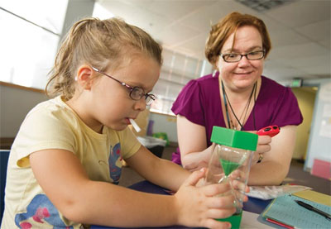
Imagine the possibilities … if saliva could be used instead of blood as a research and diagnostic specimen…
Attachment 1a Goal 1 Exemplar Recruitment Flyer
Wouldn’t it be great….if everything could be tested painlessly and simply – through saliva?
The Johns Hopkins University Center for Interdisciplinary Salivary Bioscience Research is seeking men and non-pregnant women from ages 18 to 35 who are not currently taking prescription medications (other than birth control) for participation in a study that will help expand this cutting edge field.
Approved March 21, 2012
- Participation lasts 45 minutes and involves completing a short questionnaire and donating oral fluid, blood, and urine samples.
- Samples will be used to develop and validate assays for analytes of several different types in oral fluids.

Participants may receive $50.00
To participate in this research study, please call 443-287-4581.
PI: Douglas Granger
Protocol No.: NA_00046518
443-287-4581 | 443-287-4581 | 443-287-4581 | 443-287-4581 | 443-287-4581 | 443-287-4581 | 443-287-4581

