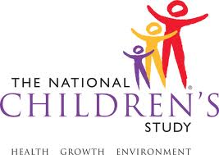 | National Children’s Study  [Insert Institutional Name]  Project ______________

WARNING!
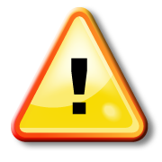
Some of the items included in this saliva collection kit may pose a choking hazard for infants and small children. Please do not leave infants or children unsupervised with these items. Always grip one end of swab firmly yourself when collecting saliva from a child.

