SALIVA COLLECTION INSTRUCTIONS - MOTHER
Step 1: Record time |  |  | Step 2: Select tube
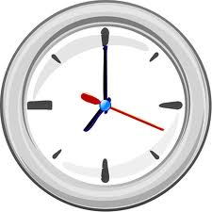 | Record time on sample collection sheet |  | 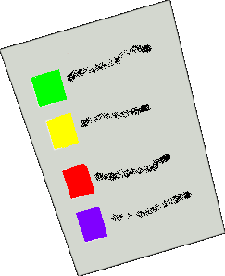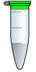 | Match tube color with label on collection sheet
Step 3: Mother saliva collection (straw OR swab method)
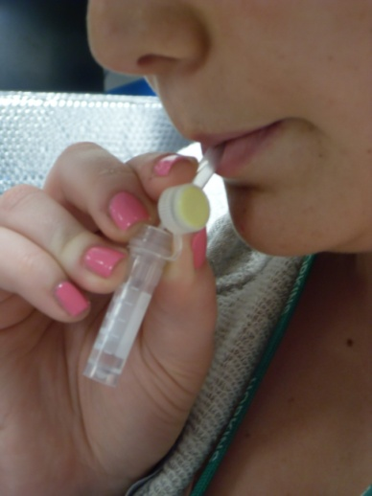 |  | Straw method  1) Insert straw in mouth  2) Allow saliva to collect in tube (1mL)  3) Cap the tube, discard straw | 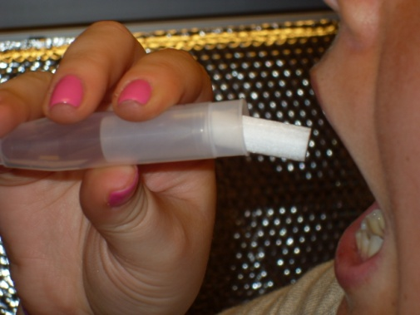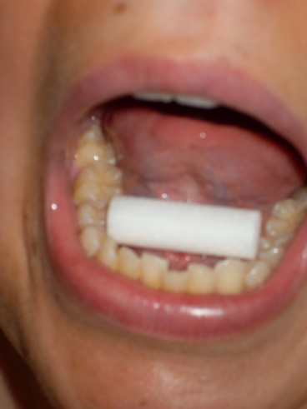 |  | Swab method  1) Insert swab under tongue, close mouth  2) Hold for 2 minutes until saturated  3) Place swab in tube and cap the tube
Step 4: Freeze sample |  |  | Good Job!
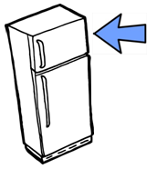 |  | Immediately place sample in freezer | 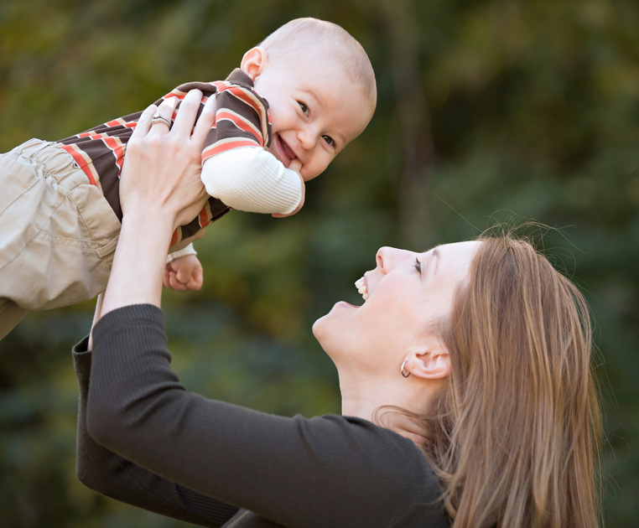
SALIVA COLLECTION INSTRUCTIONS – INFANT/CHILD
Step 1: Record time |  |  | Step 2: Select tube
 | Record time on sample collection sheet |  |  | Match tube color with label on collection sheet
Step 4: Infant/Child saliva collection
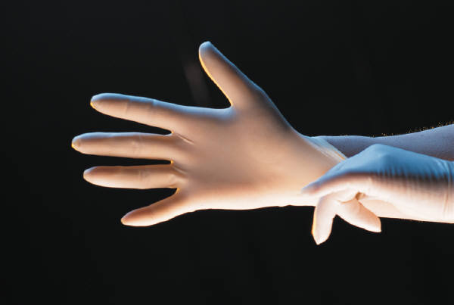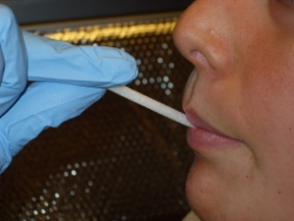 |  | 1) Firmly grasp one end of swab with gloved hand  2) Place other end of swab under child’s tongue for 2 minutes  Do not let go of swab! | 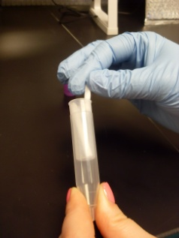 |  | 3) Switch sides of swab and repeat process  4) Fold swab  5) Place folded swab in tube and cap the tube  6) Discard glove
Step 6: Freeze sample |  |  | Good Job!
 |  | Immediately place sample in freezer

