Packing the Samples for Shipping

  - Place frozen samples inside ziplock bag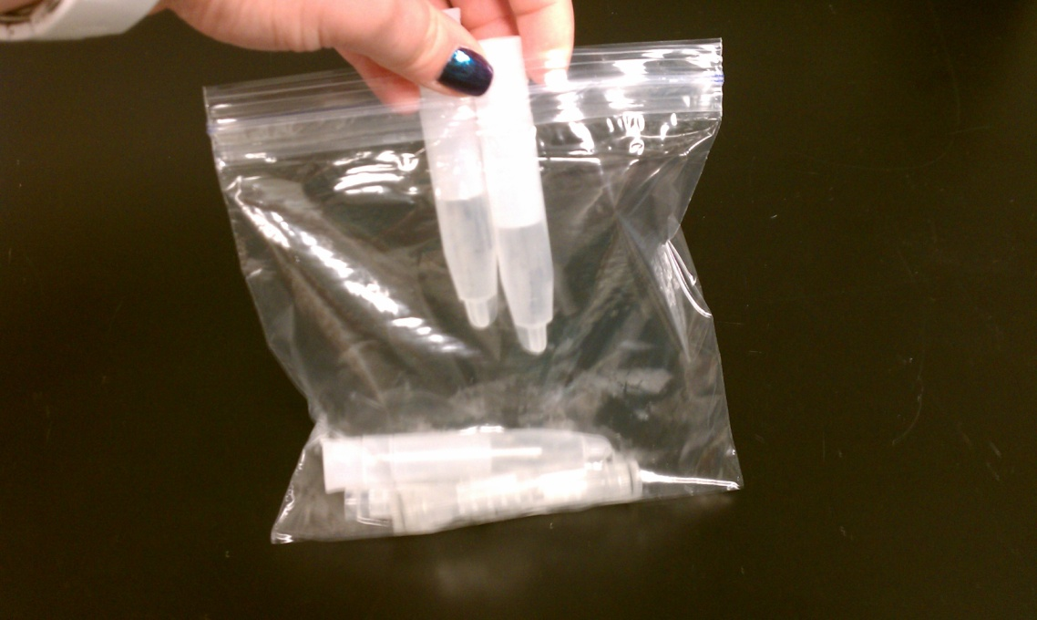
  - Place 2 frozen Polar Packs on bottom of insulated shipper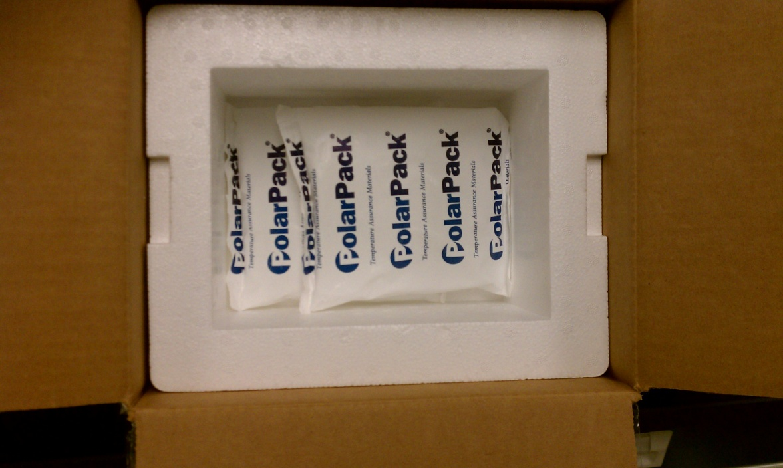
Packing the Samples for Shipping

  - Place bag of samples on top of Polar Packs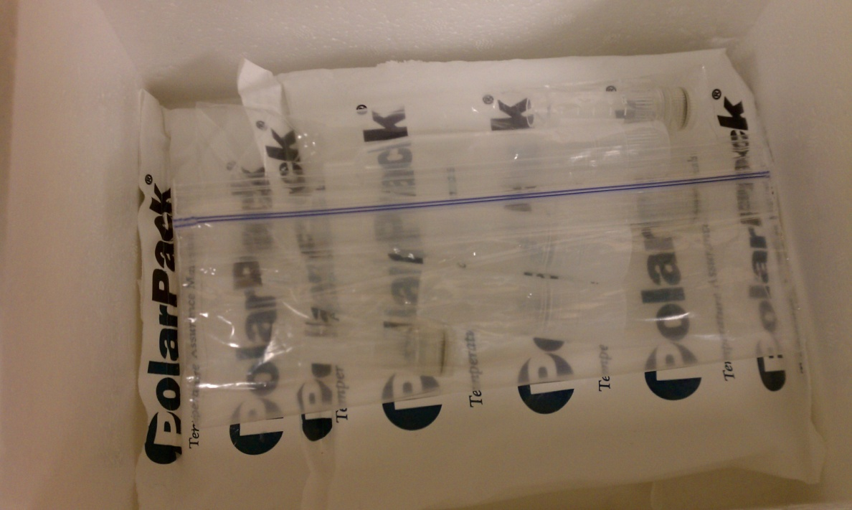
  - Place remaining frozen Polar Pack on top of samples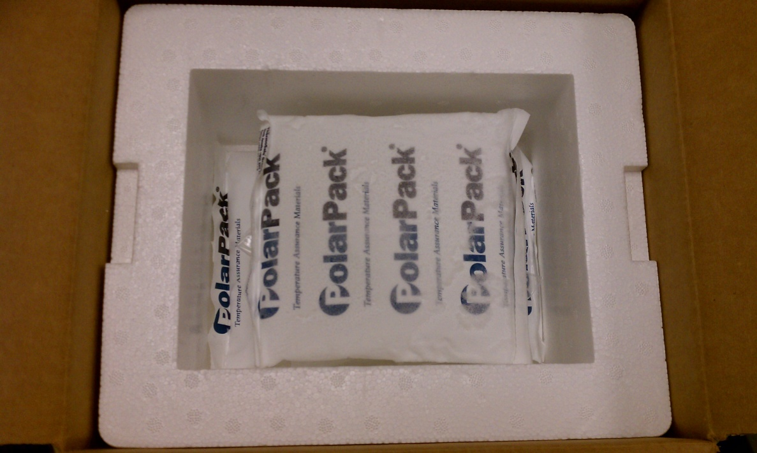
Packing the Samples for Shipping

  - Place Styrofoam lid on shipper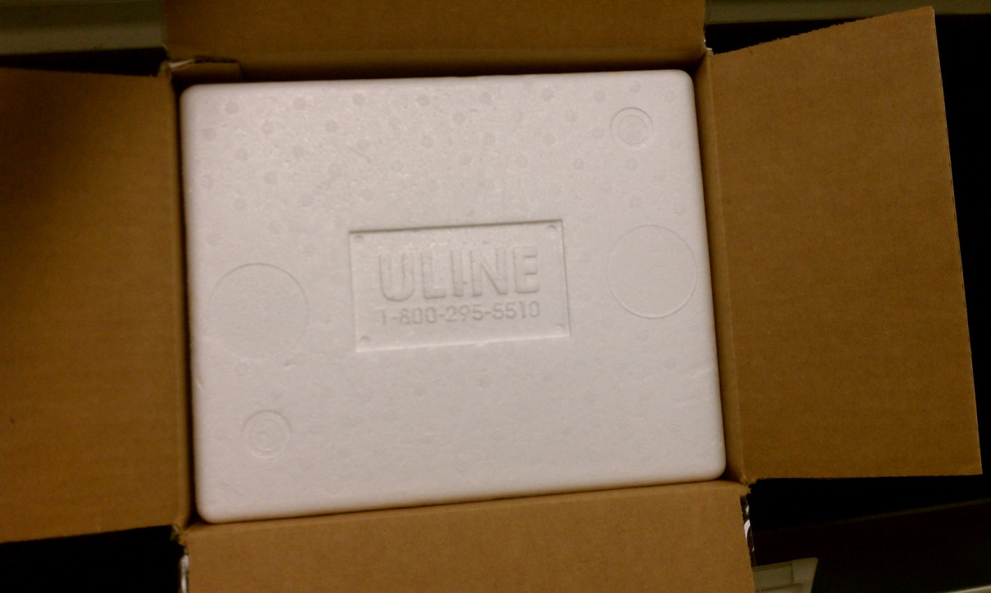
  - Close cardboard flaps and seal all edges with packing tape