Mother Interview

LOI2-QUEX-13

Interview Introduction

IN001. ID Number

Thank you for agreeing to participate in this study. We are about to begin the interview portion of today’s home visit, which will take about an hour to complete. Your answers are important to us. There are no right or wrong answers, just those that help us to understand your situation. There are questions about where you live, your lifestyle routines, and your pregnancy during this interview and you can always refuse to answer any question or group of questions.

IN002. Are you ready to begin?

YES 1
NO 2 (END interview)

Household Composition and Demographics: Part 1

.
DE002. How many people, both children and adults, live in this household? Include any persons who usually stay here but are temporarily away on business, vacation, in the hospital, on full-time active military duty, or students living temporarily away from home. Do not include anyone who is in a nursing home or other institution including yourself, what is the total number of people who live here?

|___|___|
NUMBER

REFUSED 9--97
DON’T KNOW 9--98

BOX DE01

CHECK ITEM:
- IF DE002 = “1”, GO TO DE009.
- OTHERWISE, CONTINUE WITH DE003.

DE003. How many people live in your household who are age 0-5 years?_________
6-10 years?_________
11-17 years?_________
>18 years?___________

DE008. Is the biological father of your baby living in this household?

YES 1
NO 2
DECEASED 3
REFUSED 9--7
DON’T KNOW 9--8

DE009. Now I’d like to ask about your marital status. What is your current marital status? Are you:

INTERVIEWER INSTRUCTION:
CONFIRM IF KNOWN.

Married, 01
Not married but living together with a partner of the opposite sex, 02
Not married but living together with a partner of the same sex, 03
Widowed, 04
Divorced, 05
Separated, or 06
Never been married? 07
REFUSED 9--97
DON’T KNOW 9--98

BEGIN LOOP DE01

- ASK DE010-DE013 ABOUT RESPONDENT.
- CYCLE THROUGH DE010-DE013 ABOUT THE BIOLOGICAL FATHER OF BABY UNLESS DE008 IS CODED ‘3’
- CYCLE THROUGH AND ASK DE010-DE013 ABOUT SPOUSE OR RESIDENT PARTNER IF THIS IS NOT THE BIOLOGICAL FATHER (RECORD CODED ‘2’ IN DE008).

DE010. {Do you} consider yourself to be Hispanic, or Latino/a?

INTERVIEWER INSTRUCTION:
IF ASKING ABOUT A FEMALE HOUSEHOLD MEMBER READ LATINA.

YES 1
NO 2 (DE012)
REFUSED 9--7 (DE012)
DON’T KNOW 9--8 (DE012)

DE011. Please give me the number of the group that represents {your/NAME’s} Hispanic origin or ancestry.

SHOW CARD DE2.

PUERTO RICAN 01
CUBAN/CUBAN AMERICAN 02
DOMINICAN (REPUBLIC) 03
MEXICAN 04
MEXICAN AMERICAN 05
CENTRAL OR SOUTH AMERICAN 06
OTHER 96
REFUSED 9--97
DON’T KNOW 9--98

DE012. What race do you consider yourself to be? You may select one or more.

PROBE: Anything else?

SELECT ALL THAT APPLY.

White, 1
Black or African American, 2
American Indian or Alaska Native, 3
Asian, or 4
Native Hawaiian or Other Pacific Islander? 5
SOME OTHER RACE? (SPECIFY): 6
REFUSED 9--97
DON’T KNOW 9—98

DE013. Please look at the card and tell me what is the highest degree or level of school that {you/NAME} {have/has} completed?

SHOW CARD DE3.

NO SCHOOL 01

ELEMENTARY
NURSERY SCHOOL TO 4TH GRADE 02
5TH-6TH GRADE 03
7TH-8TH GRADE 04

HIGH SCHOOL
9TH GRADE 05
10TH GRADE 06
11TH GRADE 07
12TH GRADE (NO DIPLOMA) 08
HIGH SCHOOL DIPLOMA 09
GED OR EQUIVALENT 10

COLLEGE
SOME COLLEGE CREDITS, BUT LESS THAN 1 YEAR 11
1 OR MORE YEARS OF COLLEGE, BUT NO DEGREE 12
ASSOCIATE DEGREE: OCCUPATIONAL, TECHNICAL, OR
VOCATIONAL PROGRAM 13
ASSOCIATE DEGREE: ACADEMIC PROGRAM 14
BACHELOR’S DEGREE (e.g., BA, BS) 15

GRADUATE
MASTER’S DEGREE (e.g., MA, MS, MSW, MEng, MBA) 16
PROFESSIONAL SCHOOL DEGREE (e.g., MD, DDS, DVM, JD) 17
DOCTORAL DEGREE (e.g., Ph.D., Ed.D.) 18
REFUSED 9--97
DON’T KNOW 9--98

END LOOP DE01

- ASK DE010-DE013 ABOUT THE BIOLOGICAL FATHER OF BABY (UNLESS DE008 IS CODED ‘3’)
- ASK DE010-DE013 ABOUT SPOUSE OR RESIDENT PARTNER IF THIS IS NOT THE BIOLOGICAL FATHER (RECORD CODED “1” OR “12” IN DE007 AND RECORD CODED ‘2’ IN DE008).
- WHEN COMPLETE, CONTINUE WITH NEXT SECTION.

DM001. These next questions are about your background and cultural heritage.

What is your date of birth, enter month and year only

DM002. Were you born in the United States?

YES 1 (DM005)
NO 2
REFUSED 9--97 (DM005)
DON’T KNOW 9--98 (DM005)

DM003. In what country were you born?

INTERVIEWER INSTRUCTION:
SELECT COUNTRY FROM LIST.

(Source: U.S. State Department List, Independent States in the World)

REFUSED 9--97
DON’T KNOW 9--98

DM004. About how long have you lived in the United States?

INTERVIEWER INSTRUCTION:
IF LESS THAN ONE YEAR, ENTER ”00”.

|___|___|
YEARS

REFUSED 9--97
DON’T KNOW 9--98

DM005. Was your mother born in the United States?

YES 1 (DM007)
NO 2
REFUSED 9--97 (DM007)
DON’T KNOW 9--98 (DM007)

DM007. Was your father born in the United States?

YES 1 (DM009)
NO 2
REFUSED 9--97 (DM009)
DON’T KNOW 9--98 (DM009)

DM009 What language do you prefer to speak?
English 1 (DM007)
Spanish 2
Chinese 3
Japanese 4
Korean 5
Tagalong 6
OTHER 7 (GO TO DM009A)
DM009A Please Specify:_______________________________
REFUSED 9--97 (DM007)
DON’T KNOW 9--98 (DM007)

Other, please specify

Discrimination
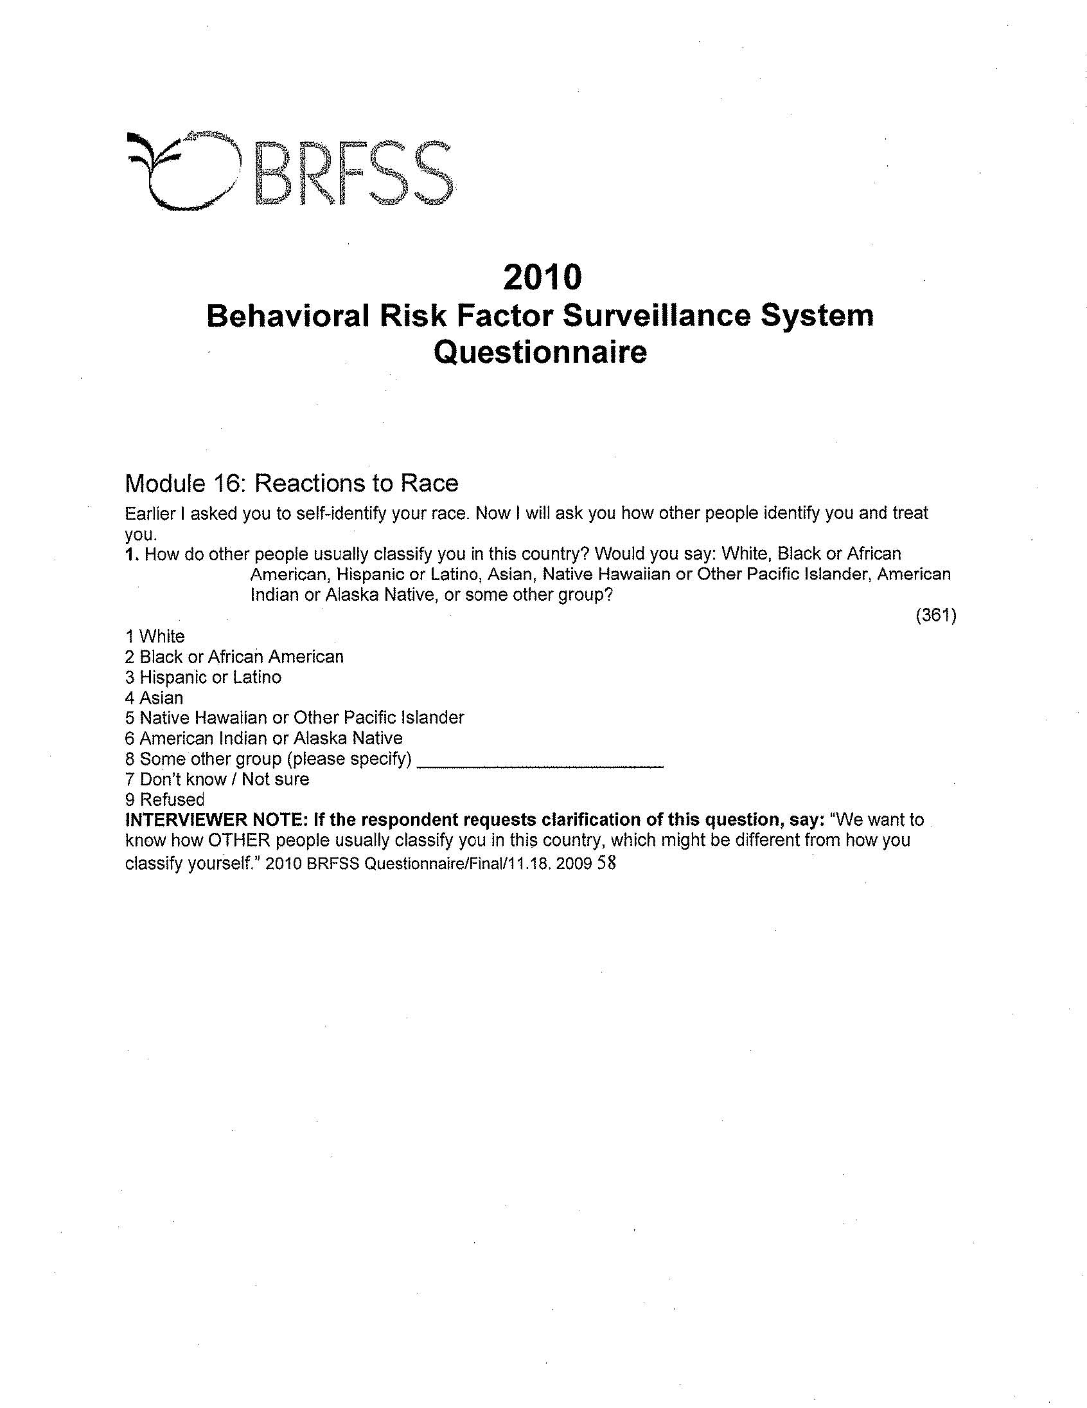

DM020. I’d like to find out how you see yourself in relation to other people in the United States.

DM021. Please look at this card. Think of this ladder as representing where people stand in the United States. At the top of the ladder are the people who are the best off – those who have the most money, the most education and the most respected jobs. At the bottom are the people who are the worst off – who have the least money, least education, and the least respected jobs or no job.
Where would you place yourself on this ladder?

Please point to the rung where you think you stand at this time in your life, relative to other people in the United States.

SHOW CARD DM1.

RUNG A 01
RUNG B 02
RUNG C 03
RUNG D 04
RUNG E 05
RUNG F 06
RUNG G 07
RUNG H 08
RUNG I 09
RUNG J 10
REFUSED 9--97
DON’T KNOW 9--98

Health Literacy

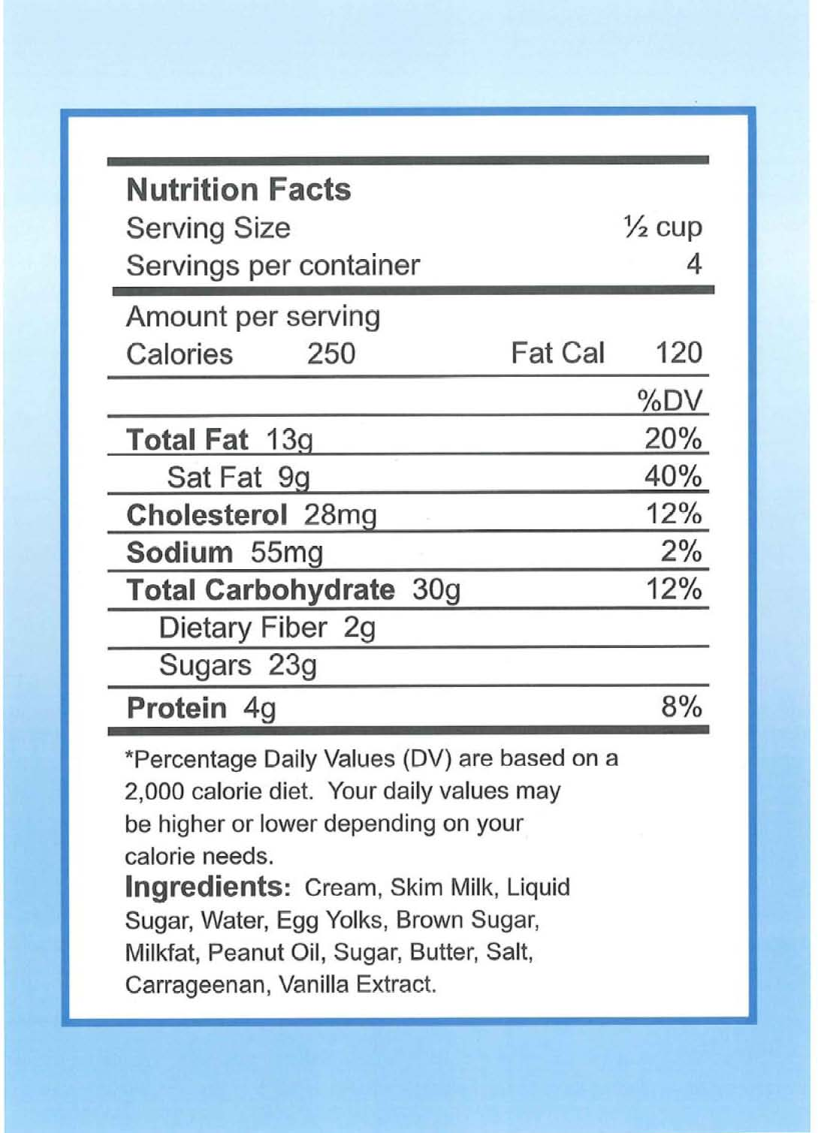
THIS INFORMATION IS ON THE BACK OF A CONTAINER OF A PINT OF ICE CREAM. PLEASE READ THE INFORMATION AND ANSWER THE FOLLOWING QUESTIONS.
- If you eat the entire container, how many calories will you eat?
- If you are allowed to eat 60 grams of carbohydrates as a snack, how much ice cream could you have?
- Your doctor advises you to reduce the amount of saturated fat in your diet. You usually have 42 g of saturated fat each day, which includes one serving of ice cream. If you stop eating ice cream, how many grams of saturated fat would you be consuming each day?

- If you usually eat 2500 calories in a day, what percentage of your daily value of calories will you be eating if you eat one serving?
Maternal Medical History

MC001. Next, I have some general questions about your health and health insurance.

DM013. Do you currently have insurance through a current or former employer or union either through yourself or another family member?

YES 1
NO 2
REFUSED 9--97
DON’T KNOW 9--98

DM015. (Do you currently have:)

Medicaid, Medical Assistance, or any kind of government-assistance plan for those with low incomes or a disability?

YES 1
NO 2
REFUSED 9--97
DON’T KNOW 9--98

MC002. Would you say your health in general is . . .

Excellent, 1
Very good, 2
Good, 3
Fair, or 4
Poor? 5
REFUSED 9--97
DON’T KNOW 9--98

MC012. Have you ever been told by a doctor or other health care provider that you had any of the following conditions?
YES NO REF DK

MC017 Hypertension or high blood pressure when you’re not pregnant?
MC018 Diabetes when you’re not pregnant
MC044. Bipolar disorder?
MC045. Depression, other than bipolar disorder?
MC046. An anxiety disorder, such as generalized anxiety disorder or obsessive compulsive disorder (OCD)?
MC050. Any other chronic or long lasting conditions?

YES 1
NO 2 (EOS)
REFUSED 9--97 (EOS)
DON’T KNOW 9--98 (EOS)

MC051. What other chronic condition or conditions were you diagnosed with?

___________________________
OTHER CONDITION

REFUSED 9--97
DON’T KNOW 9--98

Doctor Visits and Hospitalizations and Experiences with Care

I am now going to ask some questions about visits to a doctor or other health care provider.
In the 12 months before you knew you were pregnant did you have a visit to a doctor or other health provider?

YES 1
NO 2
REFUSED 9--97
DON’T KNOW 9--98

In the 12 months before you knew you were pregnant did you have a visit to a doctor or other health provider where you discussed plans for pregnancy?

YES 1
NO 2
REFUSED 9--97
DON’T KNOW 9--98

DV001. Is there a place that you usually go to when you are sick or need advice about your health?
YES 1
NO 2
THERE IS MORE THAN ONE PLACE 3
REFUSED 9-97
DON”T KNOW 9-98

DV002. [If DV001=3, “What kind of place do you go to most often?] Is it a doctor's office, emergency room, hospital outpatient department, clinic, or some other place?
DOCTOR'S OFFICE 1
HOSPITAL EMERGENCY ROOM 2
HOSPITAL OUTPATIENT DEPARTMENT 3
CLINIC OR HEALTH CENTER 4
SOME OTHER PLACE 5
DOES NOT GO TO ONE PLACE MOST OFTEN 6
REFUSED 9-97
DON”T KNOW 9-98

IF DV002 =5, READ "WHAT KIND OF PLACE IS IT?"; RECORD VERBATIM RESPONSE.

DV003. A personal doctor or nurse is a health professional who knows you well and is familiar with your health history. This can be a general doctor, a specialist doctor, a nurse practitioner, or a physician's assistant. Do you have one or more persons you think of as your personal doctor or nurse?
YES, ONE PERSON 1
YES, MORE THAN ONE PERSON 2
NO 3
REFUSED 9-97
DON”T KNOW 9-98

DV004. Sometimes people have difficulty getting health care when they need it. By health care, I mean medical care as well as other kinds of care like dental care and mental health services. During the past 12 months, was there any time when you needed health care but it was delayed or not received?
YES 1
NO 2 [SKIP TO DV006]
REFUSED 9-97
DON”T KNOW 9-98

DV005. What type of care was delayed or not received?
MEDICAL CARE 1
DENTAL CARE 2
MENTAL HEALTH SERVICES 3
SOMETHING ELSE 4
REFUSED 9-97
DON’T KNOW 9-98

DV006. During the past 12 months, how often did you get the specific information you needed from your doctors and other health care providers?
NEVER 1
SOMETIMES 2
USUALLY 3
ALWAYS 4
REFUSED 9-97
DON’T KNOW 9-98

DV008. When you get written information at a doctor’s office, would you say it is very easy, somewhat easy, somewhat difficult, or very difficult to understand?
VERY EASY 1
SOMEWHAT EASY 2
SOMEWHAT DIFFICULT 3
VERY DIFFICULT 4
DON”T GET WRITTEN INFORMATION 5
REFUSED 9-97
DON’T KNOW 9-98
- How confident are you filling out medical forms by yourself?
 Extremely sure
 Quite a bit sure
 Somewhat sure
 A little bit sure
 Not at all sure

- How often do you need to have someone help you when you read instructions, pamphlets, or other written material from your doctor or pharmacy?
 Never
 Rarely
 Sometimes
 Often
 Always

DV009. [If LANGUAGE ENGLISH THEN SKIP TO NEXT SECTION]
An interpreter is someone who repeats what one person says in a language used by another person. During the past 12 months, did you or need an interpreter to help speak with [his/her] doctors or other health care providers?
YES 1
NO 2 [SKIP TO NEXT SECTION]
REFUSED 9-97
DON’T KNOW 9-98

DV010. When you needed an interpreter, how often were you able to get someone other than a family member to help you speak with [his/her] doctors or other health care providers?
NEVER 1
SOMETIMES 2
USUALLY 3
ALWAYS 4
REFUSED 9-97
DON’T KNOW 9-98

Knowledge of Infant Development
ACASI

AI001. These next questions may be somewhat sensitive. Like all of the other questions that you have answered today, your response will be kept confidential. If you are not sure about an answer, give us your best estimate. If you’d like you can listen to the questions using headphones and enter your information directly into the computer. You can also listen to the questions without headphones or I can read the questions to you.

Which would you prefer? Would you like to:

Listen to the questions on your own using headphones, 1
Listen to the questions on your own without headphones, or 2
Have me read the questions to you? 3 (EOS)

ACASI Practice

AP001. The first two questions are practice questions and are not part of the study. They will help you learn how to use this computer. Remember that you need to press the ‘NEXT’ button after you have answered each question. If at any time you make a mistake answering a question, you can press the ‘CLEAR’ button to erase your answer and then select the correct answer. Press “NEXT” to see the first practice question.

AP002. What is your favorite soft drink?

Coke 1
Pepsi 2
Sprite 3
7-Up 4
Another soft drink 5

REFUSED 9--97
DON’T KNOW 9--98

AP003. During a typical week, how many movies do you watch?

|___|___|
NUMBER OF MOVIES

REFUSED 9--97
DON’T KNOW 9--98

AP004. You have now completed the practice questions and are ready to begin the study questions. If at any point, you don’t know the answer to a question or prefer not to answer, press the “NEXT” button without selecting an answer and follow the computer’s instructions. Let your interviewer know if you need help while answering the questions on your own.

Please put on the headphones now. Your interviewer will help you adjust the volume. When you are ready, press ‘NEXT’ to see the first question.

T1 Mom Visit: ACASI – Family Income

FI001. Family income is important in analyzing the data we collect and is often used in scientific studies to compare groups of people who are similar. Please remember that all the data you provide is confidential.

FI010. Of these income groups, which category best represents {your/the total combined family} income during {LAST CALENDAR YEAR}? Remember, a family is a group of two or more people who live together and who are related by birth, marriage, or adoption.

Less than $4,999 01 (FI012)
$5,000-$9,999 02 (FI012)
$10,000-$19,999 03 (FI012)
$20,000-$29,999 04 (FI012)
$30,000-$39,999 05 (FI012)
$40,000-$49,999 06 (FI012)
$50,000-$74,999 07 (FI012)
$75,000-$99,999 08 (FI012)
$100,000-$199,000 09 (FI012)
$200,000 or more 10 (FI012)

REFUSED 9--97
DON’T KNOW 9--98

FI011. Was your total family income in {LAST CALENDAR YEAR} before taxes:

$20,000 or more, or 1
Less than $20,000? 2

REFUSED 9--97
DON’T KNOW 9--98

FI012. Are there any other family members, not living in this household, who are also supported by this income?

Yes 1
No 2 (EOS)

REFUSED 9--97 (EOS)
DON’T KNOW 9--98 (EOS)

Including yourself, how many adults in your household contribute to the family income?

FI013. How many other family members, not living in this household, are supported by this income?

|___|___|
NUMBER

REFUSED 9--97
DON’T KNOW 9--98

T1: Mom Visit- Reading Comprehension

#ADD WOODCOCK JOHNSON, WOODCOCK MUNOZ

TR001. I’d like to confirm the contact information you previously provided of friends or relatives not currently living with you. We may use this information in case we have trouble contacting you in the future.

TR002. Is {NAME} still a good person to contact in case we have trouble reaching you?

YES 1
NO 2 (BOX TR04)
REFUSED 9--97 (BOX TR04)
DON’T KNOW 9--98 (BOX TR04)

TR003. Does {NAME} still live at {STREET} {CITY}, {STATE} {ZIP CODE}?

YES 1 (TR005)
YES WITH CORRECTIONS 2
NO, NEW ADDRESS NEEDED 3
REFUSED 9--97 (TR005)
DON’T KNOW 9--98 (TR005)

TR004. What is {NAME}’s correct address?

INTERVIEWER INSTRUCTIONS:
PROMPT AS NECESSARY TO COMPLETE INFORMATION

_____________________________________________________
STREET

_____________________________________________________
CITY

|___|___| |___|___|___|___|___|
STATE ZIP CODE

REFUSED 9--97
DON’T KNOW 9--98

TR005. Is {NAME}’s telephone number still {PHONE NUMBER}?

YES 1 (BOX TR04)
YES WITH CORRECTIONS 2
NO, NUMBER HAS BEEN CHANGED 3
REFUSED 9--97 (BOX TR04)
DON’T KNOW 9--98 (BOX TR04)

TR006. What is {NAME}’s phone number?

|___|___|___|___|___|___|___|___|___|___|
PHONE NUMBER

NONE 9--91
REFUSED 9--97
DON’T KNOW 9--98

TR007. What is his/her email address?

TR012. {Sometimes if people move or change their telephone number, we have difficulty reaching them.} Could I have the name of a friend or relative not currently living with you who should know where you could be reached in case we have trouble contacting you?

YES 1
NO 2 (TR021)
REFUSED 9--97 (TR021)
DON’T KNOW 9--98 (TR021)

TR013. What is this person’s name?

INTERVIEWER INSTRUCTION:
CONFIRM SPELLING OF FIRST AND LAST NAMES.

______________ __________________
FIRST NAME LAST NAME

REFUSED 9--97 (TR021)
DON’T KNOW 9--98 (TR021)

TR014. What is his/her relationship to you?

MOTHER/FATHER 01
BROTHER/SISTER 02
AUNT/UNCLE 03
GRANDPARENT 04
NEIGHBOR 05
FRIEND 06
OTHER (SPECIFY): 96
REFUSED 9--97
DON’T KNOW 9--98

TR015. What is his/her address?

INTERVIEWER INSTRUCTIONS:
PROMPT AS NECESSARY TO COMPLETE INFORMATION

_____________________________________________________
STREET

_____________________________________________________
CITY

|___|___| |___|___|___|___|___|
STATE ZIP CODE

REFUSED 9--97 (BOX TR08)
DON’T KNOW 9--98

TR016. What is his/her telephone number?

|___|___|___|___|___|___|___|___|___|___|
PHONE NUMBER

NONE 9--91
REFUSED 9--97
DON’T KNOW 9--98

TR016B. What is his/her email address?

TR017. Now I’d like to collect information on a second contact. What is this person’s name?

INTERVIEWER INSTRUCTION:
CONFIRM SPELLING OF FIRST AND LAST NAMES.

______________ __________________
FIRST NAME LAST NAME

NO SECOND CONTACT PROVIDED 9--91 (TR021)
REFUSED 9--97 (TR021)
DON’T KNOW 9--98 (TR021)

TR018. What is his/her relationship to you?

MOTHER/FATHER 01
BROTHER/SISTER 02
AUNT/UNCLE 03
GRANDPARENT 04
NEIGHBOR 05
FRIEND 06
OTHER (SPECIFY): 96
REFUSED 9--97
DON’T KNOW 9--98

TR019. What is his/her address?

INTERVIEWER INSTRUCTIONS:
PROMPT AS NECESSARY TO COMPLETE INFORMATION

_____________________________________________________
STREET

_____________________________________________________
CITY

|___|___| |___|___|___|___|___|
STATE ZIP CODE

REFUSED 9--97 (BOX TR021)
DON’T KNOW 9--98

TR020. What is his/her telephone number?

|___|___|___|___|___|___|___|___|___|___|
PHONE NUMBER

NONE 9--91
REFUSED 9--97
DON’T KNOW 9--98

TR021. What is his/her email address?

TR022. Thank you for answering these questions. This completes the interview.

