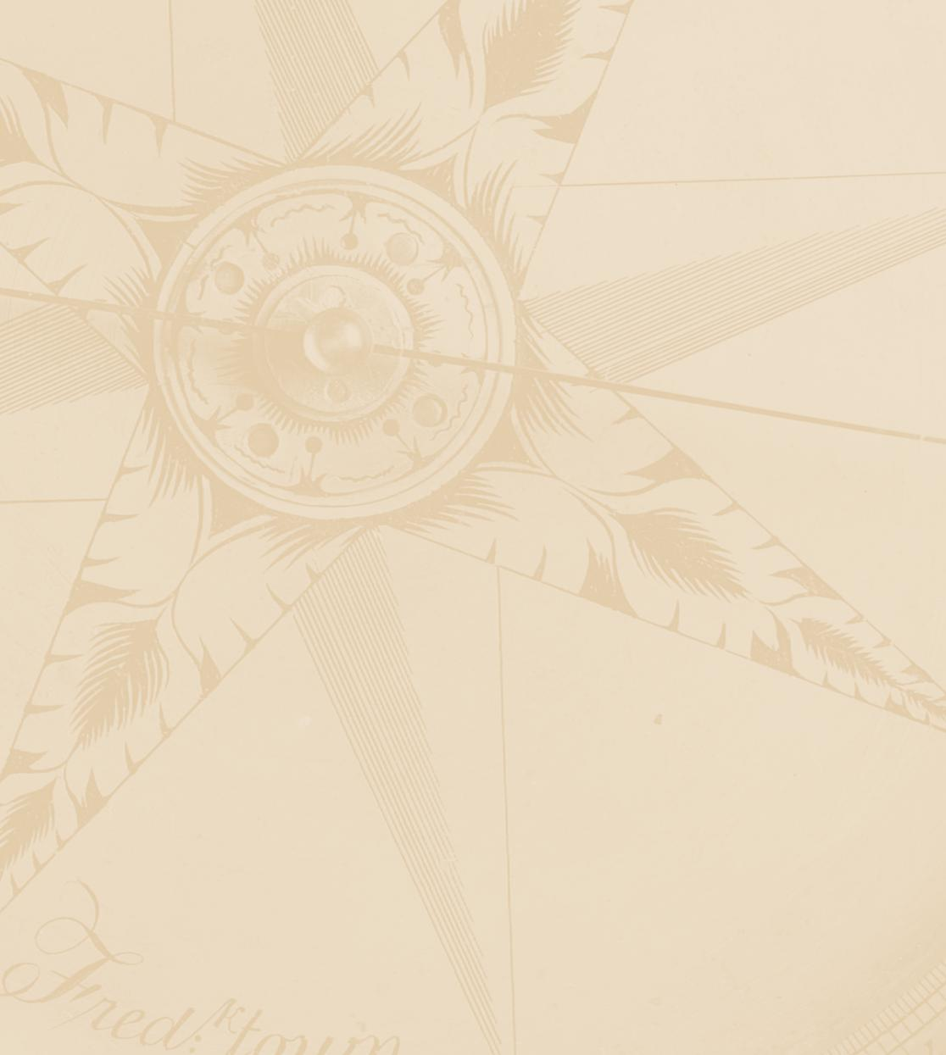

**United States Mint Research: 2013 New Product Concept Testing**

*Survey Questionnaire*

OMB Control #xxxx-xxxx-xxxx.

October 3, 2012

**Note to reader/Programmer:**

**Bold lines in between questions signify page/screen breaks.**

**All questions are asked of ALL unless otherwise specified.**

**Insertions will be in brackets.**

**Do not display section headers.**

**Programming instructions in this document will be displayed in boxes like this one.**

Welcome to the United States Mint’s survey.

This survey is designed to help the United States Mint understand how it can improve the products and services it provides. According to the Paperwork Reduction Act of 1995, no persons are required to respond to a collection of information unless it displays a valid OMB number. The valid OMB control number for this information collection is xxxx-xxxx-xxxx. ***Your participation in this survey is ENTIRELY VOLUNTARY and should require approximately 10 minutes of your time.***

**It is National Analysts’ policy to keep interviews anonymous and responses confidential.  Consistent with this policy, National Analysts will only entrust survey data with other entities when: 1) the participant gives explicit permission to release this data, or 2) the data is shared with an entity who agrees in writing that the data will be held strictly confidential and that the data will be used for research purposes only, or 3) the release of this data is required by law.**

**You will not be contacted for sales purposes as a result of participating in this survey.**

**For further information on National Analysts’ privacy policy, you can view our website at** [**www.nationalanalysts.com/privacy/domestic-global.asp**](http://www.nationalanalysts.com/privacy/domestic-global.asp)

If you have any questions or problems while completing the survey, please call XXXXXX weekdays from 9:00 AM to 5:00 PM EST at 1-800-342-9102 x (xxxx), or send an e-mail to [xxxxxx@nationalanalysts.com](mailto:xxxxxx@nationalanalysts.com)

Please click the Next button.

To begin, we will first take a few minutes to familiarize you with our survey.

The survey will NOT ALLOW YOU TO SKIP A QUESTION. If you do not know an exact answer, then please give your best estimate.

You may close the browser to pause the program to take a break. When you re-enter the survey, the survey will return to the screen where you closed the browser.

Please click the Next button to begin.

**Programming: Sampling Cells**

|  |  |
| --- | --- |
| 1 | Have purchased $1 Coin(s) or Medal(s) |
| 2 | Have **not** purchased $1Coins **or** Medals but **have** purchased Commemorative Coin(s) |
| 3 | Have **not** purchased $1Coins, Medals, **or** Commemorative Coins but **have** purchased any other coin / or set from the United States Mint |

|  |
| --- |
| SCREENING CRITERIA |

**Section S: Screening Criteria**

S1. Have you purchased any coins or other merchandise from the United States Mint during the past 2 years?

|  |  |
| --- | --- |
| Yes | ο |
| No | ο |

**Send to terminate screen if “No.”**

S2. What is your age in years?

|  |
| --- |
| **Age (in years)** |
| _______ |

**Send to terminate screen if under 18. Max. is 120**

S3. In total, about how much have you spent on purchases from the United States Mint in the past 2 years?

*Please answer in whole dollars.*

$_____________

**Range = 1-99,999**

S4 When was the very first time that you ever purchased coins or other merchandise directly from the United States Mint?

|  |  |
| --- | --- |
| **First time purchased coins directly from United States Mint** |  |
| Within the past 12 months | ο |
| 13 months to 23 months ago | ο |
| 2 to 5 years ago | ο |
| 6 to 10 years ago | ο |
| 11 to 20 years ago | ο |
| More than 20 years ago | ο |

**Termination Screen**

Based on what you know about the United States Mint, what are your impressions?

|  |
| --- |
| This is an open-end box to type in; do not force entry |

Thank you very much for taking the time to complete this survey.  Your feedback is very important to the United States Mint and greatly appreciated!

Q1. Which of the following items have you ***ever*** bought ***directly from the United States Mint***?

*Select all that apply.*

|  |  |
| --- | --- |
| **Product Types** | **Ever Purchased from the United States Mint** |
| **Annual Coin Sets** |  |
| Annual **Clad** Proof Sets (Full set, Quarters, Presidential $1 Coin) |  |
| - Full set | □ |
| - Quarters set | □ |
| - Presidential $1 Coin set | □ |
| Annual **Silver** Proof Sets (Full set, Quarters) |  |
| - Full set | □ |
| - Quarters set | □ |
| Uncirculated Sets | □ |
| **American Eagle Coins** |  |
| American Eagle **Silver** Coins | □ |
| American Eagle **Gold** Coins | □ |
| American Eagle **Platinum** Coins | □ |
| American Eagle **25th Anniversary** Special Set (sold in 2011 as a silver set) | □ |
| American Eagle **San Francisco** Two-Coin Silver Proof Set (sold in 2012) | □ |
| **Gold Coins (Not American Eagle)** | |
| Gold Coins (e.g., American Buffalo and First Spouse) | □ |
| **Commemorative Coins** |  |
| **Gold** Commemorative Coins or Commemorative Coin Sets | □ |
| **Silver** Commemorative Coins or Commemorative Coin Sets | □ |
| **Clad** Commemorative Coins or Commemorative Coin Sets | □ |
| **Medals** |  |
| Medals (e.g., First Spouse, Sept. 11th 2011, Historical, Humanitarian/Cultural, Military, etc.) | □ |
| **$1 Coins** | |
| 2012 Presidential $1 Four-Coin Set (Philadelphia or Denver Mint Mark) | □ |
| 2012 Presidential $1 Coin Uncirculated Set | □ |
| 2011 Presidential $1 Coin and First Spouse Medal Set | □ |
| 2012 Annual Uncirculated Dollar Coin Set (4 Presidential and 1 Native American) | □ |
| **America the Beautiful Coins** | |
| 5 oz. Silver Coins | □ |

Q2a. Which of the following items have you bought ***directly from the United States Mint*** in the past***2 years***?

*Select all that apply.*

|  |  |
| --- | --- |
| **Product Types** | **Purchased from the United States Mint in the Past Two Years** |
| **Annual Coin Sets** |  |
| Annual **Clad** Proof Sets (Full set, Quarters, Presidential $1 Coin) |  |
| - Full set | □ |
| - Quarters set | □ |
| - Presidential $1 Coin set | □ |
| Annual **Silver** Proof Sets (Full set, Quarters) |  |
| - Full set | □ |
| - Quarters set | □ |
| Uncirculated Sets | □ |
| **American Eagle Coins** |  |
| American Eagle **Silver** Coins | □ |
| American Eagle **Gold** Coins | □ |
| American Eagle **Platinum** Coins | □ |
| American Eagle **25th Anniversary** Special Set (sold in 2011 as a silver set) | □ |
| American Eagle **San Francisco** Two-Coin Silver Proof Set (sold in 2012) | □ |
| **Gold Coins (Not American Eagle)** | |
| Gold Coins (e.g., American Buffalo and First Spouse) | □ |
| **Commemorative Coins** |  |
| **Gold** Commemorative Coins or Commemorative Coin Sets | □ |
| **Silver** Commemorative Coins or Commemorative Coin Sets | □ |
| **Clad** Commemorative Coins or Commemorative Coin Sets | □ |
| **Medals** |  |
| Medals (e.g., First Spouse, Sept. 11th 2011, Historical, Humanitarian/Cultural, Military, etc.) | □ |
| **$1 Coins** | |
| 2012 Presidential $1 Four-Coin Set (Philadelphia or Denver Mint Mark) | □ |
| 2012 Presidential $1 Coin Uncirculated Set | □ |
| 2011 Presidential $1 Coin and First Spouse Medal Set | □ |
| 2012 Annual Uncirculated Dollar Coin Set (4 Presidential and 1 Native American) | □ |
| **America the Beautiful Coins** | |
| 5 oz. Silver Coins | □ |

**Only show items checked in Q1.**

**If only 1 item would be shown in Q2a/b then skip.**

Q2b. Which of the following items have you bought ***directly from the United States Mint***in the past ***year***?

|  |  |
| --- | --- |
| **Product Types** | **Purchased from the United States Mint in the Past Year** |
| **Annual Coin Sets** |  |
| Annual **Clad** Proof Sets (Full set, Quarters, Presidential $1 Coin) |  |
| - Full set | □ |
| - Quarters set | □ |
| - Presidential $1 Coin set | □ |
| Annual **Silver** Proof Sets (Full set, Quarters) |  |
| - Full set | □ |
| - Quarters set | □ |
| Uncirculated Sets | □ |
| **American Eagle Coins** |  |
| American Eagle **Silver** Coins | □ |
| American Eagle **Gold** Coins | □ |
| American Eagle **Platinum** Coins | □ |
| American Eagle **25th Anniversary** Special Set (sold in 2011 as a silver set) | □ |
| American Eagle **San Francisco** Two-Coin Silver Proof Set (sold in 2012) | □ |
| **Gold Coins (Not American Eagle)** | |
| Gold Coins (e.g., American Buffalo and First Spouse) | □ |
| **Commemorative Coins** |  |
| **Gold** Commemorative Coins or Commemorative Coin Sets | □ |
| **Silver** Commemorative Coins or Commemorative Coin Sets | □ |
| **Clad** Commemorative Coins or Commemorative Coin Sets | □ |
| **Medals** |  |
| Medals (e.g., First Spouse, Sept. 11th 2011, Historical, Humanitarian/Cultural, Military, etc.) | □ |
| **$1 Coins** | |
| 2012 Presidential $1 Four-Coin Set (Philadelphia or Denver Mint Mark) | □ |
| 2012 Presidential $1 Coin Uncirculated Set | □ |
| 2011 Presidential $1 Coin and First Spouse Medal Set | □ |
| 2012 Annual Uncirculated Dollar Coin Set (4 Presidential and 1 Native American) | □ |
| **America the Beautiful Coins** | |
| 5 oz. Silver Coins | □ |

**Only show items checked in Q2a.**

Q3. Have you ***ever*** purchased any of the following ***from a source other than the United States Mint?***

|  |  |  |
| --- | --- | --- |
| **Coin Type from Any Source** | **Yes** | **No** |
| American Buffalo 24K Gold Coin | ο | ο |
| American Eagle Gold Coin | ο | ο |
| First Spouse 24K Gold Coin | ο | ο |
| American Eagle 25th Anniversary Special Set (sold in 2011 as silver set) | ο | ο |
| American Eagle San Francisco Two-Coin Silver Proof Set (sold in 2012) | ο | ο |

|  |
| --- |
| Benchmark future purchase intent |

Q4a. How likely are you to purchase each of the following types of coins from the U.S. Mint in the next 12 months?

|  |  |
| --- | --- |
| **Product type** | **Not at All Extremely**  **Likely Likely** |
| **1 2 3 4 5 6** |
| **Annual Coin Sets** |  |
| Annual **Clad** Proof Sets |  |
| - Full set | ο ο ο ο ο ο |
| - Quarters set | ο ο ο ο ο ο |
| - Presidential $1 Coin set | ο ο ο ο ο ο |
| Annual **Silver** Proof Sets |  |
| - Full set | ο ο ο ο ο ο |
| - Quarters set | ο ο ο ο ο ο |
| Uncirculated Sets | ο ο ο ο ο ο |
| **American Eagle Coins** |  |
| American Eagle **Silver** Coins | ο ο ο ο ο ο |
| American Eagle **Gold** Coins | ο ο ο ο ο ο |
| **Gold Coins (Not American Eagle)** |  |
| Gold Coins (e.g., American Buffalo and First Spouse) | ο ο ο ο ο ο |
| **Commemorative Coins** |  |
| **Gold** Commemorative Coins or Commemorative Coin Sets | ο ο ο ο ο ο |
| **Silver** Commemorative Coins or Commemorative Coin Sets | ο ο ο ο ο ο |
| **Clad** Commemorative Coins or Commemorative Coin Sets | ο ο ο ο ο ο |
| **Medals** | |
| Medals (e.g., First Spouse, Sept. 11th 2011, Historical, Humanitarian/Cultural, Military, etc.) | ο ο ο ο ο ο |
| **$1 Coins** | |
| 2012 Presidential $1 Four-Coin Set (Philadelphia or Denver Mint Mark) | ο ο ο ο ο ο |
| 2012 Presidential $1 Coin Uncirculated Set | ο ο ο ο ο ο |
| 2011 Presidential $1 Coin and First Spouse Medal Set | ο ο ο ο ο ο |
| 2012 Annual Uncirculated Dollar Coin Set (4 Presidential and 1 Native American) | ο ο ο ο ο ο |
| **America the Beautiful Coins** |  |
| 5 oz. Silver Coins | ο ο ο ο ο ο |

Q4b. How many of each of the following products are you likely to purchase from the U.S. Mint in next 12 months?

|  |  |
| --- | --- |
| **Product types** | **Number you Expect to Purchase from the United States Mint  (Next 12 Months)** |
| **Annual Coin Sets** |  |
| Annual **Clad** Proof Sets |  |
| - Full set |  |
| - Quarters set |  |
| - Presidential $1 Coin set |  |
| Annual **Silver** Proof Sets |  |
| - Full set |  |
| - Quarters set |  |
| Uncirculated Sets |  |
| **American Eagle Coins** |  |
| American Eagle **Silver** Coins |  |
| American Eagle **Gold** Coins |  |
| **Gold Coins (Not American Eagle)** |  |
| Gold Coins (e.g., American Buffalo and First Spouse) |  |
| **Commemorative Coins** |  |
| **Gold** Commemorative Coins or Commemorative Coin Sets |  |
| **Silver** Commemorative Coins or Commemorative Coin Sets |  |
| **Clad** Commemorative Coins or Commemorative Coin Sets |  |
| **Medals** | |
| Medals (e.g., First Spouse, Sept. 11th 2011, Historical, Humanitarian/Cultural, Military, etc.) |  |
| **$1 Coins** | |
| 2012 Presidential $1 Four-Coin Set (Philadelphia or Denver Mint Mark) |  |
| 2012 Presidential $1 Coin Uncirculated Set |  |
| 2011 Presidential $1 Coin and First Spouse Medal Set |  |
| 2012 Annual Uncirculated Dollar Coin Set (4 Presidential and 1 Native American) |  |
| **America the Beautiful Coins** |  |
| 5 oz. Silver Coins |  |

**Only ask rows >1 in Q4a**

**Range = 0 to 9999**

|  |
| --- |
| MONADIC CELLS |

**Programming: Please create 8 monadic cells as defined below. Respondents in the 8 monadic cells should be divided evenly among the 3 sampling cells using a sequential assignment within each cell. Please include a code in the database for the cell.**

|  |
| --- |
| Product features shown depending on cell assignment below |



***\*MONADIC CELL VARIATIONS A–H APPLY TO Q5a–Q7c***

|  |
| --- |
| $1 Coin & Currency Set Interest |

**The United States Mint is considering offering a new set containing [$1 Coin &Currency Set Item/Alternative [A-H]] and a $1 bill from the Bureau of Engraving and Printing in 2013. The cost will be [insert estimated cost].** *\*\*[Reviewer’s Note: Prices are provided only so that respondents can properly assess their interest in each option. We are not attempting to assess sensitivity to differences in or changes to price.]*

Q5a. How appealing is the $1 Coin &Currency Set described above, either for yourself or as a gift?

|  |  |
| --- | --- |
|  | **Not at All                                          Extremely**  **Appealing                                        Appealing** |
| **1           2           3           4             5           6** |
| **As a gift** | □            □            □            □             □           □ |
| **For your own collection** | □            □            □            □            □            □ |
|  |  |

Q5b. How likely will you be to purchase the $1 Coin &Currency Set, either for yourself or as a gift?

|  |  |
| --- | --- |
| **Product Type** | **Not at All Extremely**  **Likely Likely** |
| **1 2 3 4 5 6** |
| **Coin &Currency Set** | ο ο ο ο ο ο |

Q5c. How many $1 Coin &Currency Sets would you be likely to purchase if it is offered in 2013?

____________________

**Only ask if >1 in Q5a**

**Range is 0 to 9999**

|  |
| --- |
| Teddy Roosevelt Coin & Medal Set Interest |

**The Teddy Roosevelt Presidential Dollar coin will be available in 2013 as part of the Presidential Dollar coin series. In honor of his historic presidency, the United States Mint is considering offering a [Teddy Roosevelt Coin &Medal Set Item/Alternative [A-H]. It will cost [insert estimated cost.]** *\*\*[Reviewer’s Note: Prices are provided only so that respondents can properly assess their interest in each option. We are not attempting to assess sensitivity to differences in or changes to price.]*

Q6a. How appealing is the Teddy Roosevelt Coin& Medal Set described above, either for yourself or as a gift?

|  |  |
| --- | --- |
|  | **Not at All                                          Extremely**  **Appealing                                        Appealing** |
| **1           2           3           4             5           6** |
| **As a gift** | □            □            □            □             □           □ |
| **For your own collection** | □            □            □            □            □            □ |
|  |  |

Q6b. How likely will you be to purchase the Teddy Roosevelt Coin& Medal Set, either for yourself or as a gift?

|  |  |
| --- | --- |
| **Product Type** | **Not at All Extremely**  **Likely Likely** |
| **1 2 3 4 5 6** |
| **Teddy Roosevelt Coin & Medal Set** | ο ο ο ο ο ο |

Q6c. How many Teddy Roosevelt Coin & Medal Sets would you be likely to purchase if it is offered in 2013?

____________________

**Only ask if >1 in Q6a**

**Range is 0 to 9999**

Q6d. Regardless of your preferences above, do you think this type of set should be created only for well-known presidents (i.e., Teddy Roosevelt), or do you think it should be a new series available for all presidents going forward?

|  |  |
| --- | --- |
| **Presidential Coin & Medal Set Options** |  |
| Should be created only for well-known presidents | ο |
| Should be created for all presidents | ο |
| Other______________ | ο |
| I have no opinion | ο |

|  |
| --- |
| 5-Star General Set Interest |

**The 5-Star Generals Commemorative Coin Act (Public Law 111-262) authorizes the Secretary of the Treasury to mint clad, silver and gold coins in 2013 in recognition of 5 United States Army 5-Star Generals: George Marshall, Douglas MacArthur, Dwight Eisenhower, Henry “Hap” Arnold, and Omar Bradley. All are alumni of the United States Army Command and General Staff College (CGSC), Fort Leavenworth, Kansas. The coins will celebrate the 132nd Anniversary of the founding of the CGSC.**

**This commemoratives program will include a $5 ¼ oz. gold coin featuring an image of General MacArthur, a $1 silver coin featuring the images of Generals Marshall and Eisenhower, and a $0.50 clad coin featuring the images of Generals Arnold and Bradley. The coins will be sold individually and together as a set of three coins, all in traditional commemorative boxes [insert prices].** *\*\*[Reviewer’s Note: Prices are provided only so that respondents can properly assess their interest in each option. We are not attempting to assess sensitivity to differences in or changes to price.]*

**In addition to these products, the United States Mint is also considering a special set containing [Insert Description and Estimated Price of 5-Star General Set Item/Alternative [A-H] ].** *\*\*[Reviewer’s Note: Prices are provided only so that respondents can properly assess their interest in each option. We are not attempting to assess sensitivity to differences in or changes to price.]*

**The special set would include additional information about the General(s) included in a less formal package than the traditional boxes.**

Q7a. How appealing is the 5-Star General Set described above, as the product offering for a special set for this program?

|  |  |
| --- | --- |
|  | **Not at All                                          Extremely**  **Appealing                                        Appealing** |
| **1           2           3           4             5           6** |
| **As a gift** | □            □            □            □             □           □ |
| **For your own collection** | □            □            □            □            □            □ |
|  |  |

Q7b. How likely will you be to purchase the 5-Star General Set, either for yourself or as a gift?

|  |  |
| --- | --- |
| **Product Type** | **Not at All Extremely**  **Likely Likely** |
| **1 2 3 4 5 6** |
| **5-Star General Set** | ο ο ο ο ο ο |

Q7c. How many 5-Star General Sets would you be likely to purchase if it is offered in 2013?

____________________

**Only ask if >1 in Q7a**

**Range is 0 to 9999**

**Demographic Information**

QD1. What is the highest level of education you have attained?

|  |  |
| --- | --- |
| Grade school (8th grade or less) | ο |
| Some high school | ο |
| High school graduate | ο |
| Some college, no degree | ο |
| Vocational training/2 –year college | ο |
| 4-year college/bachelor’s degree | ο |
| Post-graduate training/degree | ο |

QD2. Which of the following best describes your current employment status?

|  |  |
| --- | --- |
| Full-time | ο |
| Part-time | ο |
| Retired | ο |
| Not employed or student | ο |

QD3. Are you Hispanic or Latino?

|  |  |
| --- | --- |
| Yes | ο |
| No | ο |

QD4. What is your race? Please select one or more.

|  |  |
| --- | --- |
| American Indian or Alaska Native? | □ |
| Asian? | □ |
| Black or African American? | □ |
| Native Hawaiian or other Pacific Islander? | □ |
| White? | □ |

QD5. What is your gender?

|  |  |
| --- | --- |
| Male | ο |
| Female | ο |

QD6. Which of the following best describes your occupation?

|  |  |
| --- | --- |
| Managerial or professional | ο |
| Technical, sales, or administrative | ο |
| Service occupations | ο |
| Precision products, crafts or repairs | ο |
| Operators, fabricators, or laborers | ο |
| Farming, forestry, or fishing | ο |
| Other (Specify) _____________________________ | ο |

**Skip QD6 if QD2 is Row 3 or 4**

QD7. Which of the following categories best describes your total household income before taxes in 2011? Your best estimate is fine.

|  |  |
| --- | --- |
| Less than $10,000 | ο |
| Between $10,000 to $19,999 | ο |
| $20,000 to $29,999 | ο |
| $30,000 to $39,999 | ο |
| $40,000 to $49,999 | ο |
| $50,000 to $74,999 | ο |
| $75,000 to $99,999 | ο |
| $100,000 or more | ο |

QD8. In the past year, have you sold any U.S. coins for income purposes other than to round out a personal collection?

|  |  |
| --- | --- |
| Yes | ο |
| No | ο |

QD9. To confirm, are you a coin dealer?

|  |  |
| --- | --- |
| Yes | ο |
| No | ο |

**Only ask QD9 if answered “Yes” in QD8.**

**If answered “No” in QD8 send them to survey exit screen.**

______________________________________________________________________

Thank you for participating in this survey.

**Programmer: Add any necessary language for exiting the survey.**