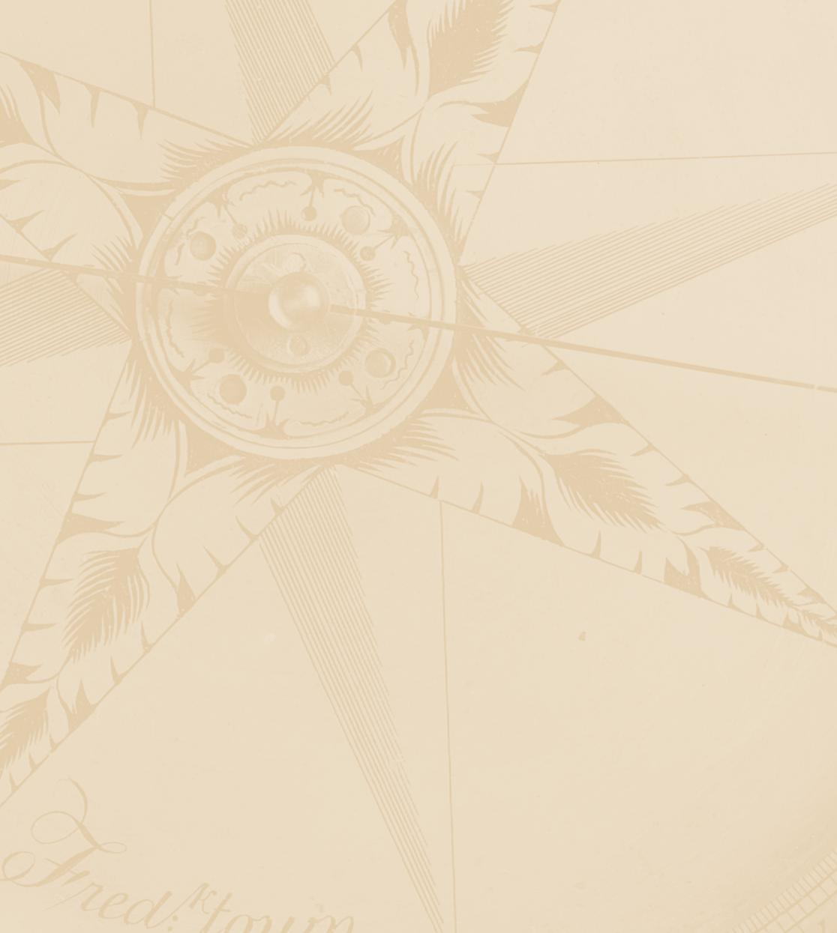
United States Mint Pre-Wave
Advertising Tracking Research
July 16, 2014


Note to Reader/Programmer:
Bold lines in between questions signify page/screen breaks.
Insertions will be in brackets.
Do not display section headers.
Please add a warning when exiting the survey, “Are you sure you want to exit the survey now?”
For Open End responses, please give warning the first two times a respondent tries to proceed without entering a response (soft force), then stop showing warning.

INTRODUCTION

[INTRODUCTION FOR CUSTOMERS:
Welcome to the United States Mint’s survey.

This survey is designed to help the United States Mint understand how it can improve the products and services it provides. According to the Paperwork Reduction Act of 1995, no persons are required to respond to a collection of information unless it displays a valid OMB number. The valid OMB control number for this information collection is 1525-0012-0193.

Your participation in this survey is ENTIRELY VOLUNTARY and should require approximately 15 minutes of your time.]

[INTRODUCTION FOR NON-CUSTOMERS:
National Analysts Worldwide, a research and consulting firm, is conducting a research study on consumer products.

Your participation in this survey is ENTIRELY VOLUNTARY and should require approximately 15 minutes of your time.]

INTRODUCTION FOR ALL:
It is National Analysts Worldwide’s policy to keep interviews anonymous. Consistent with this policy, National Analysts Worldwide will only entrust survey data with other entities when: 1) the participant gives explicit permission to release this data, or 2) the data is shared with an entity who agrees in writing that the data will be held strictly adequately protected and that the data will be used for research purposes only, or 3) the release of this data is required by law.

You will not be contacted for sales purposes as a result of participating in this survey.

For further information on National Analysts’ privacy policy, you can view our website at:
www.nationalanalysts.com/privacy/domestic-global.asp

If you have any questions or problems while completing the survey, please send an email to Brent Whitesell at questions862@nationalanalysts.com, or call weekdays from 9:00 AM to 5:00 PM Eastern at (215) 496-6963.

Please click the Forward button to continue.
_________________________
PROGRAMMING:
- Second digit of US Mint sample indicates spending.

Survey navigation tips:

· If you don’t know the exact number to a numerical question, please just give your best estimate.

· Always click on [INSERT THE IMAGE OF THE WORD NEXT AND THE NEXT BUTTON PICTURE] at the bottom of the page to move forward. You may need to scroll down to see the button.

· Please don’t use the forward and back buttons on your browser's navigation bar while you are in the survey.

Section A: Screener – do not display this line

S-1. First we need to ask a few introductory questions for classification purposes. Do you or does someone in your household or immediate family work…

Please select one answer for each row.

 |  | Yes | No
1 | For an organization that produces, distributes, or sells collectible coins? (e.g., coin dealer) | ο | ο
2 | As a journalist/freelance writer? | ο | ο
_________________________
PROGRAMMING:
- ASK ALL
- TERMINATE HERE IF “YES” TO ANY ROW

S-2. What is your age in years?

Please type your age.
Age (in years)
___
_________________________
PROGRAMMING:
- ASK ALL
- IF UNDER 18, TERMINATE HERE
- IF PANEL, TERMINATE IF OVER 70
- IF CUSTOMER, ONLY TERMINATE IF UNDER 18

S-3. Are you…?

1 | Male | ο
2 | Female | ο
_________________________
PROGRAMMING:
- ASK PANEL

S-4. In 2013, what was your total annual household income before taxes?

Total Household Income
1 | Less than $10,000 | ο
2 | $10,000 to $19,999 | ο
3 | $20,000 to $29,999 | ο
4 | $30,000 to $39,999 | ο
5 | $40,000 to $49,999 | ο
6 | $50,000 to $74,999 | ο
7 | $75,000 to $99,999 | ο
8 | $100,000 or more | ο
_________________________
PROGRAMMING:
- ASK PANEL

Throughout this survey, we will be using the term collectible U.S. coins.
By collectible U.S. coin, we mean a specially minted high-quality U.S. coin which is never placed in circulation (such as proof or uncirculated coins). They can be an individual coin or part of a set.

S-5. Have you collected, occasionally saved, or sometimes put aside any type of U.S. coins (such as America the Beautiful Quarters, 50 State Quarters, Presidential $1 Coins, etc.), either for yourself or for others, in the last 2 years?

Select one.
1 | Yes | ο
2 | No | ο
3 | Not sure | ο
_________________________
PROGRAMMING:
- ASK ALL
- TERMINATE AT END OF SCREENER IF “NO”

S-6. In which state is your primary residence?

State
[INSERT DROP DOWN MENU]
_____________________
Programming:
- Ask All
- DROP DOWN MENU with 53 levels – each of the 50 u.s. states, district of columbia, other u.s. territory, and outside u.s.
- terminate at end of screener if “outside u.s.” or “Other U.S. Territory”

S-7. Which of the following websites have you visited in the past three months?

(Select all that apply.)

 | Website
1 | Facebook
2 | Pinterest
3 | Twitter
4 | Google
5 | Yahoo
6 | Bing
_____________________
Programming:
- Ask All

S-8. What companies or sources, if any, are you aware of that offer collectible U.S. coins for sale?

Please list any companies or sources in the spaces below. If you are not aware of any please indicate in the check-box below.

____________________________________
____________________________________
____________________________________
____________________________________

[PROGRAMMING: Allow 12 lines to type on]

I am not aware of any companies or sources that offer collectible U.S. coins for sale | ο
_____________________
Programming:
- Ask All

S-9a. From what companies or sources, if any, do you recall having seen any advertisements about collectible U.S. coins during the past six months?

Please list any companies or sources in the sections below. If you have seen advertisements in both categories, please list them in both sections. If you are not aware of any please indicate in the check-boxes below.

In Print or on the Internet?

____________________________________
____________________________________
____________________________________
____________________________________

[PROGRAMMING: Allow 6 lines to type on]

I do not recall having heard or seen any advertisements in Print or on the Internet | ο

S-9b.
On TV or on the Radio?

____________________________________
____________________________________
____________________________________

[PROGRAMMING: Allow 12 lines to type on]

I do not recall having heard or seen any advertisements on TV or Radio | ο
_____________________
Programming:
- Ask all
- Ask S-9a and S-9b on same screen

S-10. To the best of your knowledge, which of the companies listed below, if any, offer collectible U.S. coins for sale?

 |  | Offer Collectible U.S. Coins for Sale
1 | United States Mint
2 | The Morgan Mint
3 | Washington Mint
4 | The Franklin Mint
5 | National Collectors Mint
6 | New York Mint
7 | None of the above | ο
_____________________
Programming:
- Ask all
- do not allow “None of the above” to be selected with any other row
- randomize rows Except “None of the above” is always last

S-11a. From which of the companies listed below, if any, do you recall having heard or seen any advertisements about collectible U.S. coins during the past six months?

On TV or on the Radio?

 |  | Yes, I saw/heard TV or Radio Ads in Past 6 Months
1 | United States Mint
2 | The Morgan Mint
3 | Washington Mint
4 | The Franklin Mint
5 | National Collectors Mint
6 | New York Mint
7 | None of the above | ο

S-11b.
In Print or on the Internet?

 |  | Yes, I saw Print or Internet Ads in Past 6 Months
1 | United States Mint
2 | The Morgan Mint
3 | Washington Mint
4 | The Franklin Mint
5 | National Collectors Mint
6 | New York Mint
7 | None of the above | ο
_____________________
Programming:
- Ask All
- show s-11a and s-11b on same screen
- do not allow “None of the above” to be selected with any other row
- keep same order as s-10

TERMINATION SCREEN FOR CUSTOMERS:

Thank you very much for taking the time to complete this survey. Your feedback is very important to the United States Mint and greatly appreciated!
_____________________
Programming:
- Show for customer termination only

TERMINATION SCREEN FOR NON-CUSTOMERS:

Thank you very much for taking the time to complete this survey, which was designed to help the United States Mint understand how it can improve the products and services it provides. According to the Paperwork Reduction Act of 1995, no persons are required to respond to a collection of information unless it displays a valid OMB number. The valid OMB control number for this information collection is 1525-0012-XXXX.

Your feedback is very important to us and greatly appreciated!
_____________________
Programming:
- Show for Panel termination only
- end here if ineligible. eligible respondents should proced to q1

Section B: Recall and Awareness – do not display this line

Q1. Please indicate how familiar you are with each of the companies listed below.

 |  | Never heard of this company | Only know the name of the company | Know something about the company but have never purchased collectible U.S. coins from them | Purchased collectible U.S. coins from them in the past, but have not bought from them in the past 12 months | Purchased collectible U.S. coins from them in the past 12 months
1 | United States Mint | ο | ο | ο | ο | ο
2 | The Morgan Mint | ο | ο | ο | ο | ο
3 | Washington Mint | ο | ο | ο | ο | ο
4 | The Franklin Mint | ο | ο | ο | ο | ο
5 | National Collectors Mint | ο | ο | ο | ο | ο
6 | New York Mint | ο | ο | ο | ο | ο
_________________________
PROGRAMMING:
- KEEP SAME ORDER AS S-10
- IF COLUMN 5 (PURCHASED COLLECTIBLE U.S. COINS FROM THEM IN THE PAST 12 MONTHS) IS SELECTED FOR UNITED STATES MINT, ASK Q12

Q2. To the best of your recollection, how would you describe the major theme(s) or message(s) of the United States Mint advertisements about collectible U.S. coins you heard or saw in the past six months?

_________________________
PROGRAMMING:
- ASK IF S-11A OR S-11B “UNITED STATES MINT” IS CHECKED
- OPEN ENDED TEXT BOX
- DO NOT FORCE RESPONSE

Q3. To the best of your recollection which of the following statements, if any, describes the major theme(s) or message(s) of the United States Mint advertisements about collectible U.S. coins you heard or saw in the past six months?
 |  | Heard or Saw Ads About
1 | Collectible U.S. coins make a great gift to commemorate that special event – especially for kids and newborns
2 | Collectible U.S. coins make a unique, personal gift which will be cherished in the future
3 | Share the passion of coin collecting with others
4 | United States Mint is the only source for genuine U.S. collectible coins
5 | Buy directly from the United States Mint
6 | Try the new United States Mint website
7 | None of the above | ο

_________________________
PROGRAMMING:
- ASK IF S-11A OR S-11B “UNITED STATES MINT” IS CHECKED
- RANDOMIZE ROWS 1-6
- DO NOT ALLOW “NONE OF THE ABOVE” TO BE SELECTED WITH ANY OTHER ROW

Q4. Now we would like to show you some advertisements. Please think about all of the advertising you see on TV, on the Radio, on the Internet, and in Print (e.g., newspapers, magazines).

Q4a.
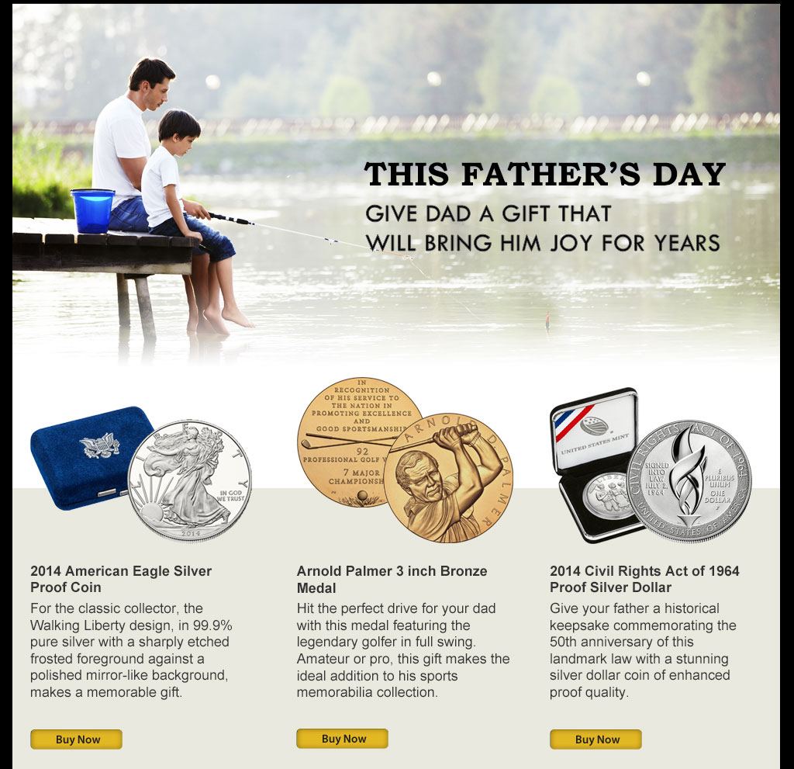

Have you seen this ad before?

1 | Yes | ο
2 | No | ο
3 | Not sure | ο

Q4b.
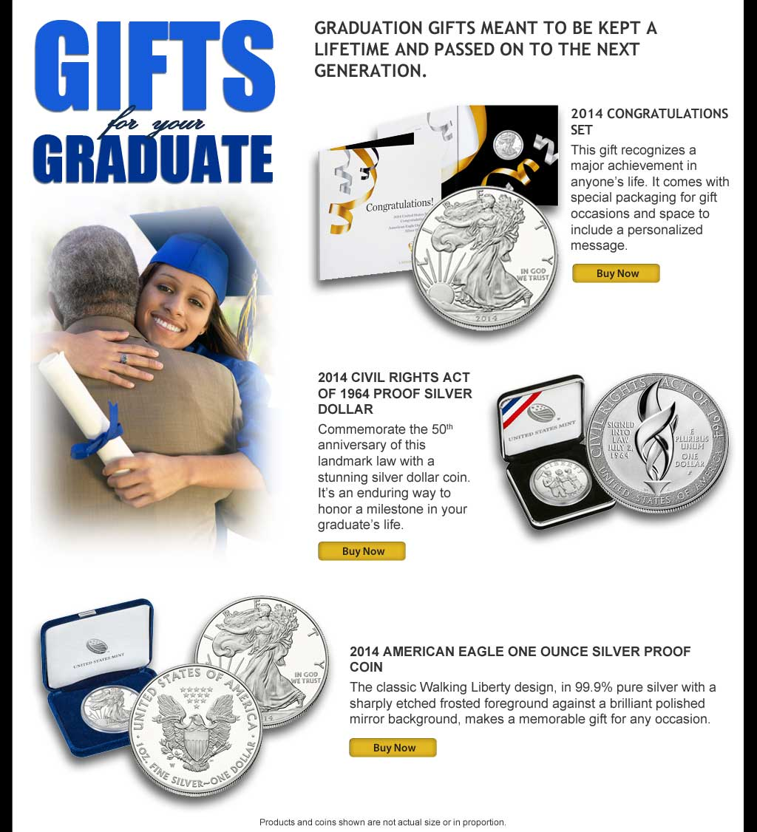

Have you seen this ad before?

1 | Yes | ο
2 | No | ο
3 | Not sure | ο

Q4c.
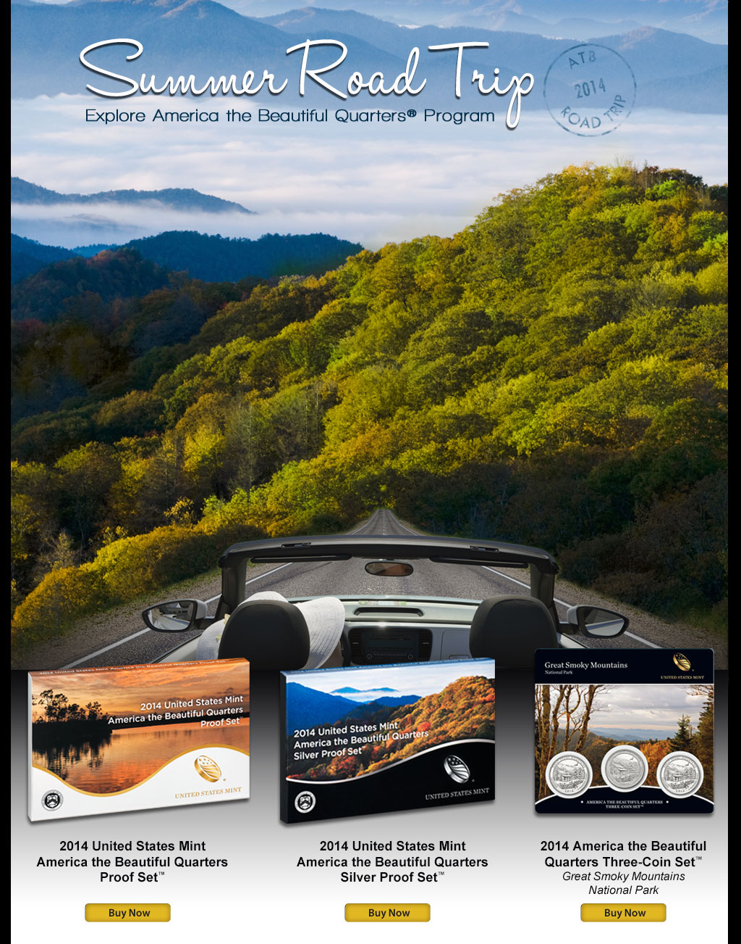

Have you seen this ad before?

1 | Yes | ο
2 | No | ο
3 | Not sure | ο

_________________________
PROGRAMMING:
- ASK ALL
- SHOW EACH OF Q4A THROUGH Q4C ON DIFFERENT SCREEN
- RANDOMIZE ORDER OF Q4A THROUGH Q4C

Q5. In the past 3 months, have you visited the United States Mint website?

1 | Yes | ο
2 | No | ο
________________________
PROGRAMMING:
- ASK ALL
- IF NO, SKIP TO Q8.

Q6. During your visit to the United States Mint website, did you purchase a product?

1 | Yes | ο
2 | No | ο
_________________________
PROGRAMMING:
- ASK IF Q5 IS “YES”

Q7. When you visited the United States Mint website, did you…

(Select all that apply.)
 |  | Yes
1 | Find information / news about the United States Mint
2 | Find United States Mint tour information
3 | Find activities, games, and lessons for kids / students
4 | Research / browse coins or medals
5 | Check out a specific product
6 | Look up order history
7 | Track an order
8 | Find shipping / return policies
9 | Other? Please specify:
________________________
PROGRAMMING:
- ASK IF Q5 IS “YES”
- ALLOW TEXT ENTRY FOR “OTHER? PLEASE SPECIFY:”

Q8. Do you recall the URL/address for the United States Mint website?

1 | Yes | ο
2 | No | ο
_________________________
PROGRAMMING:
- ASK ALL
- DISPLAY Q8 “Do you recall the URL/address for the United States Mint” FIRST. IF AND ONLY IF “YES” (ROW 1) IS SELECTED, DISPLAY Q9 “Please write it in below:” ON SAME PAGE

Q9. Please write it in below:

www.____________________________________
_________________________
PROGRAMMING:
- ASK IF Q8 IS “YES” (ROW 1)

Q10. In the next 12 months, how likely or unlikely would you be to consider purchasing collectible U.S. coins from the United States Mint – either for yourself or as a gift?

Use a scale from “1” to “6” where “1” means “Extremely unlikely to consider purchasing collectible U.S. coins from the United States Mint” and “6” means “Extremely likely to consider purchasing collectible U.S. coins from the United States Mint.”

 | Extremely  Unlikely |  |  |  |  |  |  |  |  | Extremely  Likely
 | 1 | 2 | 3 |  |  | 4 |  |  | 5 |  | 6
Likelihood of considering purchasing collectible U.S. coins from the United States Mint | ο | ο | ο |  |  | ο |  |  | ο |  | ο
_________________________
PROGRAMMING:
- ASK ALL
- SKIP TO Q12 IF “1”OR “2”

Q11. Would you be likely to consider collectible U.S. coins from the United States Mint…

 |  | Yes
1 | For yourself? | ο
2 | As a gift for another person? | ο
3 | Both for yourself and as a gift? | ο
_________________________
PROGRAMMING:
- ASK IF Q10 IS “3-6”

Q12. In the past 12 months, did you purchase collectible coins from the United States Mint…

 |  | Yes
1 | For yourself? | ο
2 | As a gift for another person? | ο
3 | Both for yourself and as a gift? | ο
_________________________
PROGRAMMING:
- ASK IF COLUMN 5 IS SELECTED FOR UNITED STATES MINT IN Q1

Q13. [INSERT WHEN COLUMN 5 IS SELECTED FOR ANY COMPANY IN Q1: Earlier you indicated having purchased from: [INSERT NAMES OF COMPANIES IN Q1 IN WHICH COLUMN 5 IS SELECTED].]

In the past 12 months, did you [INSERT WHEN COLUMN 5 IS SELECTED FOR ANY COMPANY IN Q1: also] purchase any collectible U.S. coins from…

 |  | Yes | No
1 | Coin dealers? | ο | ο
2 | eBay or other internet auction site? | ο | ο
3 | QVC or other shopping channel? | ο | ο
4 | Other source? Please specify: ________________ | ο | ο
_________________________
PROGRAMMING:
- ASK ALL
- INSERT NAMES OF COMPANIES IN Q1 IN WHICH COLUMN 5 IS SELECTED: IF ONE IS SELECTED, INSERT NAME FOLLOWED BY A PERIOD; IF TWO OR MORE ARE SELECTED, INSERT EACH AS A BULLET POINT UNDERNEATH THE PARAGRAPH
- REQUIRE TEXT ENTRY FOR “OTHER SOURCE? PLEASE SPECIFY:”

Q14. Please indicate how much you agree or disagree with the following statements.

Use a scale of “1” to “6” where “1” means “strongly disagree” and “6” means "strongly agree.”

 |  | Strongly  Disagree |  |  |  |  |  |  |  |  | Strongly  Agree
 |  | 1 | 2 | 3 |  |  | 4 |  |  | 5 |  | 6
1 | Collectible (e.g., proof) coins are more valuable in the long run than coins in circulation | ο | ο | ο |  |  | ο |  |  | ο |  | ο
2 | The United States Mint is the only genuine source for U.S. currency | ο | ο | ο |  |  | ο |  |  | ο |  | ο
3 | Collectible (e.g., proof) coins make great gifts for holidays or other special occasions (births, birthdays, graduations, etc.) | ο | ο | ο |  |  | ο |  |  | ο |  | ο
4 | The best way to appreciate the craftsmanship and beauty of the coin is with a collectible (e.g., proof) coin | ο | ο | ο |  |  | ο |  |  | ο |  | ο

________________________
PROGRAMMING:
- ASK ALL
- RANDOMIZE ROWS

Q15. Please indicate whether or not, to the best of your knowledge, each of the following coin or coin-related products is offered for sale by the United States Mint.

 |  | Currently Offered by the United States Mint?
 |  | Yes | No | Unsure
1 | America the Beautiful Quarters | ο | ο | ο
2 | Presidential $1 Coins | ο | ο | ο
3 | Special commemorative coins | ο | ο | ο
4 | Antique U.S. coins | ο | ο | ο
5 | Painted, gold-plated, or colorized U.S. coins such as colorized 50 State Quarters | ο | ο | ο
6 | Collectible Presidential bronze medals | ο | ο | ο
7 | Other collectible bronze medals (e.g., Nelson Mandela, Cherokee Nation Code Talkers) | ο | ο | ο
8 | Coin jewelry and other coin-related gift items | ο | ο | ο
9 | American Buffalo Coins | ο | ο | ο
10 | American Eagle Silver coins | ο | ο | ο
11 | American Eagle Gold coins | ο | ο | ο
12 | American Eagle Platinum coins | ο | ο | ο
13 | Annual U.S. Proof coin sets | ο | ο | ο
14 | Annual U.S. Silver Proof coin sets | ο | ο | ο
99 | To ensure our survey is working properly, please select “No” in this row.
____________________
PROGRAMMING:
- ASK ALL
- DISPLAY ROW 99 TRAP QUESTION TO PANEL ONLY
- RANDOMIZE ROWS BUT KEEP ROWS 6 AND 7 TOGETHER

Q16 Several different types of products that are available from the United States Mint are shown on this page. Please take a moment to read the descriptions provided, and for each, please indicate the degree to which you would be likely to consider purchasing them, either for yourself, or as a gift for someone else, in the next 12 months.

Rate each item from 1-6, where 1 means “Not at All Likely” and 6 means “Extremely Likely”.

 |  | Not at All  Likely |  |  |  |  |  |  |  |  | Extremely  Likely
 |  | 1 | 2 | 3 |  |  | 4 |  |  | 5 |  | 6
1 | An Annual United States Mint Proof Set®  Proof coins are extraordinarily well crafted and have a polished or mirror-like appearance. The United States Mint Proof Set contains all 14 circulating coins in stunning proof condition displayed in three protective lenses. Each of these coins bears the “S” mint mark of the United States Mint at San Francisco. Price: $31.95  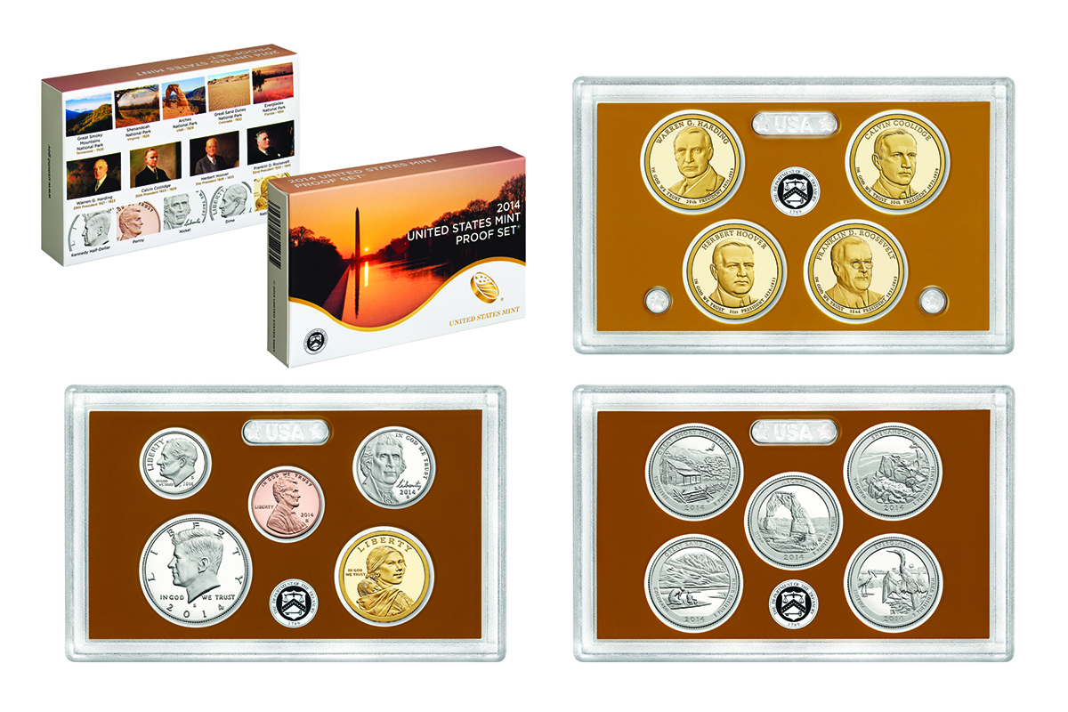 | ο | ο | ο |  |  | ο |  |  | ο |  | ο
2 | An Annual United States Mint Silver Proof Set®  Proof coins are extraordinarily well crafted and have a polished or mirror-like appearance. The United States Mint Silver Proof Set contains all 14 circulating coins in stunning proof condition displayed in three protective lenses. Each of these coins bears the “S” mint mark of the United States Mint at San Francisco. The quarters, half-dollar and dime are produced in 90% silver, also known as "coin silver."  Price: $53.95  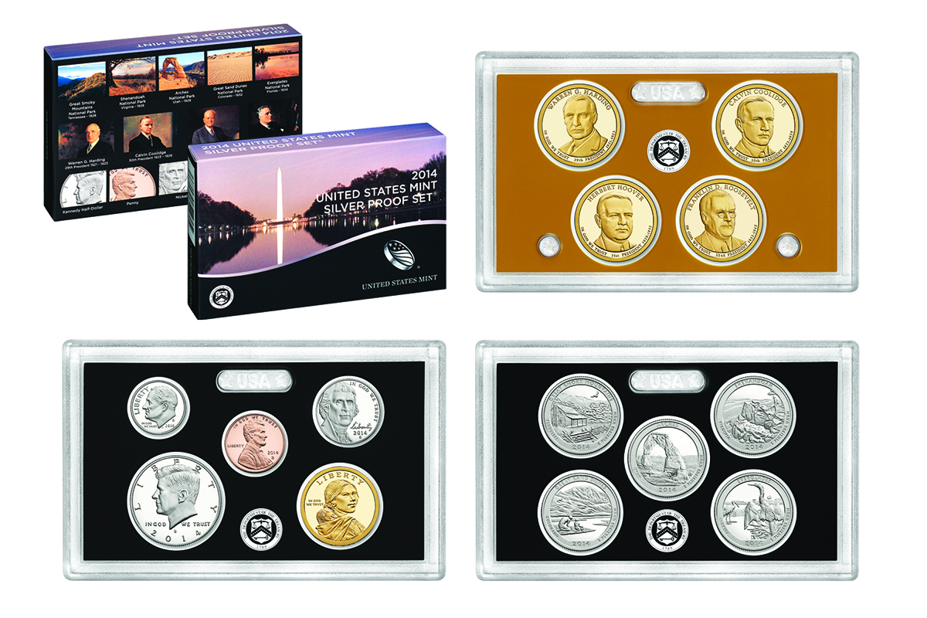 | ο | ο | ο |  |  | ο |  |  | ο |  | ο
3 | An Annual United States Mint Uncirculated Coin Set®  The United States Mint Uncirculated Coin Set contains two folders of 14 coins each from 2014, one with coins from the United States Mint at Denver and the other with coins from the United States Mint at Philadelphia, for a total of 28 coins. Price: $27.95  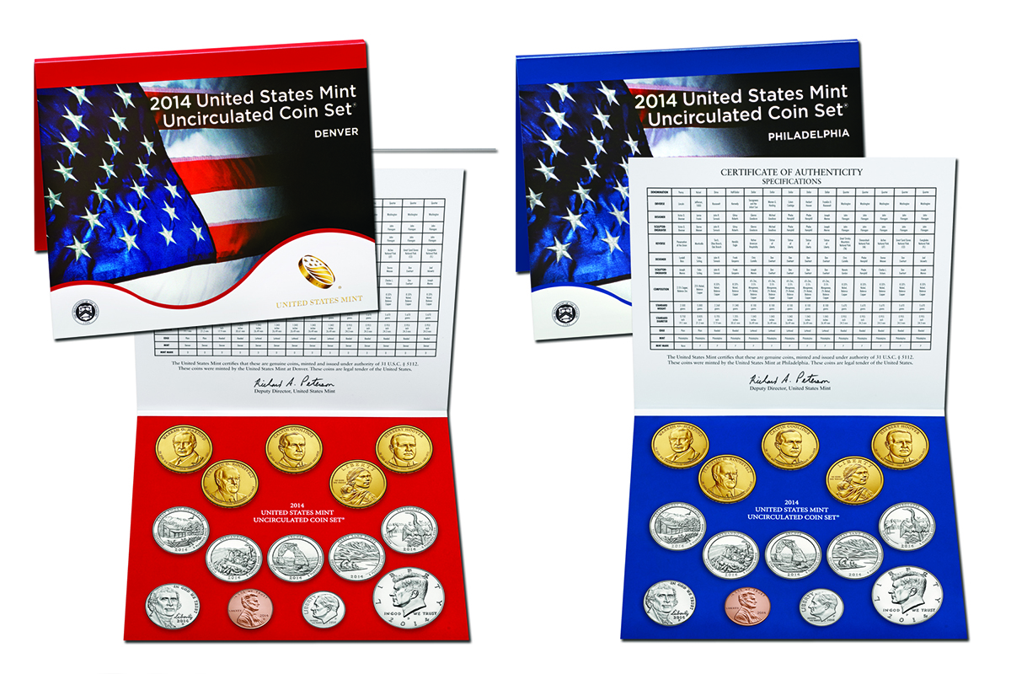 | ο | ο | ο |  |  | ο |  |  | ο |  | ο
4 | An Annual United States Mint America the Beautiful Quarters Proof Set™  Proof coins are extraordinarily well crafted and have a polished or mirror-like appearance. The 2014 United States Mint America the Beautiful Quarters Proof Set, contains five quarters which honor Great Smoky Mountains National Park in Tennessee; Shenandoah National Park in Virginia; Arches National Park in Utah; Great Sand Dunes National Park in Colorado; and Everglades National Park in Florida..  Price: $14.95  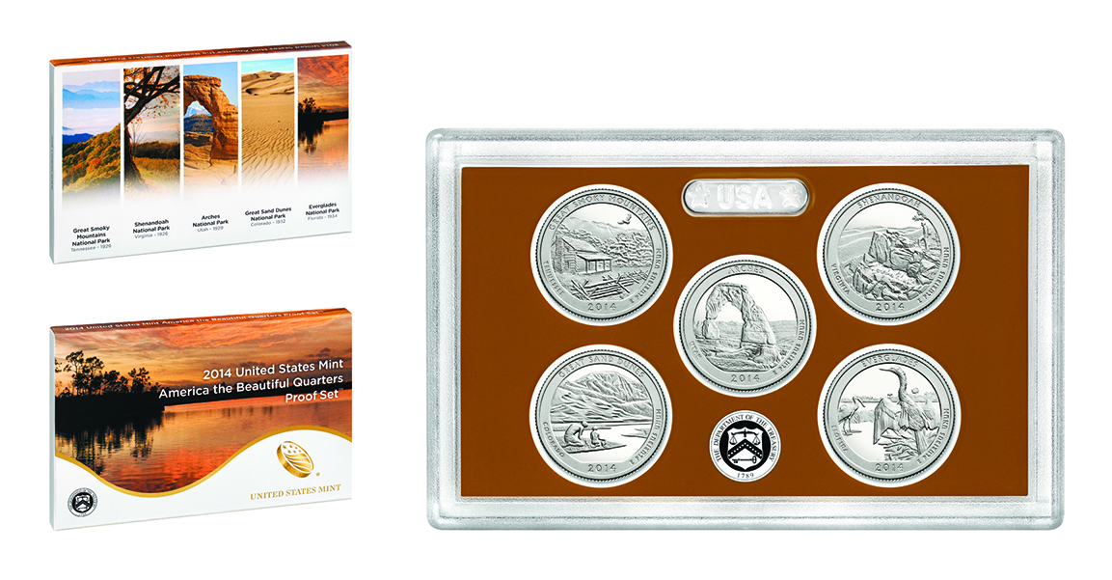 | ο | ο | ο |  |  | ο |  |  | ο |  | ο
5 | An Annual United States Mint America the Beautiful Quarters Silver Proof Set™  Proof coins are extraordinarily well crafted and have a polished or mirror-like appearance. The 2014 United States Mint America the Beautiful Quarters Silver Proof Set contains five quarters each struck in lustrous 90 percent silver which honor Great Smoky Mountains National Park in Tennessee; Shenandoah National Park in Virginia; Arches National Park in Utah; Great Sand Dunes National Park in Colorado; and Everglades National Park in Florida.  Price: $31.95  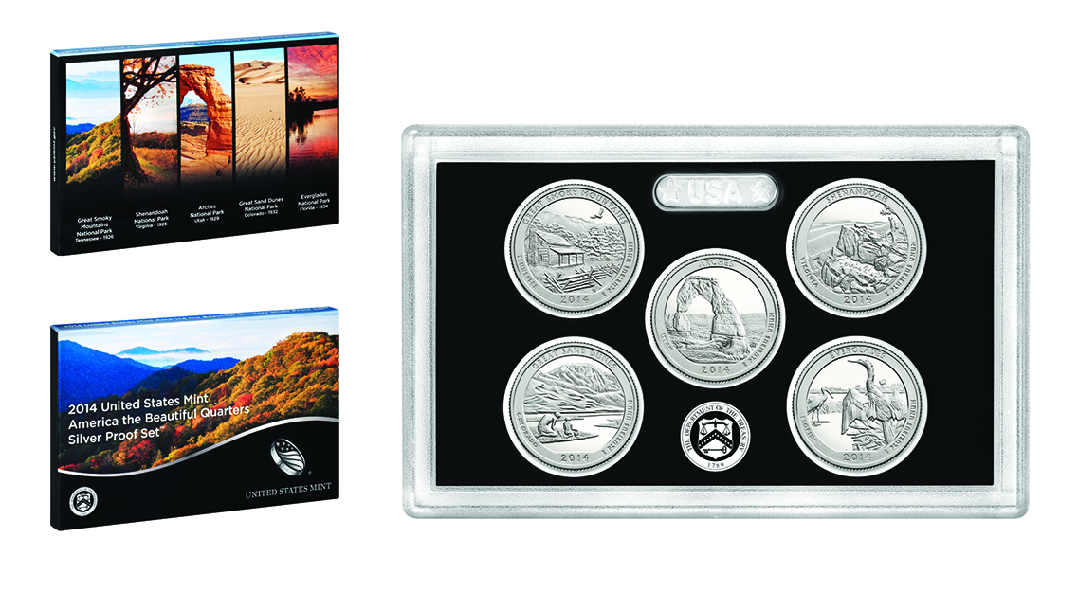 | ο | ο | ο |  |  | ο |  |  | ο |  | ο
6 | An American Eagle Silver Proof One Ounce Coin  The American Eagle Proof Coins are collector versions of the official United States Mint American Eagle Bullion Coins. A full-length figure of Liberty in full stride is featured on one side, and an eagle holding a shield and olive branch is featured on the other. The coin is packaged in an attractive velvet case. (1.5” diameter) Price: $52.95  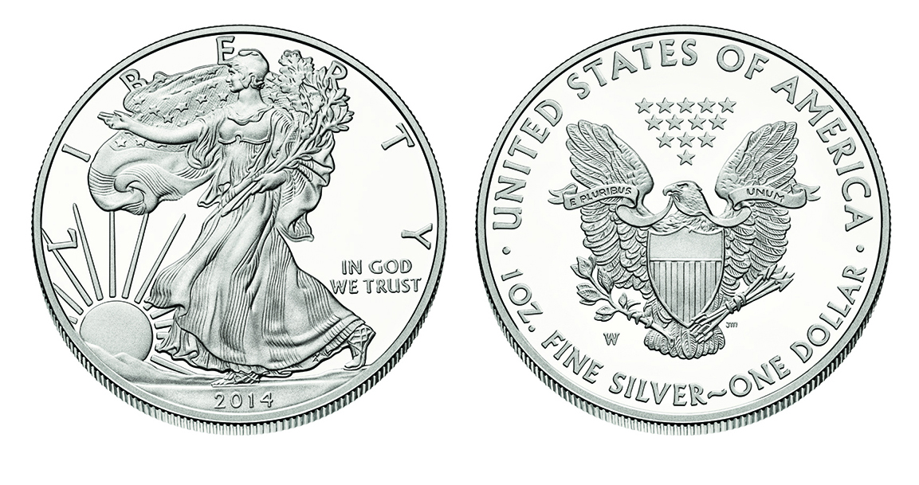 | ο | ο | ο |  |  | ο |  |  | ο |  | ο
7 | An Annual United States Mint Presidential Proof Set®  Proof coins are extraordinarily well crafted and have a polished or mirror-like appearance. The 2014 United States Mint Presidential $1 Coin Proof Set features Presidents Warren Harding, Calvin Coolidge, Herbert Hoover, and Franklin Roosevelt. Each coin has a common reverse design featuring a striking rendition of the Statue of Liberty. These 2014 coins feature large, dramatic artwork, as well as edge-incused inscriptions of the year of minting or issuance, E PLURIBUS UNUM and the mint mark. IN GOD WE TRUST appears on the face of the coin.  Price: $18.95  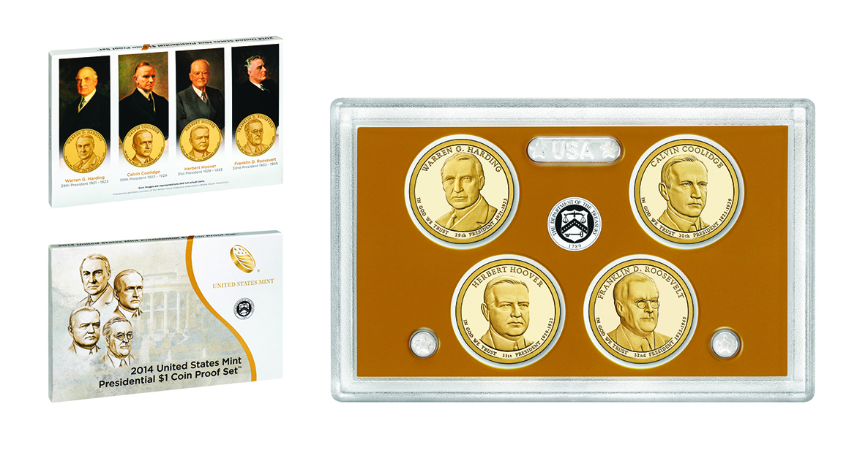 | ο | ο | ο |  |  | ο |  |  | ο |  | ο
8 | Any other United States Mint Products | ο | ο | ο |  |  | ο |  |  | ο |  | ο
_________________________
PROGRAMMING:
- ASK ALL

Q17. In the past 12 months, have you…
 |  | Yes | No
1 | Purchased coins for yourself (e.g., to start or add to a coin collection)? | ο | ο
2 | Purchased coins for someone else (e.g., as a gift)? | ο | ο
3 | Kept/collected/saved coins (e.g., coins found in your change) for yourself? | ο | ο
4 | Kept/collected/saved coins (e.g., coins found in your change) for someone else (e.g., as a gift)? | ο | ο
_________________________
PROGRAMMING:
- ASK ALL

Q18. In the next 12 months, would you be likely to consider purchasing an enduring gift to commemorate a special occasion for someone you know (such as collectible coins, jewelry/watch, or other keepsake items that have lasting value?)

1 | Yes | ο
2 | No | ο
_________________________
PROGRAMMING:
- ASK ALL

Section C: Demographics – do not display this line

Our few remaining questions are for classification purposes only.

Q19. Are you…?

1 | Male | ο
2 | Female | ο
_________________________
PROGRAMMING:
- ASK CUSTOMERS

Q20. In 2013, what was your total annual household income before taxes?

Total Household Income
1 | Less than $10,000 | ο
2 | $10,000 to $19,999 | ο
3 | $20,000 to $29,999 | ο
4 | $30,000 to $39,999 | ο
5 | $40,000 to $49,999 | ο
6 | $50,000 to $74,999 | ο
7 | $75,000 to $99,999 | ο
8 | $100,000 or more | ο
9 | Prefer Not to Answer | ο
_________________________
PROGRAMMING:
- ASK CUSTOMERS

Q21. Which of the following best describes your current employment status?

1 | Full-time | ο
2 | Part-time | ο
3 | Retired | ο
4 | Student or not employed | ο
_________________________
PROGRAMMING:
- ASK ALL

Q22. Do you have any children under age 18 currently living in your household?

1 | Yes | ο
2 | No | ο
_________________________
PROGRAMMING:
- ASK ALL
- IF NO, SKIP TO Q23.

Q23. How many children under age 18 do you have currently living in your household?

Please type in a number.
Number of Children
___
_________________________
PROGRAMMING:
- ASK IF “YES” IN Q21.

Q24. Do you have any grandchildren under age 18?

1 | Yes | ο
2 | No | ο
_________________________
PROGRAMMING:
- ASK ALL

Q25. Are you Hispanic or Latino?

1 | Yes | ο
2 | No | ο
_________________________
PROGRAMMING:
- ASK ALL

Q26. Do you consider yourself to be…

1 | American Indian or Alaska Native? | ο
2 | Asian? | ο
3 | Black or African American? | ο
4 | Native Hawaiian or other Pacific Islander? | ο
5 | White? | ο
6 | Other? Please specify: ________________ | ο
_________________________
PROGRAMMING:
- ASK ALL
- ALLOW TEXT ENTRY FOR “OTHER? PLEASE SPECIFY:”

Q27. Do you consider the area in which you live to be…

1 | Urban | ο
2 | Suburban | ο
3 | Rural | ο
_________________________
PROGRAMMING:
- ASK ALL

Q28. What is your Zip Code?

Please type in a number.
Zip Code
___
_________________________
PROGRAMMING:
- ASK ALL

THANK YOU SCREEN FOR CUSTOMERS:

Thank you very much for taking the time to participate in this research! Your feedback is important to the United States Mint and is greatly appreciated.

THANK YOU SCREEN FOR PANEL:

Thank you very much for taking the time to participate in this research!

This survey is designed to help the United States Mint understand how it can improve the products and services it provides. According to the Paperwork Reduction Act of 1995, no persons are required to respond to a collection of information unless it displays a valid OMB number. The valid OMB control number for this information collection is 1525-0012-0193.

