APPENDIX 1
DATA COLLECTION COMMUNICATION MATERIALS*

* Parent consent letters and student interview letters were submitted and approved by OMB (OMB# 1850-0852 v.8) but have been modified based on the field test data collection experience.
TABLE OF CONTENTS

Parent Consent Forms 1
Written Parental Permission Form – Base Year Participant 2
Written Parental Permission Form – Base Year Nonparticipant 4
Implied Parental Consent Form – Base Year Participant 6
Implied Parental Consent Form – Base Year Nonparticipant 8
Student Script 10
Hsls:09 First Follow-Up Study Student Script For In-School Data Collection 11
Parent/Student Brochure 13
Parent/Student Main Study Brochure 14
Parent-only Interview Communications 18
Parent: Initial Contact Letter 19
Parent: Subsequent Contact Letter 21
Parent: Introductions to Subsequent Contact Letter 22
Parent: Postcard Reminder 24
Parent: Subsequent Postcard 25
Parent: Initial Flyer 26
Parent: Subsequent Flyer 27
Parent: Abbreviated Questionnaire (PAPI) and Incentive Letter 28
Parent and Student Interview Needed Communications 30
Parent and Student: Initial Contact Letter 31
Parent and Student: Subsequent Contact Letter 33
Parent and Student: Initial Flyer 37
Parent and Student: Subsequent Flyer 38
Parent Complete or Not in Subsample; Student Interview Needed Communications 39
Parent Complete or not in Subsample/Student Needed: Initial Contact Letter 40
Parent Complete or Not in Subsample/Student Needed: Subsequent Contact Letter 42
Parent Complete or Not in Subsample/Student Needed: Introductions to Subsequent Contact Letter 44
Parent Complete or Not in Subsample/Student Needed: Flyer 46
Student Interview and Assessment Needed Communications 47
Student Interview and Assessment Needed: Initial Contact Letter 48
Student Interview and Assessment Needed: Subsequent Contact Letter 50
Student Interview and Assessment Needed: Introductions to Subsequent Contact Letter 51
Student Interview and Assessment Needed: Initial Postcard 52
Student Interview and Assessment Needed: Subsequent Postcard 53
Student Interview and Assessment Needed: Flyer 54
Student Assessment Needed Communications 55
Student Assessment Only: Initial Contact Letter 56
Student Assessment Only: Subsequent Contact Letter 57
Student Assessment Only: Introductions to Subsequent Contact Letter 58
Administrator Contact Communications 59
Administrator: Initial Contact Letter 60
Administrator: Subsequent Reminder Letter 62
Administrator: Introductions to Subsequent Reminder Letters 63
Administrator: Postcard 64
Counselor Contact Communications 65
Counselor: Initial Contact Letter 66
Counselor: Subsequent Contact Letter 68
Counselor: Introductions to Subsequent Reminder Letter 69
Counselor: Postcard 70
Staff Brochure for F1FS 72

Parent Consent Forms

Written Parental Permission Form – Base Year Participant
Dear parent/guardian:
About two years ago, your teenager participated in the High School Longitudinal Study of 2009 (HSLS:09), a national longitudinal research study that began with ninth graders in 2009. I am writing to ask for your help with the HSLS:09 first follow-up study.
The purpose of HSLS:09 is to understand the impact of the high school experience on students’ learning and their education and career choices and to explore the transitions students make from high school to further education, the labor force, and adulthood. HSLS:09 is sponsored by the National Center for Education Statistics in the U.S. Department of Education’s Institute of Education Sciences. The study is being conducted under contract by RTI International, a nonprofit research organization based in North Carolina.
In a few weeks, your teenager will be asked to spend approximately 90 minutes completing a computerized questionnaire and a math assessment in school. Over 21,000 students from over 900 high schools across the country have taken part in this study to date. We will also ask a school administrator and a school counselor to each complete a questionnaire which will provide information about programs and practices at the school. In addition, we may ask you to complete a parent questionnaire that will provide important background information.
An important feature of HSLS:09 is that it is longitudinal, meaning it follows the same students as they progress through school and eventually enter the workforce and/or go to college. We plan to contact your teenager or you in about one year to discuss plans after high school and for another follow-up about two years later, so we will ask for his/her address and telephone number and those of a relative or close friend. High school transcripts will also be collected from the school in the 2013-2014 school year.
The U.S. Department of Education is authorized by federal law to conduct HSLS:09. All information provided will be used for statistical purposes only and may not be disclosed or used in identifiable form for any other purpose, except as required by law (Public Law 107-279, Section 183). Participation is voluntary, and there is no penalty if your teenager decides not to participate. Your teenager may choose not to answer any question. The data will be collected and analyzed to understand students’ coursetaking patterns, students’ motivation and achievement, and how students decide what to do after high school.
Please take a moment to fill out the enclosed form and return it to your teenager’s school in the envelope provided. We cannot allow your teenager to participate without your written consent. As a token of our appreciation for your teenager’s participation, <<he or she will receive <<$10>><<a $10 gift card>><<a donation in the amount of $10 per participating student will be made to their school>>.
The enclosed brochure provides more information about HSLS:09. If you have questions about the study, please call Mr. Dan Pratt at RTI, toll-free, at 1-866-253-1063, between 9 AM and 5 PM Eastern Time, Monday through Friday. If you have questions about your rights as a study participant, you may call RTI’s Office for Research Protection, toll-free, at 1-866-214-2043. Both Mr. Pratt and staff from the Office for Research Protection can be reached at: RTI, P.O. Box 12194, Research Triangle Park, NC 27709.
We thank you in advance for your cooperation in this important research.
Sincerely,

Laura LoGerfo, Project Officer
National Center for Education Statistics
Institute of Education Sciences, U.S. Department of Education

High School Longitudinal Study of 2009 (HSLS:09) First Follow-Up

PARENT PERMISSION FORM

Please check only one option below to indicate your decision about your teenager’s participation in the study. Then sign the form, providing your telephone number; and print the student name and school name, where indicated.

Please return this form to your teenager’s school as soon as possible. We have enclosed an envelope addressed to the person coordinating the study at your teenager’s school.

Please check one:

I GIVE PERMISSION for my teenager, __________________________, to participate in the study.
(print student name)

I DO NOT GIVE PERMISSION for my teenager, _______________________________, to participate in the study. (print student name)

_____________________________________________________________________________
(Signature of parent or guardian)
AND
Print parent/guardian name: _______________________________________________________
Date of signature:
(___________)
Area code Telephone number
___________________________________________________________________________
Email address

PLEASE PRINT:

Student name:
School name:

FOR OFFICE USE ONLY:

Student ID:

Written Parental Permission Form – Base Year Nonparticipant

Dear parent/guardian:
About two years ago, your teenager was selected to participate in the High School Longitudinal Study of 2009 (HSLS:09), a national longitudinal research study that began with ninth graders in 2009. I am writing to ask for your help with the HSLS:09 first follow-up study.
The purpose of HSLS:09 is to understand the impact of the high school experience on students’ learning and their education and career choices and to explore the transitions students make from high school to further education, the labor force, and adulthood. HSLS:09 is sponsored by the National Center for Education Statistics in the U.S. Department of Education’s Institute of Education Sciences. The study is being conducted under contract by RTI International, a nonprofit research organization based in North Carolina.
In a few weeks, your teenager will be asked to spend approximately 90 minutes completing a computerized questionnaire and a math assessment in school. Over 21,000 students from over 900 high schools across the country have taken part in this study to date. We will also ask a school administrator and a school counselor to each complete a questionnaire which will provide information about programs and practices at the school. In addition, we may ask you to complete a parent questionnaire that will provide important background information.
An important feature of HSLS:09 is that it is longitudinal, meaning it follows the same students as they progress through school and eventually enter the workforce and/or go to college. We plan to contact your teenager or you in about one year to discuss plans after high school and for another follow-up about two years later, so we will ask for his/her address and telephone number and those of a relative or close friend. High school transcripts will also be collected from the school in the 2013-2014 school year.
The U.S. Department of Education is authorized by federal law to conduct HSLS:09. All information provided will be used for statistical purposes only and may not be disclosed or used in identifiable form for any other purpose, except as required by law (Public Law 107-279, Section 183). Participation is voluntary, and there is no penalty if your teenager decides not to participate. Your teenager may choose not to answer any question. The data will be collected and analyzed to understand students’ coursetaking patterns, students’ motivation and achievement, and how students decide what to do after high school.
Please take a moment to fill out the enclosed form and return it to your teenager’s school in the envelope provided. We cannot allow your teenager to participate without your written consent. As a token of our appreciation for your teenager’s participation in the study, <<he or she will receive <<$10>><<a $10 gift card>><<a donation in the amount of $10 per participating student will be made to their school>>.
The enclosed brochure provides more information about HSLS:09. If you have questions about the study, please call Mr. Dan Pratt at RTI, toll-free, at 1-866-253-1063, between 9 AM and 5 PM Eastern Standard Time, Monday through Friday. If you have questions about your rights as a study participant, you may call RTI’s Office for Research Protection, toll-free, at 1-866-214-2043. Both Mr. Pratt and staff from the Office for Research Protection can be reached at: RTI, P.O. Box 12194, Research Triangle Park, NC 27709.
We thank you in advance for your cooperation in this important research.
Sincerely,
Laura LoGerfo, Project Officer
National Center for Education Statistics
Institute of Education Sciences, U.S. Department of Education
High School Longitudinal Study of 2009 (HSLS:09) First Follow-Up
PARENT PERMISSION FORM

Please check only one option below to indicate your decision about your teenager’s participation in the study. Then sign the form, providing your telephone number; and print the student name and school name, where indicated.

Please return this form to your teenager’s school as soon as possible. We have enclosed an envelope addressed to the person coordinating the study at your teenager’s school.

Please check one:

I GIVE PERMISSION for my teenager, __________________________, to participate in the study.
(print student name)

I DO NOT GIVE PERMISSION for my teenager, _______________________________, to participate in the study. (print student name)

_____________________________________________________________________________
(Signature of parent or guardian)
AND
Print parent/guardian name: _______________________________________________________
Date of signature:
(___________)
Area code Telephone number
______________________________________________________________________________
Email address

PLEASE PRINT:

Student name:
School name:

FOR OFFICE USE ONLY:

Student ID:

Implied Parental Consent Form – Base Year Participant

Dear parent/guardian:
About two years ago, your teenager participated in the High School Longitudinal Study of 2009 (HSLS:09), a national longitudinal research study that began with ninth graders in 2009. I am writing to ask for your help with the HSLS:09 first follow-up study.
The purpose of HSLS:09 is to understand the impact of the high school experience on students’ learning and their education and career choices and to explore the transitions students make from high school to further education, the labor force, and adulthood. HSLS:09 is sponsored by the National Center for Education Statistics in the U.S. Department of Education’s Institute of Education Sciences. The study is being conducted under contract by RTI International, a nonprofit research organization based in North Carolina.
In a few weeks, your teenager will be asked to spend approximately 90 minutes completing a computerized questionnaire and a math assessment in school. Over 21,000 students from over 900 high schools across the country have taken part in this study to date. We will also ask a school administrator and a school counselor to each complete a questionnaire which will provide information about programs and practices at the school. In addition, we may ask you to complete a parent questionnaire that will provide important background information. You will be contacted separately to complete the parent questionnaire.
An important feature of HSLS:09 is that it is longitudinal, meaning it follows the same students as they progress through school and eventually enter the workforce and/or go to college. We plan to contact your teenager or you in about one year to discuss plans after high school and for another follow-up about two years later, so we will ask for his/her address and telephone number and those of a relative or close friend. High school transcripts will also be collected from the school in the 2013-2014 school year.
The U.S. Department of Education is authorized by federal law to conduct HSLS:09. All information provided will be used for statistical purposes only and may not be disclosed or used in identifiable form for any other purpose, except as required by law (Public Law 107-279, Section 183). Participation is voluntary, and there is no penalty if your teenager decides not to participate. Your teenager may choose not to answer any question. The data will be collected and analyzed to understand students’ coursetaking patterns, students’ motivation and achievement, and how students decide what to do after high school.
If you allow your teenager to participate, you do not need to return this form. If for any reason you object to his or her participation, please fill out the enclosed form and return it to his/her school as soon as possible. As a token of our appreciation for your teenager’s participation, <<he or she will receive <<$10>><<a $10 gift card>><<a donation in the amount of $10 per participating student will be made to their school>>.
The enclosed brochure provides more information about HSLS:09. If you have questions about the study, please call Mr. Dan Pratt at RTI, toll-free, at 1-866-253-1063, between 9 AM and 5 PM Eastern Standard Time, Monday through Friday. If you have questions about your rights as a study participant, you may call RTI’s Office for Research Protection, toll-free, at 1-866-214-2043. Both Mr. Pratt and staff from the Office for Research Protection can be reached at: RTI, P.O. Box 12194, Research Triangle Park, NC 27709.
We thank you for your cooperation in this important research.
Sincerely,
Laura LoGerfo, Project Officer
National Center for Education Statistics
Institute of Education Sciences, U.S. Department of Education

High School Longitudinal Study of 2009 (HSLS:09) First Follow-Up

PARENT PERMISSION FORM

IF YOU GRANT YOUR PERMISSION FOR YOUR TEENAGER TO PARTICIPATE IN THE STUDY, YOU DO NOT NEED TO RETURN THIS FORM.

IF YOU DO NOT CONSENT TO YOUR TEENAGER’S PARTICIPATION IN HSLS:09, PLEASE COMPLETE AND RETURN THIS FORM TO YOUR TEENAGER’S SCHOOL AS SOON AS POSSIBLE.

I DO NOT GRANT PERMISSION for my teenager, _______________________________, to participate in the High School Longitudinal Study. (print student name)

Please sign and return only if you do not grant permission for your teenager to participate.

_____________________________________________________________________________
(Signature of parent or guardian)
AND
Print parent/guardian name: _______________________________________________________
Date of signature:
(___________)
Area code Telephone number

___________________________________________________________________________
Email address

PLEASE PRINT:

Student name:
School name:

FOR OFFICE USE ONLY:

Student ID:

Implied Parental Consent Form – Base Year Nonparticipant

Dear Parent/Guardian:

About two years ago, your teenager was selected to participate in the High School Longitudinal Study of 2009 (HSLS:09), a national longitudinal research study that began with ninth graders in 2009. I am writing to ask for your help with the HSLS:09 first follow-up study.
The purpose of HSLS:09 is to understand the impact of the high school experience on students’ learning and their education and career choices and to explore the transitions students make from high school to further education, the labor force, and adulthood. HSLS:09 is sponsored by the National Center for Education Statistics in the U.S. Department of Education’s Institute of Education Sciences. The study is being conducted under contract by RTI International, a nonprofit research organization based in North Carolina.
In a few weeks, your teenager will be asked to spend approximately 90 minutes completing a computerized questionnaire and a math assessment in school. Over 21,000 students from over 900 high schools across the country have taken part in this study to date. We will also ask a school administrator and a school counselor to each complete a questionnaire which will provide information about programs and practices at the school. In addition, we may ask you to complete a parent questionnaire that will provide important background information.
An important feature of HSLS:09 is that it is longitudinal, meaning it follows the same students as they progress through school and eventually enter the workforce and/or go to college. We plan to contact your teenager or you in about one year to discuss plans after high school and for another follow-up about two years later, so we will ask for his/her address and telephone number and those of a relative or close friend. High school transcripts will also be collected from the school in the 2013-2014 school year.
The U.S. Department of Education is authorized by federal law to conduct HSLS:09. All information provided will be used for statistical purposes only and may not be disclosed or used in identifiable form for any other purpose, except as required by law (Public Law 107-279, Section 183). Participation is voluntary, and there is no penalty if your teenager decides not to participate. Your teenager may choose not to answer any question. The data will be collected and analyzed to understand students’ coursetaking patterns, students’ motivation and achievement, and how students decide what to do after high school.
If you allow your teenager to participate, you do not need to return this form. If for any reason you object to his or her participation, please fill out the enclosed form and return it to his/her school as soon as possible. As a token of our appreciation for your teenager’s participation, <<he or she will receive <<$10>><<a $10 gift card>><<a donation in the amount of $10 per participating student will be made to their school>>.
The enclosed brochure provides more information about HSLS:09. If you have questions about the study, please call Mr. Dan Pratt at RTI, toll-free, at 1-866-253-1063, between 9 AM and 5 PM Eastern Standard Time, Monday through Friday. If you have questions about your rights as a study participant, you may call RTI’s Office for Research Protection, toll-free, at 1-866-214-2043. Both Mr. Pratt and staff from the Office for Research Protection can be reached at: RTI, P.O. Box 12194, Research Triangle Park, NC 27709.
We thank you in advance for your cooperation in this important research.
Sincerely,
Laura LoGerfo, Project Officer
National Center for Education Statistics
Institute of Education Sciences, U.S. Department of Education

High School Longitudinal Study of 2009 (HSLS:09) First Follow-Up

PARENT PERMISSION FORM

IF YOU GRANT YOUR PERMISSION FOR YOUR TEENAGER TO PARTICIPATE IN THE STUDY, YOU DO NOT NEED TO RETURN THIS FORM.

IF YOU DO NOT CONSENT TO YOUR TEENAGER’S PARTICIPATION IN HSLS:09, PLEASE COMPLETE AND RETURN THIS FORM TO YOUR TEENAGER’S SCHOOL AS SOON AS POSSIBLE.

I DO NOT GRANT PERMISSION for my teenager, _______________________________, to participate in the High School Longitudinal Study. (print student name)

Please sign and return only if you do not grant permission for your teenager to participate.

_____________________________________________________________________________________
(Signature of parent or guardian)
AND
Print parent/guardian name: _______________________________________________________
Date of signature:
(___________)
Area code Telephone number

__________________________________________________________________________
Email address

PLEASE PRINT:

Student name:
School name:

FOR OFFICE USE ONLY:

Student ID:

Student Script

HSLS:09 First Follow-Up Study Student Script For In-School Data Collection
INSTRUCTION TO SA: READ THE FOLLOWING SCRIPT VERBATIM TO THE STUDENTS PRIOR TO STARTING THE STUDENT ASSESSMENT.
Good morning/afternoon. I would like to thank you for participating in the first follow-up of the High School Longitudinal Study of 2009 — HSLS:09 for short. My name is ________________ and I represent RTI, a non-profit research organization that has been hired to administer the study by the National Center for Education Statistics from the U.S. Department of Education.
We think the best way to learn about students’ school-related experiences, decisions, and plans for the future—is by asking the students themselves! Therefore we’re asking you to complete a computerized questionnaire which will help educators and policy makers understand your needs and interests better.
We’re also assessing the level of academic achievement of students in the United States so that effective programs and services for future high school students can be developed—so we’ll be asking you to complete a computerized mathematics assessment too! You’ll complete the student questionnaire first and then fill out the mathematics assessment—it will take no more than 90 minutes total.
All of the information you give us will be strictly protected and your teachers, school staff, and parents will never know how you answered. The math assessment will not affect your grades—in fact, no one at the school will ever see your scores!
[DO NOT READ IF STUDENTS ARE NOT ALLOWED TO RECEIVE THE $10]
When you have finished both the assessment and questionnaire, [IF INCENTIVE PERMITTED, USE APPLICABLE PHRASING: I will give you $10/I will give you a $10 gift card/your school will receive $10 for each participating student] as a thank you for your participation.
Your participation in HSLS:09 is voluntary, and you don’t have to answer any questions you don’t want to. Your answers will be used for statistical purposes only and will be combined with other students’ responses for things like statistical reports to Congress. Your answers won’t be disclosed, or used, in identifiable form for any purpose unless otherwise compelled by law (Public Law 107-279, Section 183).
We are also asking your principal, school counselor and one parent or guardian to complete a questionnaire. This will help provide contextual information such as school programs and practices.
In about a year, you will be contacted again about participating in another follow-up to this study. Therefore we’ll be asking you to provide contact information today so that we will be able to get in touch with you then.
When you first log in, you be asked to complete a questionnaire. When you finish the questionnaire or after 35-minutes, you will see a series of instructions for the math assessment which are also printed on the scratch paper that you received. This test contains 40 multiple-choice mathematics items. For each item:

- Read the item carefully and try your best to identify the correct answer from among the four choices. If you can eliminate at least one answer, you are encouraged to guess the answer. You will not lose any credit for guessing when you aren’t completely sure of the answer.
- Use scratch paper if necessary.
- To answer a question, click on the answer you think is correct.
- Then click on the Next button to move on to the next item.
- You may use a scientific calculator for any item on this test. If you do not have a calculator of your own, you may use the online calculator by clicking on the Show Calculator button.
- If time permits, you will be able to return to the questions that you have skipped or marked for review at the end of each section.
You may now begin.

Parent/Student Brochure

Parent/Student Main Study Brochure

[HSLS:09 Brochure Logo]

High School Longitudinal Study of 2009
Conducted for:
National Center for Education Statistics
U.S. Department of Education
Institute of Education Sciences
Conducted by:
RTI International
Research Triangle Park, NC
27709-2194

[Logo]

High School Longitudinal Study of 2009
The first follow-up of the High School Longitudinal Study of 2009 (HSLS:09) is now underway! This exciting study is being conducted by RTI International for the National Center for Education Statistics (NCES) and is a national study of teenagers and their parents, school administrators, and school counselors. HSLS:09 will examine how home, school, peer, and community factors influence teenagers’ learning and development and will explore how these factors impact the high school experience. HSLS:09 is particularly interested in learning how teenagers make choices regarding their education and careers, with a special focus in science, technology, engineering, and mathematics (STEM) education and career choices.

Why is the study being conducted?
HSLS:09 is being conducted in an effort to understand a number of important issues related to how teenagers make decisions as they progress through high school and into further education or the workforce. Because these teenagers are being followed over time, HSLS:09 provides an excellent basis for understanding a number of important issues including, but not limited to the following:
- What influences teenagers to take STEM courses and pursue STEM careers?
- What factors influence whether teenagers decide to go to college?
- How can we improve the quality of math and science education in the United States?
- How can we improve the high school experience?
- How do the characteristics of high schools and colleges influence decisions teenagers make about their lives?
- How do gender, race and ethnicity, and at-risk status influence teenagers’ success in school and work?
- How do changes in young people’s lives and their connections with communities, schools, teachers, families, parents, and friends influence topics, such as
– academic, social, and interpersonal growth;
– transitions from high school to college or the workforce; and
– teenagers’ decisions about courses, majors, and careers, both in general and related to math and science?

Who is conducting the study?
The first follow-up of HSLS:09 is being conducted under contract by RTI International, a nonprofit research organization based in North Carolina, and is sponsored by the National Center for Education Statistics (NCES) in the U.S. Department of Education’s Institute for Education Sciences. NCES is authorized to conduct this study under the Education Sciences Reform Act of 2002 (Public Law 107-279, Section 153).

What is involved for teenagers?
We are asking that selected teenagers complete a 35-minute questionnaire that will focus on the transition from high school to further education and the workforce. They also will complete a 40-minute math assessment that will determine their knowledge in algebra and algebraic reasoning. The questionnaire covers topics such as:
- influences on teenagers’ decisions about high school courses, college and careers
- beliefs and attitudes about math, science, and school in general
- activities outside of school including employment
- factors that lead teenagers into or out of math, science and technology courses
- educational aspirations and expectations
- preparation and plans for the teenager’s college costs and financial aid
- background information.

The questionnaires and assessments will be completed on school computers, if available, or laptop computers will be provided for the students to use for the study. Teenagers who no longer attend their ninth grade school will be asked to participate by telephone or online.

A second follow-up to determine plans after high school will take place in summer and fall of 2013 after most students have graduated. Additionally, high school transcripts will be collected during the 2013-2014 school year. Students will be asked to provide contact information (e.g., name, address, telephone number) during the interview. We will also request contact information for their parents or guardians and one other person to facilitate locating efforts in future follow-ups.

Will the math assessment hurt or help a student’s school grades?
Neither. The assessment will only be used for study purposes. No one in the school will see the score a student receives on the assessments.

How many students are participating in HSLS:09?
Over 21,000 students from more than 900 schools have participated in HSLS:09 to date.

Will students receive an excused absence from class?
Yes. The absence is excused, and any school assignments that are missed due to participation in the study may be made up.

What else does this study involve?
In addition to the student components, HSLS:09 first follow-up includes
• a school administrator questionnaire;
• a school counselor questionnaire; and
• a parent questionnaire.

The staff and parent questionnaires will be computer-based. Information from these sources will provide a well-rounded picture of each teenager’s background, school setting, and educational performance.

What topics will the parent questionnaire cover?
The parent questionnaire will cover topics such as
• home background and education support system;
- educational aspirations and expectations for your teenager
• preparations and plans for the teenager’s future.
- college costs and financial aid
The parent questionnaire will be completed via the Web, with a telephone interviewer, or with a field interviewer.

How many parents will be selected?
One parent or guardian of some sampled students will be asked to complete a parent questionnaire.

How long will it take to complete the parent questionnaire?
The parent questionnaire will take about 30 minutes to complete.

What if English is not the parent’s native language and/or the parent would prefer to answer in a language other than English?
A Spanish-language version of the parent questionnaire can be accessed by clicking on the appropriate link within the Web survey. Additionally, bilingual telephone interviewers will be available.

Do teenagers or parents have to participate?
Participation in HSLS:09 is entirely voluntary; however, the participation of every teenager and parent is important to ensure the completeness and accuracy of results. The development of valid national results depends on a high rate of participation.

What if a teenager decides not to participate?
Even if a parent provides permission for their teenager to participate, all of the teenagers in this study still have an individual right to decide for themselves whether or not to participate in HSLS:09.

Will the responses of participants be kept confidential?
Data collected from the teenager, parent, and school staff questionnaires may only be used for statistical purposes and may not be disclosed or used in identifiable form for any other purpose, except as required by law (Public Law 107-279, Section 183). The data collected will be used in analyses to understand teenagers’ coursetaking behaviors, motivation and achievement, and how teenagers decide what to do after high school.

We have implemented strict procedures to ensure confidentiality:
- All project staff with any access to study data are liable to severe fines and imprisonment for any disclosure of individual responses.
- All electronic data are maintained in secure and protected data files, and all personally identifying information is kept in files separate from the descriptive information.
- No data released to the general public can be used to identify individual respondents, except when required by law.
- These procedures have been reviewed and approved by the federal government.

When will the data for the study be collected?
Data collection for the first follow-up of HSLS:09 will begin in early 2012. A second follow-up to collect data about teenagers’ plans after high school will take place in summer and fall of 2013, after most students have graduated. High school transcripts will be collected during the 2013-2014 school year. Additional follow-ups are planned for 2015 and beyond.

What happens if a teenager has a test scheduled, is sick, or is otherwise unable to participate on the scheduled survey day?
If a teenager misses an HSLS:09 session for any reason, we may contact the student to request their participation by telephone or on the Web.

What types of schools are participating in HSLS:09?
Information will be collected from both public and private high schools. Data are also being collected from teenagers who have transferred to different schools, are now home-schooled, or have otherwise left school.

[back panel]
The following organizations are among those that have given their support to HSLS:09:
American Association of School Administrators
American Counseling Association
American Federation of Teachers
Council of Chief State School Officers
National Association of Independent Schools
National Association of Secondary School Principals
National Catholic Educational Association, Department of Secondary Schools
National Center for Improving Science Education/WestED
National Council of Teachers of Mathematics
National Education Association
National Parent Teacher Association
National School Boards Association
National Science Teachers Association

Whom can I contact for further information about HSLS:09?
For additional information, you may call (877) 282-HSLS (877-282-4757), send e-mail to hsls-survey@rti.org, visit our website at https://surveys.nces.ed.gov/hsls, or contact:

RTI Project Director:
Mr. Dan Pratt at (919) 541-6615

RTI Principal Investigator:
Dr. Steven Ingels at (202) 974-7834

NCES Project Officer:
Dr. Laura LoGerfo at (202) 502-7402

Parent-only Interview Communications

Parent: Initial Contact Letter

[DATE]

<PARENT NAME> Web Address: surveys.nces.ed.gov/hsls
<ADDR1> Your Study ID: <XXXXXXX>
<ADDR2> Your Password: <XXXXXXXX><PW_ind>
<CITY STATE ZIP>
Dear <Parent or Guardian Name>:
About two-and-a-half years ago, <STUDENT NAME> < “participated” / “was selected to participate”> in the High School Longitudinal Study of 2009 (HSLS:09), sponsored by the National Center for Education Statistics (NCES) in the U.S. Department of Education’s Institute of Education Sciences. A follow-up survey to the HSLS:09 is now underway, and we would like you to complete an interview. On average, the interview will take about 30 minutes to complete.
Your participation is voluntary, but as a parent of a sampled student your input is extremely important and provides a unique source of information. With more than 21,000 students in the study, HSLS:09 will inform policymakers on how the experience of high school impacts learning, as well as future educational and career pathways. Even large educational organizations have endorsed HSLS:09, such as the National Parent Teacher Association (National PTA), the National Education Association (NEA), and the American Federation of Teachers (AFT). To complete the online survey, please log in using the web address, study ID, and password provided at the top right of this page.
HSLS:09 is conducted by RTI International under contract with NCES. Data collected are used only for statistical purposes and may not be disclosed or used, in identifiable form for any other purpose except as required by law (Public Law 107-279, Section 183). The enclosed brochure provides more information about HSLS:09 and RTI. In addition, results from prior studies are available on the HSLS:09 website given above. If you have questions about the study, please call Randy Ottem toll-free at 1-877-282-4757. If you have questions about your rights as a study participant, you may call RTI’s Office for Research Protection toll-free at 1-866-214-2043.
We thank you in advance for your cooperation in this important research.
Sincerely,

Jack Buckley, Commissioner
National Center for Education Statistics
Institute of Education Sciences
U.S. Department of Education

Enclosure: HSLS:09 Brochure

NCES is authorized to conduct HSLS:09 under the Education Sciences Reform Act of 2002 (Public Law 107-279, Section 153). According to the Paperwork Reduction Act of 1995, no persons are required to respond to a collection of information unless it displays a valid OMB control number. The valid OMB control number of this information collection is 1850-0852, and the study is completely voluntary. The time required to complete this information collection is estimated to average 30 minutes per response, including the time to review instructions, search existing data resources, gather the data needed, and complete and review the information collection. If you have any comments concerning the accuracy of the time estimate or suggestions for improving the interview, please write to: High School Longitudinal Study of 2009 (HSLS:09), National Center for Education Statistics, 1990 K Street NW, Washington, DC 20006.

Parent: Subsequent Contact Letter
[Date]

«fname» «mname» «lname» «suffix»
«addr1»
«addr2»
«city», «state» «zip» «zip4»

Dear «fname» «lname»:
<<A VARIETY OF INTRODUCTIONS WILL BE INSERTED INTO THIS LETTER WHICH CAN BE FOUND ON THE NEXT PAGE>>
Study ID: «caseid»
Password: «password»<<PW_ind>>
You can complete the parent interview by telephone or online in approximately 30 minutes. To complete the interview with one of our professional telephone interviewers, call toll-free at 1-877-282-4757. If you prefer to use the Web, log in at https://surveys.nces.ed.gov/hsls/ using the study ID and password provided above. <TO BE ADDED AT END OF DATA COLLECTION FOR QUALIFIED SAMPLE MEMBERS: As a token of our appreciation for your participation, we will send you $20 upon completion of the questionnaire.> If you have already completed the interview, we thank you for your time.
HSLS:09 is conducted by RTI International under contract with the National Center for Education Statistics (NCES). The enclosed brochure provides more information about HSLS:09 and RTI. Data collected are used only for statistical purposes and may not be disclosed, or used, in identifiable form for any other purpose except as required by law (Public Law 107-279, Section 183). If you have questions about the study, please call Randy Ottem toll-free at 1-877-282-4757 or the NCES Project Officer of HSLS, Dr. Laura LoGerfo, at 202-502-7402. If you have questions about your rights as a study participant, you may call RTI’s Office for Research Protection toll-free at 1-866-214-2043.
Thank you in advance for making HSLS:09 a success!
Sincerely,

Dan Pratt
HSLS:09 Project Director
RTI International

NCES is authorized to conduct HSLS:09 under the Education Sciences Reform Act of 2002 (Public Law 107-279, Section 153). According to the Paperwork Reduction Act of 1995, no persons are required to respond to a collection of information unless it displays a valid OMB control number. The valid OMB control number of this information collection is 1850-0852, and it is completely voluntary. The time required to complete this information collection is estimated to average 30 minutes per response, including the time to review instructions, search existing data resources, gather the data needed, and complete and review the information collection. If you have any comments concerning the accuracy of the time estimate or suggestions for improving the interview, please write to: High School Longitudinal Study of 2009 (HSLS:09), National Center for Education Statistics, 1990 K Street NW, Washington, DC 20006.

Parent: Introductions to Subsequent Contact Letter
Introduction A:
As a parent or guardian of one of the approximately 21,000 students who <“participated” / “were selected to participate”> in the High School Longitudinal Study of 2009 (HSLS:09), you recently received information on how to complete the parent interview. HSLS:09 focuses on the impact of the high school experience on students’ learning, and their education and career choices, and will be used by policymakers and researchers for years to come. You have a unique opportunity to contribute to the understanding of how the home environment affects students’ learning and their decisions during and after high school.
Introduction B:
Please take a moment to contribute your unique insight into <<student first name’s>> high school experience by completing a follow-up interview for the High School Longitudinal Study of 2009 (HSLS:09). Your responses will help educators, researchers, and policymakers better understand and improve high school education in the United States. Your input will greatly contribute to the understanding of how the home environment affects students’ learning and their decisions during and after high school.
Introduction C:
You can contribute to the success of high school education in the United States by completing the parent interview for the High School Longitudinal Study of 2009 (HSLS:09). This important study focuses on students and their parents, school administrators, and school counselors to understand how school, home, and other influences affect the choices that students make during and after high school. Your input about the home environment is an essential component of the study and will help educators and policymakers make informed decisions about the future of high schools in the United States.
Introduction D:
Your perspective and opinion as a parent of one of the approximately 21,000 students who <“participated” / “were selected to participate”> in the High School Longitudinal Study of 2009 (HSLS:09) can shape the future of high school education in the United States. Please take a 30 minutes out of your busy schedule to complete your HSLS:09 interview.
Introduction E:
We would like for you to participate in the High School Longitudinal Study of 2009 (HSLS:09) so that policymakers and researchers are informed of your unique experiences and perspectives in regards to your teenager’s education. Completing the parent interview is an easy and effective way to make a difference in your teenager’s and our nation’s future.
Introduction F:
As the parent or guardian of <student> who <is participating/was selected to participate> in the High School Longitudinal Study of 2009 (HSLS:09), you can provide a unique insight and perspective on what it takes for students to be successful in school by completing the parent interview. By participating in this important research, you are providing a voice for all of the parents and guardians of teenagers who were not selected to participate in this study.
Introduction G:
We are writing to ask you to take a moment to contribute your unique insight into your teenager’s high school experience by completing a follow-up interview for the High School Longitudinal Study of 2009 (HSLS:09). The time spent by you and other parents completing the interview could greatly benefit our nation’s education system. Your input will influence policymaker decisions on a wide array of education practices, such as changes to curriculum or access to financial aid. Because your teenager <“is participating”/“was selected to participate”> in HSLS:09, your input is key to the success of this follow-up study.

Parent: Postcard Reminder

PO Box 12194
Research Triangle Park, NC 27709-2194
RTI Project #0212678.002.335

ADDRESS SERVICE REQUESTED

«fname»«mname»«lname»«suffix»

«addr1»

«addr2»

«city», «state» «zip» «zip4»

Study ID «caseid»
«panelinfo»
High School
Longitudinal
Study of 2009
Please take a moment to contribute your unique insight into <<student first name’s>> high school experience by completing a follow-up interview for the High School Longitudinal Study of 2009. The time you spend completing the parent interview will greatly contribute to policymakers’ decisions on the future of high school education in the United States.
To complete a web interview over our secure website, log in to https://surveys.nces.ed.gov/hsls using the information below:

Study ID = «userid» Password = «password»<PW_ind>
RTI International is conducting this study for the National Center for Education Statistics (NCES) in the U.S. Department of Education’s Institute of Education Sciences. If you have any questions or problems completing the web interview, or would like to complete the interview by telephone with a professionally trained interviewer, please contact the HSLS:09 help desk at 1-877-282-4757.
Thank you.

Parent: Subsequent Postcard
PO Box 12194
Research Triangle Park, NC 27709-2194
RTI Project #0212678.002.335

ADDRESS SERVICE REQUESTED

«fname»«mname»«lname»«suffix»

«addr1»

«addr2»

«city», «state» «zip» «zip4»

Study ID «caseid»
«panelinfo»
High School
Longitudinal
Study of 2009

Your unique insight into <<student first name’s>> high school experience will greatly contribute to policymakers’ decisions on the future of high school education in the United States. Please take a moment to complete a follow-up interview for the High School Longitudinal Study of 2009 (HSLS:09).
To complete a web interview over our secure website, log in to https://surveys.nces.ed.gov/hsls using the information below:

Study ID = «userid» Password = «password»<PW_ind>
RTI International is conducting this study for the National Center for Education Statistics (NCES) in the U.S. Department of Education’s Institute of Education Sciences. If you have any questions or problems completing the web interview, or would like to complete the interview by telephone with a professionally trained interviewer, please contact the HSLS:09 help desk at 1-877-282-4757.
Thank you.

Parent: Initial Flyer
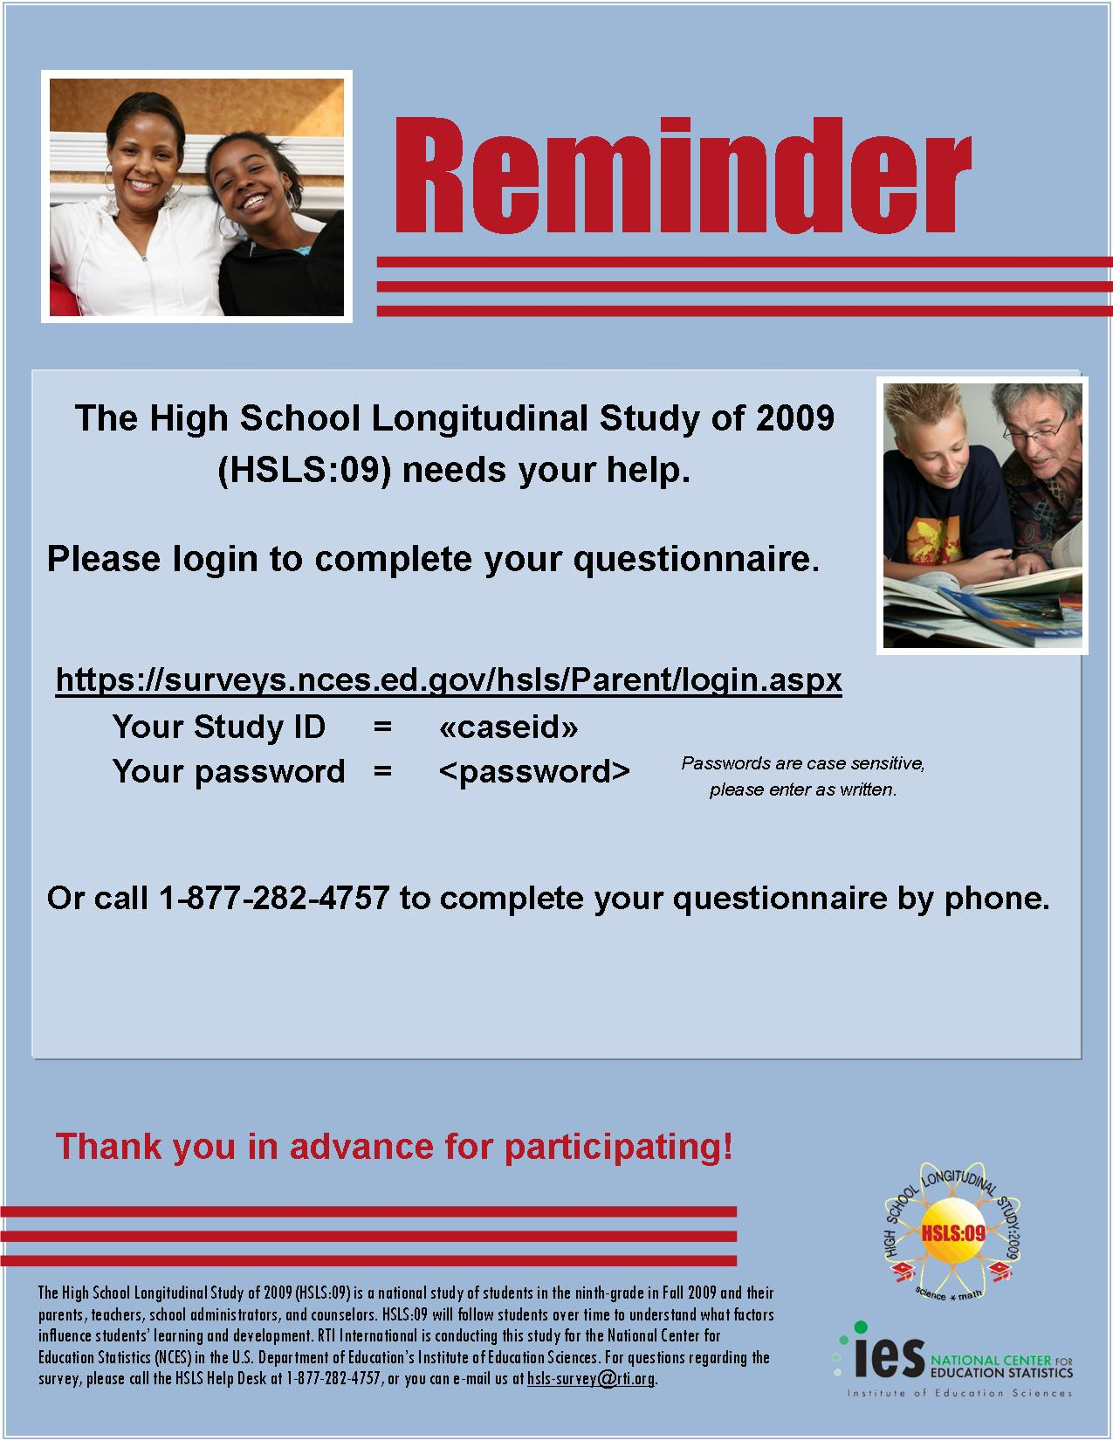

Parent: Subsequent Flyer
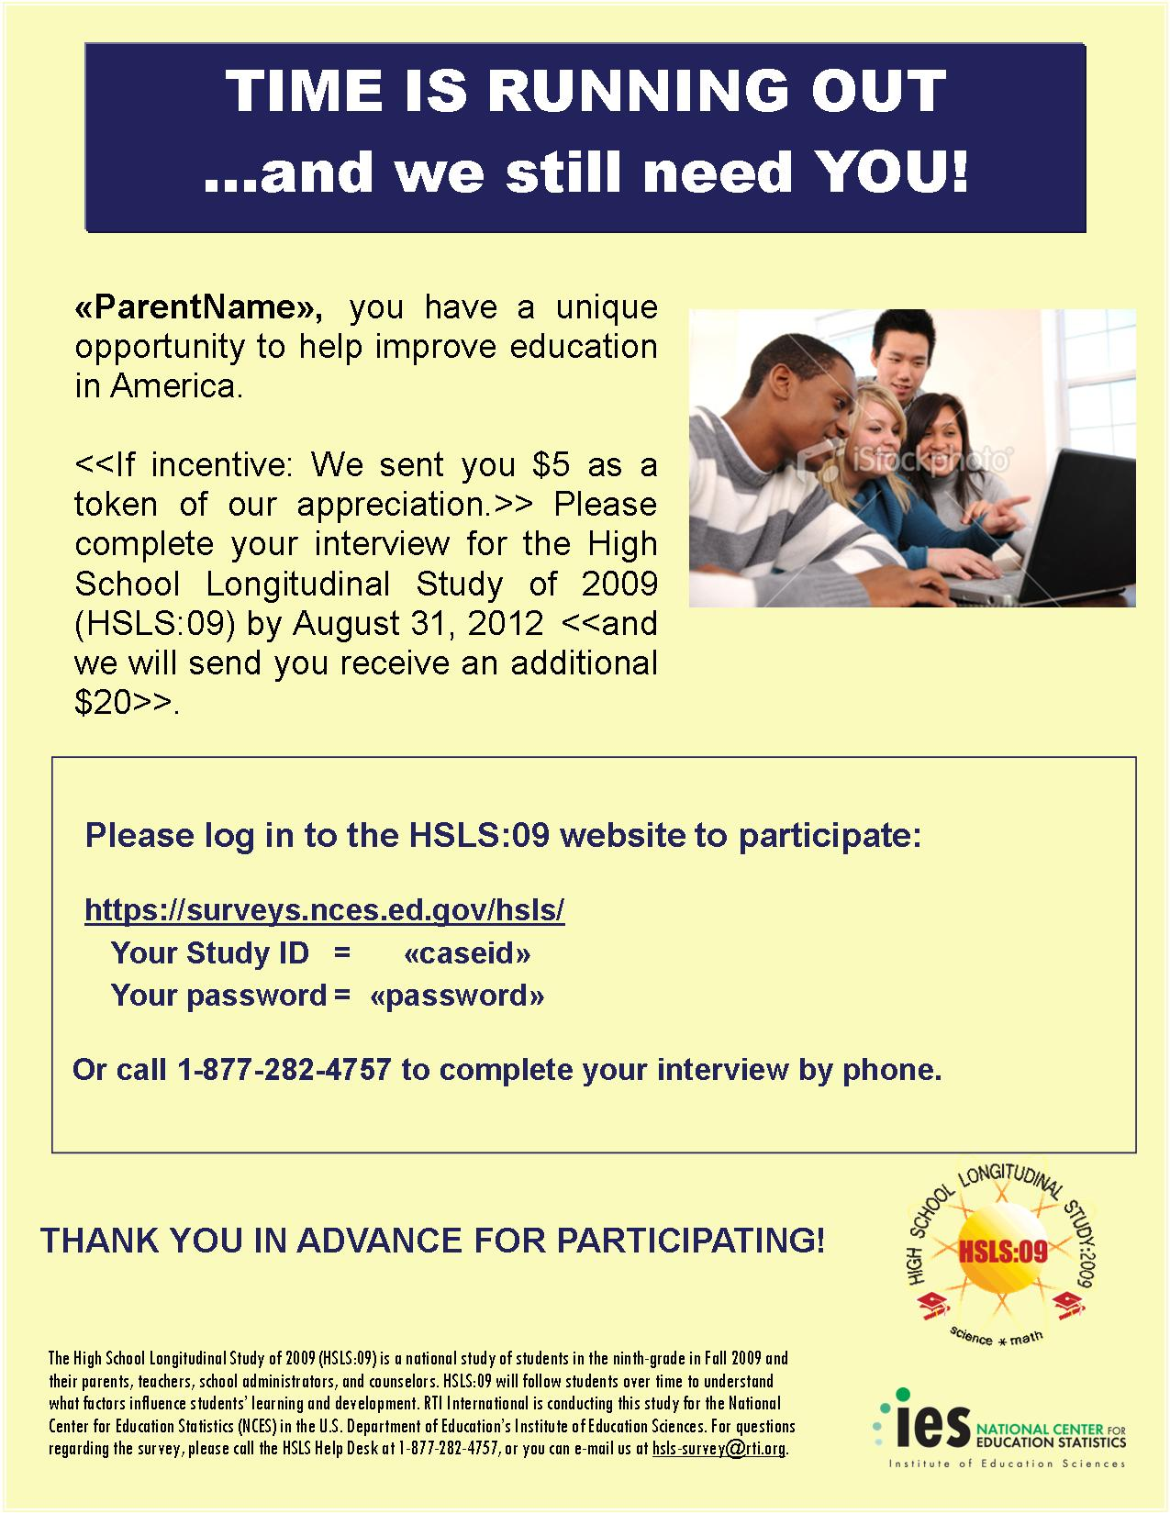

Parent: Abbreviated Questionnaire (PAPI) and Incentive Letter

[Date]

«fname» «mname» «lname» «suffix» Study ID: «caseid»
«addr1» Password: «password»
«addr2»
«city», «state» «zip» «zip4»

Dear «fname» «lname»:
In order to make participation in the High School Longitudinal Study of 2009 (HSLS:09) even easier, we have enclosed a shortened version of the parent interview for your convenience. Please help us make the study a success. We would like to learn about <<student_Name>>’s educational experience, so please take about five minutes to fill out this two-page questionnaire and return it in the enclosed business reply envelope. Your participation is voluntary, but as a parent of a sampled student you are very important and offer a unique source of information. With more than 21,000 students in the study, the HSLS:09 will inform policymakers on how the experience of high school impacts learning, as well as future educational and career pathways. <IF SM QUALIFIES FOR INCENTIVE: We have enclosed $5 as a token of our appreciation for your continued participation.>
If you prefer, you can complete the full interview by telephone or online in approximately 30 minutes. To complete the interview with one of our professional telephone interviewers, call toll-free at 1-877-282-4757. If you prefer to use the Web, log on at https://surveys.nces.ed.gov/hsls/ using the study ID and password provided above. <if incentivized: If you complete the interview on the phone or on the Web, we will mail $20 in appreciation for your contribution.> If you have already completed the interview, we thank you for your time.
Conducted by RTI International under contract with NCES, HSLS:09 has been endorsed by organizations such as the National Parent Teacher Association (National PTA), the National Education Association (NEA), and the American Federation of Teachers (AFT). The enclosed brochure provides more information about HSLS:09 and RTI. Data collected are used only for statistical purposes and may not be disclosed, or used, in identifiable form for any other purpose except as required by law (Public Law 107-279, Section 183). If you have questions about the study, please call Randy Ottem toll-free at 1-877-282-4757 or the NCES Project Officer of HSLS, Dr. Laura LoGerfo, at 202-502-7402. If you have questions about your rights as a study participant, you may call RTI’s Office for Research Protection toll-free at 1-866-214-2043.
Sincerely,
Dan Pratt
HSLS:09 Project Director
RTI International

NCES is authorized to conduct HSLS:09 under the Education Sciences Reform Act of 2002 (Public Law 107-279, Section 153). According to the Paperwork Reduction Act of 1995, no persons are required to respond to a collection of information unless it displays a valid OMB control number. The valid OMB control number of this information collection is 1850-0852, and it is completely voluntary. The time required to complete this information collection is estimated to average 5 minutes for the shortened interview, or 30 minutes per full-length interview, including the time to review instructions, search existing data resources, gather the data needed, and complete and review the information collection. If you have any comments concerning the accuracy of the time estimate or suggestions for improving the interview, please write to: High School Longitudinal Study of 2009 (HSLS:09), National Center for Education Statistics, 1990 K Street NW, Washington, DC 20006.

Parent and Student Interview Needed Communications

Parent and Student: Initial Contact Letter
[DATE]

<PARENT NAME> Web Address: surveys.nces.ed.gov/hsls
<ADDR1> Parent Study ID: <XXXXXXXX>
<ADDR2> Parent Password: <XXXXXXXX><PW_ind>
<CITY STATE ZIP>
Dear <Parent or Guardian Name>:
About two-and-a-half years ago, <STUDENT NAME> < “participated” / “was selected to participate”> in the High School Longitudinal Study of 2009 (HSLS:09), sponsored by the National Center for Education Statistics (NCES) in the U.S. Department of Education’s Institute of Education Sciences. A follow-up survey to HSLS:09 is now underway, and we would like you to complete an interview, and for your teenager to complete an interview and a math assessment.
<STUDENT_FNAME>’s and your participation is voluntary, but is very important as you are a unique source of information. With more than 21,000 students in the study, the HSLS:09 will inform policymakers on how the experience of high school impacts learning, as well as future educational and career pathways. Large educational organizations have endorsed HSLS:09, such as the National Parent Teacher Association (National PTA), the National Education Association (NEA), and the American Federation of Teachers (AFT).
The student interview will take approximately 35 minutes to complete. In addition, we are also asking that <STUDENT_FNAME> complete a 40 minute math assessment, which will not be shared with teachers or school officials. We will send <STUDENT_FNAME> a check for $<int_inc> for finishing the interview, and $10 for finishing the math assessment in appreciation for participating.
To complete the parent survey, please log in using the web address, study ID, and password provided at the top right of this page. For your teenager’s interview and math assessment, please give <STUDENT_FNAME> the enclosed letter, which describes the study and provides log-in information to the student questionnaire. Giving the enclosed letter to your teenager indicates that you consent to allow your teenager to participate. If you prefer, you may also indicate your consent after logging in to the online parent interview. Data collected are used only for statistical purposes and may not be disclosed or used, in identifiable form for any other purpose except as required by law (Public Law 107-279, Section 183).
HSLS:09 is conducted by RTI International under contract with NCES. The enclosed brochure provides more information about HSLS:09 and RTI. In addition, results from prior studies are available on the HSLS website given above. If you have questions about the study, please call Randy Ottem toll-free at 1-877-282-4757. If you have questions about your rights as a study participant, you may call RTI’s Office for Research Protection toll-free at 1-866-214-2043.
We thank you in advance for your cooperation in this important research.
Sincerely,

Jack Buckley
Commissioner
National Center for Education Statistics
Institute of Education Sciences
U.S. Department of Education

Enclosure: HSLS:09 brochure
Student letter

NCES is authorized to conduct HSLS:09 under the Education Sciences Reform Act of 2002 (Public Law 107-279, Section 153). According to the Paperwork Reduction Act of 1995, no persons are required to respond to a collection of information unless it displays a valid OMB control number. The valid OMB control number of this information collection is 1850-0852, and the study is completely voluntary. The time required to complete this information collection is estimated to average 30 minutes per response for parents and 75 minutes for teenagers, including the time to review instructions, search existing data resources, gather the data needed, and complete and review the information collection. If you have any comments concerning the accuracy of the time estimate or suggestions for improving the interview, please write to: High School Longitudinal Study of 2009 (HSLS:09), National Center for Education Statistics, 1990 K Street NW, Washington, DC 20006.

Parent and Student: Subsequent Contact Letter
[Date]

«fname» «mname» «lname» «suffix» Parent Study ID: «caseid»
«addr1» Parent Password: «password»<<PW_ind>>
«addr2»
«city», «state» «zip» «zip4»

Dear «fname» «lname»:
<<A VARIETY OF INTRODUCTIONS WILL BE INSERTED INTO THIS LETTER WHICH CAN BE FOUND ON THE NEXT PAGE>>
<STUDENT_FNAME>’s and your participation is voluntary, but is very important to the success of the study. The student interview will take approximately 35 minutes to complete. In addition, we are also asking that <STUDENT_FNAME> complete a 40 minute math assessment, which will not be shared with teachers or school officials. If completed by <DATE>, we will send <STUDENT_FNAME> a check for $<int_inc> for finishing the interview, and $10 for finishing the math assessment in appreciation for participating.
The parent interview should take approximately 30 minutes to complete. If you have already completed the questionnaire, thank you for your time.
To complete the online parent survey, please log in using the web address, study ID, and password provided at the top right of this page. For your teenager’s interview and math assessment, please give <STUDENT_FNAME> the enclosed letter, which describes the study and provides login information to the student portion. Giving the enclosed letter to your teenager indicates that you consent to allow your teenager to participate. If you prefer, you may also consent after logging into the online parent interview.
HSLS:09 is conducted by RTI International under contract with the National Center for Education Statistics (NCES). The enclosed brochure provides more information about HSLS:09 and RTI. Data collected are used only for statistical purposes and may not be disclosed, or used, in identifiable form for any other purpose except as required by law (Public Law 107-279, Section 183). If you have questions about the study, please call Randy Ottem toll-free at 1-877-282-4757 or the NCES Project Officer of HSLS, Dr. Laura LoGerfo, at 202-502-7402. If you have questions about your rights as a study participant, you may call RTI’s Office for Research Protection toll-free at 1-866-214-2043.
Thank you in advance for making HSLS:09 a success!
Sincerely,

Dan Pratt
HSLS:09 Project Director
RTI International

<<Enclosure: Student Letter>>

NCES is authorized to conduct HSLS:09 under the Education Sciences Reform Act of 2002 (Public Law 107-279, Section 153). According to the Paperwork Reduction Act of 1995, no persons are required to respond to a collection of information unless it displays a valid OMB control number. The valid OMB control number of this information collection is 1850-0852, and it is completely voluntary. The time required to complete this information collection is estimated to average 30 minutes for parents and 75 minutes for teenagers, including the time to review instructions, search existing data resources, gather the data needed, and complete and review the information collection. If you have any comments concerning the accuracy of the time estimate or suggestions for improving the interview, please write to: High School Longitudinal Study of 2009 (HSLS:09), National Center for Education Statistics, 1990 K Street NW, Washington, DC 20006.

Parent and Student: Introductions to Subsequent Contact Letter
Introduction A:
As a parent or guardian of one of the approximately 21,000 students who <“participated” / “were selected to participate”> in the High School Longitudinal Study of 2009 (HSLS:09), you recently received information on how to complete a follow-up interview. The HSLS:09 study focuses on the impact of the high school experience on students’ learning and their education and career choices, and will inform policymakers and researchers for years to come. You have a unique opportunity to contribute to the understanding of how the home environment affects students’ learning and their decisions during and after high school.
Introduction B:
We are writing to ask you and <<student first name>> to take a moment to contribute your unique insights and experiences of high school by completing follow-up interviews for the High School Longitudinal Study of 2009 (HSLS:09). Your responses will help educators, researchers, and policymakers better understand and improve high school education in the United States.
Introduction C:
You and <<student first name>> can contribute to the success of high school education in the United States by completing follow-up interviews for the High School Longitudinal Study of 2009 (HSLS:09). This exciting study focuses on students and their parents, school administrators, and school counselors to understand how school, home, and other influences affect the choices that students make during and after high school. Your input and experiences are an essential component of the study and will help educators and policymakers make informed decisions about the future of high schools in the United States.
Introduction D:
As one of only approximately 21,000 students who <“participated” / “were selected to participate”> in the High School Longitudinal Study of 2009 (HSLS:09), your input can shape the future of high school education in the United States. Please take time out of your busy schedules to complete follow-up questionnaires for HSLS:09.
Introduction E:
We would like for you and <<student first name’s>> to participate in the High School Longitudinal Study of 2009 (HSLS:09) so that policymakers and researchers are informed of your unique experiences and perspectives in regards to your teenager’s education. This exciting study focuses on students and their parents, school administrators, and school counselors to understand how school, home, and other influences affect the choices that students make during and after high school. Participating in this study is an easy way to make a difference in your teenager’s and our nation’s future.
Introduction F:
As the parent or guardian of <student> who <is participating/was selected to participate> in the High School Longitudinal Study of 2009 (HSLS:09), you and <student fname> can provide a unique insight and perspective on what it takes for students to be successful in school by completing a follow-up interview. By participating in this important research, you are providing a voice for all of the parents and guardians of teenagers who were not selected to participate in this study.

Introduction G:
We are writing to ask you take a moment to contribute your unique insight into your teenager’s high school experience by completing a follow-up interview for the High School Longitudinal Study of 2009 (HSLS:09), as well as asking <<student first name>> to participate. The small amount of time spent completing the interview could produce great benefits for our nation’s education system. Your input will influence policymaker decisions on a wide array of practices affecting your teenager’s education, such as changes to curriculum or access to financial aid. Because your teenager <“is participating”/“was selected to participate”> in HSLS:09, your input is key to the success of this follow up study.

Parent and Student: Initial Flyer
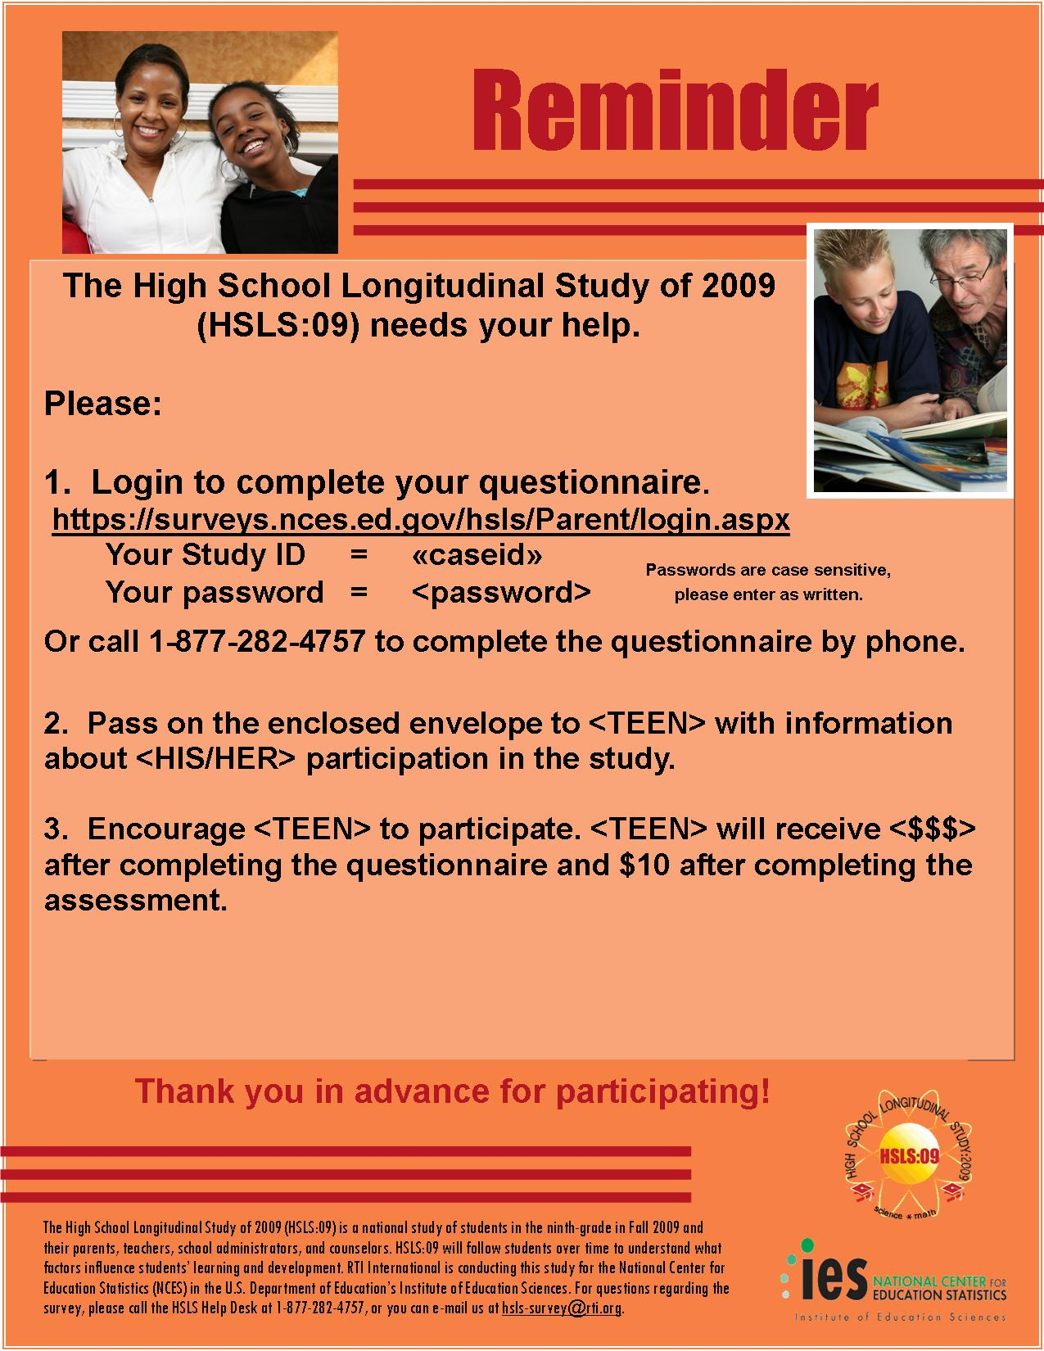

Parent and Student: Subsequent Flyer
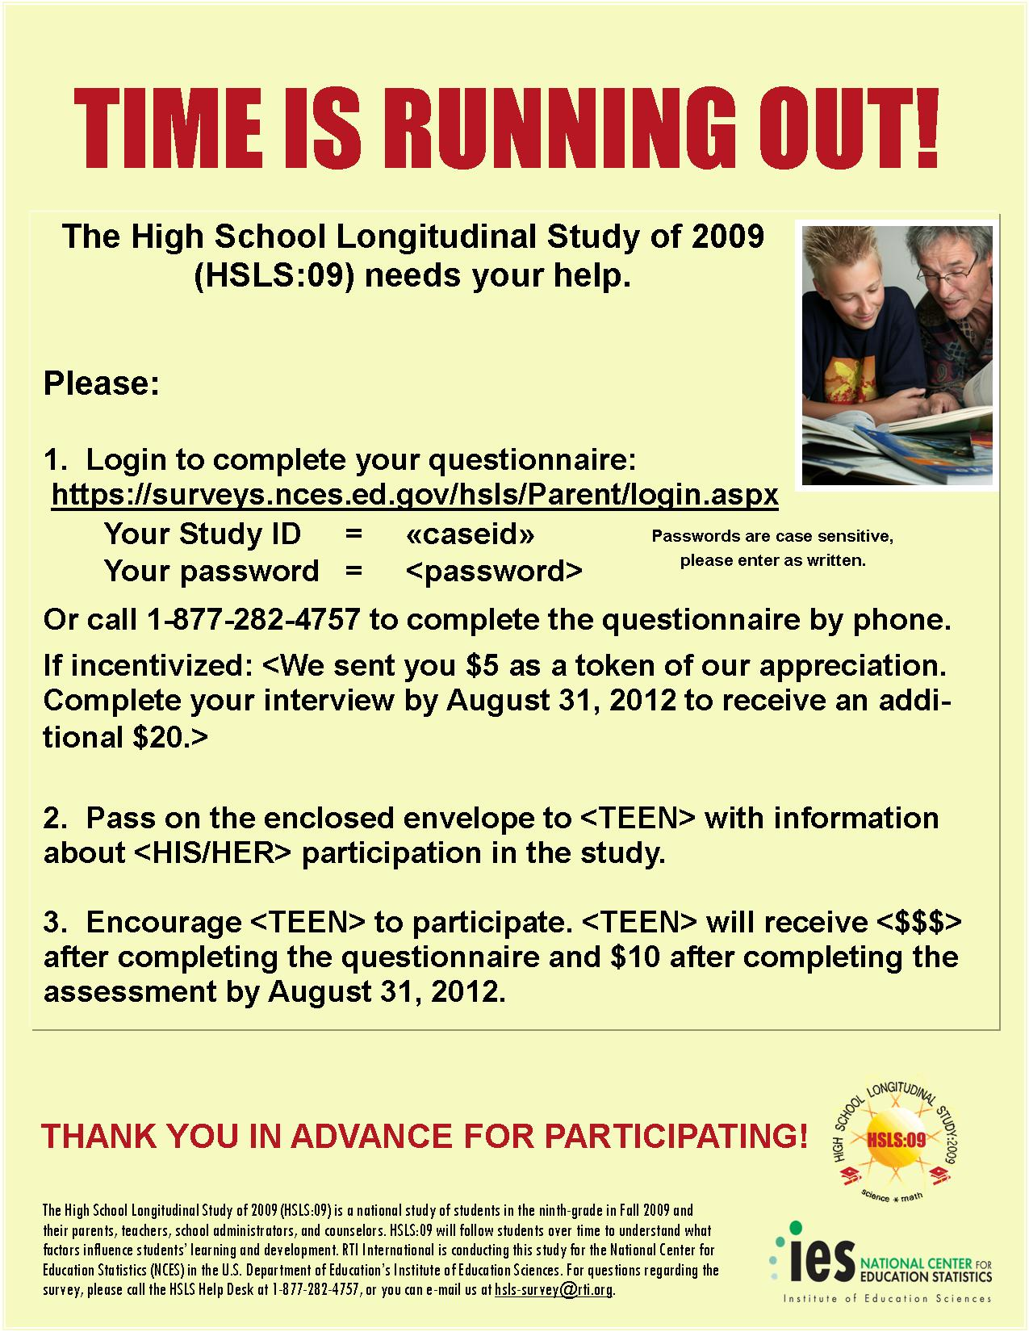

Parent Complete or Not in Subsample; Student Interview Needed Communications

Parent Complete or not in Subsample/Student Needed: Initial Contact Letter

[DATE]

<PARENT NAME> Web address: surveys.nces.ed.gov/hsls
<ADDR1> Parent study ID: <XXXXXXXX>
<ADDR2> Parent password: <XXXXXXXX><PW_ind>
<CITY STATE ZIP>
Dear <Parent or Guardian Name>:
About two-and-a-half years ago, <STUDENT NAME> < “participated” / “was selected to participate”> in the High School Longitudinal Study of 2009 (HSLS:09), sponsored by the National Center for Education Statistics (NCES) in the U.S. Department of Education’s Institute of Education Sciences. A follow-up survey to HSLS:09 is now underway, and we would like your teenager to complete an interview and a math assessment.
<STUDENT NAME>’s participation is voluntary, but very important to contribute. With more than 21,000 students in the study, the HSLS:09 will inform policymakers on how the experience of high school impacts learning, as well as future educational and career pathways. Even large educational organizations have endorsed HSLS:09 such as the National Parent Teacher Association (National PTA), the National Education Association (NEA), and the American Federation of Teachers (AFT),
The student interview includes a 35-minute questionnaire and a 40-minute mathematics assessment, which will not be shared with teachers or school officials. We will send <STUDENT_FNAME> a check for $<int_inc> for finishing the interview, and $10 for finishing the math assessment in appreciation for participating.
Please give < STUDENT_FNAME > the enclosed letter which describes the study and provides log-in information. Giving the enclosed letter to your teenager indicates that you consent to allow your teenager to participate. If you prefer, you may also consent by logging in to the website listed above and entering the parent study ID and parent password. Data collected are used only for statistical purposes and may not be disclosed or used, in identifiable form for any other purpose except as required by law (Public Law 107-279, Section 183).
HSLS:09 is conducted by RTI International under contract with NCES. The enclosed brochure provides more information about HSLS:09 and RTI. In addition, results from prior studies are available on the HSLS website given above. If you have questions about the study, please call Randy Ottem toll-free at 1-877-282-4757. If you have questions about your rights as a study participant, you may call RTI’s Office for Research Protection toll-free at 1-866-214-2043.
We thank you in advance for your cooperation in this important research.
Sincerely,

Jack Buckley
Commissioner
National Center for Education Statistics
Institute of Education Sciences
U.S. Department of Education

Enclosure: HSLS:09 Brochure
Student letter
NCES is authorized to conduct HSLS:09 under the Education Sciences Reform Act of 2002 (Public Law 107-279, Section 153). According to the Paperwork Reduction Act of 1995, no persons are required to respond to a collection of information unless it displays a valid OMB control number. The valid OMB control number of this information collection is 1850-0852, and the study is completely voluntary. The time required to complete the information collection for students is estimated to average 75 minutes per response, including the time to review instructions and complete a questionnaire and an assessment. If you have any comments concerning the accuracy of the time estimate or suggestions for improving the interview, please write to: High School Longitudinal Study of 2009 (HSLS:09), National Center for Education Statistics, 1990 K Street NW, Washington, DC 20006.

Parent Complete or Not in Subsample/Student Needed: Subsequent Contact Letter

[DATE]

<PARENT NAME> Web Address: surveys.nces.ed.gov/hsls
<ADDR1> Parent Study ID: <XXXXXXXX>
<ADDR2> Parent Password: <XXXXXXXX><PW_ind>
<CITY STATE ZIP>
Dear <Parent or Guardian Name>:
<<A VARIETY OF INTRODUCTIONS WILL BE INSERTED INTO THIS LETTER WHICH CAN BE FOUND ON THE NEXT PAGE>>
<STUDENT_FNAME>’s participation is voluntary, but is very important to the success of the study. The interview will take approximately 35 minutes to complete. In addition, we are also asking that <STUDENT_FNAME> complete a 40 minute math assessment, which will not be shared with teachers or school officials. We will send <STUDENT_FNAME> a check for $<int_inc> for finishing the interview, and $10 for finishing the math assessment in appreciation for participating.
For your teenager’s interview and math assessment, please give <STUDENT_FNAME> the enclosed letter, which describes the study and provides login information. Giving the enclosed letter to your teenager indicates that you consent to allow your teenager to participate. If you prefer, you may also give your consent by logging into the website listed above, using the “Parent Study ID” and “Parent Password.”
Conducted by RTI International under contract with NCES, HSLS:09 has been endorsed by organizations such as the National Parent Teacher Association (National PTA), the National Education Association (NEA), and the American Federation of Teachers (AFT). The enclosed brochure provides more information about HSLS:09 and RTI. Data collected are used only for statistical purposes and may not be disclosed, or used, in identifiable form for any other purpose except as required by law (Public Law 107-279, Section 183). If you have questions about the study, please call Randy Ottem toll-free at 1-877-282-4757 or the NCES Project Officer of HSLS, Dr. Laura LoGerfo, at 202-502-7402. If you have questions about your rights as a study participant, you may call RTI’s Office for Research Protection toll-free at 1-866-214-2043.
We thank you in advance for your cooperation in this important research.
Sincerely,

Dan Pratt
HSLS:09 Project Director
RTI International

Enclosure: Student Letter

NCES is authorized to conduct HSLS:09 under the Education Sciences Reform Act of 2002 (Public Law 107-279, Section 153). According to the Paperwork Reduction Act of 1995, no persons are required to respond to a collection of information unless it displays a valid OMB control number. The valid OMB control number of this information collection is 1850-0852, and the study is completely voluntary. The time required to complete this information collection is estimated to average 75 minutes for teenagers, including the time to review instructions, search existing data resources, gather the data needed, and complete and review the information collection. If you have any comments concerning the accuracy of the time estimate or suggestions for improving the interview, please write to: High School Longitudinal Study of 2009 (HSLS:09), National Center for Education Statistics, 1990 K Street NW, Washington, DC 20006.

Parent Complete or Not in Subsample/Student Needed: Introductions to Subsequent Contact Letter
Introduction A:
We are writing to ask for <<StudentFirstName>>‘s participation in the High School Longitudinal Study of 2009 (HSLS:09) by completing a student interview and assessment. <<IF PARENT COMPLETED: We sincerely appreciate your valuable time completing the parent follow-up.>> HSLS:09 will help researchers and policymakers understand how the home environment affects students’ learning and what decisions they decide to make during and after high school.
Introduction B:
<<IF PARENT COMPLETED: Thank you very much for participating in the High School Longitudinal Study of 2009 (HSLS:09).>> We are writing to ask that <<StudentFirstName>> <<IF PARENT COMPLETED: also complete their questionnaire and math assessment>> <<IF PARENT NOT IN SUBSAMPLE: complete a questionnaire and math assessment for the High School Longitudinal Study of 2009 (HSLS:09).>> With your teenager’s input, researchers will have a complete picture of how experiences in high school and the home environment influence the paths students take after high school.
Introduction C:
Your participation in the first follow-up to the High School Longitudinal Study of 2009 (HSLS:09) is greatly appreciated. <<StudentFirstName>>‘s completion of the student interview and assessment is an essential component to the High School Longitudinal Study of 2009 (HSLS:09). This exciting study focuses on students and their parents, school administrators, and school counselors to understand how the home environment affects students’ learning and their decisions during and after high school
Introduction D:
We would like to hear <<Student first name>>’s perspective on experiences in high school in order to understand how they impact learning, and education and career choices. For that reason, we are asking you to please encourage <<StudentFirstName>> to complete the student interview and the math assessment. Your teenager’s participation will help policymakers and researchers make informed decisions about education practices and policy.
Introduction E:
We are writing to ask that <<StudentFirstName>> participate in the High School Longitudinal Study of 2009 (HSLS:09) by completing the student interview and math assessment. To fully understand your teenager’s experience we need their input. Please encourage <<StudentFirstName>> to participate in the study today.
Introduction F:
Thank you for your family’s participation in the High School Longitudinal Study of 2009 (HSLS:09). Your unique perspective will help researchers and policy makers understand what it takes for students to be successful. We would still like to interview <<StudentFirstName>> for the HSLS:09 First Follow-up Study so that we have a complete picture of the high school experience.
Introduction G:
<<StudentFirstName>>‘s input is key to the success of the High School Longitudinal Study of 2009 (HSLS:09). We would like your teenager to complete the student interview and assessment as well before the study ends on <DATE>. The time spent completing the HSLS:09 interviews could greatly benefit the future of high school education in the U.S. We sincerely appreciate your family’s participation.

Parent Complete or Not in Subsample/Student Needed: Flyer
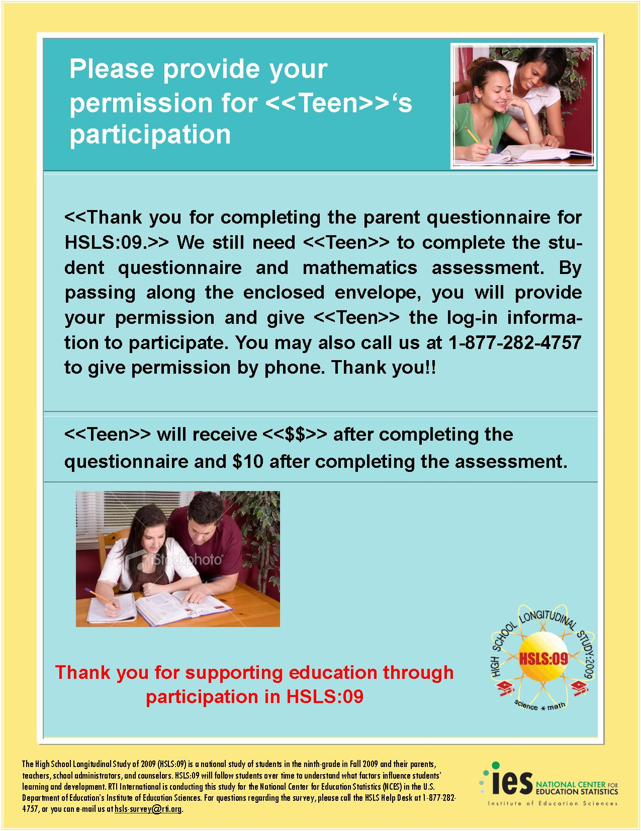

Student Interview and Assessment Needed Communications

Student Interview and Assessment Needed: Initial Contact Letter

[DATE]

<STUDENT NAME> Web Address: surveys.nces.ed.gov/hsls
<ADDR1> Student Study ID: <XXXXXXXX>
<ADDR2> Parent Password: <XXXXXXXX><PW_ind>
<CITY STATE ZIP>
Dear <Student Name>:
About two-and-a-half years ago, you < “participated” / “were selected to participate”> in the High School Longitudinal Study of 2009 (HSLS:09), sponsored by the Institute of Education Science’s National Center for Education Statistics (NCES), which is the statistical agency of the U.S. Department of Education. As you may remember, HSLS:09 will follow a group of high school students through high school and beyond, such as college and the labor force, to understand how the experiences of high school impact student learning and decisions about education and careers. Along with 21,000 students from across the United States, your answers could contribute to research and influence policymakers’ decisions about high school education in the U.S.
Your participation is voluntary but extremely important to the success of this study. The study will include a 35-minute questionnaire and a 40-minute mathematics assessment. Your answers will never be shared with your parents, teachers, or school staff. We will send you a check for $<int_inc> after you complete the interview, and another $10 after you complete the math assessment. You may access the interview and the assessment by using the web link and the unique student study ID and password provided above.
HSLS:09 is conducted by RTI International under contract with NCES. Data collected are used only for statistical purposes and may not be disclosed or used, in identifiable form for any other purpose except as required by law (Public Law 107-279, Section 183). The enclosed brochure provides more information about HSLS:09 and RTI. In addition, results from the first round of the study are available on the HSLS website given above. If you have questions about the study, please call Randy Ottem toll-free at 1-877-282-4757. If you have questions about your rights as a study participant, you may call RTI’s Office for Research Protection toll-free at 1-866-214-2043. If you have questions about your rights as a study participant, you may call RTI’s Office for Research Protection toll-free at 1-866-214-2043.
We thank you in advance for your cooperation in this important research.
Sincerely,

Jack Buckley
Commissioner
National Center for Education Statistics
Institute of Education Sciences
U.S. Department of Education

Enclosure: HSLS:09 Brochure

NCES is authorized to conduct HSLS:09 under the Education Sciences Reform Act of 2002 (Public Law 107-279, Section 153). According to the Paperwork Reduction Act of 1995, no persons are required to respond to a collection of information unless it displays a valid OMB control number. The valid OMB control number of this information collection is 1850-0852, and the study is completely voluntary. The time required to complete the information collection for students is estimated to average 75 minutes per response, including the time to review instructions, search existing data resources, gather the data needed, and complete and review the information collection. If you have any comments concerning the accuracy of the time estimate or suggestions for improving the interview, please write to: High School Longitudinal Study of 2009 (HSLS:09), National Center for Education Statistics, 1990 K Street NW, Washington, DC 20006.

Student Interview and Assessment Needed: Subsequent Contact Letter
[Date]

«fname» «mname» «lname» «suffix» Study ID: «caseid»
«addr1» Password: «password»<PW_ind>
«addr2»
«city», «state» «zip» «zip4»

Dear «fname» «lname»:
<<A VARIETY OF INTRODUCTIONS WILL BE INSERTED INTO THIS LETTER WHICH CAN BE FOUND ON THE NEXT PAGE>>
Your participation is voluntary but extremely important to the success of this study. The study will include a 35-minute questionnaire and a 40-minute mathematics assessment. Your answers will never be shared with your parents, teachers, or school staff. We will send you a check for $<int_inc> after you complete the interview, and another $10 after you complete the math assessment.
To make your participation as convenient as possible, you can complete the interview by web or phone. If you prefer to respond by web, log into our secure site at https://surveys.nces.ed.gov/hsls/ using the study ID and password provided above. Although the math assessment can only be completed online, you can complete the interview portion by phone by calling toll-free at 1-877-282-4757.
Conducted by RTI International under contract with NCES, HSLS:09 has been endorsed by organizations such as the National Parent Teacher Association (National PTA), the National Education Association (NEA), and the American Federation of Teachers (AFT). The enclosed brochure provides more information about HSLS:09 and RTI. Data collected are used only for statistical purposes and may not be disclosed, or used, in identifiable form for any other purpose except as required by law (Public Law 107-279, Section 183). If you have questions about the study, please call Randy Ottem toll-free at 1-877-282-4757 or the NCES Project Officer of HSLS, Dr. Laura LoGerfo, at 202-502-7402. If you have questions about your rights as a study participant, you may call RTI’s Office for Research Protection toll-free at 1-866-214-2043.
Thank you in advance for making HSLS:09 a success!
Sincerely,

Dan Pratt
HSLS:09 Project Director
RTI International

NCES is authorized to conduct HSLS:09 under the Education Sciences Reform Act of 2002 (Public Law 107-279, Section 153). According to the Paperwork Reduction Act of 1995, no persons are required to respond to a collection of information unless it displays a valid OMB control number. The valid OMB control number of this information collection is 1850-0852, and it is completely voluntary. The time required to complete this information collection is estimated to average 75 minutes per response, including the time to review instructions, search existing data resources, gather the data needed, and complete and review the information collection. If you have any comments concerning the accuracy of the time estimate or suggestions for improving the interview, please write to: High School Longitudinal Study of 2009 (HSLS:09), National Center for Education Statistics, 1990 K Street NW, Washington, DC 20006.

Student Interview and Assessment Needed: Introductions to Subsequent Contact Letter
Introduction A:
We are writing to ask that you please participate in a follow-up to the High School Longitudinal Study of 2009 (HSLS:09). As you may remember, HSLS:09 will follow a group of high school students through high school and into college or the labor force to understand how the experiences of high school impact student learning and decisions about education and careers. Along with 21,000 students from across the United States, your answers will contribute to research and will influence policymakers’ decisions about high school education in the U.S.
Introduction B:
The High School Longitudinal Study of 2009 (HSLS:09) wants to know how high school experience impacts student learning and decisions during and after high school about education and career choices. Your perspective is very important to us. Please take this time to complete the questionnaire and assessment.
Introduction C:
You can be a voice for high school teenagers across the nation by participating in the High School Longitudinal Study of 2009 (HSLS:09). Share your experiences and perspectives on what it takes for teenagers to be successful in school, and you will contribute to research and inform policymakers’ decisions on the future of high school education in the United States.
Introduction D:
We need teenagers like you to make this study successful before the High School Longitudinal Study of 2009 (HSLS:09) Follow-Up Study ends on <DATE>. As you may remember, HSLS:09 will follow a group of high school students through high school and beyond, such as college and the labor force, to understand how the experiences of high school impact student learning and decisions about education and careers. Along with 21,000 students from across the United States, your answers will contribute to research and will influence policymakers’ decisions about high school education in the U.S.

Student Interview and Assessment Needed: Initial Postcard

PO Box 12194
Research Triangle Park, NC 27709-2194
RTI Project #0212678.002.235

ADDRESS SERVICE REQUESTED

«fname»«mname»«lname»«suffix»

«addr1»

«addr2»

«city», «state» «zip» «zip4»

Panel info: «panelinfo»
Study ID: «caseid»

High School
Longitudinal
Study of 2009
Dear <Student_Name>,
Your unique experience in high school will help educators, researchers, and policymakers improve education in the United States. Please complete the student interview and math assessment for the first follow-up to the High School Longitudinal Study of 2009 (HSLS:09). For our appreciation, we will send you $<int_incent> for completing the interview and $10 for completing the math assessment.
To complete a web interview over our secure website, log in to https://surveys.nces.ed.gov/hsls using the information below:

Study ID = «userid» Password = «password»<PW_ind>
RTI International is conducting this study for the National Center for Education Statistics (NCES) in the U.S. Department of Education’s Institute of Education Sciences. If you have any questions or problems completing your web interview, or would like to complete the interview by telephone with a professionally trained interviewer, please contact the HSLS help desk at 1-877-282-4757.

Thank you.

Student Interview and Assessment Needed: Subsequent Postcard
PO Box 12194
Research Triangle Park, NC 27709-2194
RTI Project #0212678.002.235

ADDRESS SERVICE REQUESTED

«fname»«mname»«lname»«suffix»

«addr1»

«addr2»

«city», «state» «zip» «zip4»

Panel info: «panelinfo»
Study ID: «caseid»

High School
Longitudinal
Study of 2009
Dear <Student_Name>,
We are writing to ask that you please complete the student interview and assessment for the High School Longitudinal Study of 2009 (HSLS:09). Only you can provide the insight into your high school experience to help educators, researchers, and policymakers improve high school education in the United States. After you complete the interview and the assessment, we will send you $<int_incent> for completing the interview and $10 for completing the math assessment as a token of our appreciation.
To complete a web interview over our secure website, log in to https://surveys.nces.ed.gov/hsls using the information below:

Study ID = «userid» Password = «password»<PW_ind>
RTI is conducting this study for the National Center for Education Statistics (NCES) in the U.S. Department of Education’s Institute of Education Sciences. If you have any questions or problems completing your web interview, or would like to complete the interview by telephone with a professionally trained interviewer, please contact the HSLS help desk at 1-877-282-4757.

Thank you.

Student Interview and Assessment Needed: Flyer
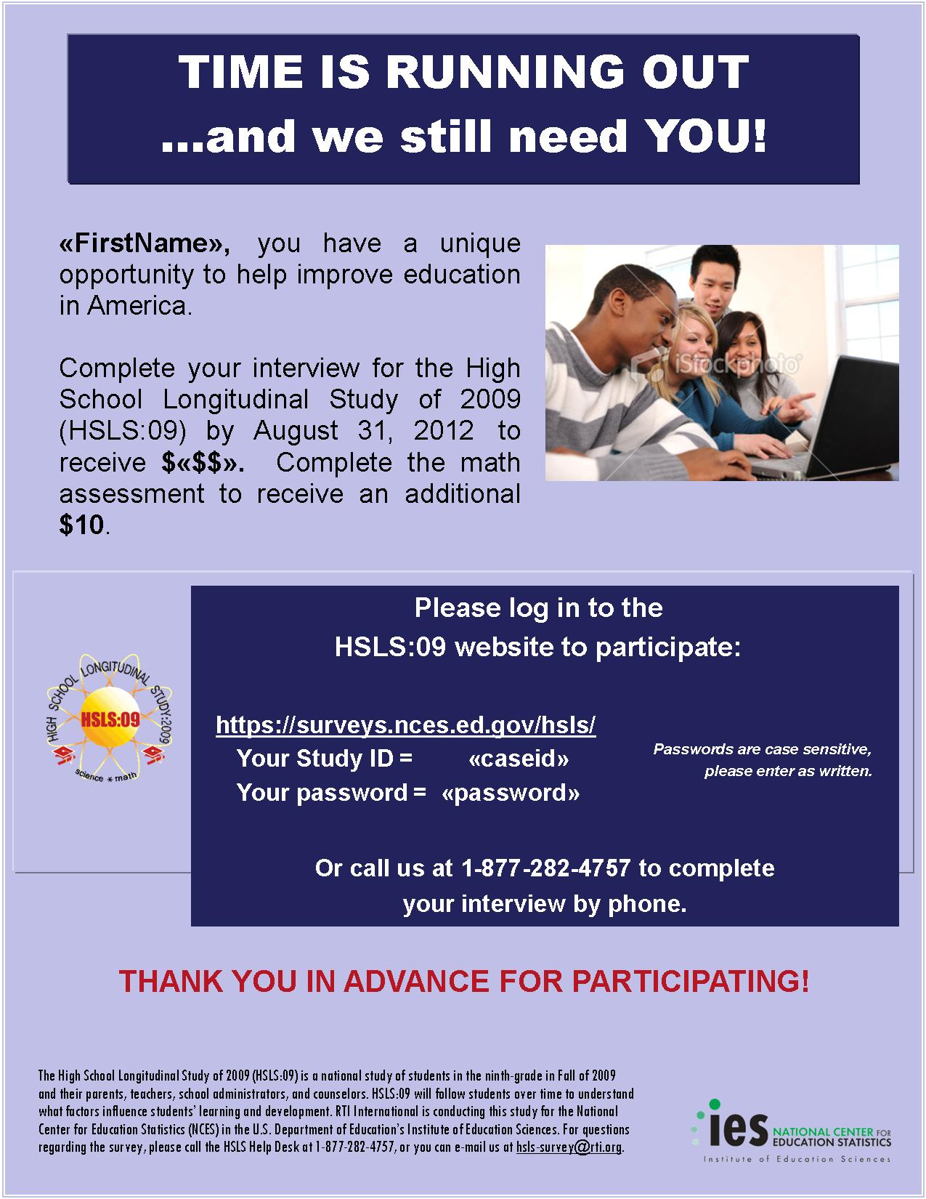

Student Assessment Needed Communications

Student Assessment Only: Initial Contact Letter
[Date]

«fname» «mname» «lname» «suffix» Study ID: «caseid»
«addr1» Password: «password»<PW_ind>
«addr2»
«city», «state» «zip» «zip4»

Dear «fname» «lname»:

We are writing to ask that you complete the High School Longitudinal Study of 2009 (HSLS:09) mathematics assessment. You have already completed the student questionnaire and we are very grateful for the valuable input you have provided. By completing the 40-minute assessment online, you will be helping to provide a complete picture of the high school experience.
Your participation is voluntary, and your answers to the assessment will not be shared with your school or your parents. You can login to the assessment at https://surveys.nces.ed.gov/hsls/ by using the study ID and password provided above. We will send you another $10 for completing the assessment, <end-date fill: if you complete it before <DATE>>, as a token of our appreciation.
Conducted by RTI International under contract with NCES, HSLS:09 has been endorsed by organizations such as the National Parent Teacher Association (National PTA), the National Education Association (NEA), and the American Federation of Teachers (AFT). The enclosed brochure provides more information about HSLS:09 and RTI. Data collected are used only for statistical purposes and may not be disclosed, or used, in identifiable form for any other purpose except as required by law (Public Law 107-279, Section 183). If you have questions about the study, please call Randy Ottem toll-free at 1-877-282-4757 or the NCES Project Officer of HSLS, Dr. Laura LoGerfo, at 202-502-7402. If you have questions about your rights as a study participant, you may call RTI’s Office for Research Protection toll-free at 1-866-214-2043.
Thank you in advance for making HSLS:09 a success!
Sincerely,

Dan Pratt
HSLS:09 Project Director
RTI International

NCES is authorized to conduct HSLS:09 under the Education Sciences Reform Act of 2002 (Public Law 107-279, Section 153). According to the Paperwork Reduction Act of 1995, no persons are required to respond to a collection of information unless it displays a valid OMB control number. The valid OMB control number of this information collection is 1850-0852, and it is completely voluntary. The time required to complete this information collection is estimated to average 40 minutes per response, including the time to review instructions, search existing data resources, gather the data needed, and complete and review the information collection. If you have any comments concerning the accuracy of the time estimate or suggestions for improving the interview, please write to: High School Longitudinal Study of 2009 (HSLS:09), National Center for Education Statistics, 1990 K Street NW, Washington, DC 20006.

Student Assessment Only: Subsequent Contact Letter
[Date]

«fname» «mname» «lname» «suffix» Study ID: «caseid»
«addr1» Password: «password»<PW_ind>
«addr2»
«city», «state» «zip» «zip4»

Dear «fname» «lname»:
<<A VARIETY OF INTRODUCTIONS WILL BE INSERTED INTO THIS LETTER WHICH CAN BE FOUND ON THE NEXT PAGE>>
Your participation is voluntary, and your answers to the assessment will not be shared with your school or your parents. You can login to the assessment at https://surveys.nces.ed.gov/hsls/ by using the study ID and password provided above. We will send you another $10 for completing the assessment, <end-date fill: if you complete it before <DATE>>, as a token of our appreciation.
Conducted by RTI International under contract with NCES, HSLS:09 has been endorsed by organizations such as the National Parent Teacher Association (National PTA), the National Education Association (NEA), and the American Federation of Teachers (AFT). The enclosed brochure provides more information about HSLS:09 and RTI. Data collected are used only for statistical purposes and may not be disclosed, or used, in identifiable form for any other purpose except as required by law (Public Law 107-279, Section 183). If you have questions about the study, please call Randy Ottem toll-free at 1-877-282-4757 or the NCES Project Officer of HSLS, Dr. Laura LoGerfo, at 202-502-7402. If you have questions about your rights as a study participant, you may call RTI’s Office for Research Protection toll-free at 1-866-214-2043.
Thank you in advance for making HSLS:09 a success!
Sincerely,
Dan Pratt
HSLS:09 Project Director
RTI International

NCES is authorized to conduct HSLS:09 under the Education Sciences Reform Act of 2002 (Public Law 107-279, Section 153). According to the Paperwork Reduction Act of 1995, no persons are required to respond to a collection of information unless it displays a valid OMB control number. The valid OMB control number of this information collection is 1850-0852, and it is completely voluntary. The time required to complete this information collection is estimated to average 40 minutes per response, including the time to review instructions, search existing data resources, gather the data needed, and complete and review the information collection. If you have any comments concerning the accuracy of the time estimate or suggestions for improving the interview, please write to: High School Longitudinal Study of 2009 (HSLS:09), National Center for Education Statistics, 1990 K Street NW, Washington, DC 20006.

Student Assessment Only: Introductions to Subsequent Contact Letter
Introduction A:
Please take the time to complete the High School Longitudinal Study of 2009 (HSLS:09) mathematics assessment. It will take about 40 minutes of your time and can be completed online at your convenience. You’ve already provided valuable information on the questionnaire, and we want to express our appreciation.
Introduction B:
We are writing to remind you to please complete your mathematics assessment for the High School Longitudinal Study of 2009 (HSLS:09). You have already completed the student questionnaire and we thank you. Completing the 40 minute math assessment will help ensure that we have a complete picture of high school as experienced by real students.
Introduction C:
Please take the time to complete the math assessment for the High School Longitudinal Study of 2009 (HSLS:09) before the study ends on <DATE>. HSLS:09 is interested in understanding how the school and home environment influences the decisions you make through high school and beyond. We need teenagers like you to make this study successful. The input that you already provided on the questionnaire is most appreciated.

Administrator Contact Communications

Administrator: Initial Contact Letter

[Date]

«adminname»  «schoolname»  «addr1» «addr2»  «citystzip» | Web Address: https://surveys.nces.ed.gov/hsls/  (Click on “Admin login”)  Your Study ID: «caseID»  Your Password: «passwd»m

Dear «adminname»:
<< NONPARTICIPATING SCHOOL: The first follow-up to the High School Longitudinal Study of 2009 (HSLS:09) is now underway and we thank you for your school’s continued participation in this important research.>> <<NONPARTICIPATING SCHOOL: <SAMPLED SCHOOL NAME> participated in the U.S. Department of Education’s High School Longitudinal Study (HSLS:09) in the fall of 2009. We understand that your school is unable to participate in the student component of the first follow-up study and we respect your decision. However, it is important that we collect follow-up data from each of the schools that participated in 2009. For that reason, we ask that you complete an administrator questionnaire. >> HSLS:09 seeks to understand the impact of the high school experience on students’ learning and their education and career choices, and explores the transitions students make from high school to further education, the labor force, and adulthood. HSLS:09 is being conducted by RTI International for the U.S. Department of Education’s National Center for Education Statistics (NCES).

We are asking you to complete a 30-minute questionnaire to provide your insight into the administration and policies at your school. To access the questionnaire, the web address and your unique study ID and password are provided above. The questionnaire’s first three sections mainly request factual information about your school and its programs and can be answered by you or a designee who is able to provide this information. The final section asks for subjective reports on the school climate, and we ask that this section be completed by the principal only. If someone other than you completes the initial portion of the questionnaire, please let us know so that we can give that person their own log-in credentials.
Data collected are used only for statistical purposes and may not be disclosed or used, in identifiable form for any other purpose except as required by law (Public Law 107-279, Section 183). The data collected will be used by researchers, educators, and policymakers to understand students’ coursetaking behaviors, motivation and achievement, and how students decide what pathways to follow during and after high school. Information collected from students, parents, teachers, counselors, and school administrators will help to inform and shape efforts to improve the quality of the high school experience, including math and science education in America.
HSLS:09 is endorsed by the National Association of Secondary School Principals, the American Association of School Administrators, the National Education Association and the National School Boards Association, among others. The enclosed brochure provides more information about HSLS:09. If you have any questions about your participation in the survey, please call Ms. Jane Griffin at RTI, toll-free at 1-877-292-HSLS (1-877-292-4757). If you have questions about your rights as a study participant, you may call RTI’s Office for Research Protection at 919-316-3358 in Durham, NC or toll-free at 1-866-214-2043.

We thank you in advance for your cooperation in this important research.
Sincerely,

Jack Buckley
Commissioner
National Center for Education Statistics
Institute of Education Sciences
U.S. Department of Education

Enclosure:HSLS:09 Brochure

NCES is authorized to conduct HSLS:09 under the Education Sciences Reform Act of 2002 (Public Law 107-279, Section 153). According to the Paperwork Reduction Act of 1995, no persons are required to respond to a collection of information unless it displays a valid OMB control number. The valid OMB control number of this information collection is 1850-0852, and it is completely voluntary. The time required to complete this information collection is estimated to average 30 minutes per response, including the time to review instructions, search existing data resources, gather the data needed, and complete and review the information collection. If you have any comments concerning the accuracy of the time estimate or suggestions for improving the interview, please write to: High School Longitudinal Study of 2009 (HSLS:09), National Center for Education Statistics, 1990 K Street NW, Washington, DC 20006.

Administrator: Subsequent Reminder Letter

[Date]

<SCHOOL ADMIN NAME>  <SCHOOL NAME> |  | Web Address:  Your STUDY ID: | https://surveys.nces.ed.gov/hsls  <XXXXXXXX>
<ADDR1> |  | Your PASSWORD: | <XXXXXXXX>n
<ADDR1>
<CITY STATE ZIP>
Dear <School Administrator>:
<<<A VARIETY OF INTRODUCTIONS WILL BE INSERTED INTO THIS LETTER WHICH CAN BE FOUND ON THE NEXT PAGE>>

The interview should take approximately 30 minutes to complete. You are only required to complete the final section of the interview; you may designate someone else who is knowledgeable about your school to complete the first three sections. If you wish to have someone else complete the interview, please call the HSLS:09 help desk toll-free at (877) 292-4757 to get log-in information for your designee.
You may also call us at that number to complete the interview with one of our professional telephone interviewers, or you may complete it via the Web by logging in to our secure website and using the study ID and password provided above.
Data collected are used only for statistical purposes and may not be disclosed or used, in identifiable form for any other purpose except as required by law (Public Law 107-279, Section 183). RTI is conducting this study for the National Center for Education Statistics (NCES) in the U.S. Department of Education’s Institute of Education Sciences. If you have already completed the interview, we would like to thank you. Your assistance is very much appreciated. If you have any questions or concerns about the study, please contact Jane Griffin, toll free at (877) 292-4757, or the NCES Project Officer, Dr. Laura LoGerfo, at 202-502-7402.
Thank you in advance for making HSLS:09 a success!
Sincerely,
Dan Pratt
HSLS:09 Project Director
RTI International

NCES is authorized to conduct HSLS:09 under the Education Sciences Reform Act of 2002 (Public Law 107-279, Section 153). According to the Paperwork Reduction Act of 1995, no persons are required to respond to a collection of information unless it displays a valid OMB control number. The valid OMB control number of this information collection is 1850-0852, and it is completely voluntary. The time required to complete this information collection is estimated to average 30 minutes per response, including the time to review instructions, search existing data resources, gather the data needed, and complete and review the information collection. If you have any comments concerning the accuracy of the time estimate or suggestions for improving the interview, please write to: High School Longitudinal Study of 2009 (HSLS:09), National Center for Education Statistics, 1990 K Street NW, Washington, DC 20006.

Administrator: Introductions to Subsequent Reminder Letters

Introduction A:
Recently, we sent you information on how to complete your interview for the first follow-up to the High School Longitudinal Study of 2009 (HSLS:09). This round of HSLS:09 is a continuation of a study that follows a cohort of teenagers through and after high school to understand the impact of the high school experience on students’ learning and their education and career choices. As an administrator at <SCHOOL NAME>, your knowledge of the school’s academic policies and programs and their impact on student learning is crucial to the success of this study. We also ask for your unique viewpoint as an administrator to make this study as well rounded as possible.

Introduction B:

This is a friendly reminder to please complete your questionnaire for the first follow-up to the High School Longitudinal Study of 2009 (HSLS). Your input about your school’s academic policies and programs and their impact on student learning is crucial the study’s success.

Introduction C:

Earlier this spring, we sent you information on how to complete your survey for the first follow-up to the High School Longitudinal Study of 2009 (HSLS:09). As you may remember, this round of HSLS:09 is a continuation of a study that is following a cohort of students through high school and into further education, the labor force, and adult roles. In addition to exploring the transition from high school to beyond, HSLS:09 focuses on the impact of the high school experience on students’ learning and their education and career choices. We need your help to understand the school’s academic policies and programs. Your unique viewpoint is valuable to obtain a full picture of the education experience

Introduction D:
We have been trying to reach you in regards to the administrator questionnaire for the High School Longitudinal Study (HSLS:09). Your input about your school’s academic policies and programs and their impact on student learning is crucial the study’s success. The current questionnaire is for the first follow-up to the study we are conducting in your school this spring. HSLS:09 explores the transitions students make from high school to beyond in a cohort of high school students.
Introduction E:

We understand that as the principal at <SCHOOL_NAME>, you are very busy. However, we are nearing the end of our data collection period and your unique perspective is critically important to the success of the first follow-up to the High School Longitudinal Study (HSLS:09). We are asking that you complete the questionnaire by <END_DATE>.

Administrator: Postcard
PO Box 12194
Research Triangle Park, NC 27709-2194
RTI Project #0212678.002.335
ADDRESS SERVICE REQUESTED

«fname»«mname»«lname»«suffix»

«addr1»

«addr2»

«city», «state» «zip» «zip4»

Panel info: «panelinfo»
Study ID: «caseid»

High School
Longitudinal
Study of 2009

<SCHOOL_NAME> is participating in the first follow-up to the High School Longitudinal Study of 2009 (HSLS:09). We know your time is valuable, but we are asking that you take some time to lend us your unique insight into your high school to help educators, researchers, and policymakers improve high school education in the United States. RTI is conducting this study for the National Center for Education Statistics (NCES) in the U.S. Department of Education’s Institute of Education Sciences. If you have already completed the interview, we would like to thank you. Your assistance is very much appreciated.
To complete an interview on the Web, log-in to our secure website, located at https://surveys.nces.ed.gov/hsls using the information below:

Study ID = «userid» Password = «password»q
If you have any questions or problems completing your web interview, or would like to complete the interview by telephone with a professionally trained interviewer, please contact the HSLS:09 help desk at 1-877-292-4757.
Thank you.

Counselor Contact Communications

Counselor: Initial Contact Letter
[Date]

«counselorname»  «schoolname»  «addr1» «addr2»  «citystzip» | Web Address: https://surveys.nces.ed.gov/hsls/  (Click on “Counselor login”)  Your Study ID: «caseID»  Your Password: «passwd»m

Dear «counselorname»:

Two years ago, «schoolname» participated in the High School Longitudinal Study of 2009 (HSLS:09), sponsored by the National Center for Education Statistics (NCES) in the U.S. Department of Education. Data collection has begun for the next round of the study and we need your unique perspective as a school counselor to make the study as successful as possible. The purpose of HSLS:09 is to understand the impact of the high school experience on students’ learning and educational and career choices and to explore the transitions from high school to further education, the work force, and adulthood. Students, counselors, and administrators from over 900 schools have participated in HSLS:09.

Your participation is voluntary; however, as a counselor at «schoolname», your understanding of the influence of the school’s academic policies and programs on the overall learning environment is crucial to the study. Therefore, we are asking that you complete an online questionnaire, which will take approximately 30 minutes to complete. To begin the questionnaire, please log in using the web link and unique study ID and password provided above.

Data collected are used only for statistical purposes and may not be disclosed or used, in identifiable form for any other purpose except as required by law (Public Law 107-279, Section 183). Information collected from students, parents, counselors, and school administrators will help to inform and shape efforts to improve the quality of the high school experience, including math and science education in America.

HSLS:09 is endorsed by the National Association of Secondary School Principals, the American Association of School Administrators, the National Education Association and the National School Boards Association, among others. The enclosed brochure provides more information about HSLS:09. If you have any questions about your participation in the survey, please call Ms. Jane Griffin at RTI, toll-free at 1-877-292-HSLS (1-877-292-4757). If you have questions about your rights as a study participant, you may call RTI’s Office for Research Protection at 919-316-3358 in Durham, NC or toll-free at 1-866-214-2043.

We thank you in advance for your cooperation in this important research.

Sincerely,

Jack Buckley
Commissioner
National Center for Education Statistics
Institute of Education Sciences
U.S. Department of Education

Enclosure: HSLS:09 Brochure

NCES is authorized to conduct HSLS:09 under the Education Sciences Reform Act of 2002 (Public Law 107-279, Section 153). According to the Paperwork Reduction Act of 1995, no persons are required to respond to a collection of information unless it displays a valid OMB control number. The valid OMB control number of this information collection is 1850-0852, and it is completely voluntary. The time required to complete this information collection is estimated to average 30 minutes per response, including the time to review instructions, search existing data resources, gather the data needed, and complete and review the information collection. If you have any comments concerning the accuracy of the time estimate or suggestions for improving the interview, please write to: High School Longitudinal Study of 2009 (HSLS:09), National Center for Education Statistics, 1990 K Street NW, Washington, DC 20006.

Counselor: Subsequent Contact Letter
[Date]

<COUNSELOR NAME>  <SCHOOL NAME> |  | Web Address:  Your STUDY ID: | https://surveys.nces.ed.gov/hsls  <XXXXXXXX>
<ADDR1> |  | Your PASSWORD: | <XXXXXXXX>n
<ADDR1>
<CITY STATE ZIP>
Dear <Counselor>:
<<A VARIETY OF INTRODUCTIONS WILL BE INSERTED INTO THIS LETTER WHICH CAN BE FOUND ON THE NEXT PAGE>>

The questionnaire should take approximately 30 minutes to complete. You may call us toll-free at 1-877-292-4757 to complete the questionnaire with one of our professional telephone interviewers, or you may complete the questionnaire via the Web using the web address and login information provided above.
Data collected are used only for statistical purposes and may not be disclosed or used, in identifiable form for any other purpose except as required by law (Public Law 107-279, Section 183). If you have questions or problems completing your questionnaire online, simply call the HSLS:09 help desk, toll free, at 1-877-292-4757.
RTI is conducting this study for the National Center for Education Statistics (NCES) in the U.S. Department of Education’s Institute of Education Sciences. If you have already completed the questionnaire, we would like to thank you. Your assistance is very much appreciated. If you have any questions or concerns about the study, please contact Jane Griffin at RTI, toll-free at 1-877-292- 4757, or the NCES Project Officer, Dr. Laura LoGerfo, at 202-502-7402.
Thank you in advance for making HSLS:09 a success!
Sincerely,
Dan Pratt
HSLS:09 Project Director
RTI International

NCES is authorized to conduct HSLS:09 under the Education Sciences Reform Act of 2002 (Public Law 107-279, Section 153). According to the Paperwork Reduction Act of 1995, no persons are required to respond to a collection of information unless it displays a valid OMB control number. The valid OMB control number of this information collection is 1850-0852, and it is completely voluntary. The time required to complete this information collection is estimated to average 30 minutes per response, including the time to review instructions, search existing data resources, gather the data needed, and complete and review the information collection. If you have any comments concerning the accuracy of the time estimate or suggestions for improving the interview, please write to: High School Longitudinal Study of 2009 (HSLS:09), National Center for Education Statistics, 1990 K Street NW, Washington, DC 20006.

Counselor: Introductions to Subsequent Reminder Letter
Introduction A:
Recently, we sent you information on how you can help make the High School Longitudinal Study of 2009 (HSLS:09) successful by completing your counselor questionnaire. As a counselor at <SCHOOL NAME>, your knowledge of the school’s academic policies and programs and their impact on student learning is crucial to the study. At the core of HSLS:09 is a cohort of students whom we are following through high school and into further education, the labor force, and adult roles. In addition to exploring the transition from high school to beyond, HSLS:09 also focuses on the impact of the high school experience on students’ learning and their education and career choices.
Introduction B:
We have been trying to reach you in regards to your participation in an important study, the High School Longitudinal Study of 2009 (HSLS:09). This study is the first follow-up to a study conducted at your school during the fall of 2009, and your school is participating again this spring. We are asking you to take approximately 30 minutes to complete your counselor questionnaire. Your input about your school’s academic policies and programs and their impact on student learning is crucial to the success of this study. HSLS:09 is a unique study that follows high school students through high school and into further education, the labor force, and adult roles. The study focuses on how high school experiences impact students’ learning and their education and career choices.
Introduction C:
We recently sent you information regarding the counselor questionnaire for the High School Longitudinal Study of 2009. As a counselor at <SCHOOL NAME>, your knowledge of the school’s academic policies and programs and their impact on student learning is crucial to the study. We are following a cohort of students through high school and into further education, the labor force, and adult roles. In addition to exploring the transition from high school to beyond, HSLS:09 also focuses on the impact of the high school experience on students’ learning and their education and career choices.
Introduction D:
Your school is participating in High School Longitudinal Study (HSLS:09) again this year. This study is the first follow-up to a study conducted during the fall of 2009 at your school. We are asking you to take approximately 30 minutes to complete the counselor questionnaire. As a counselor at a participating high school, your input about your school’s academic policies and programs and their impact on student learning is crucial to the success of this study. HSLS:09 is a unique study that follows high school students through high school and into further education, the labor force, and adult roles.
Introduction E:
Your school is participating in the High School Longitudinal Study of 2009 (HSLS:09). We understand that as a counselor at <SCHOOL_NAME>, you are very busy. However, we are asking that you take some time out of your schedule to complete this important questionnaire. It is very important that we hear from a counselor at each participating high school. The High School Longitudinal Study (HSLS:09) is interested in understanding how school and home factors influence student education and career choices, learning, and transitions from high school to beyond. HSLS:09 data collection will end on <END_DATE>.

Counselor: Postcard

PO Box 12194
Research Triangle Park, NC 27709-2194
RTI Project #0212678.002.235
ADDRESS SERVICE REQUESTED

«fname»«mname»«lname»«suffix»

«addr1»

«addr2»

«city», «state» «zip» «zip4»

Panel info: «panelinfo»
Study ID: «caseid»

High School
Longitudinal
Study of 2009
<SCHOOL_NAME> is participating in the first follow-up to the High School Longitudinal Study of 2009 (HSLS:09). We know your time is valuable, but we are asking that you take some time to lend us your unique insight into your high school to help educators, researchers, and policymakers improve high school education in the United States. RTI is conducting this study for the National Center for Education Statistics (NCES) in the U.S. Department of Education’s Institute of Education Sciences. If you have already completed the questionnaire, we would like to thank you. Your assistance is very much appreciated.
To complete an interview on the Web, log-in to our secure website, located at https://surveys.nces.ed.gov/hsls using the information below:

Study ID = «userid» Password = «password»q
If you have any questions or problems completing your web questionnaire, or would like to complete the questionnaire by telephone with a professionally trained interviewer, please contact the HSLS:09 help desk at 1-877-292-4757.
Thank you.

Staff Brochure

Staff Brochure for F1FS

[HSLS Brochure Logo]

High School Longitudinal Study of 2009

Conducted for:
National Center for Education Statistics
U.S. Department of Education
Institute of Education Sciences
Conducted by:
RTI International
Research Triangle Park, NC
27709-2194

High School Longitudinal Study of 2009
The National Center for Education Statistics (NCES) is conducting the first follow-up study to the High School Longitudinal Study of 2009 (HSLS:09), a national study of students and their parents, school administrators, and school counselors. HSLS:09 follows students over time to understand what home, school, peer, and community factors influence students’ learning and development. The study explores how these factors impact the high school experience, especially students’ education and career choices and the transitions students make after high school. In particular, HSLS:09 focuses on students’ education and career choices in science, technology, engineering, and mathematics (STEM).

In spring 2012, questionnaires will be administered to selected school administrators, school counselors, and students and their parents. High school transcripts will be collected in the 2013-2014 school year. Additional follow-ups are planned after high school.

Q. Why is the study being conducted?
A. HSLS:09 builds on and extends a series of longitudinal high school studies that have been conducted by the U.S. Department of Education each decade since 1972. The study measures math achievement and also investigates the role of home, school, and community influences on the plans and decisionmaking of ninth-graders and how those decisions may be linked to the students’ high school coursetaking and college and career decisions. The study follows a cohort of ninth-graders over time regardless of the path they take (for example, those who have left the school, those who go directly into the military or workforce after high school, and those who are college-bound). Information collected from students, parents, school administrators, and counselors will help inform and shape efforts to improve the quality of math and science education in the United States, to increase our global competitiveness in STEM-related fields, and to improve the high school experience.

Q. Who is conducting the study?
A. The first follow-up to HSLS:09 is sponsored by the National Center for Education Statistics in the U.S. Department of Education. NCES is authorized to conduct this study under the Education Sciences Reform Act of 2002 (Public Law 107-279, Section 153). Under that law, the data provided by schools, staff, students, and their parents may be used only for statistical purposes and may not be disclosed, or used, in identifiable form for any other purpose except as required by law (Public Law 107-279, Section 183). The study is conducted under contract by RTI International, a nonprofit research organization based in North Carolina. RTI International will provide professional survey administrators to collect data.

Q. When will the data for the study be collected?
A. Data collection for HSLS:09 began in fall 2009 and the first follow-up will occur in spring 2012. The next follow-up will take place in summer and fall of 2013 after most students have graduated. Transcripts will be collected during the 2013-2014 school year. Additional follow-ups are planned for 2015 and beyond.

Q. What topics will the questionnaires cover?
The HSLS:09 student questionnaire
The student questionnaire will cover such topics as:
• influences on teenagers’ decisions about high school courses, college and careers;
• beliefs and attitudes about math, science, and school in general;
• activities outside of school, including employment;
• factors that lead teenagers into or out of math, science, and technology courses;
• educational aspirations and expectations;
• preparation and plans for the teenager’s future;
• college costs and financial aid; and
• background information.

Students sampled in 2009 will complete a questionnaire and math assessment in 2012. The assessments and questionnaires will be completed on school computers, if available, or on laptop computers provided by the study for student use. Students who have left their ninth grade school at the time of the follow-up study will be contacted to complete the study via telephone or Web.

The HSLS:09 school administrator questionnaire
The school administrator questionnaire will cover such topics as:
• school characteristics;
• programs, services, and policies;
• school statistics;
• faculty characteristics, retention and recruitment;
• emphases of counseling program; and
• school administrator’s demographic, educational, and occupational background.

The HSLS:09 school administrator questionnaire is web-based and will take approximately 30 minutes to complete.

The HSLS:09 school counselor questionnaire
The counselor questionnaire will cover topics such as:
•counseling program’s staffing and time usage;
•programs and policies;
•graduation requirements;
•math and science course placement practices;
•AP and IB course offerings and enrollment;
•programs to encourage STEM;
•resources available to struggling and excelling students; and
•services to prepare students for college admission and workforce entry.

The HSLS:09 school counselor questionnaire is web-based and will take approximately 30 minutes to complete.

The HSLS:09 parent questionnaire
Selected parents of sampled students will complete a parent questionnaire which focuses on:
• home background and education support system;
• educational aspirations and expectations for the teenager
• preparation and plans for the teenager’s future; and
• college costs and financial aid.

The HSLS:09 parent questionnaire is web-based and will take approximately 30 minutes to complete. Parents who do not have computer access will have the option of completing a telephone interview.

Q. How many students are participating in HSLS:09?
A. Over 21,000 students from more than 900 schools have participated in HSLS:09 to date.

Q. How many school staff will be selected at each school?
A. The study will include questionnaires for the school administrator and one school counselor.

Q. Will parents be included in the study?
A. One parent of some sampled students will be asked to complete a parent questionnaire.

Q. Do states, school districts, schools, school staff, students, or parents have to participate?
A. Participation in HSLS:09 is entirely voluntary; however, the participation of every student, parent, school, and school staff is important to ensure the completeness and accuracy of results. The development of valid national results depends on a high rate of participation.

Q. What if a student decides not to participate?
A. Even if parents give permission for a student to participate, the student has the right to decide whether or not to participate.

Q. Will the responses of participants be kept confidential?
A. Student, parent, and staff answers may be used only for statistical purposes and may not be disclosed or used in identifiable form for any other purpose except as required by law (Public Law 107-279, Section 183). The data collected will be used in analyses to understand students’ coursetaking behaviors, students’ motivation and achievement, and how students decide what to do after high school.

We have implemented strict procedures to protect confidentiality:
• All project staff with any access to study data are liable to severe fines and imprisonment for any disclosure of individual responses.
• All electronic data will be maintained in secure and protected data files, and all personally identifying information are kept in files separate from the descriptive information.
• Data will be released to the general public in aggregate format and will not contain individually identifiable information.
• These procedures have been reviewed and approved by the federal government.

Q. When will the results be available?
A. A brief descriptive report will accompany the release of the data in 2013.

Q. Will the study just include public schools?
A. Information will be collected from public and private high schools, including Catholic schools. Data are also being collected from students who have transferred to different schools, are now home-schooled, or may have otherwise left school.

[back panel]
The following organizations are among those that have given their support to HSLS:09:
American Association of School Administrators
American Counseling Association
American Federation of Teachers
Council of Chief State School Officers
National Association of Secondary School Principals
National Catholic Educational Association, Department of Secondary Schools
National Center for Improving Science Education/WestED
National Council of Teachers of Mathematics
National Education Association
National Parent Teacher Association
National School Boards Association
National Science Teachers Association

Whom can I contact for further information about HSLS:09?
For additional information, you may call (877) 292-HSLS, send e-mail to hsls-survey@rti.org, visit our website at https://surveys.nces.ed.gov/hsls/, or contact:

RTI Project Director:
Mr. Dan Pratt at (919) 541-6615

RTI Principal Investigator:
Dr. Steven Ingels at (202) 974-7834

NCES Project Officer:
Dr. Laura LoGerfo at (202) 502-7402

