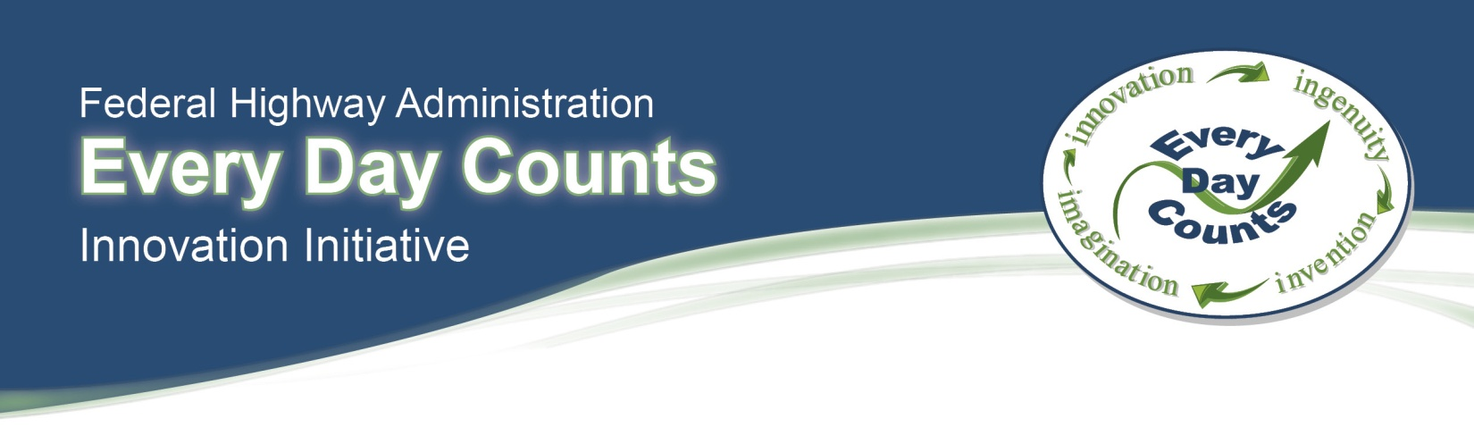

EVALUATION
FHWA Center for Accelerating Innovation

1 = Strongly Disagree; 2 = Disagree; 3 = Neutral; 4 = Agree; 5 = Strongly Agree; 0 = N/A

1
2
3
4
5
0
- The workshop will help improve my job performance.
1
0
5
4
3
2
1
0
5
4
3
2
- Subject matter was well organized.
- The workshop goals and objectives were clear.
- The presentation followed the workshop materials.
- Exercises aided in my understanding and skill development.
- The workshop provided opportunities for me to participate.
- Pace was appropriate for the amount of content covered.
- Workshop materials were clear and legible.
1
0
5
4
3
2
1
0
5
4
3
2
1
0
5
4
3
2
1
0
5
4
3
2
1
0
5
4
3
2
1
0
5
4
3
2
- The workshop advanced my knowledge of risk management.
1
4
3
2
0
5
- The workshop will help me assess and manage risk on this project.
3
2
1
0
5
4
- Was a satisfactory learning experience.

The Instructors Instructor #1 Instructor #2 Instructor #3
1
2
3
4
5
0
1
2
3
4
5
0
1
2
3
4
5
0
1
2
3
4
5
0
1
2
3
4
5
0
1
2
3
4
5
0
1
2
3
4
5
0
1
2
3
4
5
0
1
2
3
4
5
0
1
2
3
4
5
0
1
2
3
4
5
0
1
2
3
4
5
0
1
2
3
4
5
0
1
2
3
4
5
0
1
2
3
4
5
0
1
2
3
4
5
0
1
2
3
4
5
0
1
2
3
4
5
0
1
2
3
4
5
0
1
2
3
4
5
0
1
2
3
4
5
0
1
2
3
4
5
0
1
2
3
4
5
0
1
2
3
4
5
0
1
2
3
4
5
0
1
2
3
4
5
0
1
2
3
4
5
0
- Clearly stated all learning outcomes
- Made appropriate transitions and summaries throughout the workshop
- Kept discussions focused on relevant topics
- Consistently employed question and answer techniques
- Provided for application of content through experiences
- Provided positive feedback to the class
- Encouraged participants to share work experience and background
- Explained theories and concepts effectively
- Related the subject matter to my job

- The instructors were the most effective at...

- The instructors were the least effective at...

- Describe any part of the course that needs improvement.

