Exhibit B

Unaudited Financial Assessment Subsystem-Public Housing (FASS-PH) Template

To accommodate asset management, many changes will be made to the structure and content of the unaudited Financial Assessment Subsystem-Public Housing (FASS-PH) template. Because of this effort, the system has been redesigned. The look and feel of the system will also be very different from the current system as result of a Java upgrade from Cold Fusion. Below is a list of structural system changes:

- Navigation
  - Instead of tab driven navigation, the new FASS-PH Java system will be Top navigation and Side navigation driven.
  - Top navigation contains major functionality, such as public housing agency (PHA) information (name, code, address, etc.), Financial Data Schedule, and Data Collection Form.
  - Side navigation is driven by the Top navigation.
  - Top navigation – Financial Data Schedule will have side navigation such as Program/Project Listing, Asset Management Projects (AMP) Listing, Balance Sheet and Income Statement.

- Inputting Financial Data
  - PHAs are able to input Balance Sheet and Income Statement data for each AMP/project.
  - PHAs are able to input Balance Sheet and Income Statement data for each program.
  - PHAs are able to validate each AMP/project and program financial data.
  - PHAs are able to input additional data into the Data Collection Form, including the new Supplemental Information tab.

The following screen prints are taken from the current unaudited system. System modifications for asset management are in the process of being made, and new system design is currently underway. In order to ease the review of the new/modified system for asset management, the current screen prints will be used with explanations of the changes detailed below the screen print. Included in the screen prints are references to the Supplement to HUD Handbook 7475.1, Rev., Chg. 1, Financial Management Handbook (herein the Supplement), dated April 2007.

Public Housing Template for Unaudited Submissions

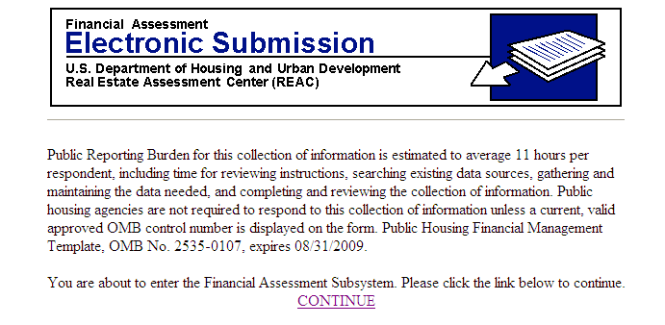

The content of this screen will be updated with the new expiration date.

Unaudited Screen 1

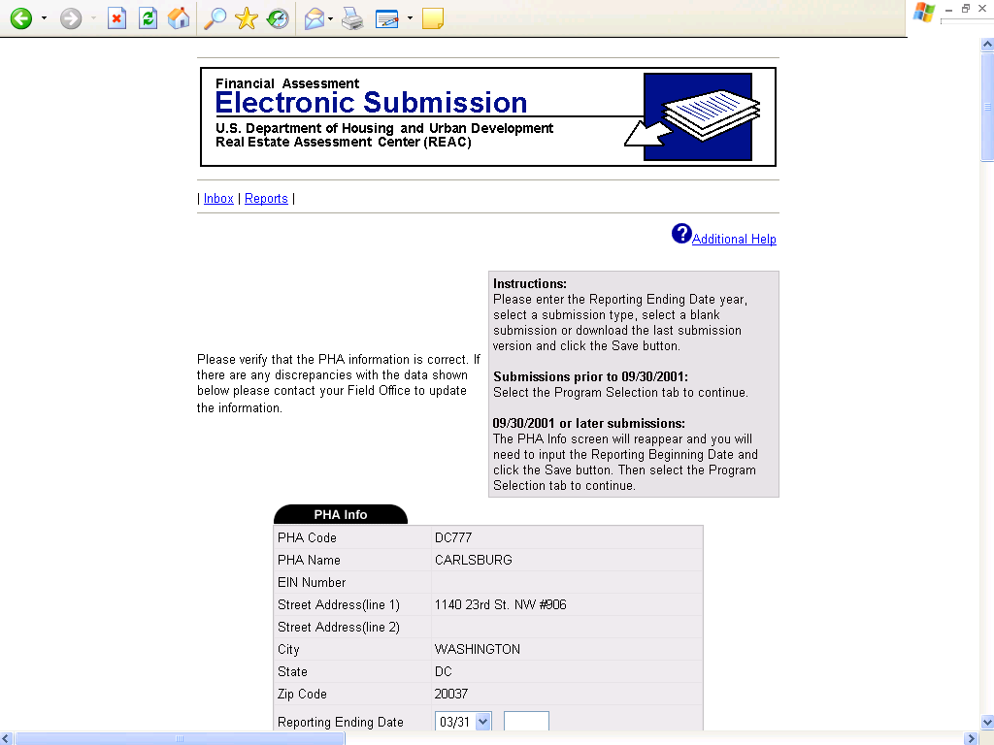

The top of the PHA information screen will be similar in content to what is shown above. The standard PHA information will be shown. However, the overall screen contains more input choices. The most important of which is the asset management type choices. This option will determine what type of Financial Data Schedule (FDS) the PHA will complete. For example, if a PHA selects asset management with a Central Office Cost Center (COCC)/elimination column, then the PHA will be prompted to complete a column of the FDS for eliminations and a COCC column. Also, if a PHA selects asset management, it will need to access the AMP/project selection screen to fill out an FDS for each individual AMP/project. These changes are applicable to the following three screen prints.
Unaudited Screen 1 Continued

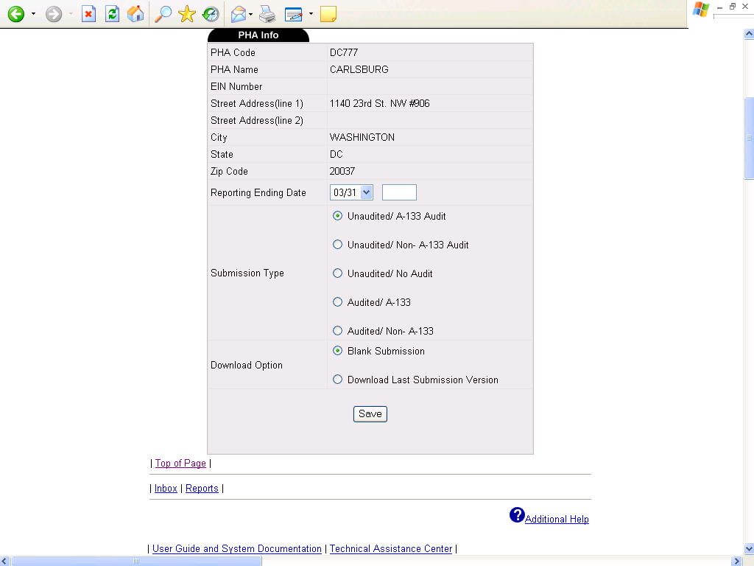

This screen print will be affected by the changes mentioned in unaudited screen 1.

Unaudited Screen 2

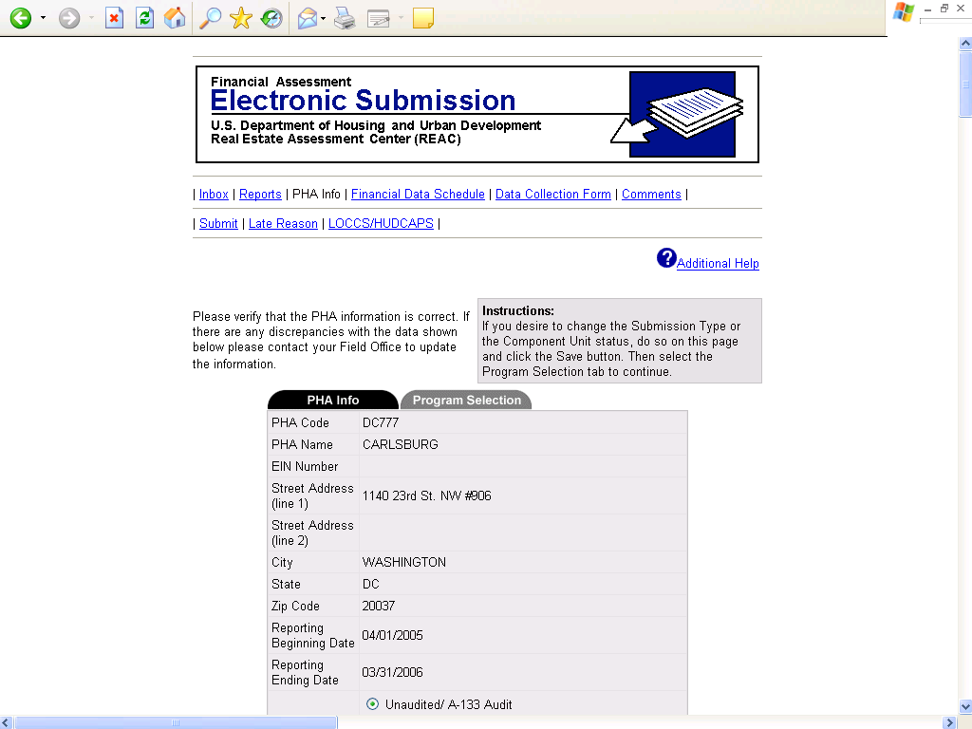

This screen print will be affected by the changes mentioned in unaudited screen 1.

Unaudited Screen 2 Continued

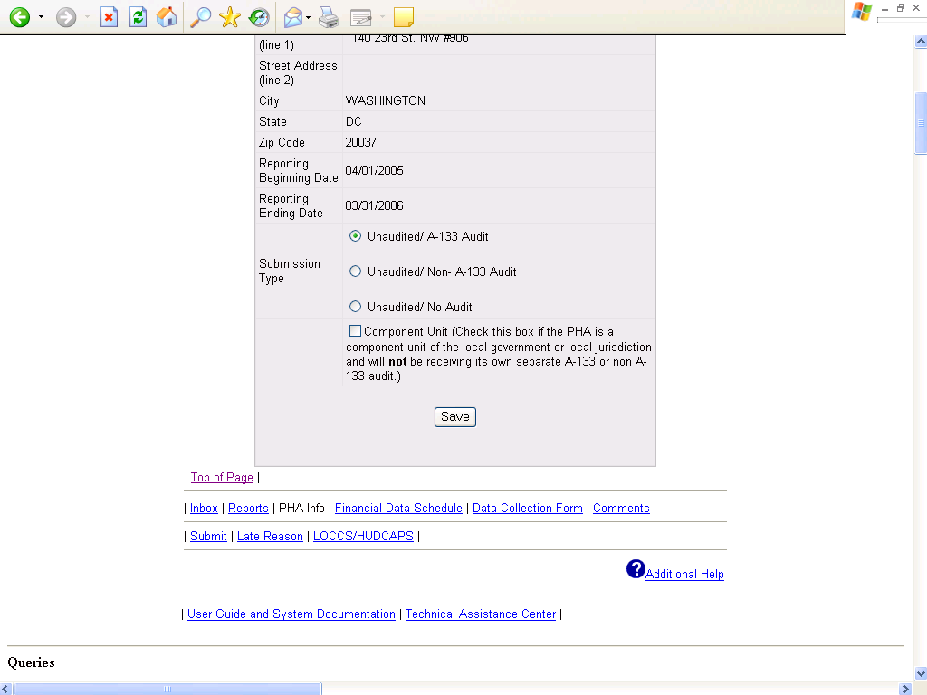

This screen print will be affected by the changes mentioned in unaudited screen 1.

Unaudited Screen 3

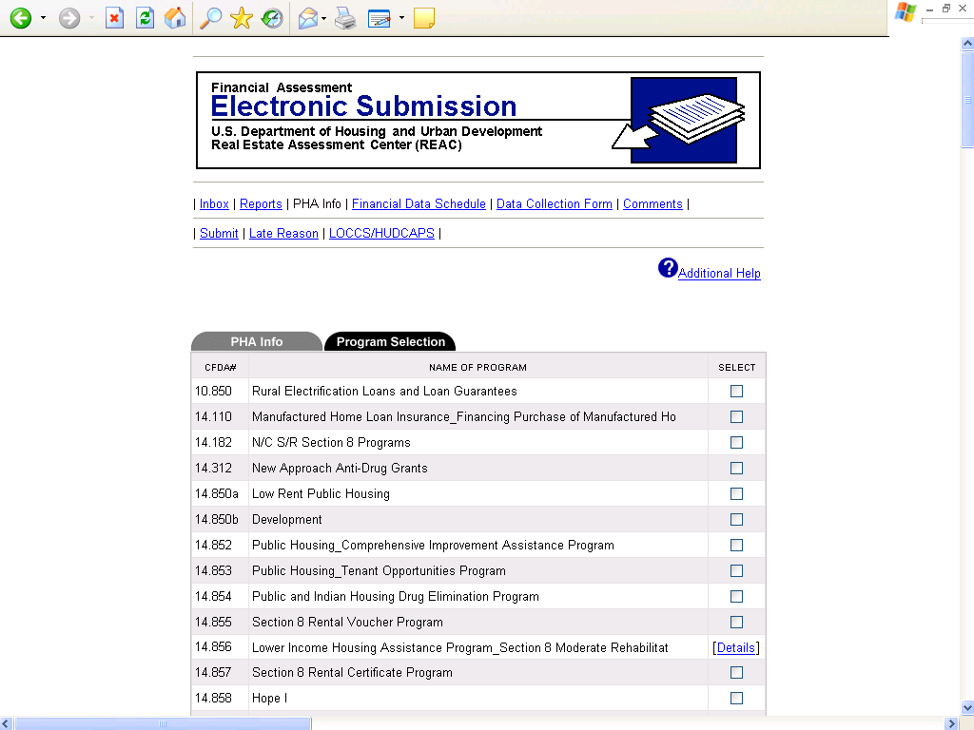

Unlike the current system, PHA and AMP/project selections are not done on the PHA Information screen. There are separate screens for both AMP/project selection and program selection. The user will be prompted to select an AMP/project or a program, and then fill out the appropriate FDS. PHAs are also able to select a FDS for the Central Office Cost Center (COCC) and the elimination column. These changes are applicable to the following screen print.

Unaudited Screen 3 Continued

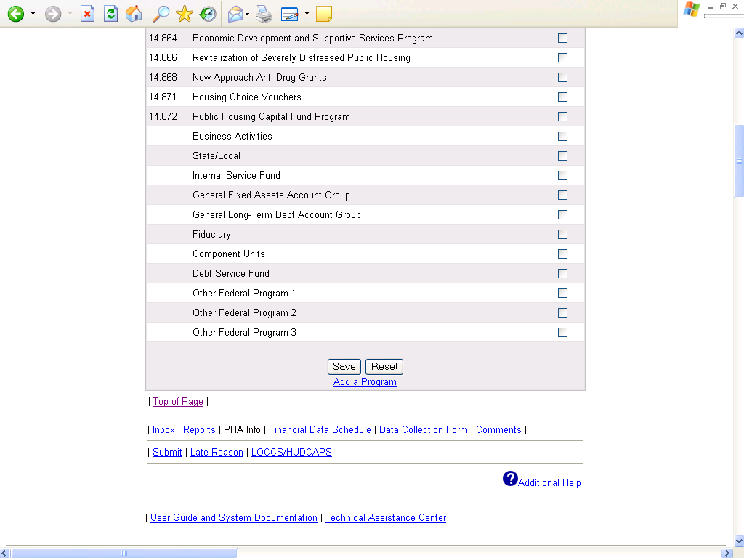

The above Program Selection screen contains the changes mentioned in unaudited screen 3.

Unaudited Screen 4

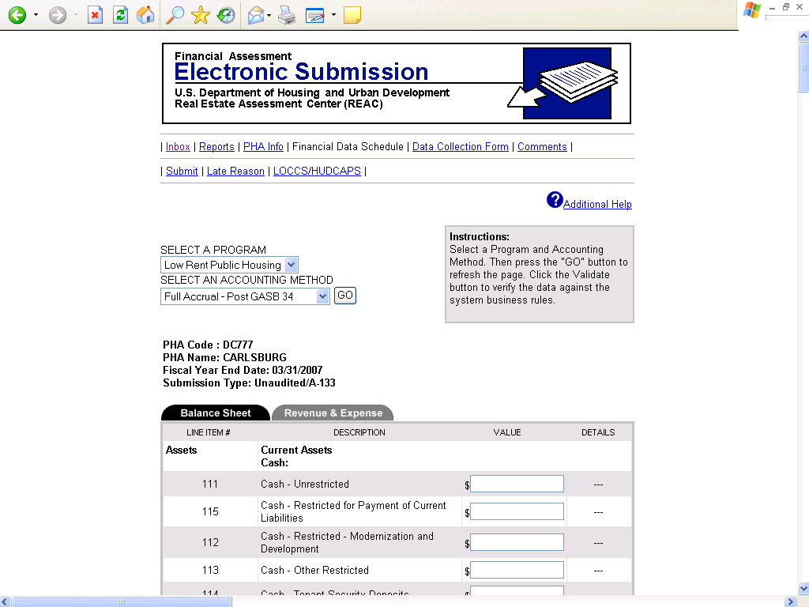

The Balance Sheet portion of the FDS has been modified (see the Supplement, page 11, Table 3.1, Preliminary Changes to FDS Balance Sheet Line Items). The Balance Sheet includes additional line items. Also, many line items have been deleted, mostly due to GASB 34. The Balance Sheet submission for Low Rent Public Housing and the Capital Fund Programs is combined under AMPs/projects. Below is a list of additional line items.

BALANCE SHEET:

Line 356 (FASB 5 liabilities)
Line 357 (Accrued pension liabilities)
Line 509.2 (Fund balance reserved)
Line 511.2 (Undesignated fund balance)
Line 512.2 (Unreserved undesignated fund balance)

These changes are applicable to the following five screen prints.

Unaudited Screen 4 Continued

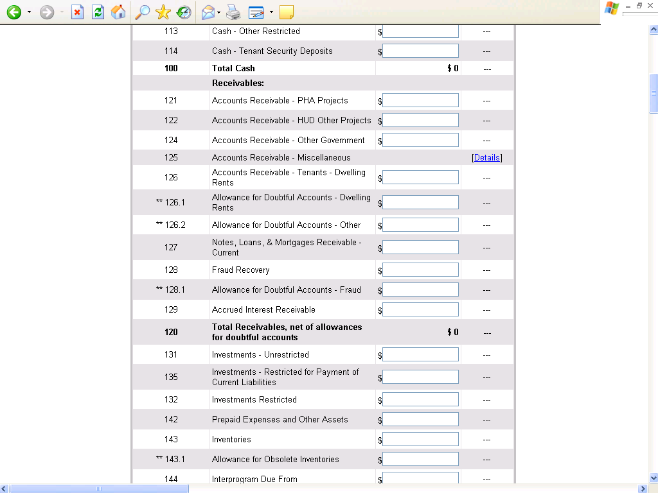

This screen print will be affected by the changes mentioned in unaudited screen 4.

Unaudited Screen 4 Continued

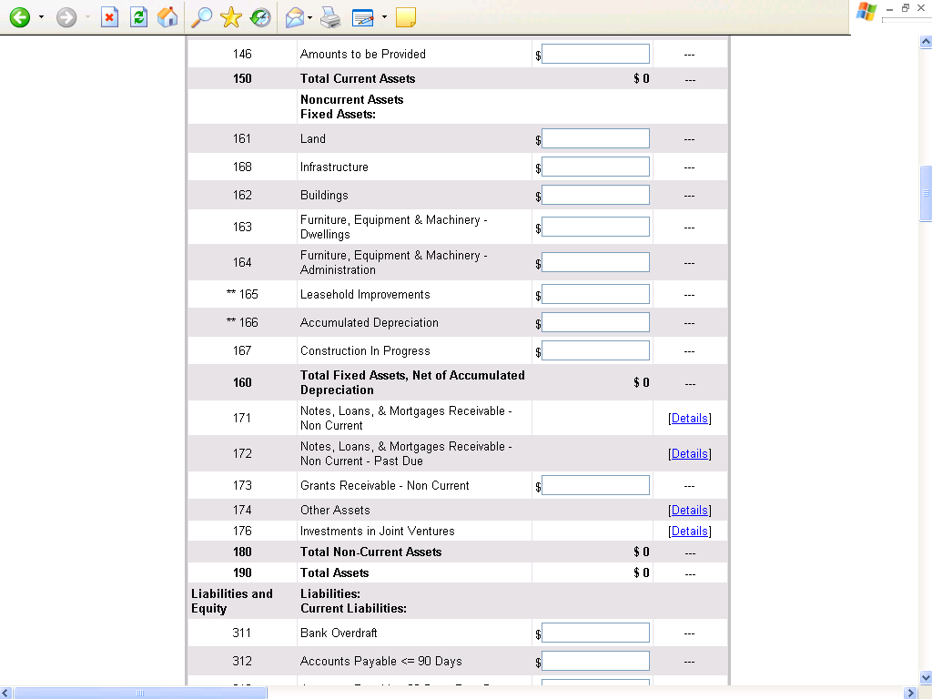

This screen print will be affected by the changes mentioned in unaudited screen 4.

Unaudited Screen 4 Continued

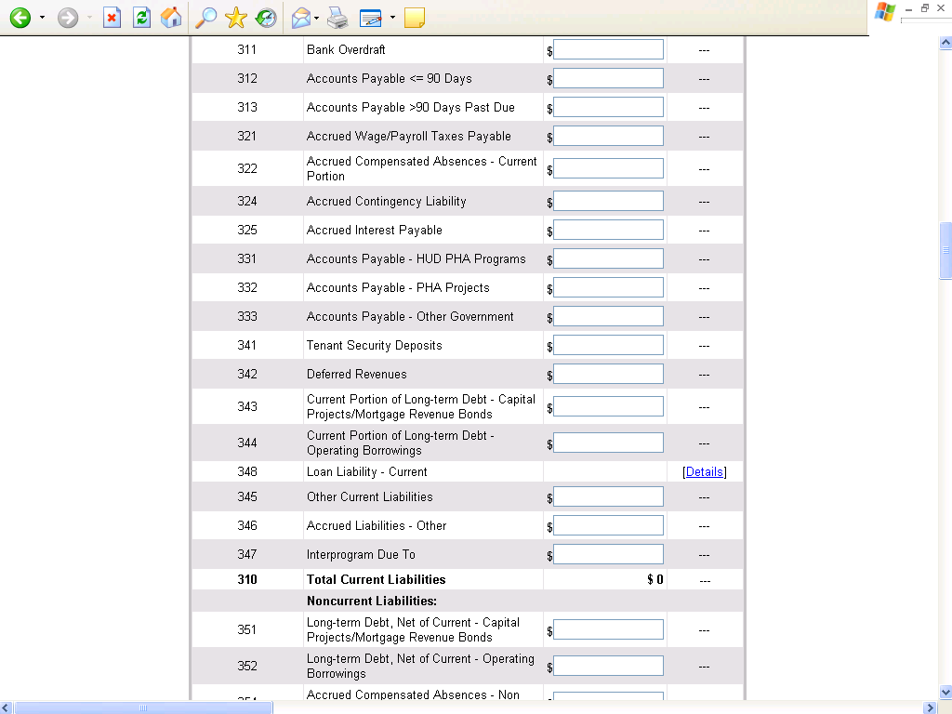

This screen print will be affected by the changes mentioned in unaudited screen 4.

Unaudited Screen 4 Continued

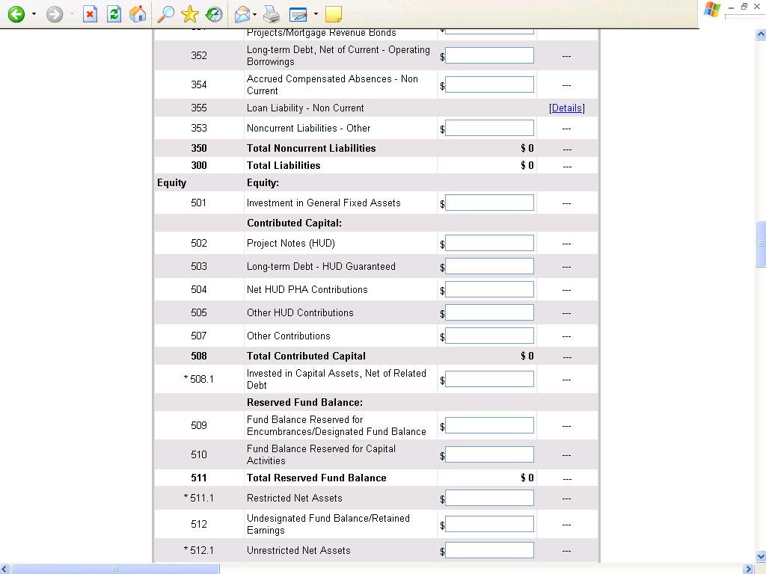

This screen print will be affected by the changes mentioned in unaudted screen 4.

Unaudited Screen 4 Continued

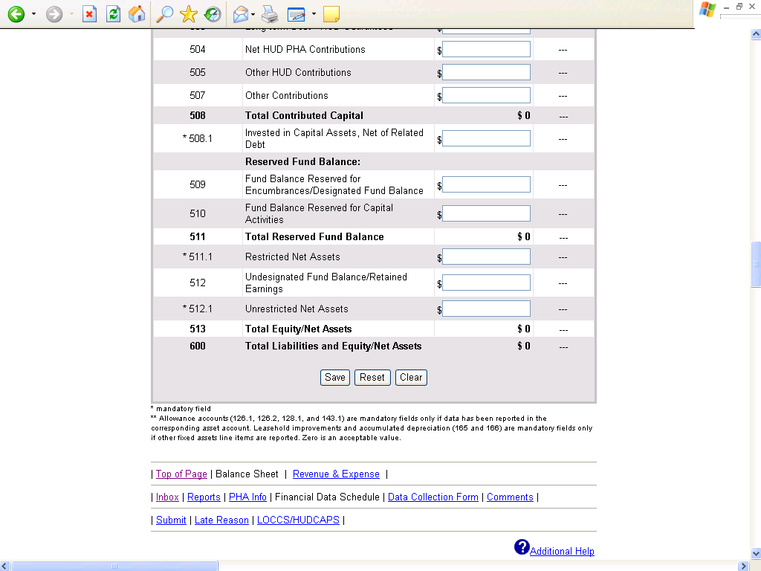

This screen print will be affected by the changes mentioned in unaudited screen 4.

Unaudited Screen 5

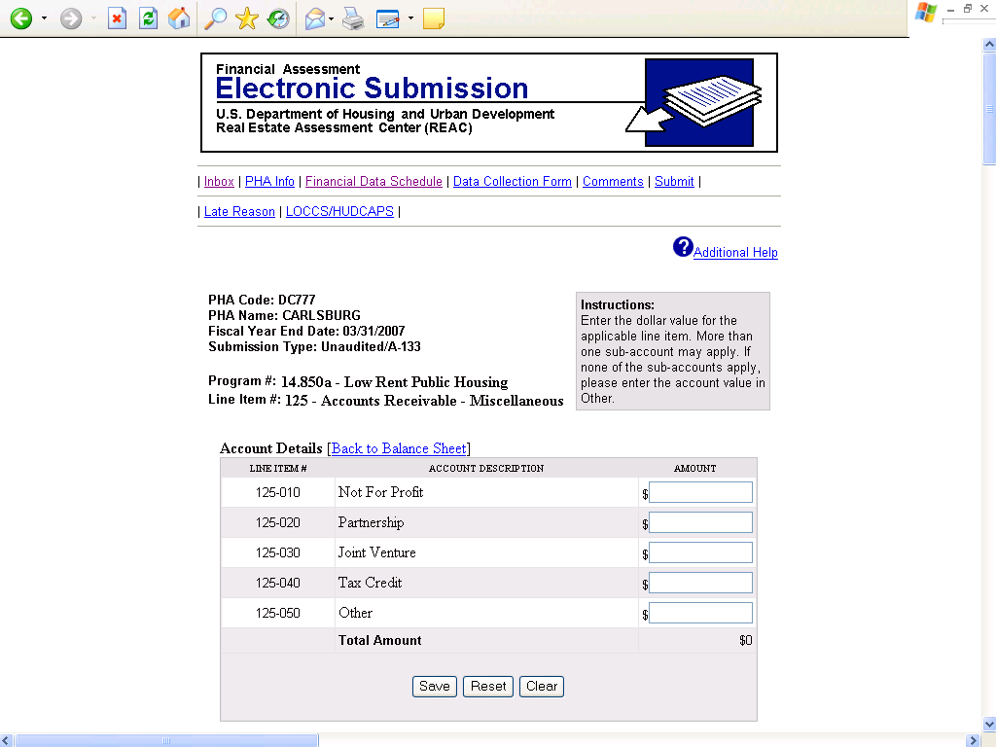

The content of this screen will remain largely unchanged from the current system.

Unaudited Screen 6

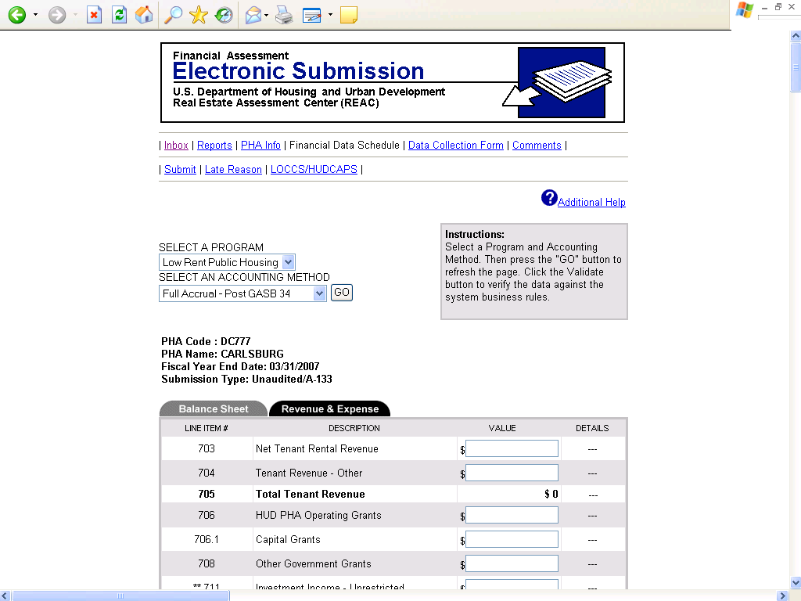

The Revenue and Expense statement has been modified due to asset management (see the Supplement, page 39, Section 7.10, Assignment of Costs). The FDS line item numbers have gone from three digits to five. Many new line items have been added to accommodate asset management. Also, new total line items have been added. Deletions were also necessary. Most deletions were due to GASB 34. Below is a list of additional line items.

INCOME STATEMENT:

Revenues
Line 70700 (Total fee revenue)
Line 70710 (Management fee)
Line 70720 (Asset management fee)
Line 70730 (Book-keeping fee)
Line 70740 (Front line service fee)
Line 70750 (Other fees)

Expenses
Line 91300 (Management fee)
Line 91310 (Book-keeping fee)
Line 91400 (Advertising and marketing)
Line 91600 (Office expenses)
Line 91700 (Legal expenses)
Line 91800 (Travel)
Line 91900 (Other)
Line 91900 (Total operating – administrative)
Line 92000 (Asset management fee)
Line 92500 (Total tenant services)
Line 93600 (Sewer)
Line 93000 (Total utilities)
Line 94000 (Total maintenance)
Line 95000 (Total protective services)
Line 96100 (Property insurance)
Line 96120 (Liability insurance)
Line 96130 (All other insurance)
Line 96140 (Workmen’s compensation)
Line 96100 (Total insurance premiums)
Line 96210 (Compensated absences)
Line 96710 (Interest of mortgage (or bonds) payable)
Line 96720 (Interest on notes payable (short and long term))
Line 96730 (Amortization of bond issue costs)

Other Financing Sources (Uses)
Line 10091 (Inter-AMP excess cash transfer in)
Line 10092 (Inter-AMP excess cash transfer out)
Line 10093 (Transfers between programs and AMPs - In)
Line 10094 (Transfers between programs and AMPs - Out)

Memo Accounts
Line 11270 (Excess cash)
Line 11610 (Land purchases)
Line 11620 (Building expenditures)
Line 11630 (Furniture & equipment – dwelling purchases)
Line 11640 (Furniture & equipment – administrative purchases)
Line 11650 (Leasehold improvements purchases)
Line 13510 (CFFP debt service payments)
Line 13901 (Replacement housing factor funds)

These changes are applicable to the following four screen prints.

Unaudited Screen 6 Continued

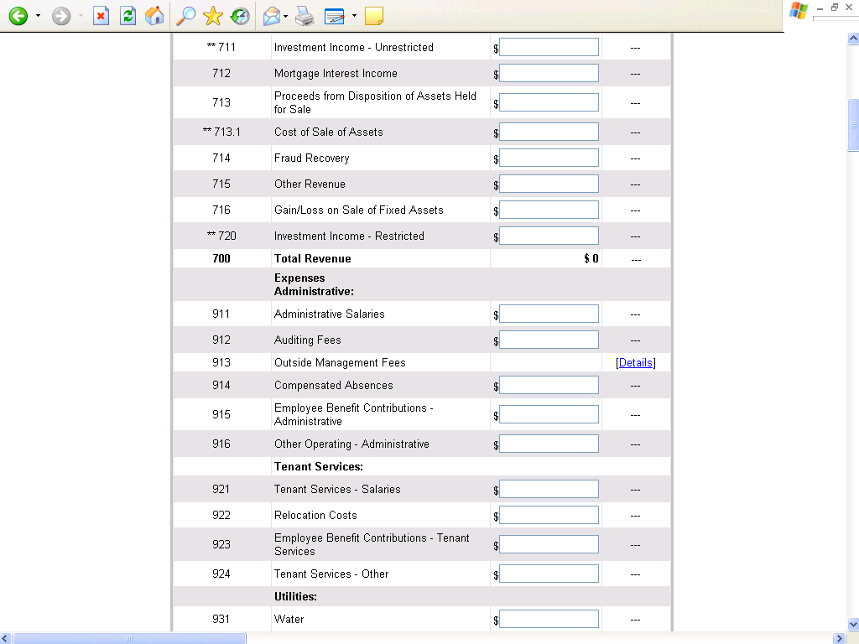

This screen print will be affected by the changes mentioned in unaudited screen 6.

Unaudited Screen 6 Continued

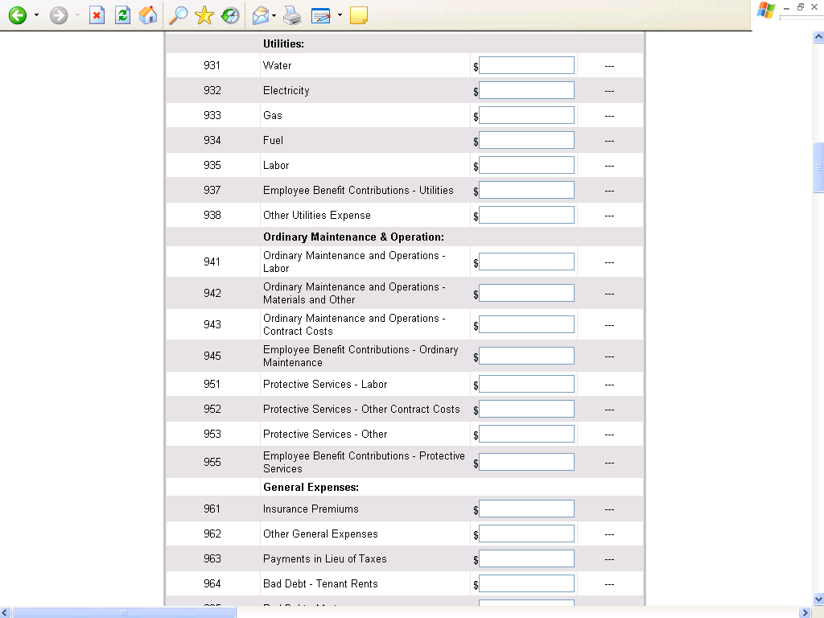

This screen print will be affected by the changes mentioned in unaudited screen 6.

Unaudited Screen 6 Continued

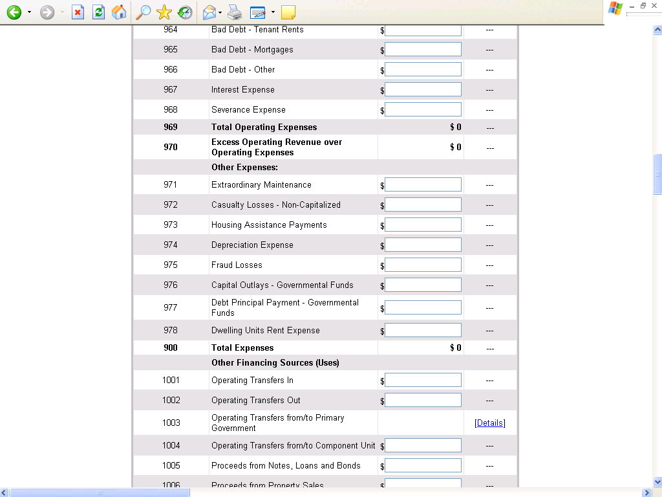
This screen print will be affected by the changes mentioned in unaudited screen 6.

Unaudited Screen 6 Continued

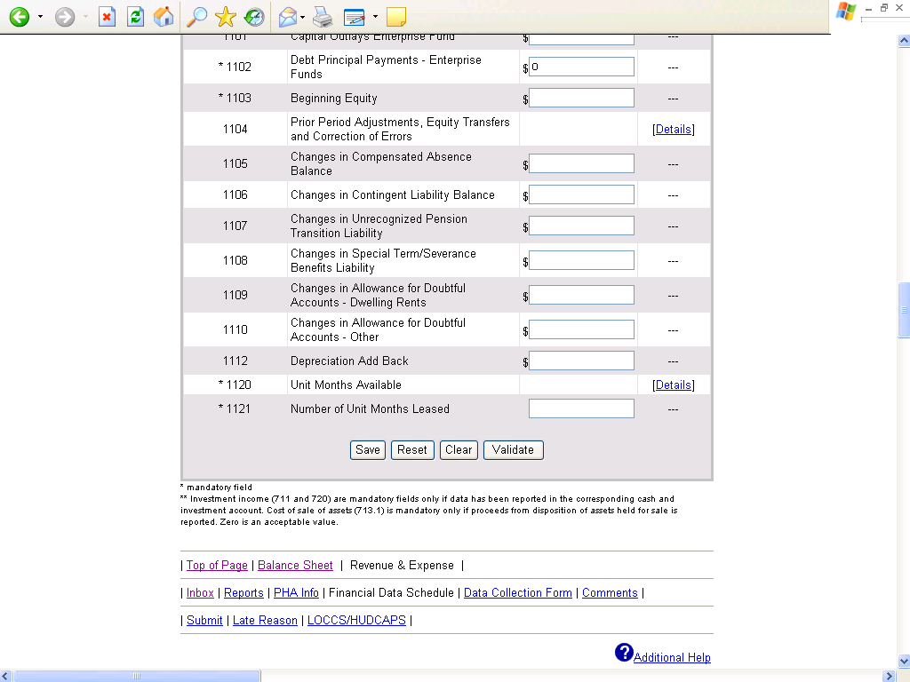

This screen print will be affected by the changes mentioned in unaudited screen 6.

Unaudited Screen 7

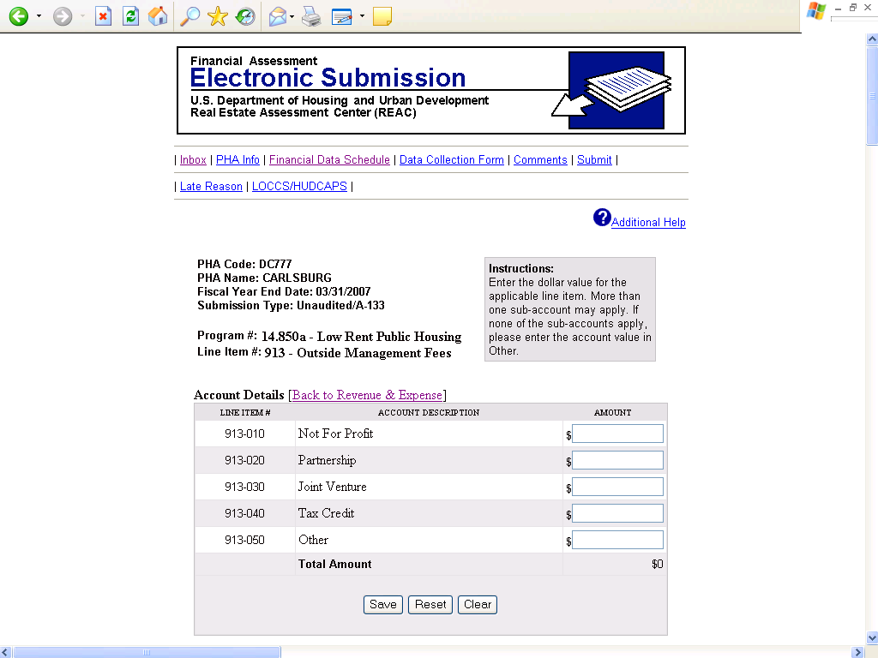

Except for the numbering scheme, this screen will remain largely unchanged from the current system.

Unaudited Screen 8

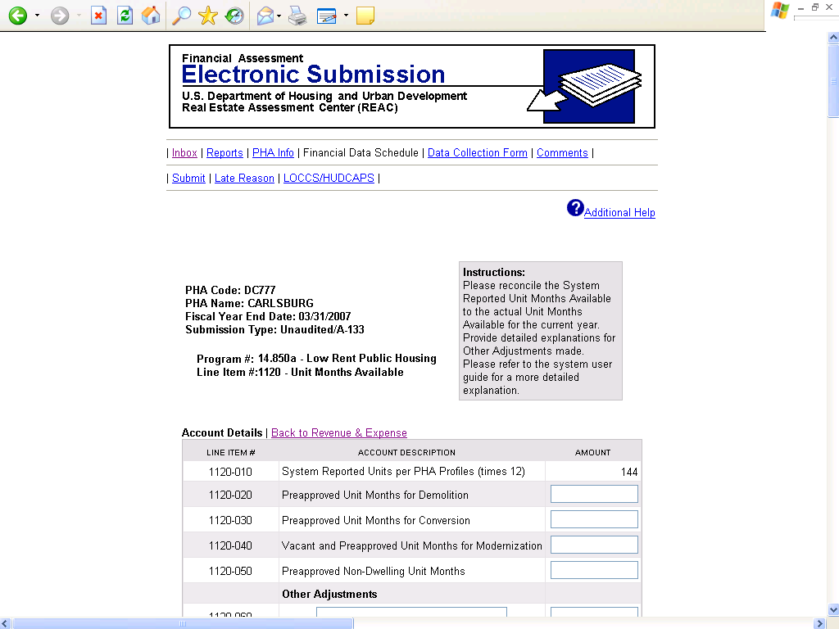

Due to asset management, line 1120 is no longer applicable. This change is applicable to the following screen print.

Unaudited Screen 8 Continued

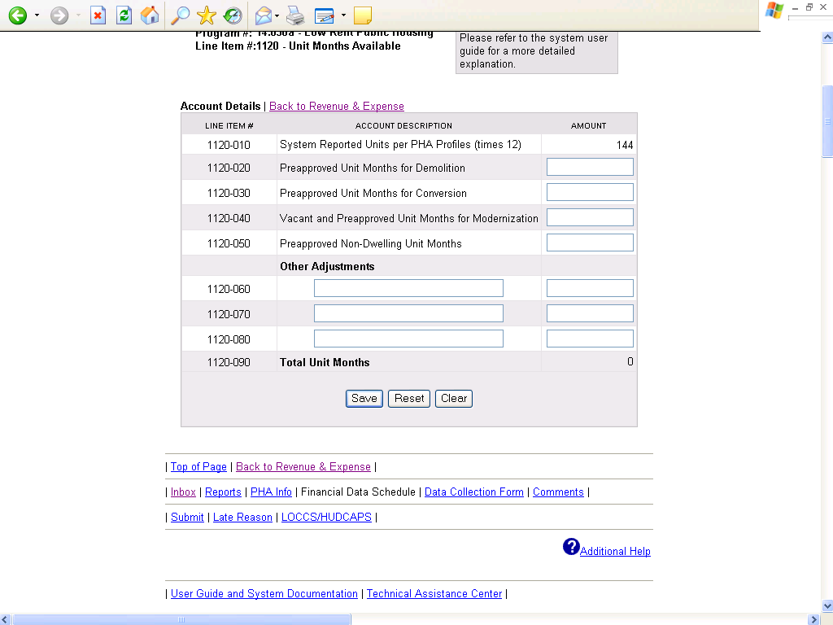

This screen print will be affected by the changes mentioned in unaudited screen 8.

Unaudited Screen 9

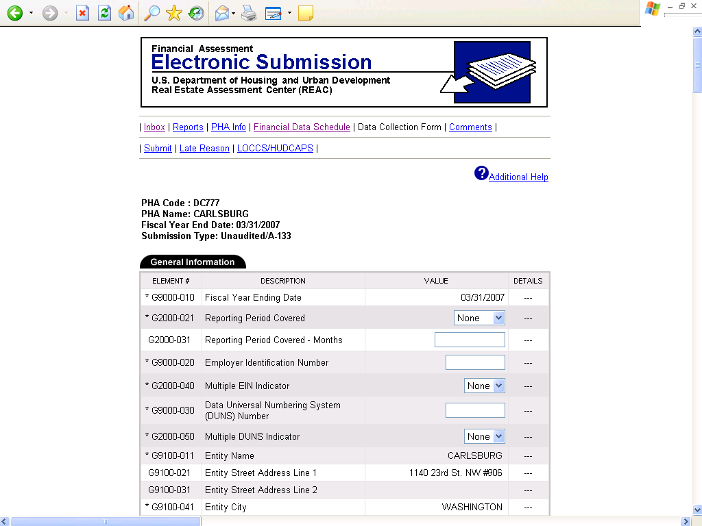

The content of the unaudited Data Collection Forms will remain largely unchanged from the current system.

Unaudited Screen 9 Continued

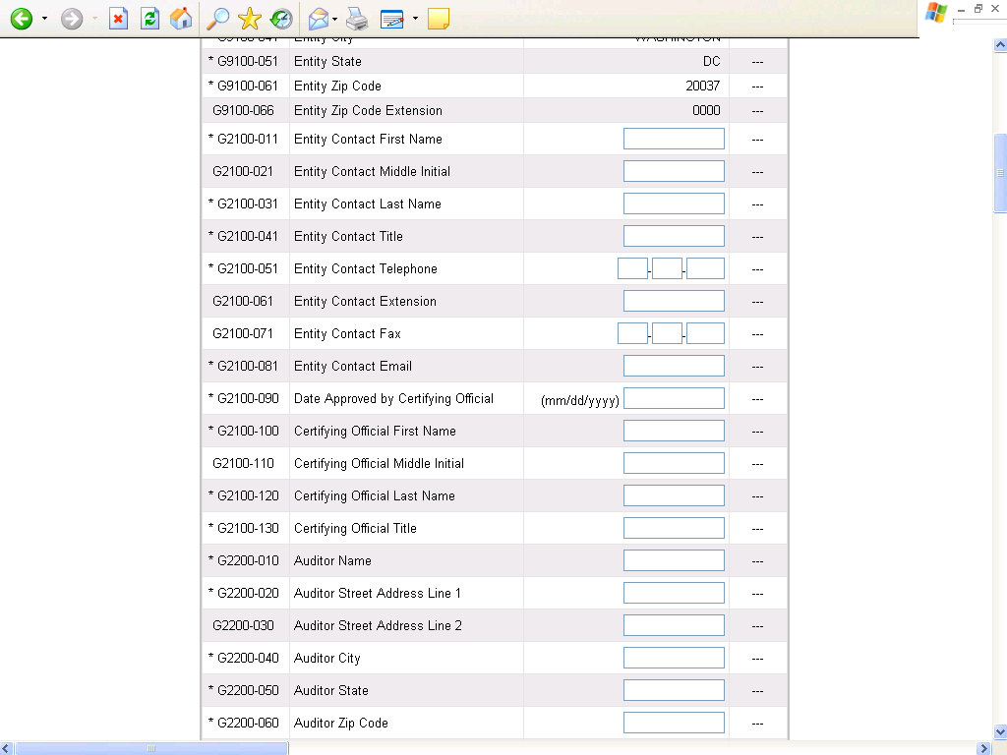

The content of the unaudited Data Collection Forms will remain largely unchanged from the current system.

Unaudited Screen 9 Continued

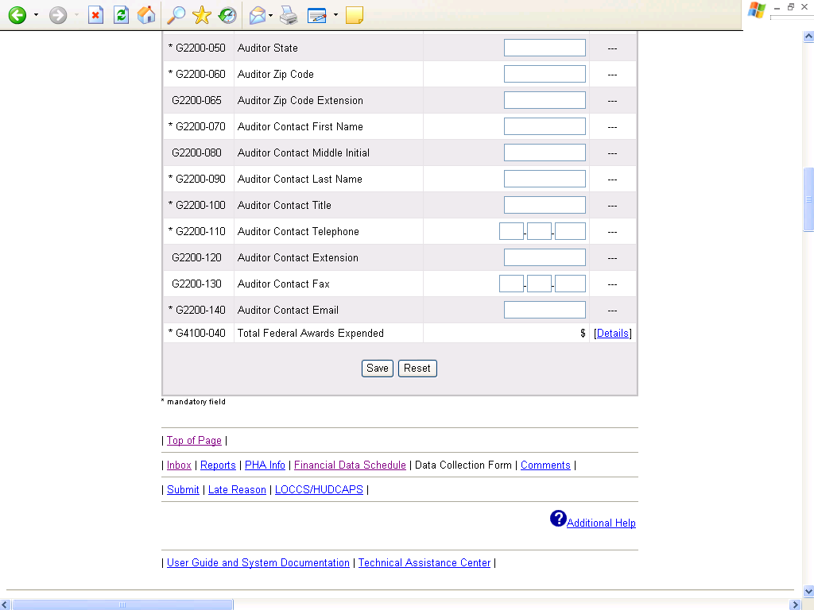

The content of the unaudited Data Collection Forms will remain largely unchanged from the current system.

Unaudited Screen 10

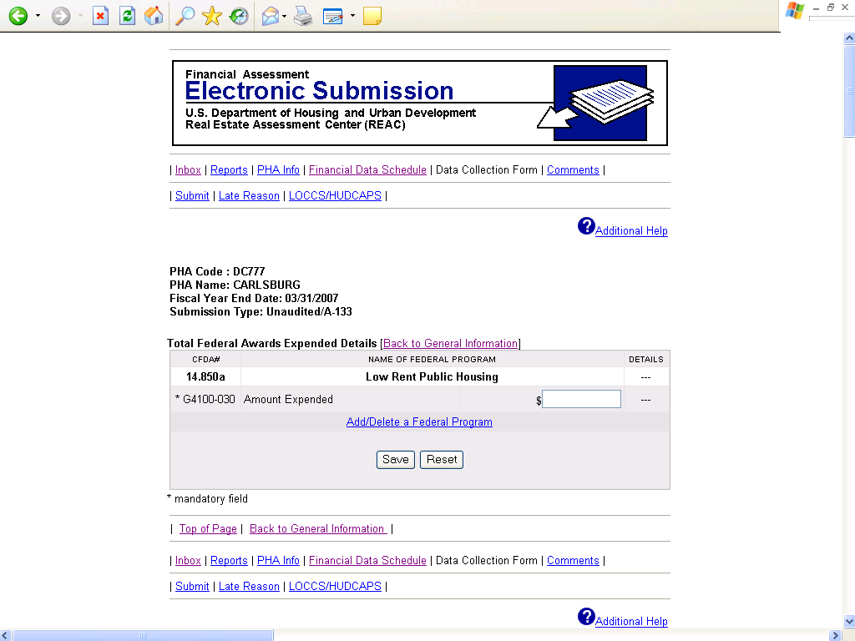

The content of the unaudited Data Collection Forms will remain largely unchanged from the current system.

Unaudited Screen 11

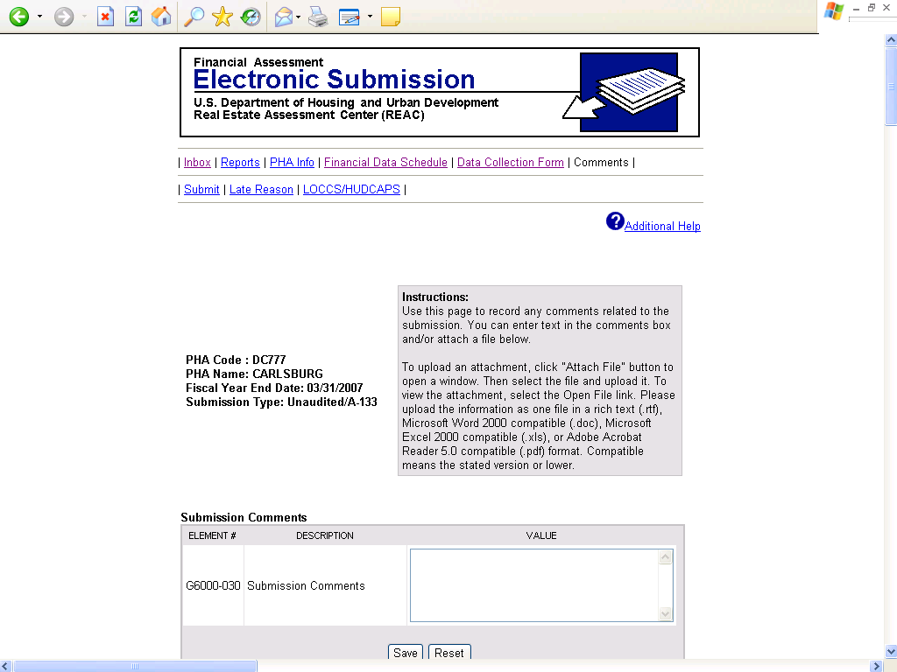

The content of the above screen will remain largely unchanged from the current system.

Unaudited Screen 12

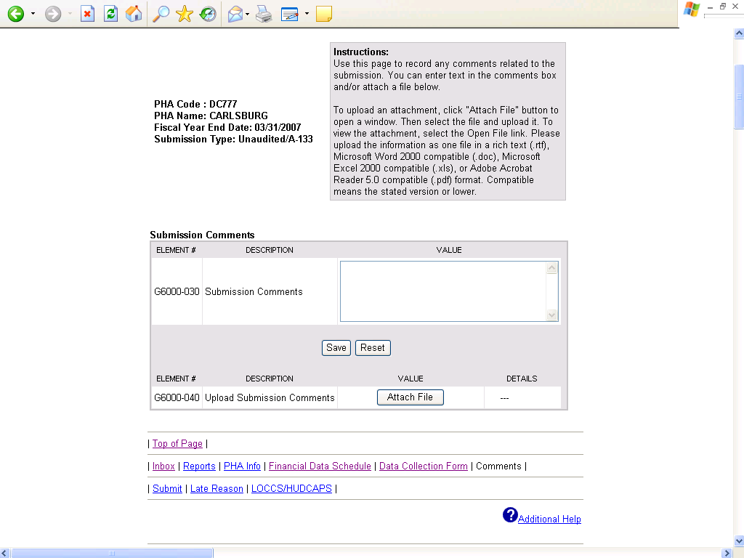

The content of the above screen will remain largely unchanged from the current system.

Unaudited Screen 13

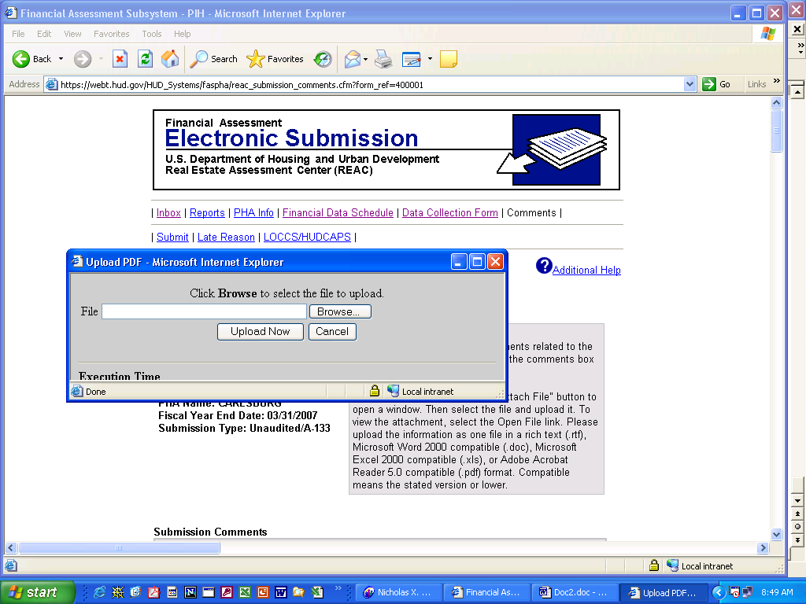

The content of the above screen will remain largely unchanged from the current system.

Unaudited Screen 14

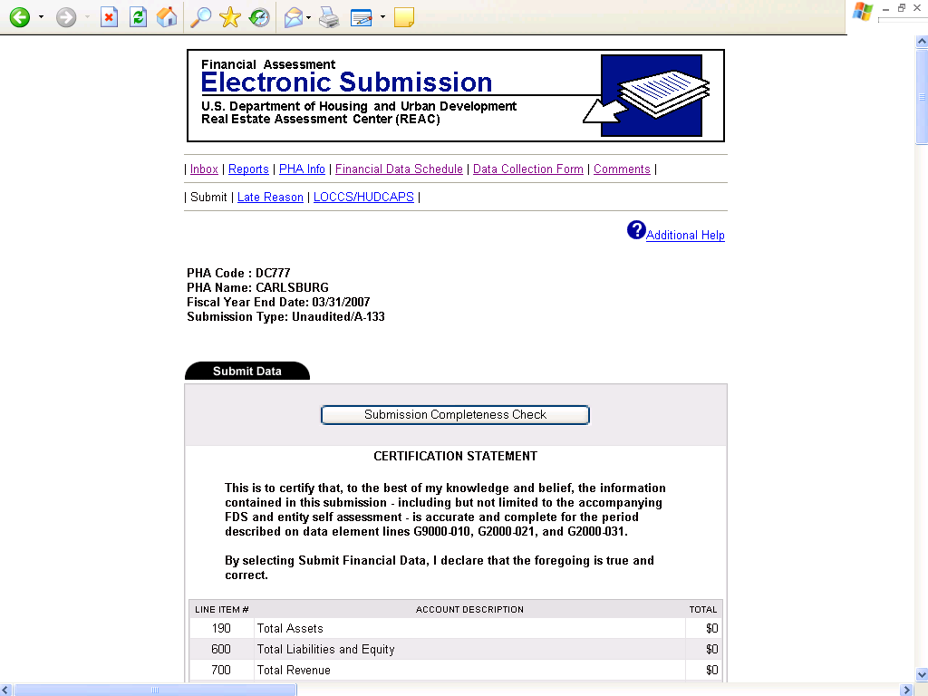

The content of the above screen will remain largely unchanged from the current system.

Unaudited Screen 14 Continued

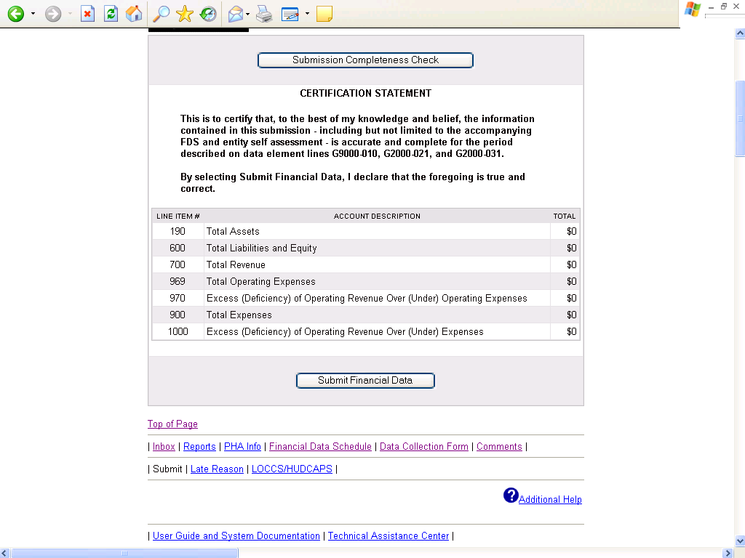

The content of the above screen will remain largely unchanged from the current system.

Unaudited Screen 15

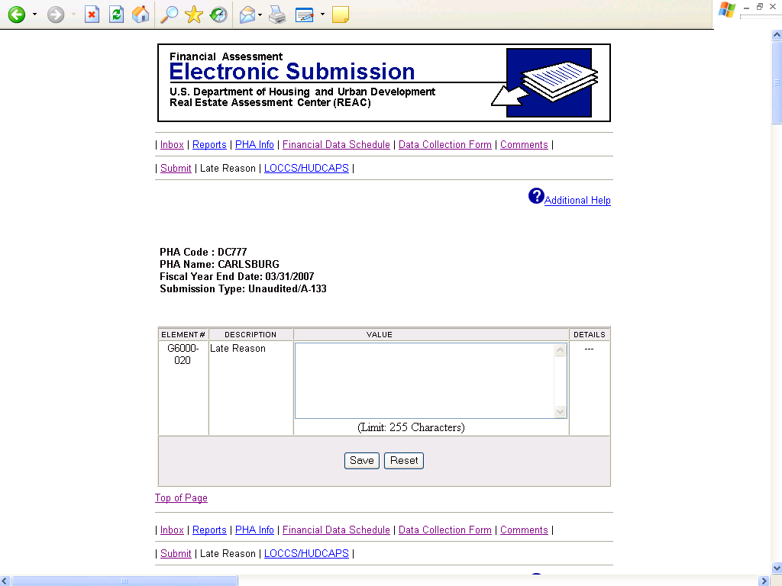

The content of the above screen will remain largely unchanged from the current system.

