Exhibit D

Audited Financial Assessment Subsystem-Public Housing (FASS-PH) Template

Contents
Audited Screen 1 – OMB Control Number Page 2
Audited Screen 2 – PHA Information Page 3
Audited Screen 3 – PHA Information Page (Program Selection Page) 4
Audited Screen 4 – PHA Information Page (Add a Program Page) 5
Audited Screen 5 – PHA Information Page (PHA Comments Page) 6
Audited Screen 6 – PHA Information Page (Late Reason Page) 7
Audited Screen 7 – PHA Information Page (Material Difference Page) 8
Audited Screen 8 – FDS Balance Sheet Page 9
Audited Screen 9 – FDS Balance Sheet Page (Detail Links) 11
Audited Screen 10 – FDS Income Statement Page 13
Audited Screen 11 – FDS Income Statement Page (Detail Links) 16
Audited Screen 12 – FDS Income Statement Page (HCV Program Detail Links) 19
Audited Screen 13 – Data Collection Form Page (General Information) 26
Audited Screen 14 – Data Collection Form Page (Financial Statement) 28
Audited Screen 15 – Data Collection Form Page (Federal Program) 30
Audited Screen 16 – Data Collection Form Page (Supplemental Information) 33
Audited Screen 17 – Notes and Findings Page 34
Audited Screen 18 – Auditor’s Agreed Upon Procedures Page 37
Audited Screen 19 – Submit Page 38

Audited Screen 1 – OMB Control Number Page
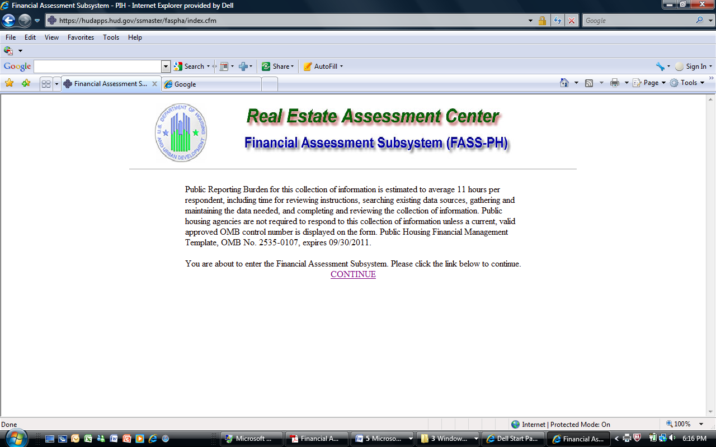

Audited Screen 2 – PHA Information Page

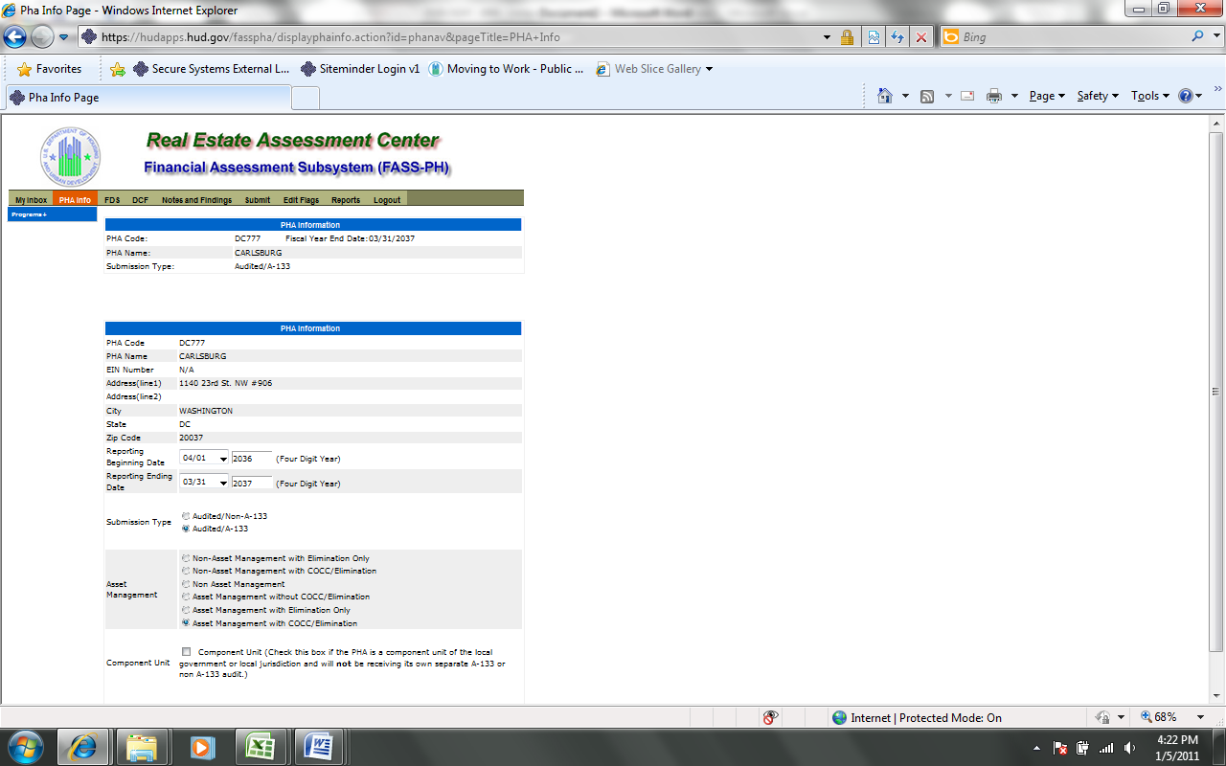

Audited Screen 3 – PHA Information Page (Program Selection Page)

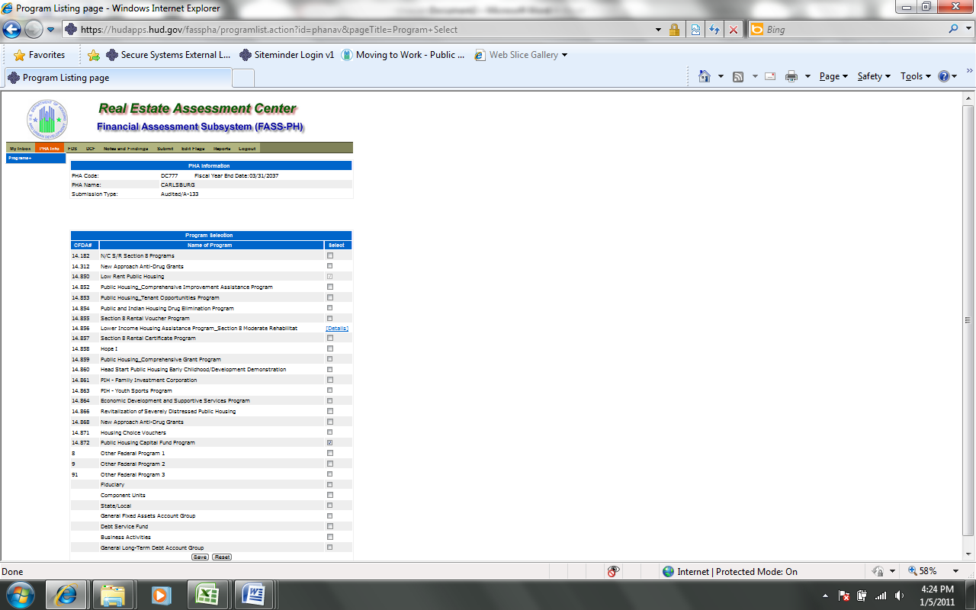

Audited Screen 4 – PHA Information Page (Add a Program Page)

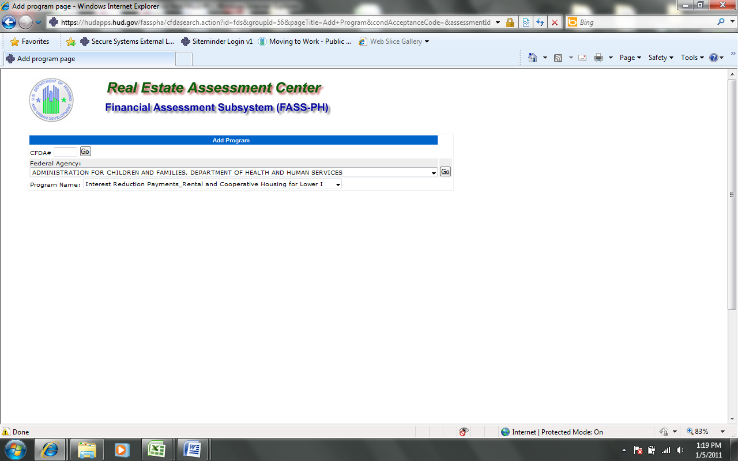

Audited Screen 5 – PHA Information Page (PHA Comments Page)

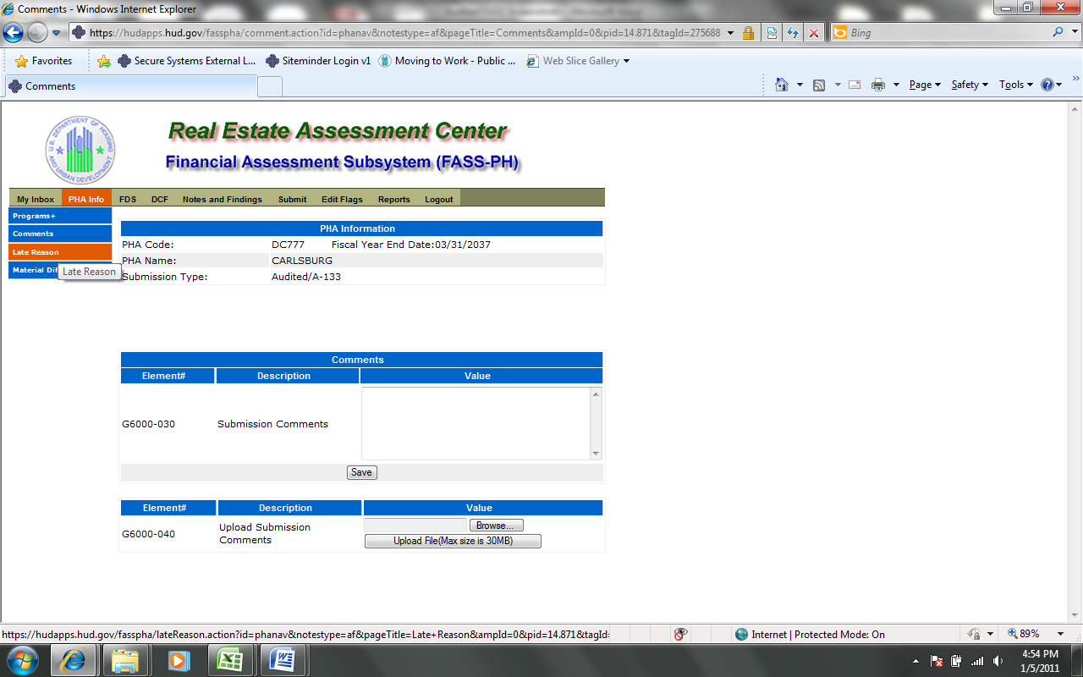

Audited Screen 6 – PHA Information Page (Late Reason Page)

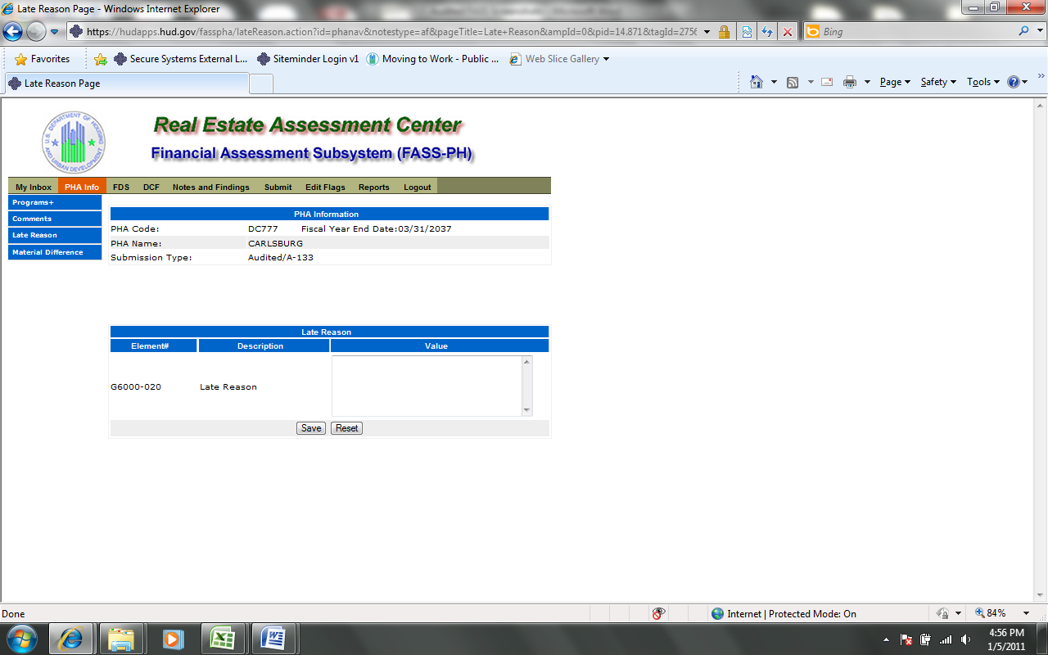

Audited Screen 7 – PHA Information Page (Material Difference Page)

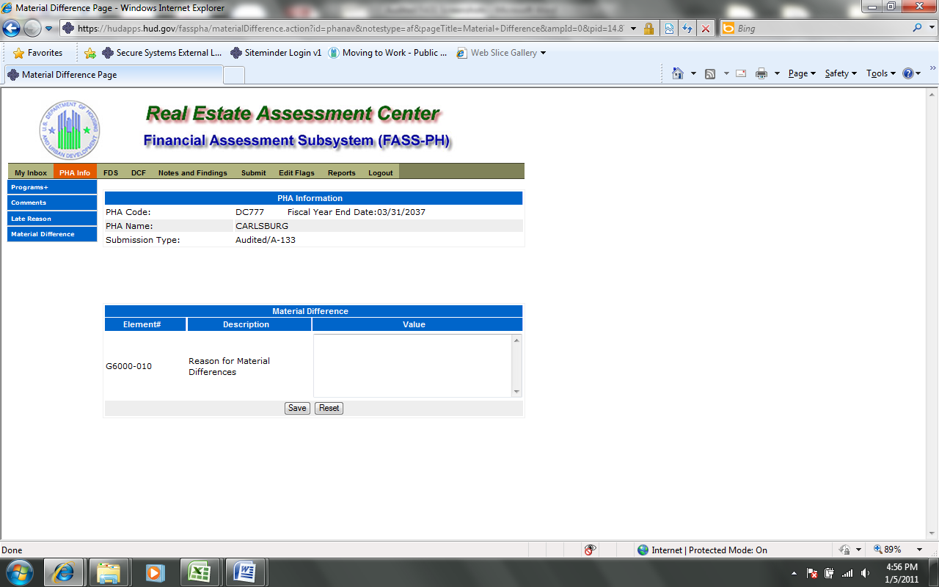
Audited Screen 8 – FDS Balance Sheet Page

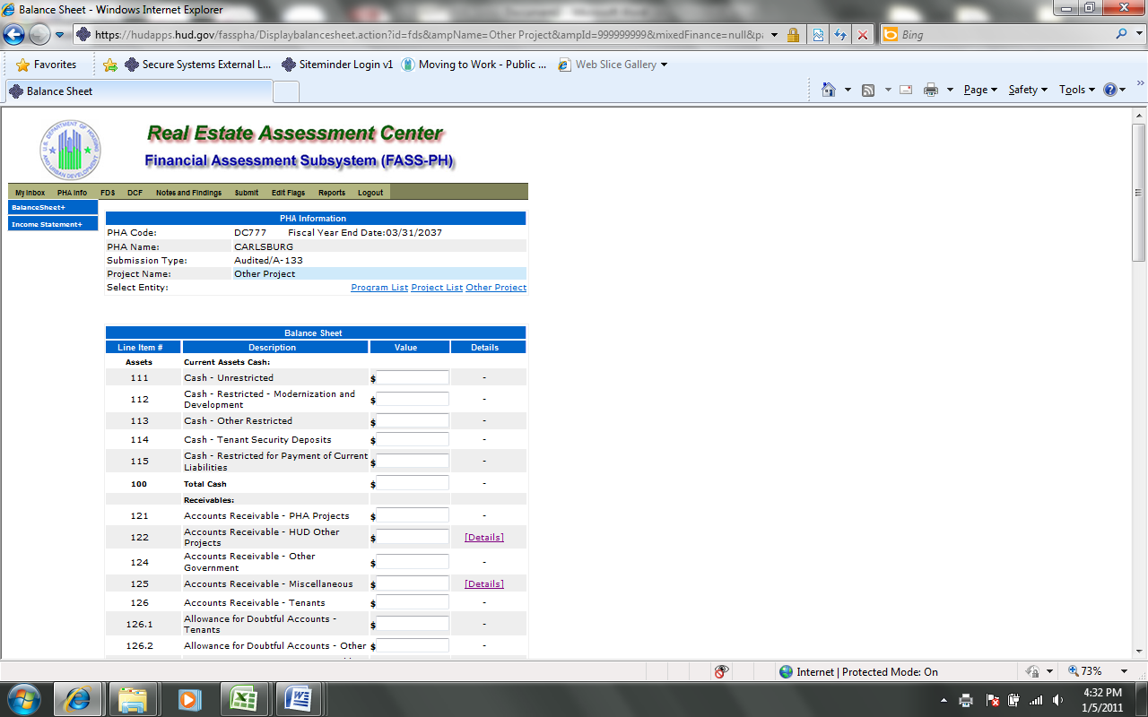
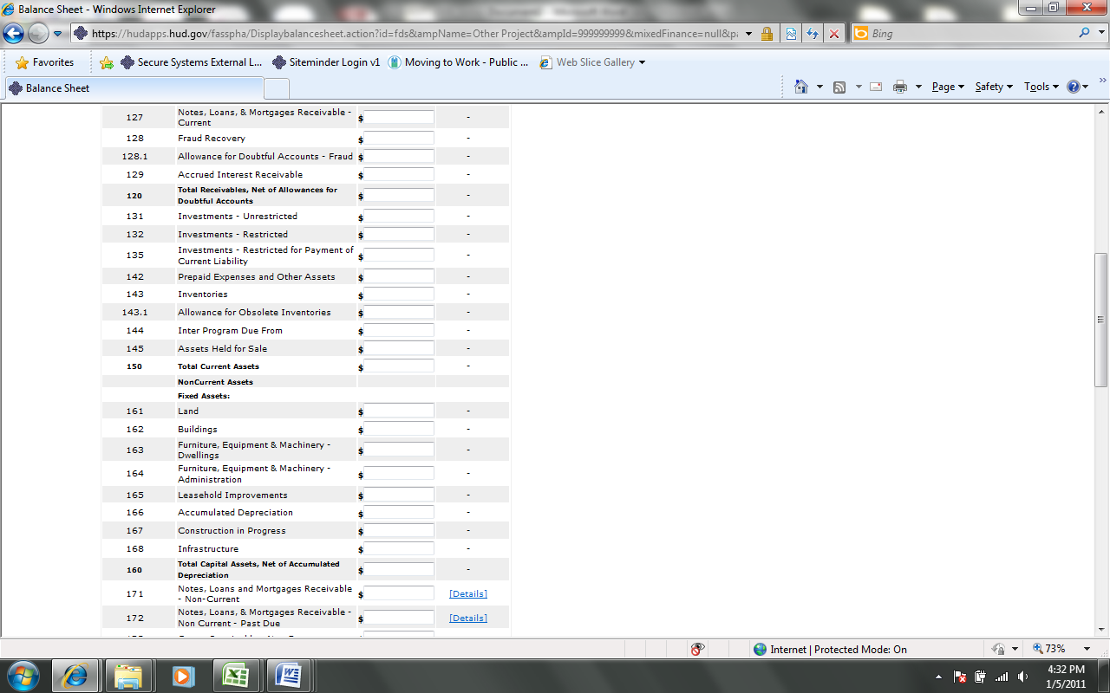

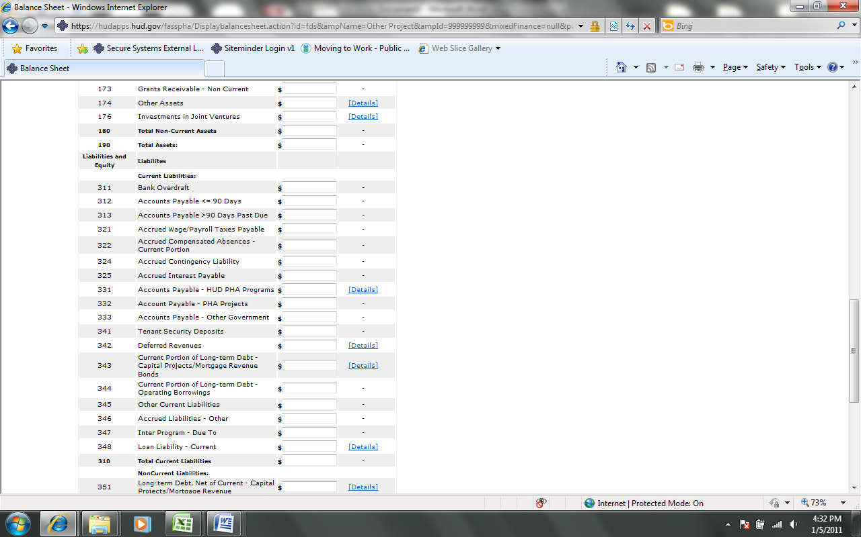
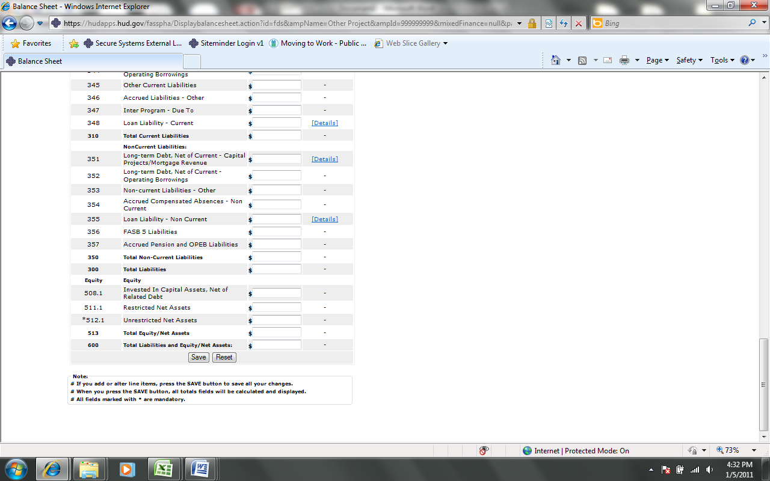

Audited Screen 9 – FDS Balance Sheet Page (Detail Links)

The following screen provides the detail link associated for the following FDS line Item: 122. FDS Line Items 331 and 342 have a similar detail link.

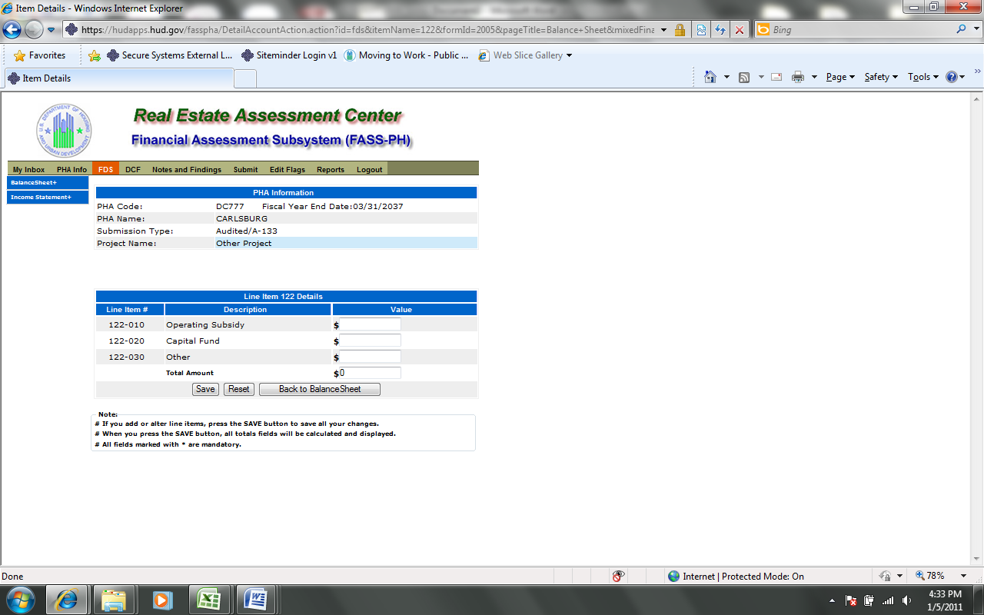

The following screen provides the detail link associated for the following FDS line Item: 125. FDS Line Items 171, 172, 174, 176, 348, and 355 have a similar detail link.

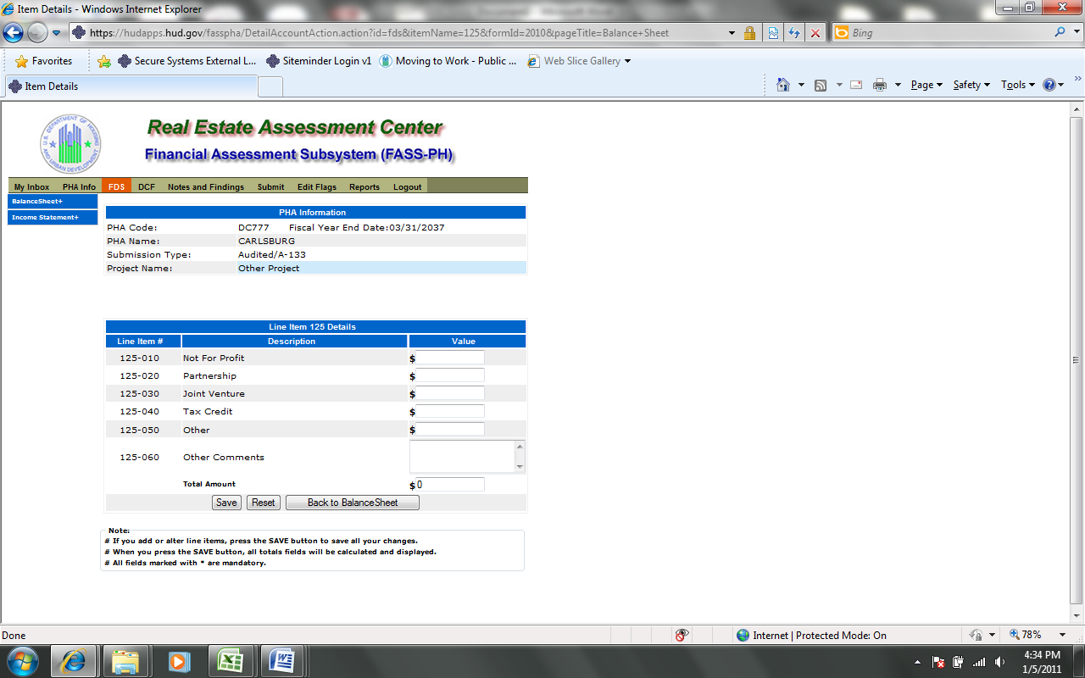

The following screen provides the detail link associated for the following FDS Line Item: 343. FDS Line Item 315 has a similar detail link.

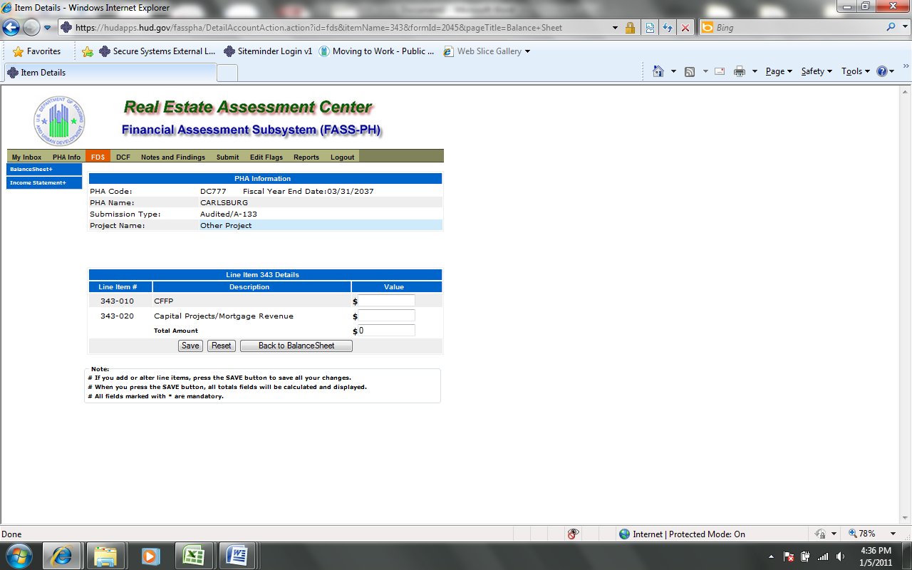

Audited Screen 10 – FDS Income Statement Page

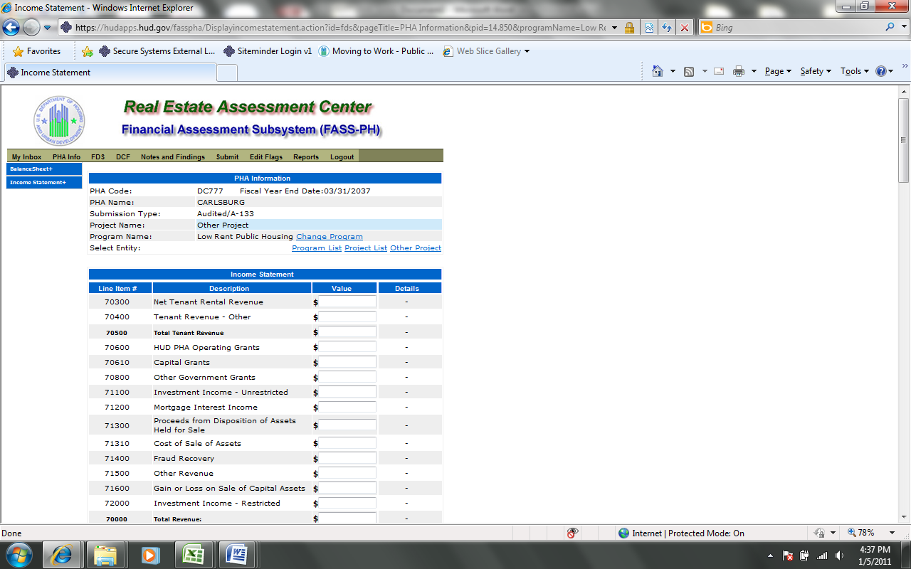
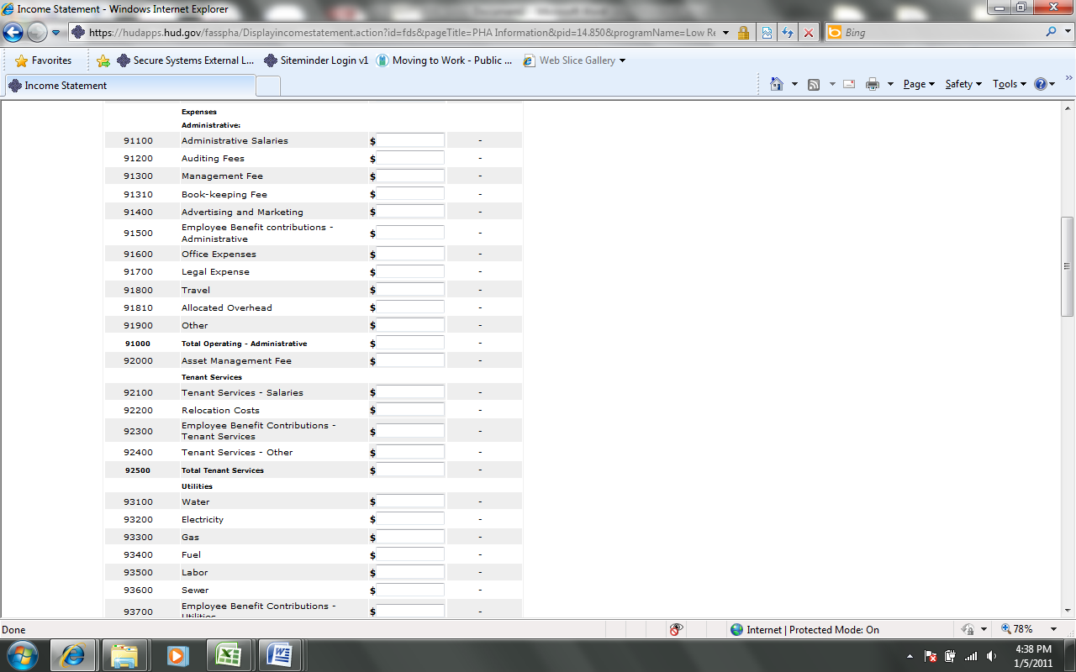
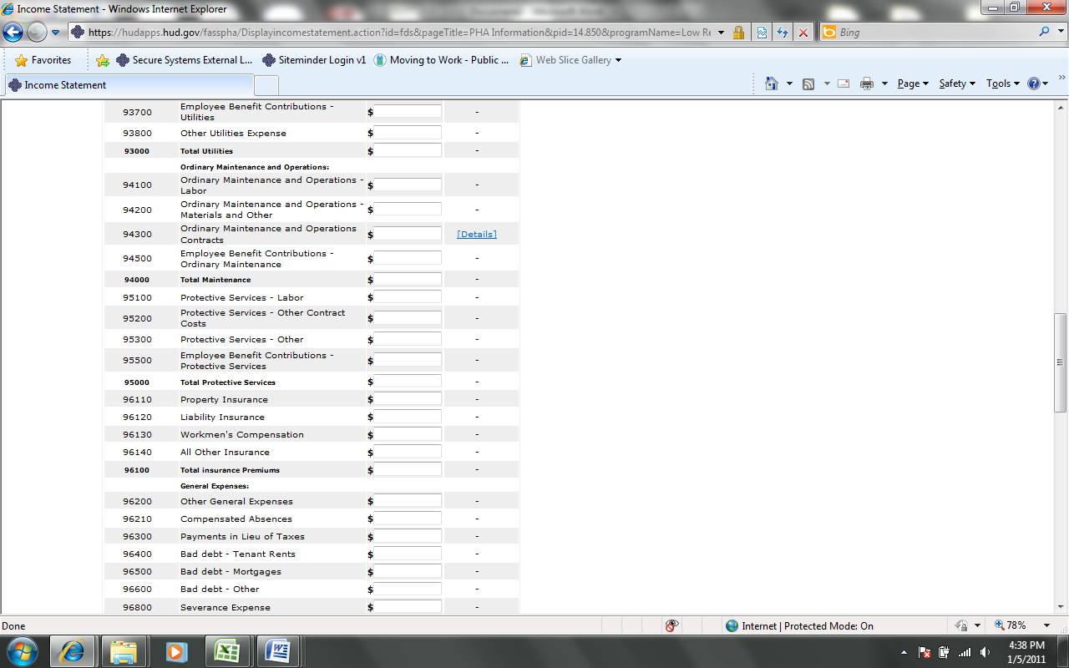
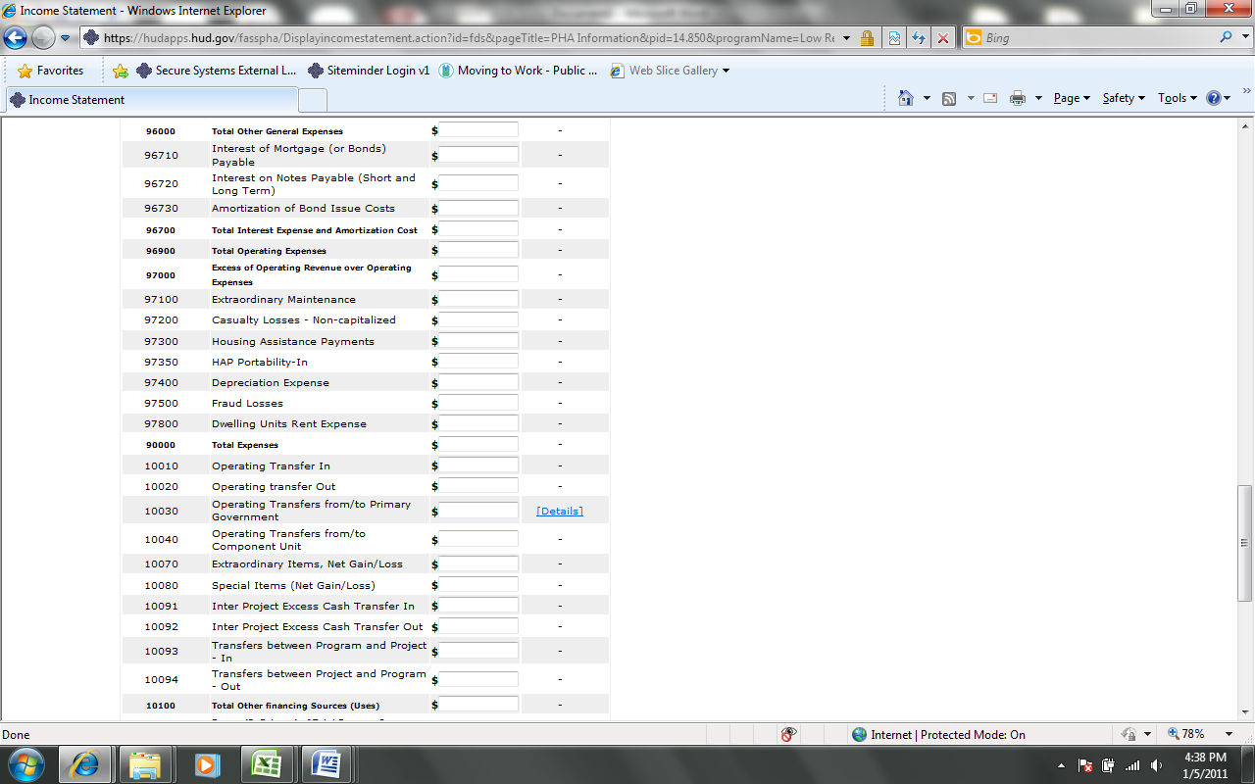
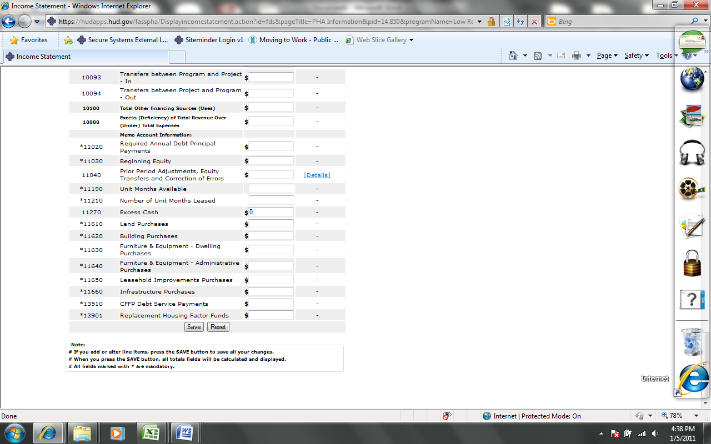

Audited Screen 11 – FDS Income Statement Page (Detail Links)

The following screen provides the detail link associated with the following FDS Line Item: 94300.

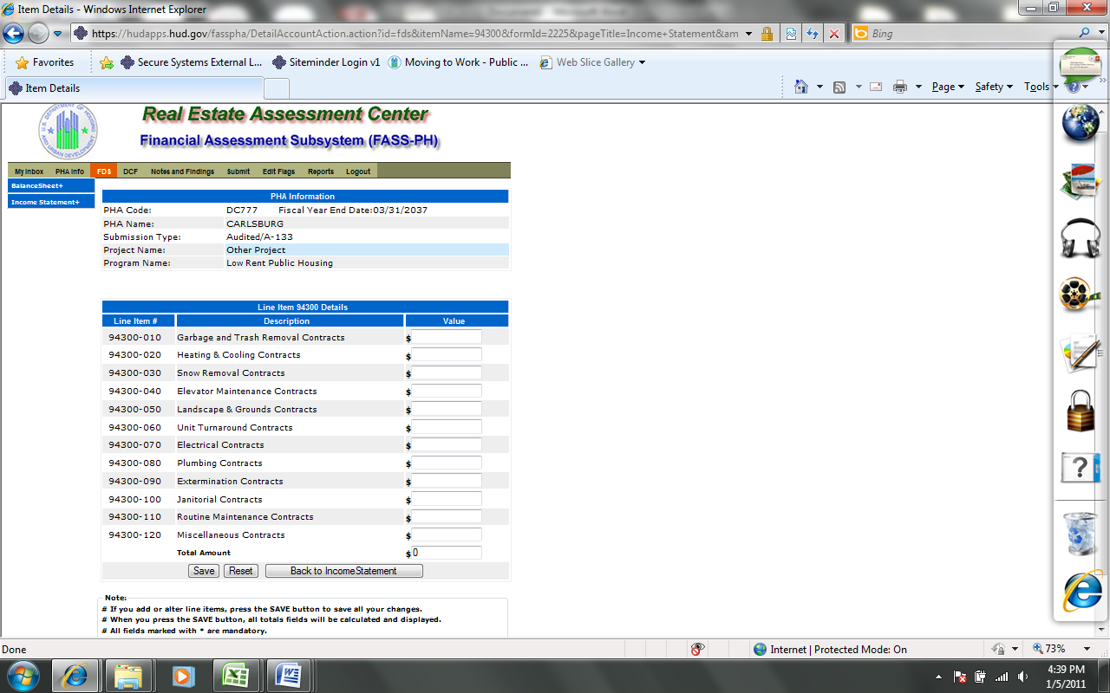

The following screen provides the detail link associated with the following FDS Line Item: 10030.

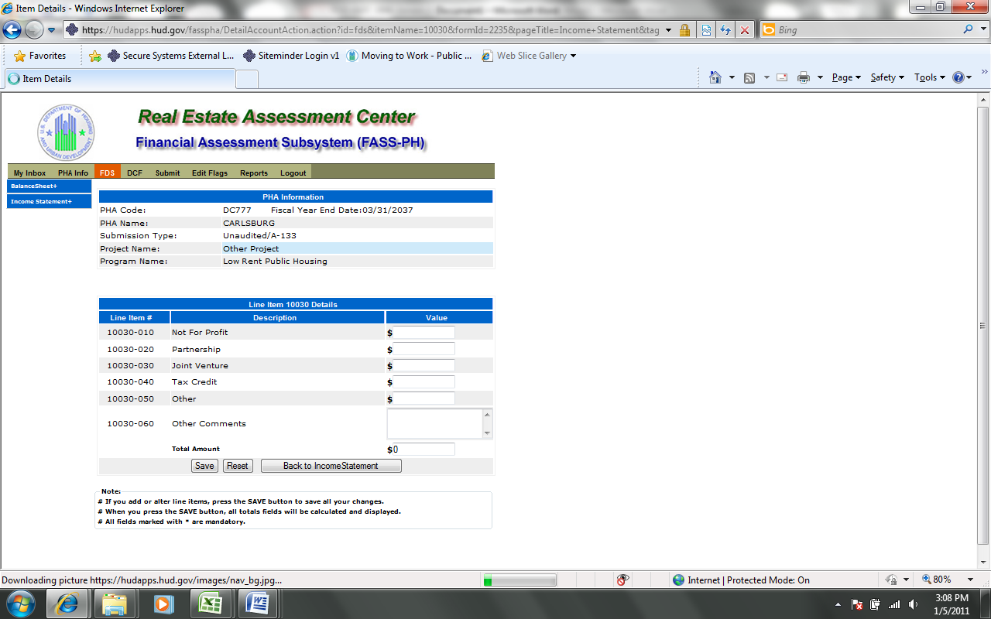

The following screen provides the detail link associated with the following FDS Line Item:
11040

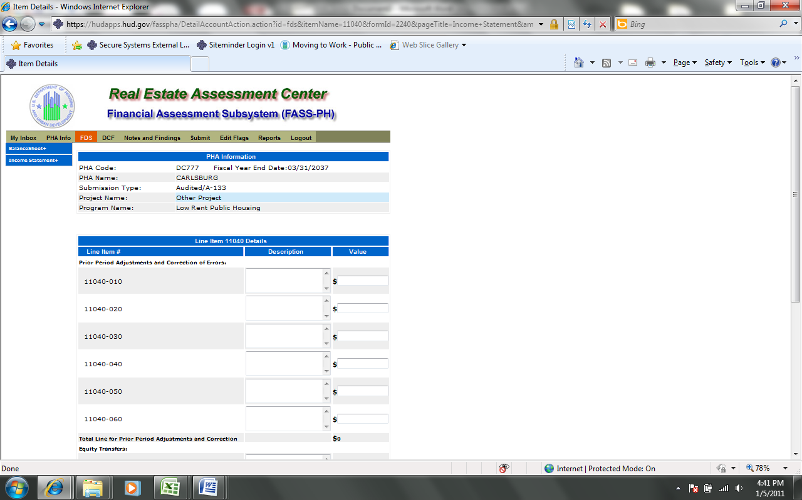
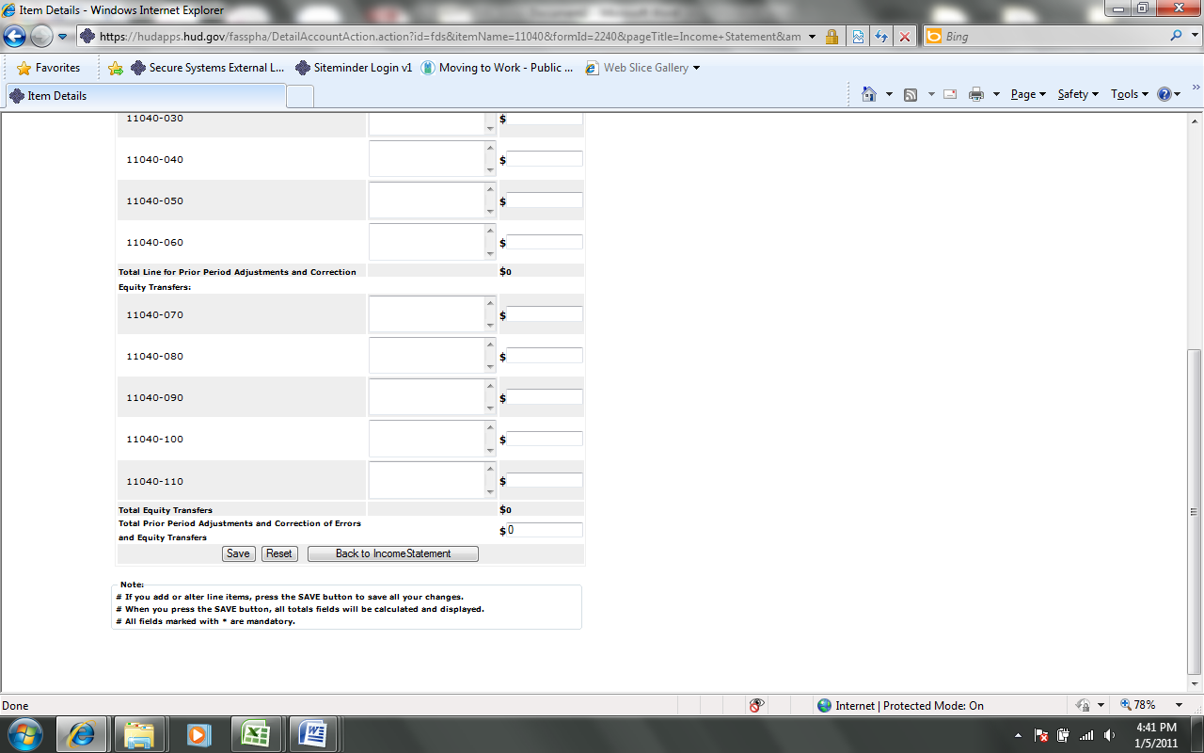

Audited Screen 12 – FDS Income Statement Page (HCV Program Detail Links)

The following screen provides the detail link associated with the following FDS Line Item: 70600. This detail link is only applicable to the Housing Choice Voucher Program.

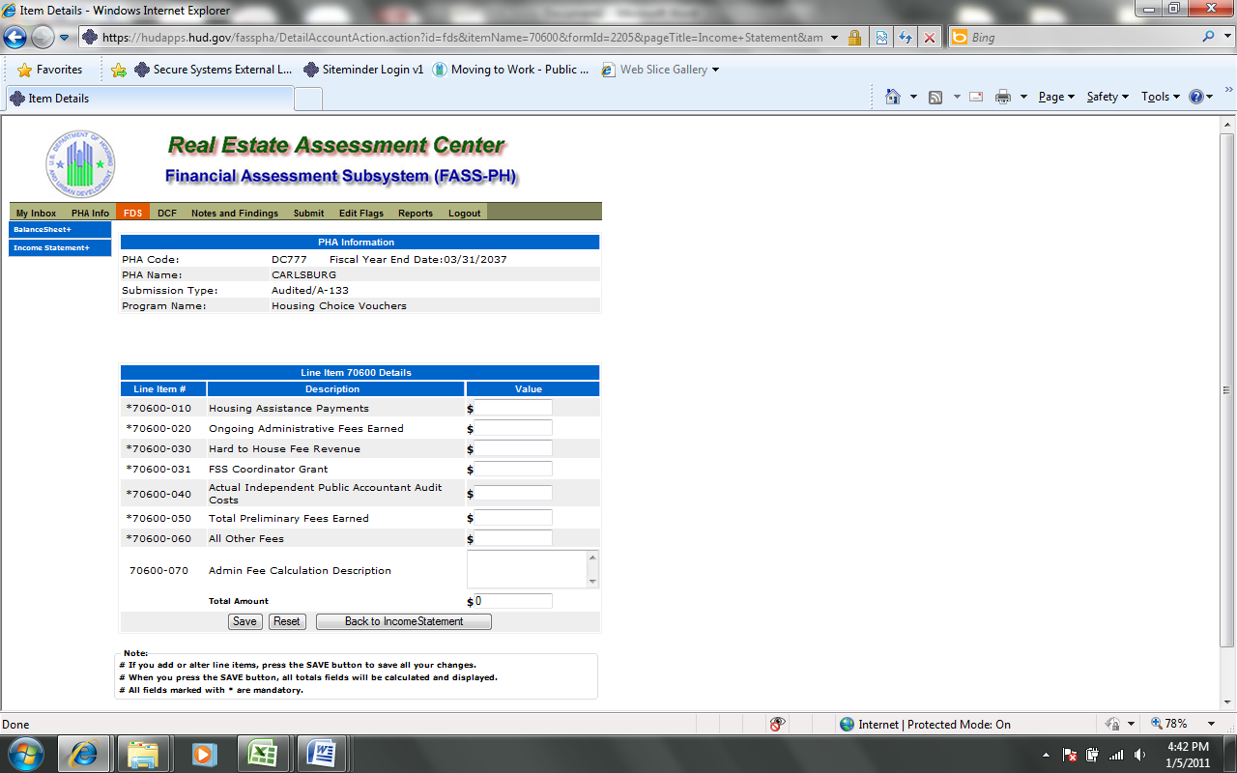

The following screen provides the detail link associated with the following FDS Line Item: 71100. This detail link is only applicable to the Housing Choice Voucher Program.

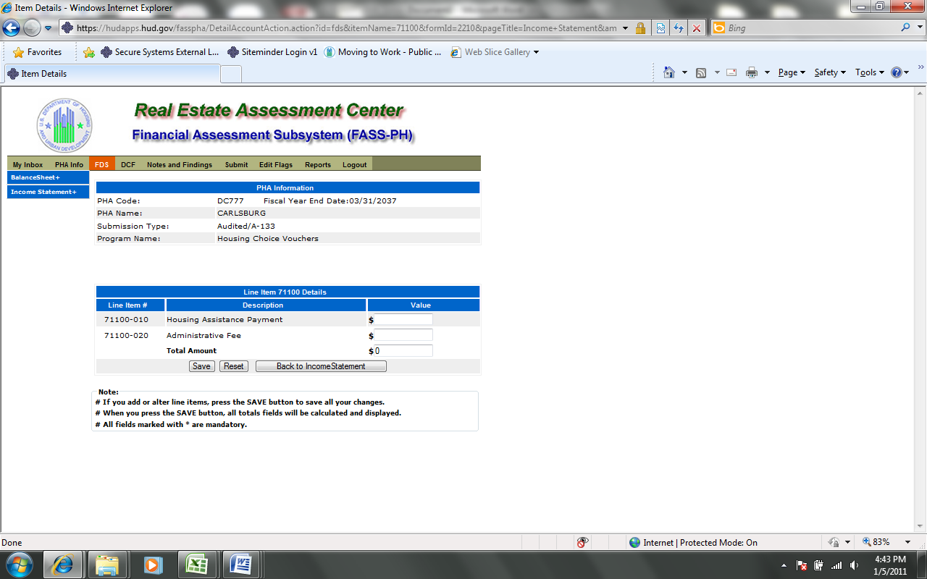

The following screen provides the detail link associated with the following FDS Line Item: 71400. This detail link is only applicable to the Housing Choice Voucher Program.

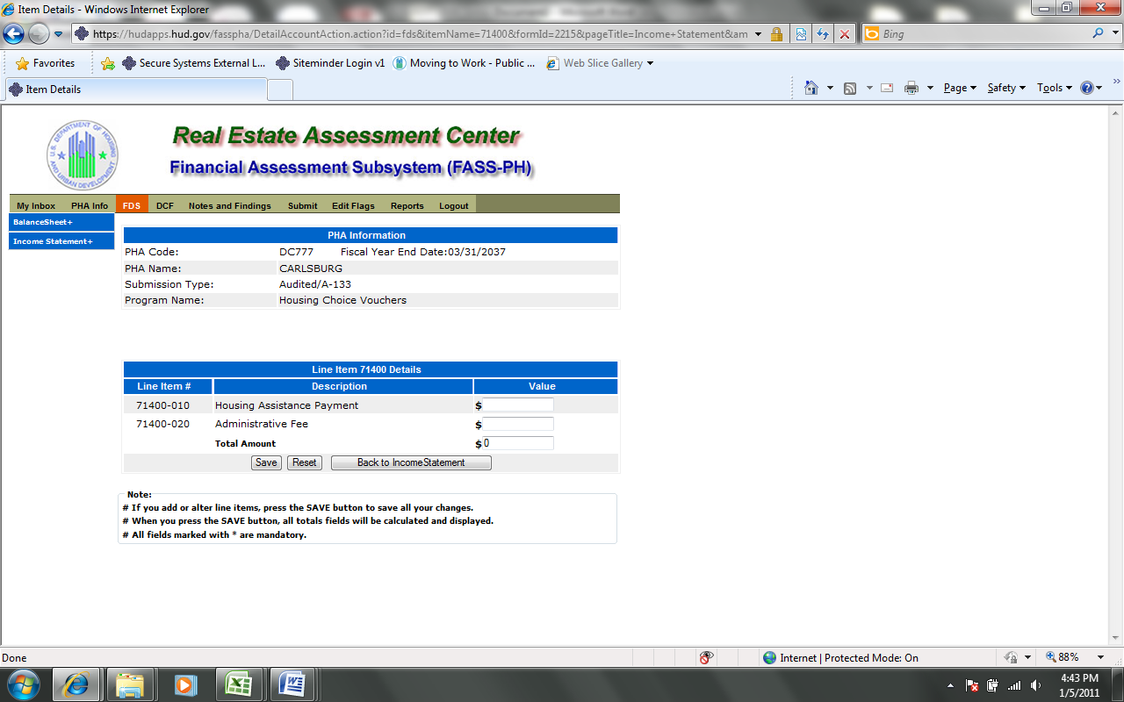

The following screen provides the detail link associated with the following FDS Line Item: 72000. This detail link is only applicable to the Housing Choice Voucher Program.

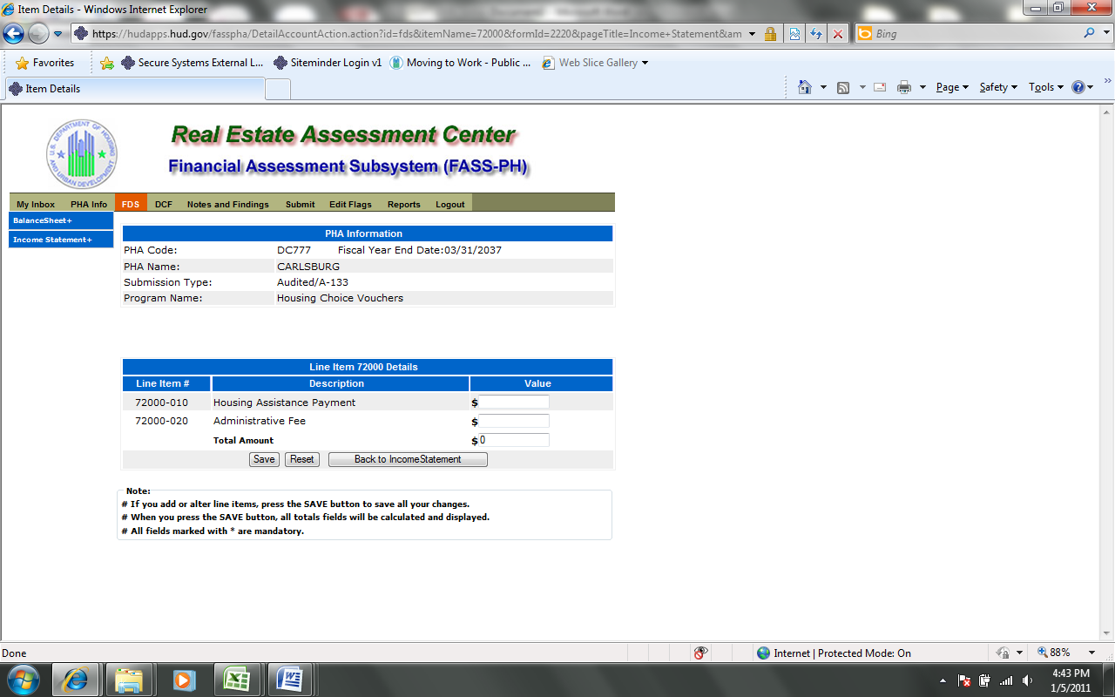

The following screen provides the detail link associated with the following FDS Line Item: 97300. This detail link is only applicable to the Housing Choice Voucher Program.

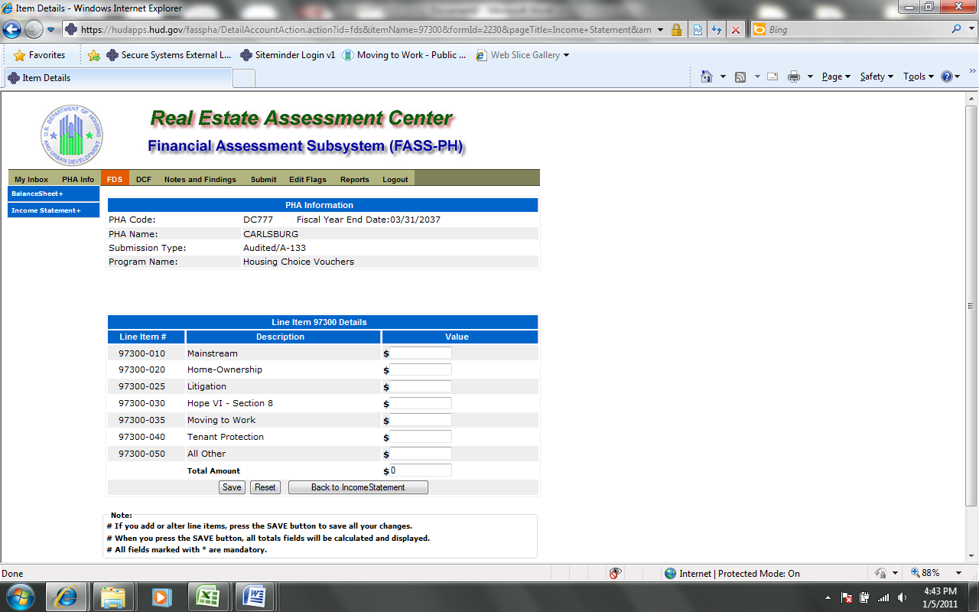

The following screen provides the detail link associated with the following FDS Line Item: 11170. This detail link is only applicable to the Housing Choice Voucher Program.

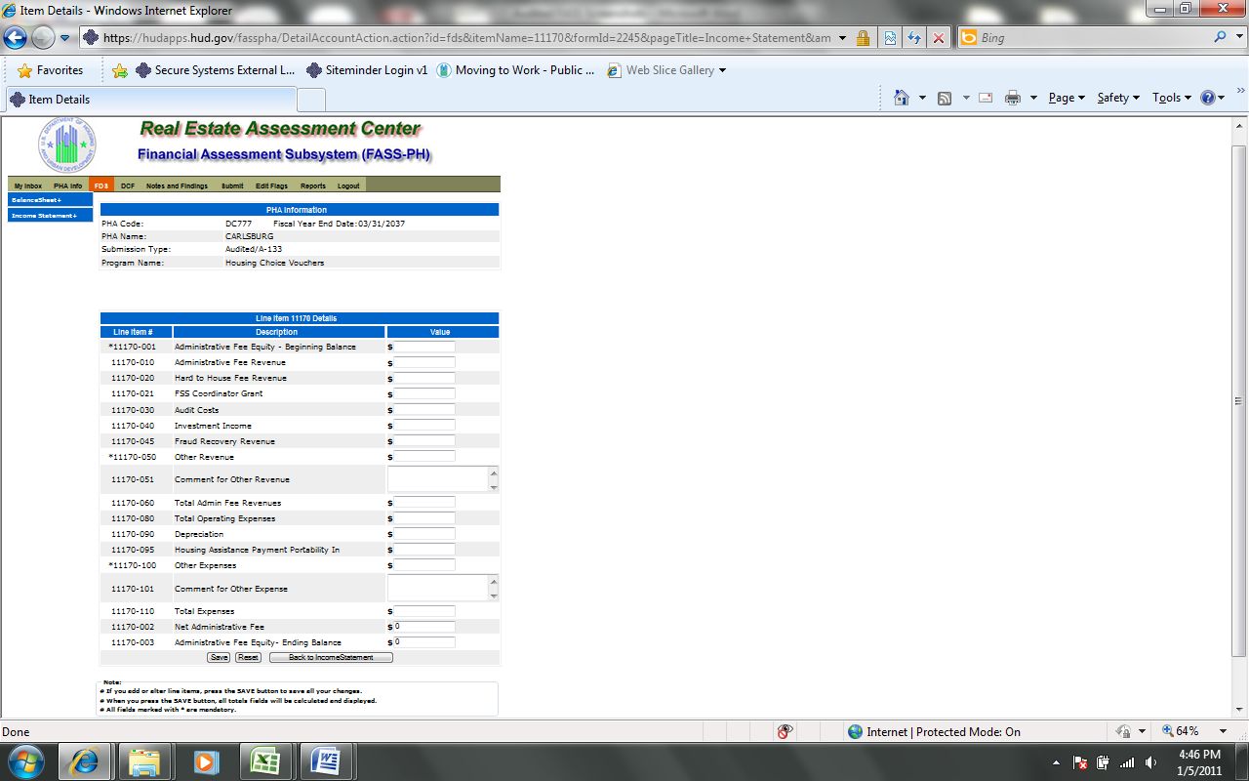

The following screen provides the detail link associated with the following FDS Line Item: 11180. This detail link is only applicable to the Housing Choice Voucher Program.

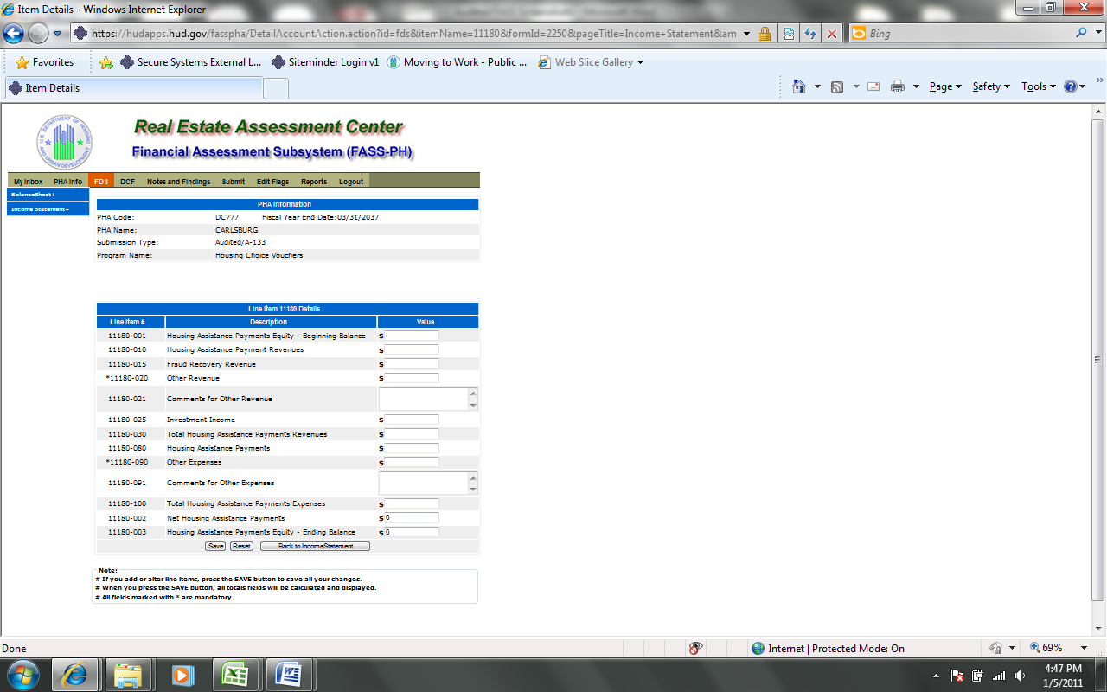

The following screen provides the detail link associated with the following FDS Line Item: 11190. This detail link is only applicable to the Housing Choice Voucher Program.

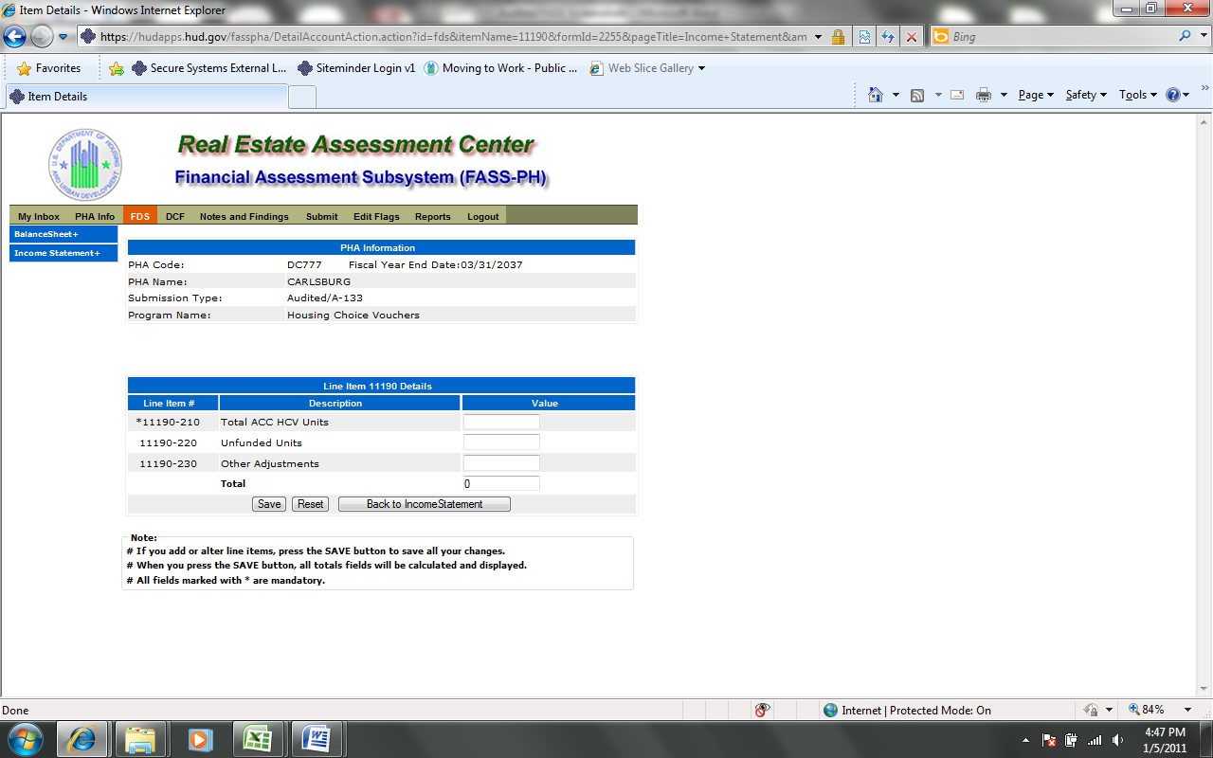

Audited Screen 13 – Data Collection Form Page (General Information)

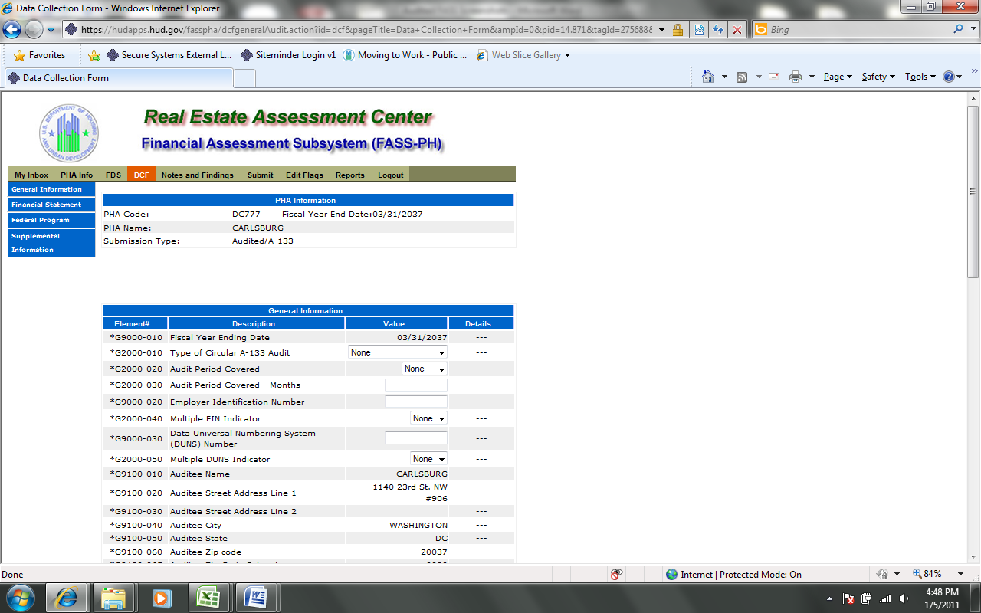
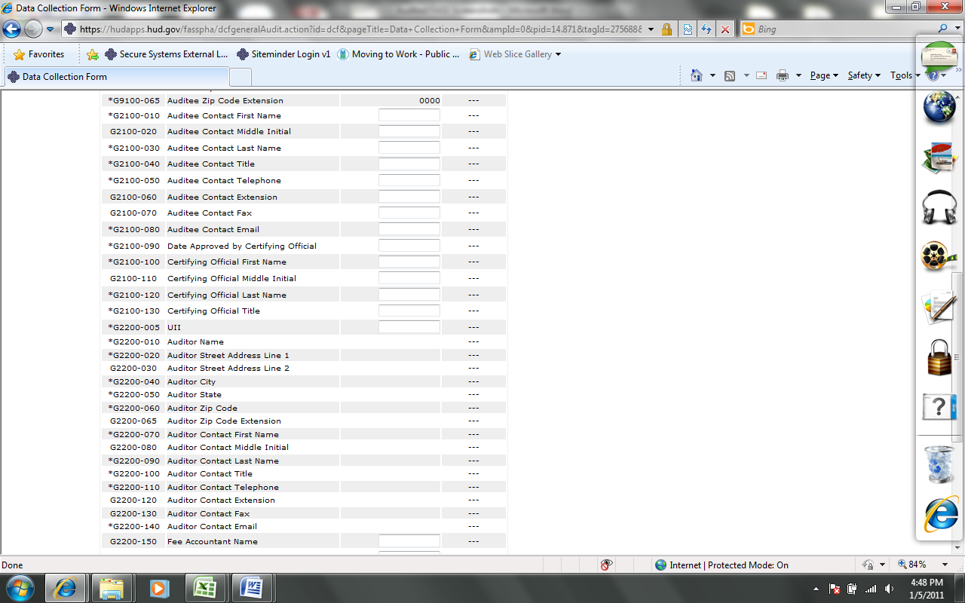
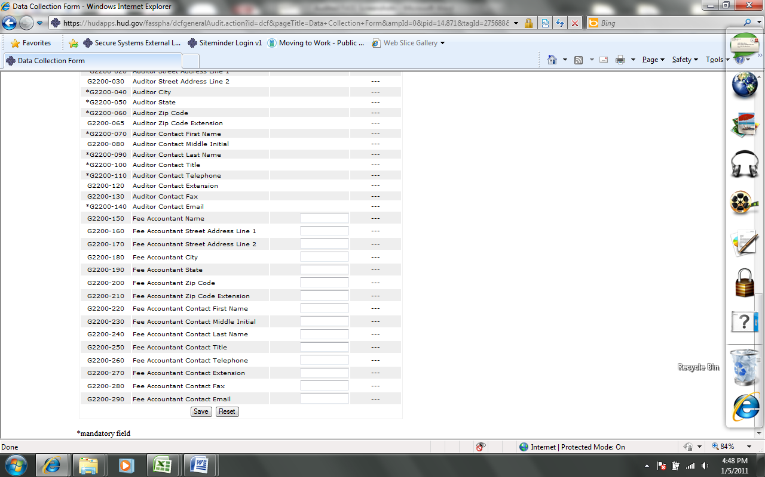

Audited Screen 14 – Data Collection Form Page (Financial Statement)

Financial Statement Page
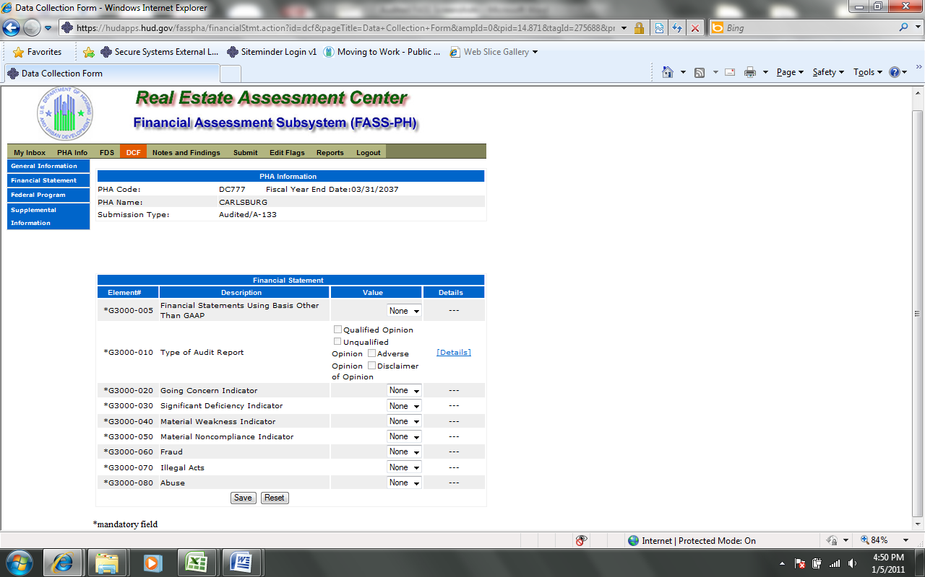

Fund Opinion Page
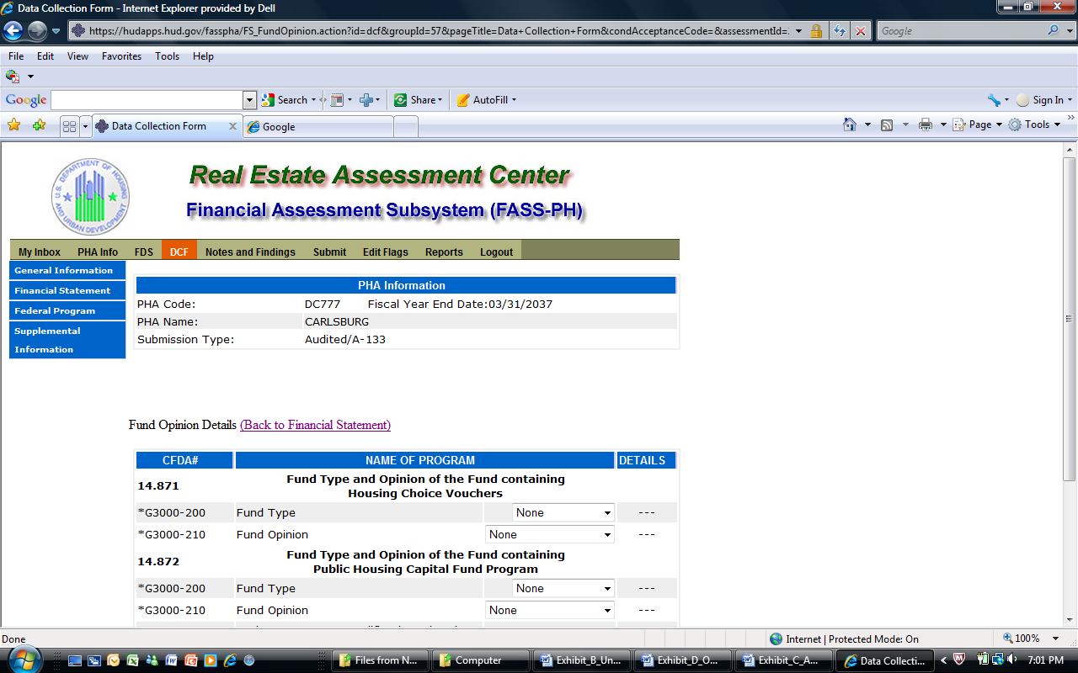
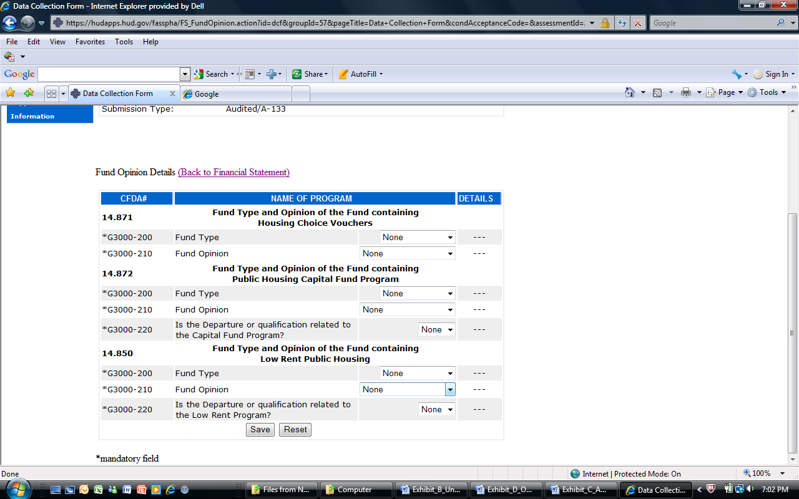

Audited Screen 15 – Data Collection Form Page (Federal Program)

Federal Programs Page
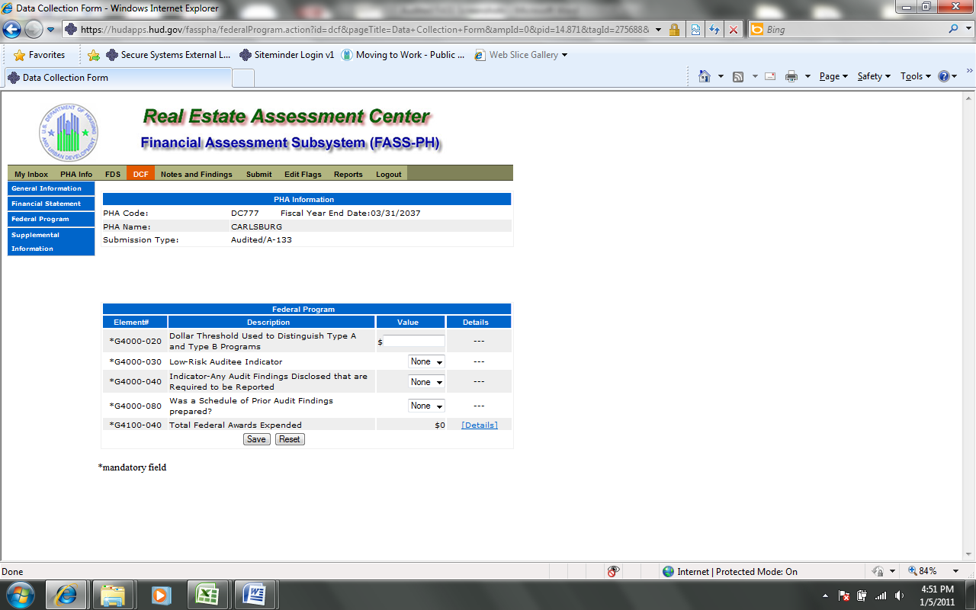
Total Federal Awards Expended Details Page
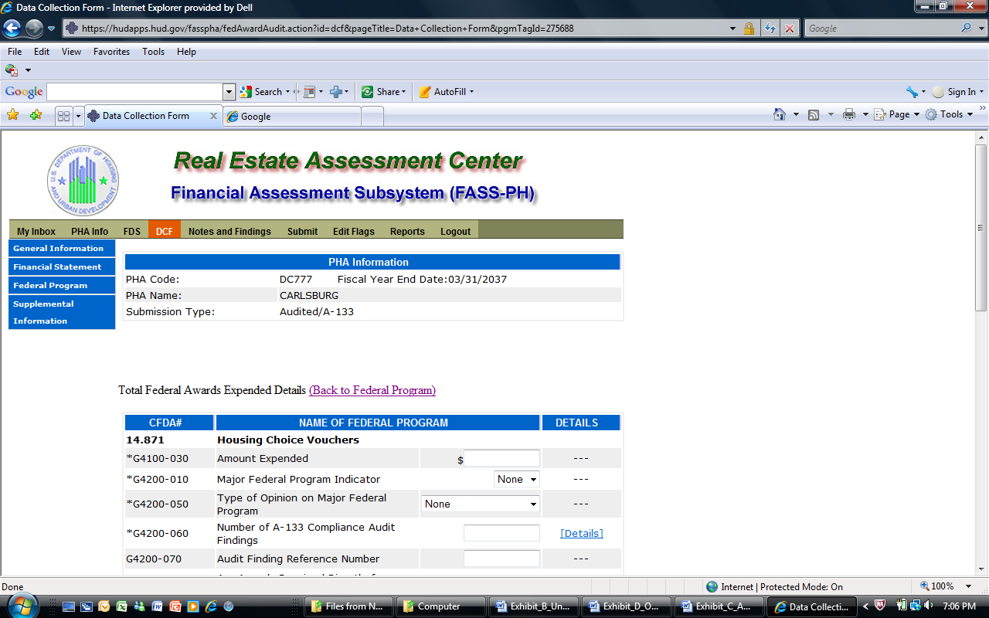
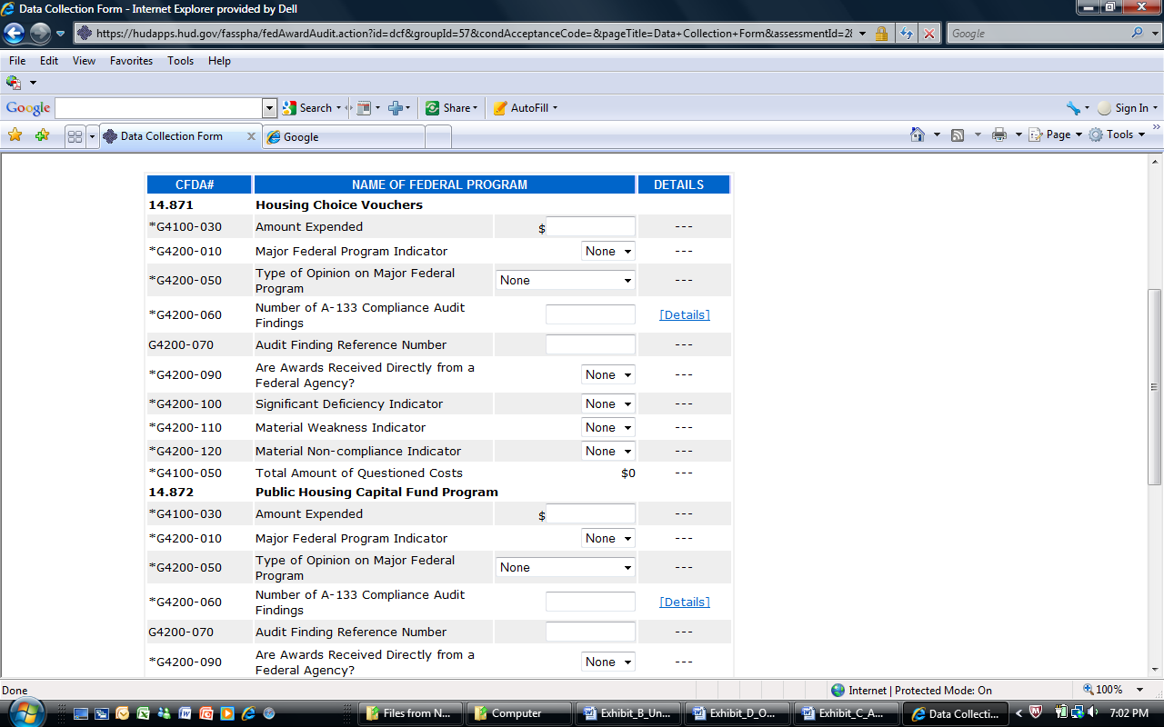
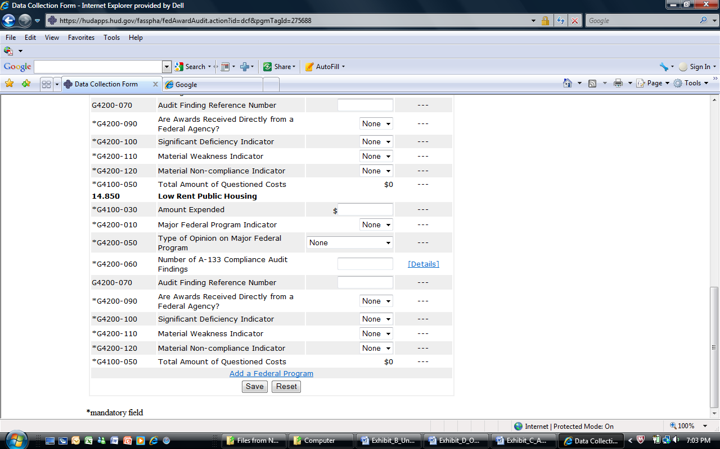

Compliance Requirement Page
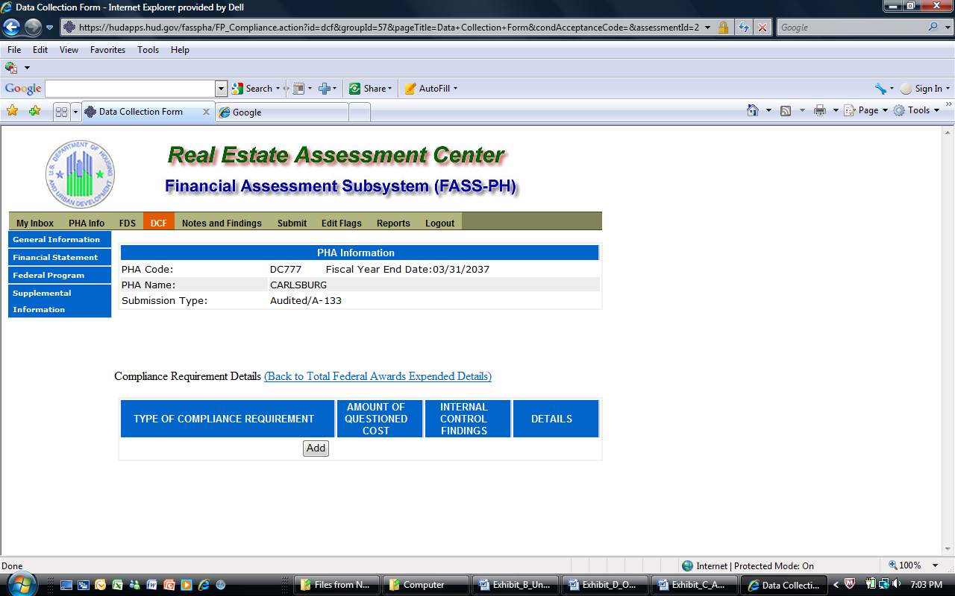

Add a Compliance Requirement Page
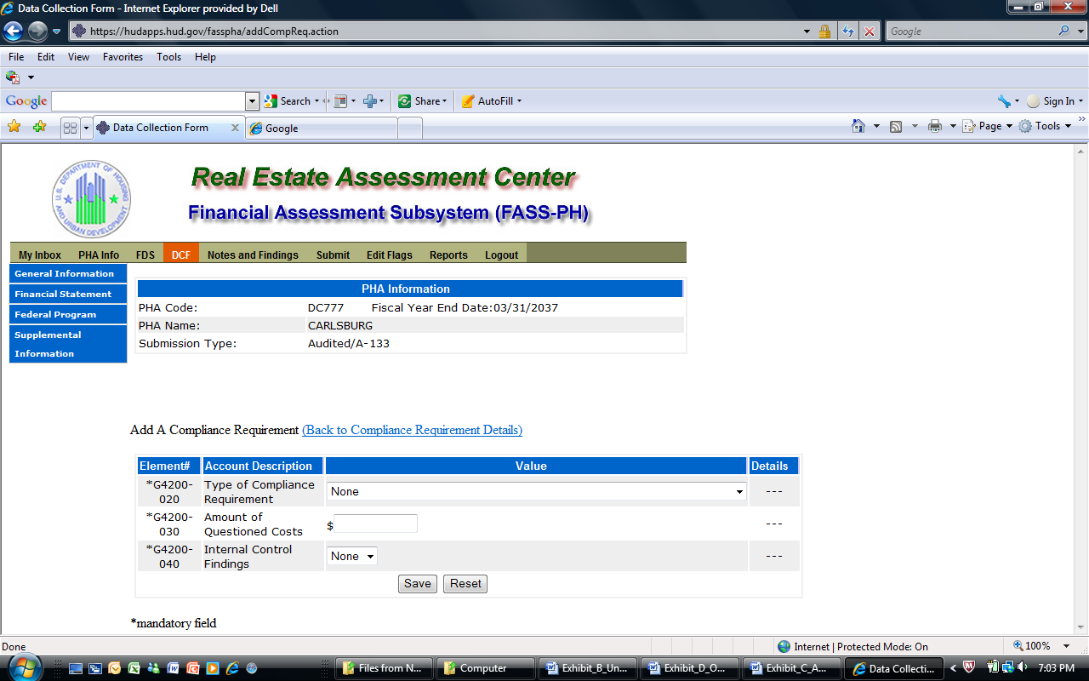

Audited Screen 16 – Data Collection Form Page (Supplemental Information)

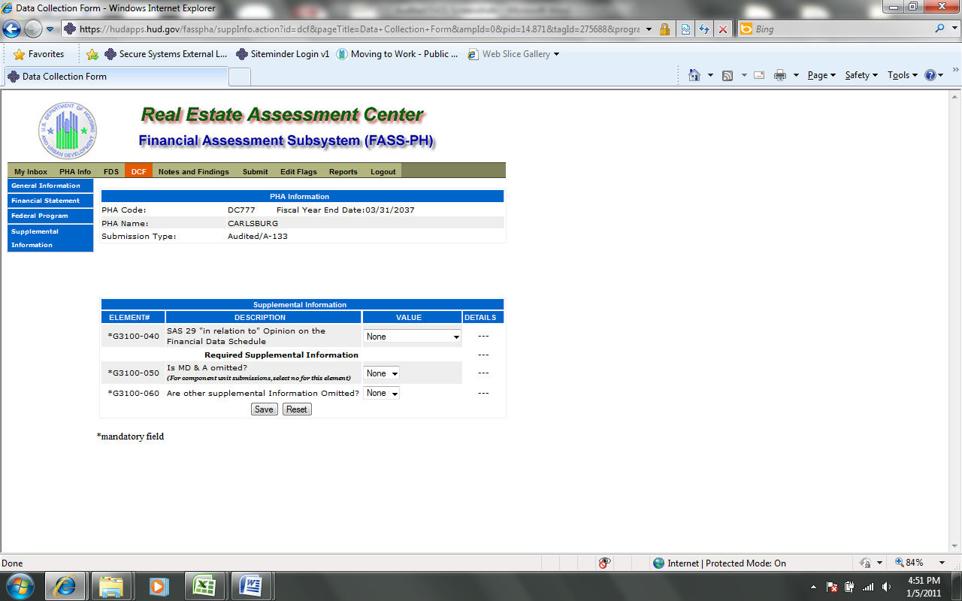

Audited Screen 17 – Notes and Findings Page

Notes Page
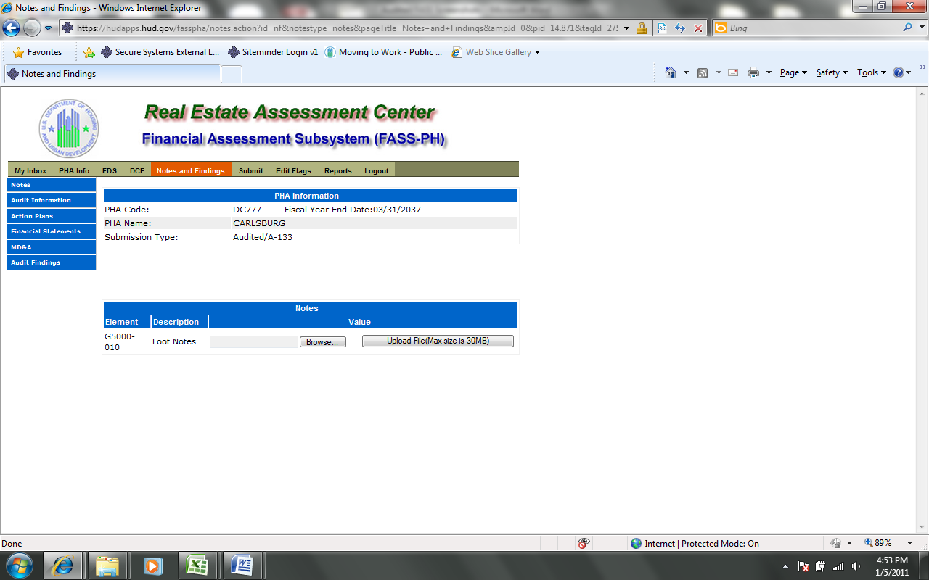

Audit Information Page
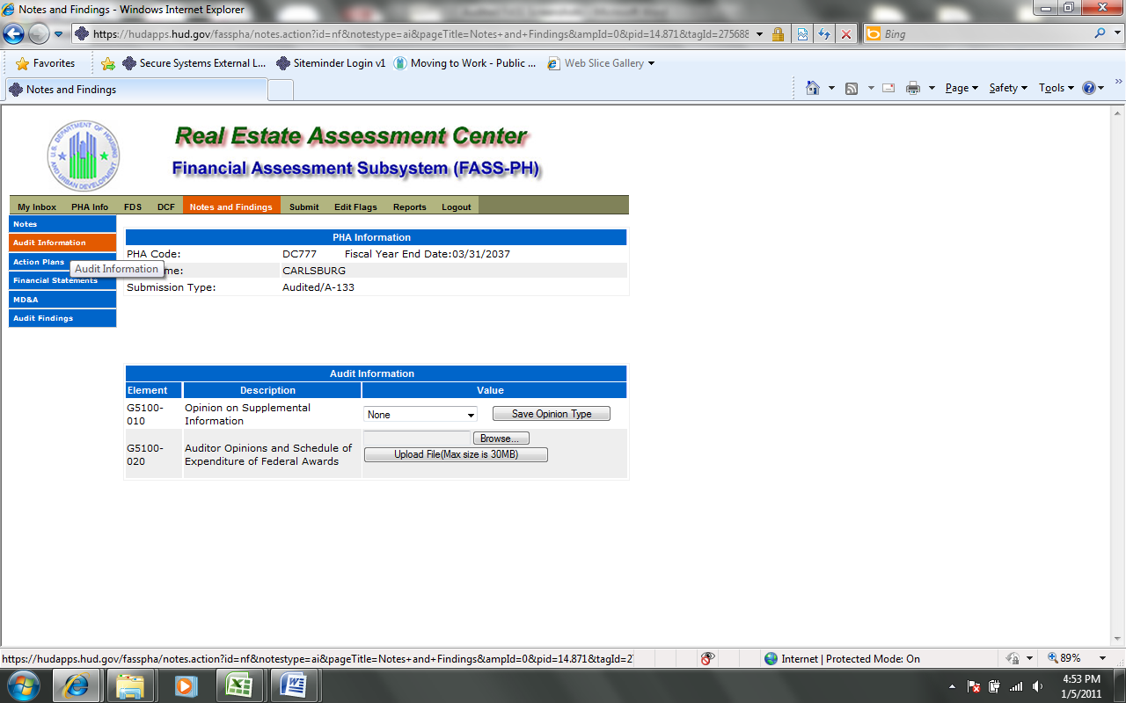

Action Plans Page
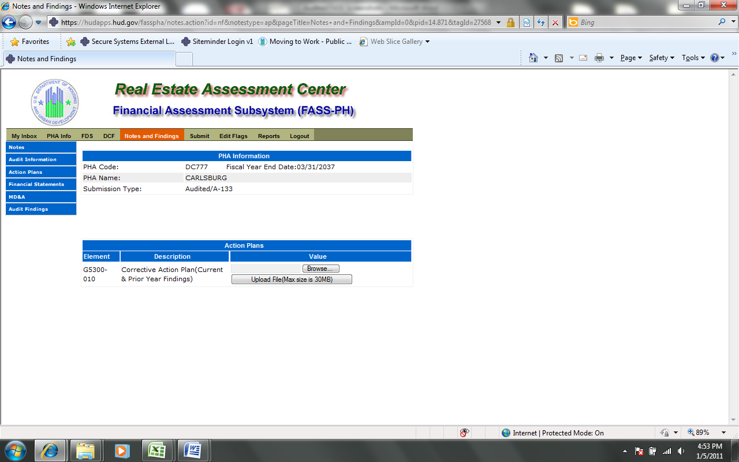

Financial Statement Page
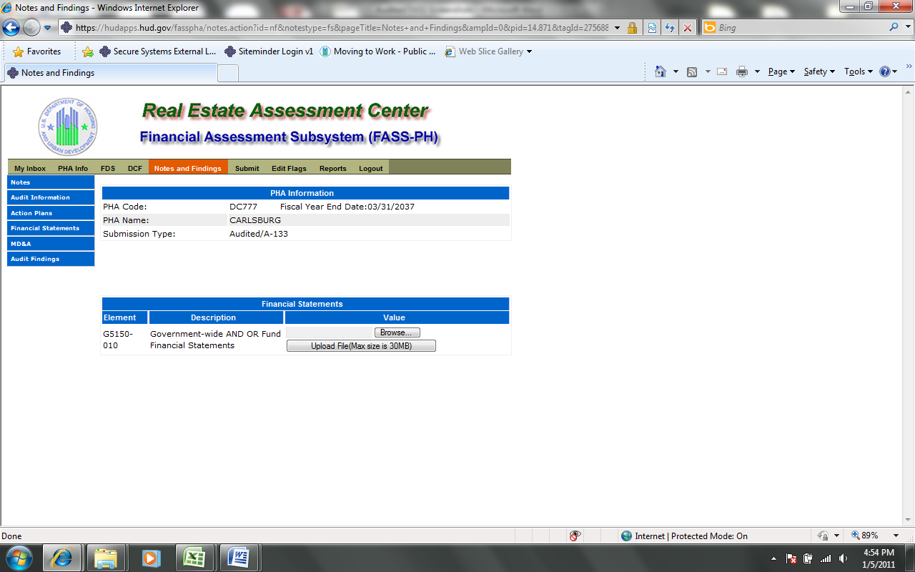

MD & A Page
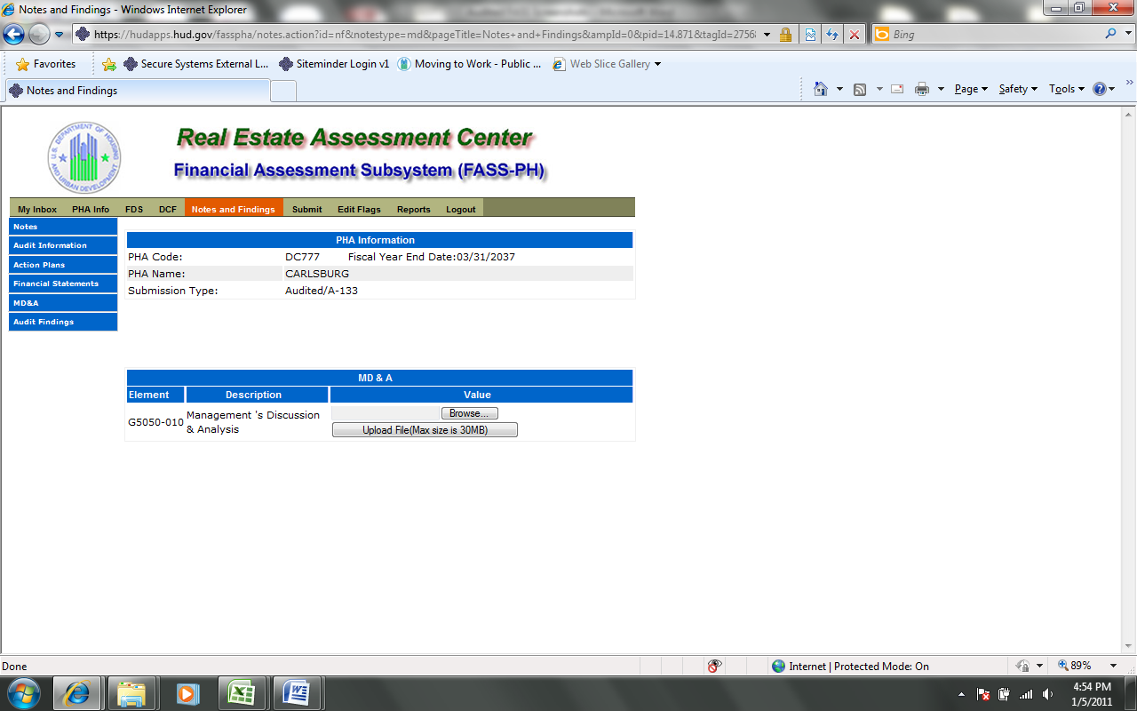

Audit Findings Page
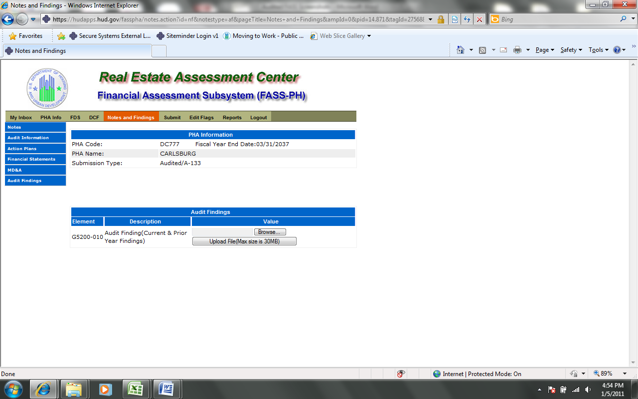

Audited Screen 18 – Auditor’s Agreed Upon Procedures Page
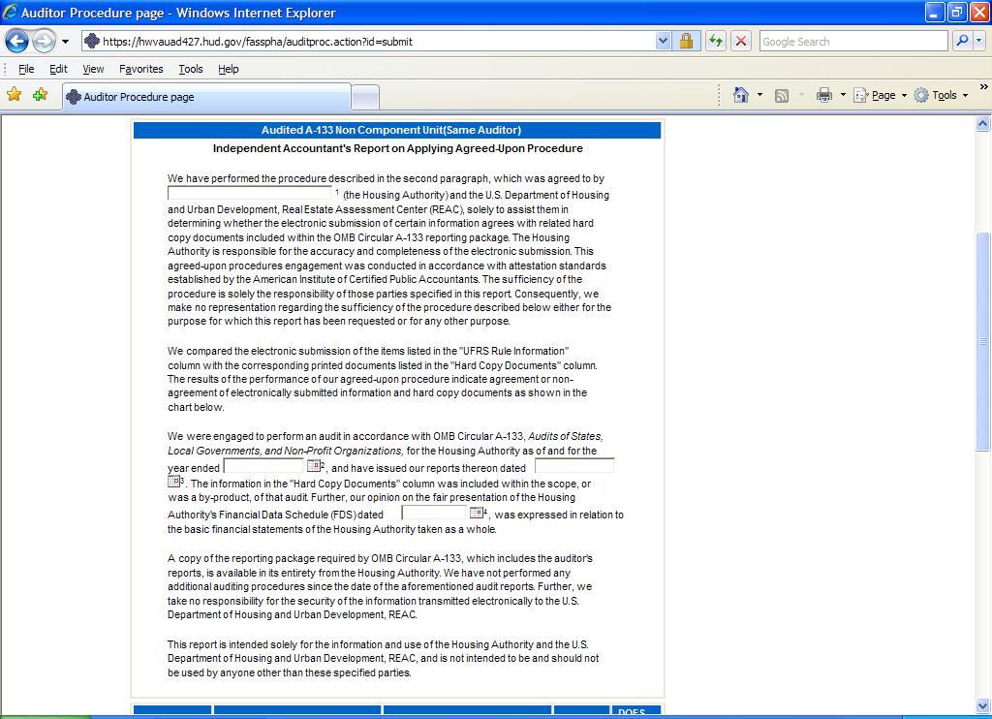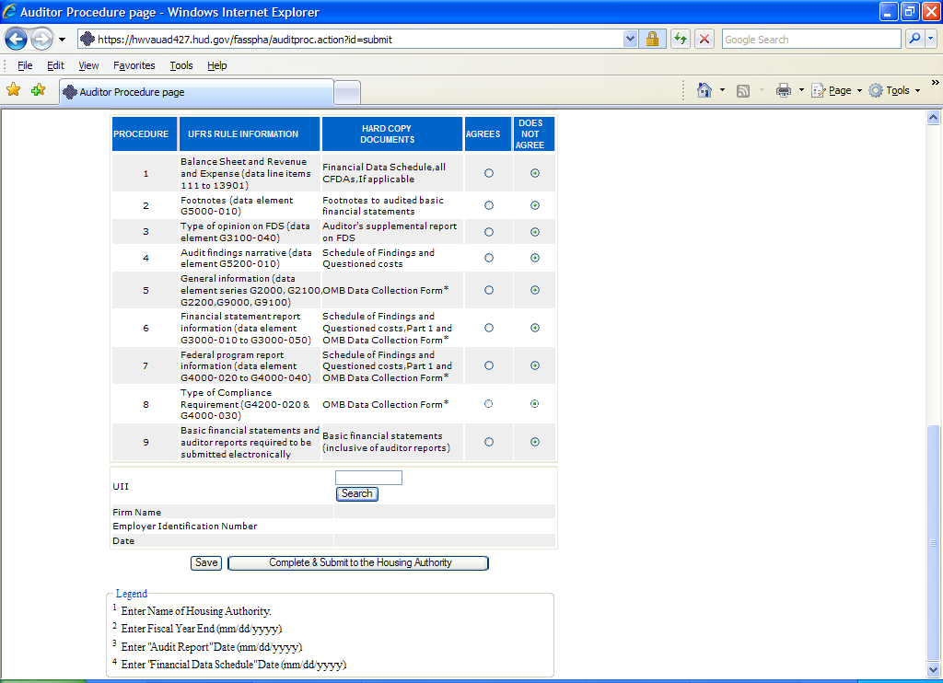

Audited Screen 19 – Submit Page

