Emergency Alert National Test System (EANTS) Screenshots

Welcome screen displayed prior to November 9
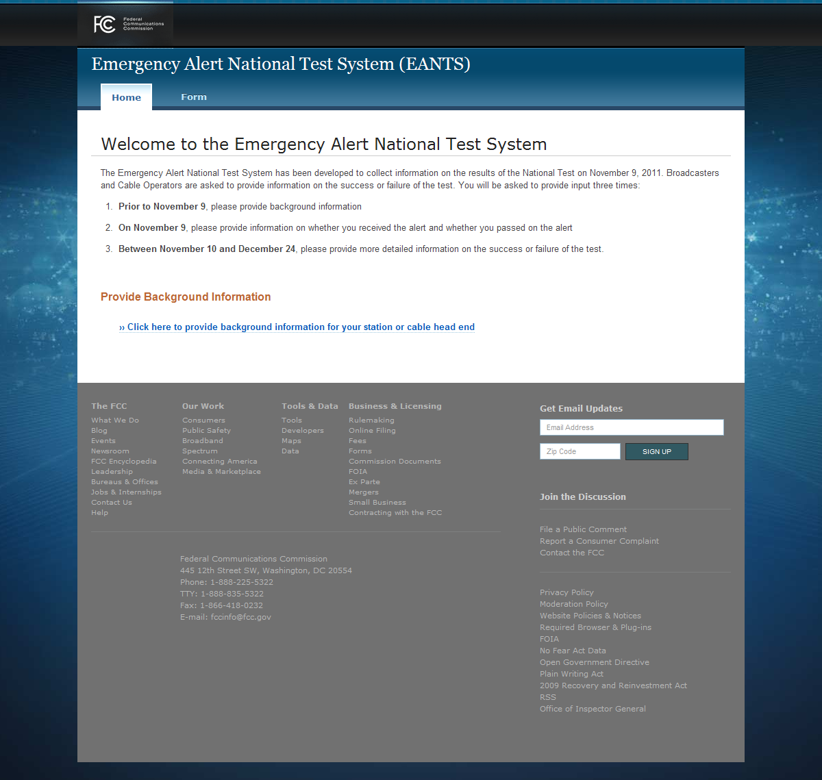

Background Information screen showing fields for ‘Broadcaster’ EAS Participant option, and showing Emergency Contact Info
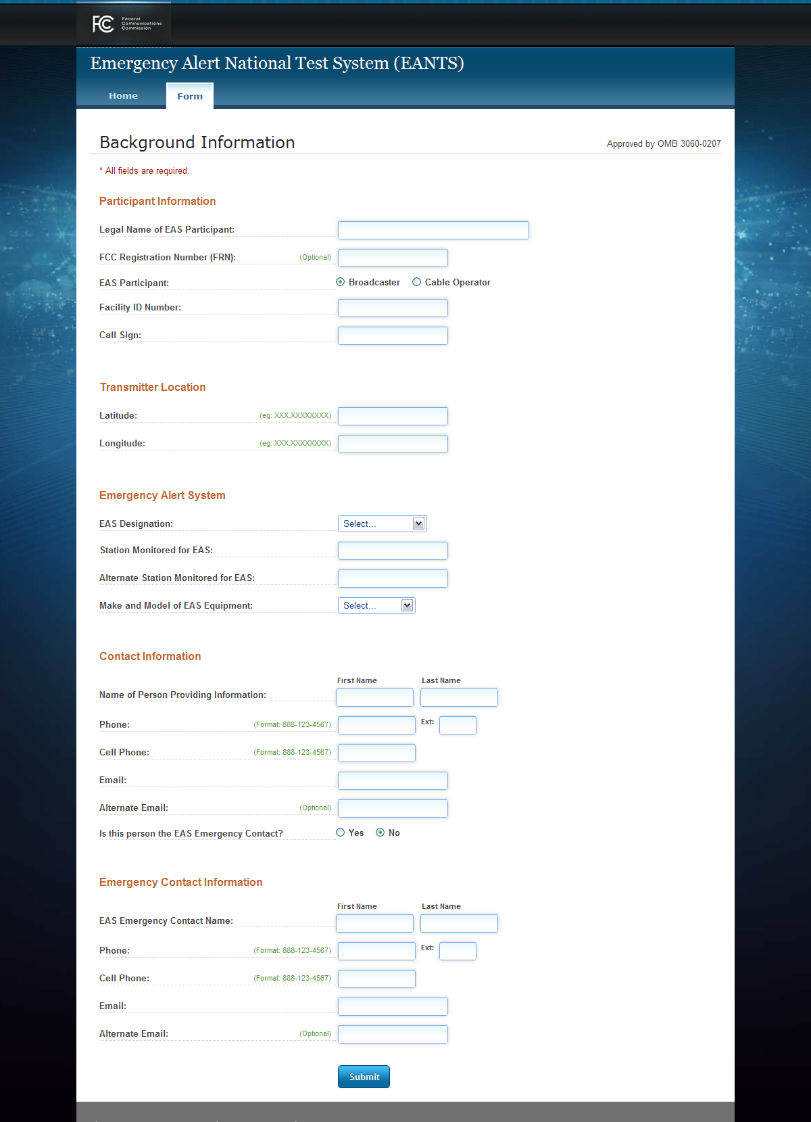
Background Information screen showing fields for ‘Cable Operator’ EAS Participant option; the EAS Equipment Make and Model selection as ‘Other’, and no Emergency Contact Info
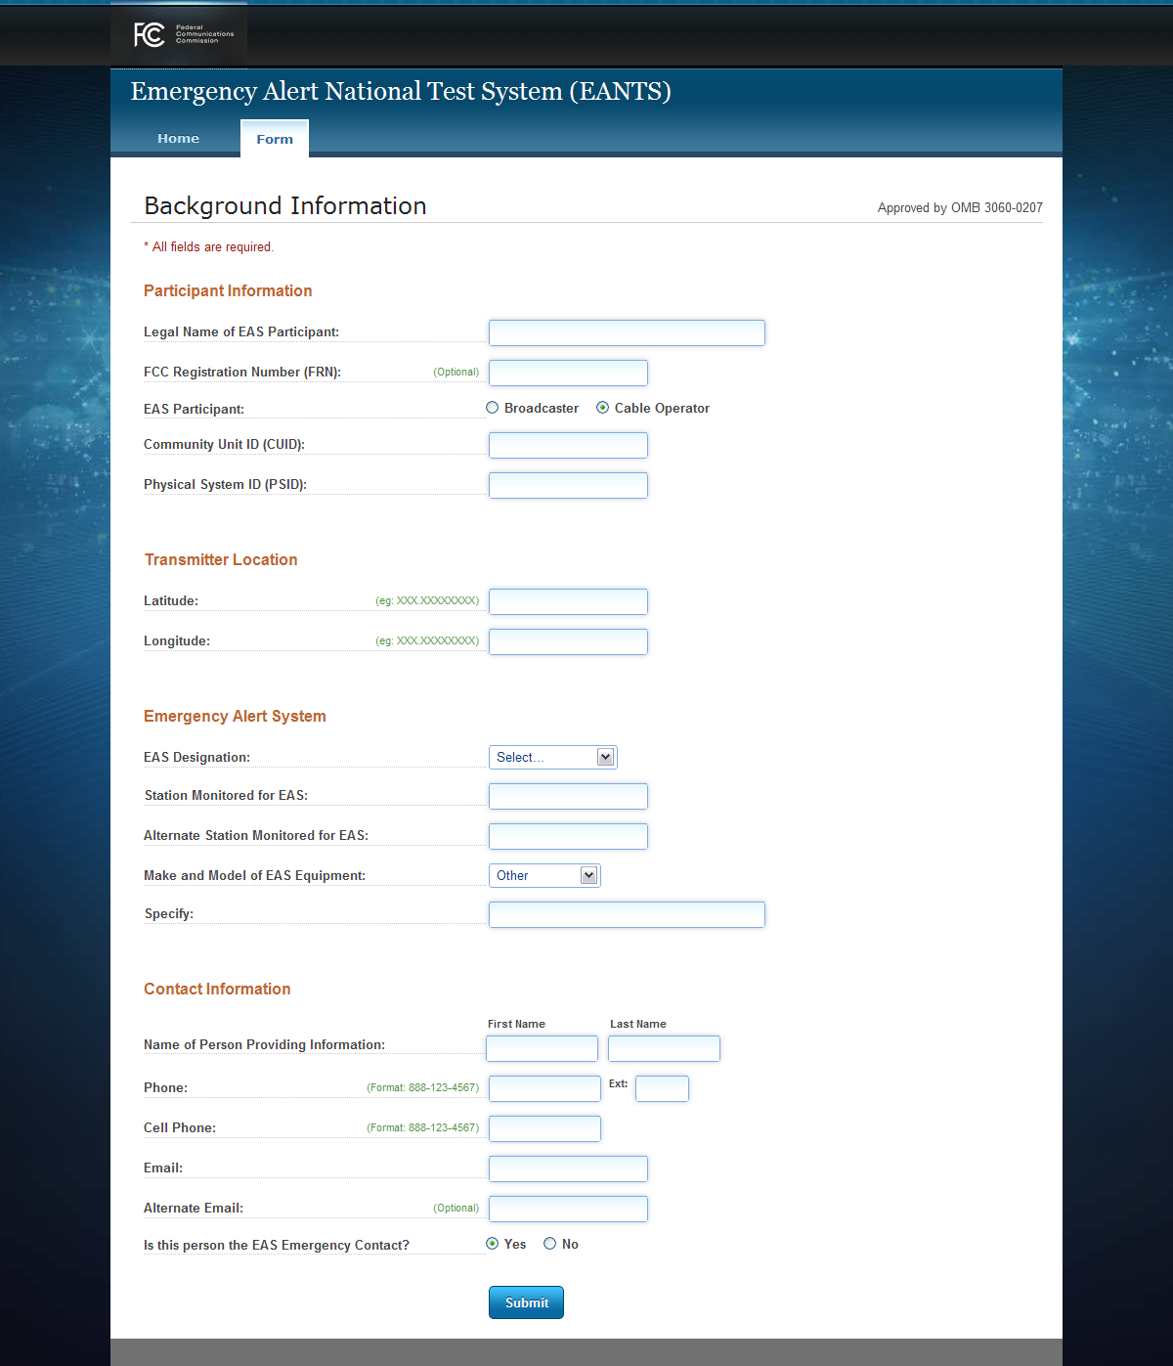

Background Information ‘Information Submitted’ screen
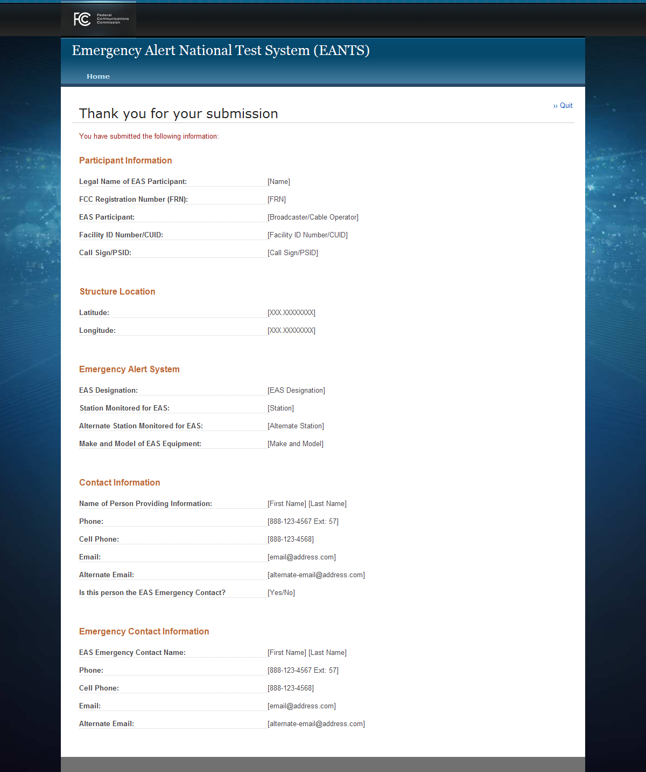

Welcome screen displayed on November 9
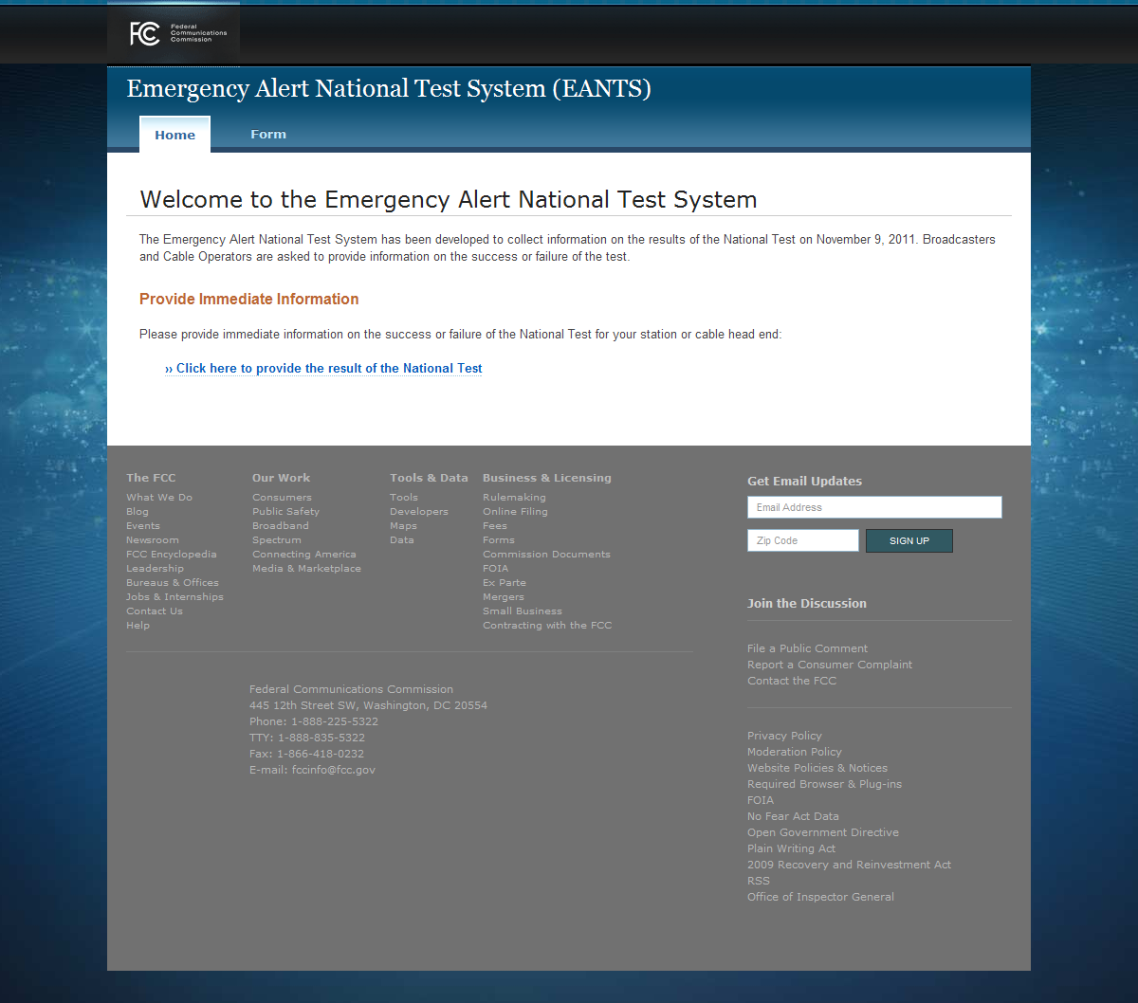

Day-of-Test Result screen showing fields for ‘Broadcaster’ EAS Participant option, and showing the second Emergency Alert question
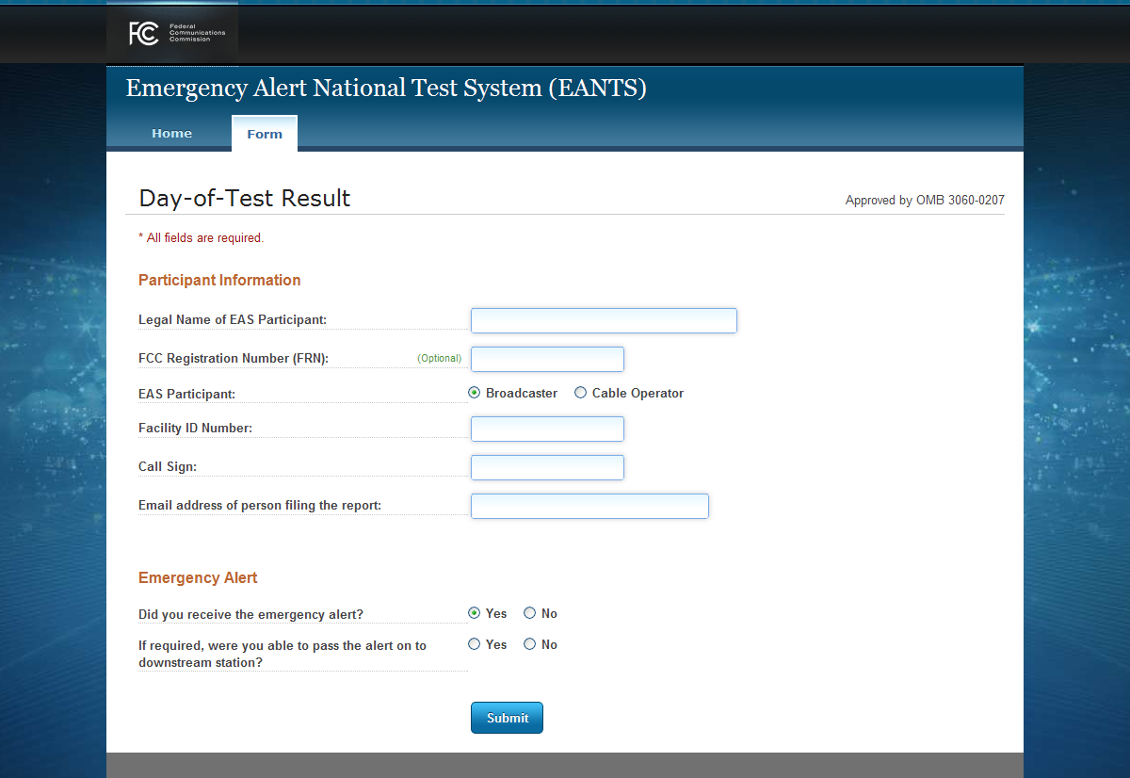

Day-of-Test Result screen showing fields for ‘Cable Operator’ EAS Participant option, and not showing the second Emergency Alert question
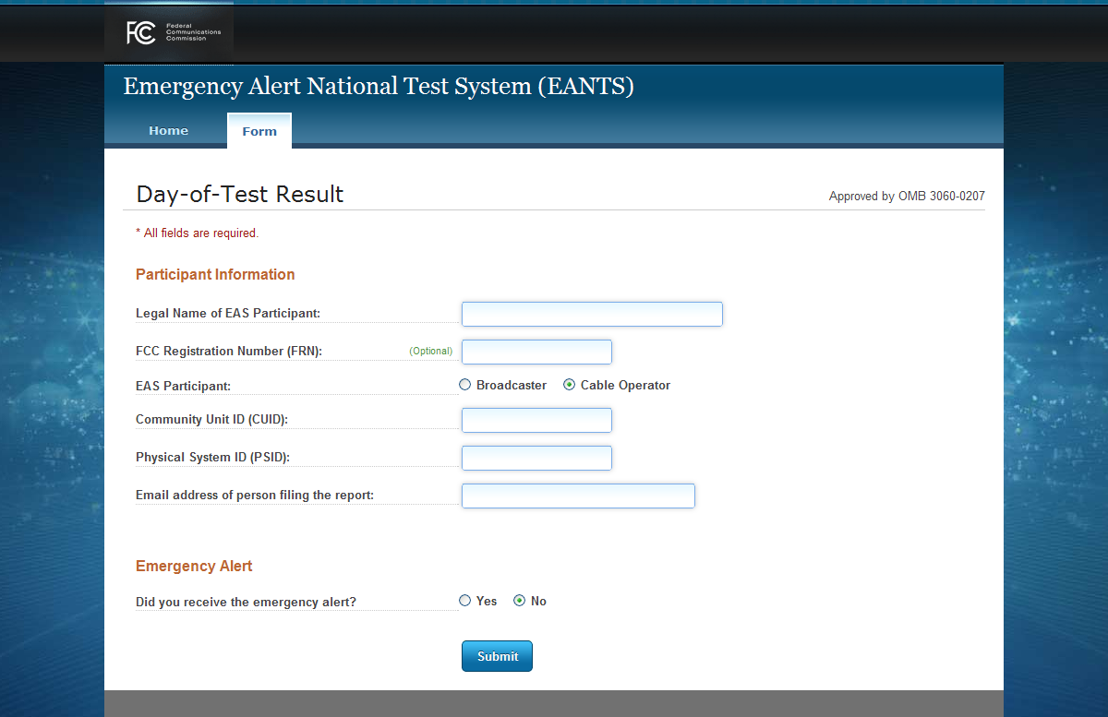

Day-of-Test Result ‘Information Submitted’ screen

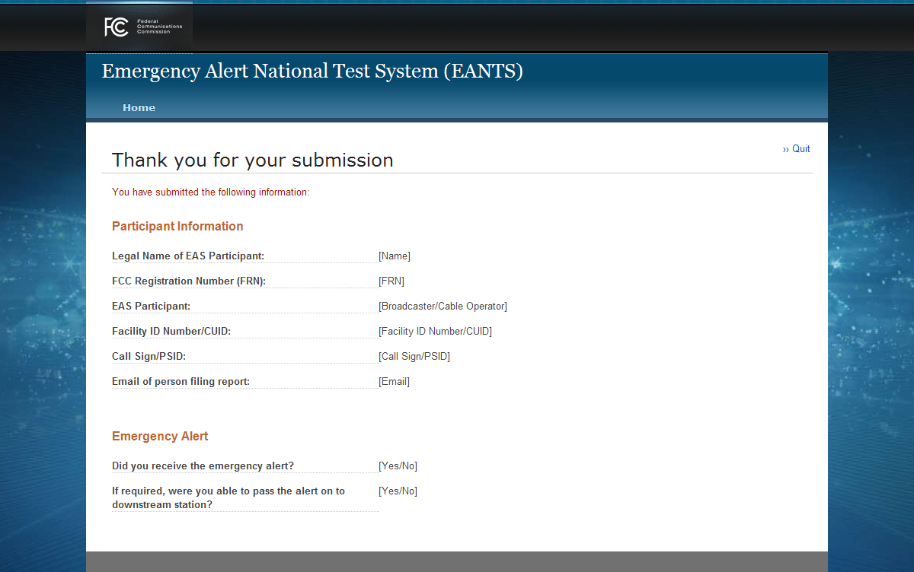
Welcome screen displayed between November 10 and December 24
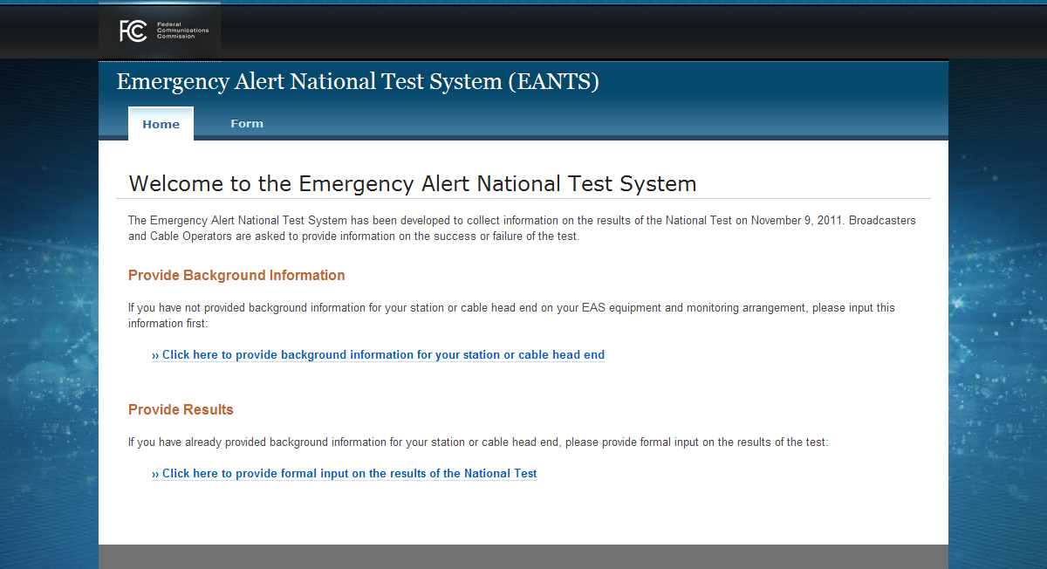

Detailed EAS Results screen showing field for ‘Broadcaster’ EAS Participant option
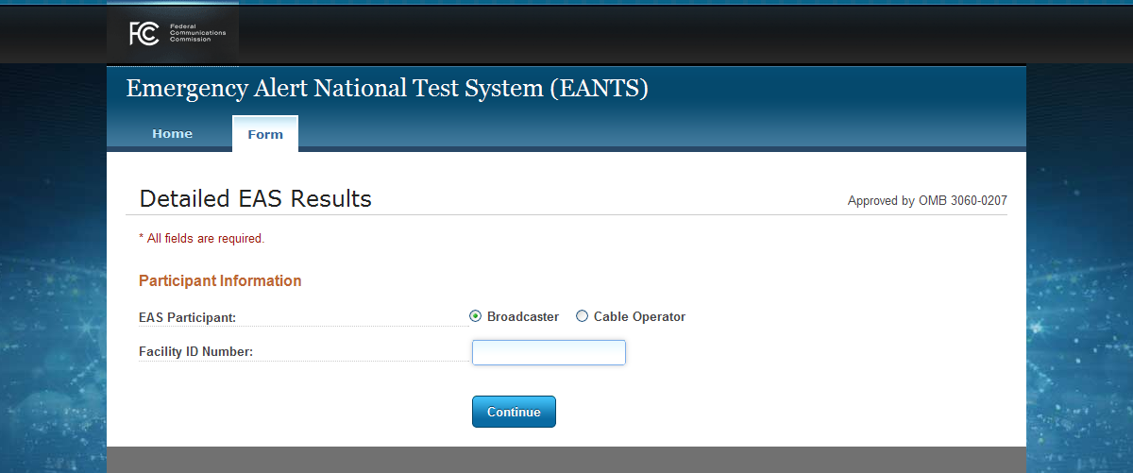

Detailed EAS Results screen showing field for ‘Cable Operator’ EAS Participant option

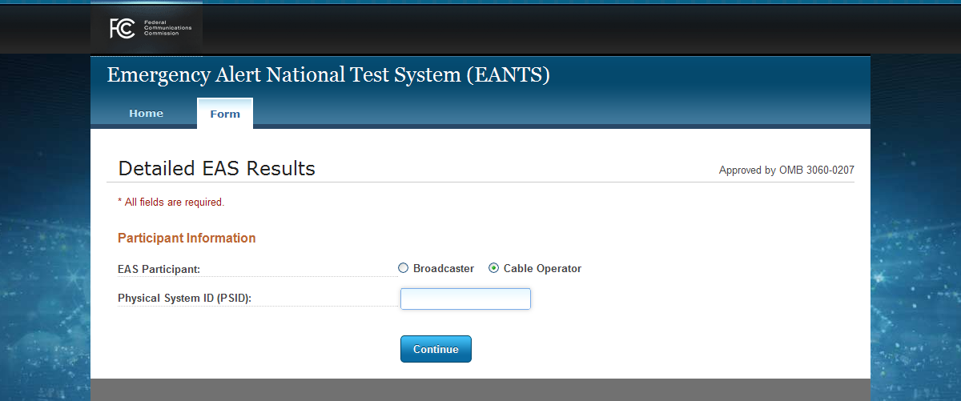

Detailed EAS Results screen showing fields for ‘Broadcaster’ EAS Participant option, with error example
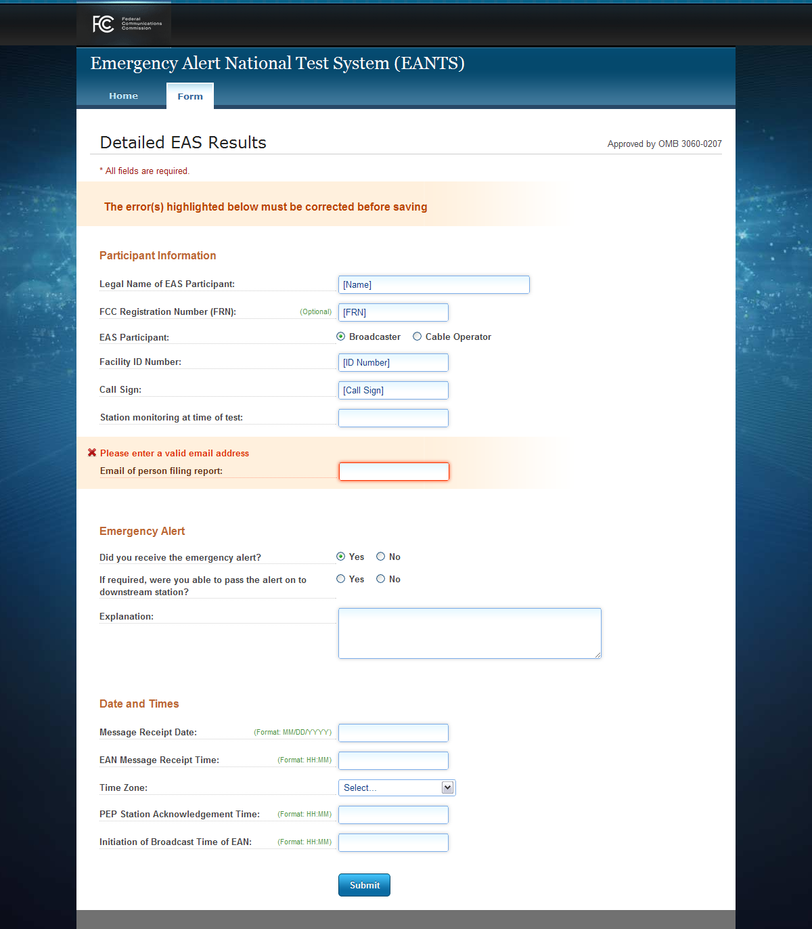

Detailed EAS Results screen showing fields for ‘Cable Operator’ EAS Participant option, with error example
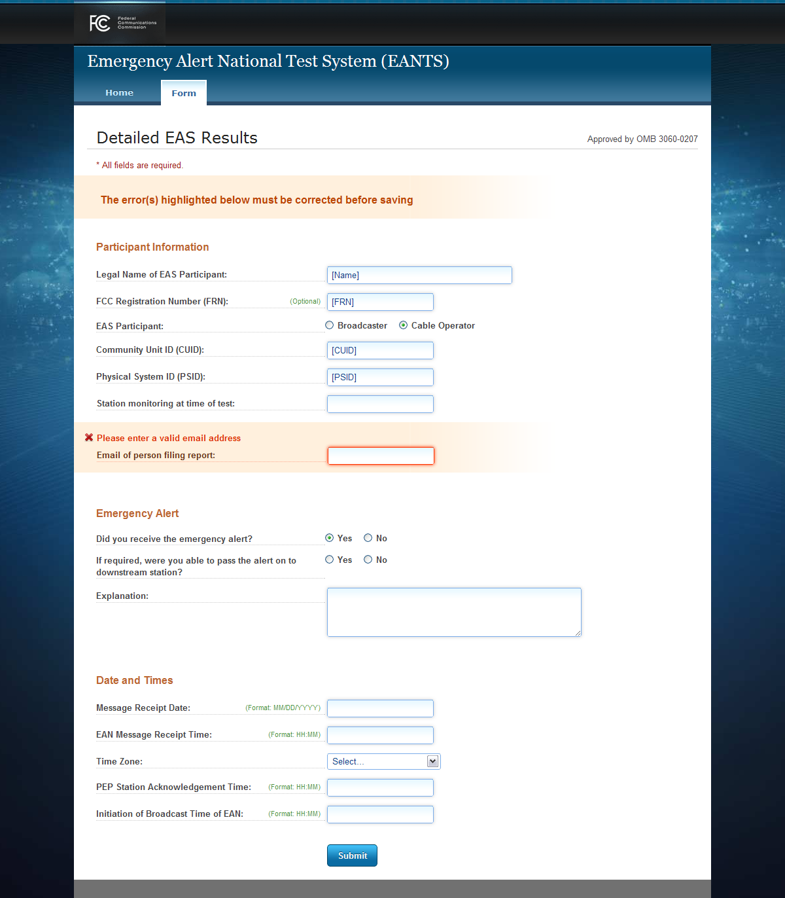

Detailed EAS Results ‘Information Submitted’ screen
