**ATTACHMENT D: IMATS Application Screenshots**

Figure . IMATS screenshot: home page

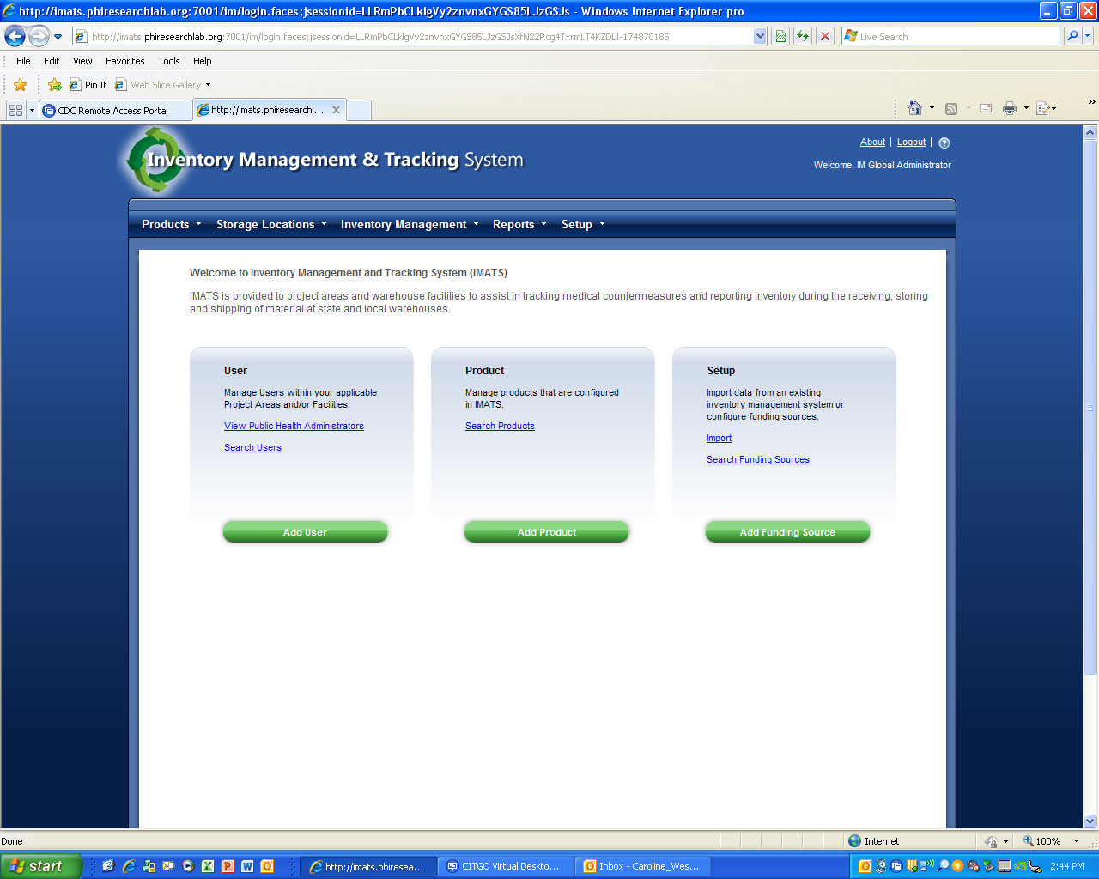

Figure . IMATS screenshot: search users

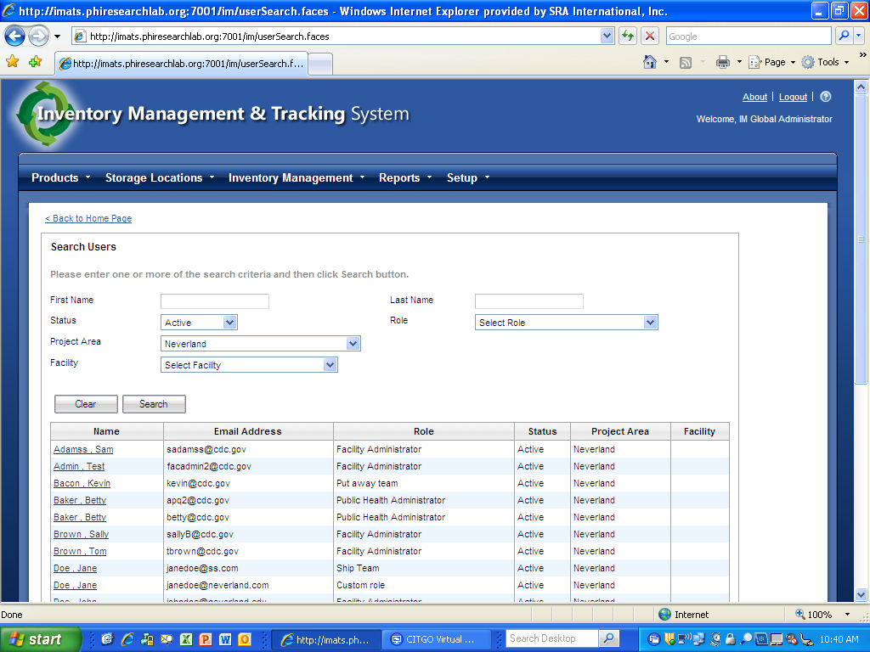

Figure . IMATS screenshot: add product

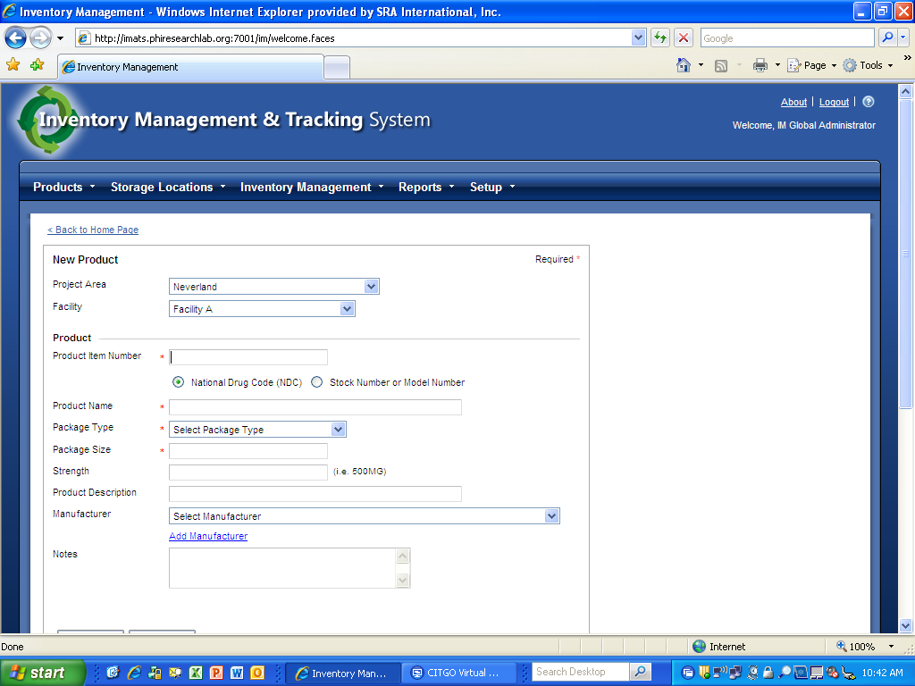

Figure . IMATS screenshot: count inventory report

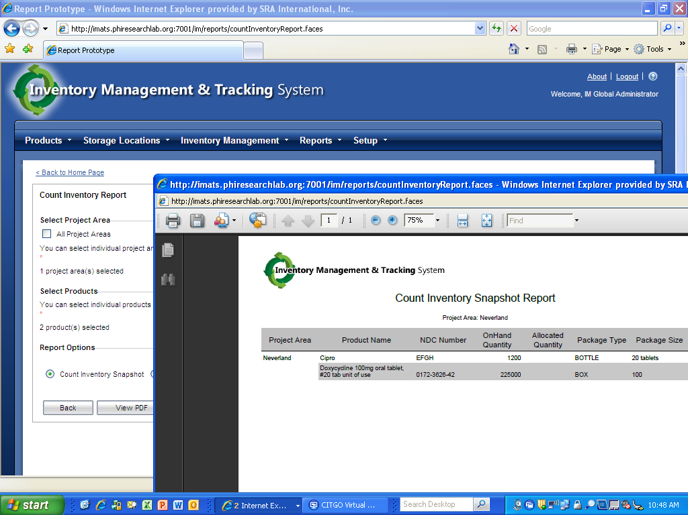

Figure . IMATS screenshot: contact sensitive help

