Attachment C– Data Collection Instrument: Online version (Snapshots)

Qualifier: STD program currently has Federal Direct Assistance staff (Question #9)
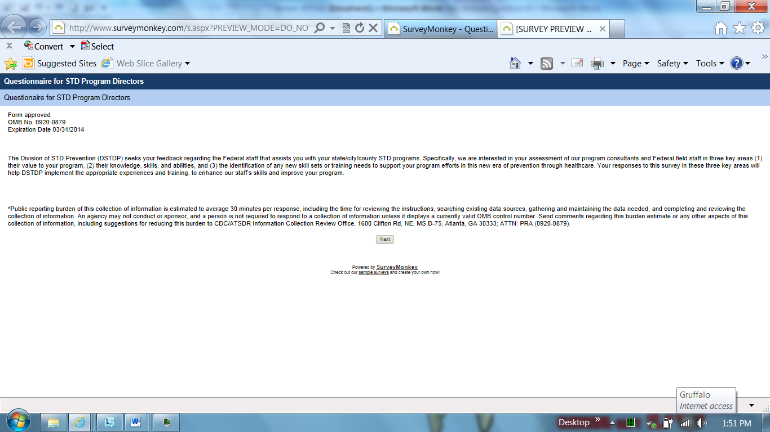

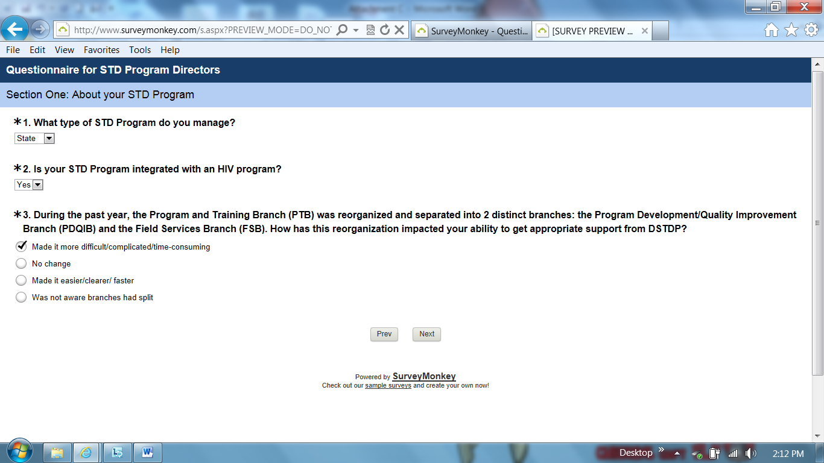

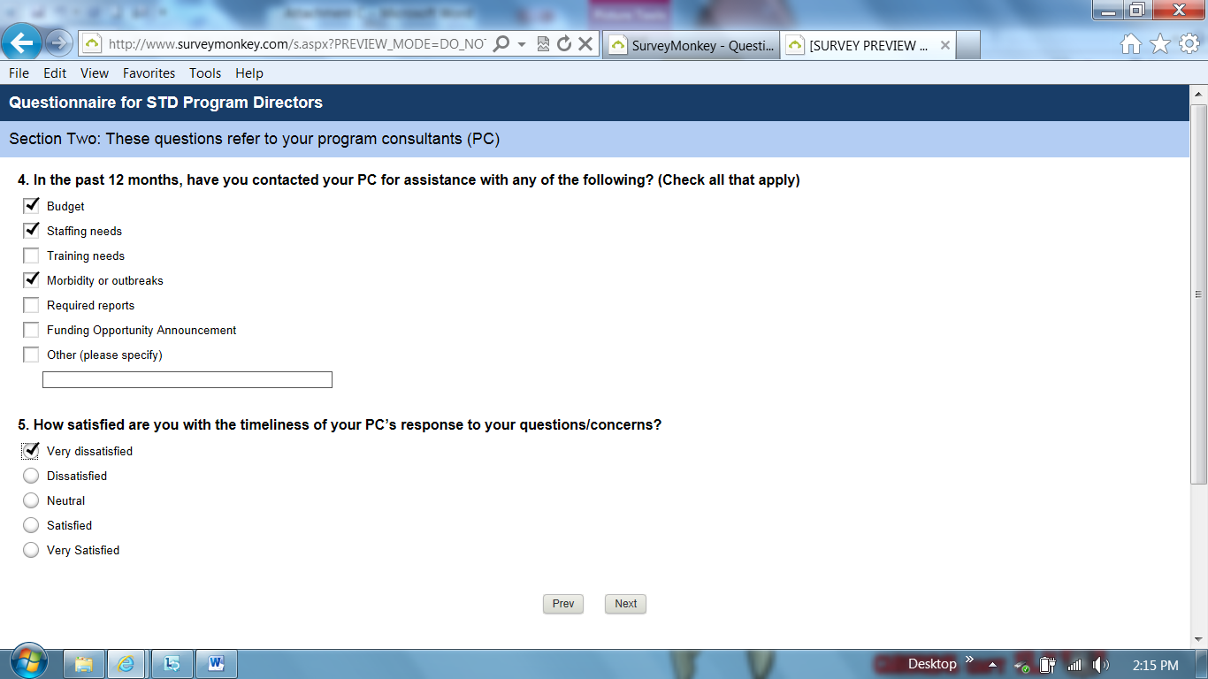

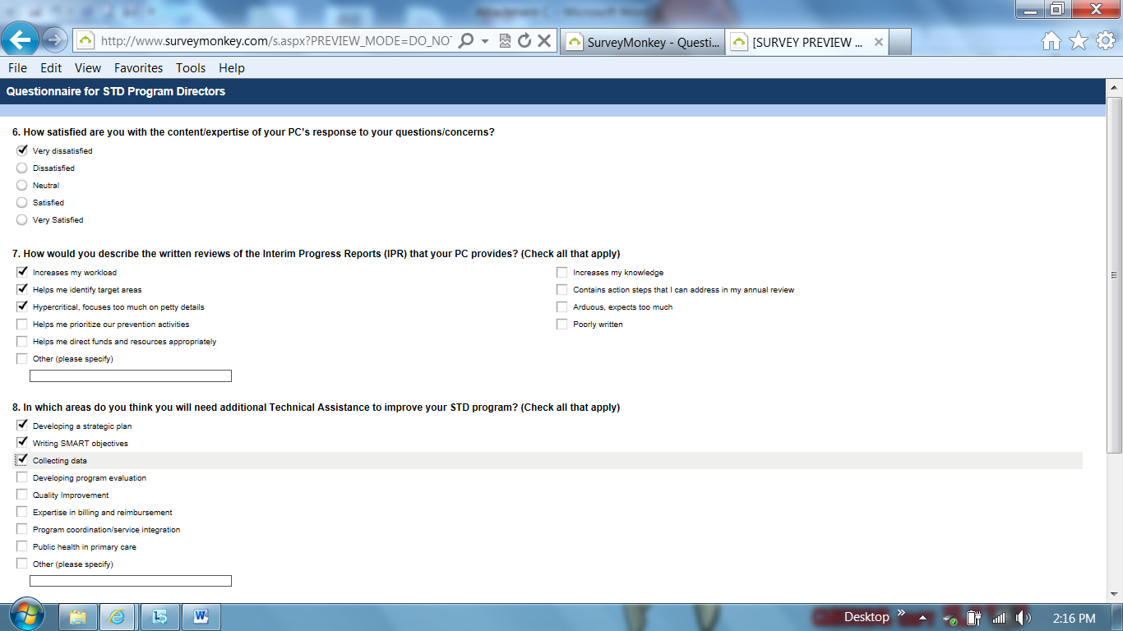

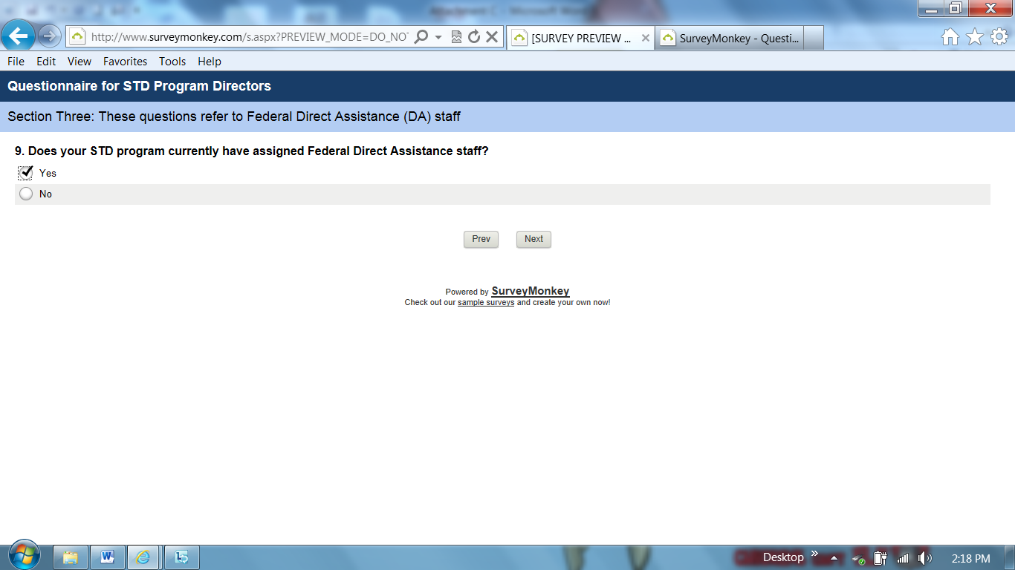

Q9: Skip pattern if Yes go to question “How many Federal STD staff are assigned to your STD program?”

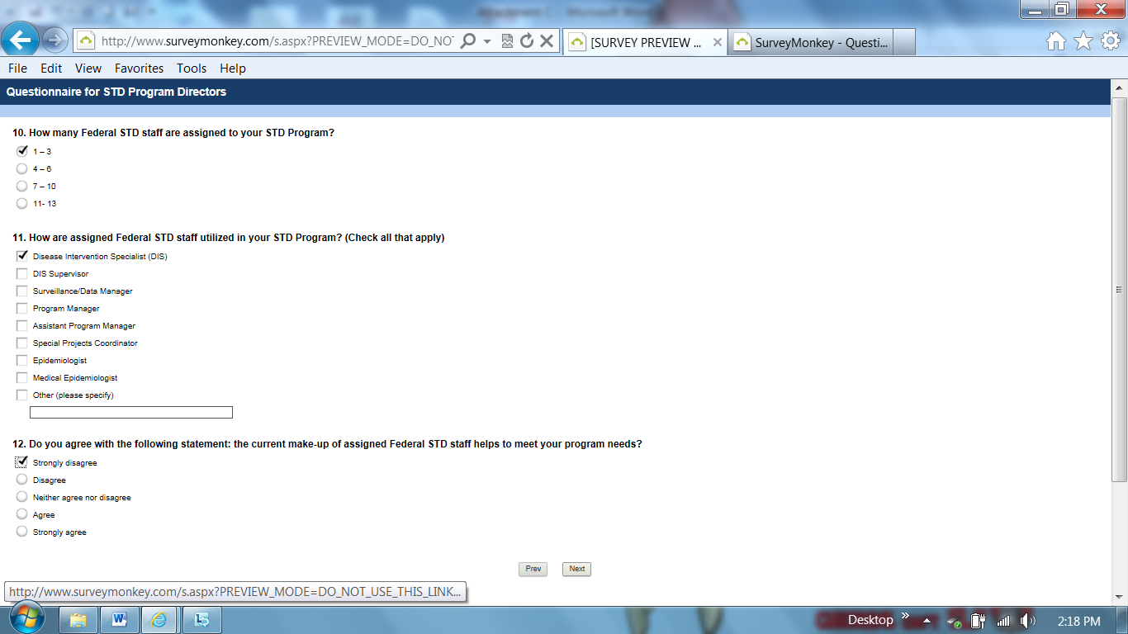

Q12: Skip pattern if Strongly disagree or Disagree go to question “Why do you disagree with the statement: that Federal STD staff helps to meet your program needs?”

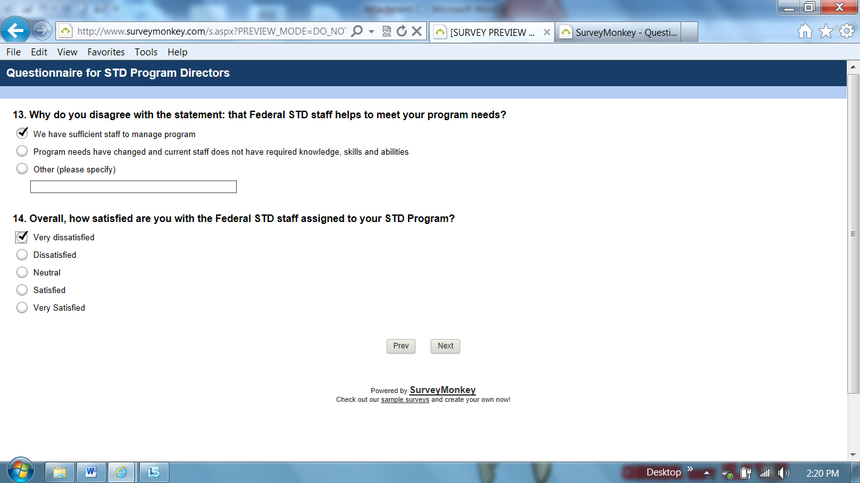

Q14: Skip pattern if Very dissatisfied or Dissatisfied go to question “Why are you dissatisfied with the Federal STD staff assigned to your program?”

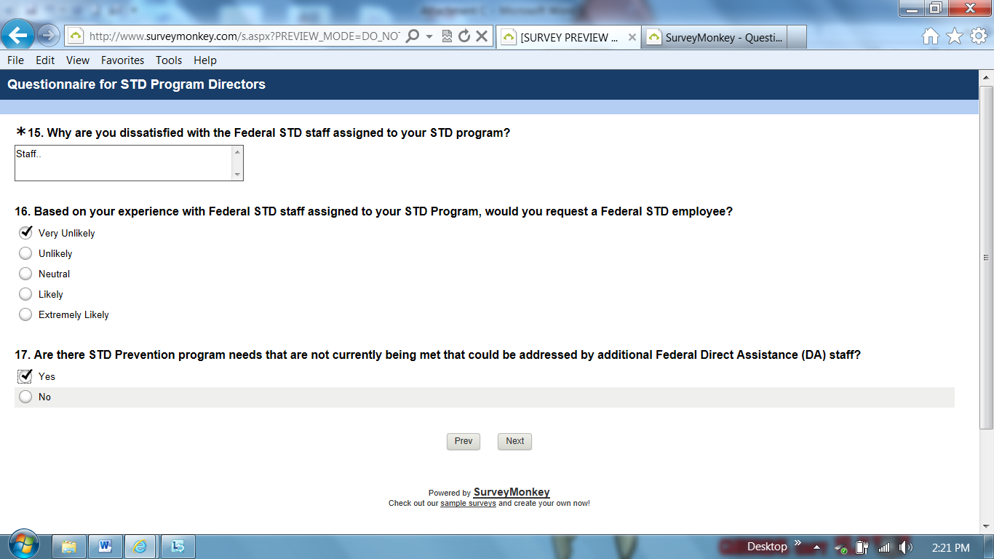

Q17: Skip pattern if Yes go to question “You answered yes to the previous questions; please describe any program positions that would be addressed by additional Federal DA staff?”

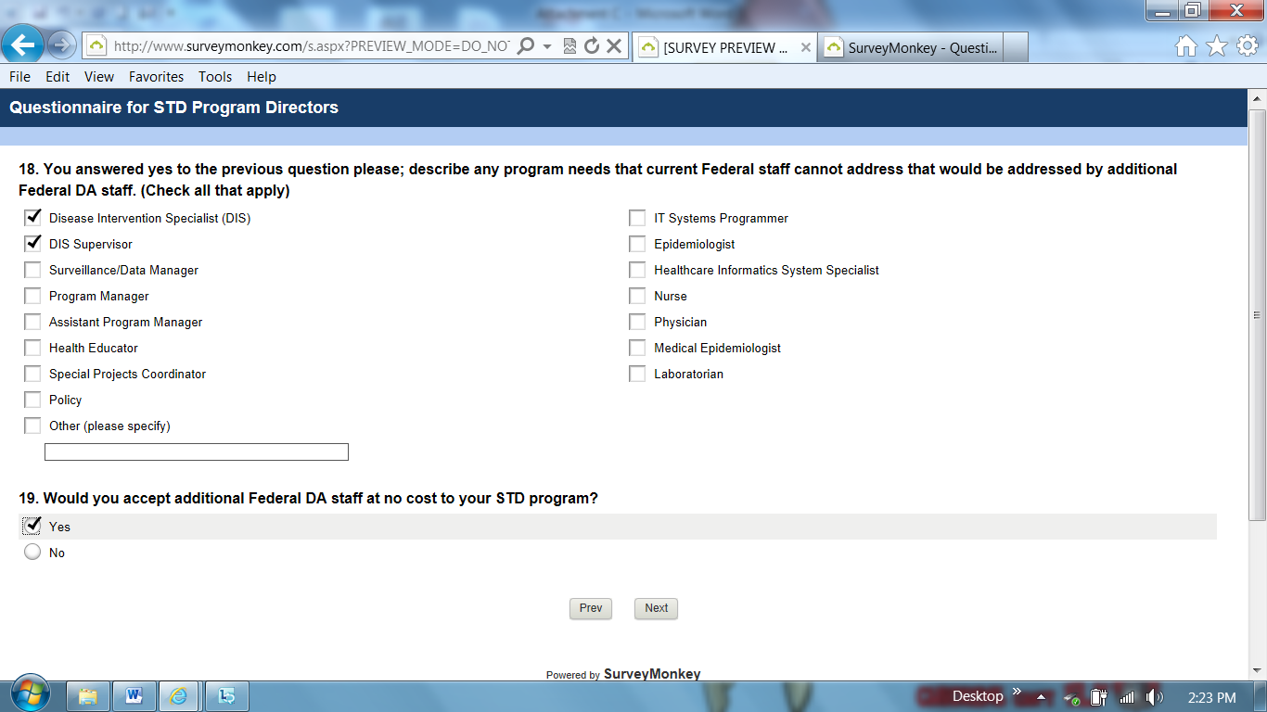

Q19: Skip pattern if Yes go to question “What assistance is needed from CDC Atlanta to help you manage the career development needs of Direct Assistance (DA) staff in your STD Program?”

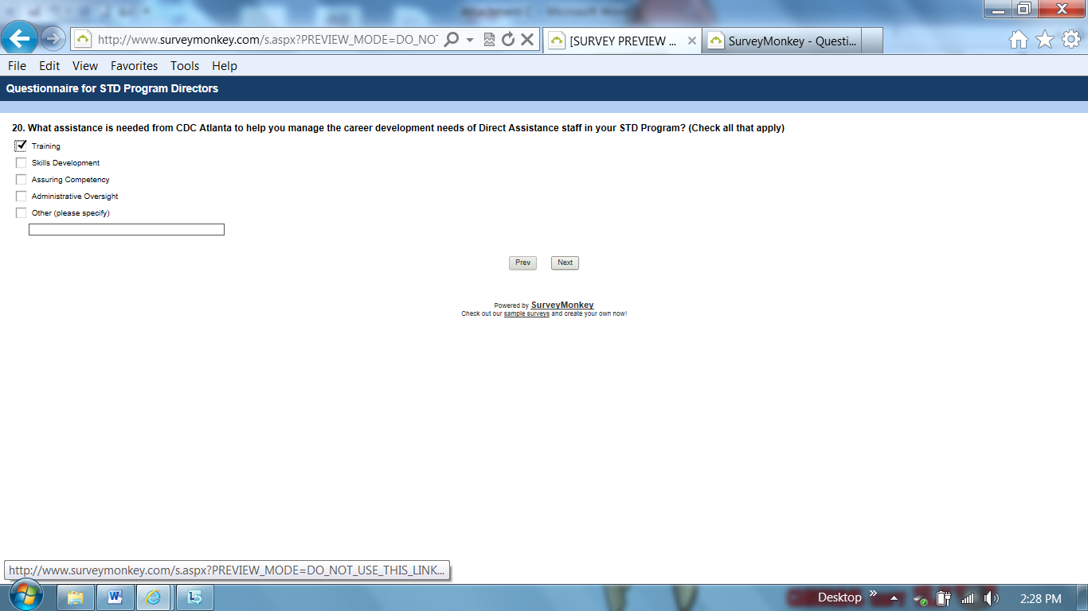

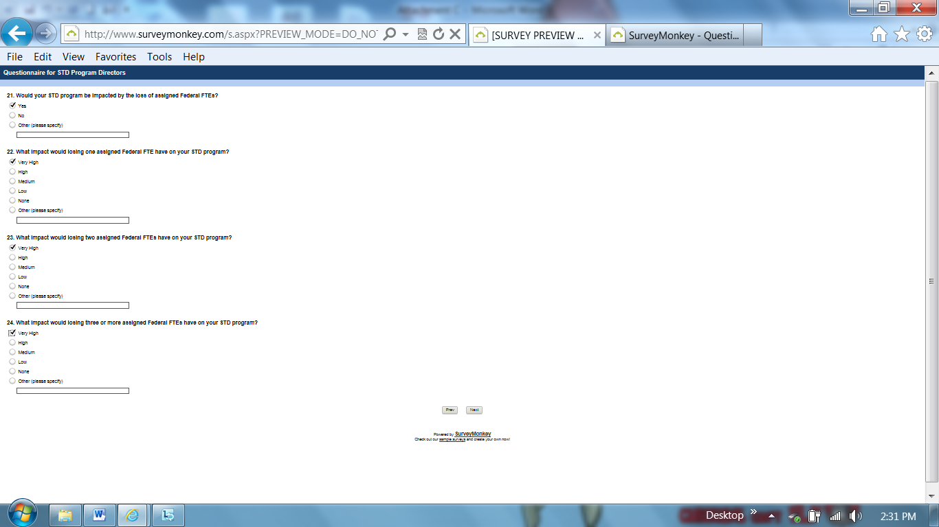

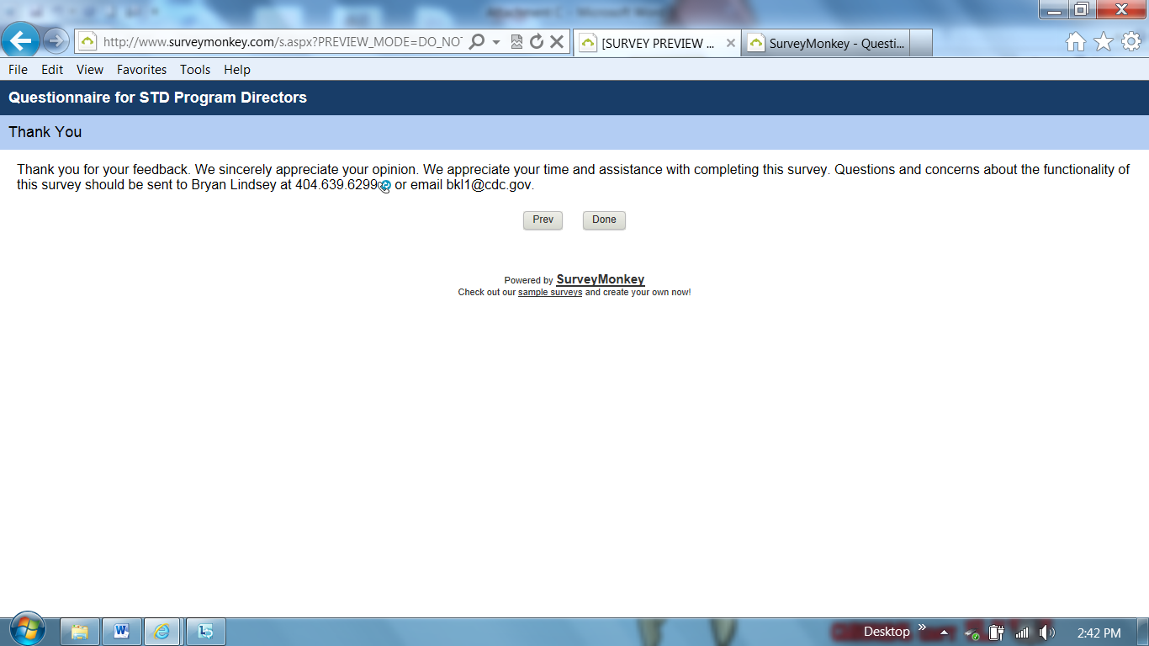

Qualifier: STD program currently has Federal Direct Assistance staff (Question #9)

Q9: Skip pattern if Yes go to question “How many Federal STD staff are assigned to your STD program?”

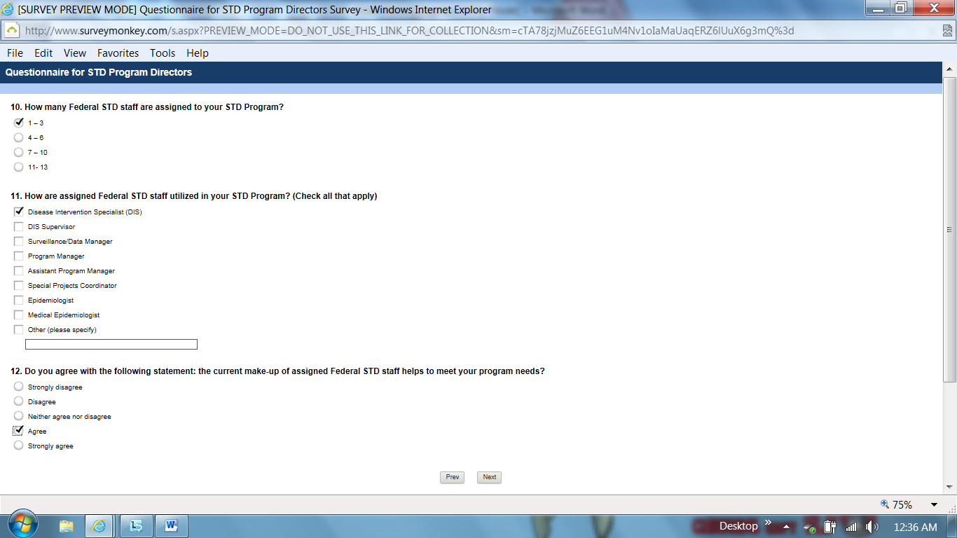

Q12: Skip pattern if Neither agree or disagree; Strongly agree; or Agree go to question “Overall, how satisfied are you with the Federal STD staff assigned to your STD Program?”

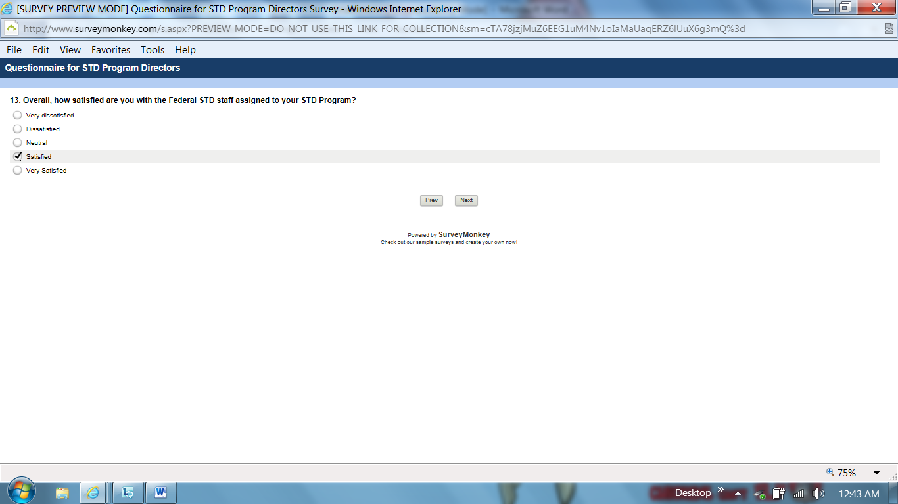

Q13: Skip pattern if Neutral; Satisfied; or Very Satisfied go to question “Are there STD Prevention program needs that are not currently being met that could be addressed by additional Federal Direct Assistance (DA) staff?”

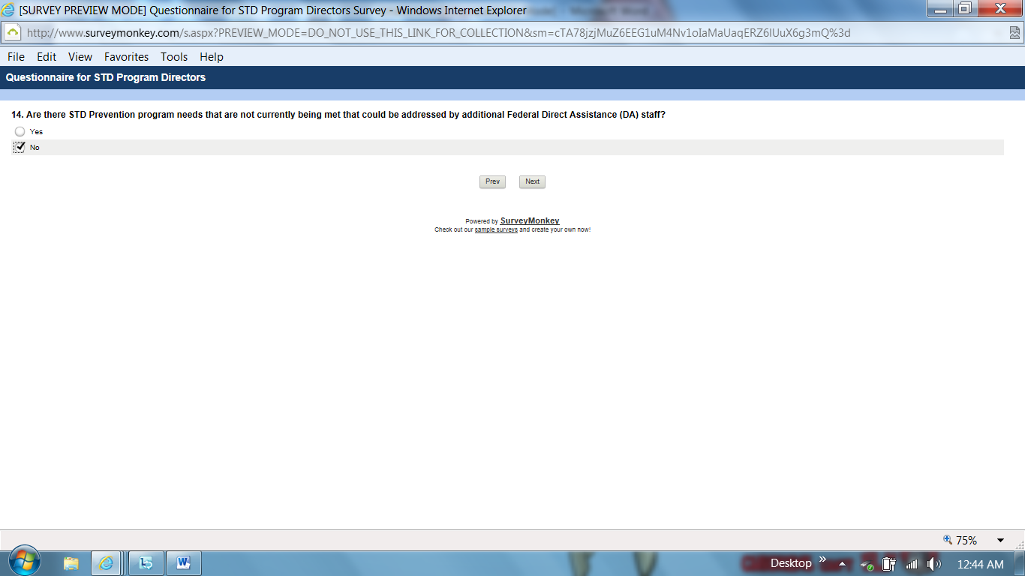

Q14: Skip pattern if No go to “Thank you, End of Survey.”

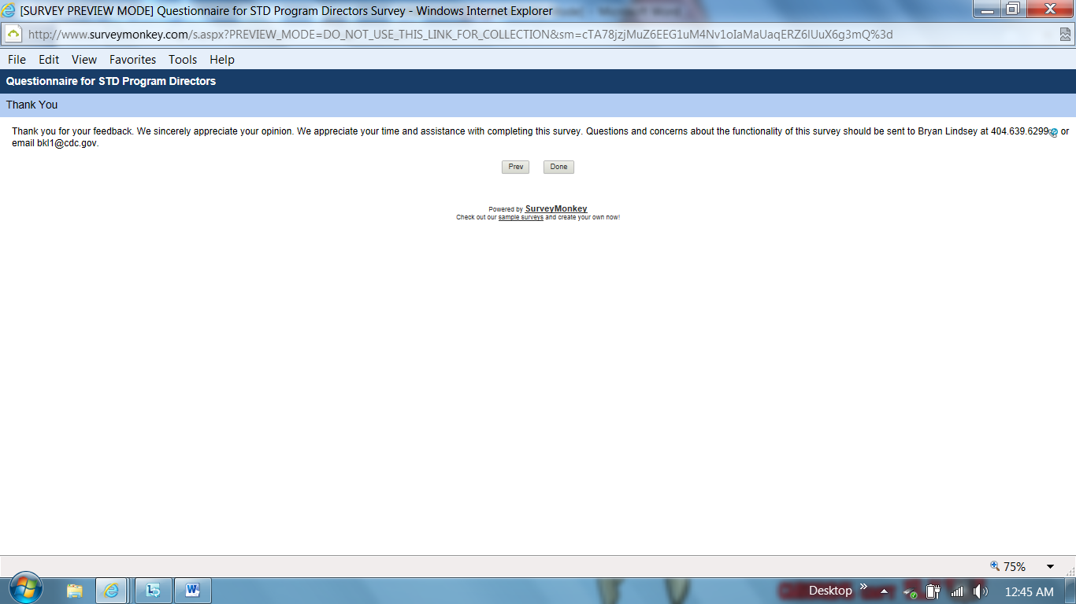

Qualifier: STD program currently has Federal Direct Assistance staff (Question #9)
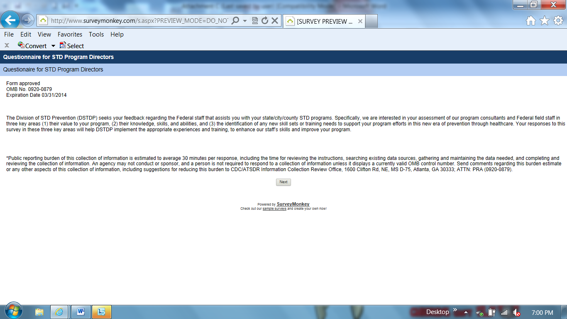

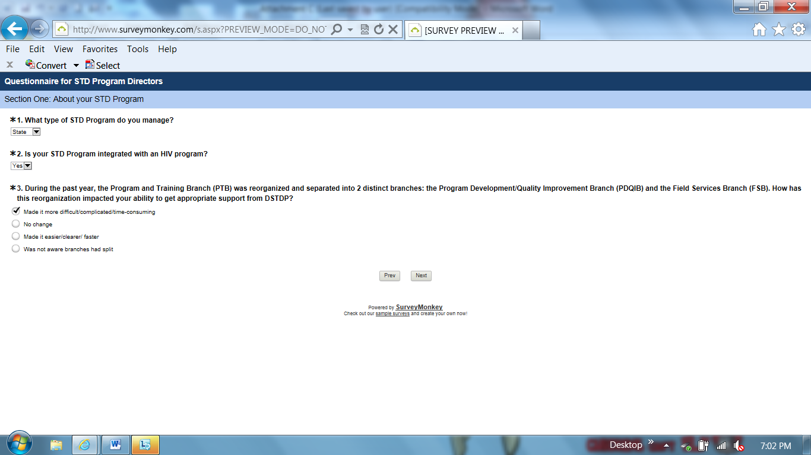

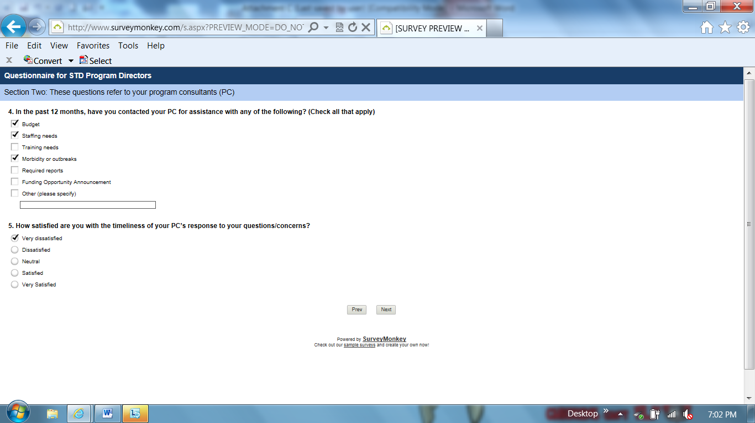

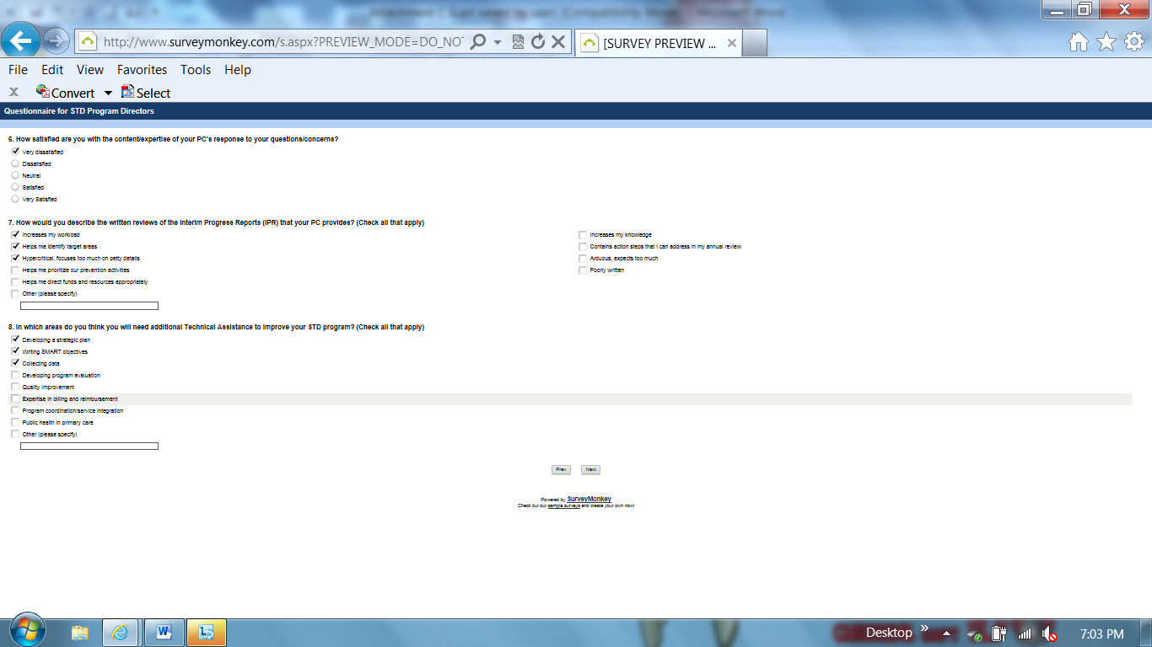

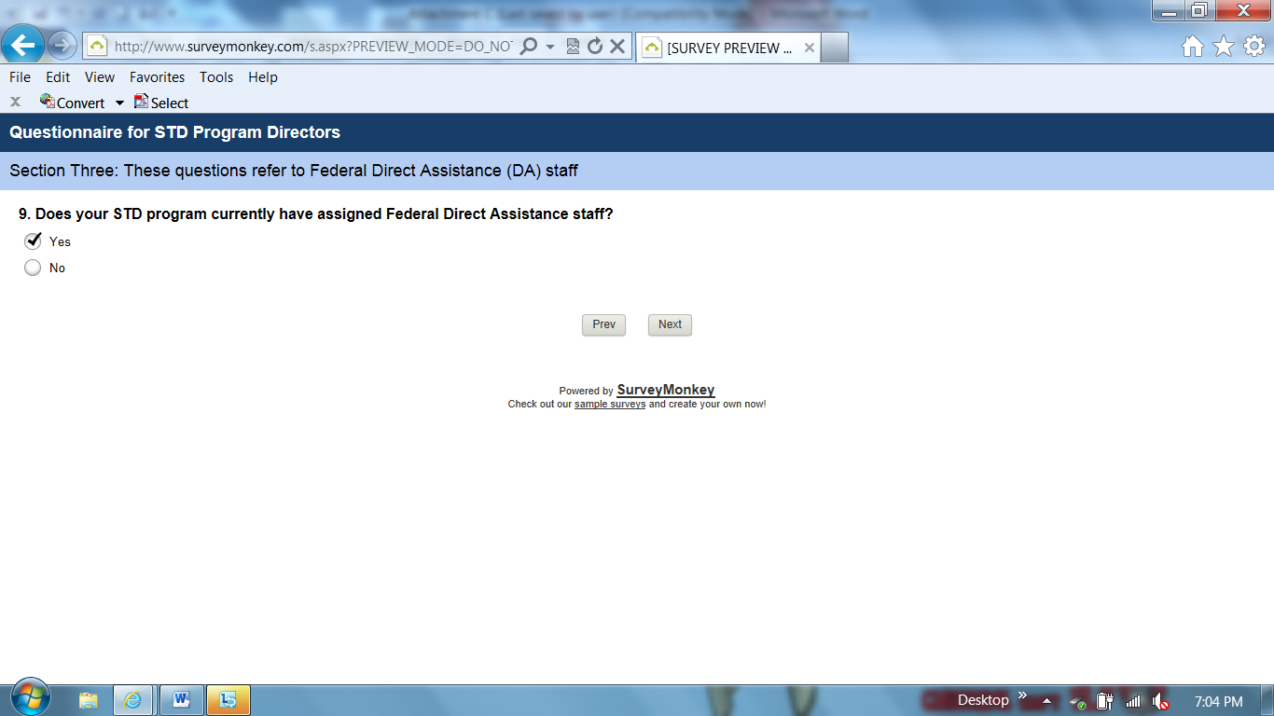

Q9: Skip pattern if Yes go to question “How many Federal STD staff are assigned to your STD program?”

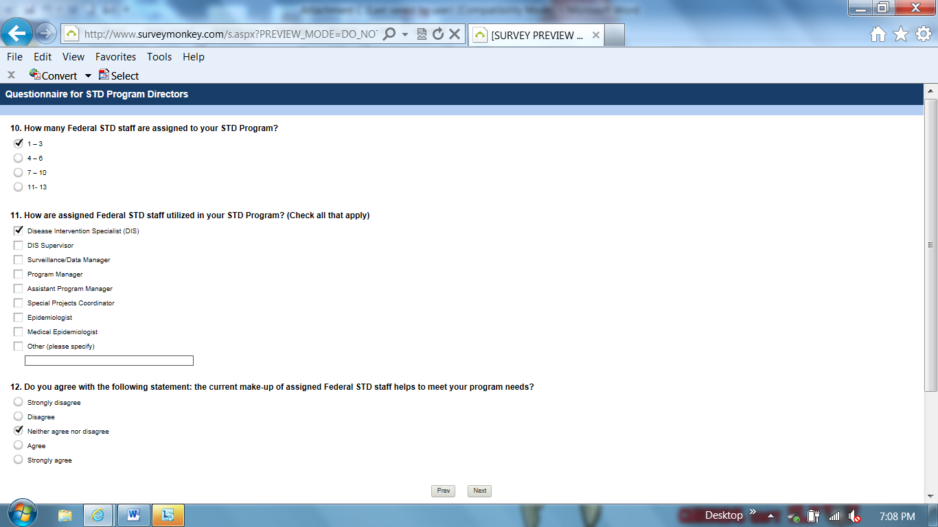

Q12: Skip pattern if Neither agree or disagree; Strongly agree; or Agree go to question “Overall, how satisfied are you with the Federal STD staff assigned to your STD Program?”

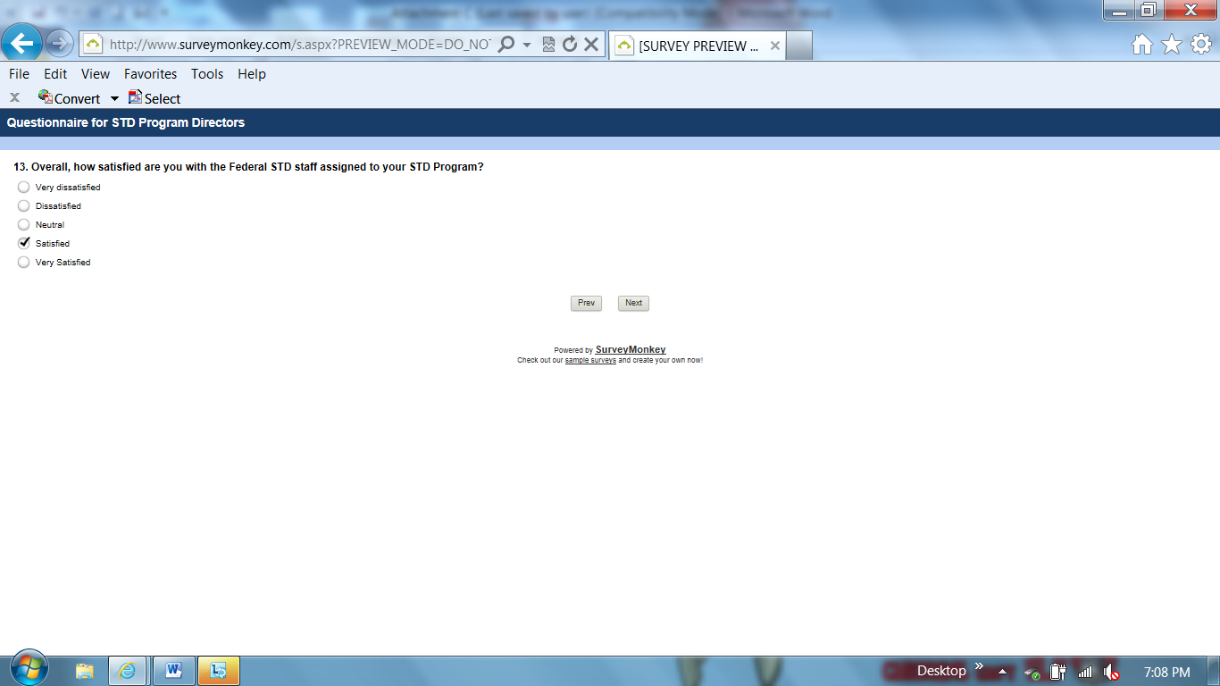

Q13: Skip pattern if Neutral; Satisfied; or Very Satisfied go to question “Are there STD Prevention program needs that are not currently being met that could be addressed by additional Federal Direct Assistance (DA) staff?”

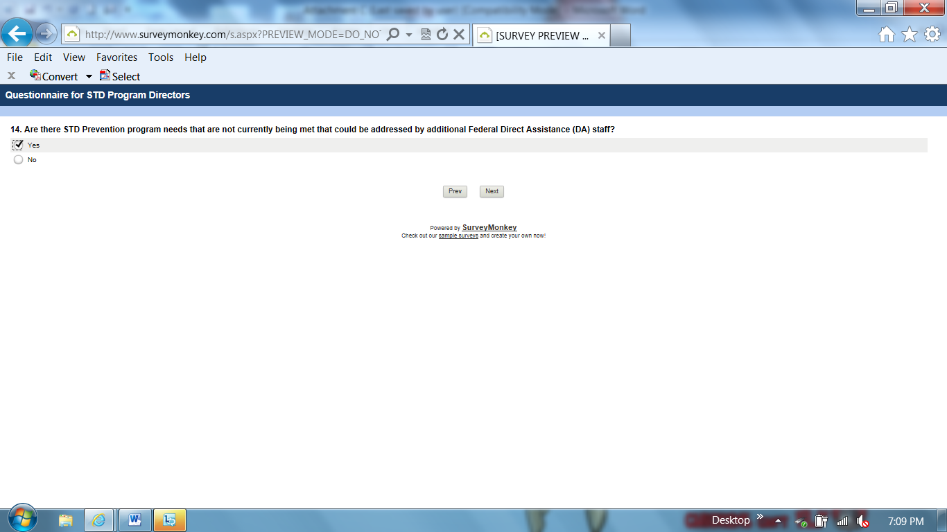

Q14: Skip pattern if Yes go to question “You answered yes to the previous questions; please describe any program positions that would be addressed by additional Federal DA staff?”

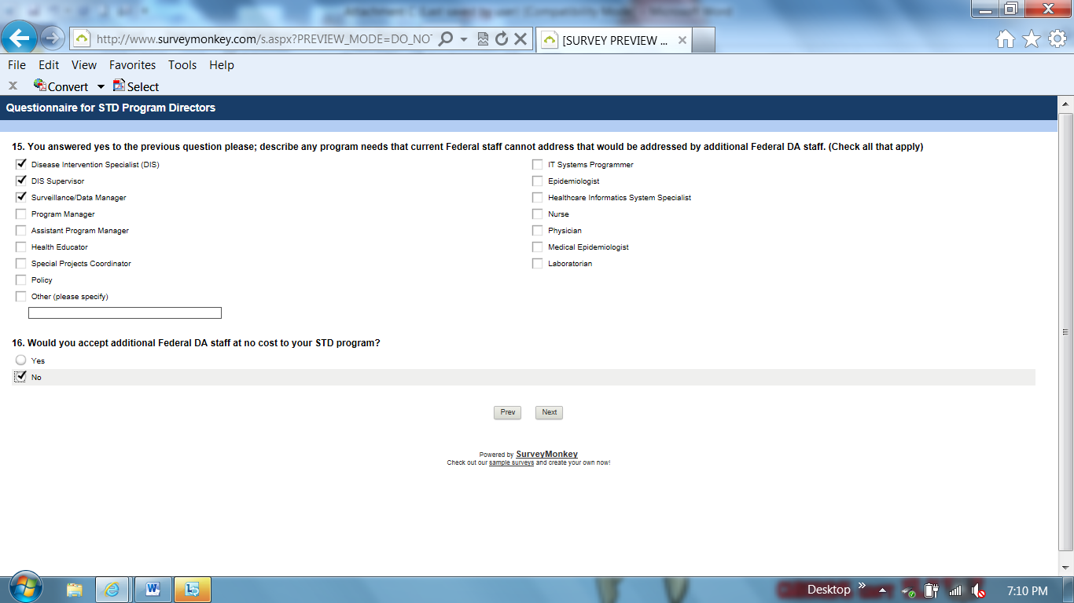

Q16: Skip pattern if No go to question “Why would you decline an offer to receive additional Federal staff for your STD Program?”

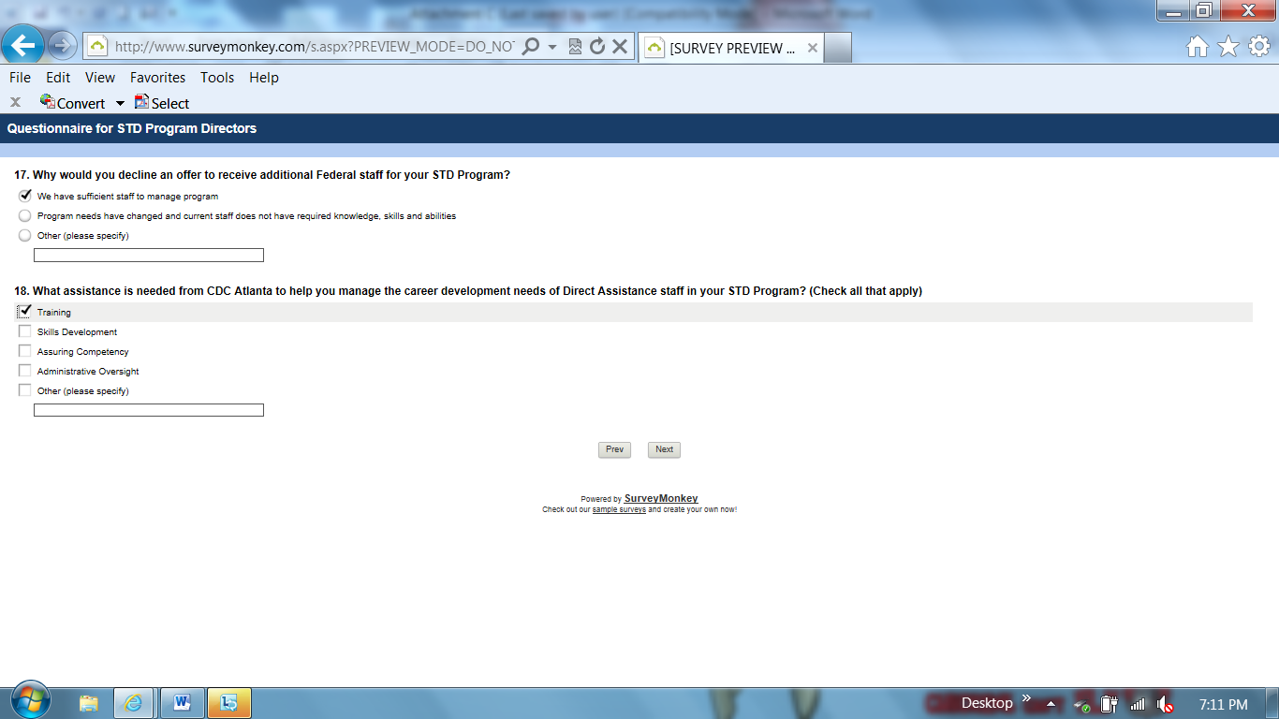

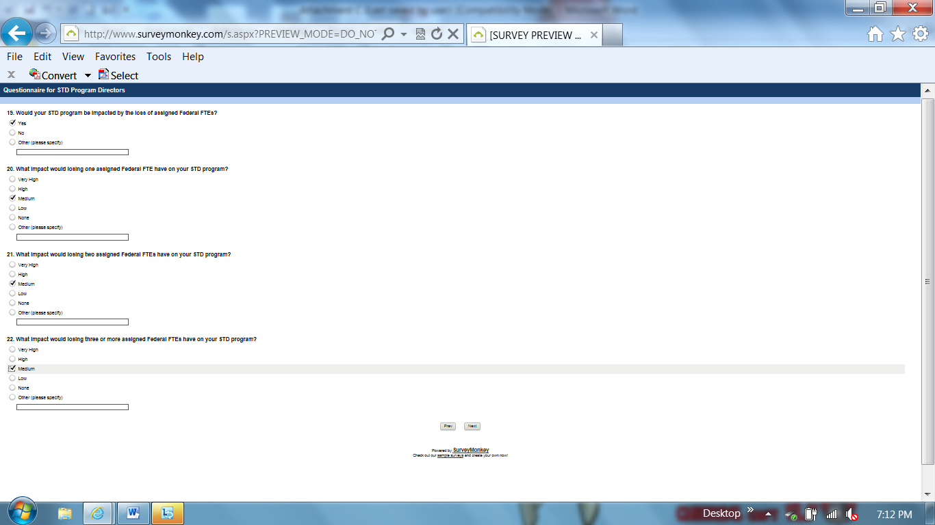

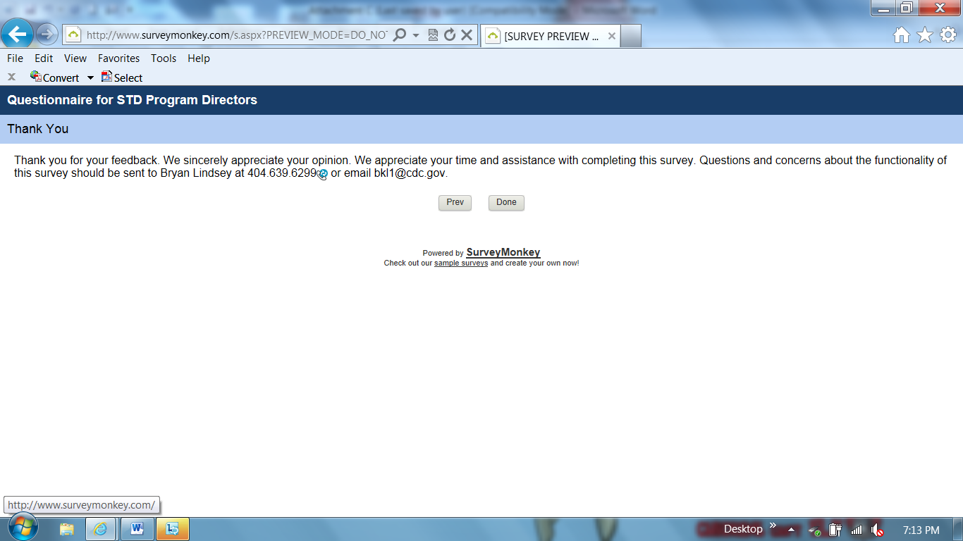

Qualifier: STD program does not have Federal Direct Assistance staff (Question #9)
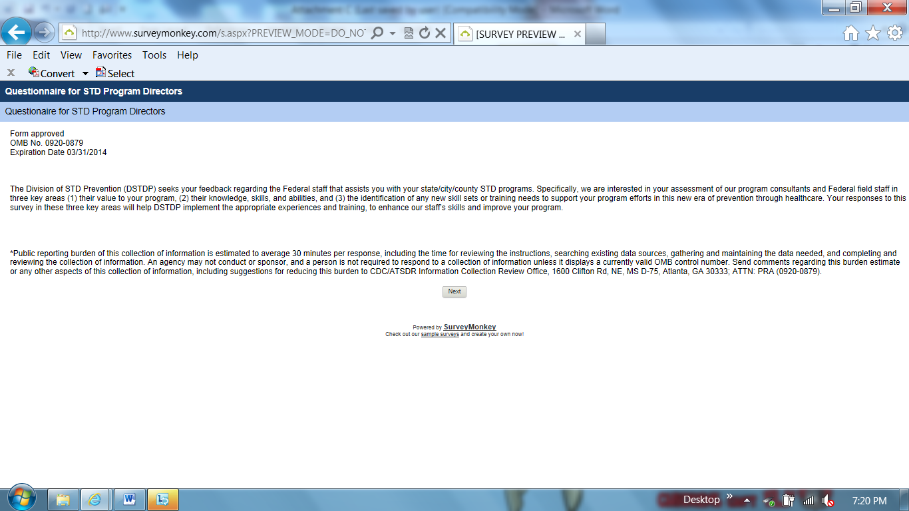

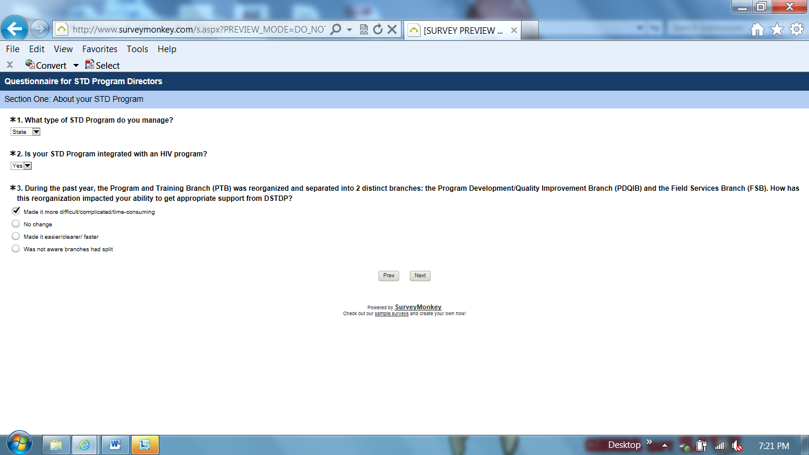

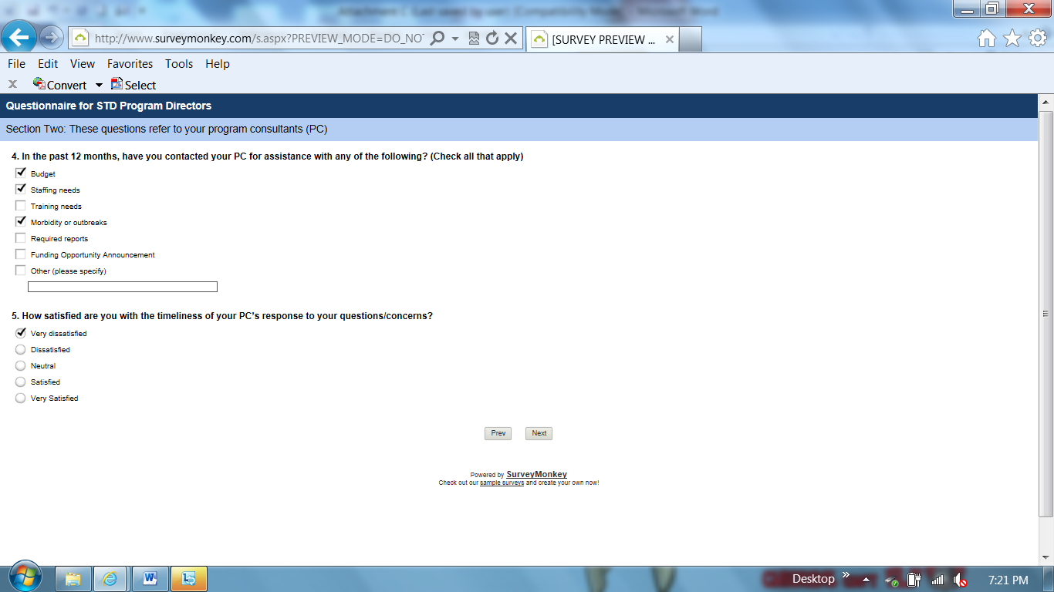

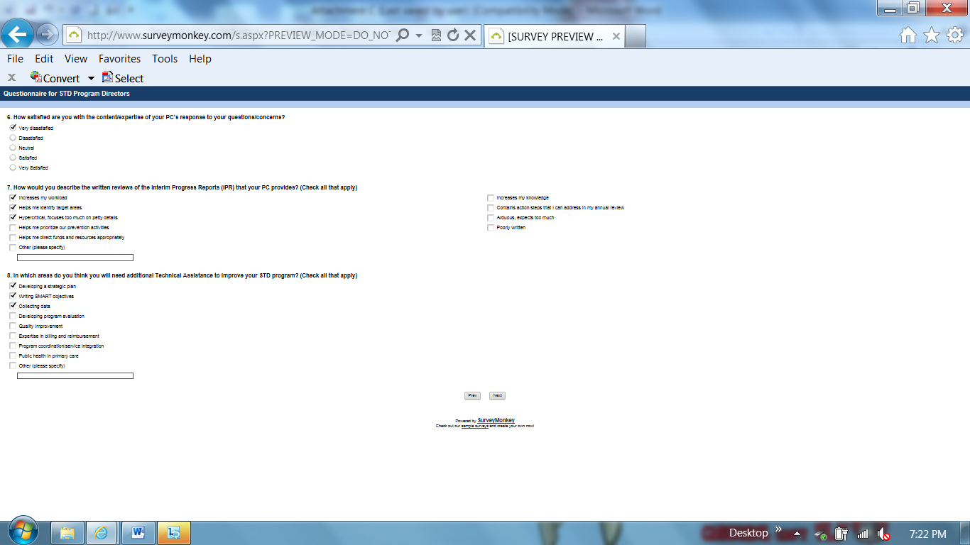

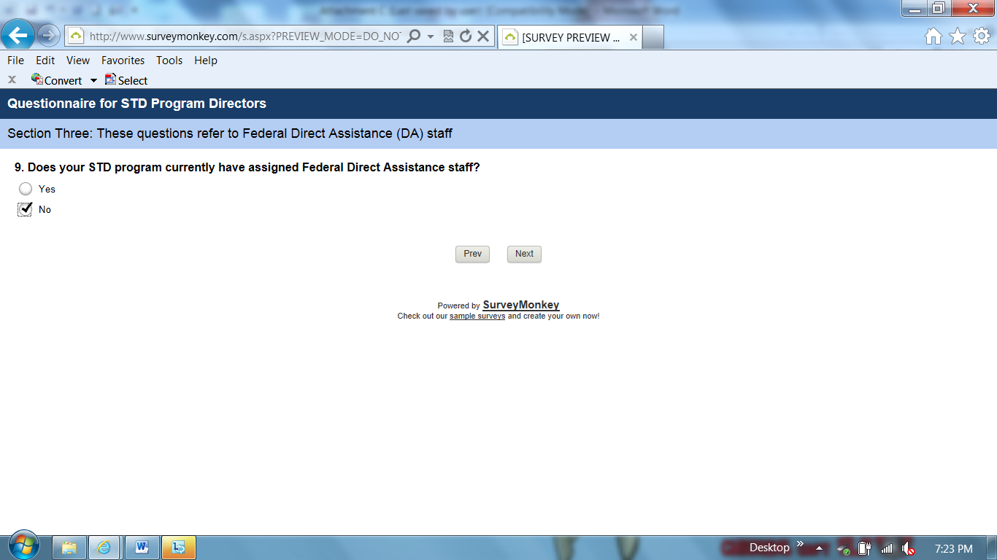

Q9: Skip pattern if No go to question “Has your state/city/county STD program ever had Direct Assistance staff assigned to it?”

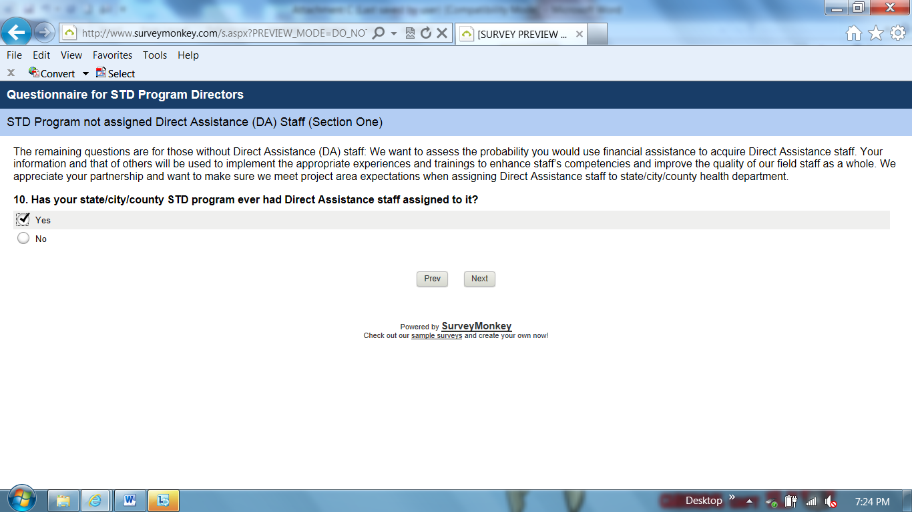

Q10: Skip pattern if Yes go to question “Based on your experience with Direct Assistance STD staff assigned to your state/city/county STD Program, how likely are you to request a Direct Assistance STD employee in the future?”

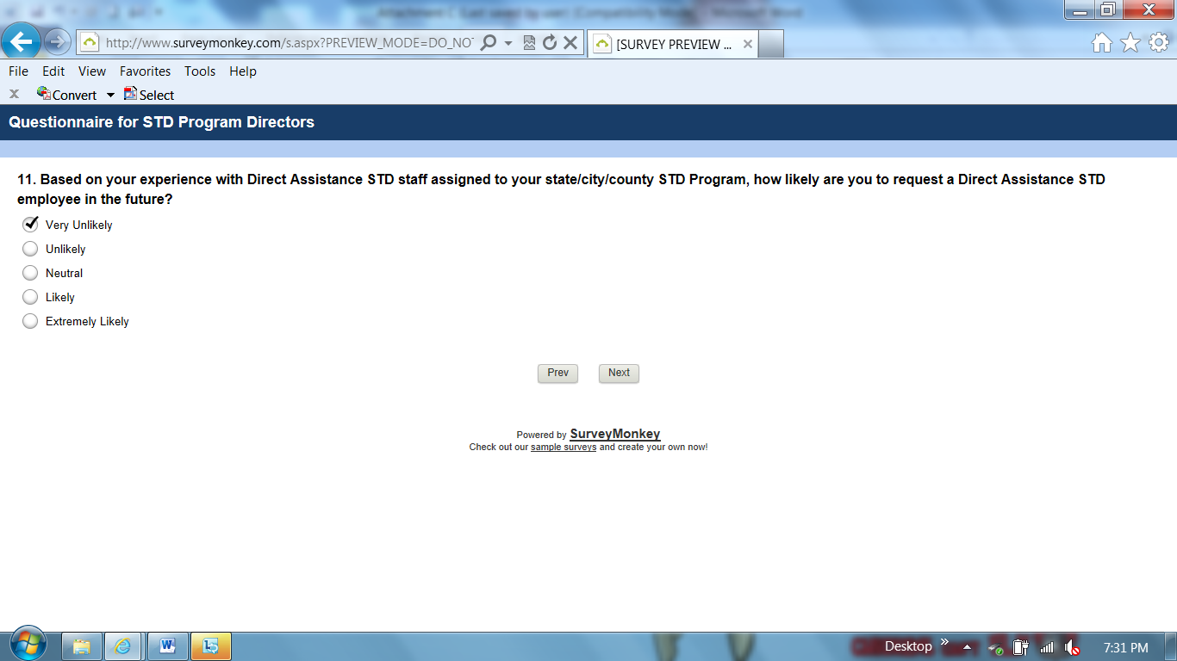

Q11: Skip pattern if Very Unlikely or Unlikely go to question “Why wouldn’t you request a Direct Assistance STD employee to meet your program needs?”

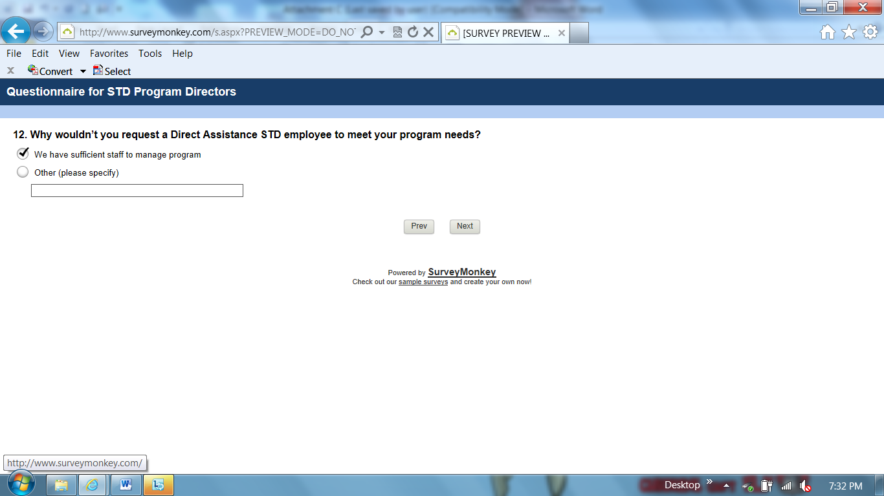

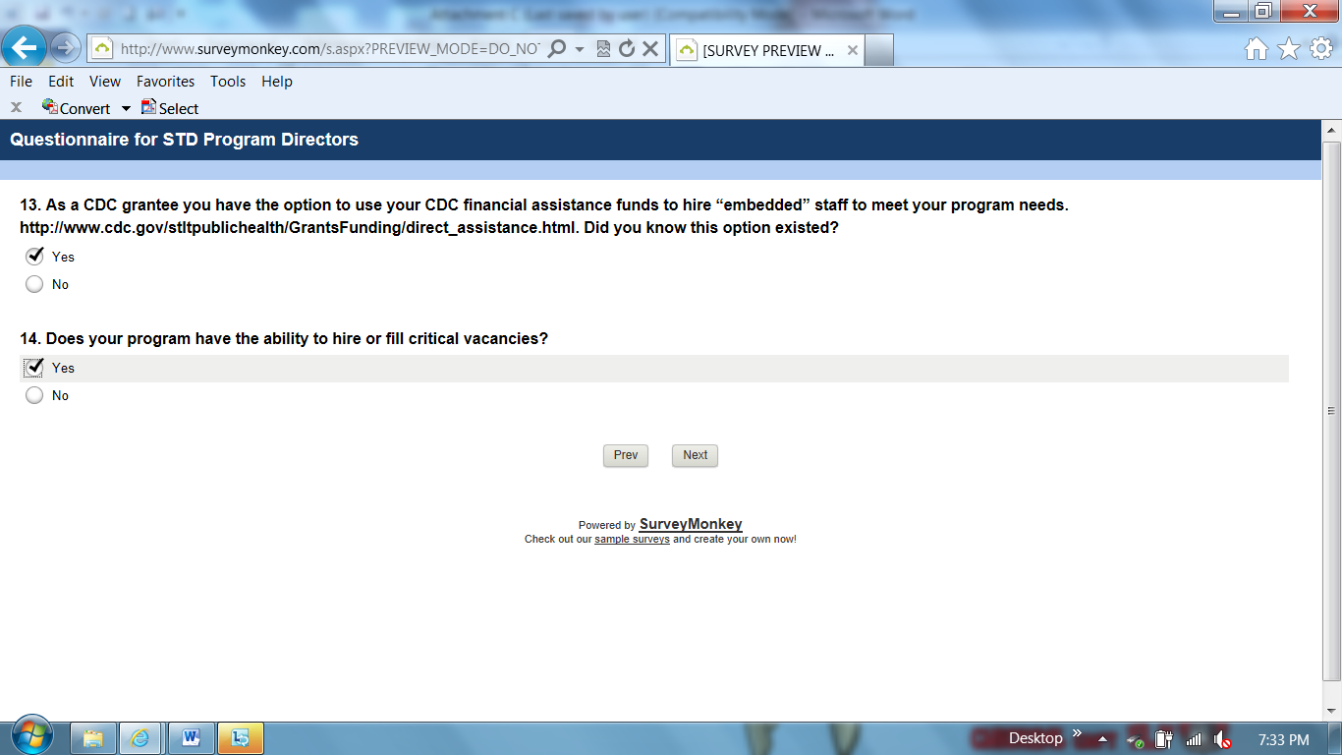

Q14: Skip pattern if Yes go to question “Would you be willing to use your Financial Assistance funds to hire federal staff to fill critical vacancies?”

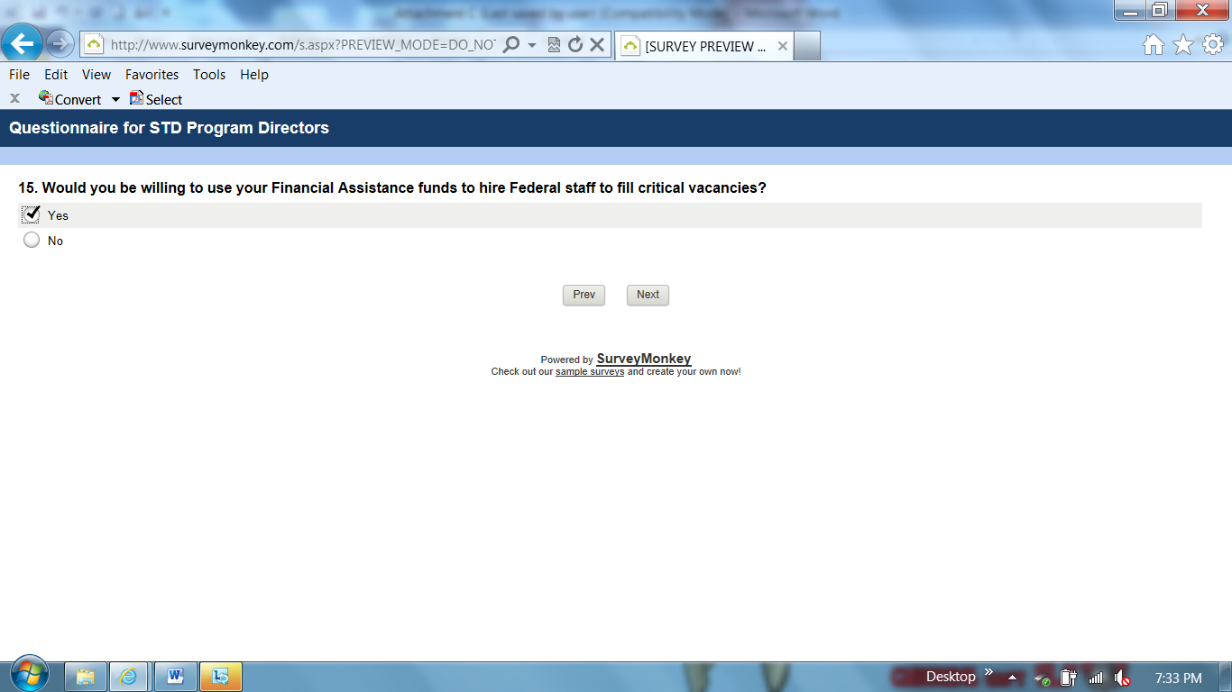

Q15: Skip pattern if Yes go to question “You indicated yes to the previous question; what types of CDC Direct Assistance STD staff, would you request to fill critical vacancies in your state/city/county STD Program?”

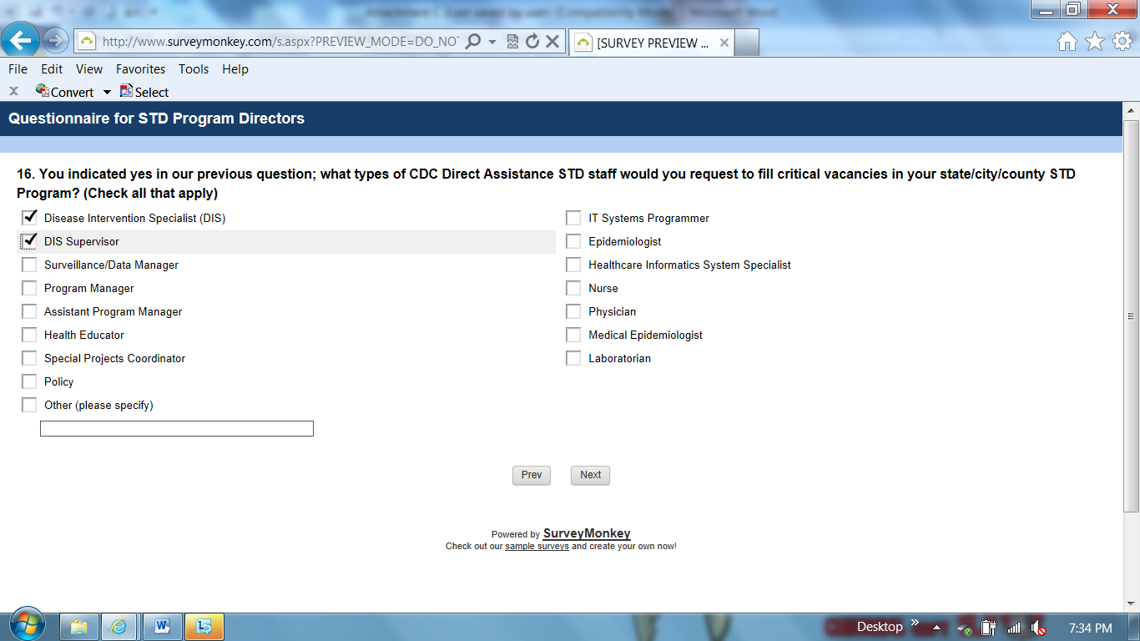

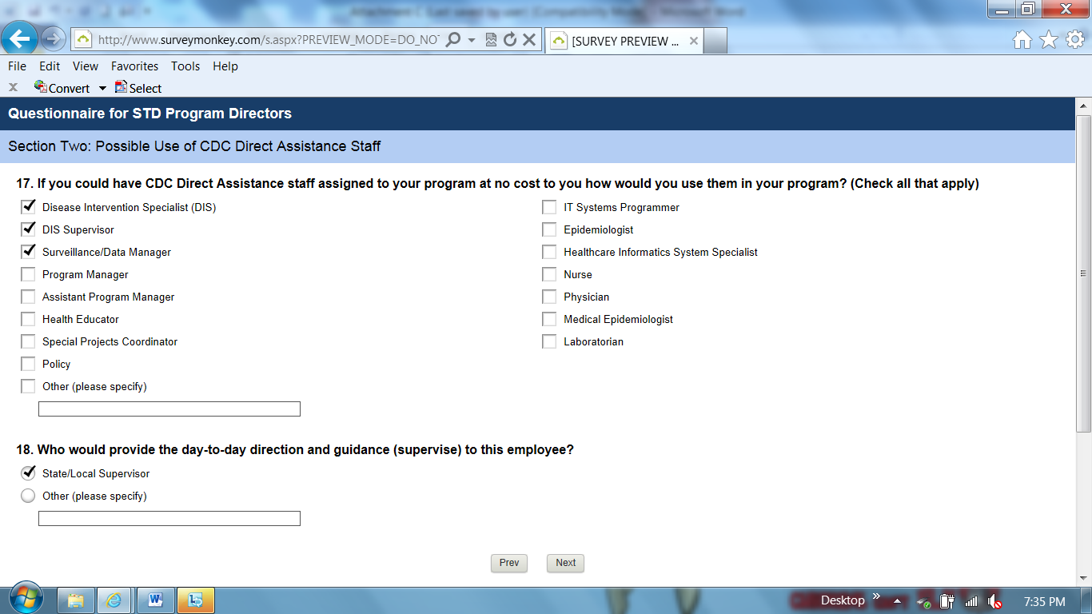

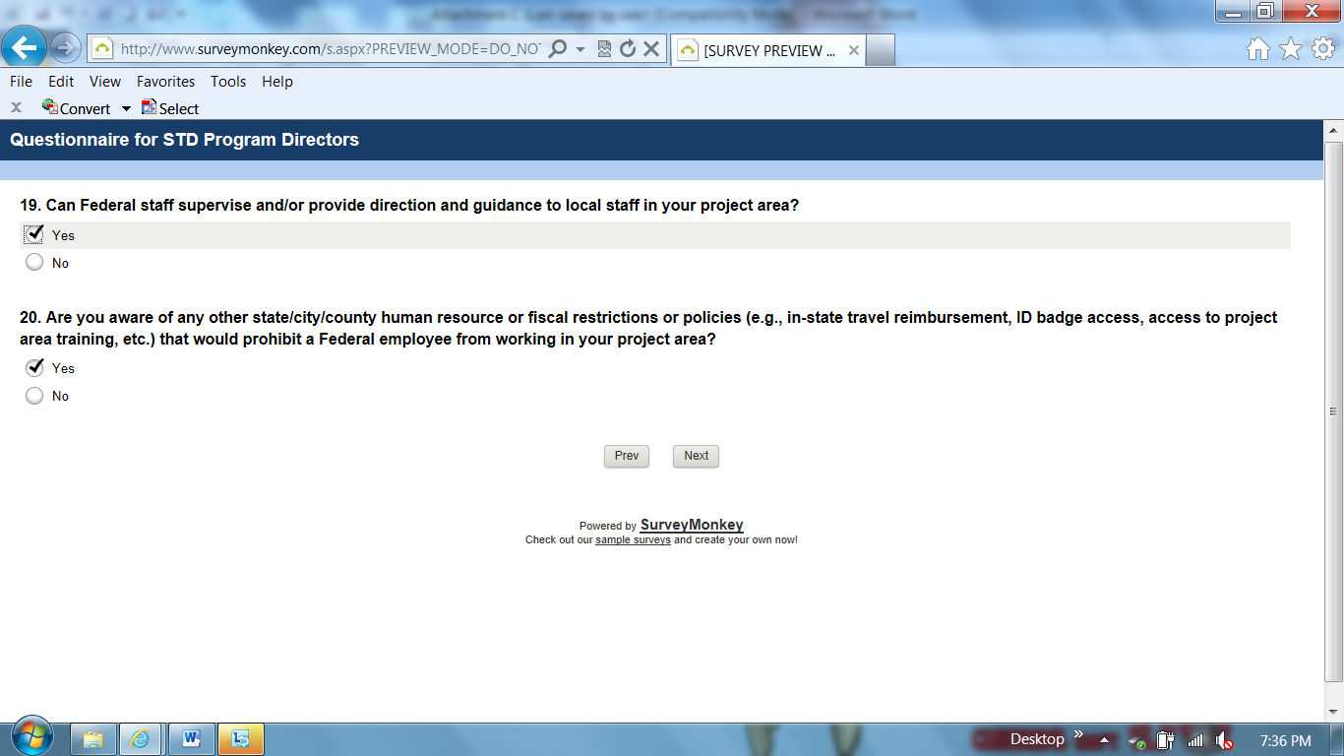

Q20: Skip pattern if Yes go to question “You indicated yes to the previous question; what kind of state/city/county human resource or fiscal restrictions or policies prohibits a Federal employee from working in your project area?”

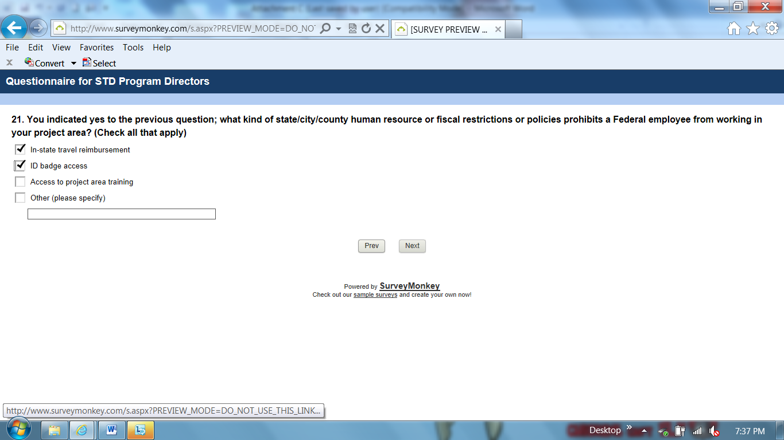

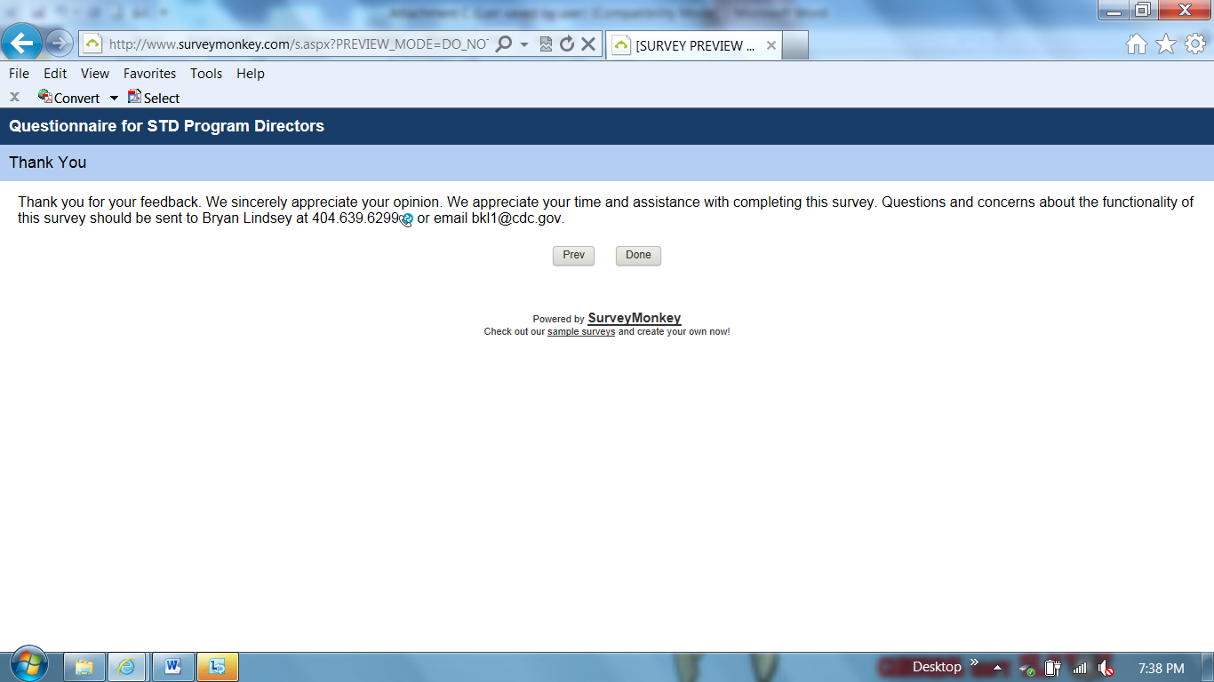

Qualifier: STD program does not have Federal Direct Assistance staff (Question #9)
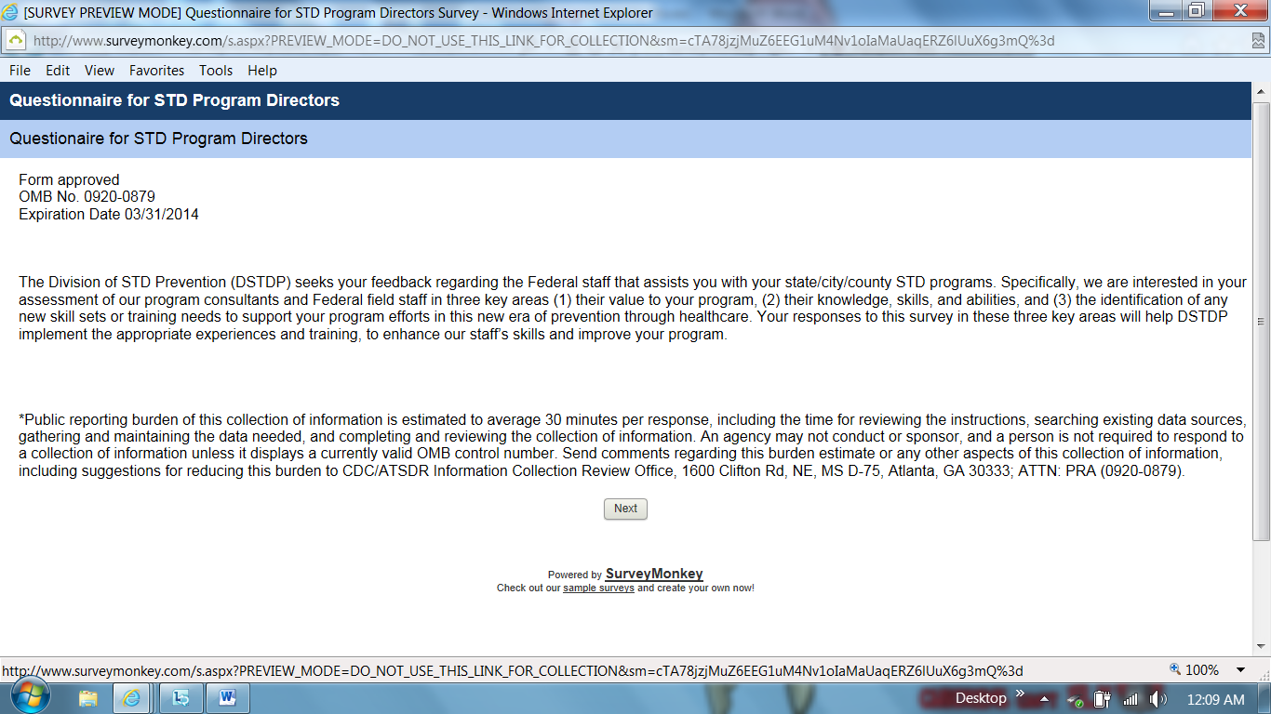

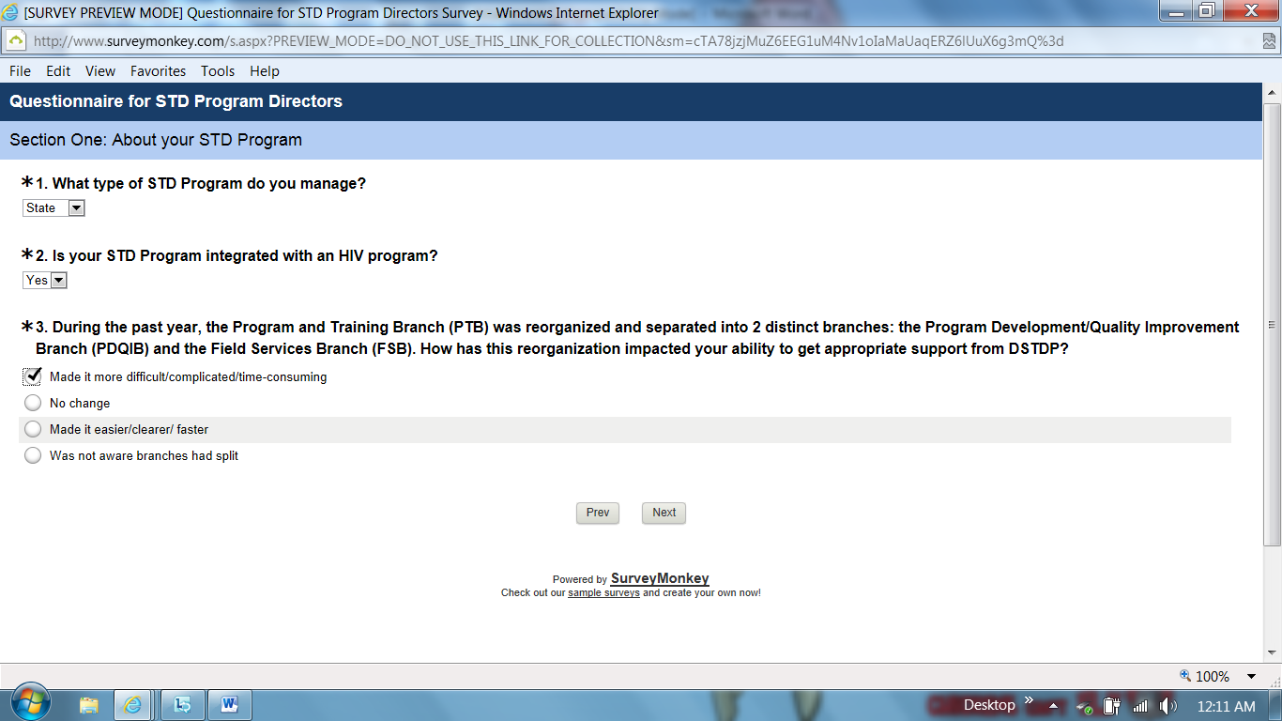

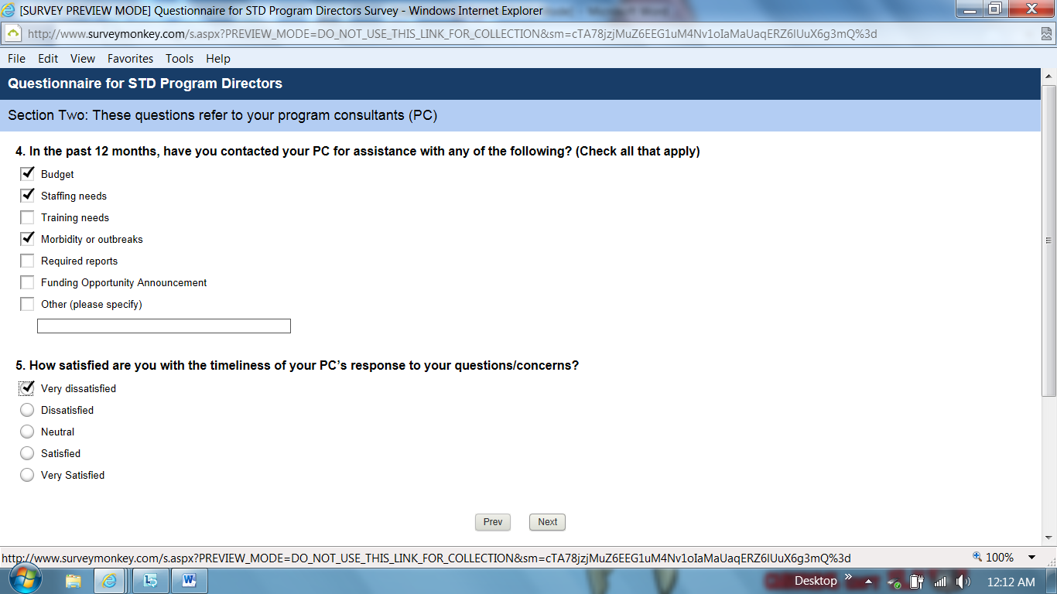

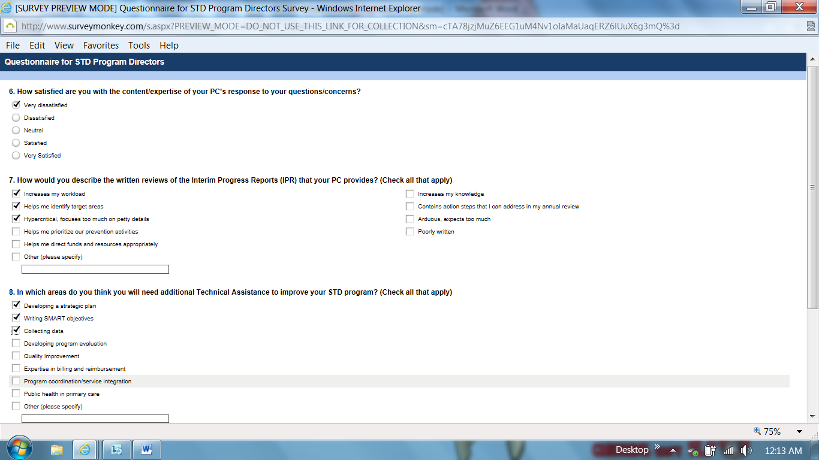

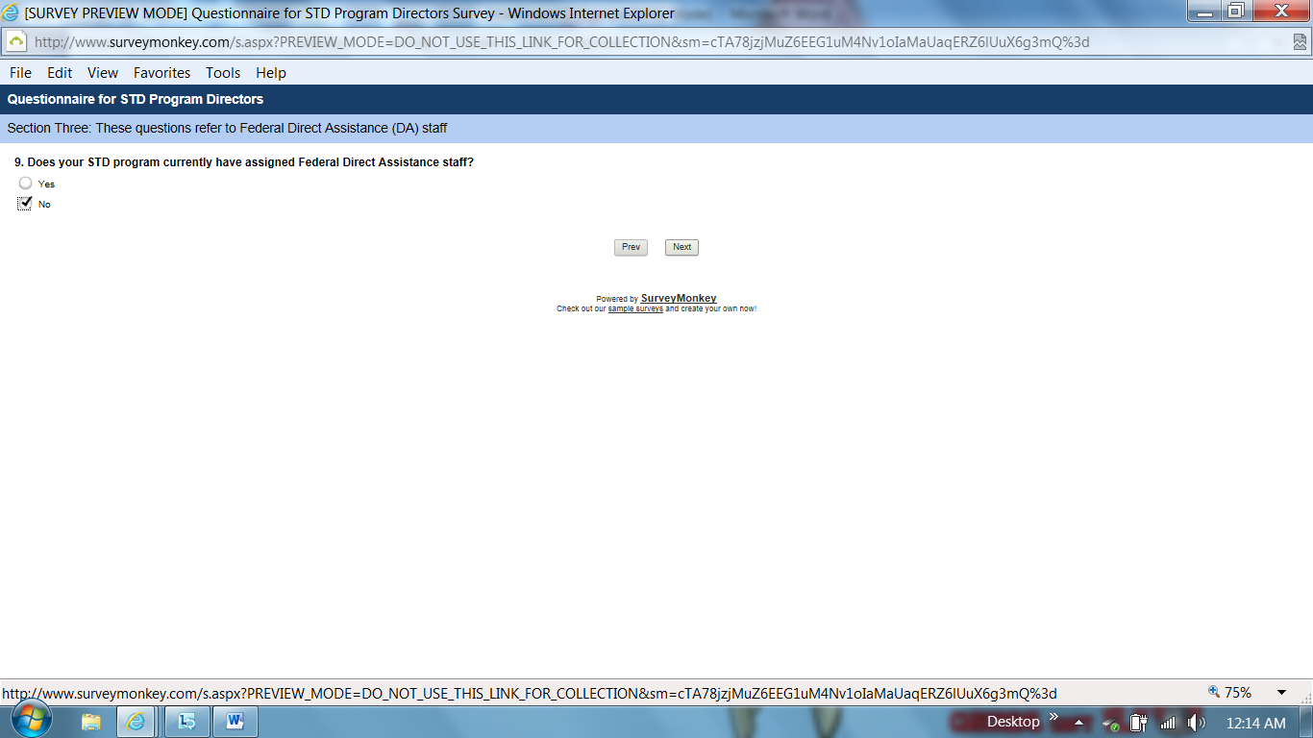

Q9: Skip pattern if No go to question “Has your state/city/county STD program ever had Direct Assistance staff assigned to it?”

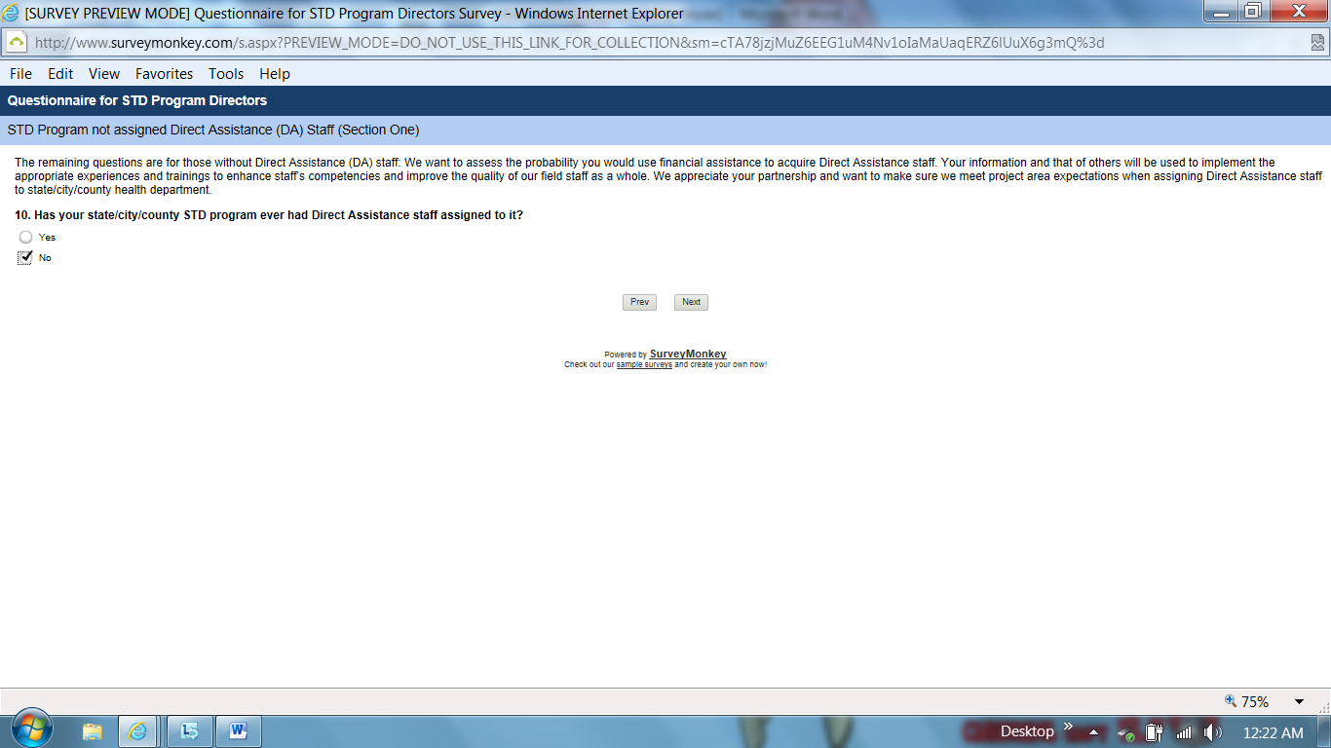

Q10: Skip pattern if No go to question “As a CDC grantee you have the option to use your CDC financial assistance funds to hire “embedded” staff to meet your program needs. http://www.cdc.gov/stltpublichealth/GrantsFunding/direct_assistance.html.
Did you know this option existed?”

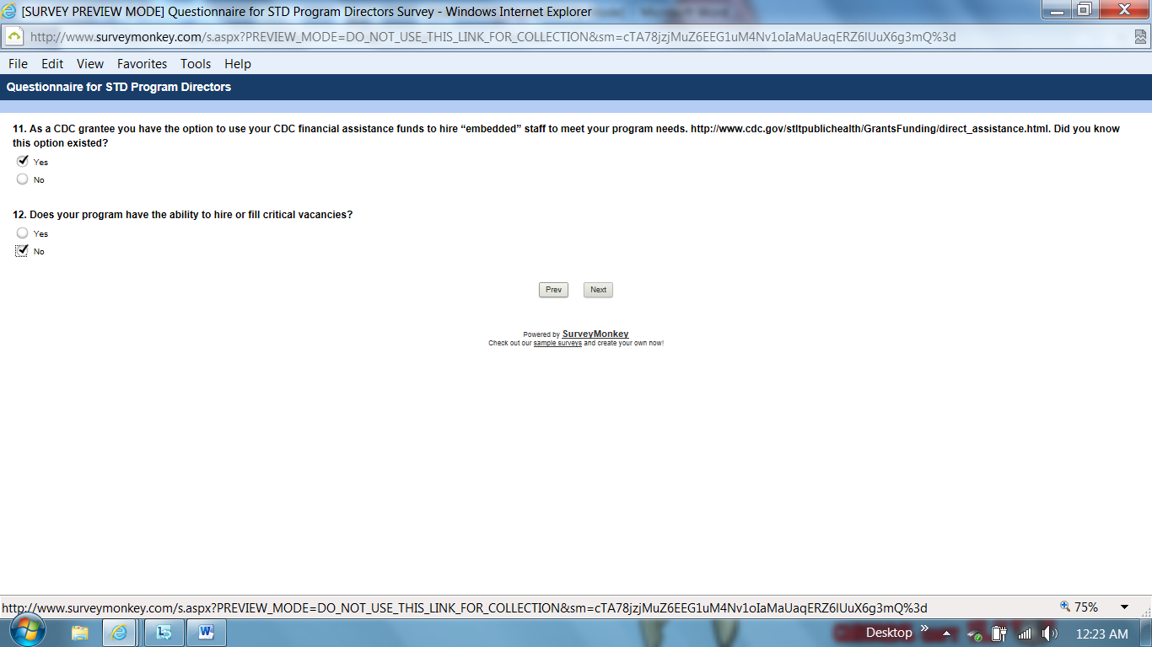

Q12: Skip pattern if No go to question “What prevents you from hiring and/or filling critical vacancies to meet program needs?”

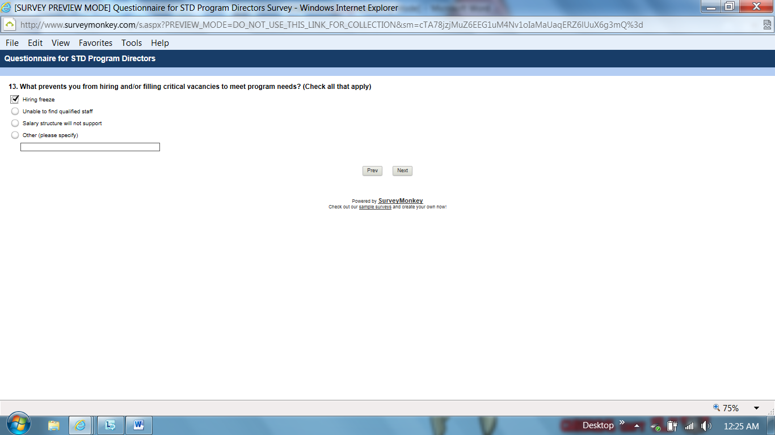

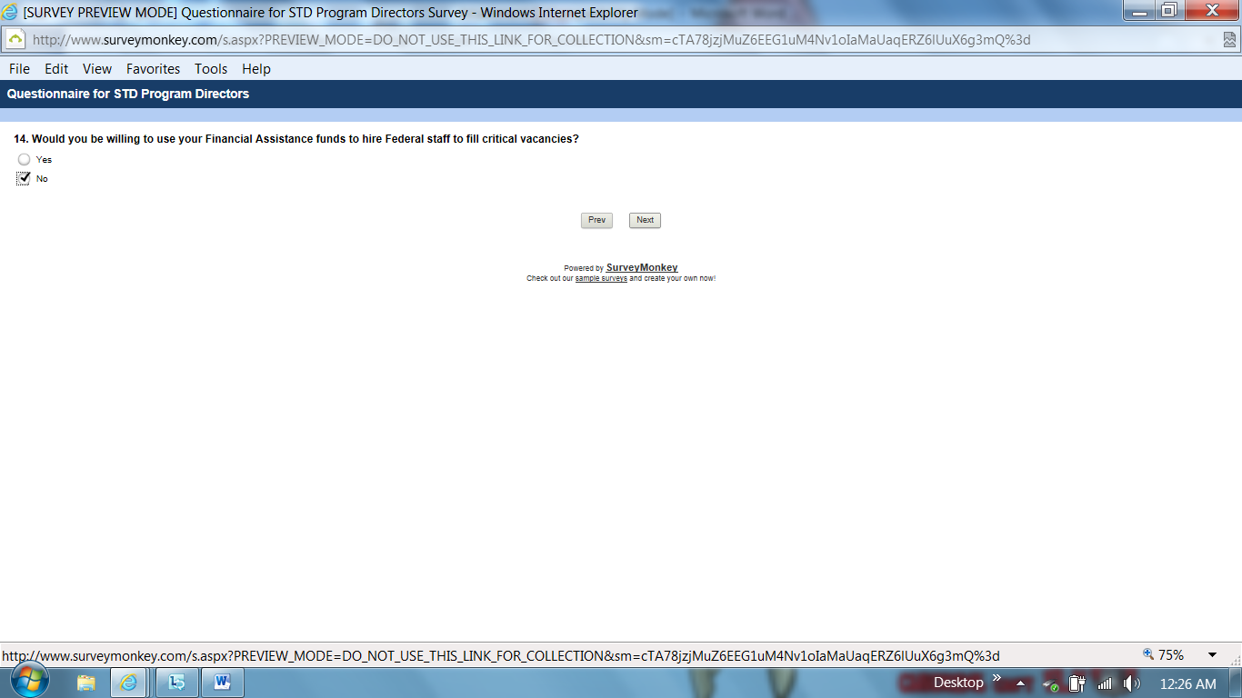

Q14: Skip pattern if No go to question “If you could have CDC Direct Assistance staff assigned to your program at no cost to you how would you use them in your program?”

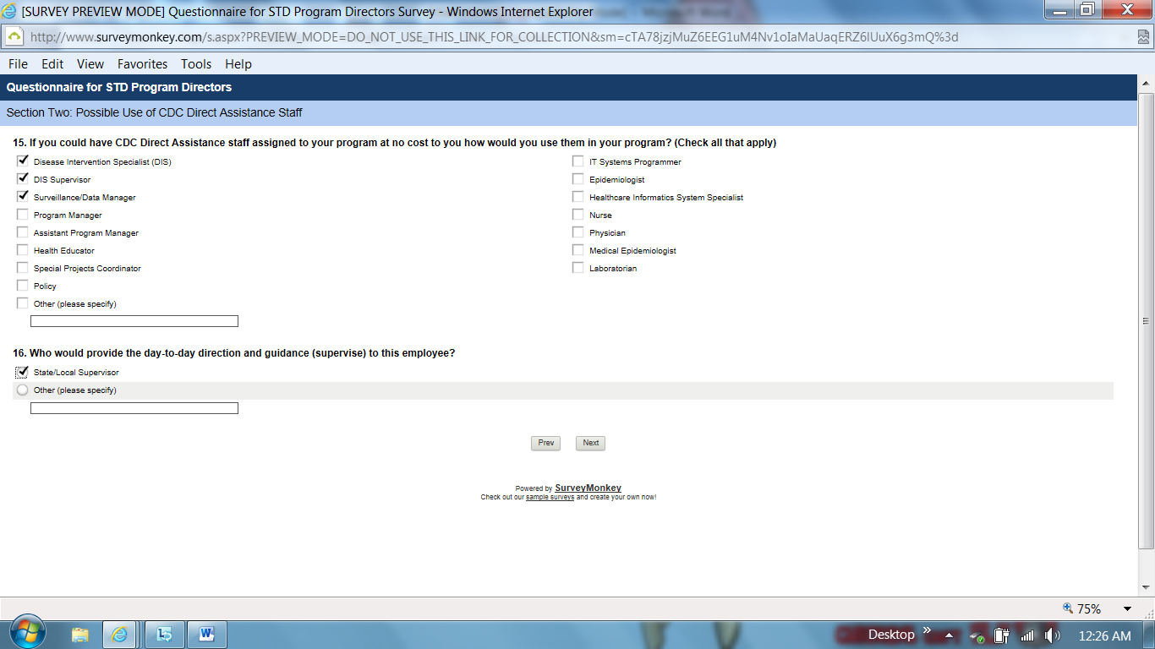

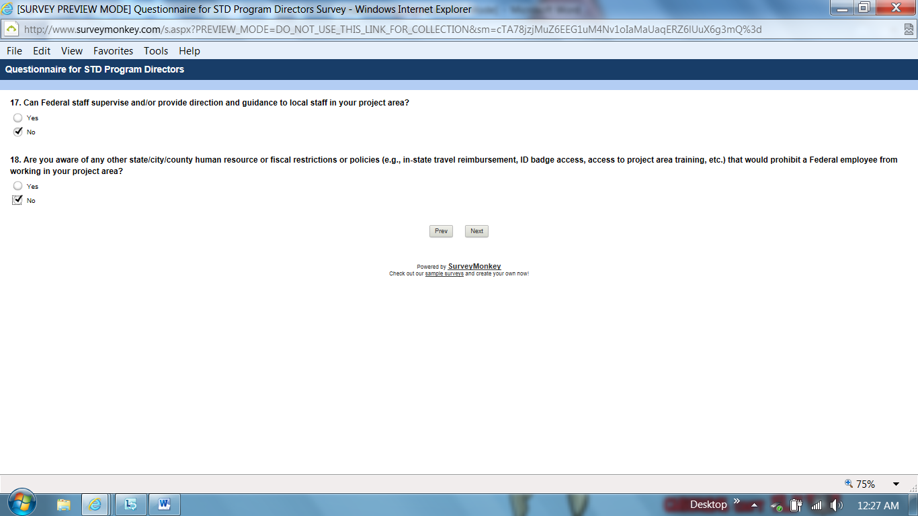

Q18: Skip pattern if No go to “Thank you, End of Survey.”

