Attachment A: CPPW Online Resource Center Screen Shots
Website: http://www.cdc.gov/CommunitiesPuttingPreventiontoWork/resources/
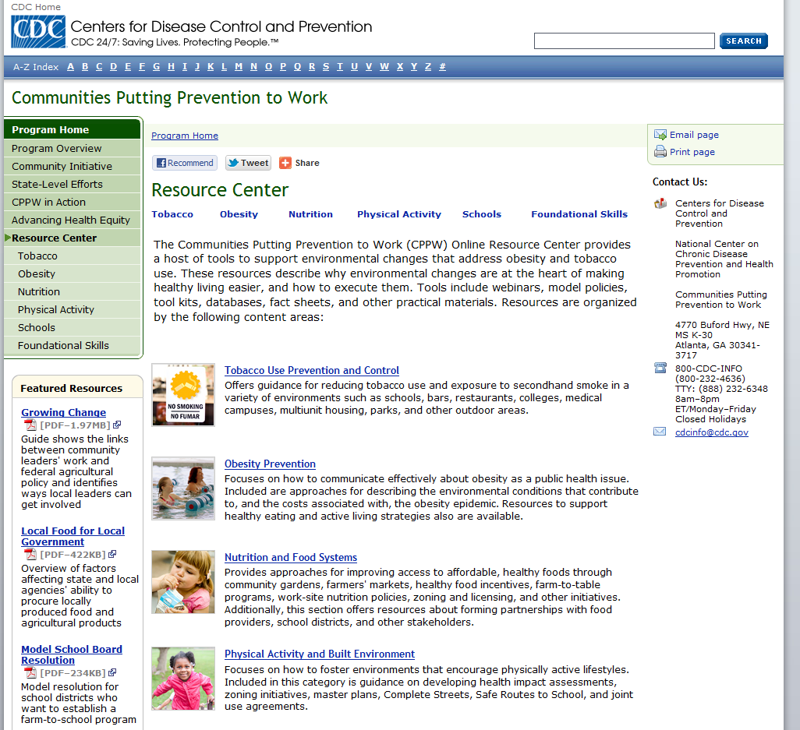

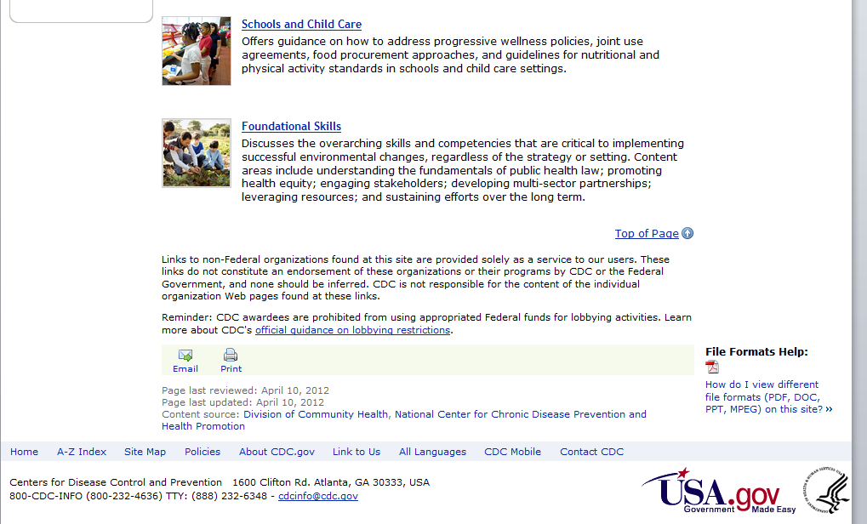

Example of Resources offered in subtopic (Obesity) of Online Resource Center
