ATTACHMENT D: IMATS Application Screenshots

Figure 1. IMATS screenshot: home page
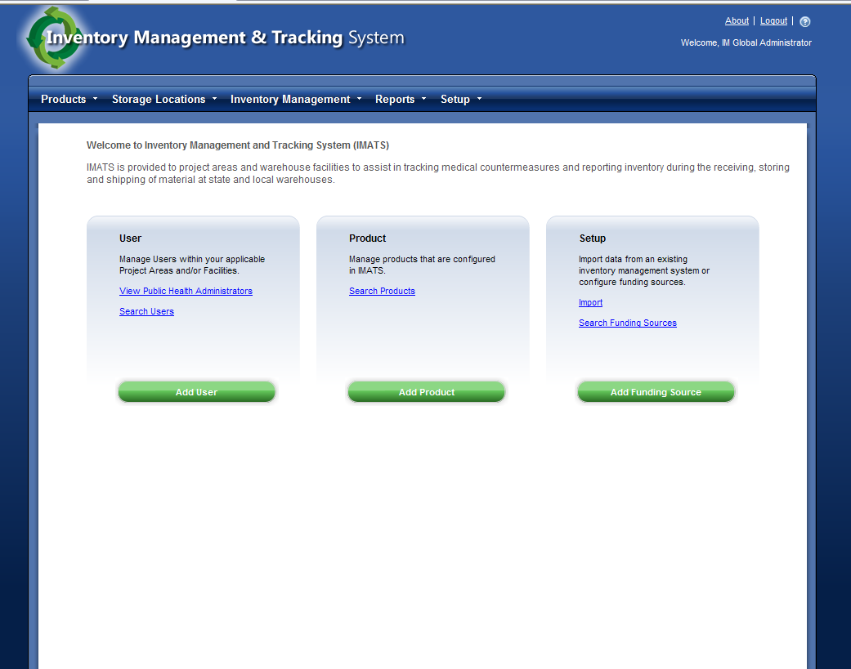
Figure 2. IMATS screenshot: search users
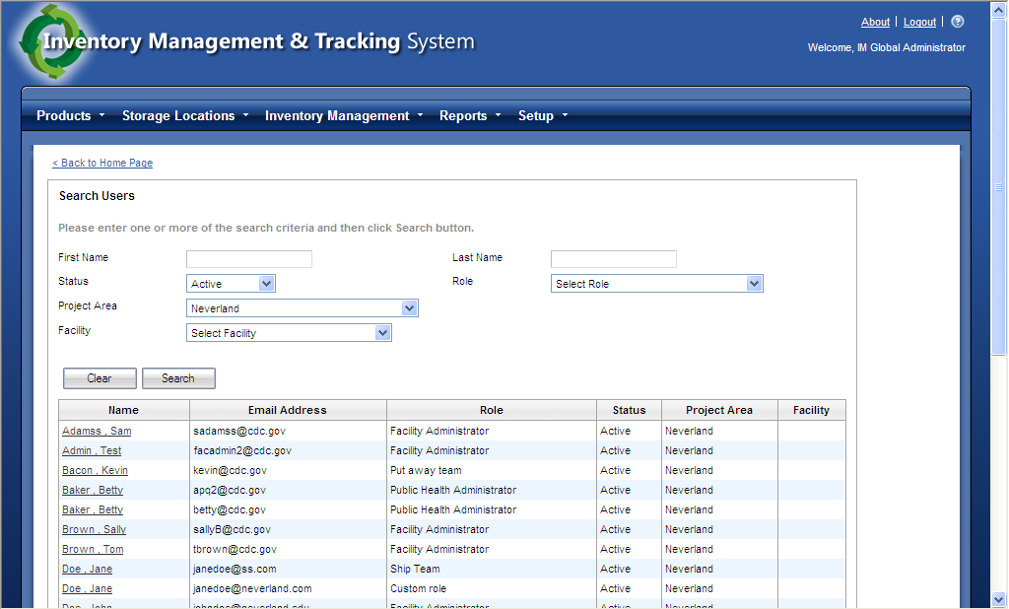

Figure 3. IMATS screenshot: add product
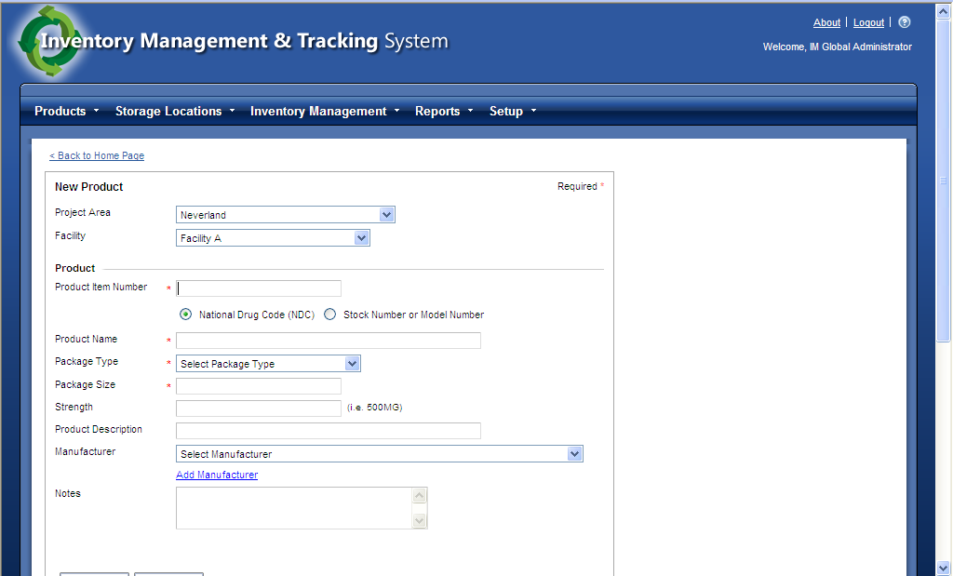

Figure 4. IMATS screenshot: count inventory report
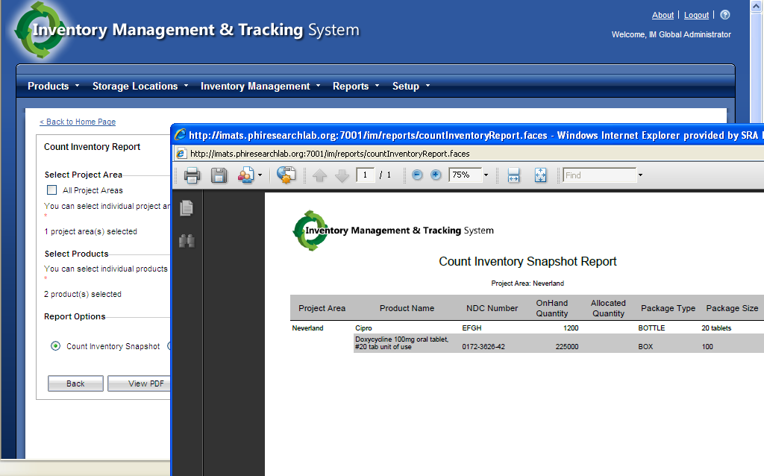
Figure 5. IMATS screenshot: contact sensitive help
