Attachment B. Map and Listing of FY 2011 NPHII Awardees
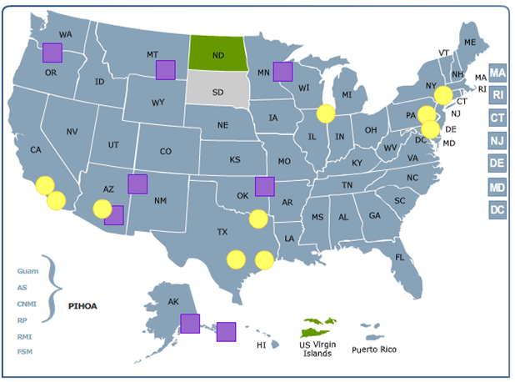
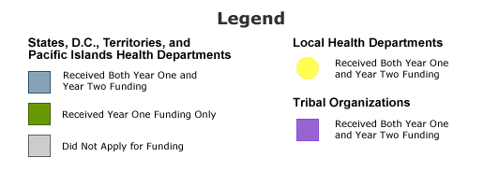

List of NPHII STLTs
NPHII STLT | Grantee Class/Type
Alabama | State Health Departments
Alaska | State Health Departments
Arizona | State Health Departments
Arkansas | State Health Departments
California | State Health Departments
Colorado | State Health Departments
Connecticut | State Health Departments
DC | State Health Departments
Delaware | State Health Departments
Florida | State Health Departments
Georgia | State Health Departments
Hawaii | State Health Departments
Idaho | State Health Departments
Illinois | State Health Departments
Indiana | State Health Departments
Iowa | State Health Departments
Kansas | State Health Departments
Kentucky | State Health Departments
Louisiana | State Health Departments
Maine | State Health Departments
Maryland | State Health Departments
Massachusetts | State Health Departments
Michigan | State Health Departments
Minnesota | State Health Departments
Mississippi | State Health Departments
Missouri | State Health Departments
Montana | State Health Departments
Nebraska | State Health Departments
Nevada | State Health Departments
New Hampshire | State Health Departments
New Jersey | State Health Departments
New Mexico | State Health Departments
New York | State Health Departments
North Carolina | State Health Departments
North Dakota | State Health Departments
Ohio | State Health Departments
Oklahoma | State Health Departments
Oregon | State Health Departments
Pennsylvania | State Health Departments
Rhode Island | State Health Departments
South Carolina | State Health Departments
Tennessee | State Health Departments
Texas | State Health Departments
Utah | State Health Departments
Vermont | State Health Departments
Virginia | State Health Departments
Washington | State Health Departments
West Virginia | State Health Departments
Wisconsin | State Health Departments
Wyoming | State Health Departments
Chicago, IL | Local Health Departments
Dallas County, TX | Local Health Departments
Houston, TX | Local Health Departments
Los Angeles County, CA | Local Health Departments
Maricopa County, AZ | Local Health Departments
New York City, NY | Local Health Departments
Philadelphia, PA | Local Health Departments
San Antonio, TX | Local Health Departments
San Diego County, CA | Local Health Departments
American Samoa | Territory and Pacific Islands Health Departments
Commonwealth of Northern Mariana Islands | Territory and Pacific Islands Health Departments
Federated States of Micronesia | Territory and Pacific Islands Health Departments
Guam | Territory and Pacific Islands Health Departments
Puerto Rico | Territory and Pacific Islands Health Departments
Republic of Palau | Territory and Pacific Islands Health Departments
Republic of Marshall Islands | Territory and Pacific Islands Health Departments
US Virgin Islands | Territory and Pacific Islands Health Departments
The Pacific Island Health Officers Association | Territory and Pacific Islands Health Departments
Alaska Native Tribal Health Consortium | American Indian/Alaska Native Tribes/Organizations
Cherokee Nation | American Indian/Alaska Native Tribes/Organizations
Gila River Indian Community | American Indian/Alaska Native Tribes/Organizations
Mille Lacs Band of Ojibwe | American Indian/Alaska Native Tribes/Organizations
Montana-Wyoming Tribal Leaders Council | American Indian/Alaska Native Tribes/Organizations
The Navajo Nation Tribal Government | American Indian/Alaska Native Tribes/Organizations
Northwest Portland Area Indian Health Board | American Indian/Alaska Native Tribes/Organizations
SouthEast Alaska Regional Health Consortium | American Indian/Alaska Native Tribes/Organizations

