Exhibit A: Screenshot Illustration of the HIOS Rate Review Data Collection System:

Initial HIOS Sign-In screen.
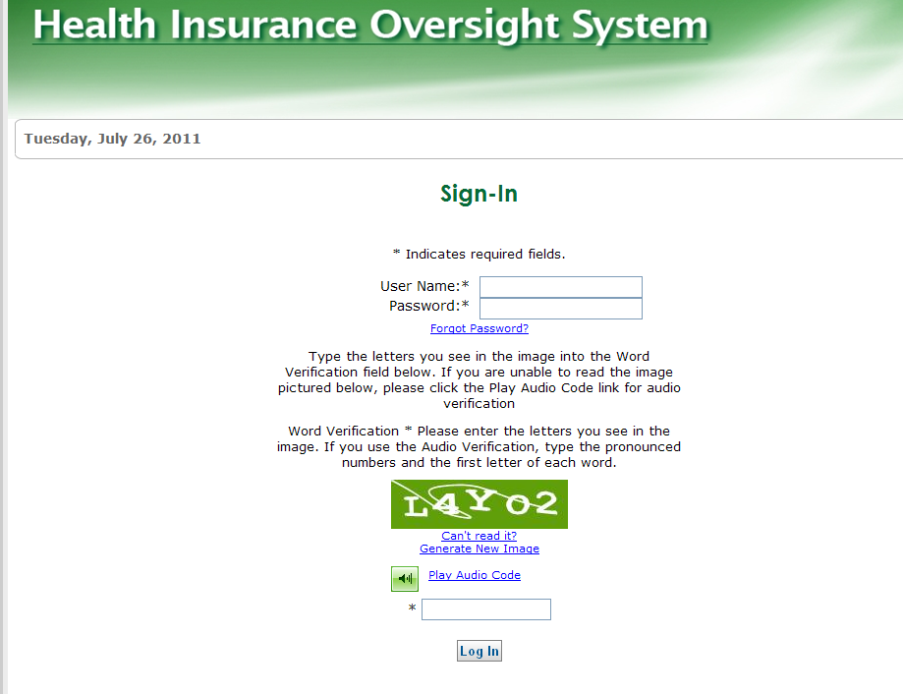

HIOS Main Page Menu

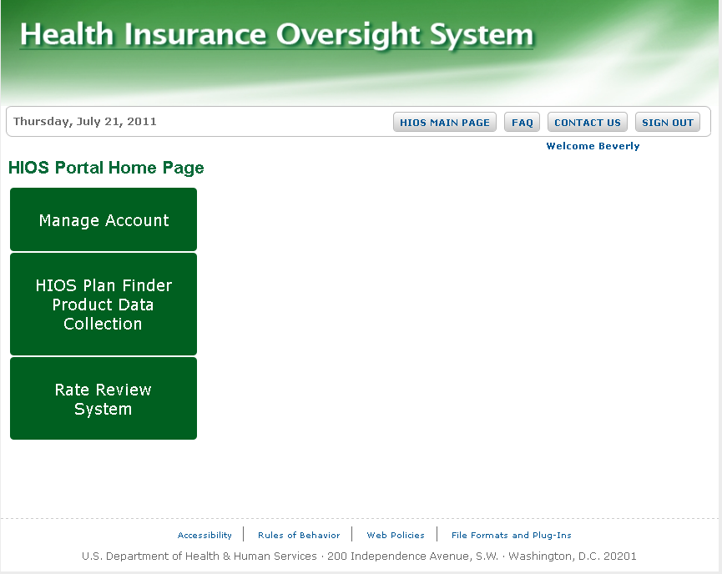

Rate Review System Module Selected

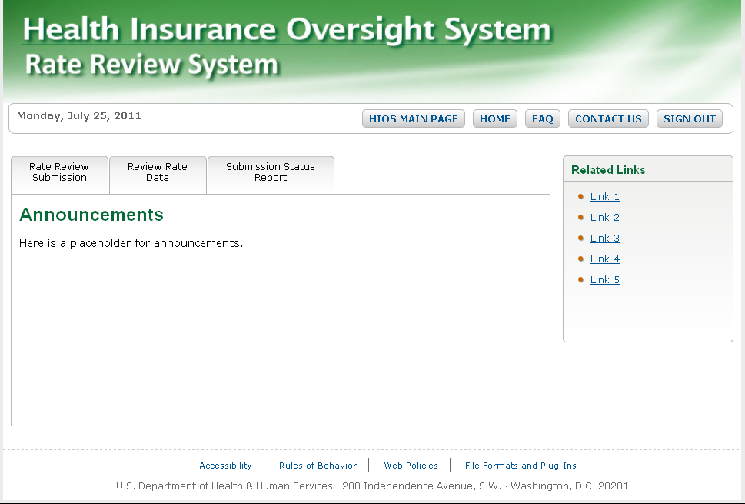

Rate Review Submission Tab Selected
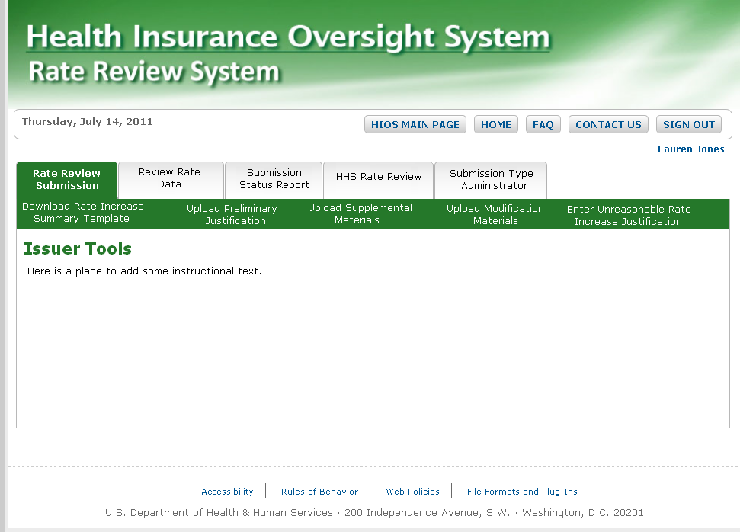
First Preliminary Justification Upload Screen (Issuers will use this Screen to locate products already stored in the HIOS system through the Plan Finder Reporting Requirements)
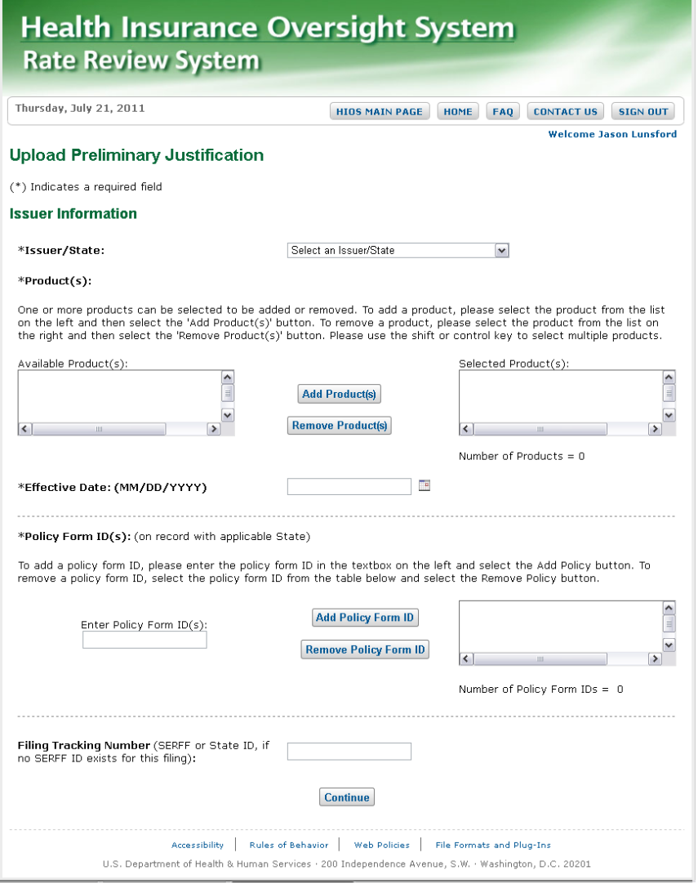

Second Preliminary Justification Upload Screen (Issuers will use this screen to upload the three parts of the Preliminary Justification.
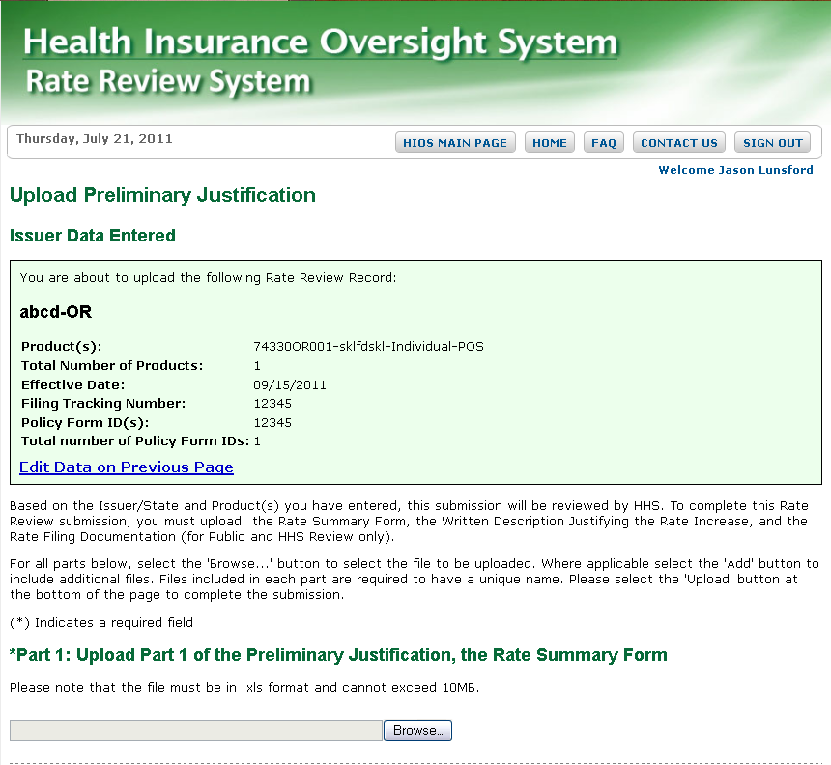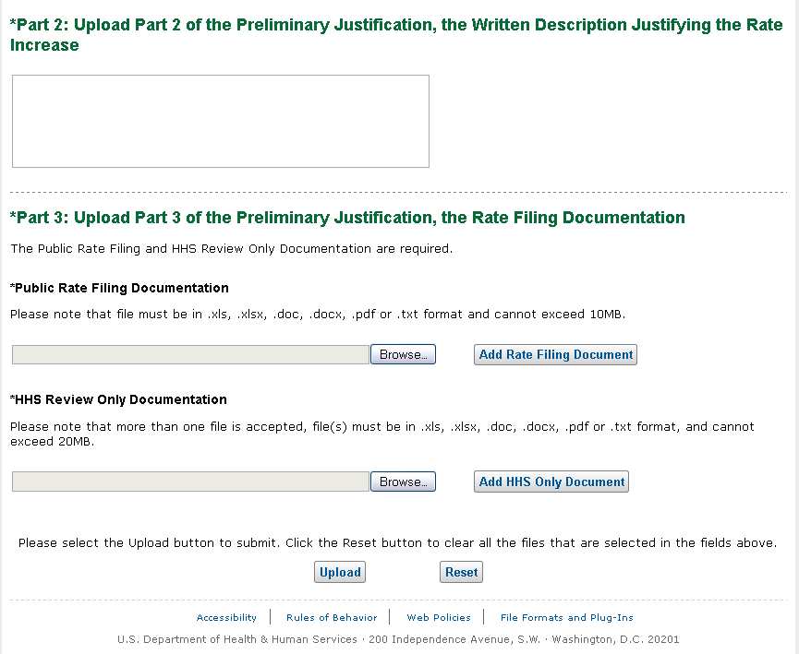

Preliminary Justification Submission Confirmation

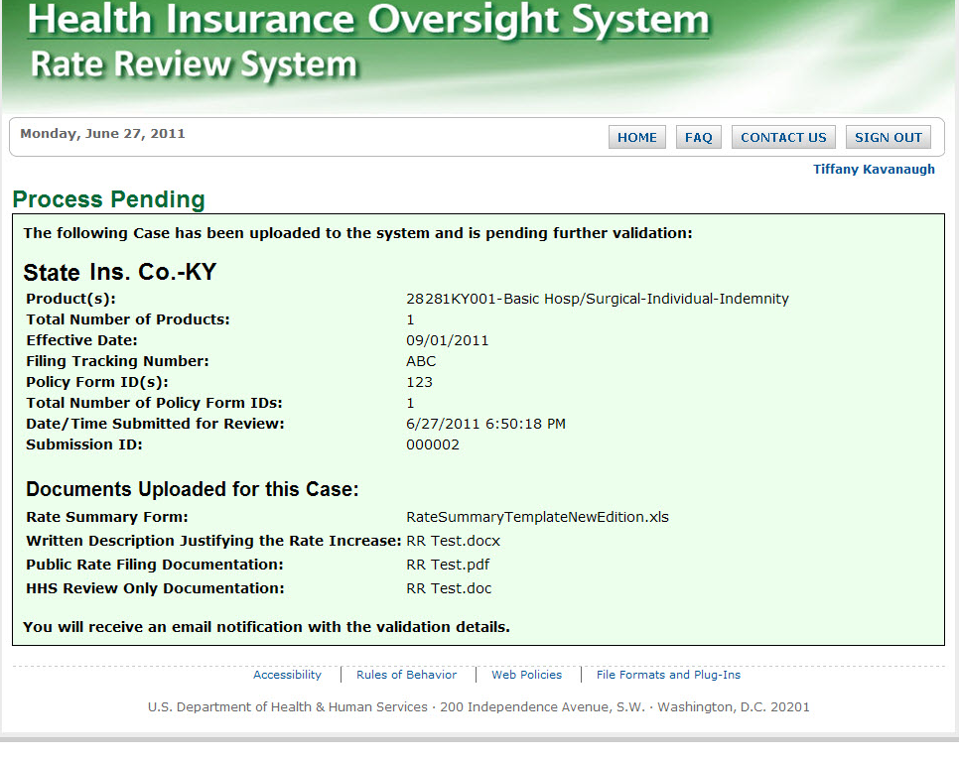

Submission of Supplemental Information Function

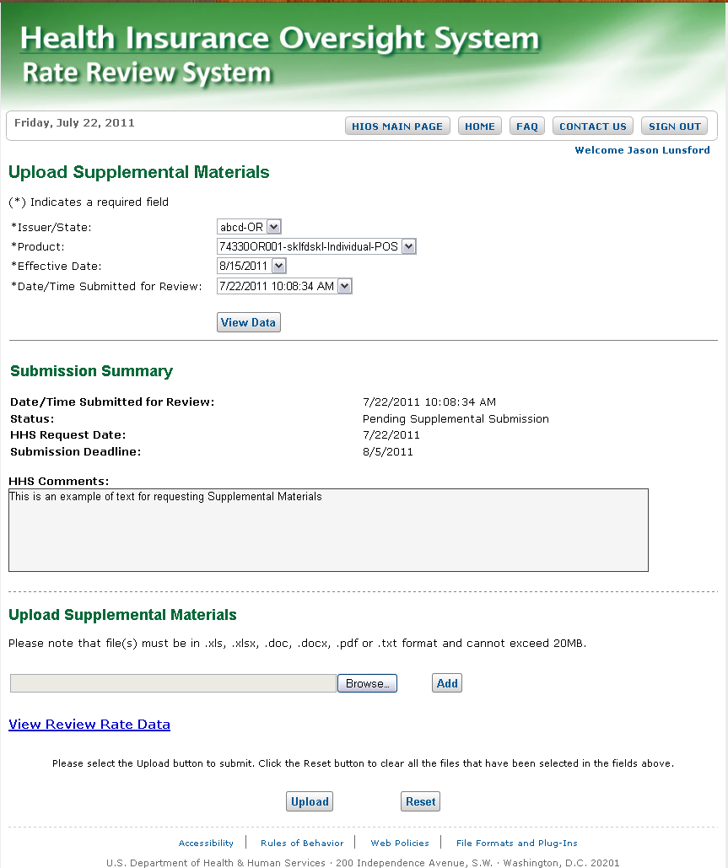

Submission of Supplemental Information Function (continued)

Modify Function

