U.S. Department of Homeland Security

601 S. 12th Street

Arlington, VA 20598-6028
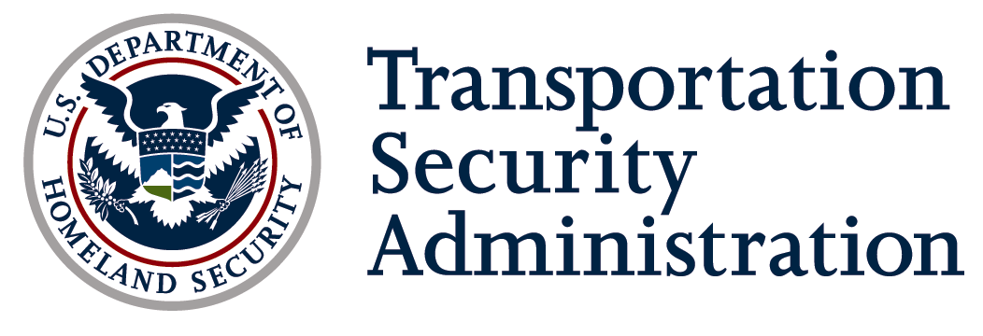

[Date]

Mr/Ms. [Name ]
[Title]
[Company]

Dear Mr/Ms. [Last Name ]:

On August 3, 2007, President Bush signed the Implementing Recommendations of the 9/11 Commission Act of 2007, P.L. 110-53 (2007) (9/11 Act). Section 1557 of the law required the Transportation Security Administration (TSA) to develop and implement a plan for inspecting the critical facilities of the 100 most critical U.S. pipeline systems. In April 2011, TSA published new Pipeline Security Guidelines which updated the criteria to be used in determining critical pipeline facilities. The new guidelines asked pipeline system operators to update their listing of critical facilities based on the new criteria.

In order for TSA to continue visiting and collecting security information at critical pipeline facilities, information is requested on critical facilities for the pipeline system(s) indicated below. To the extent that information provided is Sensitive Security Information (SSI), it will be designated as SSI and handled in accordance with 49 CFR parts 15 and 1520 and 5 USC 552.

Please provide the information requested below for each of the following [Corporate/Company name] pipeline systems:

[Pipeline system name]
[Pipeline system name]
[Pipeline system name]

1. Name of system: ___________________________

2. List of critical facilities in the U.S., as determined by the system owner and/or operator in
accordance with the TSA Pipeline Security Guidelines published in April 2011.

Include the following information:

a) Name of facility

b) Facility location (street address preferable if available) – include directions as necessary

c) brief description of facility including facility type (compressor station, pump station, meter
station, city gate, terminal, tank farm, storage, LNG plant, control/operations/security center,
bridge span, etc.)

d) Under which criteria in the TSA Pipeline Security Guidelines is the facility considered to be
critical (indicate all that apply)

e) If the facility is regulated by the Maritime Transportation Security Act (MTSA)

f) If all or part of the facility is regulated by the Chemical Facility Anti-Terrorism Standards
(CFATS)

Please send the requested information via electronic mail not later than [Date ] using the following instructions.

- Save requested critical facility information in an electronic file.
- Password protect all documents. Use the same password for all documents.
- Mark the document contents in accordance with SSI procedures (For reference on SSI marking and header and footer template, see attachment)
- In the body of the email, provide a name and contact information (phone number, email address, etc.) for TSA to contact in case any clarification is needed and to confirm receipt.
- Attach the password protected documents containing requested critical facility information to an email and send it to the following address:
pipelinesecurity@dhs.gov (NOTE: Do not include the password in this email.)
- In a separate email also addressed to pipelinesecurity@dhs.gov, provide the password to the sent documents.
- TSA will notify the person designated in step 4 to confirm receipt of the information.

For any questions, please contact Steve Froehlich at phone number 571-227-1240 or email Steven.Froehlich@dhs.gov. I personally want to thank you for your cooperation on this matter.

Sincerely,

Jack Fox
General Manager
Pipeline Security Division
Transportation Sector Network Management
Transportation Security Administration

Enclosure: Sensitive Security Information (SSI) Best Practices Guide for Non-DHS Employees

