The following application options are accessed via www.fafsa.gov
- FAFSA on the Web
- FAFSA on the Web Renewal
- FAFSA on the Web EZ
- FAFSA on the Web EZ Renewal
- FAFSA on the Phone (FOTP)
- FAFSA on the Phone EZ
- FAFSA on the Web Corrections

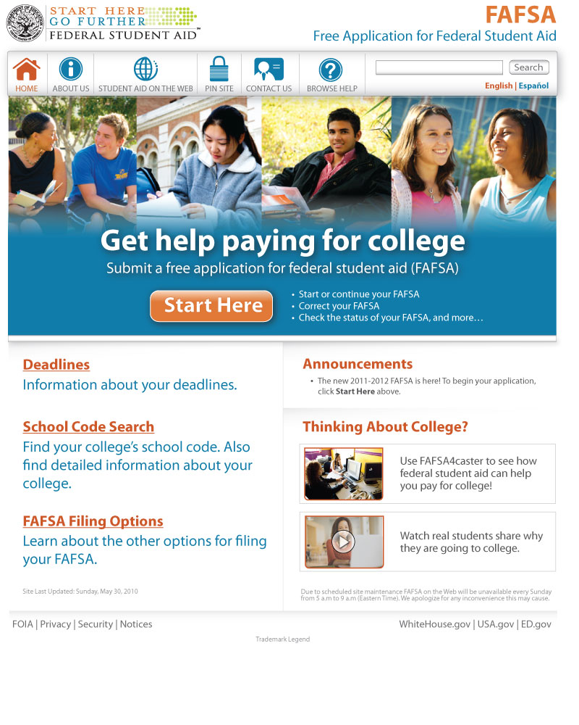

The following application options are accessed via https://faaaccess.ed.gov
- FAA Access
- FAA Access Renewal
- FAA Access EZ
- FAA Access EZ Renewal
- FAA Access Corrections

