Significant Weather Event Communication Survey

You can affect how NOAA’s National Weather Service (NWS) conveys significant weather events such as snowstorms, tornadoes, hurricanes, flooding, and more.

This survey will show you a few images that the NWS is considering to convey significant weather events. The survey will ask for your opinion on how well the images are providing important information about the events.

Eastern Research Group is doing this study for the NWS. This is not a commercial survey and your identity will not be disclosed.

Completing this survey is voluntary. By selecting “AGREE AND CONTINUE” below, you are indicating that you have read this and agree to participate in this survey. Otherwise, please select “Exit."

Thank you for taking the time to answer these questions.

Paperwork Reduction Act Statement: Public reporting burden for this collection of information is estimated to average 10 minutes per response, including the time for reviewing instructions, searching existing data sources, gathering and maintaining the data needed, and completing and reviewing the collection of information. Send comments regarding this burden estimate or any other suggestions for reducing this burden to Sarah Brabson, NOAA National Weather Service, SSMC 2, Room 17205, 1325 East West Highway, Silver Spring, MD. Notwithstanding any other provisions of the law, no person is required to respond to, nor shall any person be subjected to a penalty for failure to comply with, a collection of information subject to the requirements of the Paperwork Reduction Act, unless that collection of information displays a currently valid OMB Control Number. Confidentiality Statement: All data will remain confidential. There are no questions that ask for identifying information such as names or email addresses. Additionally, participants will not be taking the survey on their own equipment. Rented laptops will be used instead, which means that no IP addresses can be traced to an individual participant. The data is anonymous.

_____AGREE AND CONTINUE

_____EXIT

Section 1. Color

The following questions are about your interpretations of color. Please read the directions for each question carefully.

1. The Phoenix Metro area is in a flash flood warning. News has emerged that there is a river of water dangerously traveling toward communities east of Phoenix. Which of the following maps best conveys the danger of this flood emergency?
Map 2
Map 1
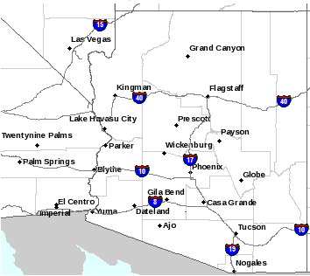
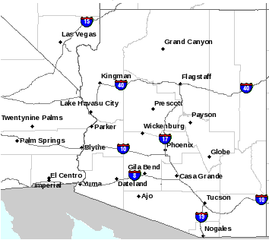

a. Map 1 (Black)

b. Map 2 (Purple)
2. Currently the Phoenix Metro area doesn’t have any severe weather. Which of these maps depicts no severe weather?

Map 2
Map 1

Map 3

a. Map 1 (Blank)

b. Map 2 (Blue)

c. Map 3 (Green)
3. Please rank (from 1-10) the danger represented by the following colors (with 1= low danger and 10 = high danger).

--Page Break for Survey—

Section 2. Language

4. Please write a word or phrase to describe severe weather that:

May Occur: _________________________

Will Occur: _________________________

5. On a scale from 1-5, if forecasters are describing a severe weather event, how serious is the threat posed by each of these words or phrases?

 | Not serious | Somewhat serious | Serious | Very serious | Extremely serious
Danger | 1 | 2 | 3 | 4 | 5
Hazardous | 1 | 2 | 3 | 4 | 5
Potential | 1 | 2 | 3 | 4 | 5
Warning | 1 | 2 | 3 | 4 | 5
Life-Threatening | 1 | 2 | 3 | 4 | 5
Threat | 1 | 2 | 3 | 4 | 5
Caution | 1 | 2 | 3 | 4 | 5
Monitor | 1 | 2 | 3 | 4 | 5
Alert | 1 | 2 | 3 | 4 | 5
Emergency | 1 | 2 | 3 | 4 | 5

6. On a scale from 1-5, how soon do you expect to feel the severe weather impacts posed by each of these words or phrases?

 | Not at all soon | Slightly soon | Soon | Very soon | Now
Danger | 1 | 2 | 3 | 4 | 5
Hazardous | 1 | 2 | 3 | 4 | 5
Potential | 1 | 2 | 3 | 4 | 5
Warning | 1 | 2 | 3 | 4 | 5
Life-Threatening | 1 | 2 | 3 | 4 | 5
Threat | 1 | 2 | 3 | 4 | 5
Caution | 1 | 2 | 3 | 4 | 5
Monitor | 1 | 2 | 3 | 4 | 5
Alert | 1 | 2 | 3 | 4 | 5
Emergency | 1 | 2 | 3 | 4 | 5

Section 3a. Feedback on Prototypes

In this next section, you will be asked to answer a few questions based on images for a weather warning system.

Please look at the following National map:
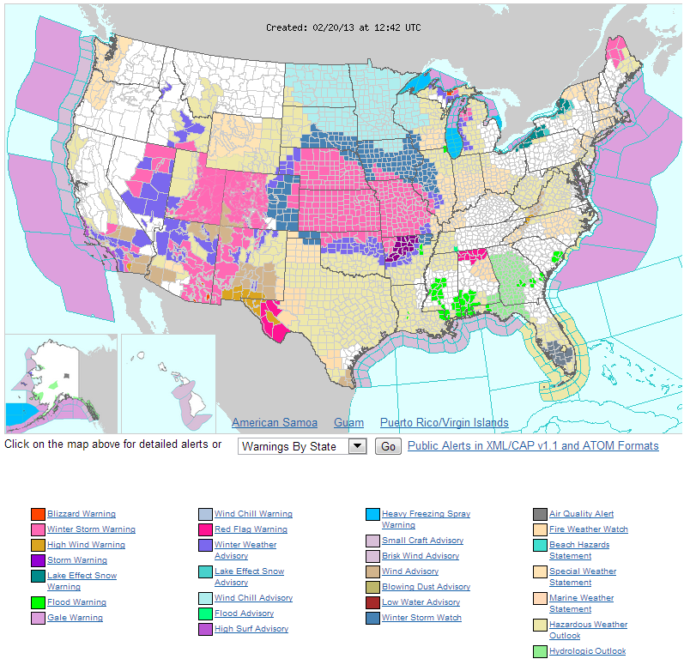
7. Based on your initial reaction to this map, what do the colors represent? [Open-ended]

8. How would you rate this map based on the following qualities?

 | Poor | Fair | Good | Very Good | Excellent
Conveys hazard type
Provides timing
Shows forecast confidence
Communicates impacts
Suggests actions to take

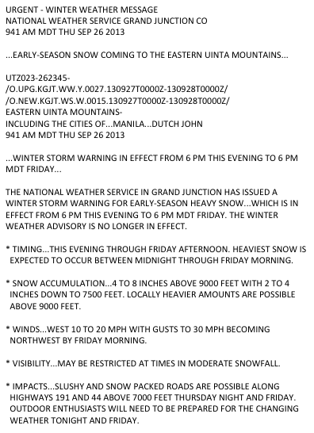
9. How would you rate this image based on the following qualities?

 | Poor | Fair | Good | Very Good | Excellent
Conveys hazard type
Provides timing
Shows forecast confidence
Communicates impacts
Suggests actions to take
Section 3b. Feedback on Prototypes

In this next section, you will be asked to answer a few questions based on images for a weather warning system.

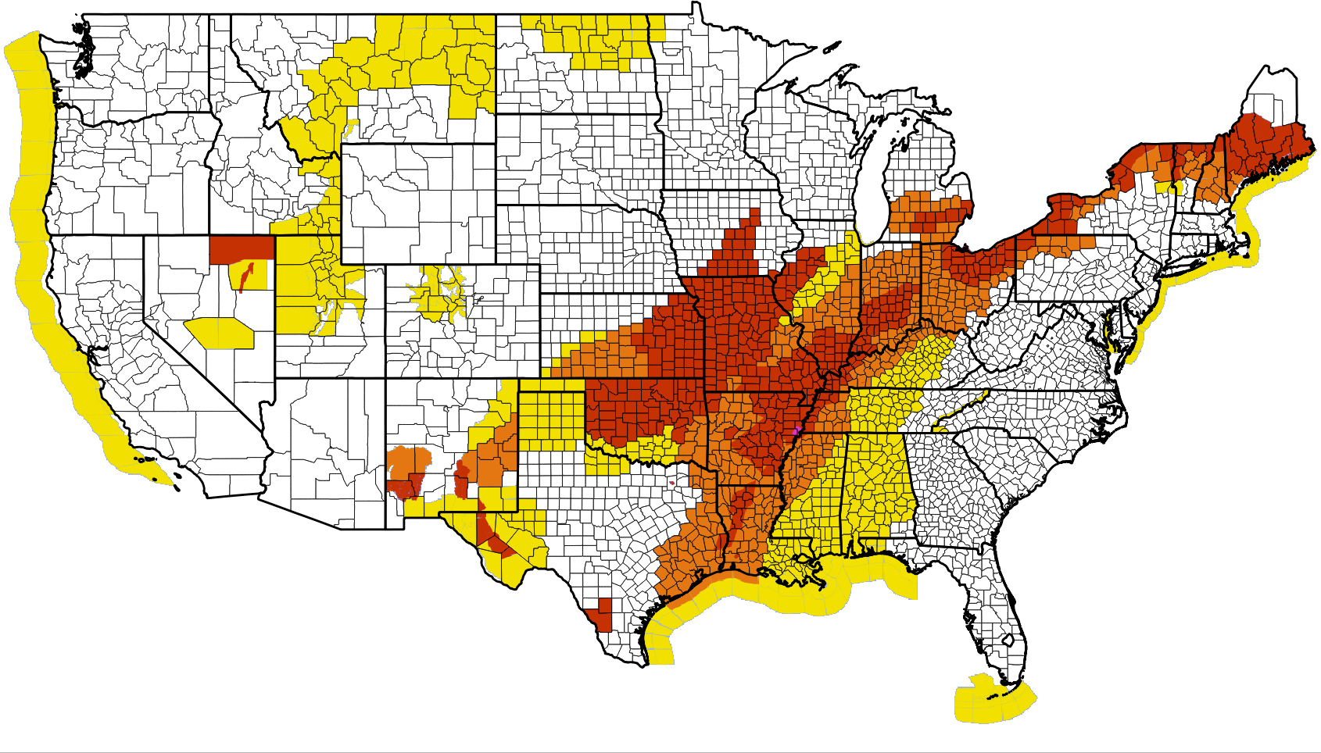
Please look at the following national map:

Be aware: Significant hazardous weather may occur. | Be prepared: Significant hazardous weather is imminent or occurring. | Take action: Dangerous weather conditions are imminent or occurring.
10. Based on your initial reaction to this map, what do the colors represent? [Open-ended]

11. How would you rate this map based on the following qualities?

 | Poor | Fair | Good | Very Good | Excellent
Conveys hazard type
Provides timing
Shows forecast confidence
Communicates impacts
Suggests actions to take

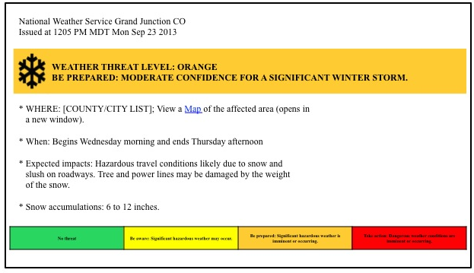

12. How would you rate this image based on the following qualities?

 | Poor | Fair | Good | Very Good | Excellent
Conveys hazard type
Provides timing
Shows forecast confidence
Communicates impacts
Suggests actions to take

Section 3c. Feedback on Prototypes

In this next section, you will be asked to answer a few questions based on images for a weather warning system.
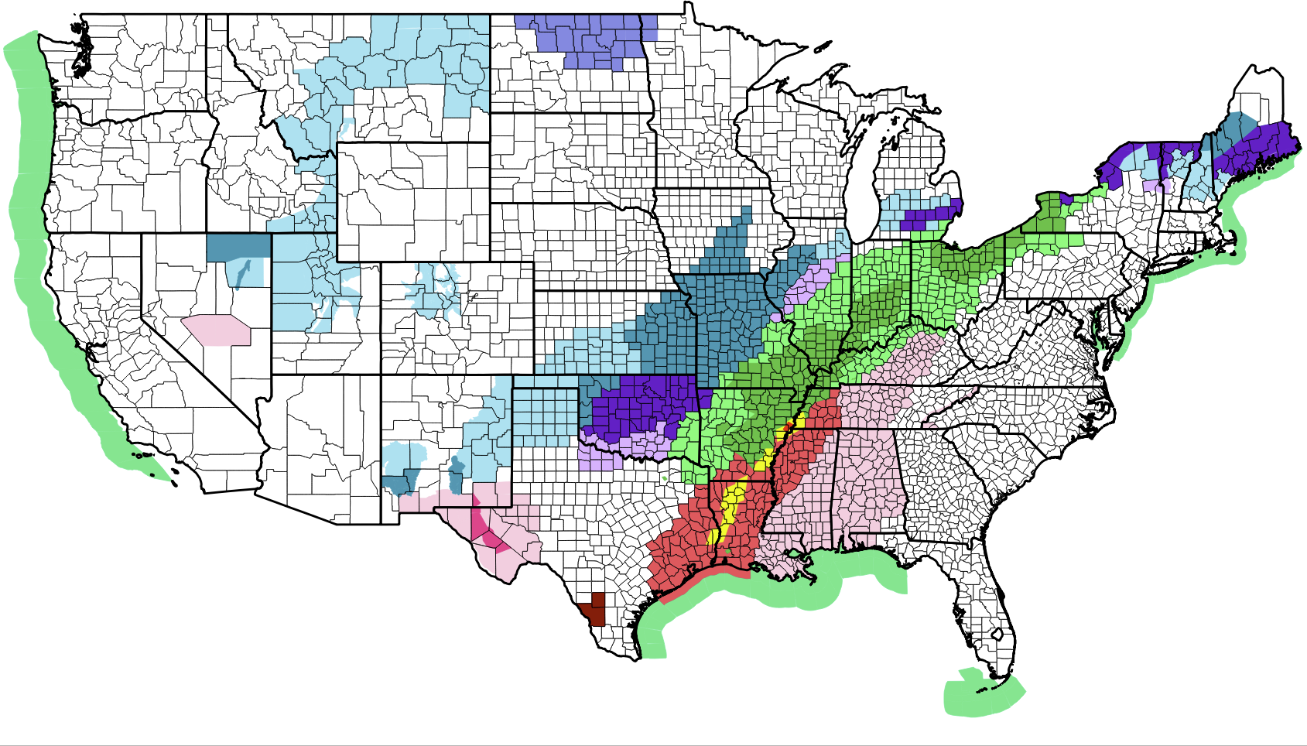
Coastal flood warning
Storm warning
Frost advisory
Winter storm watch
Wind advisory
Severe thunderstorm watch
Flood advisory
Tornado watch

13. How would you rate this image based on the following qualities?

 | Poor | Fair | Good | Very Good | Excellent
Conveys hazard type
Provides timing
Shows forecast confidence
Communicates impacts
Suggests actions to take

14. Of these three maps, which one does the BEST JOB of:

 | Map #1: Multiple (>100 colors) | Map #2: 4 colors (green, yellow, orange, red) | Map #3: 22 colors (saturated/unsaturated colors)
Conveys hazard type
Provides timing
Shows forecast confidence
Communicates impacts
Suggests actions to take

Demographics

15. Are you?
- Male
- Female
- Other/prefer not to answer

16. What is your age?

17. What is the highest level of formal education you have completed?
- Less than high school
- Some high school
- High school graduate
- Some college
- Trade/technical/vocational training
- College graduate
- Some postgraduate work
- Post graduate degree
18. What is your level of expertise in meteorology?
- No expertise
- I’m a novice
- General understanding
- A few years of experience/practice
- I’m an expert

19. What is the primary language that you speak at home?
- English
- Spanish
- Other (please specify)

20. Are you color blind?
- Yes
- No
- Don’t know

The National Weather Service is the official weather forecasting service for the United States.

