OMB Control No. 0648-0342
Expiration Date: 04/30/2015

Coastal Storms Program Gulf of Mexico Stakeholder Survey

Mode: Web-based/Paper

Thank you for participating in this survey. NOAA’s Coastal Services Center in Charleston, SC is working with Eastern Research Group, Inc. (ERG) to conduct an evaluation of NOAA’s Coastal Storms Program (CSP) in the Gulf of Mexico. NOAA implemented this program from 2007 to 2012 through the Mississippi-Alabama Sea Grant Consortium. The purpose of the evaluation is to assess the program’s progress toward its objectives and the economic impact of the program in terms of costs and benefits. As part of this evaluation, ERG is conducting this survey of stakeholders in the Gulf to better understand your satisfaction with how the program functions, the usefulness of the products it generates, and how the program benefits compare to its costs.

Your participation in the survey is completely voluntary and your identity and responses will remain anonymous.

Products Module

The first set of questions asks about a number of products and services that the Coastal Storms Program, in conjunction with Mississippi-Alabama Sea Grant, developed, implemented, or promoted between 2007 and 2012.

- Are you aware of the Community Resilience Index developed by Mississippi-Alabama Sea Grant?
___ Yes
___ No…………… Go to Question #6

- Is the Community Resiliency Index a product that you would use in your work?
___ Yes
___ No…………… Go to Question #6

- Have you used it in your work?
___ Yes
___ No…………… Go to Question #6

- How useful was the Community Resiliency Index in helping you to prepare for coastal storms?
__ Not at all useful
__ Somewhat useful
__ Very useful
__ Essential

- To what extent did the Community Resiliency Index contribute to improving the resiliency of your community?
__ Did not contribute at all
__ Made a small/moderate contribution
__ Made a large contribution
__ Was essential

- Are you aware of the Critical Facilities Tool developed NOAA? The Critical Facilities Tool is a product often used in conjunction with the Community Resiliency Index.
___ Yes
___ No…………… Go to Question #11

- Is the Critical Facilities Tool a product that you would use in your work?
___ Yes
___ No…………… Go to Question #11

- Have you used it in your work?
___ Yes
___ No…………… Go to Question #11

- How useful was the Critical Facilities Tool in helping you to prepare for coastal storms?
__ Not at all useful
__ Somewhat useful
__ Very useful
__ Essential

- To what extent did the Critical Facilities Tool contribute to improving the resiliency of your community?
__ Did not contribute at all
__ Made a small/moderate contribution
__ Made a large contribution
__ Was essential

- Are you aware of the Unstructured Grid Catalog developed by NOAA? The Unstructured Grid Catalog is a set of spatial grids for use in hydrodynamic modeling developed by various groups and shared among stakeholders in the Gulf.
___ Yes
___ No…………… Go to Question #16

- Is the Unstructured Grid Catalog a product that you would use in your work?
___ Yes
___ No…………… Go to Question #16

- Have you used it in your work?
___ Yes
___ No…………… Go to Question #16

- How useful was the Unstructured Grid Catalog in helping you to prepare for coastal storms?
__ Not at all useful
__ Somewhat useful
__ Very useful
__ Essential

- To what extent did the Unstructured Grid Catalog contribute to improving the resiliency of your community?
__ Did not contribute at all
__ Made a small/moderate contribution
__ Made a large contribution
__ Was essential

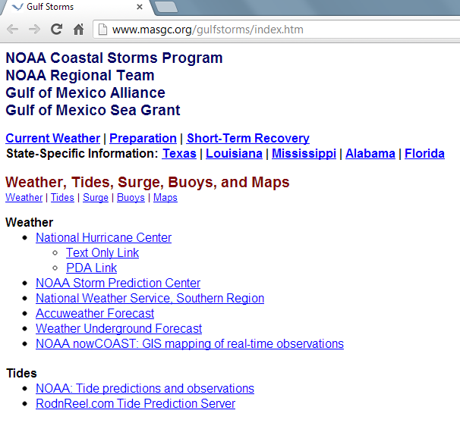
- Are you aware of the Gulf Storms Web Portal developed by NOAA, the Gulf of Mexico Alliance, and the Gulf of Mexico Sea Grant (see image)?
___ Yes
___ No………Go to Question #20

- Have you ever visited the Web Portal?
___ Yes
___ No…… Go to Question #20

- How useful was the Web Portal in helping you to prepare for storms?
__ Not at all useful
__ Somewhat useful
__ Very useful
__ Essential

- To what extent did the Web Portal contribute to improving the resiliency of your community?
__ Did not contribute at all
__ Made a small/moderate contribution
__ Made a large contribution
__ Was essential

- Are you aware of the TV series "Gambling Against Mother Nature" developed in partnership by NOAA’s Coastal Storms Program, the Mississippi/Alabama Sea Grant Consortium, WKRG-TV, the City of Orange Beach, Alabama, and grassroots, inc.?
___ Yes
___ No…………… Go to Question #23

- In your opinion, how useful was the TV series in helping members of the community be aware of the risks from coastal storms?
__ No at all useful
__ Somewhat useful
__ Very useful
__ Essential

- In your opinion, to what extent did the TV series contribute to improving the resiliency of your community?
__ Did not contribute at all
__ Made a small/moderate contribution
__ Made a large contribution
__ Was essential

- Are you aware of the Homeowner’s Handbook developed by the Mississippi Department of Marine Resources under a grant from Mississippi-Alabama Sea Grant?
___ Yes
___ No…………… Go to Question #25

- In your opinion, how useful is Homeowner’s Handbook in helping homeowners prepare for coastal storms?
__ Not at all useful
__ Somewhat useful
__ Very useful
__ Essential

- Are you aware of the StormSmart Coasts web site that NOAA and Mississippi-Alabama Sea Grant helped to promote under Coastal Storms Program (see image)?
___ Yes
___ No…………… Go to Question #28

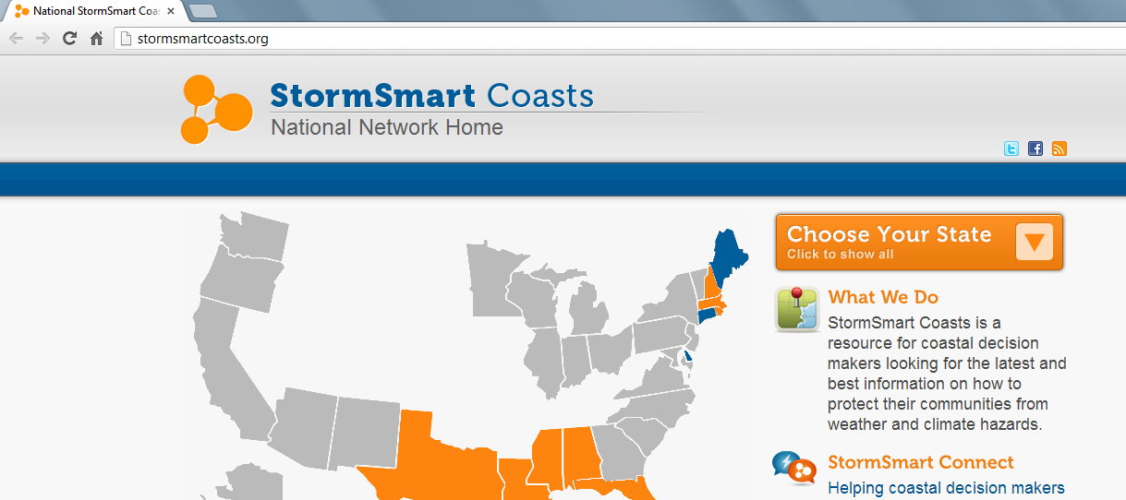

- Have you ever visited the StormSmart Coasts web site?
___ Yes
___ No…………… Go to Question #28

- How useful was the StormSmart Coasts web site in helping you to prepare for coastal storms?
__ Not at all useful
__ Somewhat useful
__ Very useful
__ Essential

- Are you aware of the StormSmart Connect web site that NOAA and Mississippi-Alabama Sea Grant helped to promote under the Coastal Storms Program (see image)?
___ Yes
___ No…………… Go to Question #36

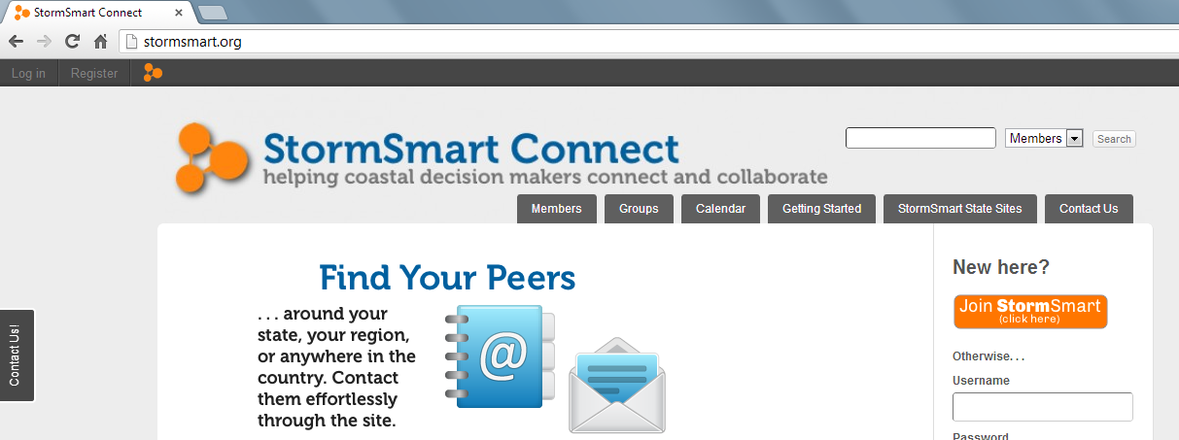

- Is the StormSmart Connect web site something that you would use in your work?
___ Yes
___ No…………… Go to Question #33

- Have you used it in your work?
___ Yes
___ No…………… Go to Question #33

- How useful was the StormSmart Connect web site in helping you to prepare for coastal storms?
__ Not at all useful
__ Somewhat useful
__ Very useful
__ Essential

- To what extent does the StormSmart Connect web site contribute to improving the resiliency of your community?
__ Did not contribute at all
__ Made a small/moderate contribution
__ Made a large contribution
__ Was essential

- Do you reside in or regularly visit a coastal community in Mississippi?

___Yes
___No……………………Go to Question #36

- Are you aware of the billboard campaign in Mississippi coastal communities (see image)?
___Yes
___No……………………Go to Question #36

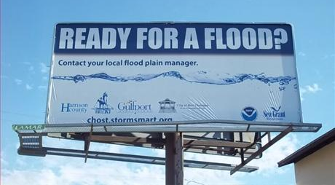

- How useful is the billboard campaign for raising community awareness of flood preparedness?

__ Not at all useful
__ Somewhat useful
__ Very useful
__ Essential

Short-Term/Mid-Term Outcomes Module

The next set of question asks about various short- and mid-term outcomes targeted by the Coastal Storms program.

- Do you currently get information on resilience, preparedness, or recovery from Mississippi-Alabama Sea Grant?
___ Yes
___ No

- Prior to 2007, did you get information on resilience, preparedness, or recovery from Mississippi-Alabama Sea Grant?
___ Yes
___ No

[Questions #38 - #42 are asked only if respondent answers “Yes” to Question #26]

- Have you followed the guidance for hazard mapping found on the StormSmart Coast web site?
___ Yes, we used the StormSmart guidance
___ We do hazard mapping, but we did not use the StormSmart guidance
___ No, we do not currently do any hazard mapping
___ Not sure/don’t know

- Have you followed the planning guidance found on the StormSmart Coast web site, such as creating a community master plan or a multi-hazard mitigation plan?
___ Yes, we used the StormSmart guidance
___ We have done planning, but we did not use the StormSmart guidance
___ No, we have not done any structured planning for storms
___ Not sure/don’t know

- Has your community followed any of the education and outreach guidance on the StormSmart Coast web site such as performing general hazard awareness training for citizens?
___ Yes, we used the StormSmart guidance
___ We have education and outreach, but we did not use the StormSmart guidance
___ No, we have no general education or training for citizens
___ Not sure/don’t know

- Has your community shared information or resources it has developed/found on storm preparedness or recovery on the StormSmart Coast web site?
___ Yes
___ No
___ Don’t know/not sure

- Are there other resources on the StormSmart Coast web site that have not been mentioned above that your community has used?
Please describe?_______________________________

- How would you describe your level of awareness regarding the potential impacts of sea level rise on your community?
___ Not at all aware
___ Slightly aware
___ Moderately aware
___ Very aware

- In your opinion, how effective has the NOAA Coastal Storms program been at improving your awareness of the impacts of sea level rise on your community through its products or outreach?
___ Not at all effective
___ Effective to a small degree
___ Moderately effective
___ Very effective

- In your opinion, in general, how aware are members of your community on the potential impacts of sea level rise on the community?
___ Not at all aware
___ Slightly aware
___ Moderately aware
___ Very aware

- In your opinion, how effective has the NOAA Coastal Storms program been at improving your community’s awareness of the impacts of sea level rise through its products or outreach?
___ Not at all effective
___ Effective to a small degree
___ Moderately effective
___ Very effective

- To what extent do you think the NOAA Coastal Storms Program, as implemented by Mississippi-Alabama Sea Grant in the Gulf of Mexico, built strong working partnerships?
___ Not at all
___ To a limited/small extent
___ To a moderate extent
___ To a large extent

- To what extent do you think the NOAA Coastal Storms Program, as implemented by Mississippi-Alabama Sea Grant in the Gulf of Mexico, developed user-driven products and services?
___ Not at all
___ To a limited/small extent
___ To a moderate extent
___ To a large extent

Resilience Module

The next set of questions asks about storm preparedness in relation to Hurricanes Katrina and Isaac.

- My community was prepared for a major storm in 2005 when Hurricane Katrina impacted the Gulf.
___ Strongly disagree
___ Disagree
___ Agree
___ Strongly agree
___ Don’t know/not sure

- My community was prepared for a major storm in August of 2012 when Hurricane Isaac impacted the Gulf.
___ Strongly disagree
___ Disagree
___ Agree
___ Strongly agree
___ Don’t know/not sure

- To what extent were you more or less prepared for Hurricane Isaac compared to Hurricane Katrina?
___ Significantly more prepared for Isaac
___ Somewhat more prepared for Isaac
___ Same level of preparedness for Isaac
___ Somewhat less prepared for Isaac
___ Significantly less prepared for Isaac
___ Don’t know/not sure

- Please describe how your community was more or less prepared for Hurricane Isaac?
Describe:____________________________________

Demographics

- How would you describe your involvement in preparing for storms in the Gulf of Mexico?
___ Federal government
___ State government
___ Local government
___Academia/University
___ Non-Profit
___ Business
___ Resident
___ Other involvement

- How long have you been involved in preparing for storms in the Gulf of Mexico?
___ Less than 3 years
___ 3 to 6 years
___ 6 to 10 years
___ More than 10 years

- What state are you most involved with in preparing for storms in the Gulf of Mexico?
___ Alabama
___ Florida
___ Louisiana
___ Mississippi
___ Texas

You have completed the survey! Thank you for your feedback!

Public reporting burden for this collection of information is estimated to average 10 minutes per response, including the time for reviewing instructions, searching existing data sources, gathering and maintaining the data needed, and completing and reviewing the collection of information. Send comments regarding this burden estimate or any other suggestions for reducing this burden to Audra Luscher, NOAA Coastal Services Center,2234 South Hobson Avenue, Charleston, SC 29405 (audra.luscher@noaa.gov, 310-713-0525 ext. 185).

Notwithstanding any other provisions of the law, no person is required to respond to, nor shall any person be subjected to a penalty for failure to comply with, a collection of information subject to the requirements of the Paperwork Reduction Act, unless that collection of information displays a currently valid OMB Control Number.

