**DATA TO SUPPORT COMMUNICATIONS TO EDUCATE CONSUMERS ON HOW TO SAFELY PURCHASE DRUGS ONLINE**

**Attachments**

1. Federal Food Drug and Cosmetic Act (21 U.S.C. Section 393)
2. Public Health Service Act (42 U.S.C. 300u(a)(4)
3. Email invitation sent to prospective survey participants
4. Survey Instrument
5. Screen shots of survey questions
6. Memo of exemption from IRB

Attachment 1. Federal Food Drug and Cosmetic Act (21 U.S.C. Section 393)

[insert]

Attachment 2. Public Health Service Act (42 U.S.C. 300u(a)(4)

[insert]

Attachment 3. Email invitation sent to prospective survey participants

Subject line: Get Rewarded for Your Time - Study about Consumers

Dear <%First%>,

Based on your e-Rewards(R) profile, you are invited to earn e-Rewards Currency for participating in a research survey.  If you qualify and complete the survey:

         Full reward amount:  $X.XX in e-Rewards Currency

Full survey length:  approximately XX minutes

To complete the survey and earn e-Rewards Currency, simply click the link below, or copy the URL into your browser:

**Error! Hyperlink reference not valid.**>

Important:  This survey may or may not be compatible with smartphones or other mobile devices, so please use your desktop or laptop computer to complete this survey.  If you find that your device isn’t compatible with a survey, please re-try your invitation link using your desktop or laptop computer.

We encourage you to respond quickly -- this e-Rewards invitation will be available only until a predetermined number of responses have been received.  Please Note:  you will only receive e-Rewards credit for taking the survey once.

Continue to check your inbox and your Member home page for future opportunities to earn e-Rewards Currency.

We value your time,

The e-Rewards Team

Follow us on Twitter:  @eRewardsUS

======================================================

Update your profile, review your account status, or cancel your membership online at:  **Error! Hyperlink reference not valid.**

Unsubscribe from future e-mails from e-Rewards: **Error! Hyperlink reference not valid.**>

======================================================

If you have an inquiry or experience problems with this message, please contact Member Services online at:  **Error! Hyperlink reference not valid.**.

Please do not reply to this e-mail.

======================================================

Read our Privacy Policy: **Error! Hyperlink reference not valid.**

Read our Member Agreement: **Error! Hyperlink reference not valid.**

(C)2012 e-Rewards, Inc. 5800 Tennyson Parkway, Suite 600, Plano, TX 75024. All rights reserved. e-Rewards and the e-Rewards logo are registered trademarks of e-Rewards, Inc.

Attachment 4. Survey Instrument

OMB no. xxxx-xxx

Date of Expiry xxxxxxxx

**Online purchases--your opinion matters**

1. Have you ever bought something over the Internet?
2. Yes [continue]
3. No [thank and terminate]
4. Not sure [thank and terminate]

You qualify to participate in this survey sponsored by the U.S. Food and Drug Administration (FDA). This 15-minute survey is completely voluntary, and all responses will be kept private to the extent possible by law.

Participating in the survey will help develop messages for safe Internet purchases that can affect your health or the health of friends or family. Plus, you will earn $4.00 in e-Rewards currency.

To begin, please click next:

1. Please indicate if you agree or disagree with each of the following statements. *Please consider online shopping to be the purchase of any good or service online using the Internet, such as consumer goods, electronics, home goods, clothing, airline or event tickets, or groceries.*

|  |  |  |  |  |  |  |
| --- | --- | --- | --- | --- | --- | --- |
|  | Strongly disagree | Disagree | Neither agree nor disagree | Agree | Strongly agree | Not Sure |
| 1. Shopping online is convenient |  |  |  |  |  |  |
| 1. Shopping online saves me time |  |  |  |  |  |  |
| 1. Shopping online saves me money |  |  |  |  |  |  |
| 1. Shopping online is complicated |  |  |  |  |  |  |
| 1. I don’t like giving my credit card number over the Internet |  |  |  |  |  |  |
| 1. I don’t like giving my personal information over the Internet |  |  |  |  |  |  |

1. Have you bought prescription medicine or lifestyle drugs that require a doctor's prescription to prevent or treat health conditions online using the Internet?

*For the purposes of this survey, please consider prescription medicine any medicine or lifestyle drugs that require a doctor’s prescription to prevent or treat health conditions. Please do not include contact lenses, pet medications, or other medicines or herbal remedies that can be purchased over the counter without a prescription.*

1. Yes [continue]
2. No [go to Q5]
3. Not sure [go to Q5]
4. [If yes to Q3] Which of the following online prescription services have you used? [please check all that apply]:
   1. Online services provided through your health insurance (for example: Blue Cross/Blue Shield, United Health, Aetna Health Insurance, CHAMPUS)
   2. Online services provided by storefront (brick-and-mortar) pharmacies that belong to a U.S. national chain (for example: CVS, RiteAid, Walgreens)
   3. Online services provided by a local storefront (brick-and-mortar) pharmacy not associated with a national chain (for example local, independent pharmacies)
   4. Websites selling prescription medicines that are not associated with health insurance or storefront (brick-and-mortar) pharmacies (for example Drugstore.com)
   5. Not sure

4(a): [If yes to Q4 D or E] Before making a purchase from the online pharmacy, did you take any of the following actions ? [please check all that apply]:

* 1. Search online for comments or ratings about the supplier
  2. Verify the pharmacy’s license on your state board of pharmacy’s website
  3. Use a website for verifying that an online pharmacy is legitimate, such as VIPPS or LegitScript
  4. Ask a health care provider (for example a physician, nurse, pharmacist, etc.) about purchasing from the supplier
  5. Ask for advice or recommendations from family or friends about the supplier
  6. None of these

1. Some people order prescription medicines online from a pharmacy outside of the U.S. because they cannot get the prescription locally, or because they find it at a lower price. To the best of your knowledge, have you purchased from an online pharmacy based in a country outside the United States?
   1. Yes
   2. No
   3. Not sure
2. Which of the following online prescription services would you consider using in the future? [Select all that apply]:
   1. Online services supplied by your health insurance (for example: BCBS, United Health, Aetna, CHAMPUS)
   2. Online services supplied by a U.S.-based chain of pharmacies (for example: CVS, RiteAid, Walgreens)
   3. Online services provided by a U.S.-based independent, storefront (brick-and-mortar) pharmacy (non-chain pharmacy)
   4. Websites selling prescription medicines that are not associated with health insurance or storefront (brick-and-mortar) pharmacies (for example Drugstore.com)
   5. Not sure
   6. I would not consider using an online prescription service in the future
3. Would you consider purchasing from an online pharmacy based in a country outside the U.S.?
   1. Yes [continue]
   2. No [go to Q.9]
   3. Not sure [continue]
4. [If yes to Q7a or Q7c] From which countries other than the U.S. would you consider buying prescriptions online? [Select all that apply]:
5. Canada
6. Mexico
7. Other Central and/or Latin American countries
8. Europe
9. India
10. China
11. Other Asian countries
12. Australia
13. I would buy from an online pharmacy without considering the country of origin
14. Regardless of whether you have purchased prescription medicines online or not, please indicate the extent to which you agree or disagree with each of the following statements based on your impressions and experiences with online shopping. [**RANDOMIZE ITEMS**]

Buying prescription medicines online would usually:

|  | Strongly disagree | Disagree | Neither agree nor disagree | Agree | Strongly agree | Not Sure |
| --- | --- | --- | --- | --- | --- | --- |
| 1. be safe |  |  |  |  |  |  |
| 1. lower my medication cost |  |  |  |  |  |  |
| 1. lower my risk of having a dangerous drug interaction |  |  |  |  |  |  |
| 1. increase my risk of having a dangerous drug interaction |  |  |  |  |  |  |
| 1. improve my ability to access and track my medication information |  |  |  |  |  |  |
| 1. get my prescription(s) filled faster |  |  |  |  |  |  |
| 1. get my prescriptions filled more conveniently |  |  |  |  |  |  |
| 1. increase the chance that my medication information will be wrongly shared |  |  |  |  |  |  |
| 1. increase the chance that my medication information will be stolen |  |  |  |  |  |  |
| 1. increase the chance of mistakes in getting my prescription filled |  |  |  |  |  |  |
| 1. lower the quality of the prescription I’m sent |  |  |  |  |  |  |
| 1. increase the chance of getting a fake medication |  |  |  |  |  |  |
| 1. increase the chance of getting my credit card information stolen |  |  |  |  |  |  |
| 1. improve my ability to get my medications on time |  |  |  |  |  |  |

1. How important was the cost of your prescription medicines in thinking about buying from an online pharmacy?
2. Very important
3. Slightly important
4. Of very little importance
5. Not at all important
6. To what extent do you agree or disagree that buying prescriptions online from a site based outside the United States (such as from Canada or India) is riskier than purchasing from an online U.S. pharmacy?
7. Agree strongly
8. Agree
9. Neither agree nor disagree
10. Disagree
11. Disagree strongly
12. Not sure
13. To what extent do you agree or disagree that you know how to purchase medications online safely?
14. Agree strongly
15. Agree
16. Neither agree nor disagree
17. Disagree
18. Disagree strongly
19. Not sure

For the following questions, please think about where you would go to find information about safely buying prescription medicines online.

1. If you want to find information about buying prescription medicines online, where would you look? [Select all that apply] **[ROTATE RESPONSE ITEMS, BUT KEEP ITEMS TOGETHER AS DESCRIBED IN 3/27 email]**
2. Television news
3. Radio news
4. Newspapers/magazines (print edition)
5. Online newspapers/magazines
6. Internet search engine (e.g. Google, Bing)
7. Blogs
8. Social networks (e.g. Facebook, Twitter)
9. Medical websites (e.g. WebMD, Mayo Clinic)
10. Government websites (e.g. CDC, FDA, NIH)
11. Government toll-free telephone lines
12. Friends and family (word of mouth)
13. My doctors
14. My pharmacist
15. My health insurance company
16. The U.S. Food and Drug Administration
17. Other (please specify:__________________________)
18. How much do you trust each of the following sources for information about buying prescription medicines online? [**ROTATE RESPONSE ITEMS, IDENTICAL TO PREVIOUS QUESTION]**

|  | Strongly distrust | Distrust | Neither trust nor distrust | Trust | Strongly trust | Unsure/ don’t know |
| --- | --- | --- | --- | --- | --- | --- |
| Television news |  |  |  |  |  |  |
| Radio news |  |  |  |  |  |  |
| Newspapers (print edition) |  |  |  |  |  |  |
| Online newspapers/magazines |  |  |  |  |  |  |
| Blogs |  |  |  |  |  |  |
| Social networks (e.g. Facebook, Twitter) |  |  |  |  |  |  |
| Medical websites (e.g. WebMD, the Mayo Clinic), |  |  |  |  |  |  |
| Government websites (e.g. CDC, FDA, NIH) |  |  |  |  |  |  |
| Friends and family (word of mouth) |  |  |  |  |  |  |
| My doctors |  |  |  |  |  |  |
| My pharmacist |  |  |  |  |  |  |
| My health insurance company |  |  |  |  |  |  |
| U.S. Food and Drug Administration |  |  |  |  |  |  |
| Other (please specify:____________) |  |  |  |  |  |  |

1. Have you seen or heard messages about safely buying prescription medicines online?
2. Yes [CONTINUE]
3. No [GO TO Q.17]
4. Not sure [CONTINUE]
5. [If “yes” or “not sure” to Q15] Did these messages motivate you to do any of the following? [Select all that apply]

a. Think about getting more information about the online pharmacy

b. Talk to my doctor or another healthcare provider about buying online medications

c. Change my online pharmacy

d. Stop using online prescription filling services

e. None of these apply, because I don’t buy prescriptions online currently nor do I plan to in the future

f. None of these apply, because I have already investigated the safety and quality of online prescriptions

1. How would you describe your current overall health?
2. Poor
3. Fair
4. Good
5. Very good
6. Excellent
7. How many different prescription medicines are regularly filled in your family?
8. None
9. One
10. Two or three
11. Four or five
12. More than five

Almost done! Please fill in these last few questions about you.

1. Where do you primarily use the Internet to make online purchases?
2. My home
3. My place of work
4. Mobile phone or tablet
5. Places other than my home or place of work (such as public library)
6. Which of the following best describes your telephone service?
7. I have a mobile phone, but NO landline in my home
8. I have a mobile phone AND a landline in my home
9. I have a landline in my home, but NO mobile phone
10. I do not have a phone
11. What is your highest level of education?
12. Less than high school graduate
13. High school graduate
14. Some college
15. College graduate
16. Graduate or professional degree
17. Not sure/Prefer not to say
18. Where do you live?
19. Large city (population of 100,000 or more)
20. Small city (population less than 100,000)
21. Suburbs
22. Rural area
23. Not sure/Prefer not to say
24. Are you a parent or guardian of a child 17 years or younger who is living at home?
25. Yes
26. No
27. Prefer not to say
28. What is your marital status?
29. Married
30. Single, never married
31. Divorced/widowed/separated
32. Civil union/domestic partnership
33. Not sure/ Prefer not to say
34. What was your household income last year before taxes?
35. Less than $25,000
36. $25,000-$34,999
37. $35,000-$49,999
38. $50,000-$74,999
39. $75,000-$99,999
40. $100,000 or more
41. Not sure/ Prefer not to say

Thank you! For guidelines on purchasing prescription medicines safely go to <http://www.fda.gov/Drugs/ResourcesForYou/Consumers/BuyingUsingMedicineSafely/BuyingMedicinesOvertheInternet/default.htm> [HOT LINK]

Public reporting burden for this collection of information is estimated to average 15 minutes per response, including the time for reviewing instructions, searching existing data sources, gathering and maintaining the data needed, and completing and reviewing the collection of information. Send comments regarding this burden estimate or another aspect of this collection of information, including suggestions for reducing this burden to:

Department of Health and Human Services  
Food and Drug Administration  
Office of the Chief Information Officer  
1350 Piccard Drive, 420A  
Rockville, MD 20850

An agency may not conduct or sponsor, and a person is not required to respond to, a collection of information unless it displays a currently valid Office of Management and Budget (OMB) control number.

Attachment 5. Screen shots of survey questions

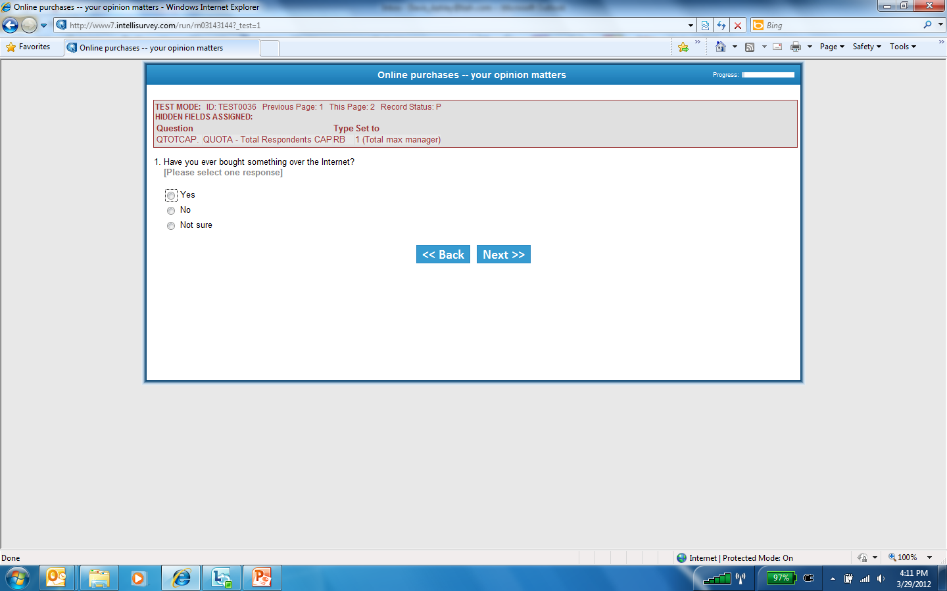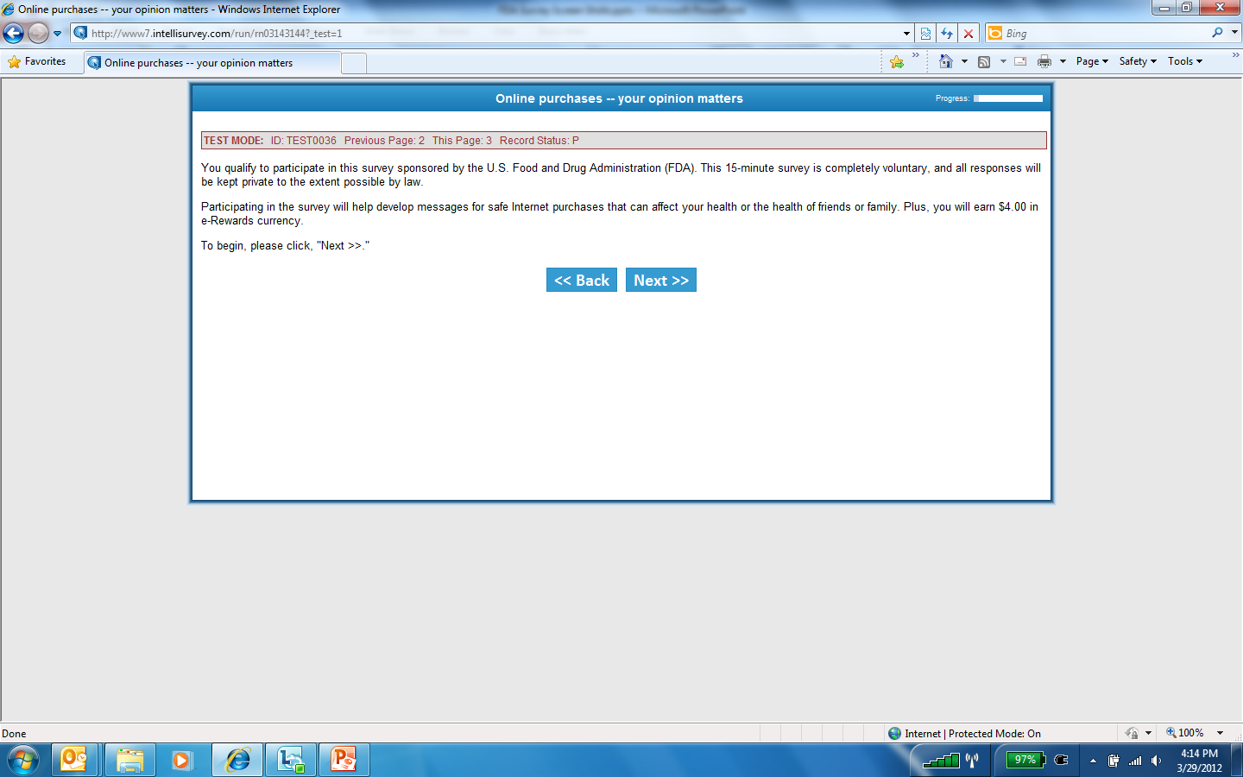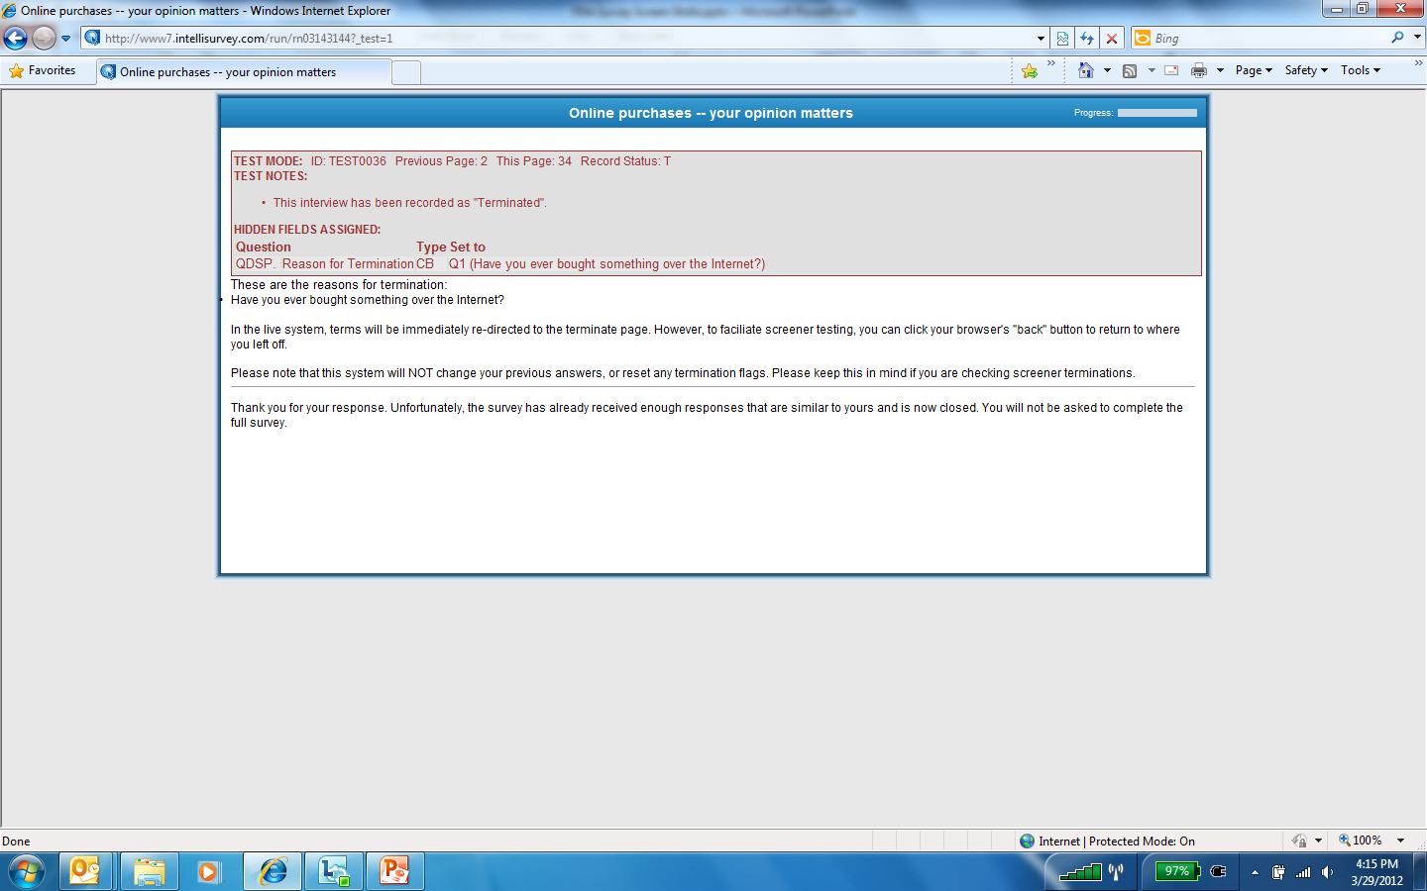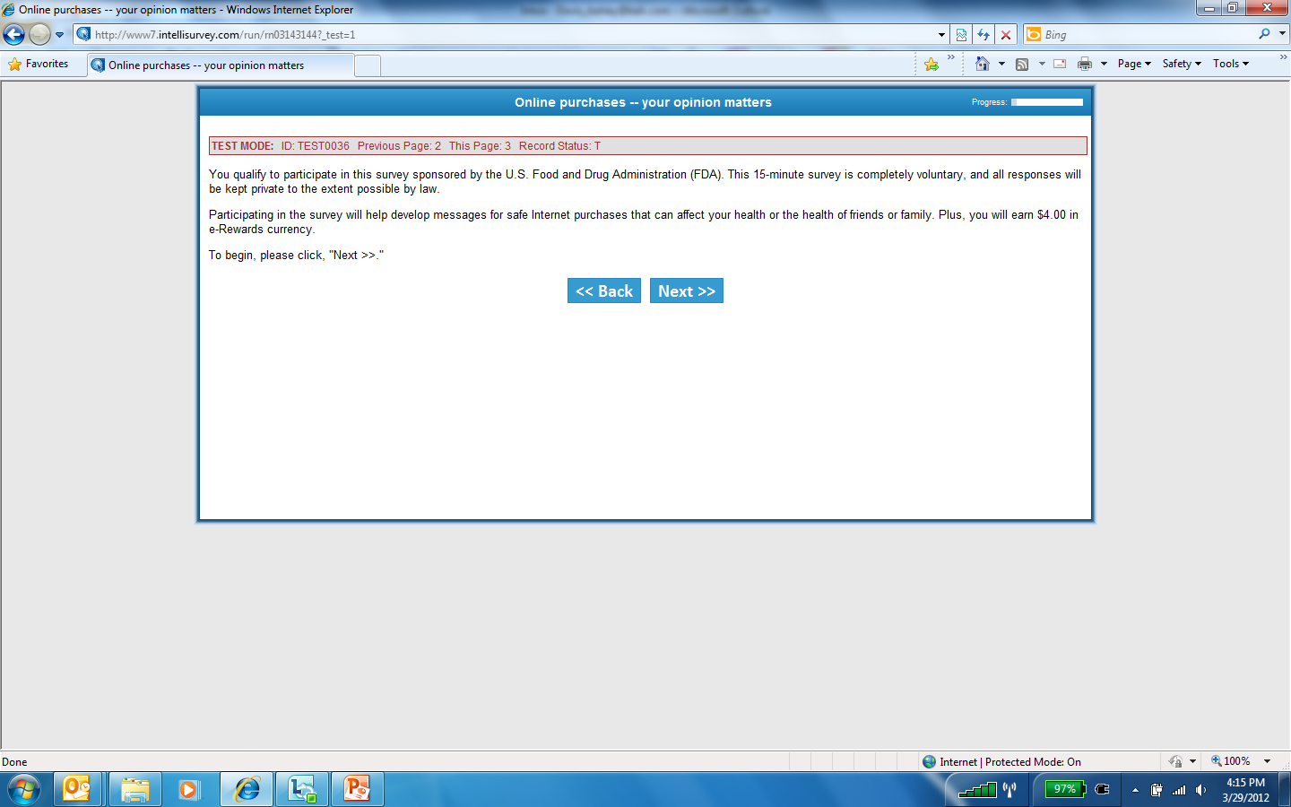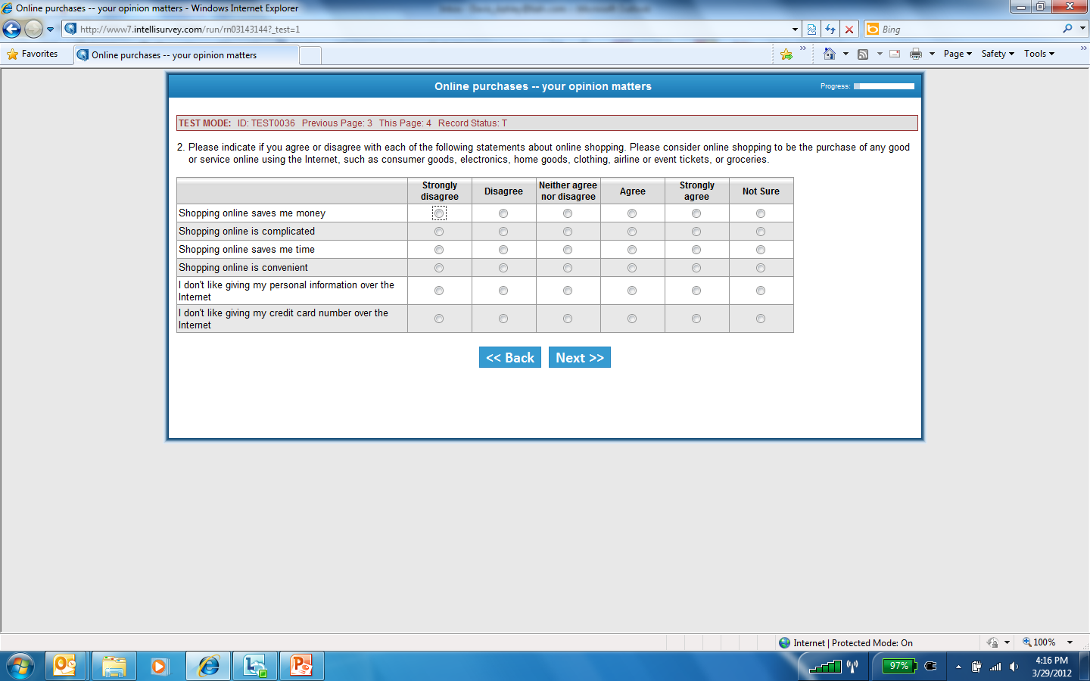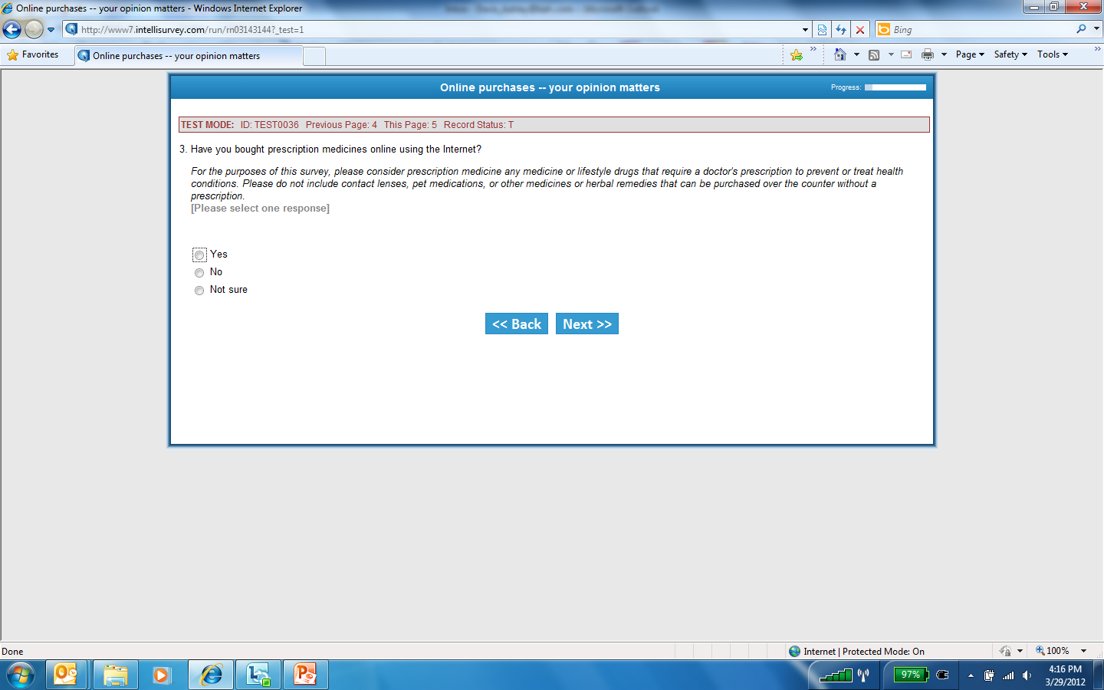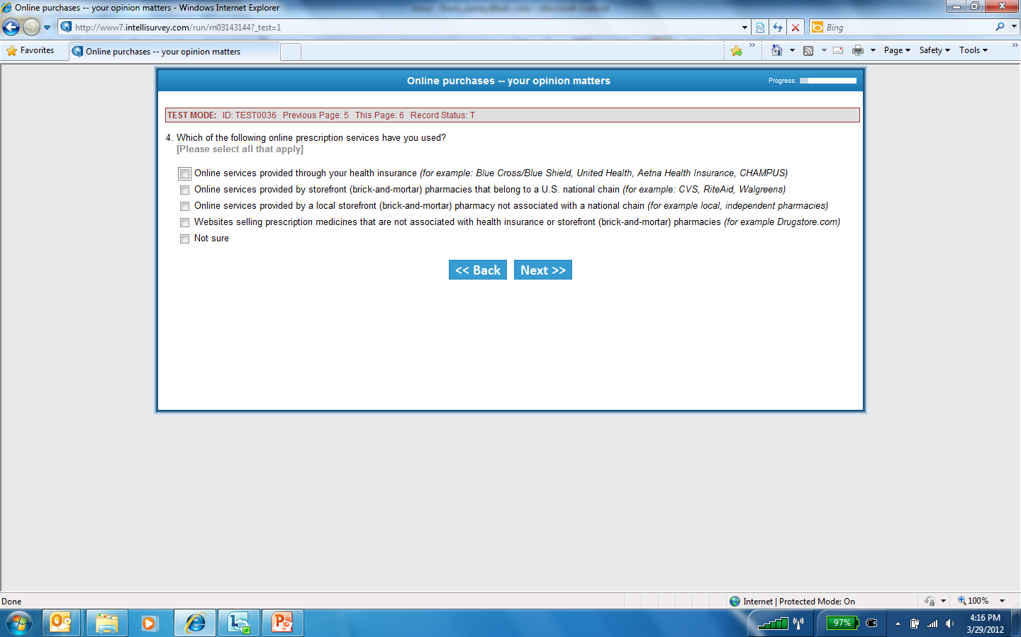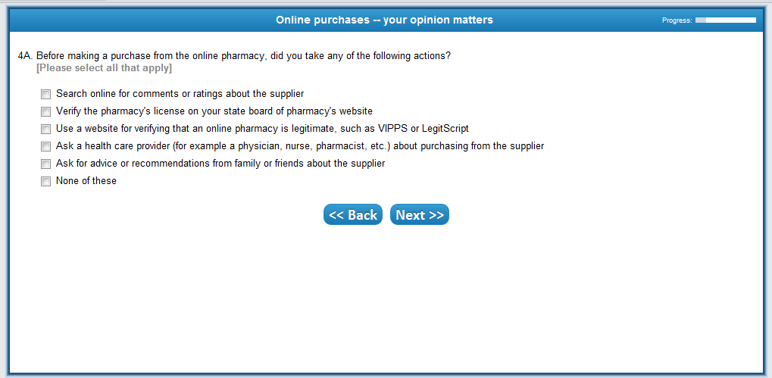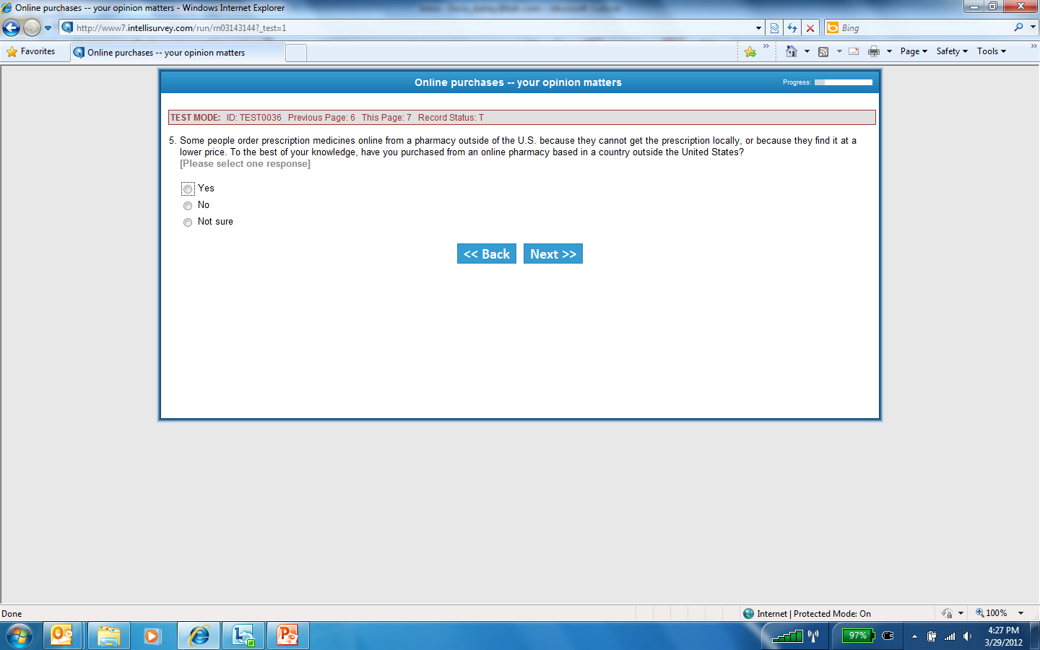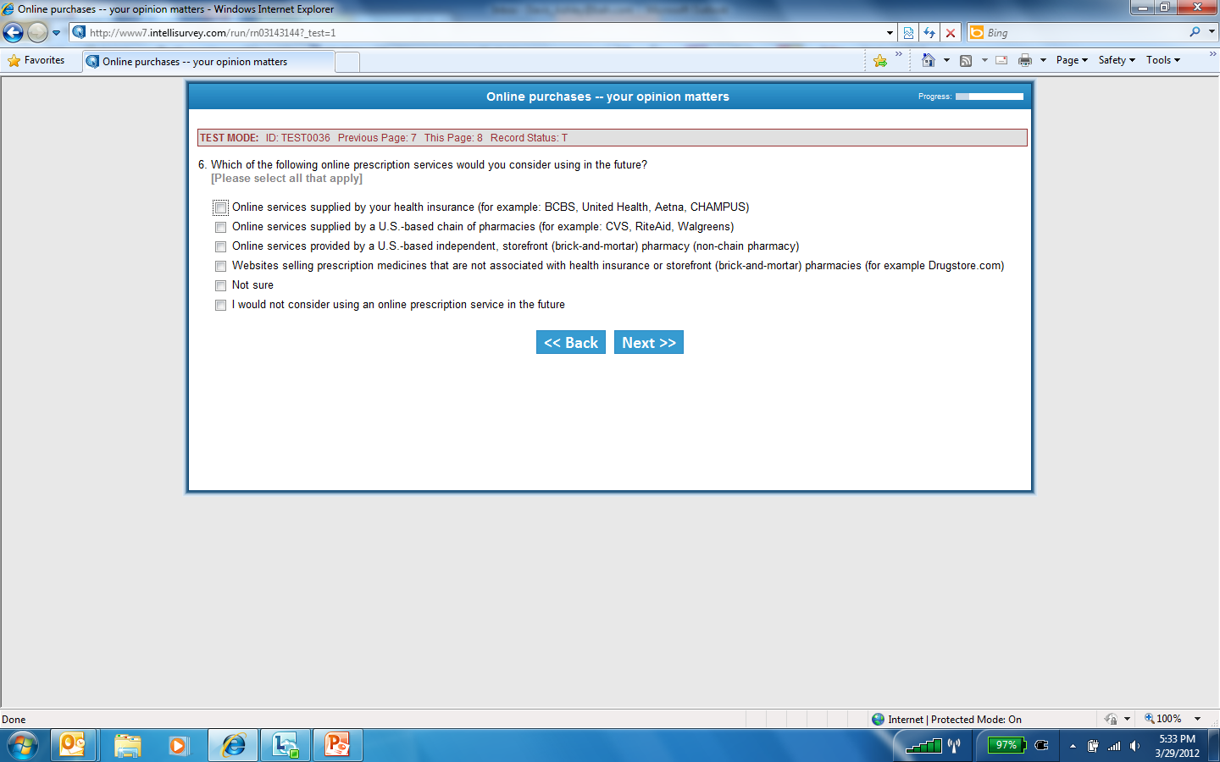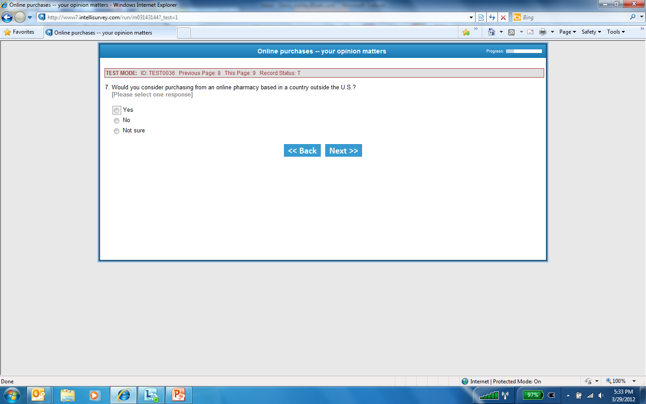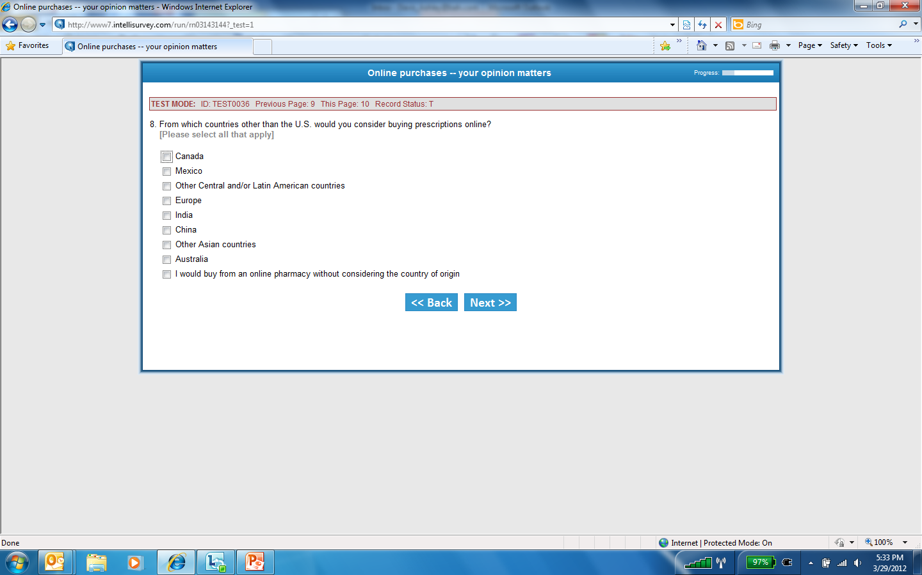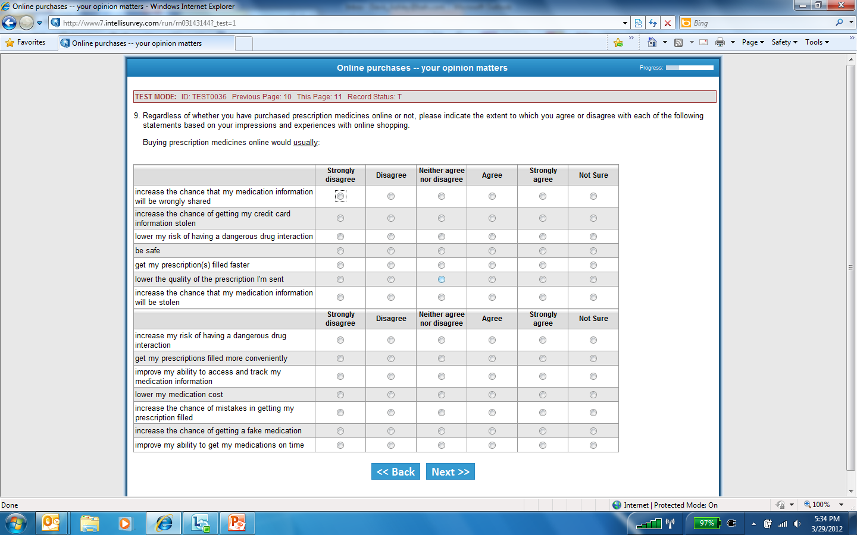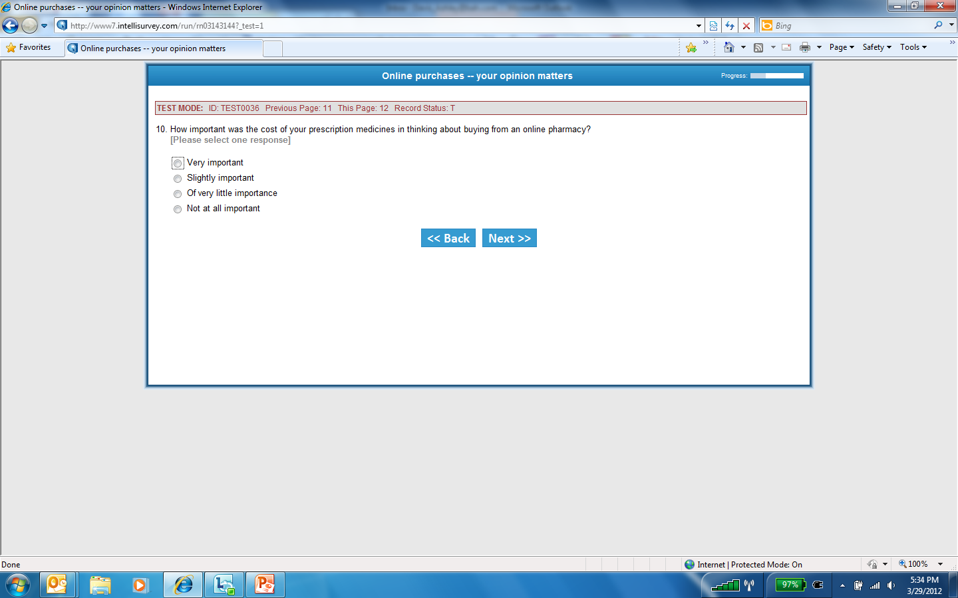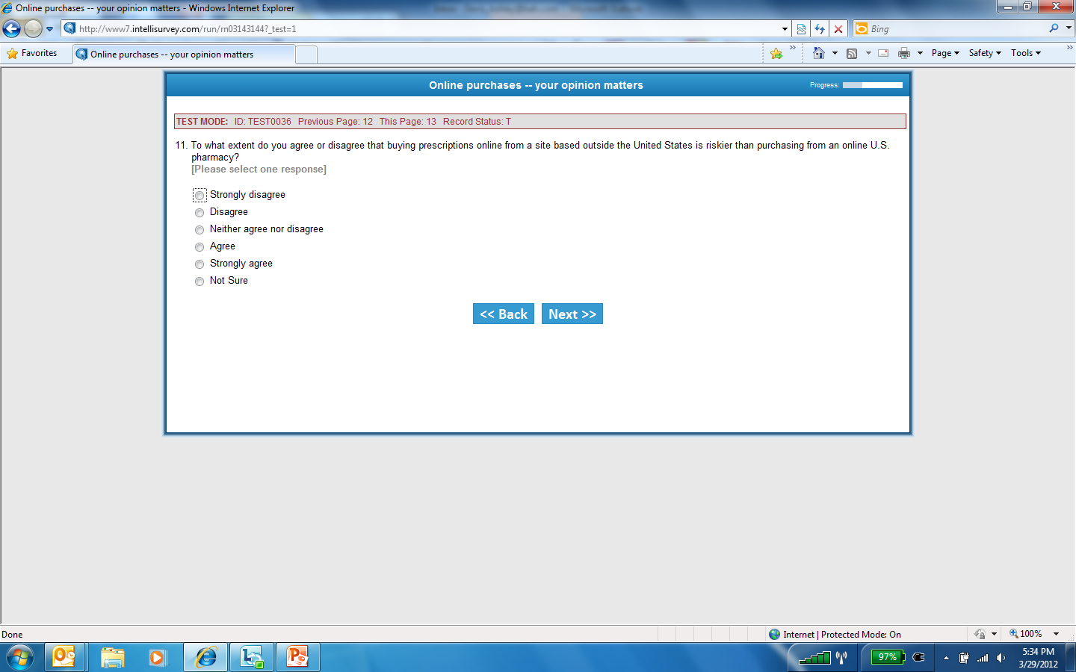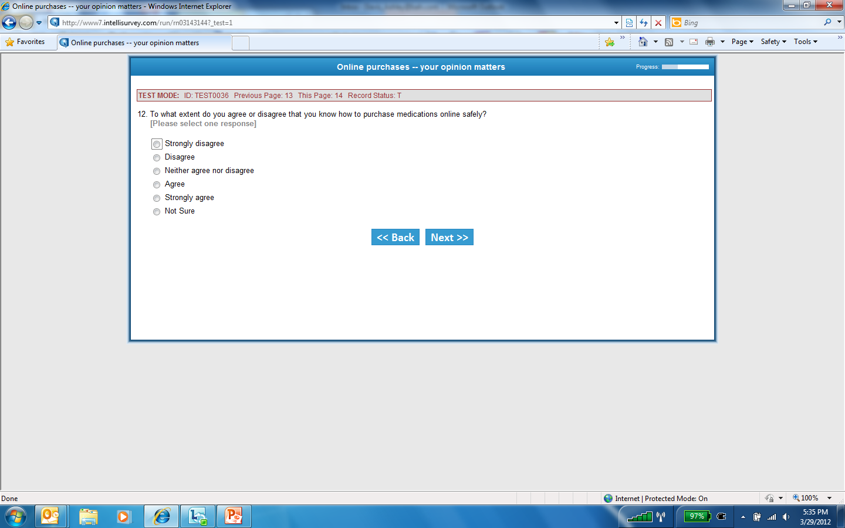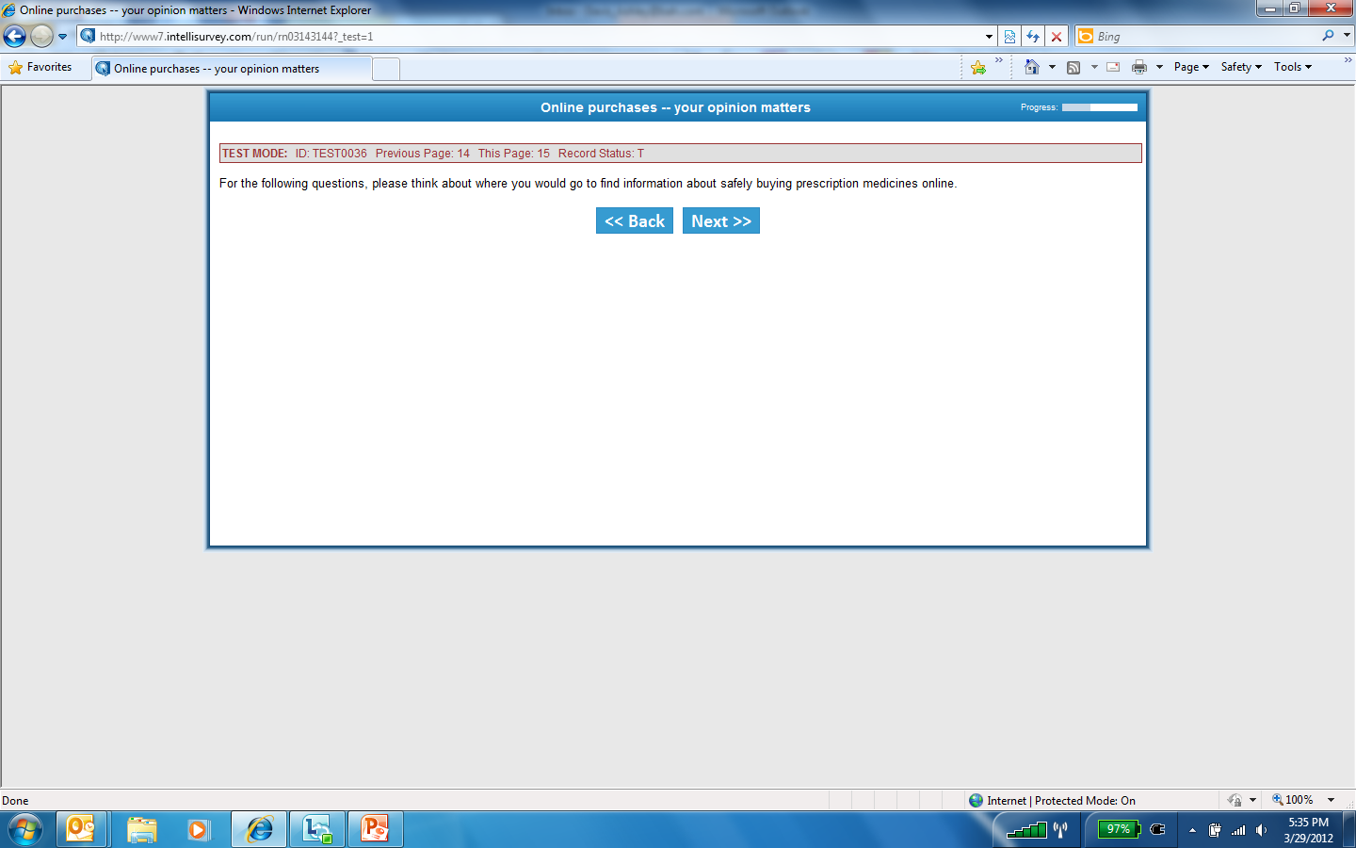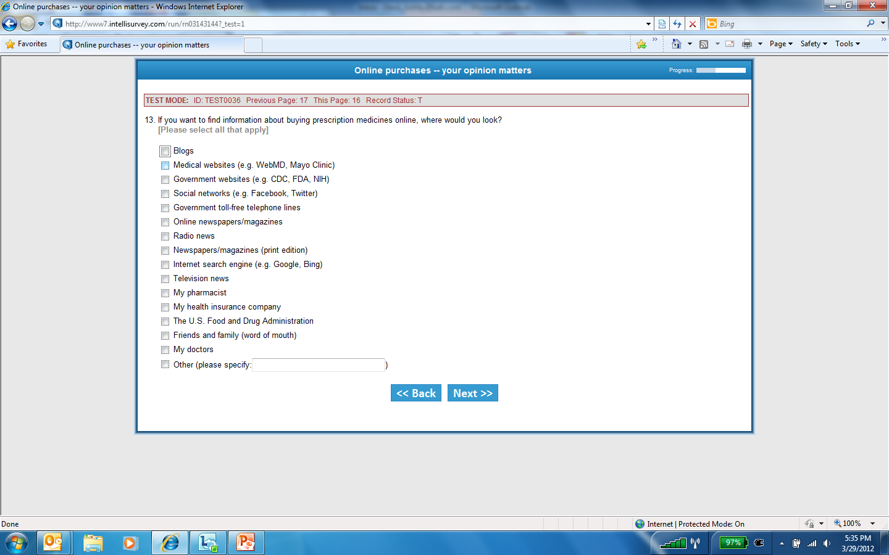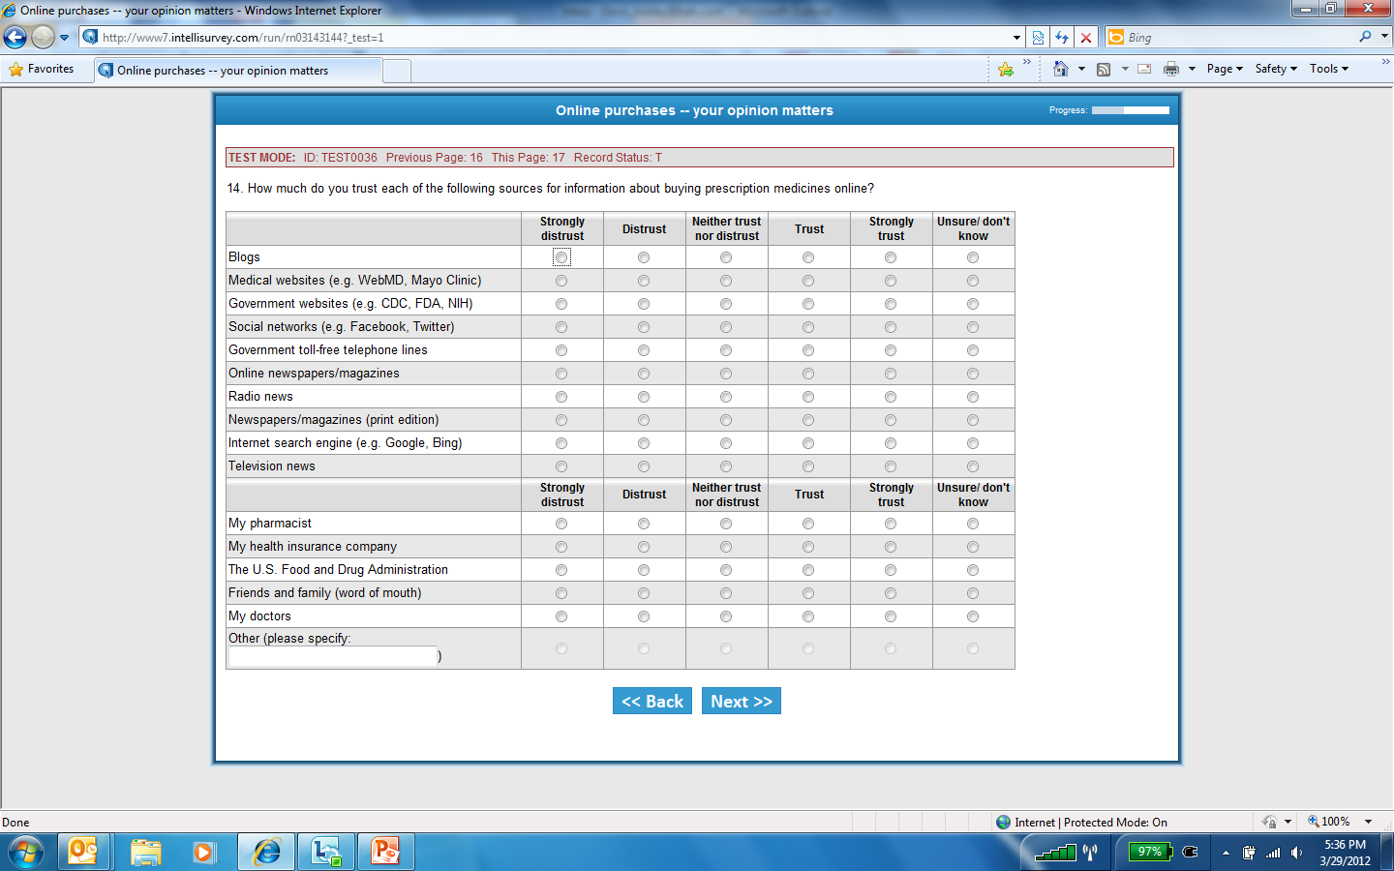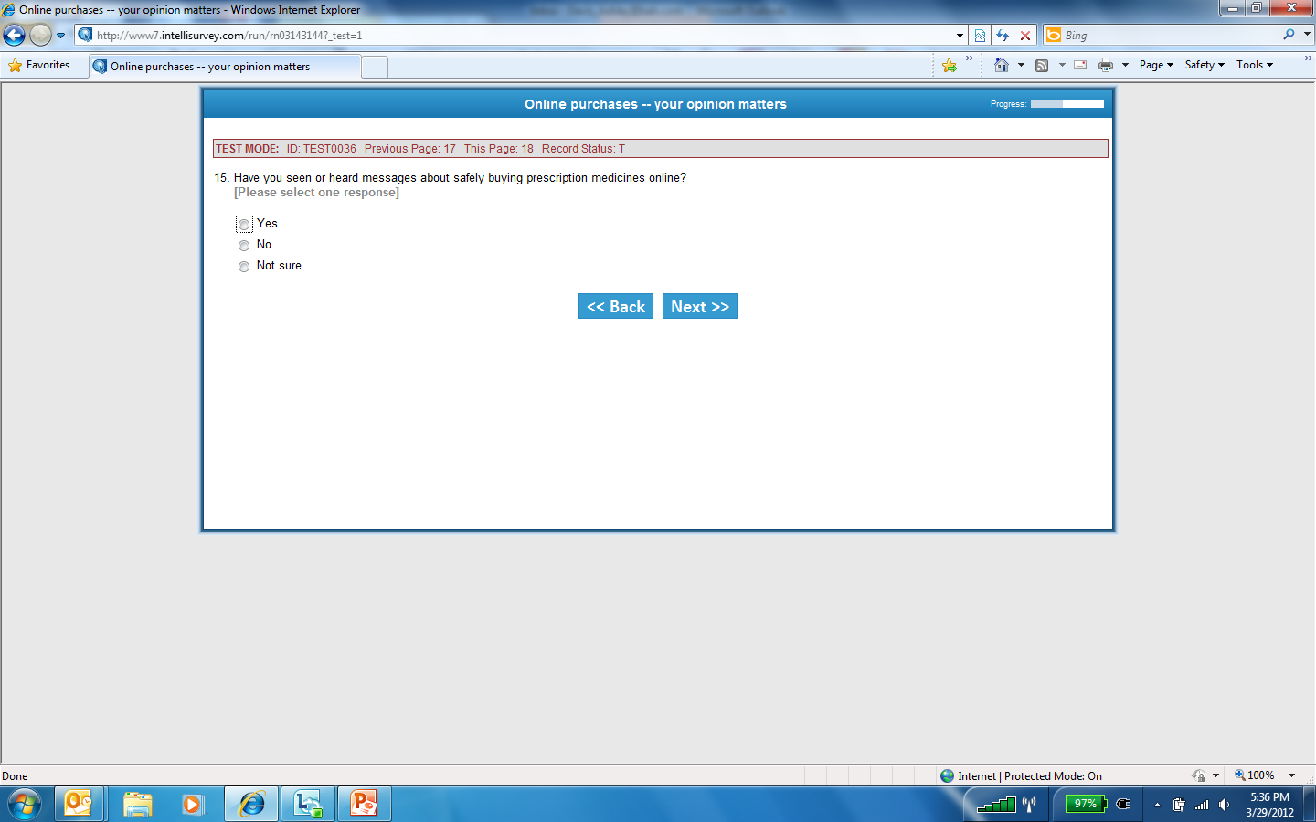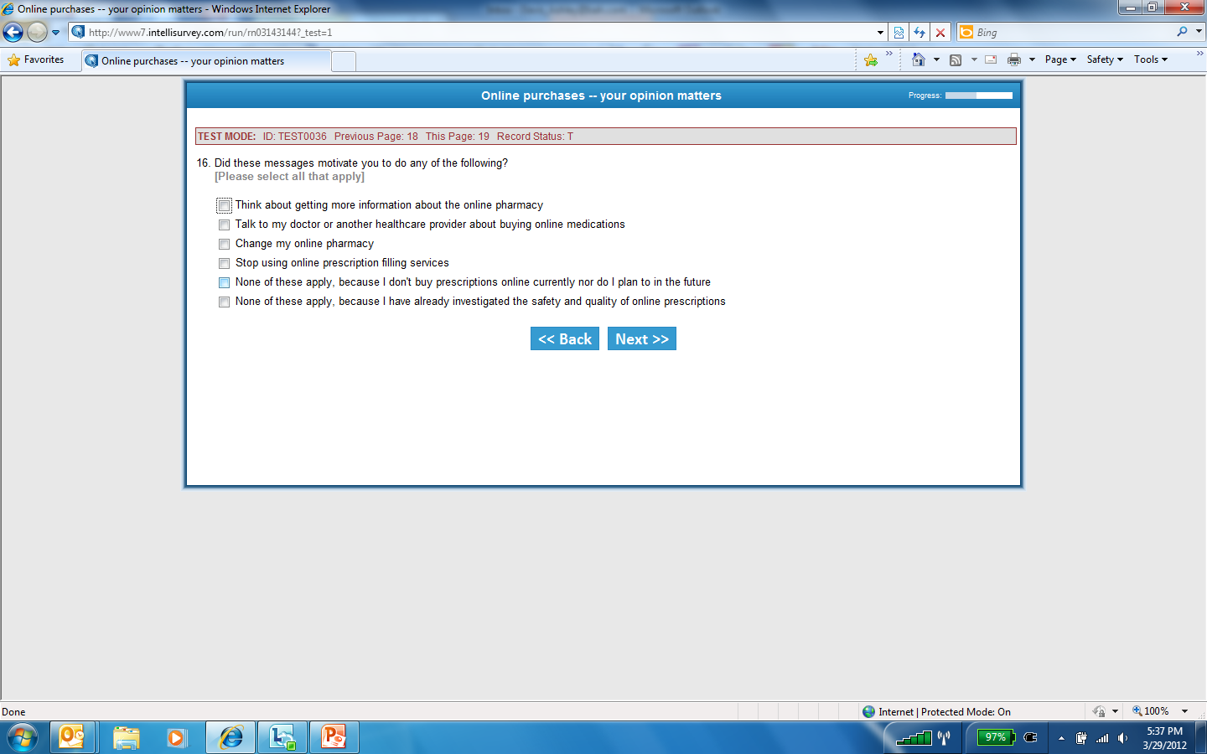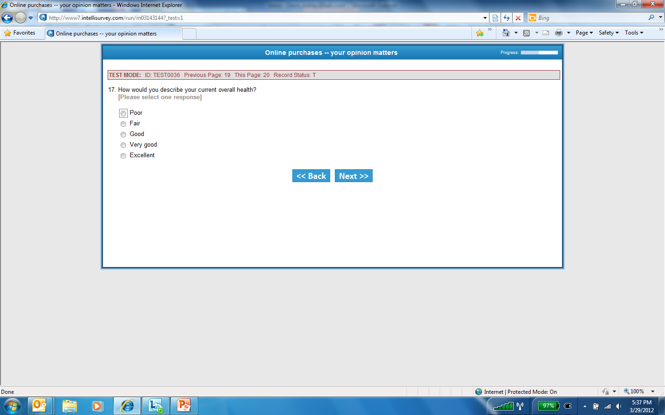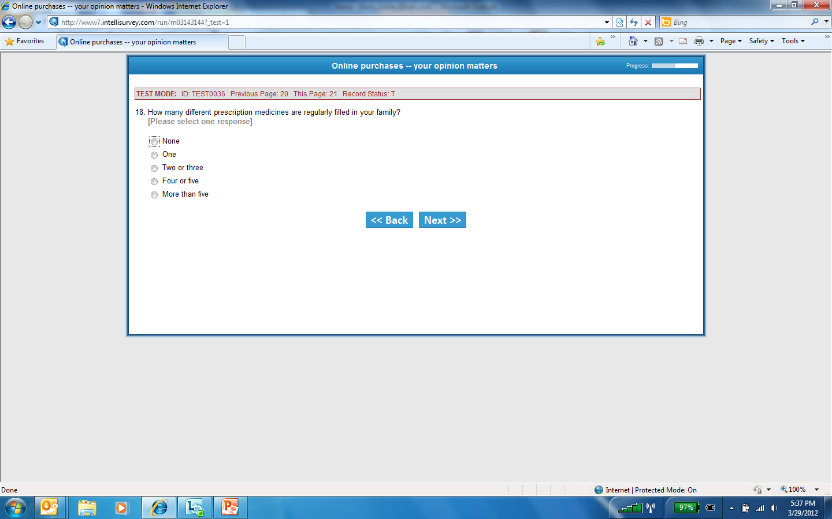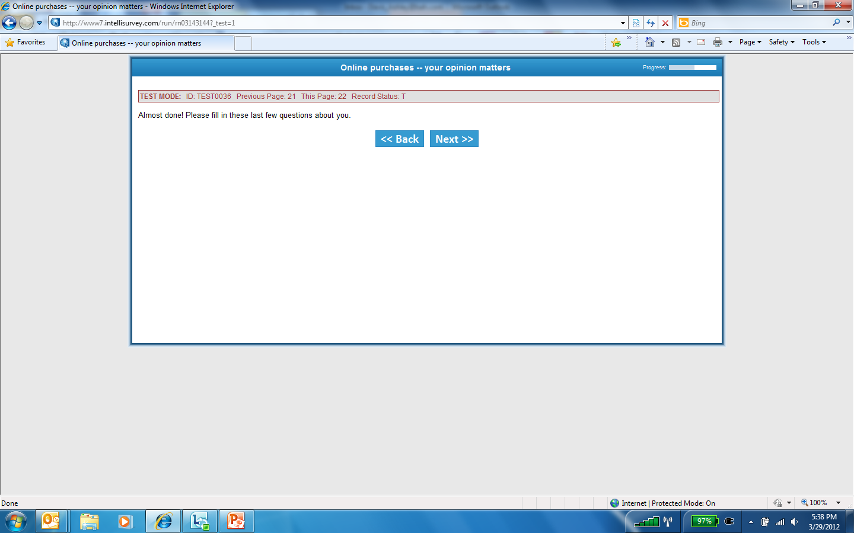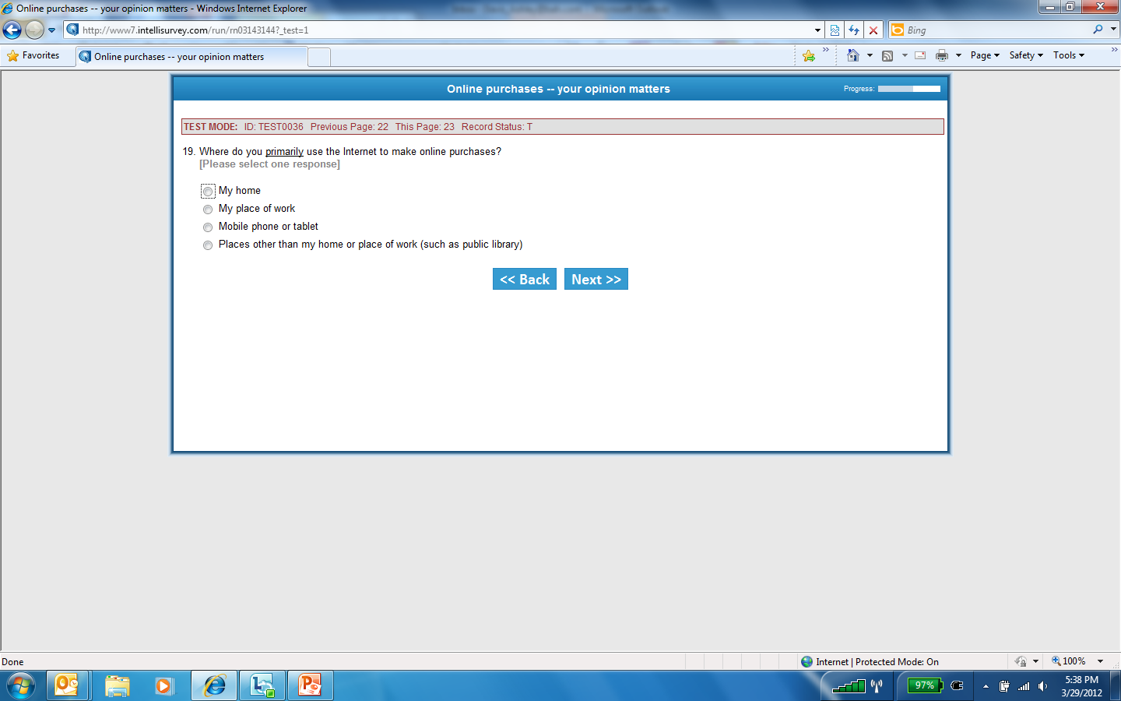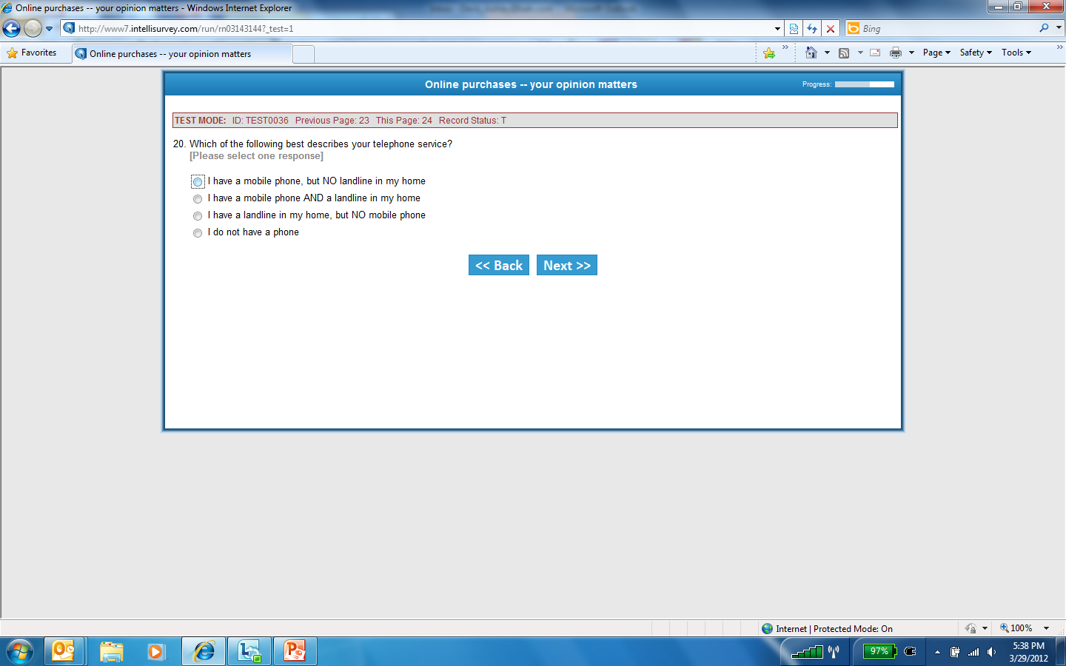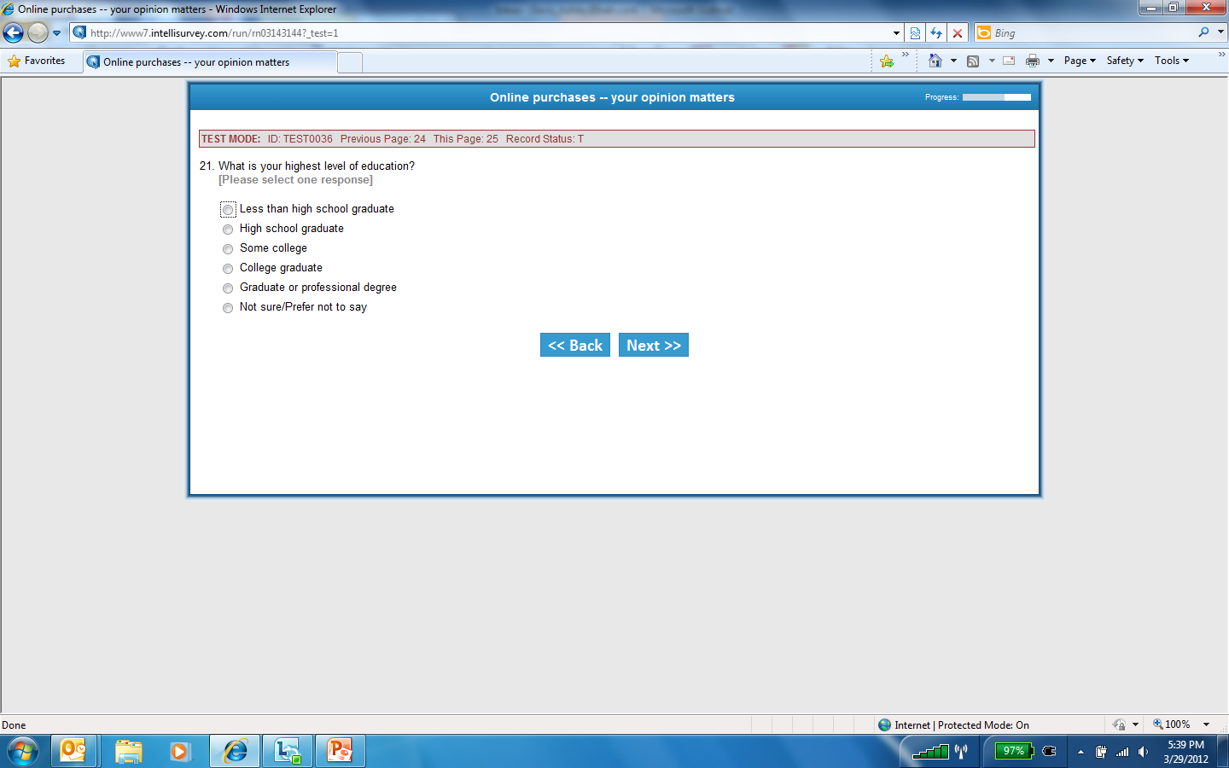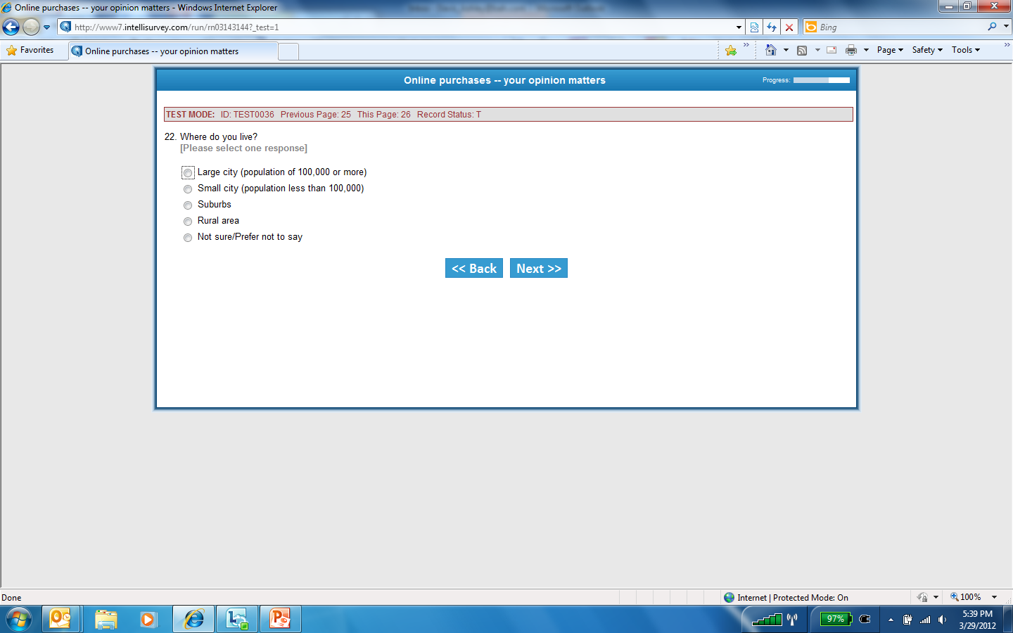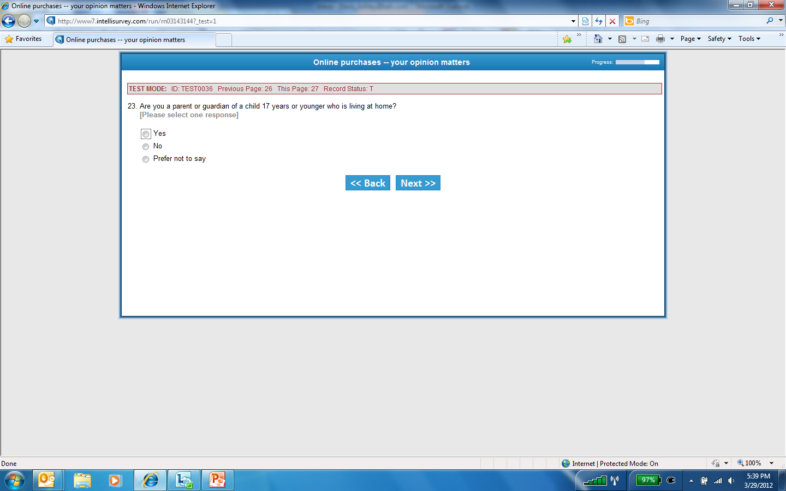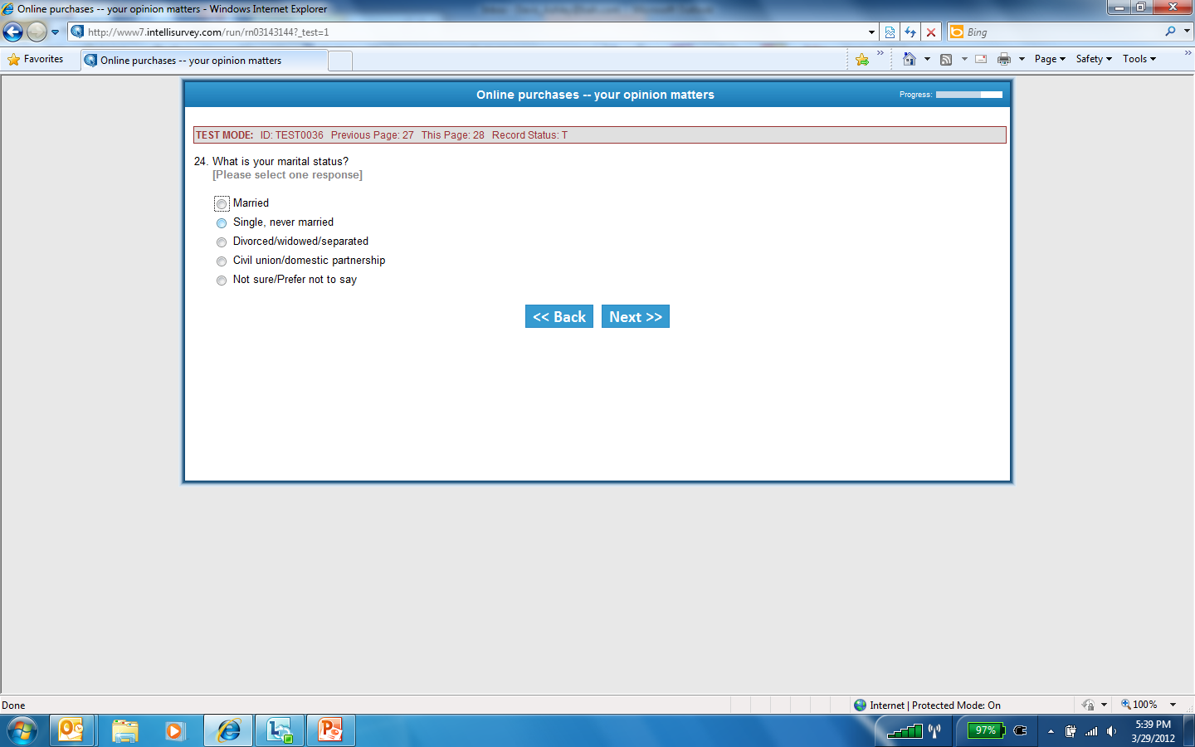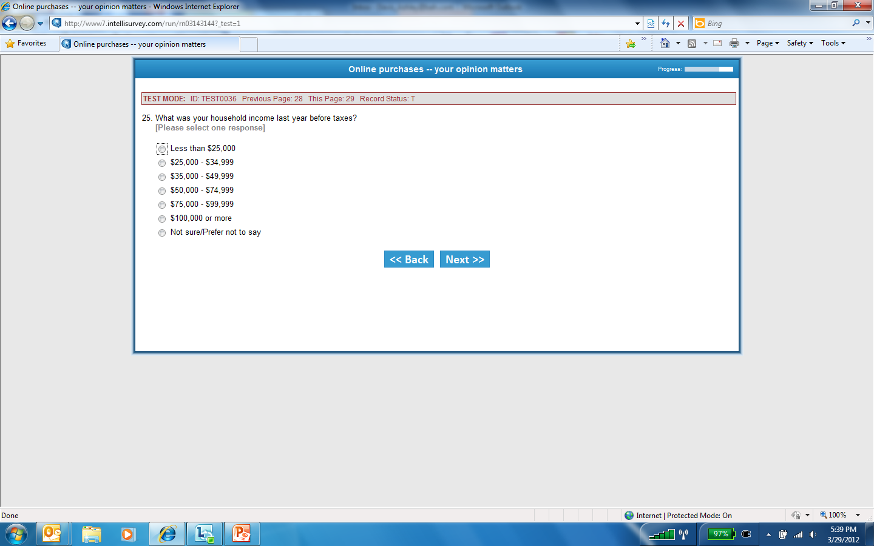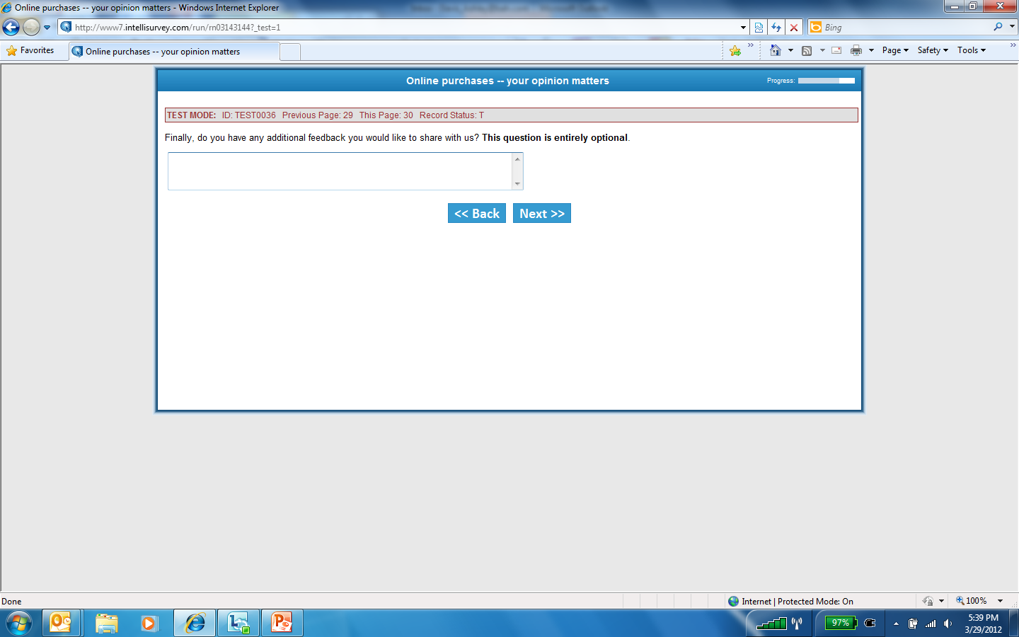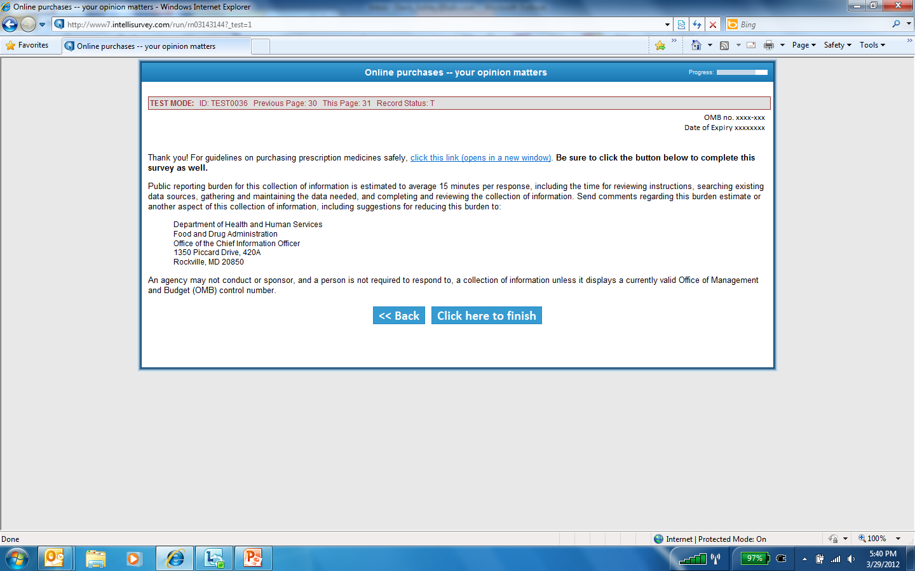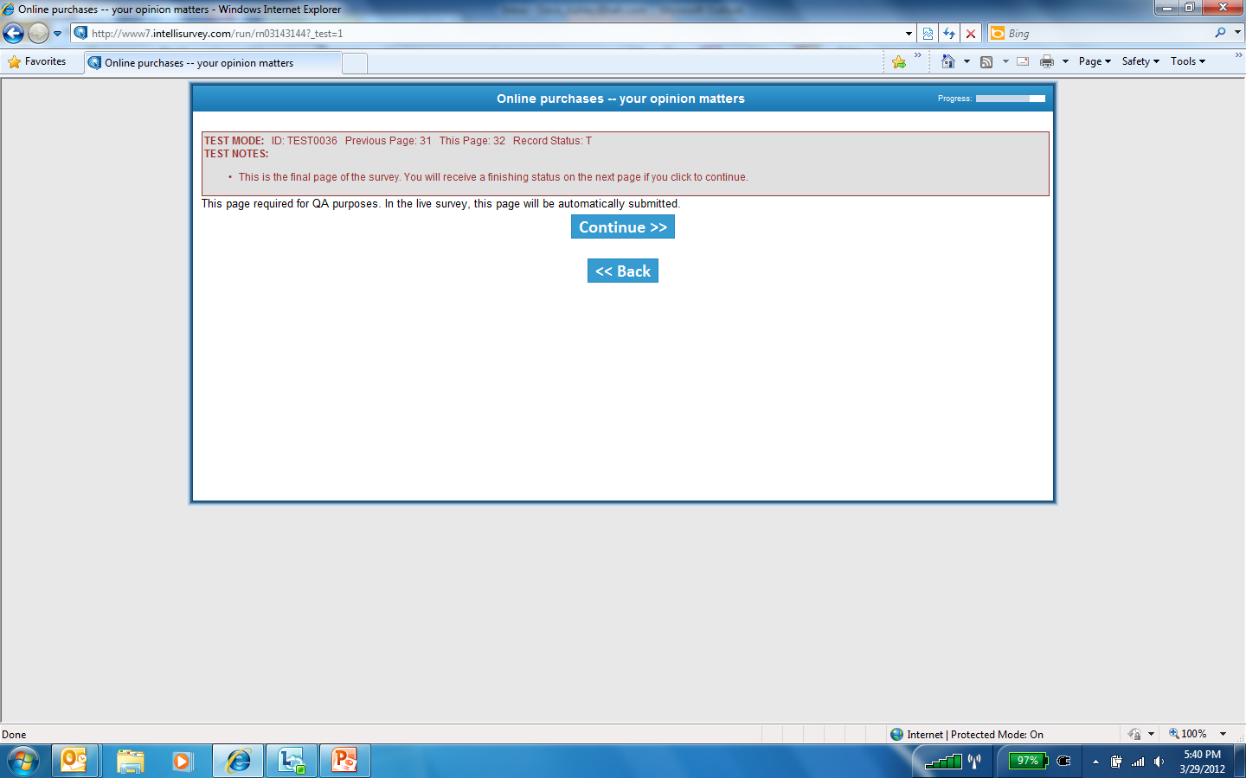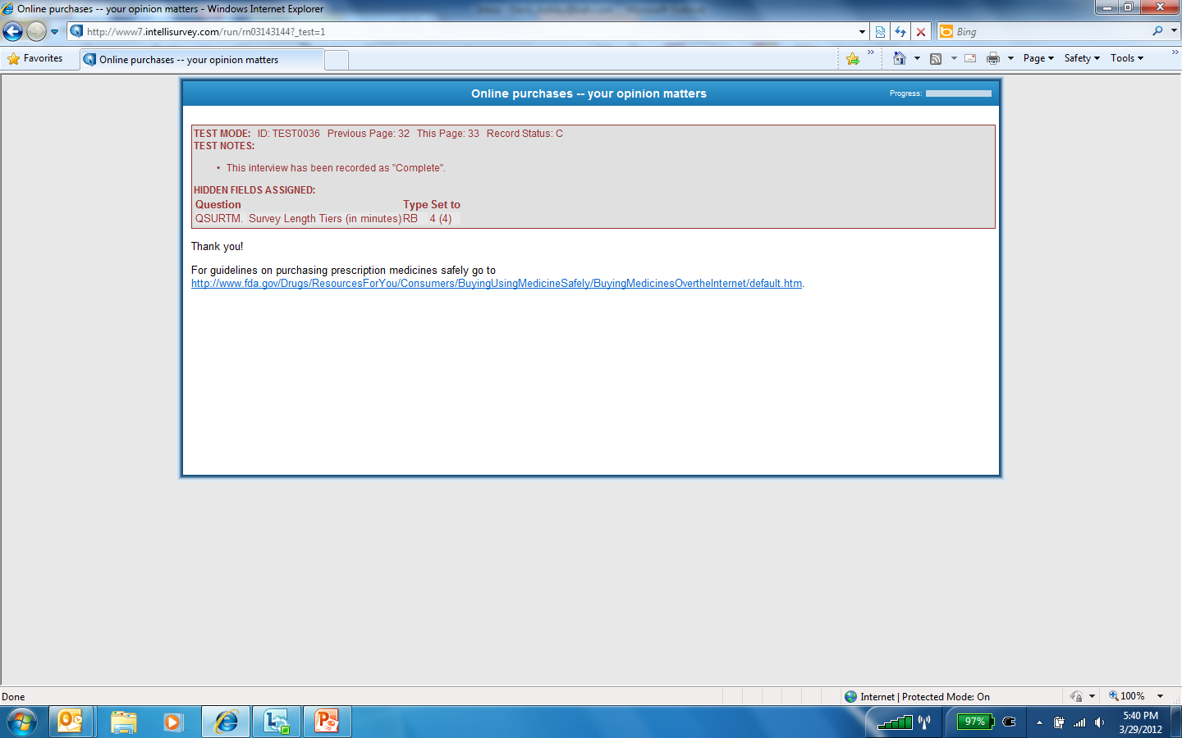

Attachment 6. Memo of Exemption from IRB

