focus group materials
This document contains the Focus Group Materials for the Message and Material Testing project for
Nonpharmaceutical Interventions.

message AND MATERIAL testing for nonpharmaceutical interventions
focus group materials
Nonpharmaceutical Interventions, 2012

Evaluation Team:
Principal Investigator:
Noreen Qualls, Centers for Disease Control and Prevention
Co-Investigators:
Kathryn Maddox, Chenega Government Consulting, LLC
Tiffani Phelps, Chenega Government Consulting, LLC
Jasmine Kenney, Chenega Government Consulting, LLC
Jennifer Callais, Oak Ridge Associated Universities/Oak Ridge Institute for Science and Education
Mary Jean Brewer, Oak Ridge Associated Universities/Oak Ridge Institute for Science and Education
Rebecca Bryant, Bryant Research, LLC

Focus group MATERIALS

The following materials will be tested by focus group participants (in order).

The following testing materials comprise the package that will be sent to participants via postal mail before the online focus group occurs.

CI-icu focus group materials for testing
- Personal NPI Guide for General Public
- NPI and CI-ICU Fact Sheet for General Public
- Personal NPI Sticky Notes for Employees and General Public
- Poster for Employees
- Personal NPI Poster for General Public
- Personal NPI Magnets for Kids
- Fact Sheet for Parents
- Checklist for Child Care/K-12 Administrators
- Fact Sheet for Child Care/K-12 Staff
- Checklist for Business Administrators
- Checklist for Mass Gathering Administrators
- Guide for Mass Gathering Attendees

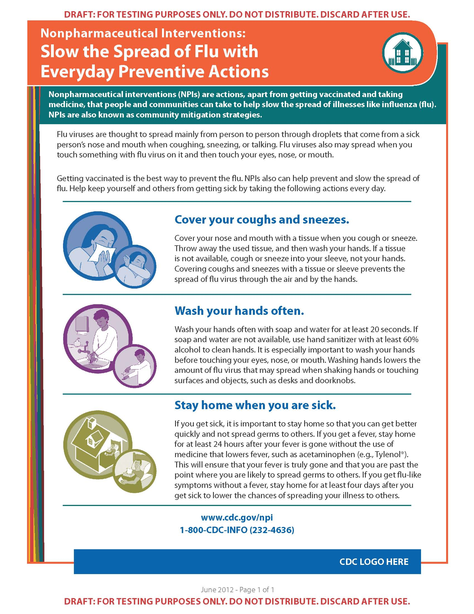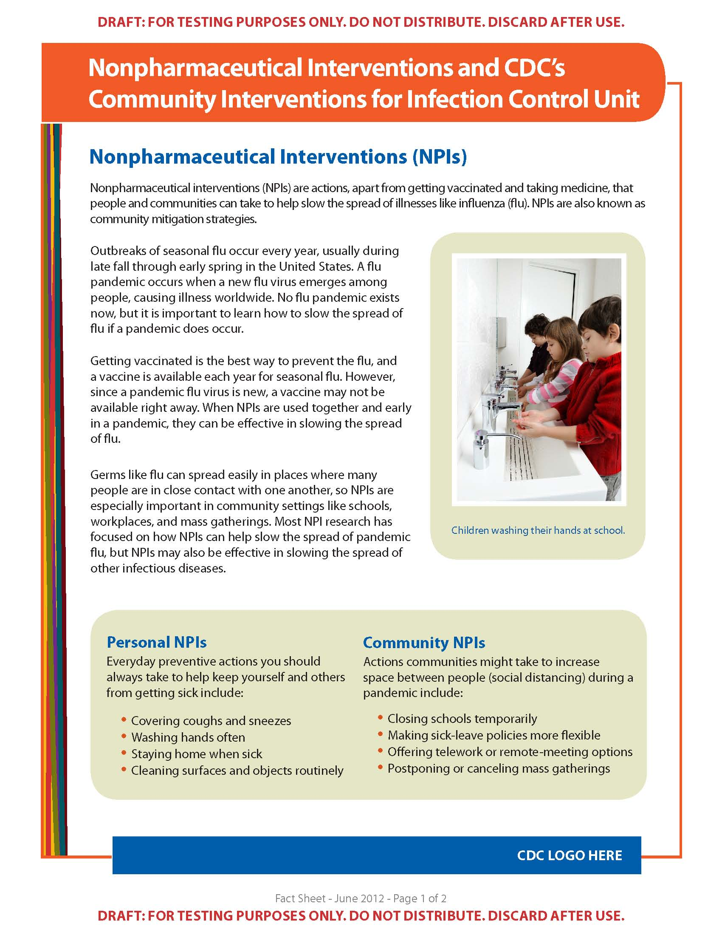
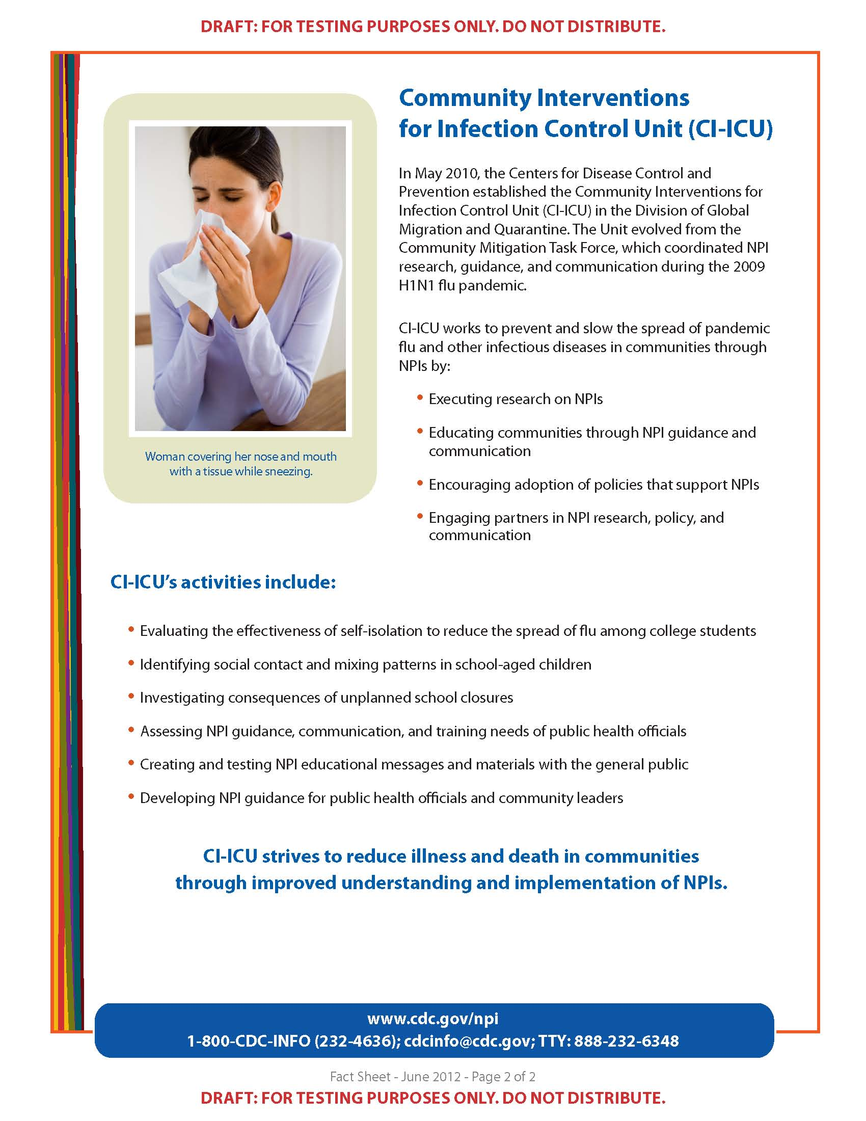
Page 2
