# Attachment 5: Concept/Ad materials

## Material 1: Orange Soda



## Material 2: Nearest Neighborhood Park

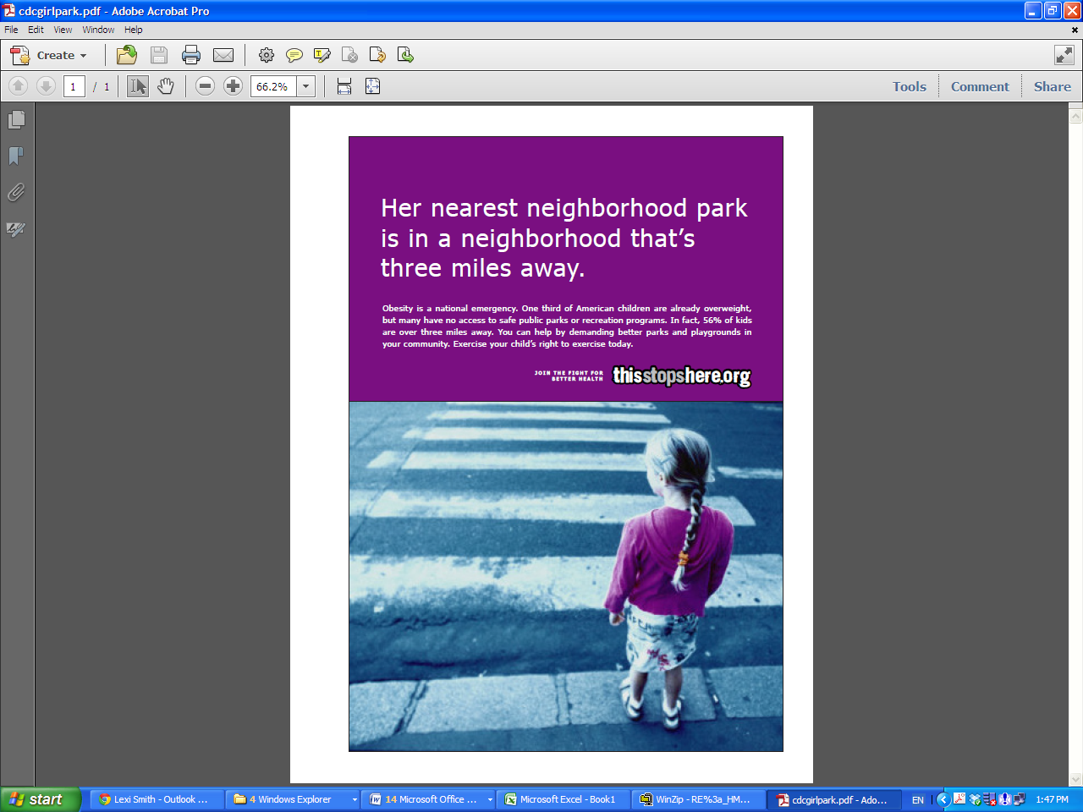

## Material 3: Corner Store*

*Note: This material will be tailored for each targeted community (e.g., the local branding of Chicago will be removed and Jefferson County, Minneapolis or Philadelphia will be substituted.)

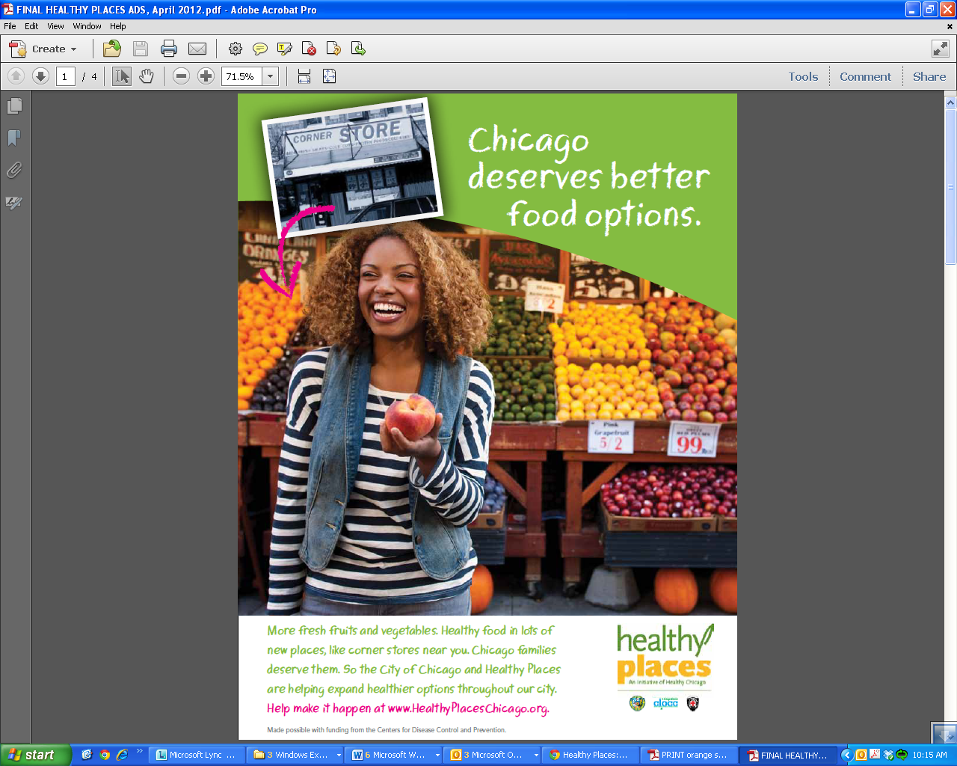

## Material 4: Children deserve more ways to be active*

*Note: This material will be tailored for each targeted community (e.g., the local branding of Chicago will be removed and Jefferson County, Minneapolis or Philadelphia will be substituted.)

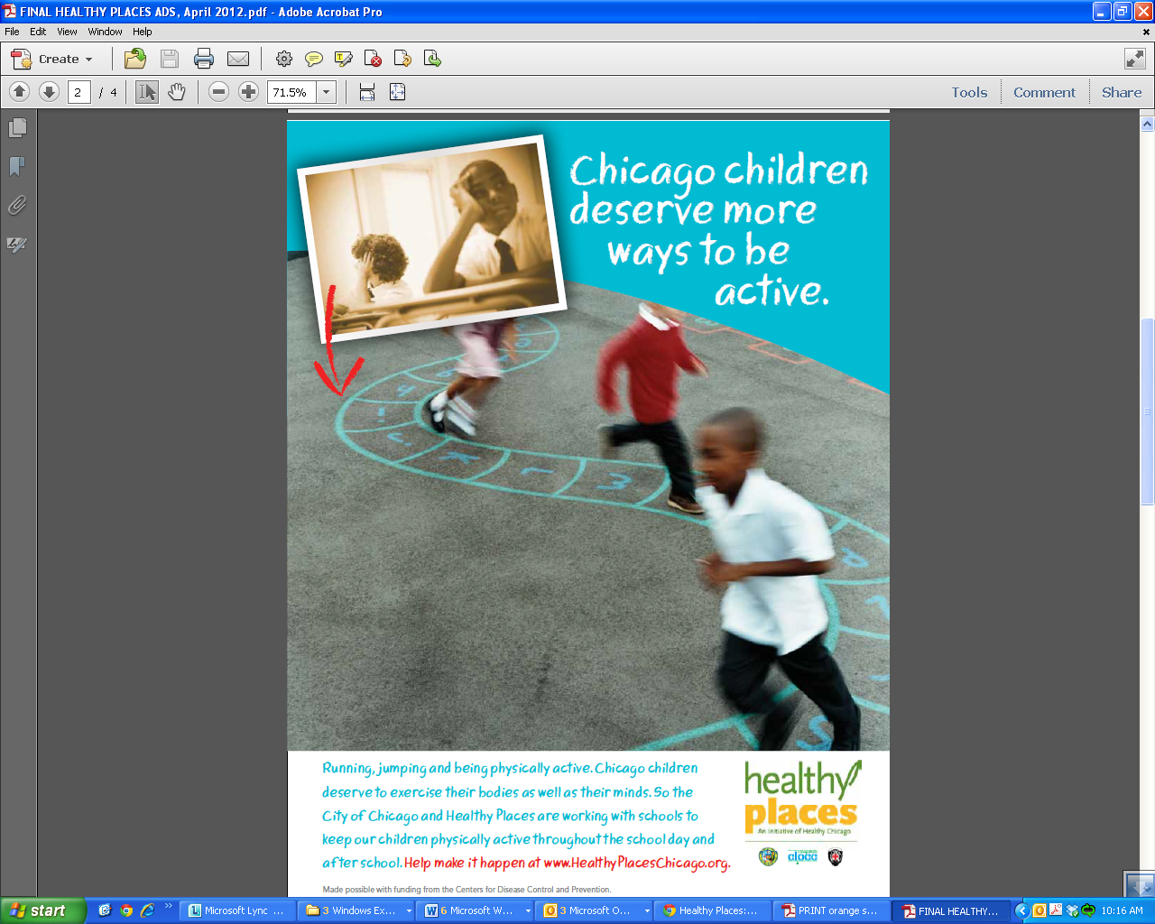

## Material 5: People-friendly streets*

*Note: This material will be tailored for each targeted community (e.g., the local branding of Chicago will be removed and Jefferson County, Minneapolis or Philadelphia will be substituted.)

