Testing Business-Case Videos for the
Centers for Disease Control and Prevention’s (CDC)
Division of Community Health

Attachment 4 to the HMTS Expedited Review Form

Contents
Attachment 4a: Eligibility Screener for Businesspeople 1
Attachment 4b: Screen Captures of Online Display of Eligibility Screener 7

Attachment 4a: Eligibility Screener for Businesspeople
Testing Business-Case Videos for
CDC’s Division of Community Health
Recruitment Overview
Identify businesspeople that fit the following general criteria to complete 60 interviews:
Business sector #1: Multiunit residential housing management
- Identify businesspeople from the multiunit residential housing management sector to complete 10 interviews.
  - May include, for example, the owner or manager of a condo or rental apartment building.
  - Must have some involvement in making decisions about policies governing the property (or properties) they own/manage.
  - Attempt to recruit a mix by region.
Business sector #2: Grocery stores or supermarkets
- Identify businesspeople (of mixed race/ethnicity) working in the grocery store/supermarket sector to complete 10 interviews.
  - May include, for example, the owner or manager of a grocery store or supermarket.
  - Must have some involvement in making decisions about the store’s inventory.
  - Attempt to recruit a mix by region.
- Identify African American businesspeople working in the grocery store/supermarket sector to complete 10 interviews.
  - May include, for example: the owner or manager of a grocery store or supermarket.
  - Must have some involvement in making decisions about the store’s inventory.
  - Attempt to recruit a mix by region.
Business sector #3: Convenience stores or corner stores
- Identify businesspeople (of mixed race/ethnicity) working in the convenience store or corner store sector to complete 10 interviews.
  - May include, for example, the owner or manager of a convenience store or corner store.
  - Must have some involvement in making decisions about the store’s inventory.
  - Attempt to recruit a mix by region.
- Identify businesspeople working in the convenience store or corner store sector to complete 20 interviews.
  - May include, for example, the owner or manager of a convenience store or corner store.
  - Must have some involvement in making decisions about the store’s inventory.
  - Attempt to recruit a mix by region.
  - At least 10 of the Hispanic business people must be fluent in Spanish.
  - [Note to recruiters: All interviews will be conducted in English. Therefore, all must be able to do the interview in English. However, 10 of the Hispanic business people will be asked to react to materials in Spanish and therefore must also have fluency in Spanish].

Public Reporting Burden Statement
Public reporting burden of this collection of information is estimated to average 5 minutes per response, including the time for reviewing instructions, searching existing data sources, gathering and maintaining the data needed, and completing and reviewing the collection of information. An agency may not conduct or sponsor, and a person is not required to respond to a collection of information unless it displays a currently valid OMB control number. Send comments regarding this burden estimate or any other aspect of this collection of information, including suggestions for reducing this burden to CDC/ATSDR Information Collection Review Office, 1600 Clifton Road NE, MS D-74, Atlanta, Georgia 30333; ATTN: PRA (0920-0572).

I. GREETING
We are recruiting people to participate in a telephone interview about issues related to the wellbeing of communities in the United States. In particular we are looking for people that work in certain business sectors. We are NOT seeking contributions and we are NOT selling anything. Your participation is voluntary.

Your answers to the following questions will help determine if you qualify to participate. These questions will take no more than 3 minutes to complete. If you qualify and are interested in participating, we will ask you to provide your contact information so you can be contacted about participating in the telephone interview. The interview would take about 30 minutes.
If you qualify and participate in the interview, you will receive $50 after completing the interview.

Would you like to continue?
( ) Yes Continue
( ) No Thank and terminate

II. SCREENING QUESTIONS

- Will you have access to a phone and a computer with Internet connection to participate in the interview?

( ) Yes Continue
( ) No Thank and terminate

You will need to have access to a computer with Internet connection because during the interview you will be shown some material and asked about your reactions to it.

- Do you currently work in or own any of the following types of businesses?

( ) Grocery store or supermarket Continue
( ) Convenience store or corner store [live link to definition] Continue
( ) Multiunit residential housing (e.g., condos or rental apartments) Continue
( ) Other Thank and terminate

[Definition: A convenience store or corner store is a small store that stocks a range of everyday items (e.g., groceries, toiletries, drinks). It can be a stand-alone store or, in other cases, may be part of a gas station]

- Please indicate your race and ethnic background. Are you?

3a. Ethnicity:

( ) Hispanic or Latino Continue to 3b
( ) Not Hispanic or Latino Continue to 3b

3b. Race [SELECT ONE OR MORE]:

( ) White Continue
( ) Black or African American Continue
( ) American Indian or Alaska Native Continue
( ) Native Hawaiian or Other Pacific Islander Continue
( ) Asian Continue

- What is your gender?

( ) Female Continue
( ) Male Continue

[Ask Q5 only of those who indicated Hispanic/Latino ethnicity]

- Are you fluent in Spanish?

( ) Yes Continue
( ) No Continue

[Questions #6 to #11 are only for those in food-related sector (e.g., grocery store)]

- Does your store(s) sell food items?

( ) Yes Continue
( ) No Thank and terminate

- What is your current position or title at the store(s)?

( ) Owner Continue
( ) Manager Continue
( ) Other [specify]: ______________________________________ Continue

- In your role as [______], are you involved in making decisions about what items are available for sale at your store(s)?

( ) Yes Continue
( ) No Thank and terminate

- Thinking about the neighborhood(s) where your store (or most of your stores) is/are located, would you say it/they are in:

( ) Low income areas Continue
( ) Middle income areas Continue
( ) Upper middle/High income areas Continue

- Thinking again about the neighborhood(s) where your store (or most of your stores) is/are located, would you generally classify it/them as: (Select all that apply)

( ) Mixed race or ethnicity Continue
( ) Majority Hispanic or Latino Continue
( ) Majority Black or African American Continue
( ) Majority White Continue
( ) Majority American Indian or Alaska Native Continue
( ) Majority Native Hawaiian or Other Pacific Islander Continue
( ) Majority Asian Continue
( ) Other (Specify) __________________________) Continue

- In what zip code is the store/largest store located? [Attempt to recruit a mix by region]

__________________ Continue to invite

[Questions #12-#17 are only for those working in multiunit residential housing sector]

- Do you currently smoke cigarettes, cigars, or other tobacco products?

( ) Yes Continue
( ) No Continue

- What is your current position or title?

( ) Property owner Continue
( ) Property manager Continue
( ) Other [specify]: ______________________________________ Continue

- In your role as [______] of the property (or properties), are you involved in making decisions about the property’s policies? By policies we mean, for example, the kinds of things that residents can and cannot do both in the property’s common areas and within their individual units.

( ) Yes Continue
( ) No Thank and terminate

- Thinking about the neighborhood(s) where your property (or most of your properties) is/are located, would you say it/they are in:

( ) Low income areas Continue
( ) Middle income areas Continue
( ) Upper middle/High income areas Continue

- Thinking again about the neighborhood(s) where your property (or most of your properties) is/are located, would you generally classify it/them as: (Select all that apply)

( ) Mixed race or ethnicity Continue
( ) Majority Hispanic or Latino Continue
( ) Majority Black or African American Continue
( ) Majority White Continue
( ) Majority American Indian or Alaska Native Continue
( ) Majority Native Hawaiian or Other Pacific Islander Continue
( ) Majority Asian Continue
( ) Other (Specify) __________________________) Continue

- In what zip code is the property/largest property located? [Attempt to recruit a mix by region]

__________________ Continue to invite

Termination language:

If the participant is not eligible:

Thank you very much for your time. We do not have any further questions for you today. We will not able to schedule your participation at this time.

Invite to interview:

If participant qualifies:

Thank you very much for answering the questions. You qualify to participate in the interview. Please provide the following contact information. It will be sent to FHI 360. FHI 360 (www.FHI360.org) is a non-profit organization that works with federal, state and local health and economic development programs. Someone from that organization will contact you soon about participating in the interview.

First Name: _________________ Last name (initial only): ______

Telephone: ____________________

E-mail address: ___________________________

Thank you again for your interest and your time today.

Attachment 4b: Screen Captures of Online Display of Eligibility Screener
Testing Business-Case Videos for
CDC’s Division of Community Health

- Pages 8-15: Screening questions for all respondents
- Page 16-23: Additional screening questions only for those reporting they own or work in grocery stores/supermarkets or convenience/corner stores
- Pages 24-29: Additional screening questions only for those reporting they own or work in multiunit residential housing

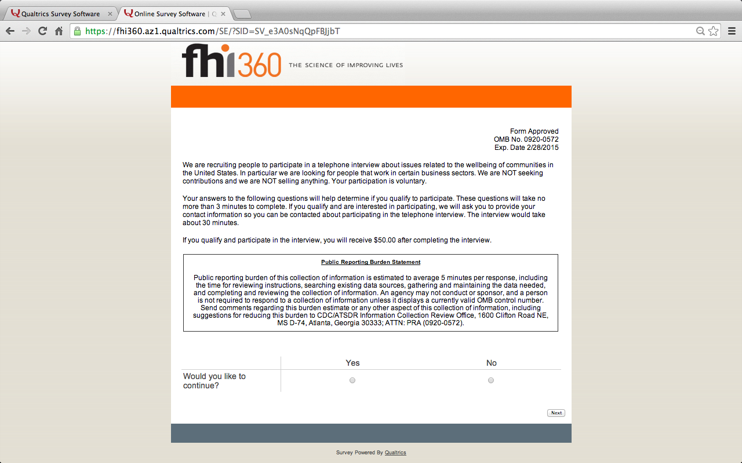

{Note to reviewers: Respondents who do not wish to continue, and select “no,” will be shown the termination screen.}

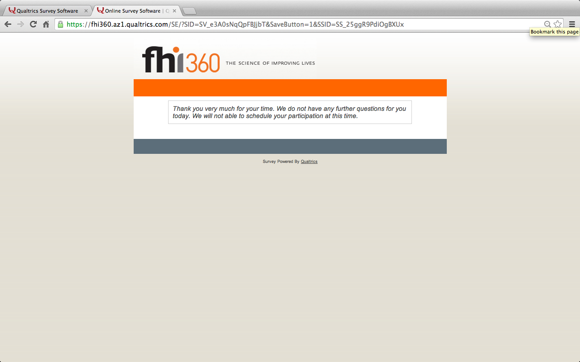

{Note to reviewers: Respondents who wish to continue, and select “yes,” will be shown the following screen.}

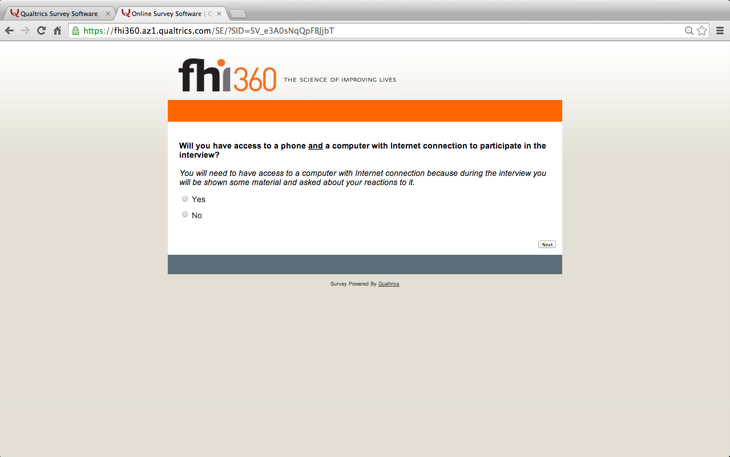

{Note to reviewers: Respondents who respond “no” to the question “Will you have access to a phone and a computer with Internet connection…?” will be shown this termination screen.}

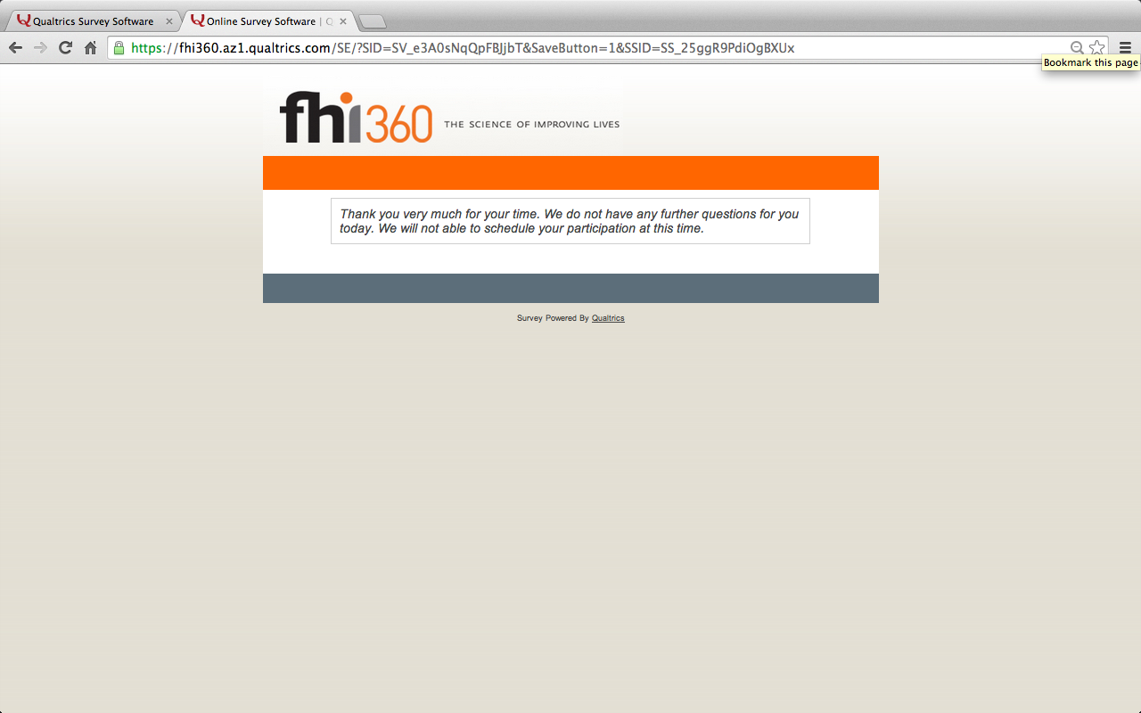

{Note to reviewers: Respondents who respond “yes” to the question “Will you have access to a phone and a computer with Internet connection…?” will be shown the following screen.}

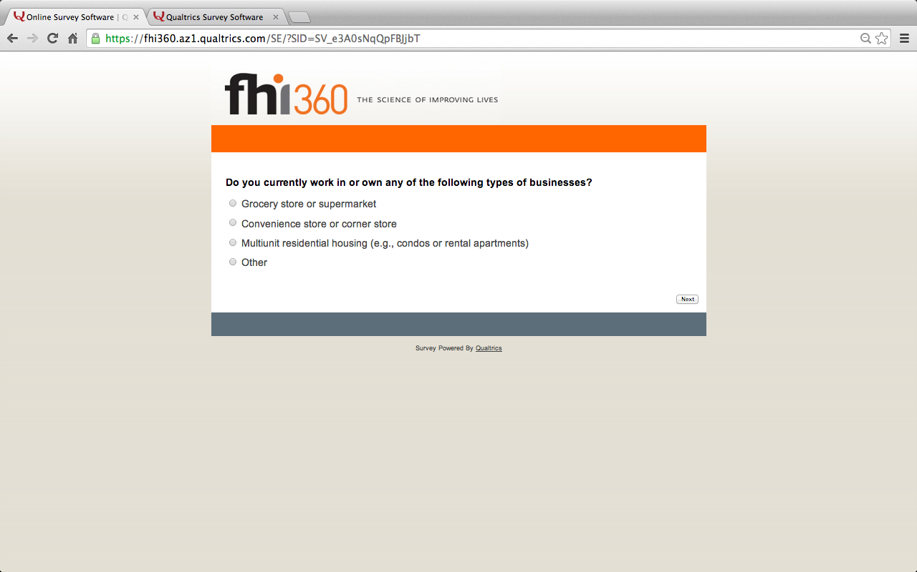

{Note to reviewers: Respondents who respond “other” to the question “Do you currently work in or own any of the following types of businesses…?” will be shown the termination screen displayed below. All others will continue to the screen on the next page.}

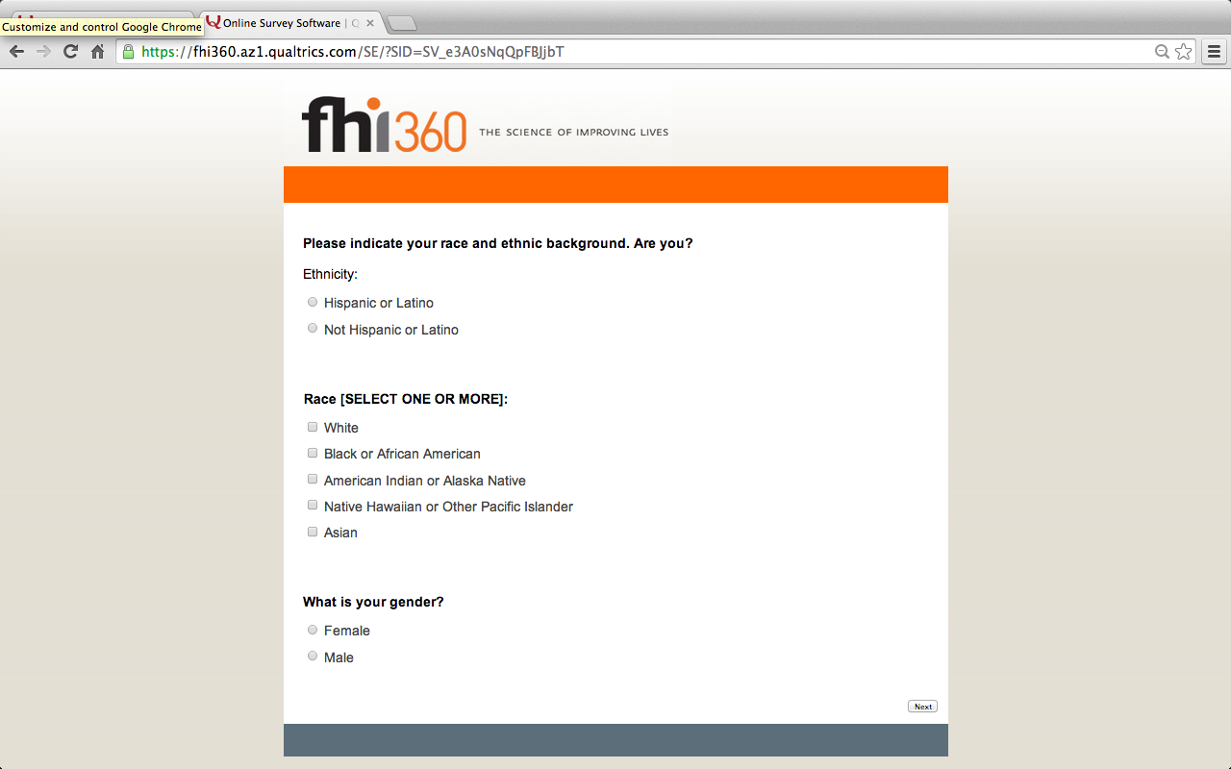

{Note to reviewers: Respondents who indicate that they are of “Hispanic or Latino” ethnicity will be shown the following screen.}

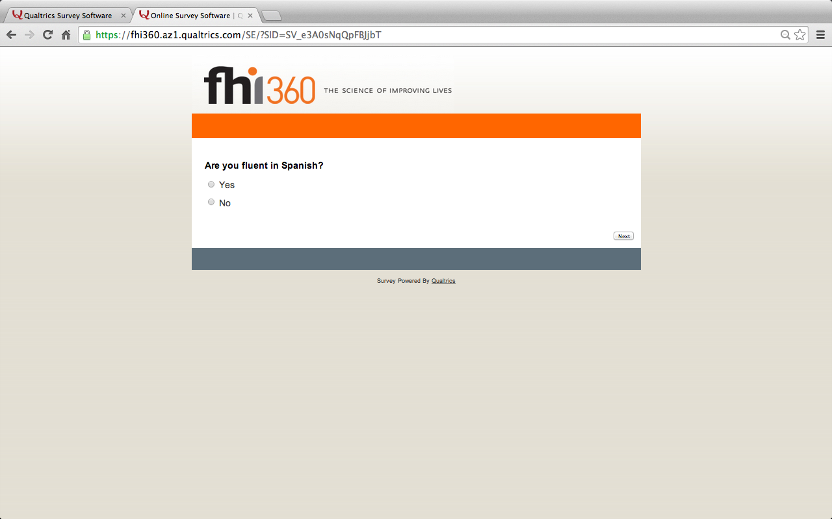

{Note to reviewers: Questions/screens on pages 16-22 will be shown to those who responded (on page 12) that they currently work in or own a “Grocery store or supermarket” or “Convenience store or corner store”.}

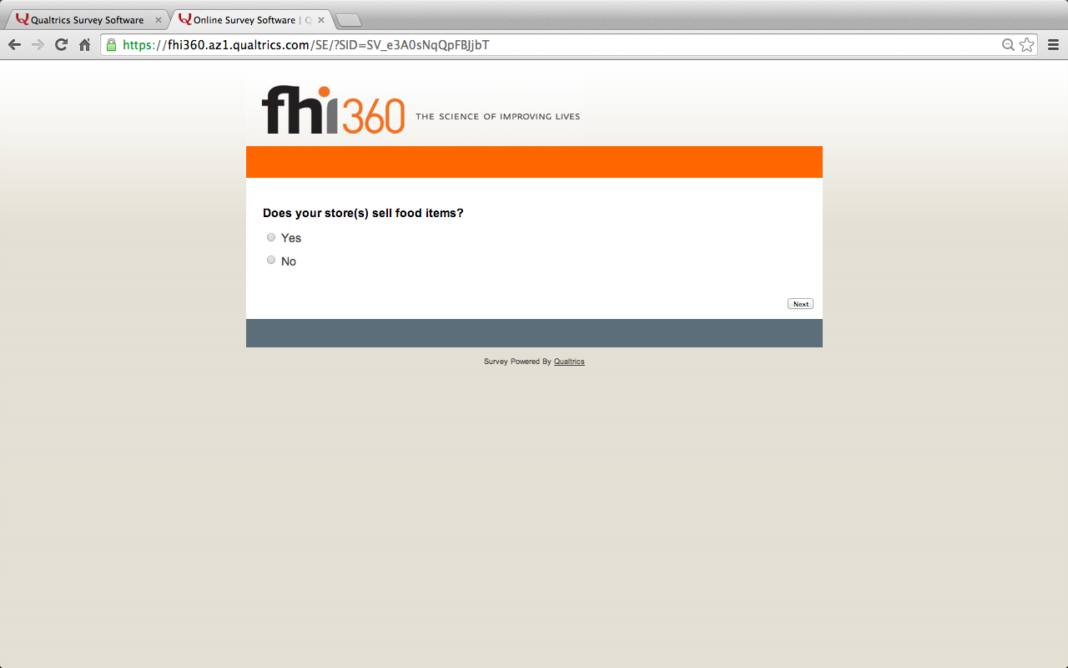

{Note to reviewers: Respondents who respond “no” to the question “Does your store(s) sell food items?” will be shown this termination screen.}

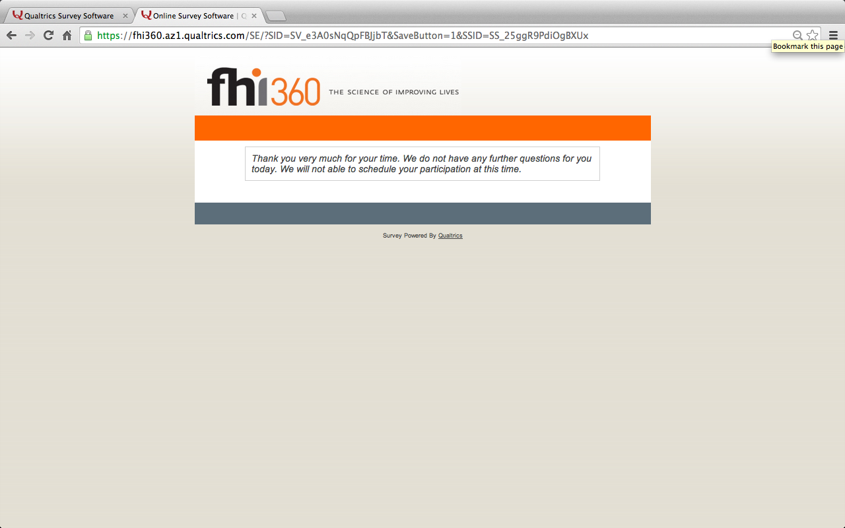

{Note to reviewers: Respondents who respond “yes” to the question “Does your store(s) sell food items?” will be shown the following screen.}

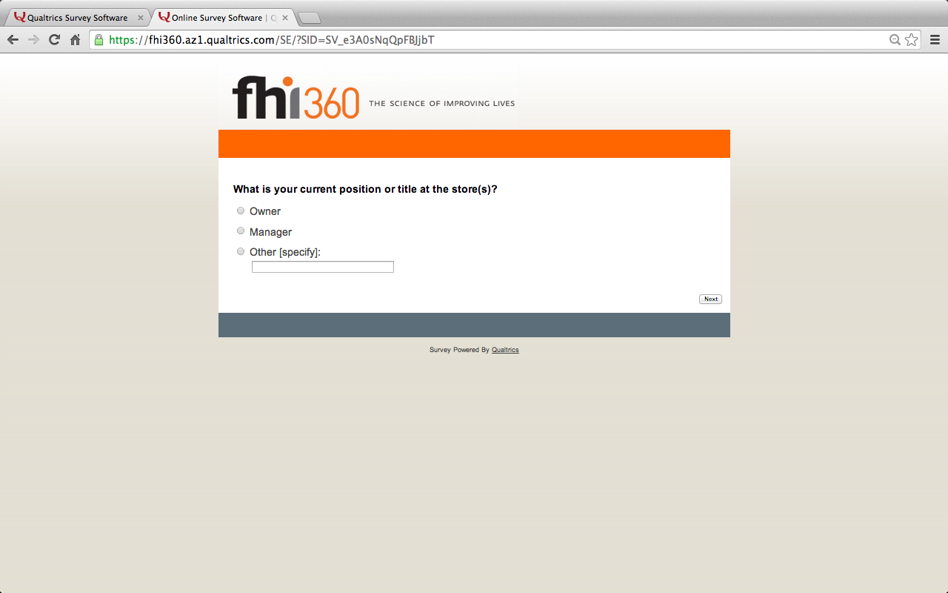

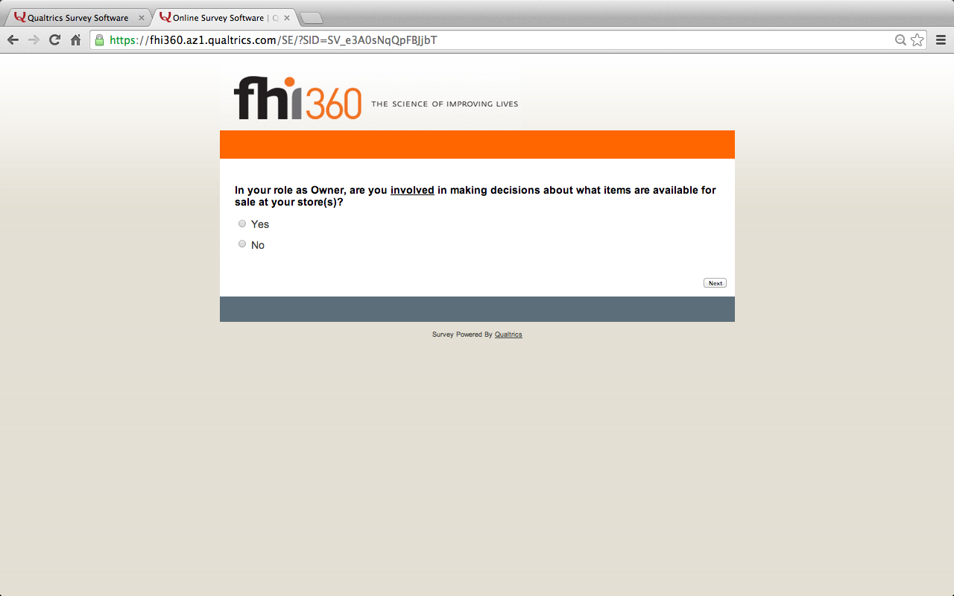

{Note to reviewers: Respondents who respond “no” to the question “In your role as [ _______ ], are you involved in making decisions about what items are available for sale at your store(s)?” will be shown this termination screen.}

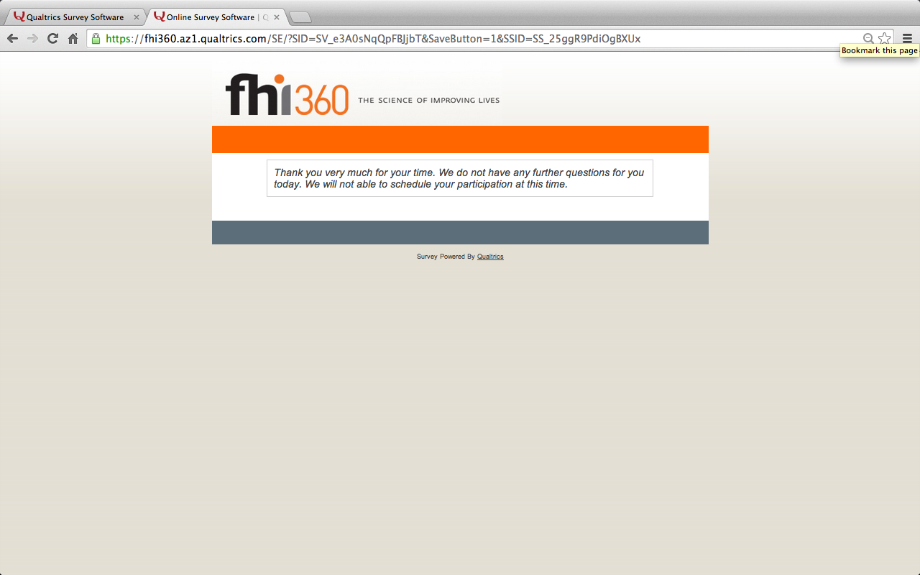

{Note to reviewers: Respondents who respond “yes” to the question “In your role as [ _______ ], are you involved in making decisions about what items are available for sale at your store(s)?” will be shown the following screen.}

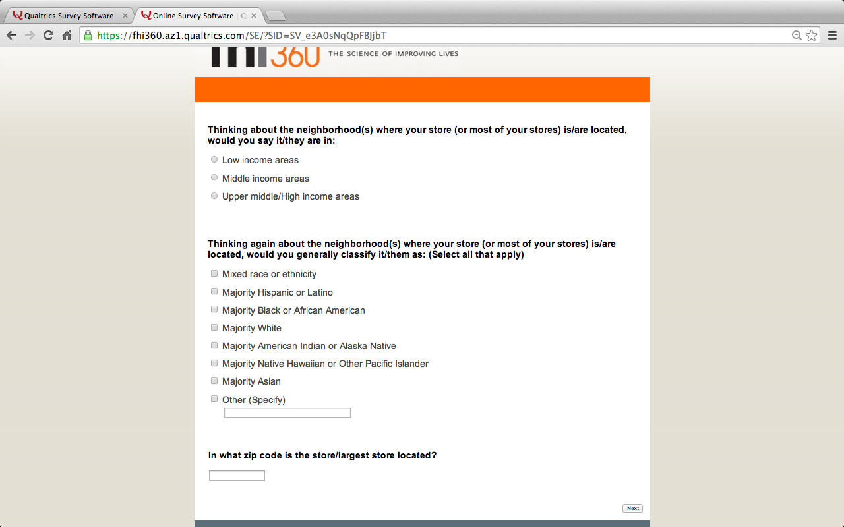

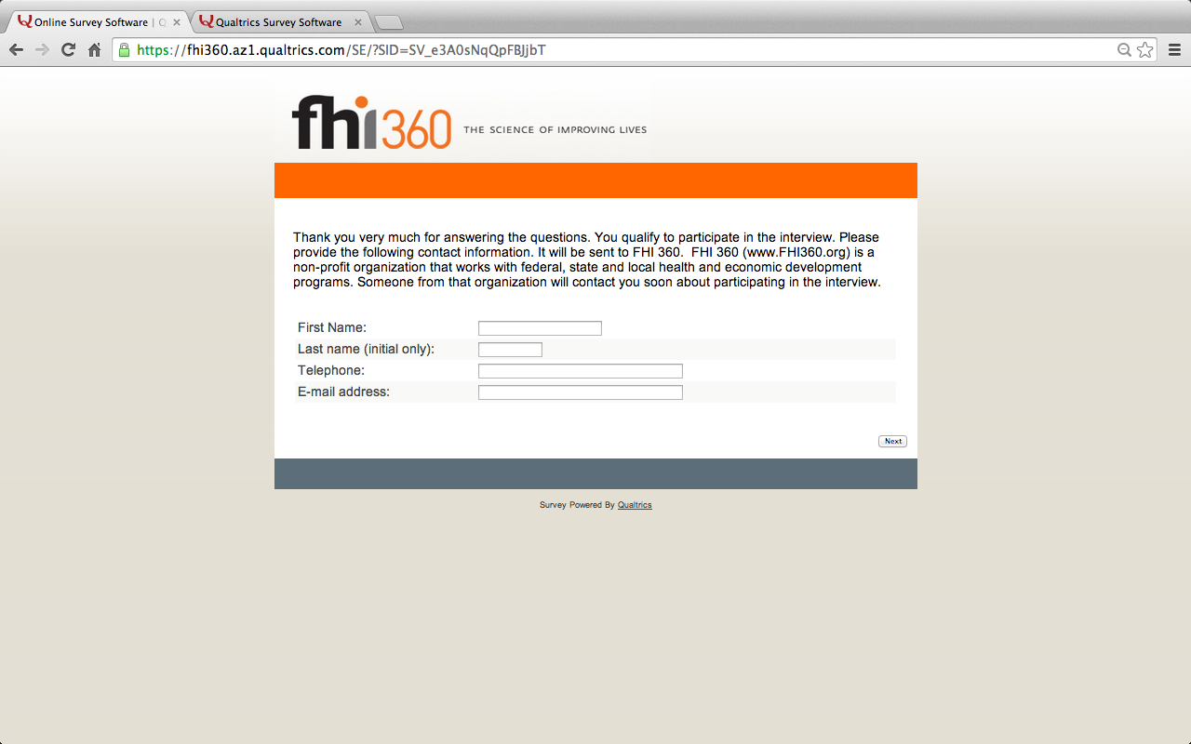

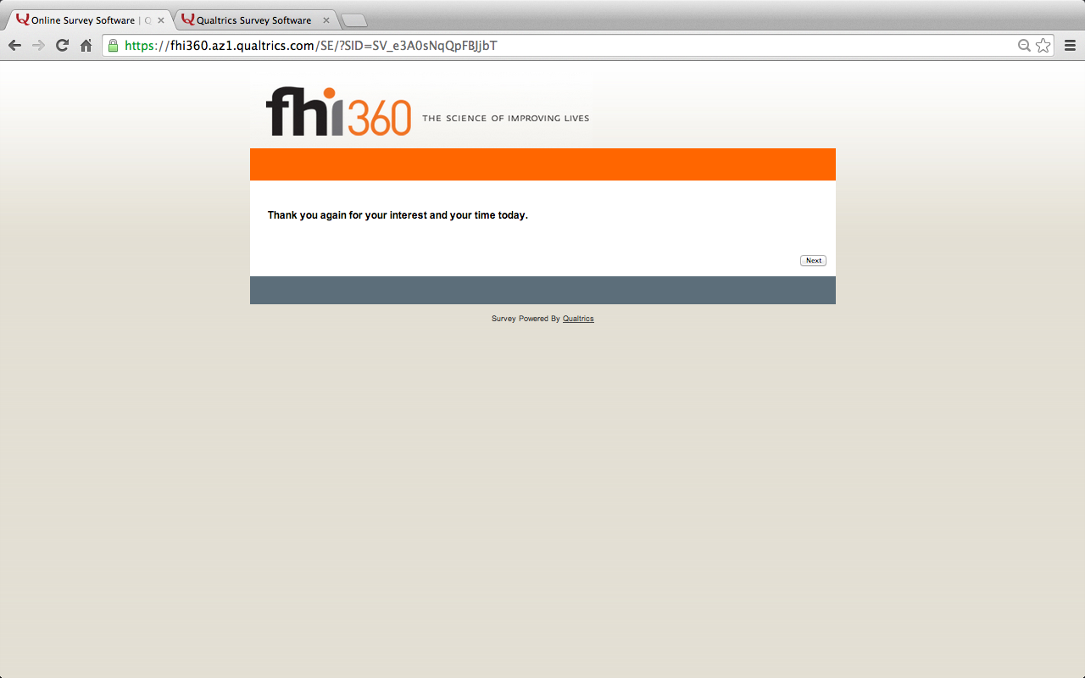

{Note to reviewers: Questions/screens on pages 24-29 will be shown to those who responded (on page 12) that they currently work in or own “Multiunit residential housing.”}

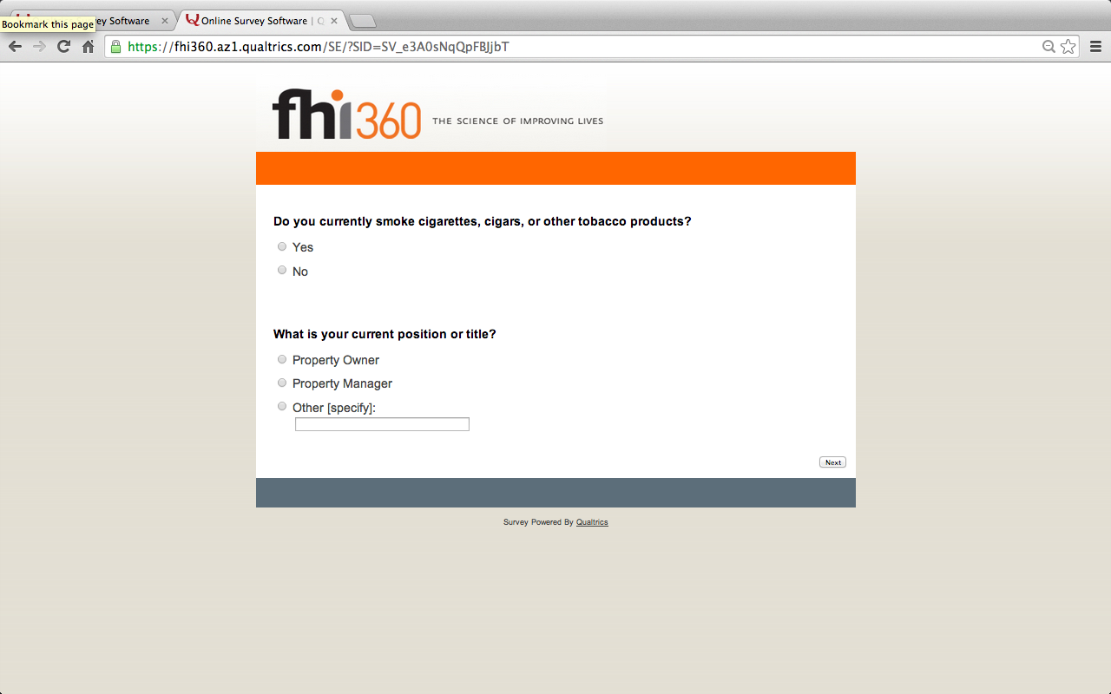

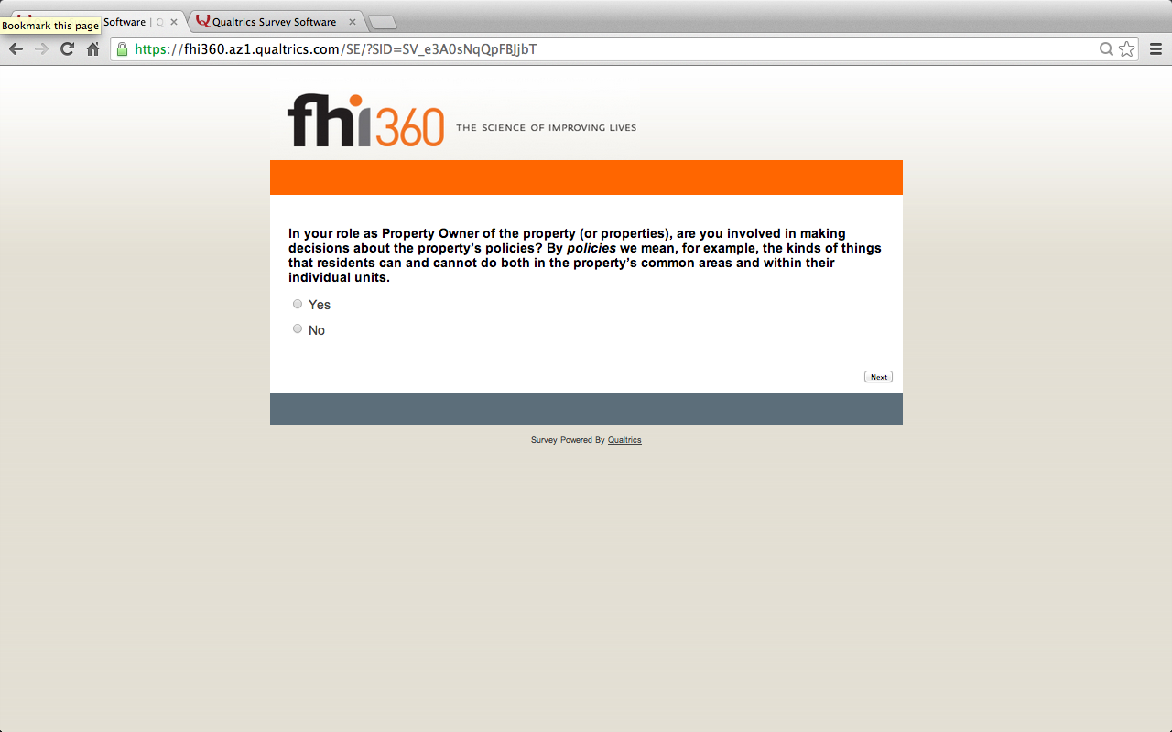

{Note to reviewers: Respondents who respond “no” to the question “In your role as [ _______ ] of the property (or properties), are you involved in making decisions about the property’s policies?” will be shown this termination screen.}

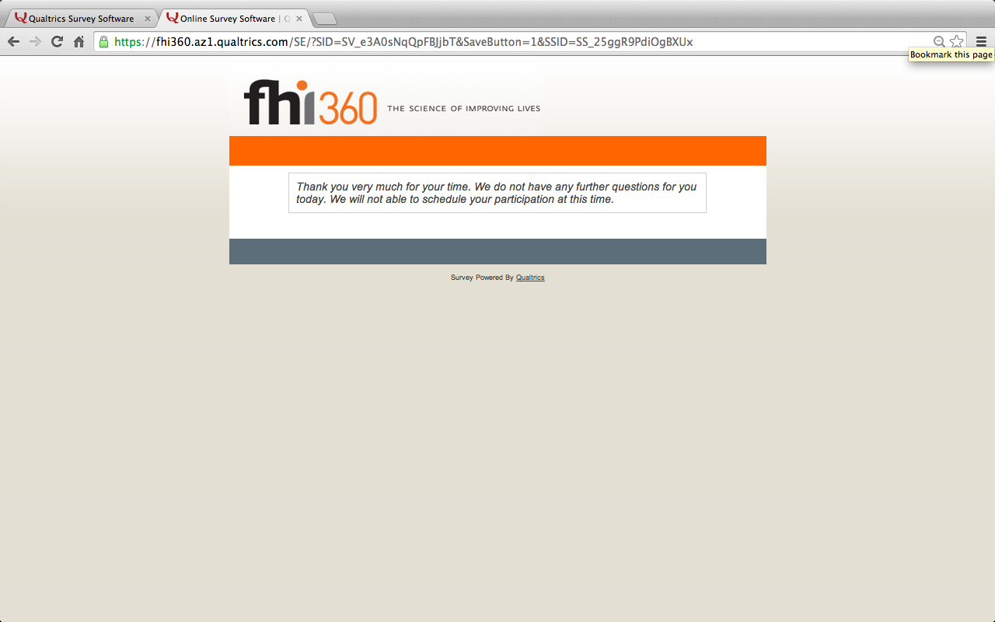

{Note to reviewers: Respondents who respond “yes” to the question “In your role as [ _______ ] of the property (or properties), are you involved in making decisions about the property’s policies?” will be shown the following screen.}

