Testing Business-Case Videos for the
Centers for Disease Control and Prevention’s (CDC)
Division of Community Health

Attachment 5 to the HMTS Expedited Review Form
Contents
Attachment 5a: Survey for Video Testing with Awardees 1
Attachment 5b: Screen Captures of Online Display of Survey 7

Attachment 5a: Survey for Video Testing with Awardees
Testing Business-Case Videos for
CDC’s Division of Community Health

[Note to survey programmer: The table below is included for reference when programming the survey.]
Video ID # | Video name/description | Participant is eligible to see video if (s)he responds “yes” to…
1 | Corner Stores – Louisville, KY (2012)  “Making the Business Case for Prevention: Healthy Corner Stores” | QB3c
2 | Smoke-free Multiunit Housing – Boston, MA (2012)  “Making the Business Case for Prevention: Smoke-free Multiunit Housing” | QB3a
3 | Grocery Stores – Parkersburg, WV (2012)  “Making the Business Case for Prevention: A Grocery Store’s Healthy Options” | QB3b
4 | African American Grocery Store – Omaha, NE (2013)  N/A | QB3_1
5 | Hispanic Corner Store – Omaha, NE (2013)  [English version]  N/A | QB3_2 (and responds “no” to QB3b_2a)
6 | Hispanic Corner Store – Omaha, NE (2013)  [Spanish version]  N/A | QB3_2 AND QB3b_2a
Public Reporting Burden Statement
Public reporting burden of this collection of information is estimated to average 30 minutes per response, including the time for reviewing instructions, searching existing data sources, gathering and maintaining the data needed, and completing and reviewing the collection of information. An agency may not conduct or sponsor, and a person is not required to respond to a collection of information unless it displays a currently valid OMB control number. Send comments regarding this burden estimate or any other aspect of this collection of information, including suggestions for reducing this burden to CDC/ATSDR Information Collection Review Office, 1600 Clifton Road NE, MS D-74, Atlanta, Georgia 30333; ATTN: PRA (0920-0572).

Title: Survey to gather feedback on business-case videos

[Introduction/Consent]
This survey is being done on behalf of CDC’s Division of Community Health to gather feedback on business-case video stories that demonstrate achievable community health changes and encourage local action nationwide.
The survey will take no more than 30 minutes to complete. You will be shown 1-2 videos and asked questions about your reactions. Each video lasts about 3 to 4 minutes. As someone working directly to implement community health efforts, the feedback you provide by taking part in this survey will be very valuable.
Your participation in this research is voluntary. If you decide to not participate it will not affect your relationship with the CDC in any way. You can choose to not answer a question and can stop participating at any time. Your answers will be kept secure to the extent permitted by law. While you will not personally benefit from participating in this research, the feedback you provide will help CDC in its efforts to produce useful communication resources to support the efforts of organizations such as yours to promote the health of people across the US.
Would you like to participate?
1 Yes
2 No

[Background]

QB1. Which of the following describes your organization’s association with the CDC Division of Community Health (DCH)?

- New REACH Demonstration Project Awardee
- New REACH Program Awardee
3 CTG Implementation Awardee
4 CTG Capacity-Building Awardee
5 CTG Small Communities Awardee
6 CTG National Network Awardee

[FOOTER ON EACH PAGE] If you have any questions about this survey, please contact Tom Lehman at studyinfo@fhi360.org or 202-884-8000.

QB2. Which of the following most closely describes your role in the program?

1 Program/Project manager
2 Communication liaison
3 Other: [Specify:___________________]

QB3. Has your organization engaged in any of the following efforts?

a Smokefree multiunit residential housing efforts

1 Yes [Eligible to see video #2]
2 No

b Increasing access to fruits and vegetables in grocery stores/supermarkets

1 Yes [Show QB3_1]
2 No

c Increasing access to fruits and vegetables in corner stores or convenience stores

1 Yes [Show QB3_2]
2 No

QB3_1. Have any of your organization’s efforts to increase access to [or the amount of] fruits and vegetables in grocery stores/supermarkets specifically focused on stores serving majority African American neighborhoods?

1 Yes [Eligible to see video #3 and #4]
2 No [Eligible to view video #3]

QB3_2. Have any of your organization’s efforts to increase access to [or the amount of] fruits and vegetables in corner stores or convenience stores specifically focused on stores serving majority Hispanic neighborhoods?

1 Yes
2 No [Eligible to see video #1. Skip to QVT1]

QB3_2a. Are you fluent in Spanish?

1 Yes [Eligible to see video #1 and #6]
2 No [Eligible to see video #1 and #5]

[Video testing]

Now we are going to show you a video. Please respond to the questions that follow. [Show video]

QVT1 What is the main message of the video you just saw?
___________________________________________________________
___________________________________________________________

QVT2 Is there anything about this video that is confusing or unclear?

1 Yes [Specify: _________________________________________]
2 No

QVT3 To what extent do you agree or disagree with each of the following statements?

 | Strongly Disagree | Disagree | Neutral | Agree | Strongly Agree
a. Overall, I liked this video | 1 | 2 | 3 | 4 | 5
b. I like the look and feel of this video | 1 | 2 | 3 | 4 | 5
c. The right messages are included in this video | 1 | 2 | 3 | 4 | 5
d. The right people are featured in this video | 1 | 2 | 3 | 4 | 5
e. This video would be helpful in my work | 1 | 2 | 3 | 4 | 5
QVT4 Thinking about the businesspeople in your community, to what extent do you agree or disagree with each of the following statements?

 | Strongly Disagree | Disagree | Neutral | Agree | Strongly Agree
a. This video would get their attention | 1 | 2 | 3 | 4 | 5
b. This video would interest them | 1 | 2 | 3 | 4 | 5
c. This video would be relevant to them | 1 | 2 | 3 | 4 | 5
d. They would learn something from this video | 1 | 2 | 3 | 4 | 5
e. This video would be believable to them | 1 | 2 | 3 | 4 | 5
f. This video would motivate them to take action | 1 | 2 | 3 | 4 | 5

QVT5 How likely are you/your organization to do each of the following?

 | Definitely  Not | Probably  Not | Possibly | Probably | Definitely
a. Use this video internally (within your organization) | 1 | 2 | 3 | 4 | 5
b. Use this video with community partners (existing or prospective) | 1 | 2 | 3 | 4 | 5
c. Use this video to do outreach with businesspeople in your community | 1 | 2 | 3 | 4 | 5

QVT6 In general, how useful would each of the following video-length formats be to support
your organization’s work on this topic? [Select all that apply]

1 1 minute or less
2 No more than 2 minutes
3 About 3 to 4 minutes (the length of the video you saw)
3 5 or more minutes

QVT7 Is there anything about this video that you would change?

1 Yes [Specify: ________________________________________________]
2 No

Now we are going to show you another video. Please respond to the questions that will follow. [Show second video]

QVT8 What is the main message of the video you just saw?
___________________________________________________________
___________________________________________________________

QVT9 Is there anything about this video that is confusing or unclear?

1 Yes [Specify: _________________________________________]
2 No

QVT10 To what extent do you agree or disagree with each of the following statements?

 | Strongly Disagree | Disagree | Neutral | Agree | Strongly Agree
a. Overall, I liked this video | 1 | 2 | 3 | 4 | 5
b. I like the look and feel of this video | 1 | 2 | 3 | 4 | 5
c. The right messages are included in this video | 1 | 2 | 3 | 4 | 5
d. The right people are featured in this video | 1 | 2 | 3 | 4 | 5
e. This video would be helpful in my work | 1 | 2 | 3 | 4 | 5

QVT11 Thinking about the businesspeople in your community, to what extent do you agree or disagree with each of the following statements?

 | Strongly Disagree | Disagree | Neutral | Agree | Strongly Agree
a. This video would get their attention | 1 | 2 | 3 | 4 | 5
b. This video would interest them | 1 | 2 | 3 | 4 | 5
c. This video would be relevant to them | 1 | 2 | 3 | 4 | 5
d. They would learn something from this video | 1 | 2 | 3 | 4 | 5
e. This video would be believable to them | 1 | 2 | 3 | 4 | 5
f. This video would motivate them to take action | 1 | 2 | 3 | 4 | 5
QVT12 How likely are you/your organization to do each of the following?

 | Definitely  Not | Probably  Not | Possibly | Probably | Definitely
a. Use this video internally (within your organization) | 1 | 2 | 3 | 4 | 5
b. Use this video with community partners (existing or prospective) | 1 | 2 | 3 | 4 | 5
c. Use this video to do outreach with businesspeople in your community | 1 | 2 | 3 | 4 | 5
QVT13 In general, how useful would each of the following video-length formats be to support
your organization’s work on this topic? [Select all that apply]

1 1 minute or less
2 No more than 2 minutes
3 About 3 to 4 minutes (the length of the video you saw)
4 5 or more minutes

QVT14 Is there anything about this video that you would change?

1 Yes [Specify: ________________________________________________]
2 No

Thank you for your input.

Attachment 5b: Screen Captures of Online Display of Survey
Testing Business-Case Videos for
CDC’s Division of Community Health

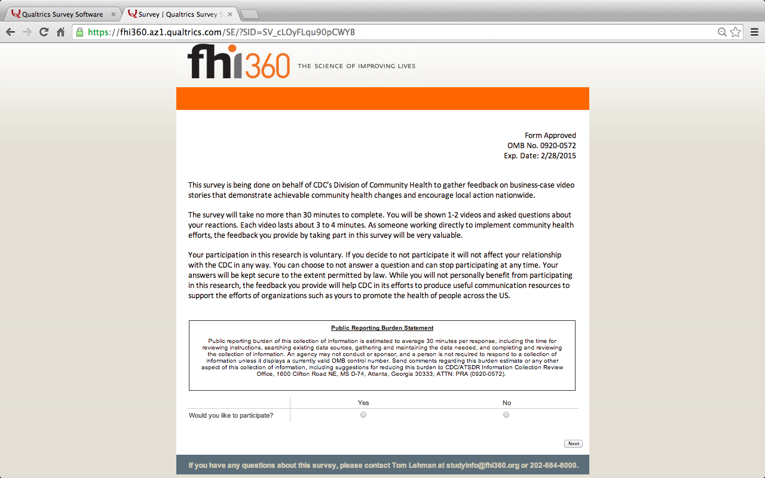

{Note to reviewers: Respondents who wish to participate and click “yes” will be shown the following screen.}

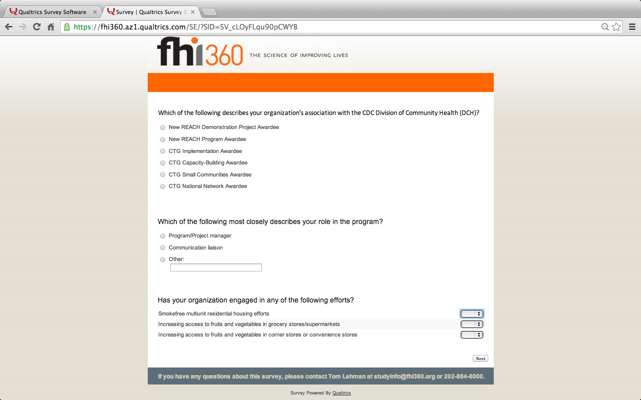

{Note to reviewers: Only respondents who selected “yes” for “Increasing access to fruits and vegetables in grocery stores/supermarkets” (see page 8) will be shown the following screen.}

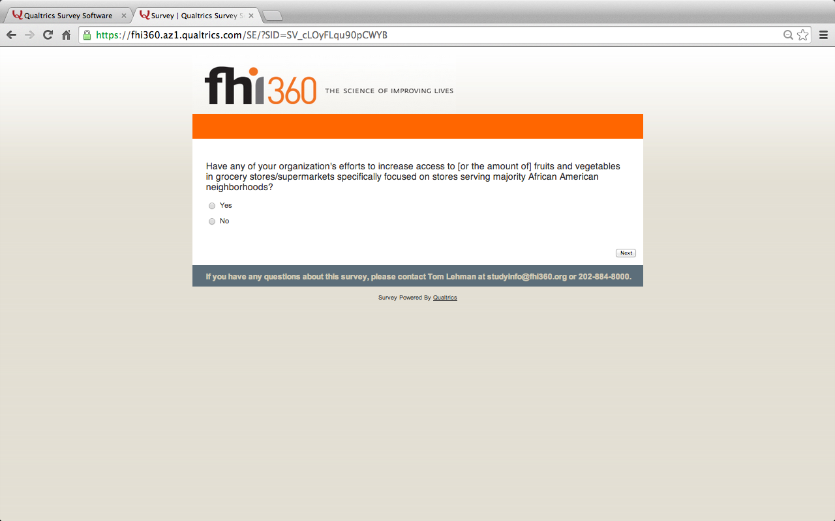

{Note to reviewers: Only respondents who selected “yes” for “Increasing access to fruits and vegetables in corner stores or convenience stores” (see page 8) will be shown the following screen.}

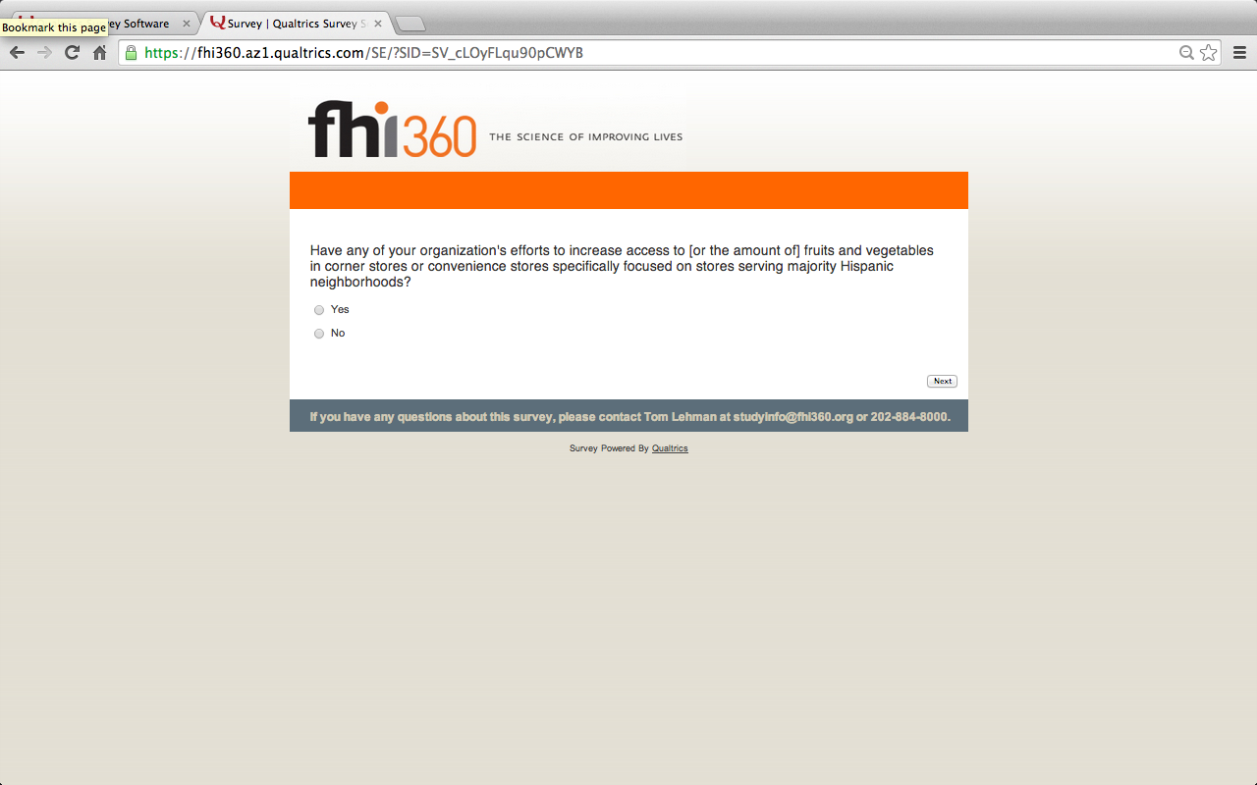

{Note to reviewers: Only respondents who responded “yes” to the question “Have any of your organization’s efforts… focused on stores serving majority Hispanic neighborhoods?” will be shown the following screen.}

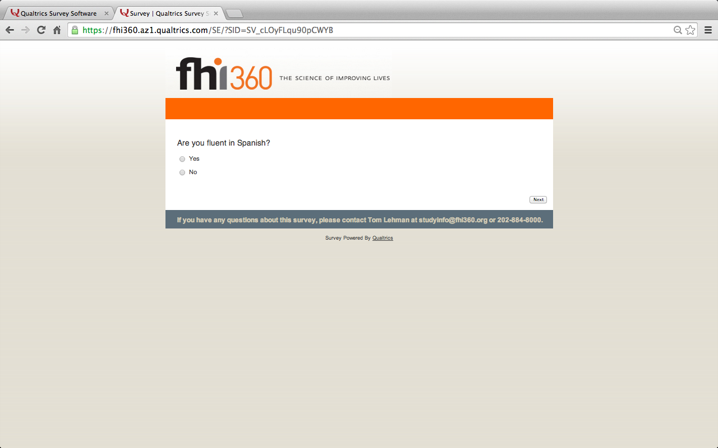

{Note to reviewers: Respondents will then be shown up to two videos. The videos they will be shown will be based on their responses to the question “Has your organization engaged in any of the following efforts…” (see pg. 8) as well as their responses to the questions on pages 9-11. The chart below summarizes which videos they may be shown based on their responses. Once they view the first video, they will be asked a set of questions. They will then be shown the second video and asked the same set of questions.}
Video ID # | Video name/description and link | Participant is eligible to see video if (s)he responds as follows…
1 | Corner Stores – Louisville, KY (2012)  “Making the Business Case for Prevention: Healthy Corner Stores”  http://youtu.be/G_VkvizRZyg | Responded “yes” to engaging in corner or convenience store efforts (see question on page 8)
2 | Smoke-free Multiunit Housing – Boston, MA (2012)  “Making the Business Case for Prevention: Smoke-free Multiunit Housing”  http://youtu.be/mccUB7FeM-E​ | Responded “yes” to engaging in smoke-free multiunit housing efforts (see question on page 8)
3 | Grocery Stores – Parkersburg, WV (2012)  “Making the Business Case for Prevention: A Grocery Store’s Healthy Options”  http://youtu.be/RlQQx-eklZU | Responded “yes” to engaging in grocery store/supermarket efforts (see question on page 8)
4 | African American Grocery Store – Omaha, NE (2013)  https://www.dropbox.com/sh/f2ypp9luf33ze03/UkLqzCrzzt/DCH%202013%20African%20American%20Video | Responded “yes” to engaging in grocery store efforts in majority African American neighborhoods (see question on page 9)
5 | Hispanic Corner Store – Omaha, NE (2013)  [English version]  https://www.dropbox.com/sh/f2ypp9luf33ze03/xLW8fYnAw5/DCH 2013 Hispanic Video | Responded “yes” to engaging in corner or convenience store efforts in majority Hispanic neighborhoods AND “no” to being fluent in Spanish (see questions on pages 10 and 11)
6 | Hispanic Corner Store – Omaha, NE (2013)  [Spanish version]  https://www.dropbox.com/sh/f2ypp9luf33ze03/xGZuDYT9Yo/DCH 2013 Spanish Video | Responded “yes” to engaging in corner or convenience store efforts in majority Hispanic neighborhoods AND “yes” to being fluent in Spanish (see questions on pages 10 and 11).

{Note to reviewers: Respondents will be shown the first video and then will be asked a set of questions. As noted before, the video shown will vary based on their responses to previous questions. However, the questions they will be asked will be the same, regardless of the video they see.}

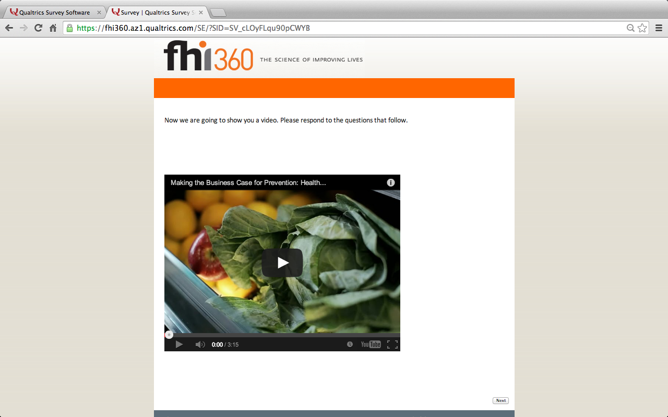

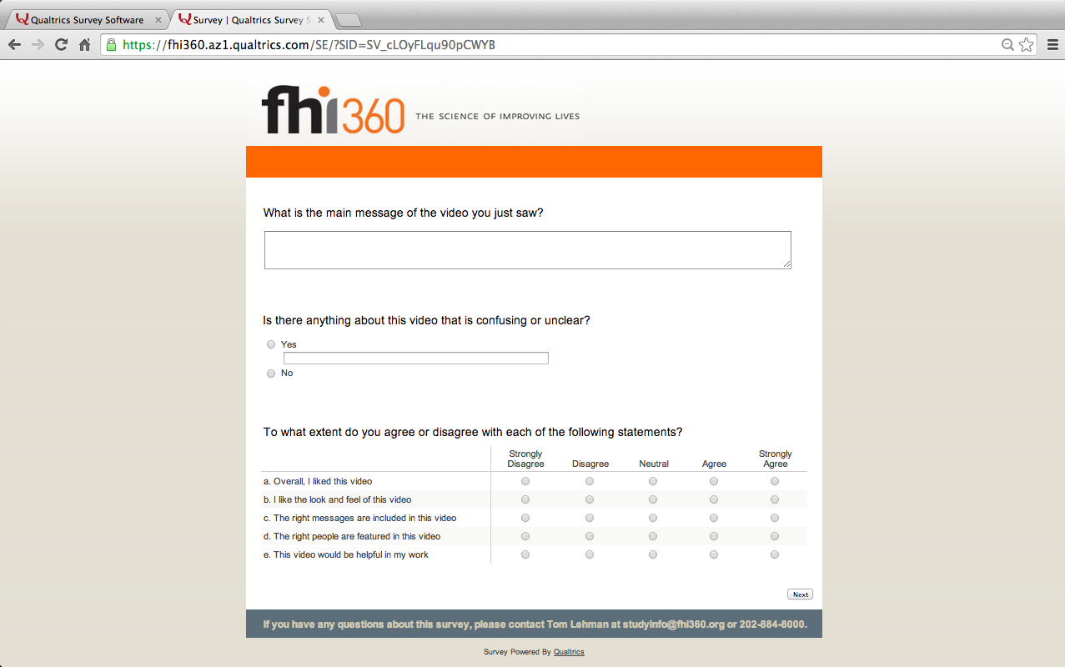

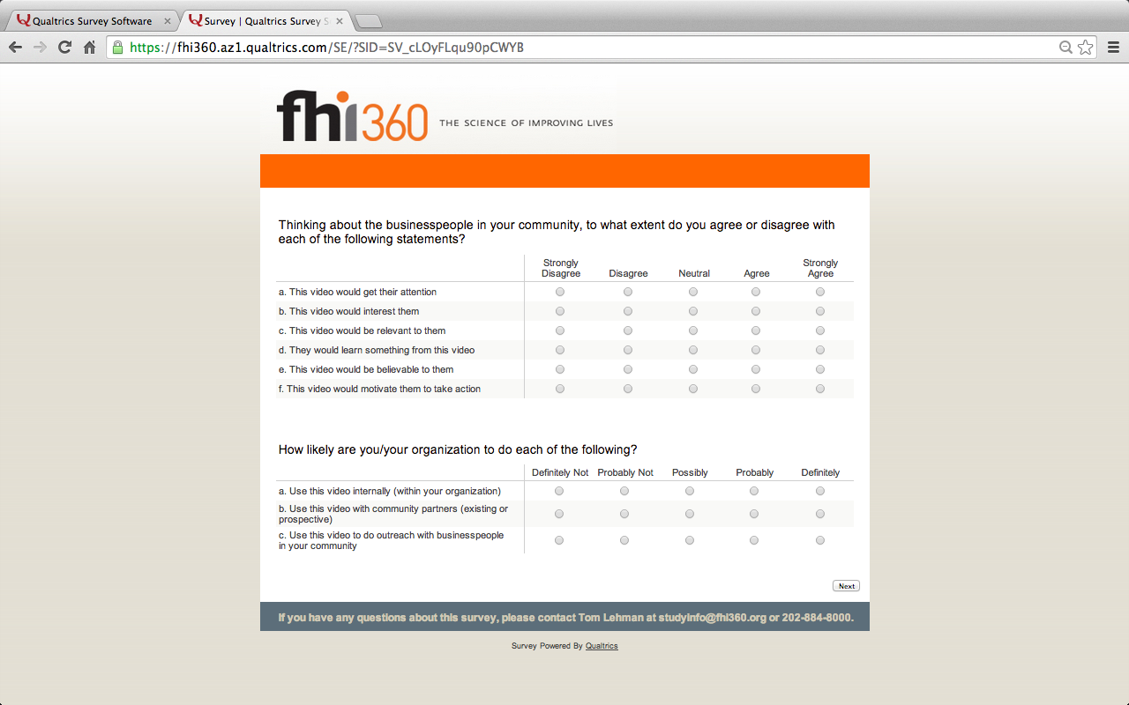

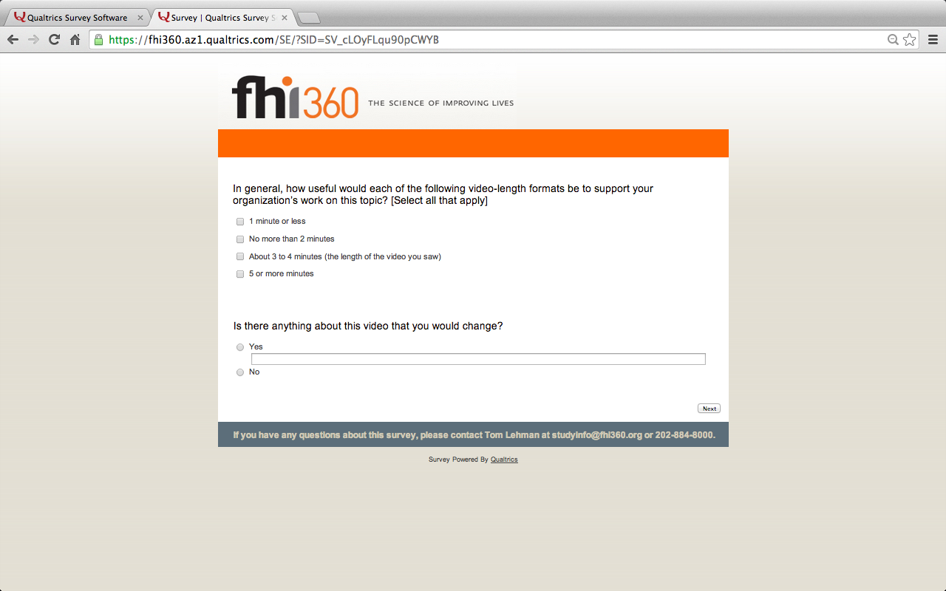

{Note to reviewers: Respondents may then be shown a second video. After viewing the second video, they will be asked to respond to the same set of questions as with the first video.}

