Audience Research on Self-Management Education Phase III
Attachment 2 to the HMTS Expedited Review Form

Contents
Concepts 1
Logos/Taglines 4
Messages 6

Concepts
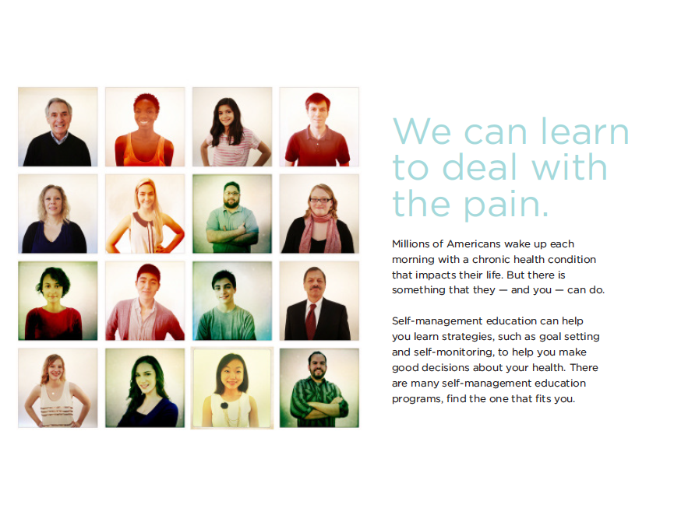

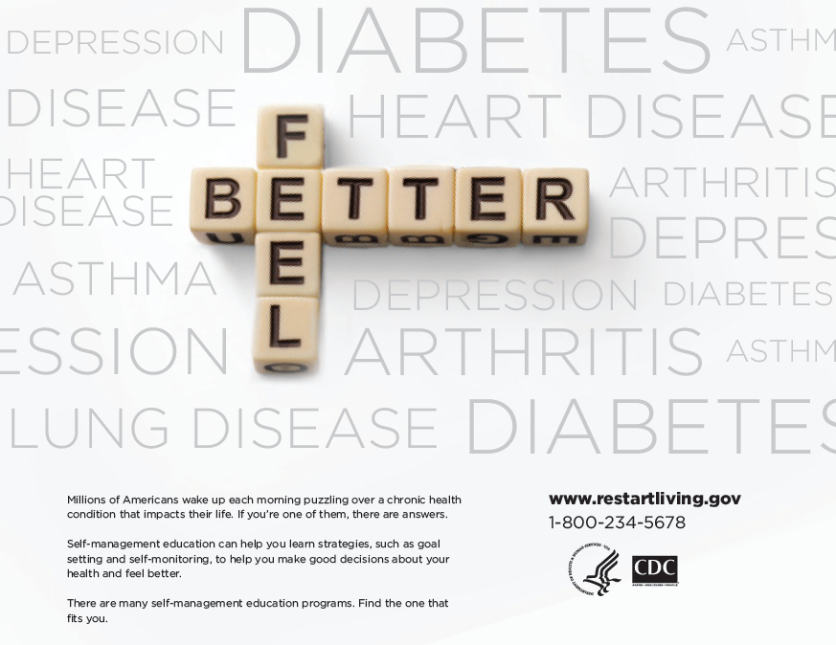
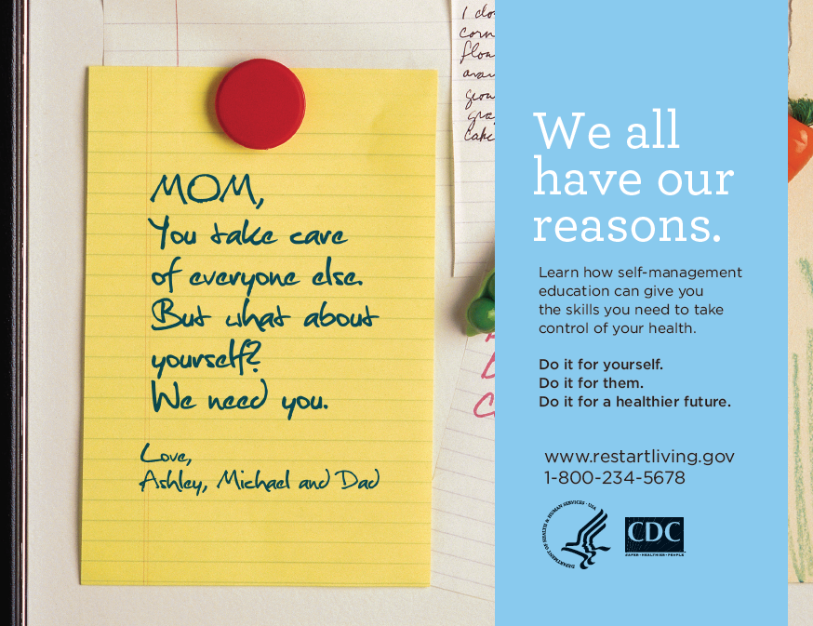

Logos/Taglines
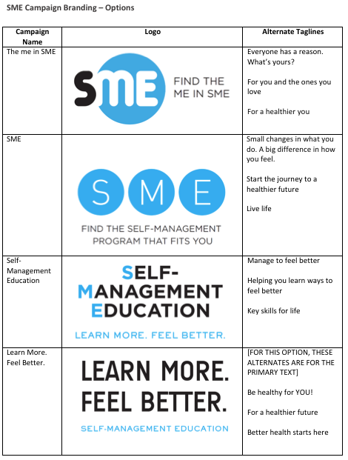
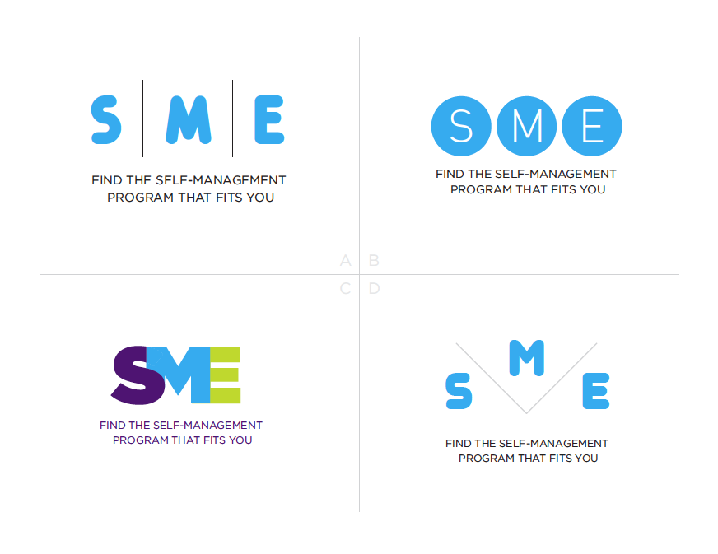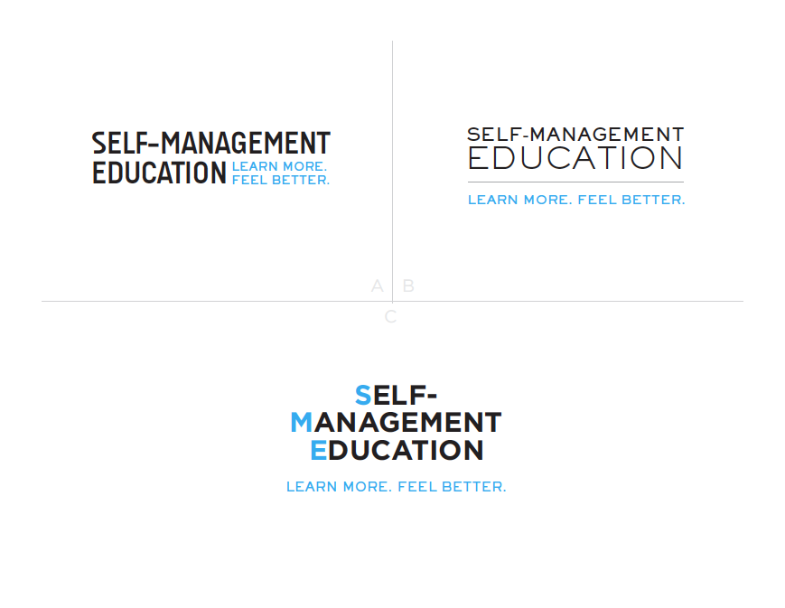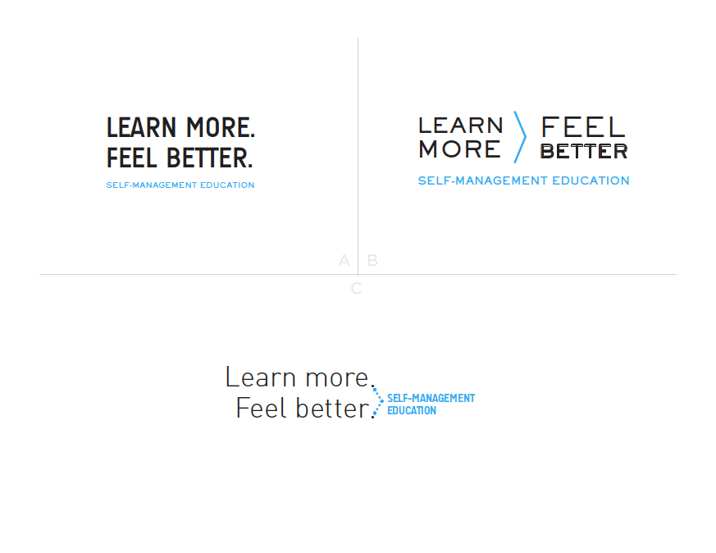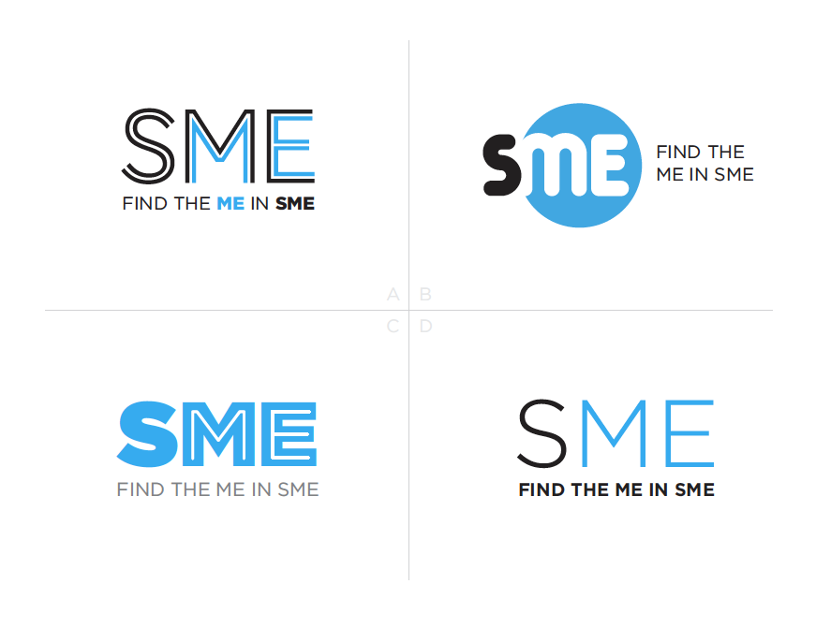

Messages
- Free yourself from your ongoing health condition and gain back the independence that you remember. Self-management education teaches you strategies and techniques that allow you to control your health. Try a self-management education program.

- Nearly 1 in 2 Americans have an ongoing health condition. Don’t let your chronic disease take over your life. Learn strategies and techniques, such as goal setting and self-monitoring to help you make good decisions about your health. Choose a healthier future, choose a self-management education program.

- You are not alone. Chronic disease affects 1 in 2 Americans but there is something you can do. Self-management education can help you learn the strategies and techniques to live a stronger, healthier life. There are many self-management education programs, find the one that fits you.

- Your chronic disease does not have to define who you are. Managing your long term health condition through self-management education can give you more energy and less stress, allowing you the time to do the things you want. Try a self-management education program.

- If you have an ongoing health condition self-management education can help you improve your quality of life. Let the people you love know you care about your health. Find out more about self-management education programs.

- Today may be a struggle, but tomorrow doesn’t have to be. Self-management education can help you develop the strategies and techniques you need to manage your chronic condition and live the life you want to live. Learn how self-management education builds independence, creates less interruption and leads to a healthier future.

- Are you managing your chronic disease? Did you know that there are things you can do each day to help you feel more energized and less stressed? Find out how self-management education can lead to a happier, healthier you.

- Did you know that 1 out of 2 Americans has a chronic disease? If you have a chronic disease or know someone who does, self-management education may be the answer. Self-management education teaches people how to make good decisions about their health so that they can feel healthier, more energized and less stressed. Find a Self-management education class for you or someone you love.

