Appendix C. Hand-held Screenshots

The images in this document are screen-shots of the hand-held electronic device (tablet) that will be used to input participants’ responses. These images will only be seen by interviewers and not by participants

Planes, Trains, and Auto-Mobility: An Innovative Approach to Increase Walking in the Atlanta Hartsfield-Jackson Airport

Hand-held Screenshots

Public reporting burden of this collection of information is estimated to average 10 minutes per response, including the time for reviewing instructions, searching existing data sources, gathering and maintaining the data needed, and completing and reviewing the collection of information. An agency may not conduct or sponsor, and a person is not required to respond to a collection of information unless it displays a currently valid OMB control number. Send comments regarding this burden estimate or any other aspect of this collection of information, including suggestions for reducing this burden to CDC/ATSDR Information Collection Review Office, 1600 Clifton Road NE, MS D-74, Atlanta, Georgia 30333; ATTN: PRA (0920-0572).
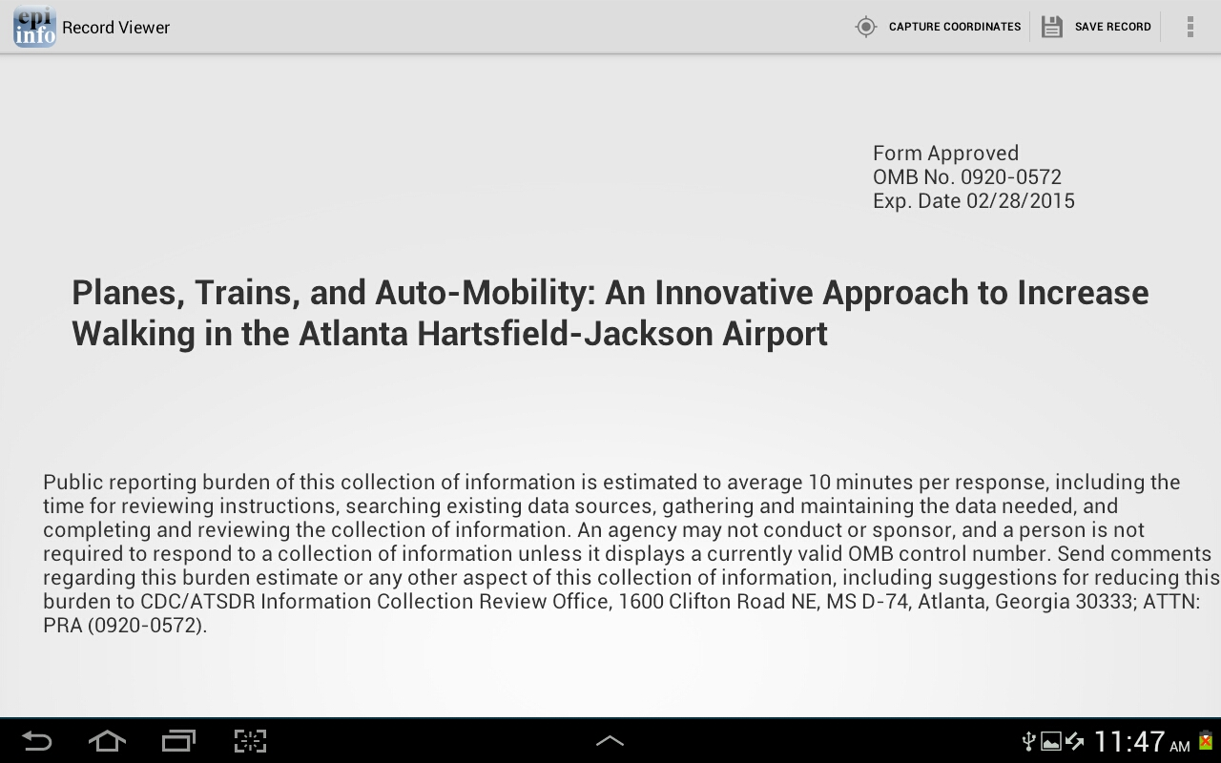*Note: “Capture Coordinates” function will be disabled during interviews.

