Healthy Homes - Asthma Page

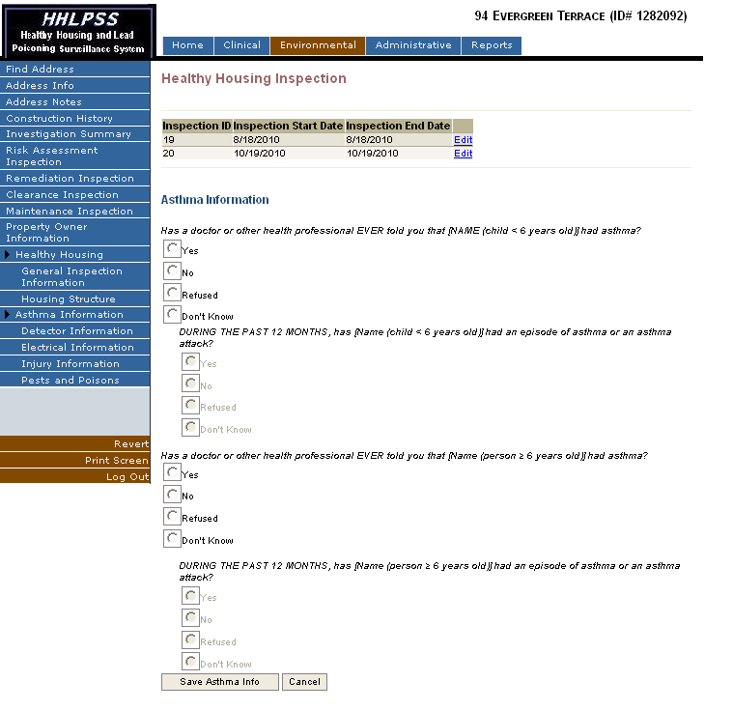

Race Selection