REQUESTED APPROVAL DATE: 11/26/14 (knowing that this is the day before Thanksgiving, 12/1/14 is fine)
NAME OF CONTACT PERSON: Adam Wong
TELEPHONE NUMBER: 202-720-2866
NAME OF OFFICE/PROGRAM: Office of the National Coordinator for Health IT

SCREENSHOTS
Screenshot 1: Basic contact info for both innovator companies and host sites
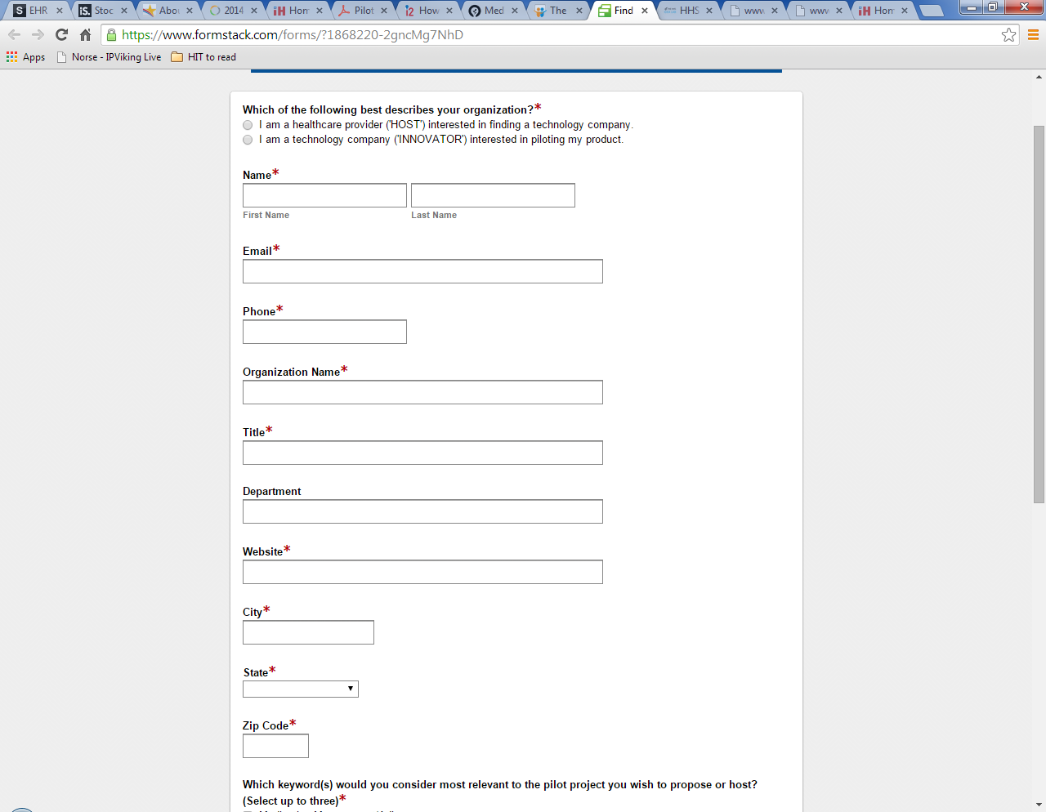

Screenshot 2: Additional information from host sites
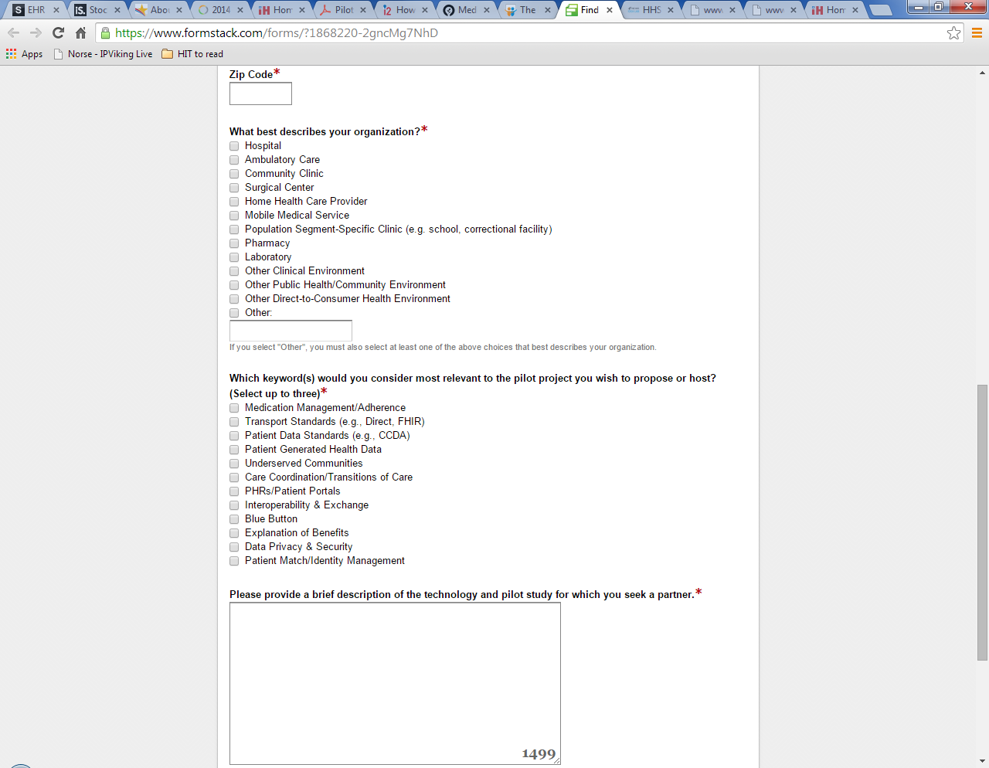

Screenshot 3.1: Additional information from innovator companies
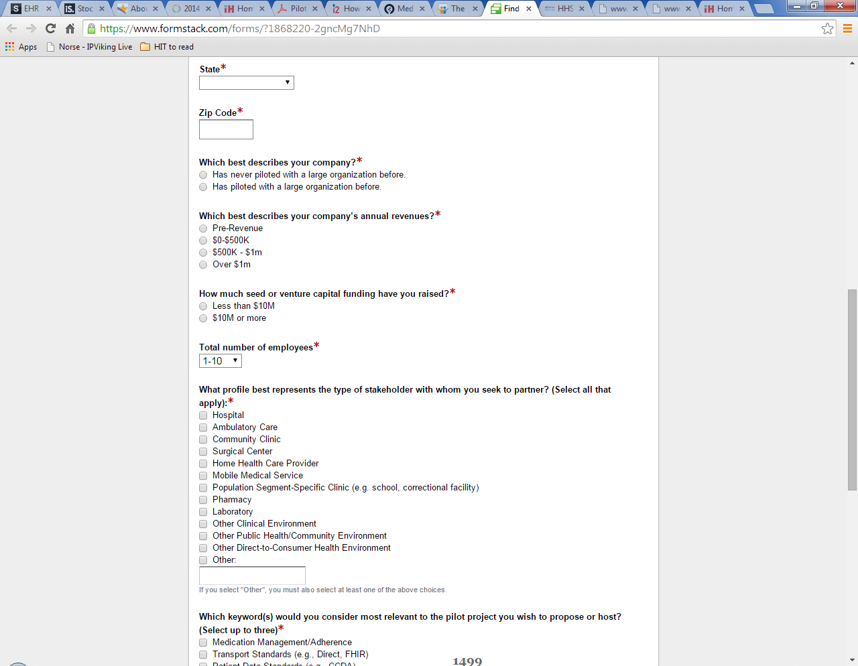

Screenshot 3.2: Additional information from innovator companies

