Screenshots of TIMS Online for OMB Submission

**Landing Page**

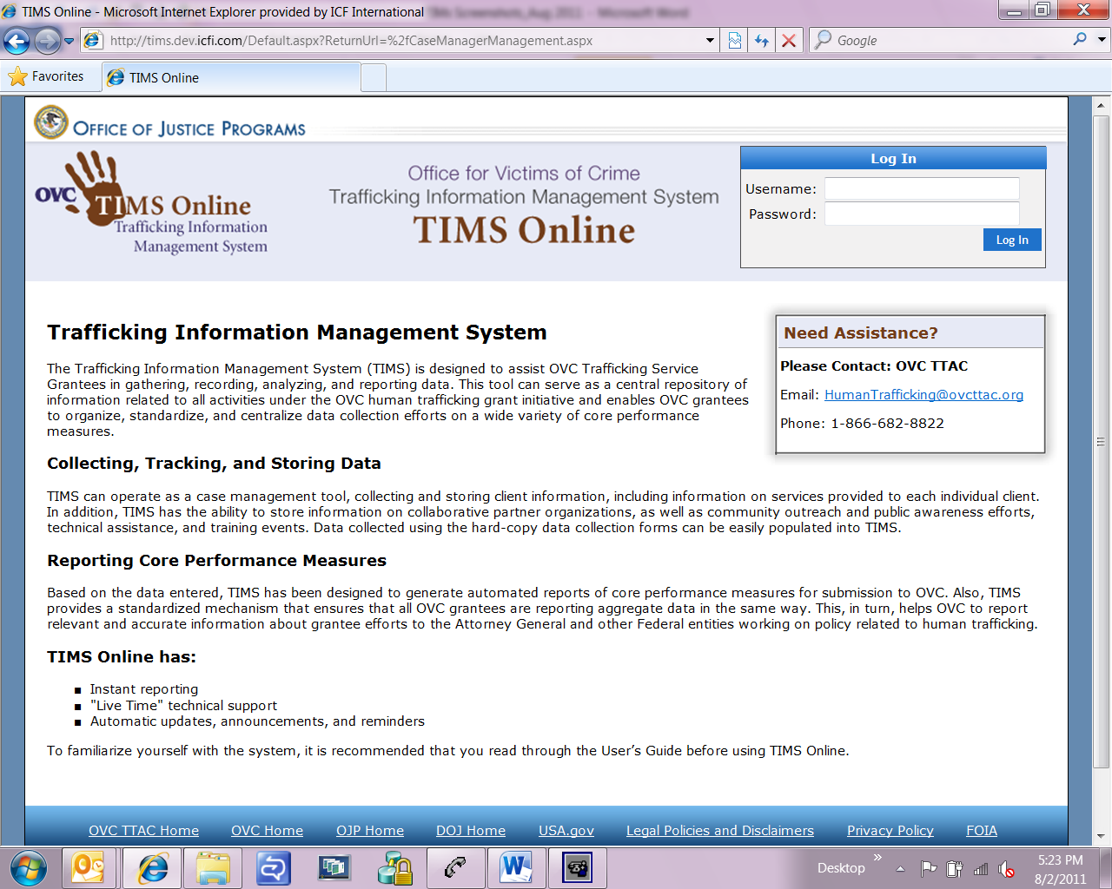

**Home Page**

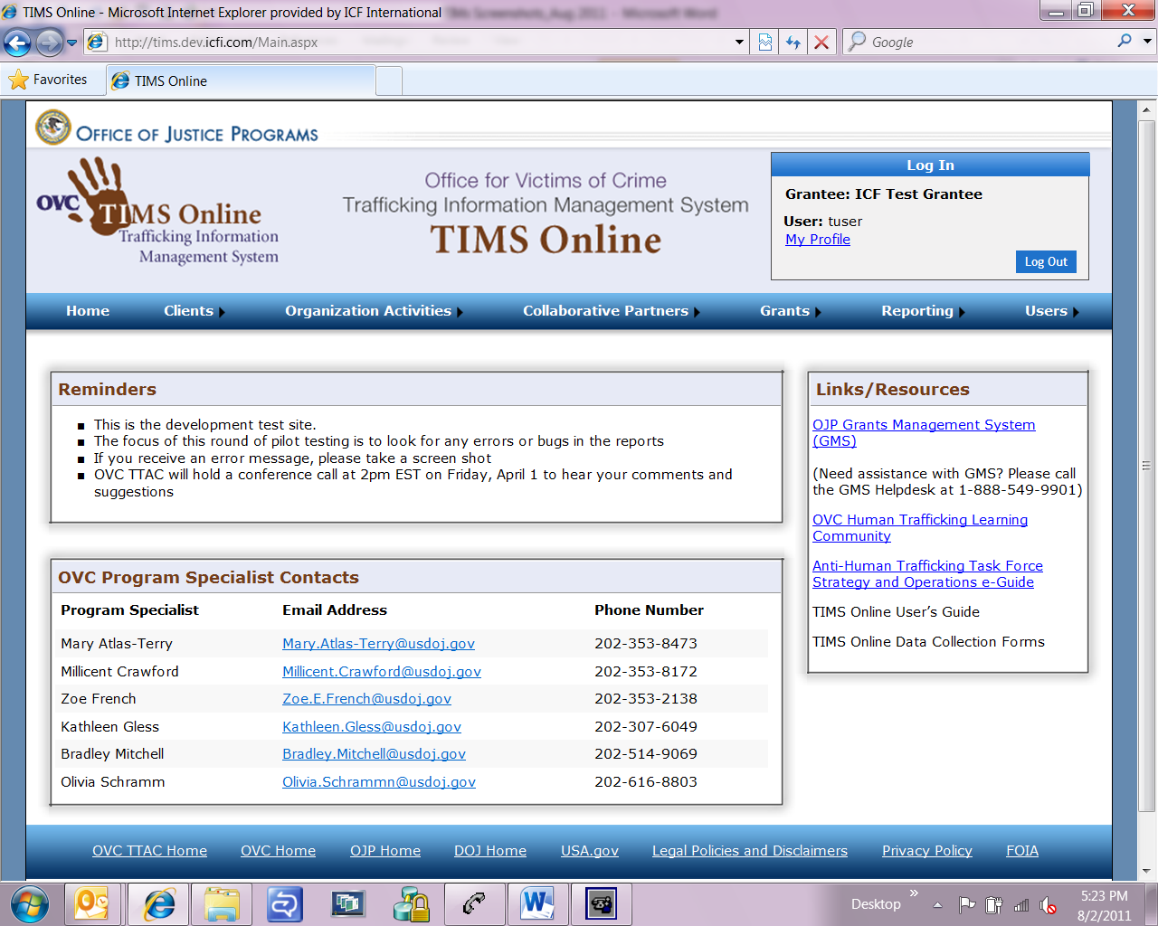

**Clients 🡪 Client Management**

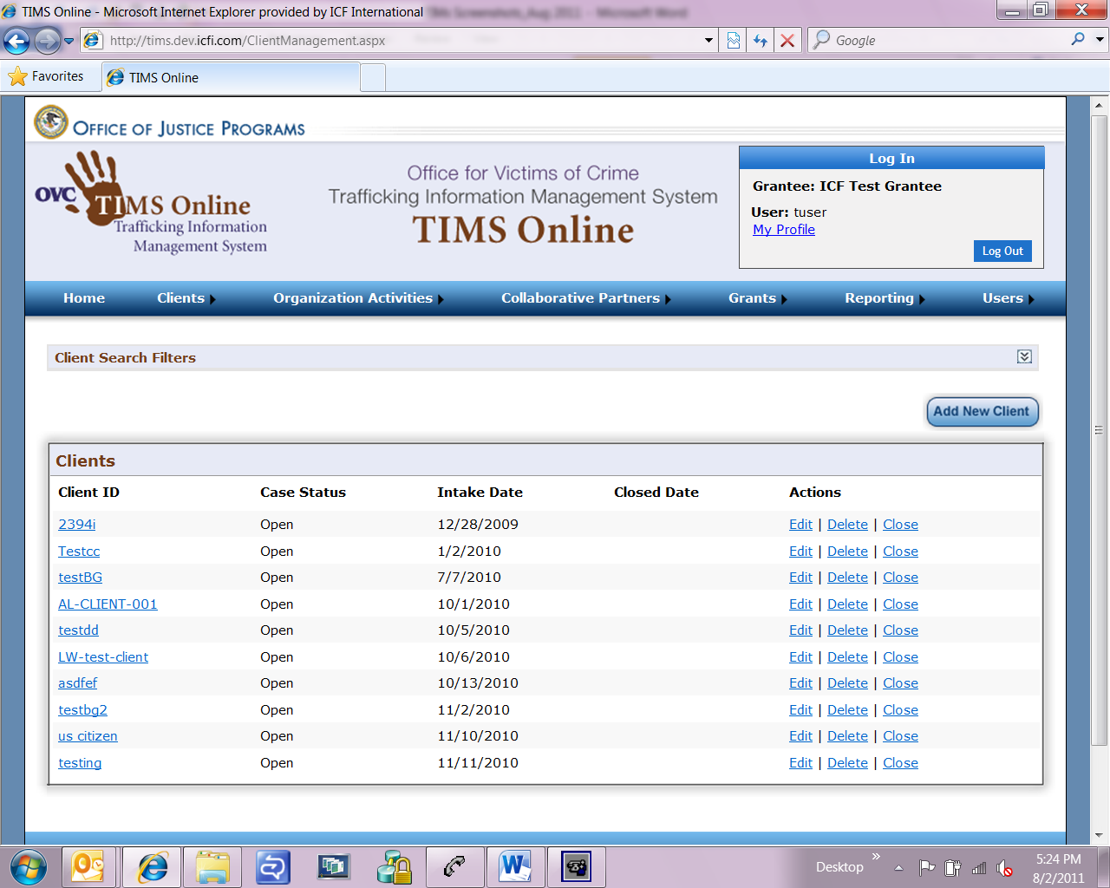

**Client Management 🡪 Identification (screen 1 of 2)**

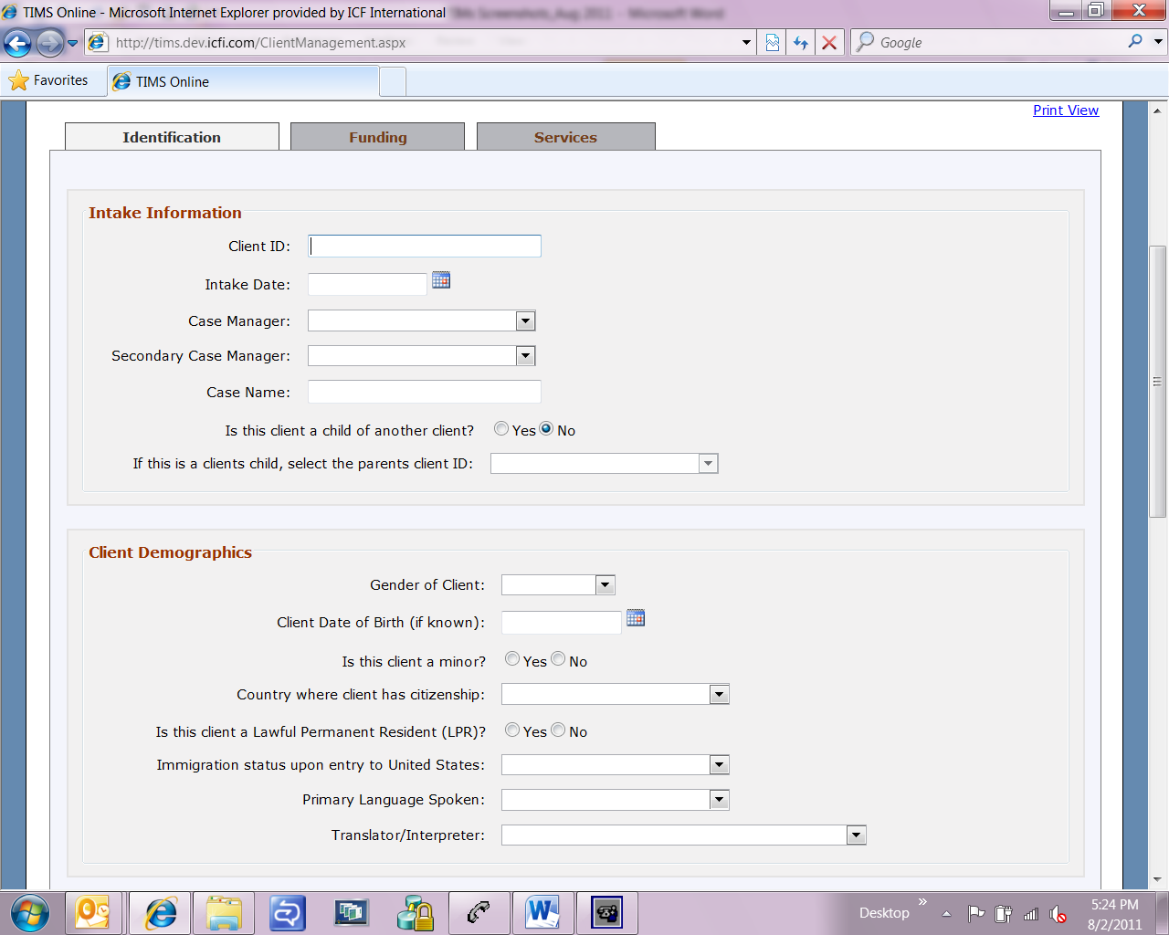

**Client Management 🡪 Identification (screen 2 of 2)**

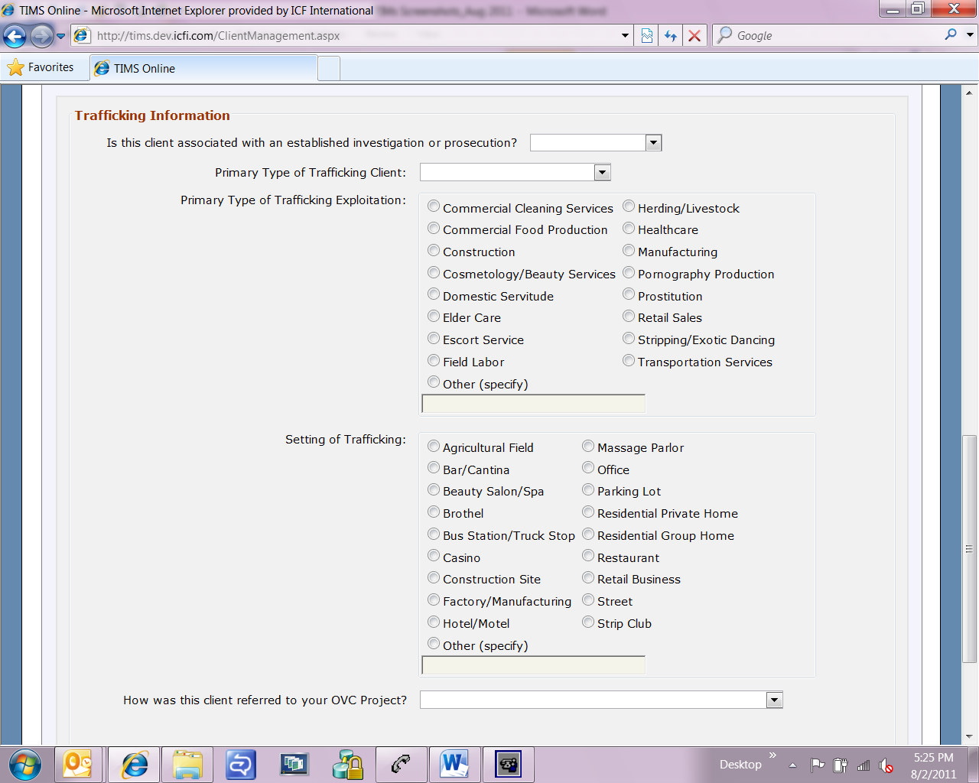

**Client Management 🡪 Funding (screen 1 of 4)**

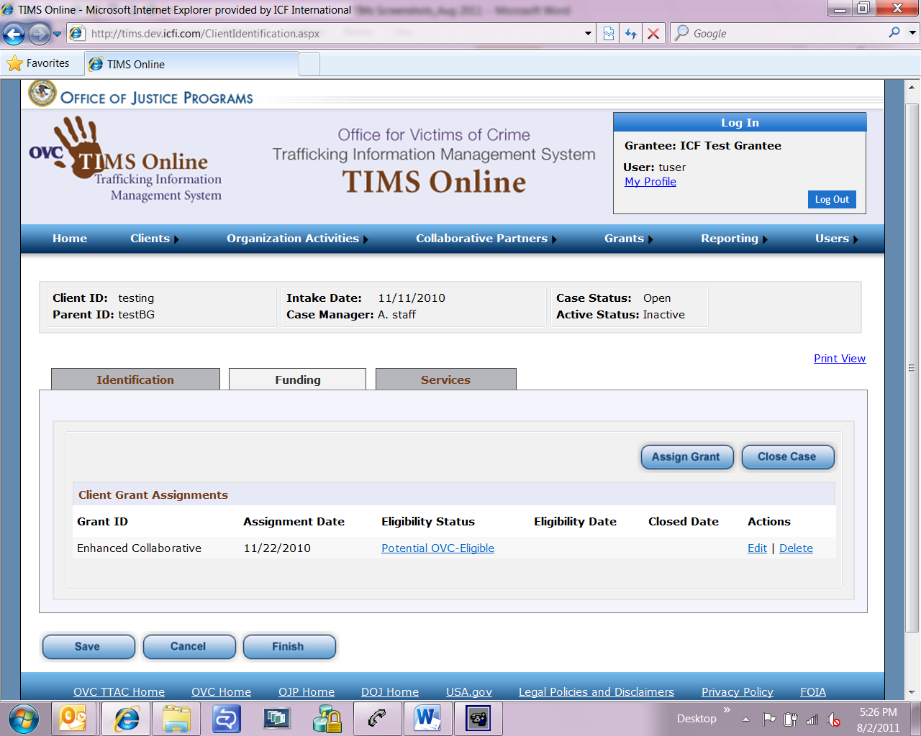

**Client Management 🡪 Funding (screen 2 of 4)**

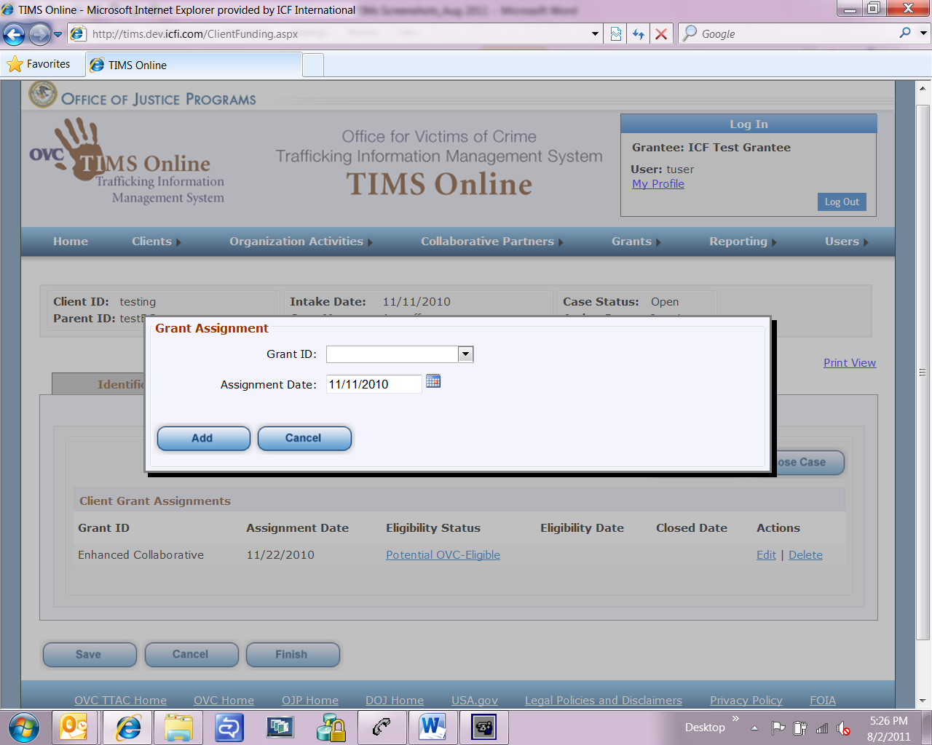

**Client Management 🡪 Funding (screen 3 of 4)**

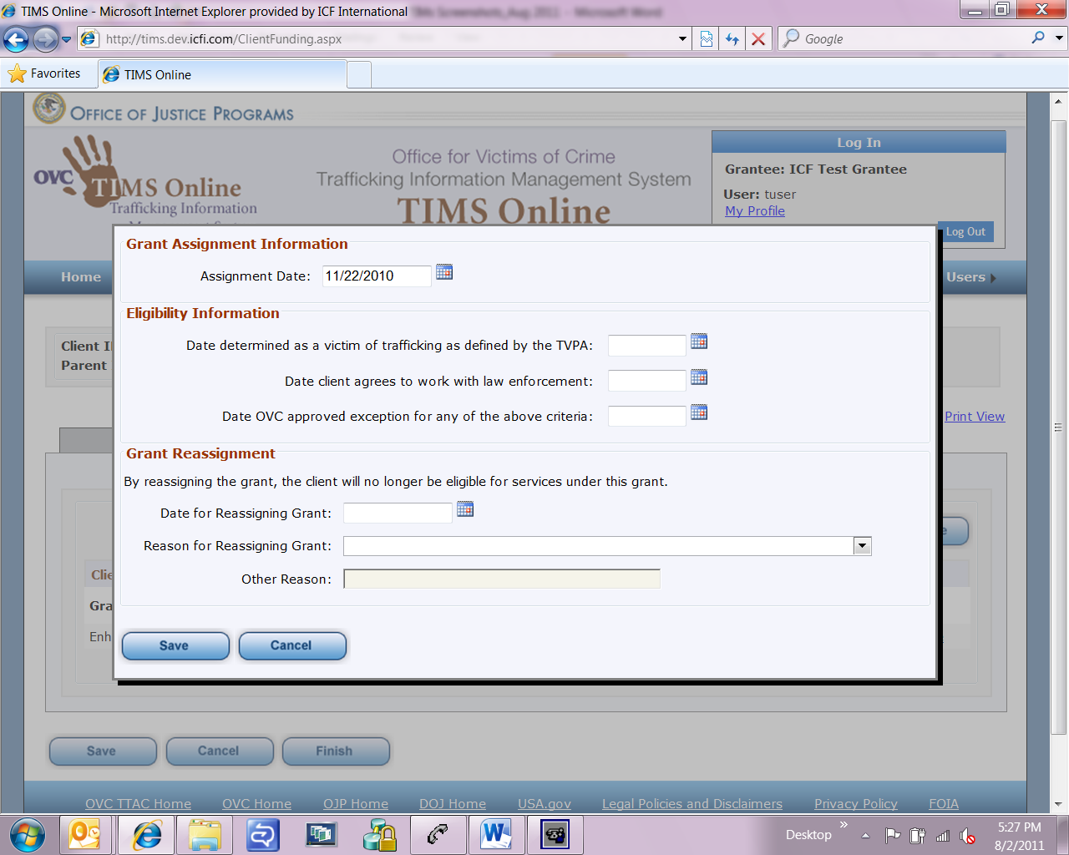

**Client Management 🡪 Funding (screen 4 of 4)**

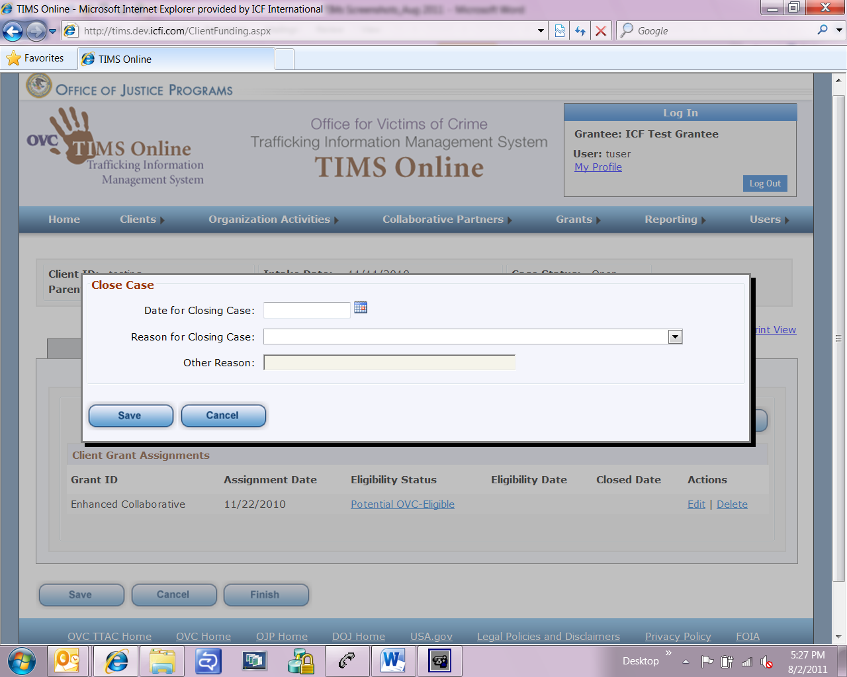

**Client Management 🡪 Services 🡪 Service Provision (screen 1 of 2)**

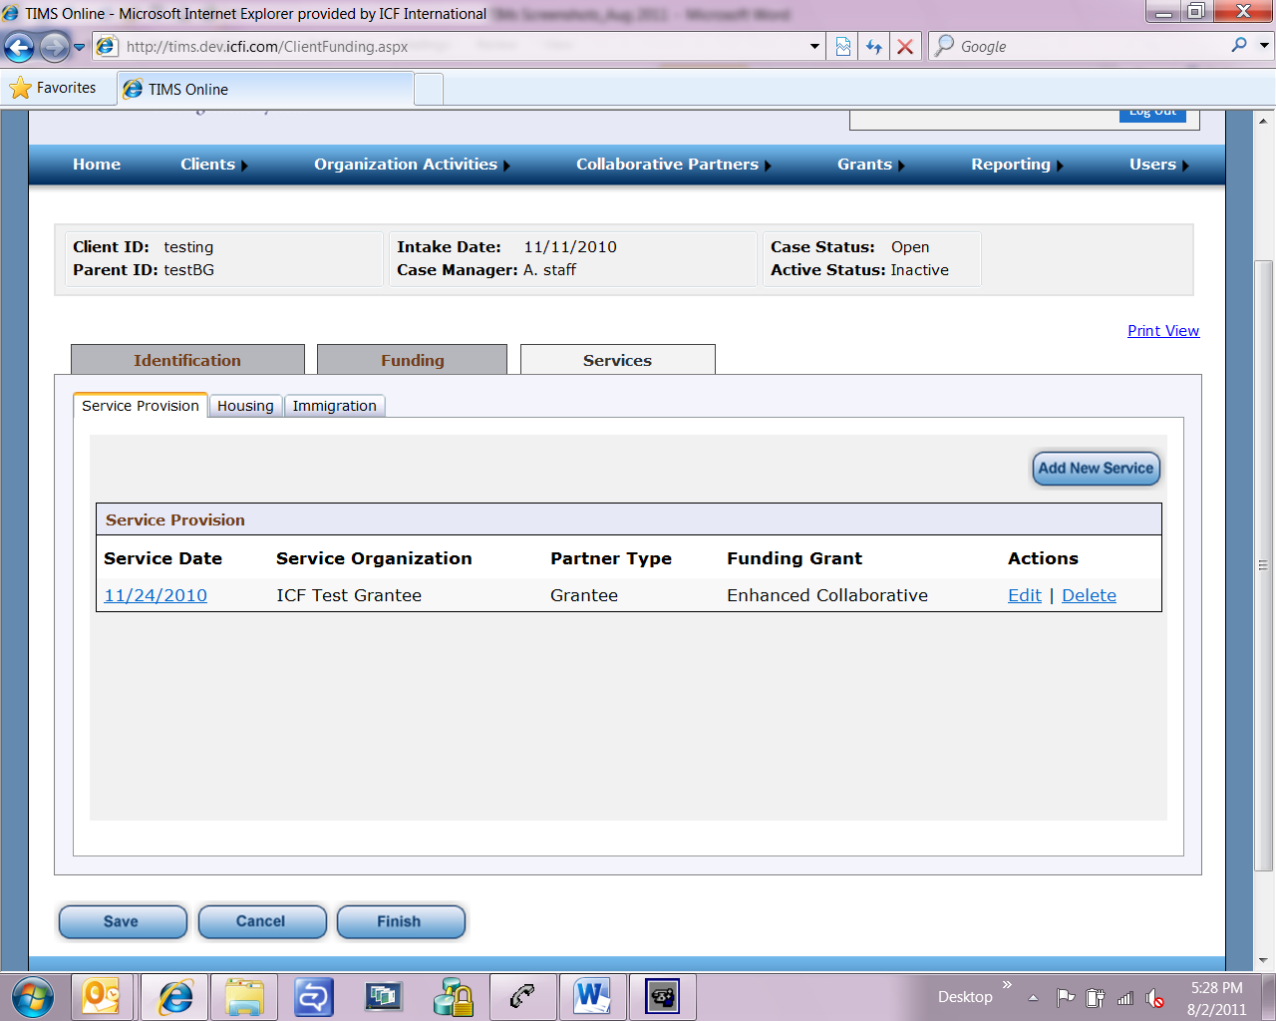

**Client Management 🡪 Services 🡪 Service Provision (screen 2 of 2)**

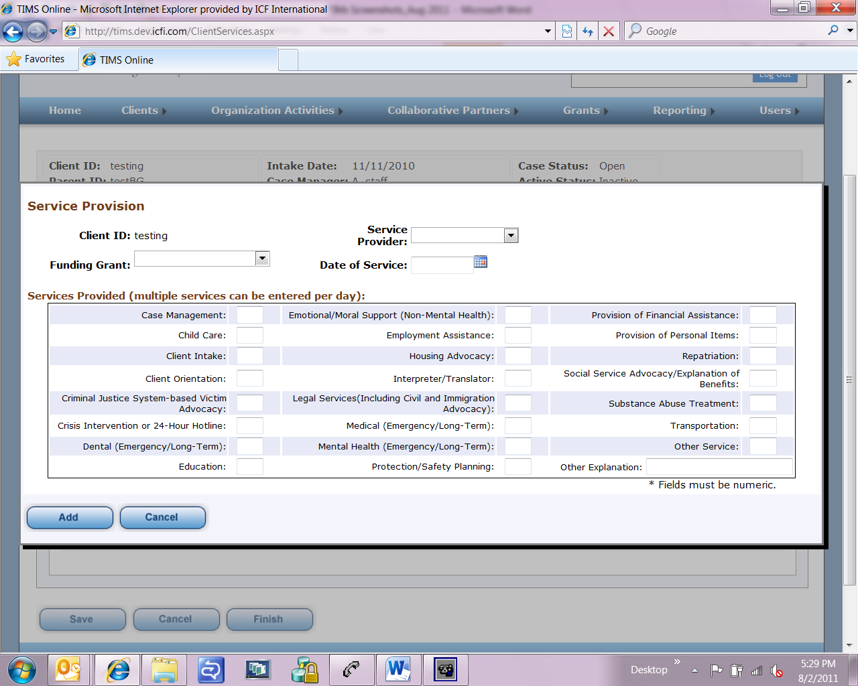

**Client Management 🡪 Services 🡪 Housing (screen 1 of 2)**

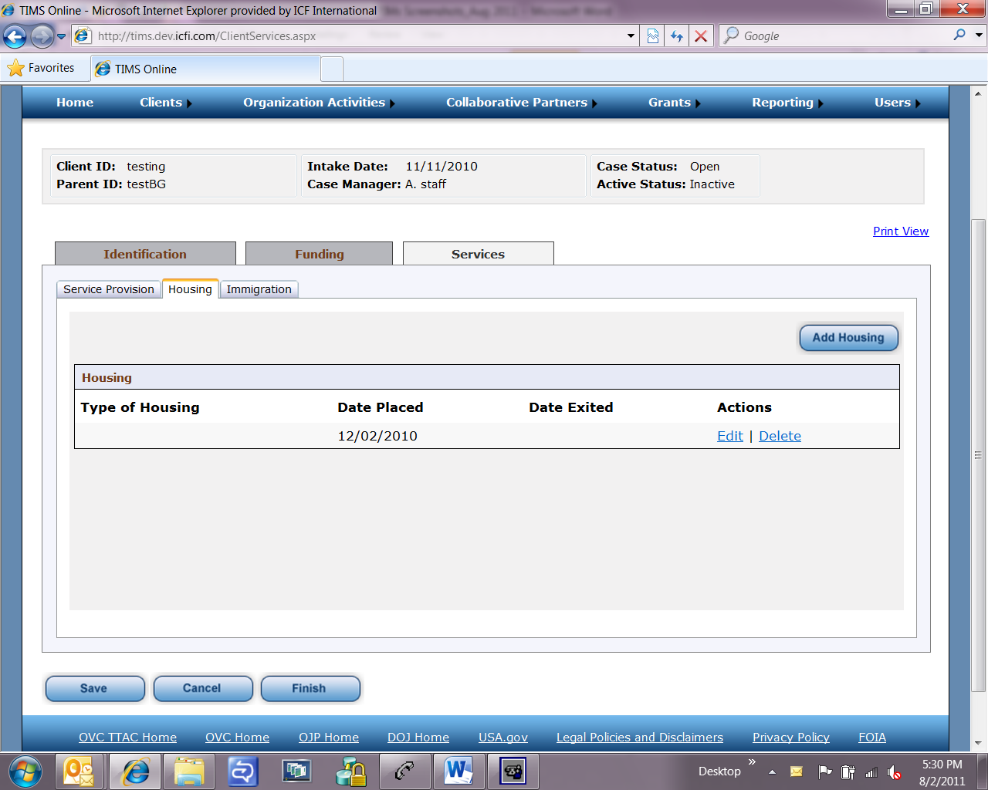

**Client Management 🡪 Services 🡪 Housing (screen 2 of 2)**

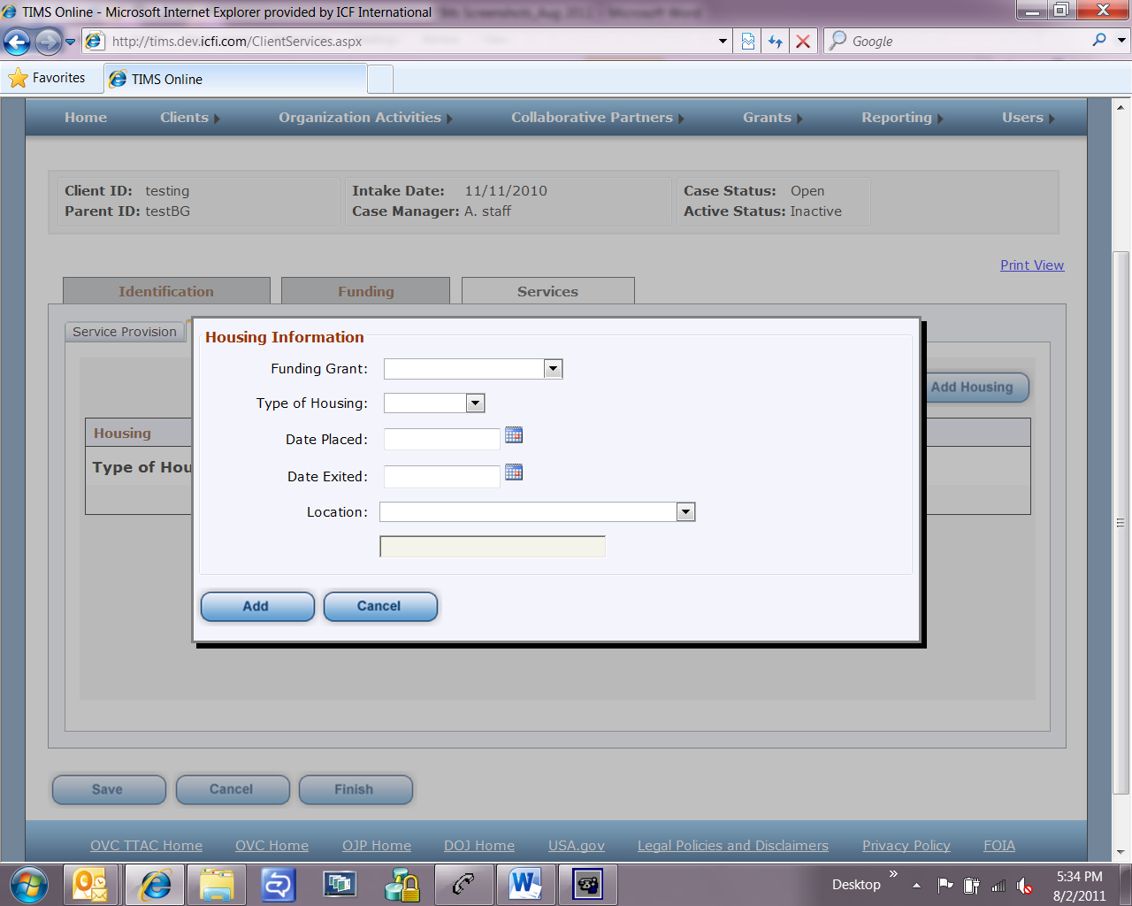

**Client Management 🡪 Services 🡪 Immigration**

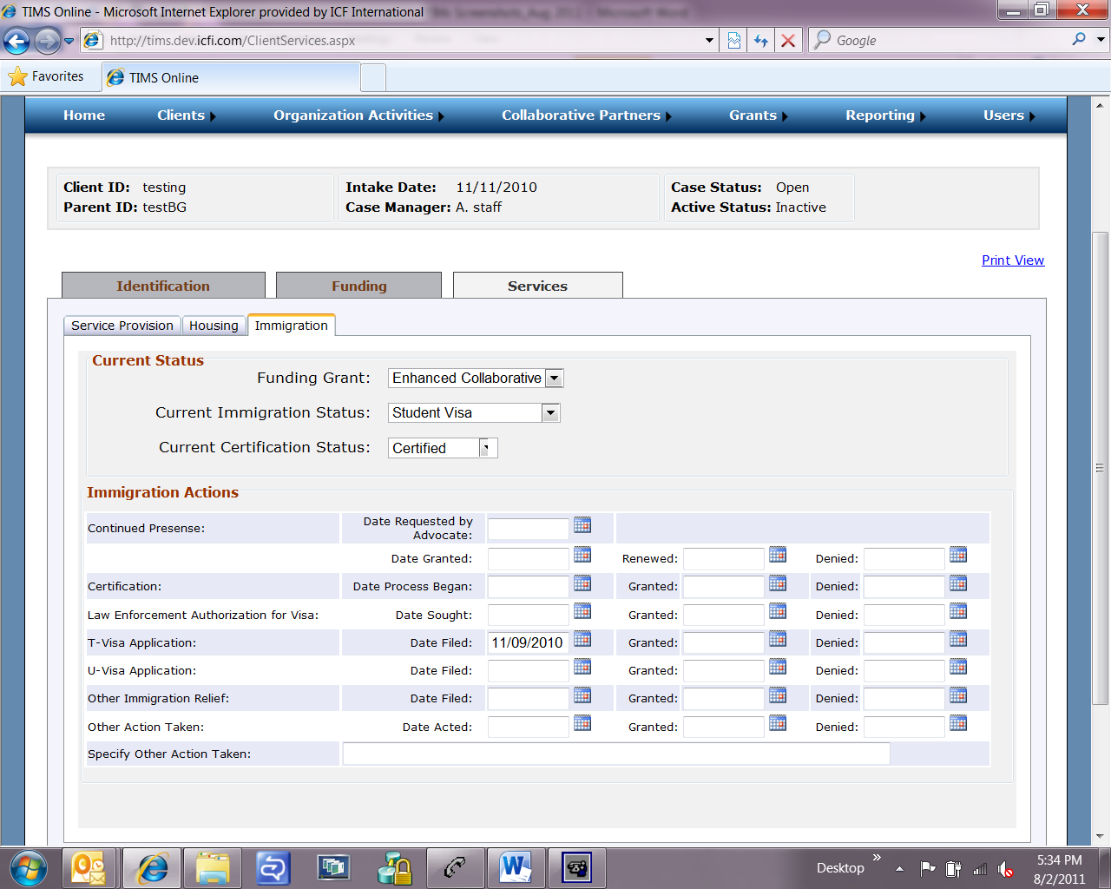

**Organization Activities 🡪 Training (screen 1 of 3)**

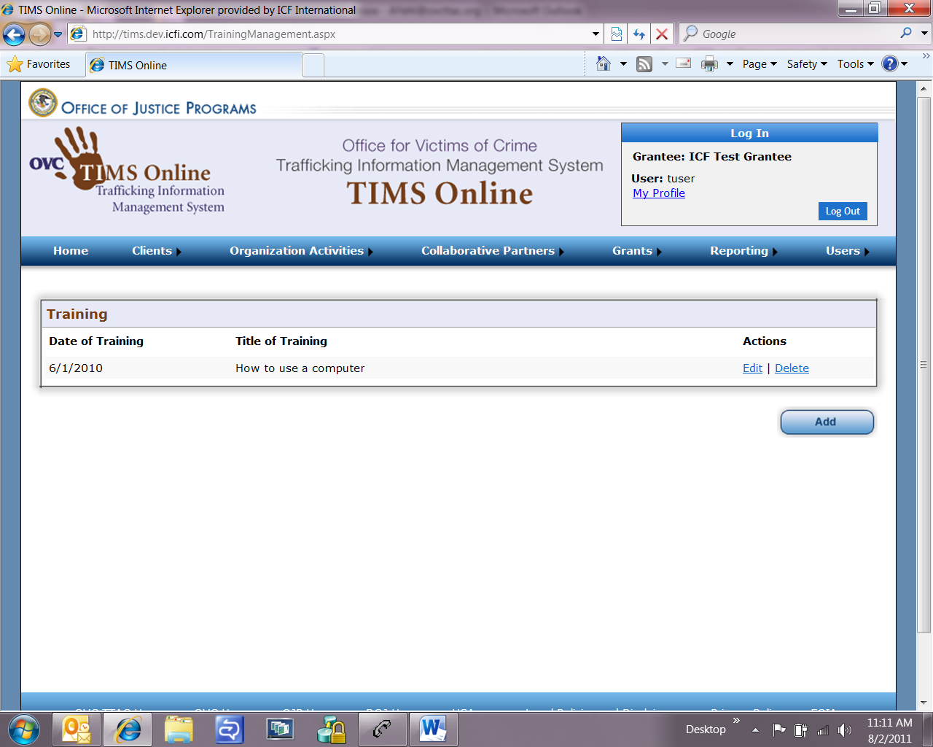

**Organization Activities 🡪 Training (screen 2 of 3)**

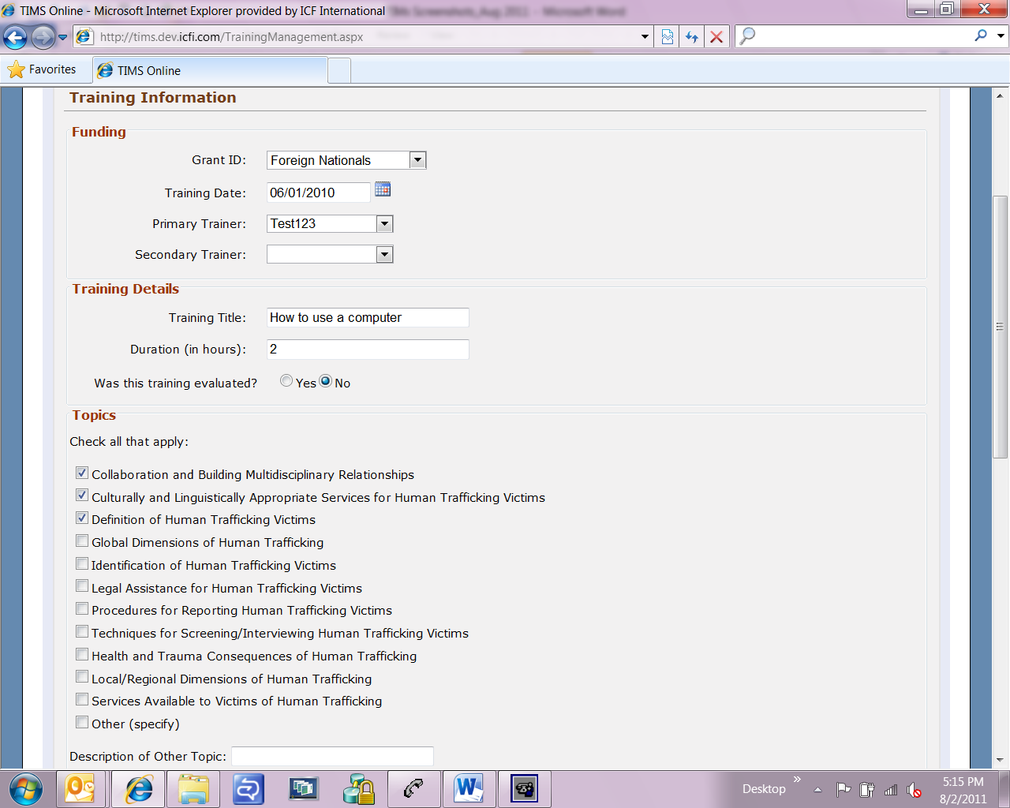

**Organization Activities 🡪 Training (screen 3 of 3)**

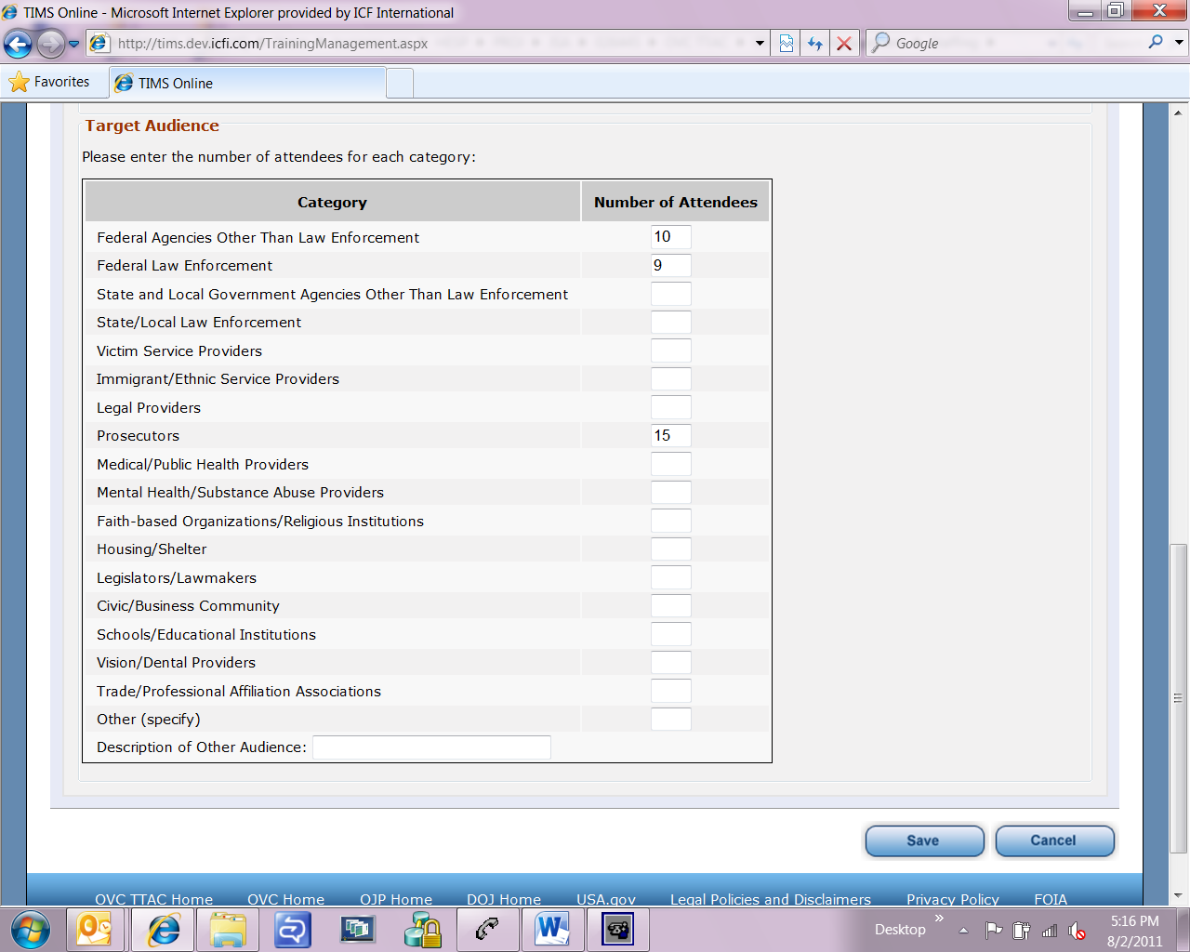

**Organization Activities 🡪 Community Outreach (screen 1 of 2)**

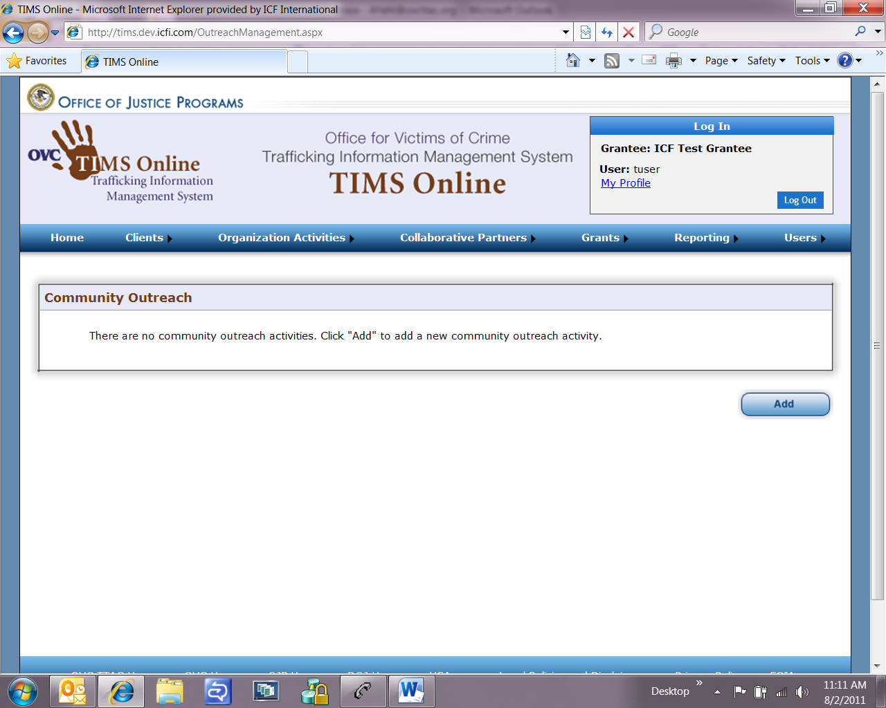

**Organization Activities 🡪 Community Outreach**

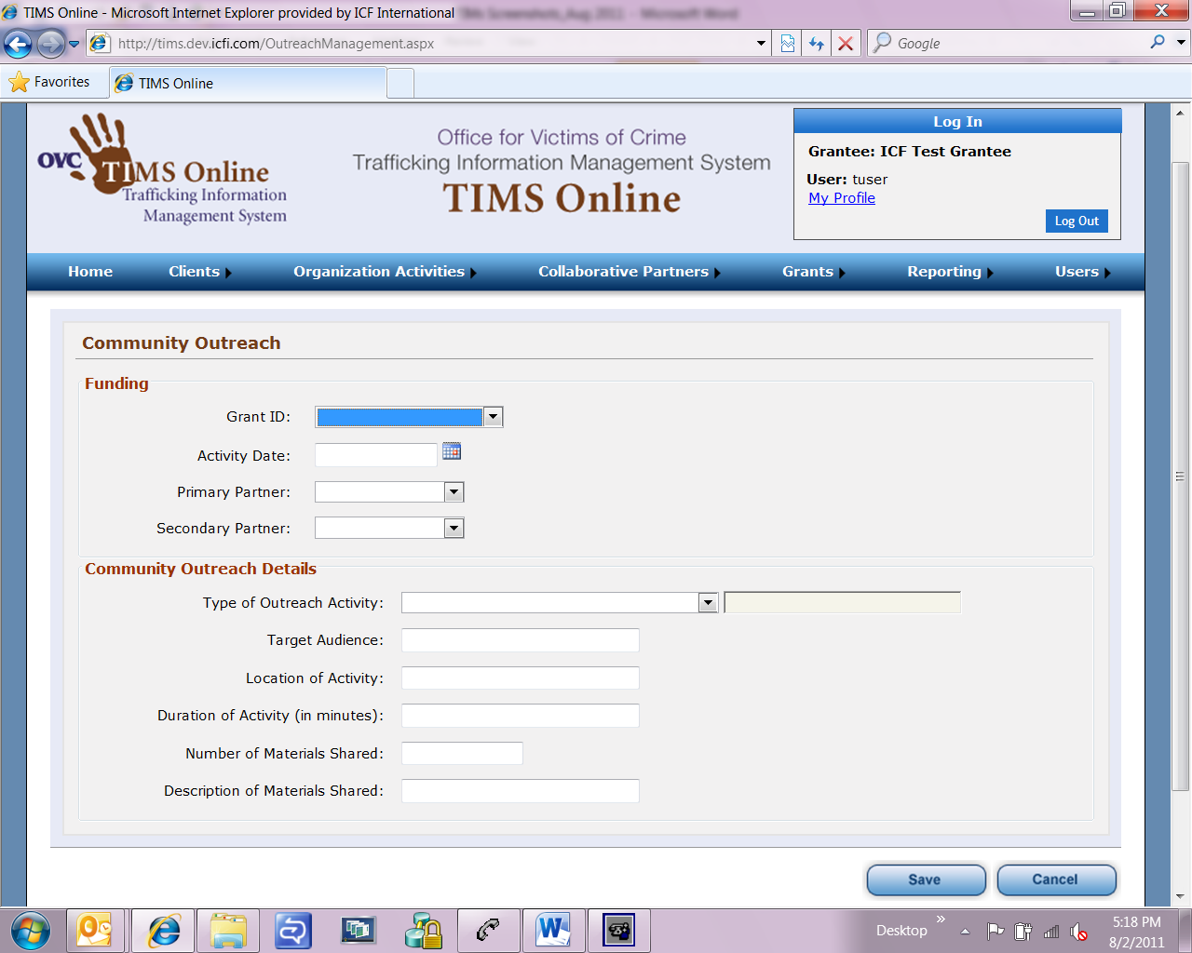

**Organization Activities 🡪 Technical Assistance (screen 1 of 2)**

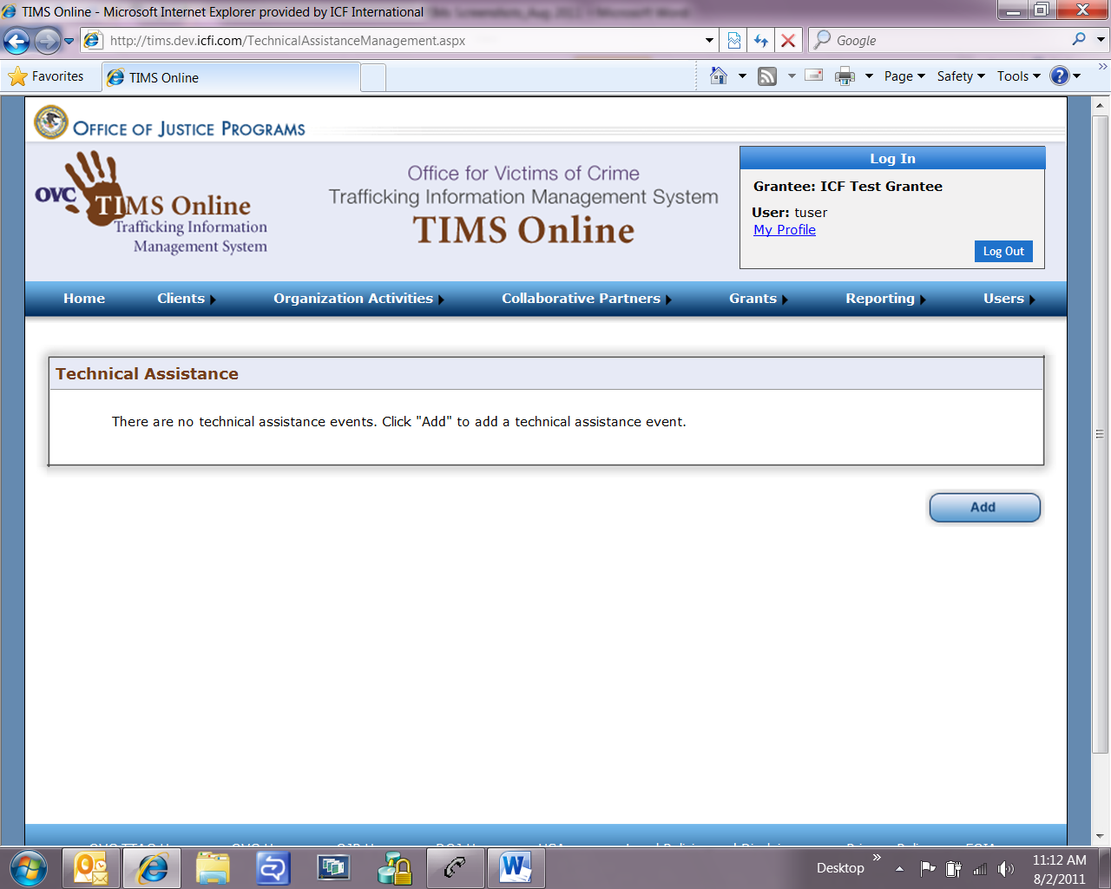

**Organization Activities 🡪 Technical Assistance (screen 2 of 2)**

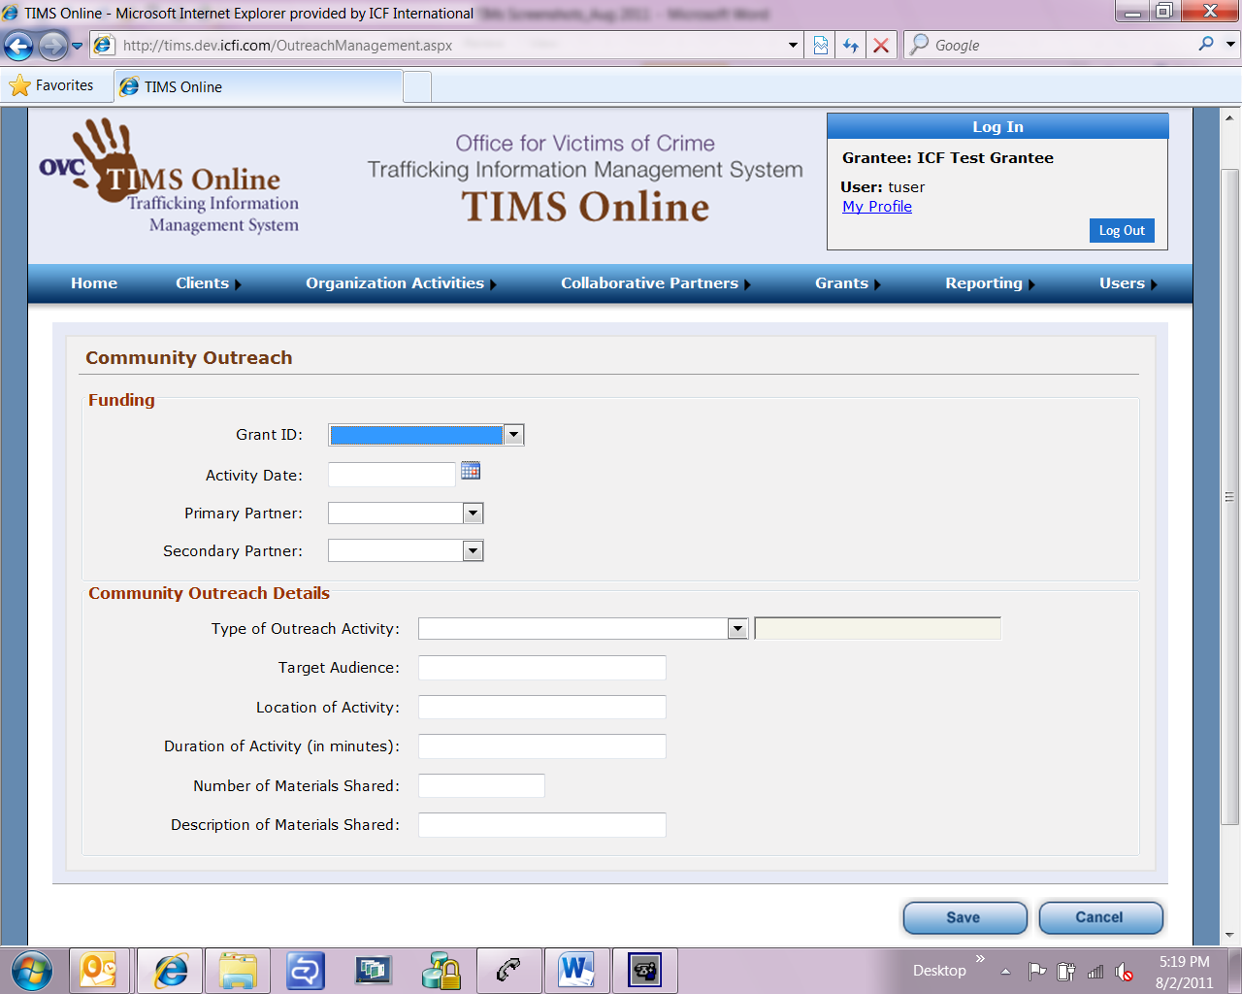

**Collaborative Partners 🡪 Partner Management (screen 1 of 2)**

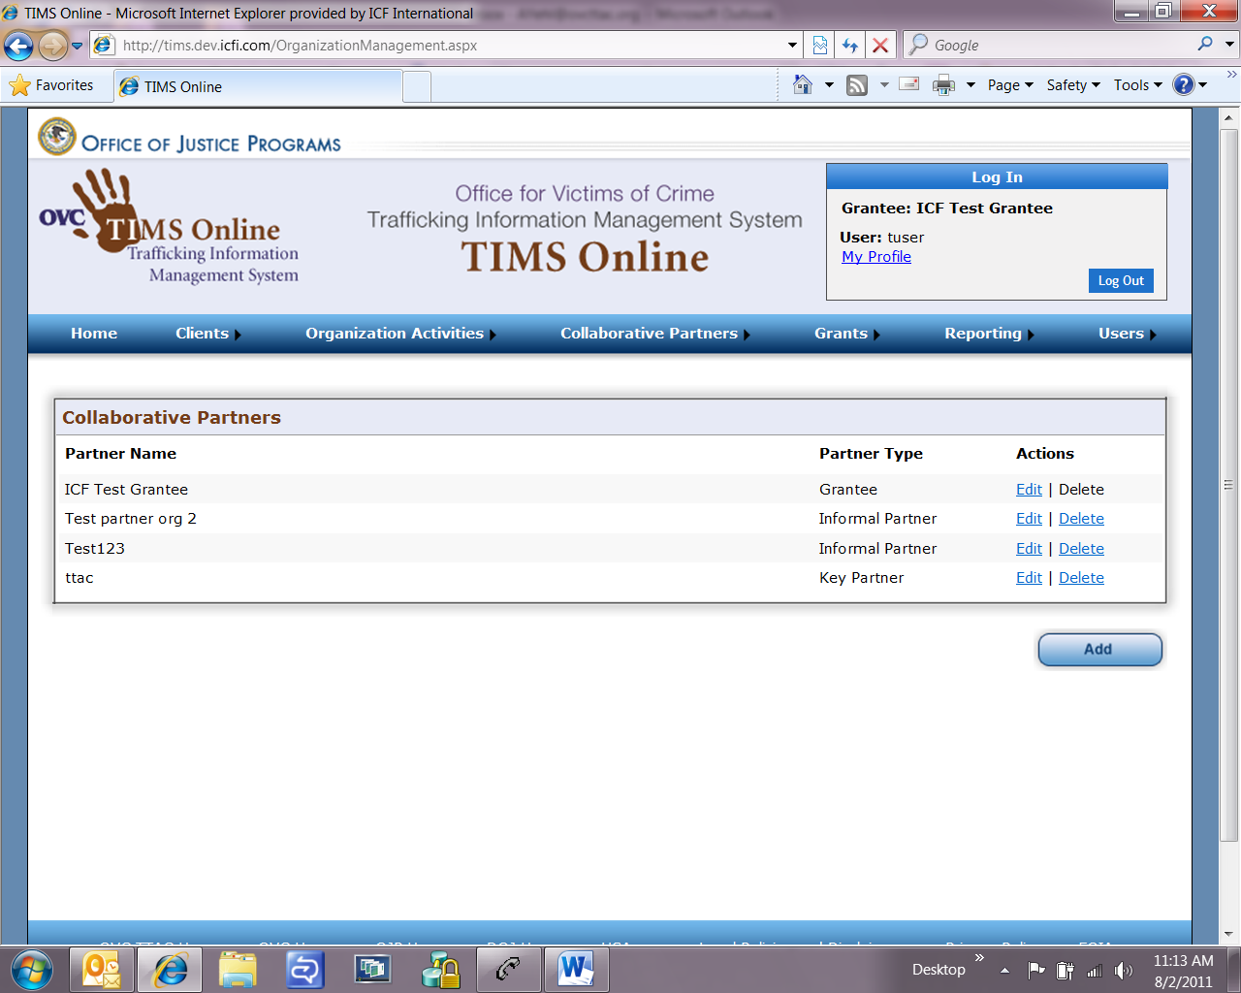

**Collaborative Partners 🡪 Partner Management (screen 2 of 2)**

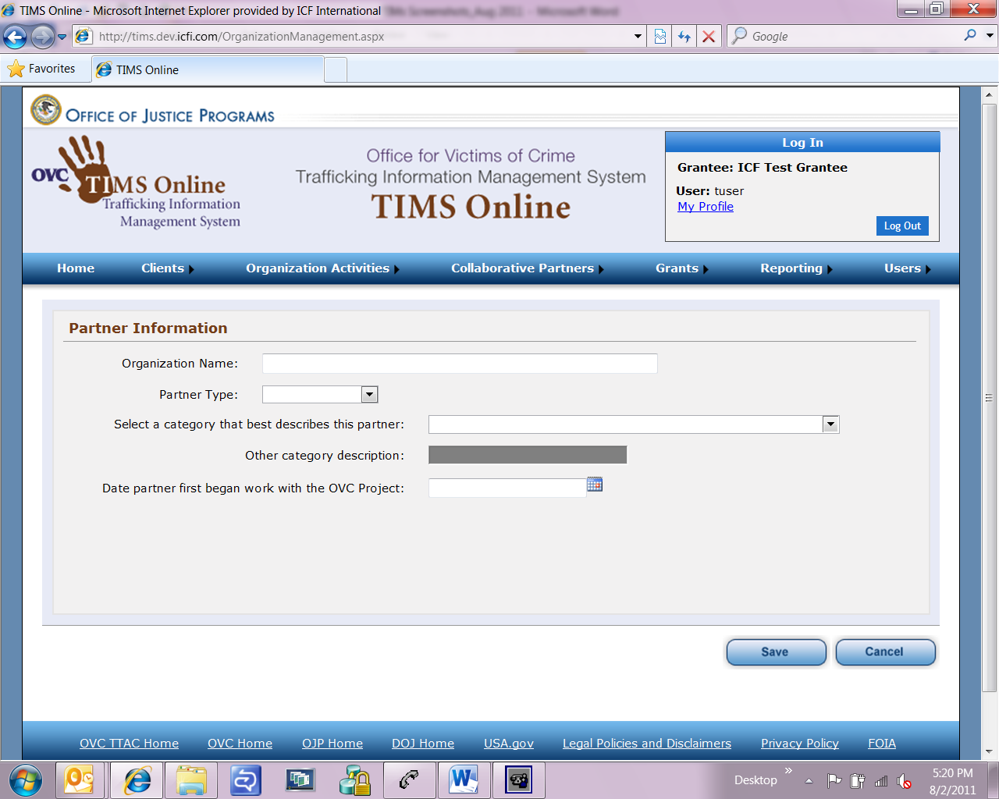

**Grants 🡪 Grant Management (screen 1 of 2)**

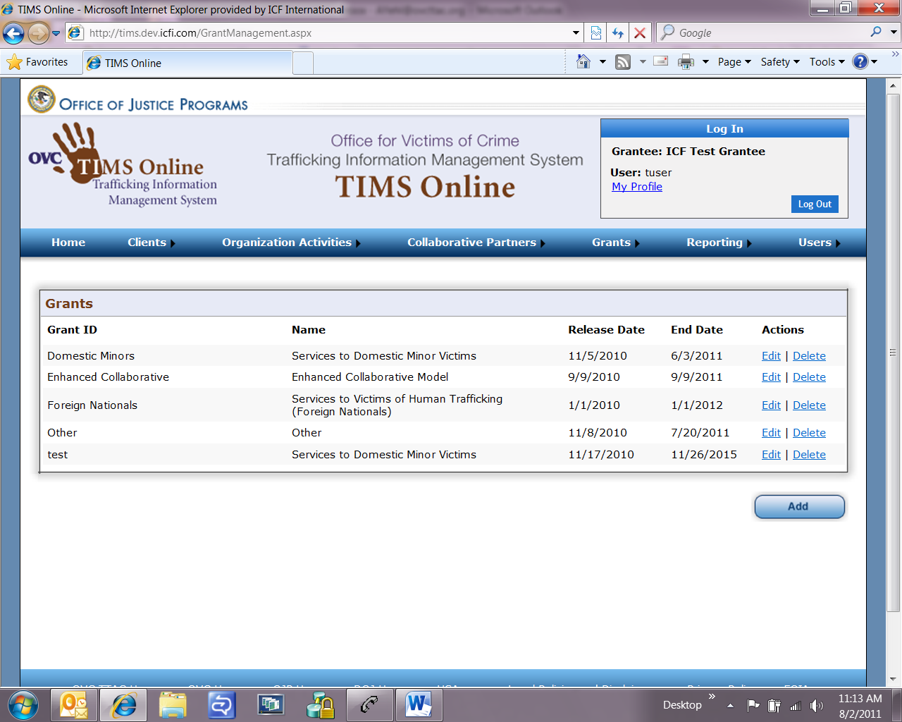

**Grants 🡪 Grant Management (screen 2 of 2)**

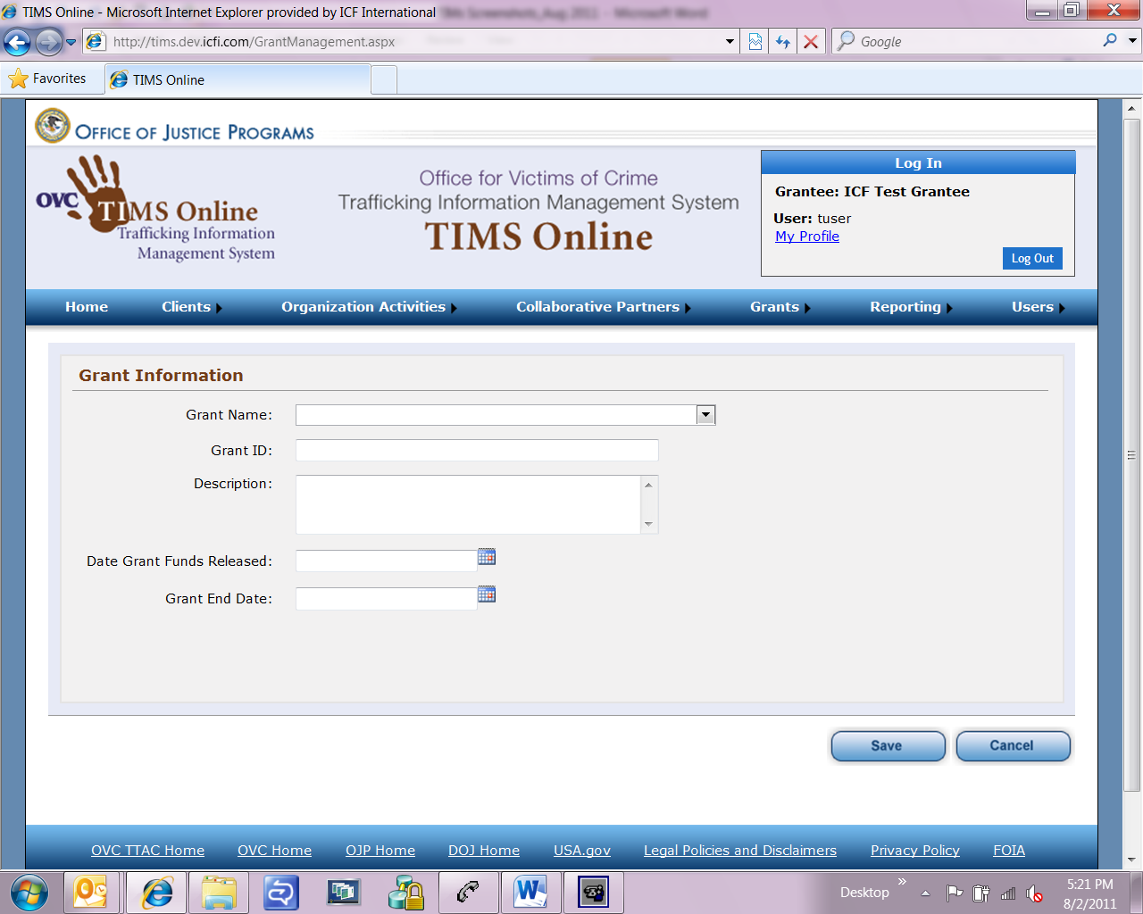

**Users 🡪 Case Manager Management (screen 1 of 2)**



**Users 🡪 Case Manager Management (screen 2 of 2)**

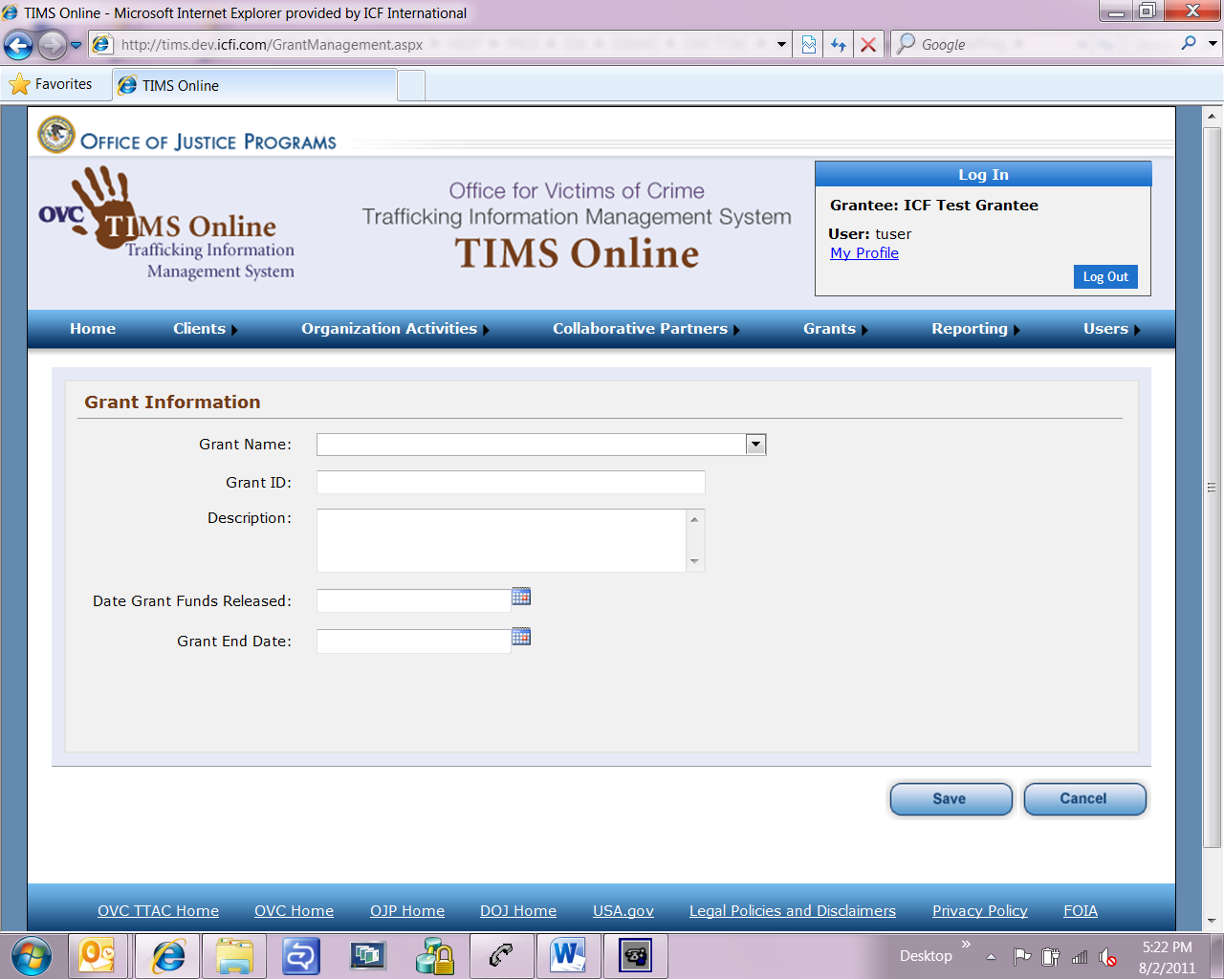

**My Profile**

