Screenshots of TIMS Online for OMB Submission

Landing Page
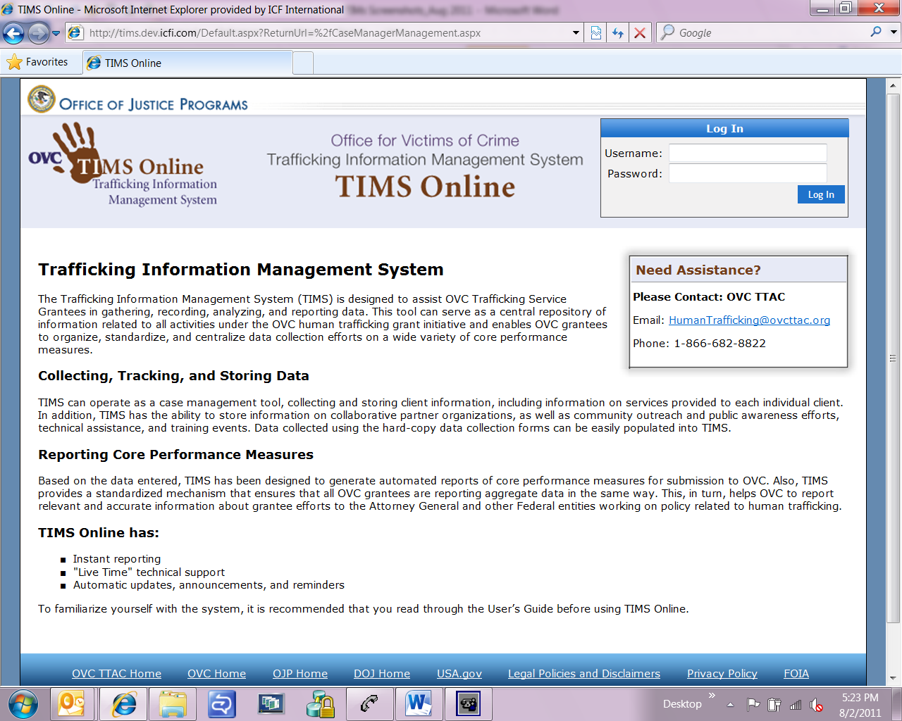

Home Page
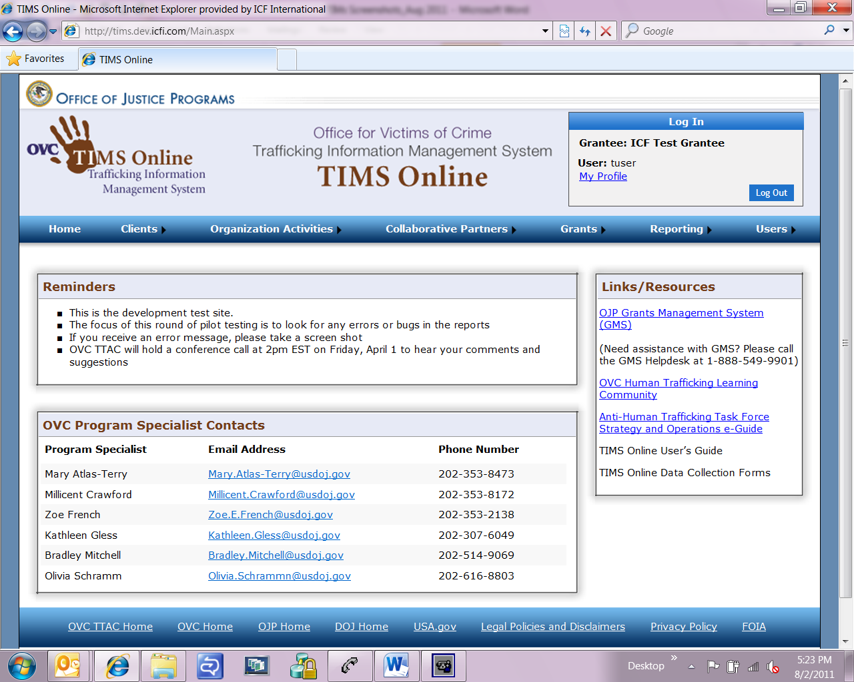

Clients Client Management
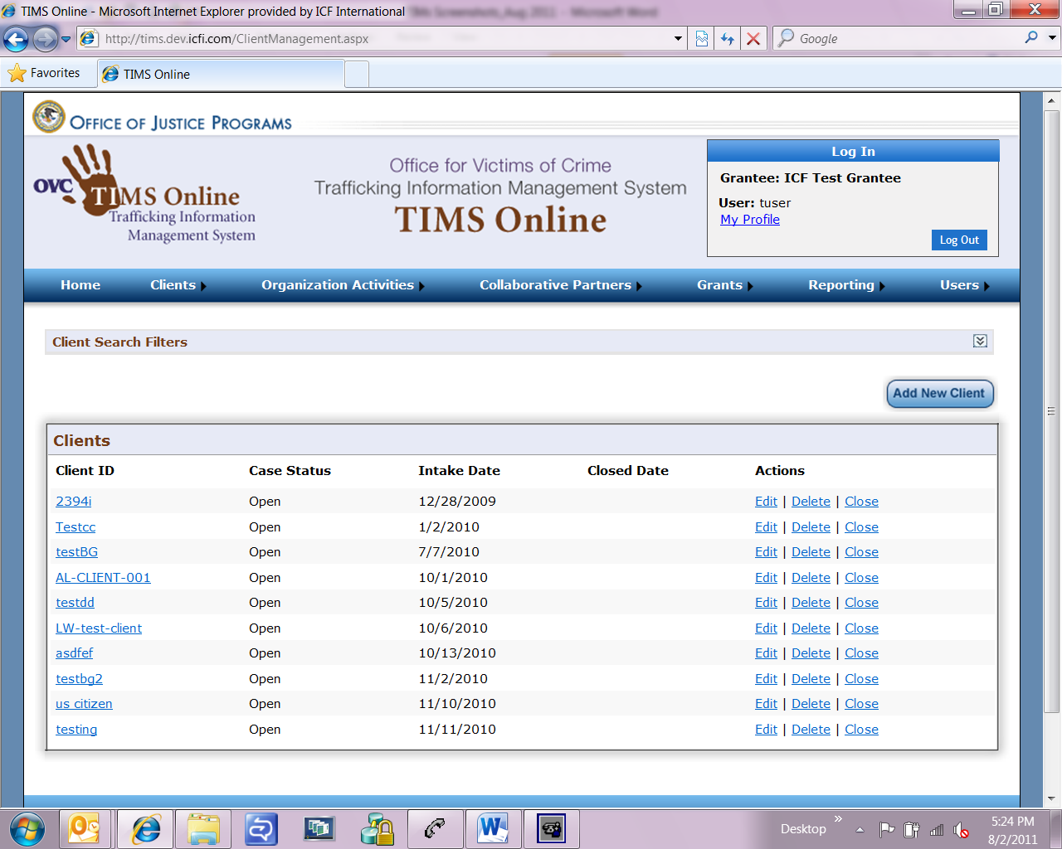

Client Management Identification (screen 1 of 2)
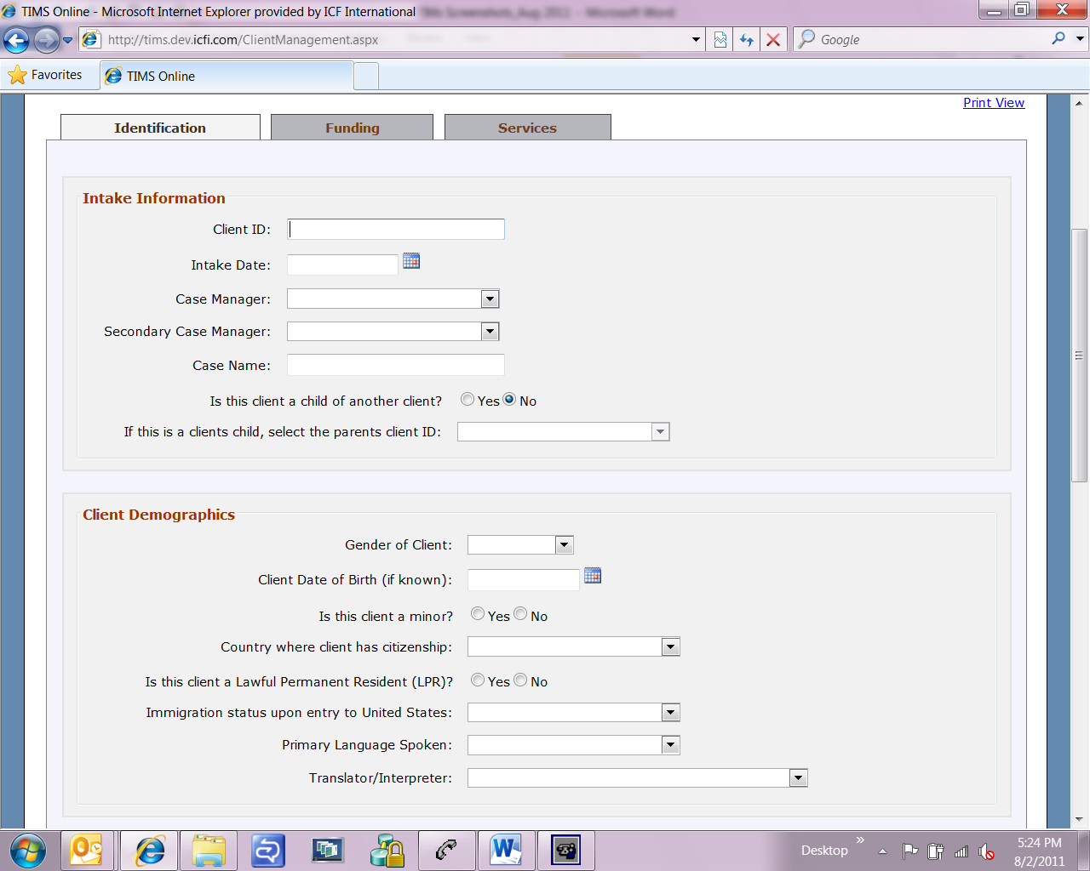

Client Management Identification (screen 2 of 2)
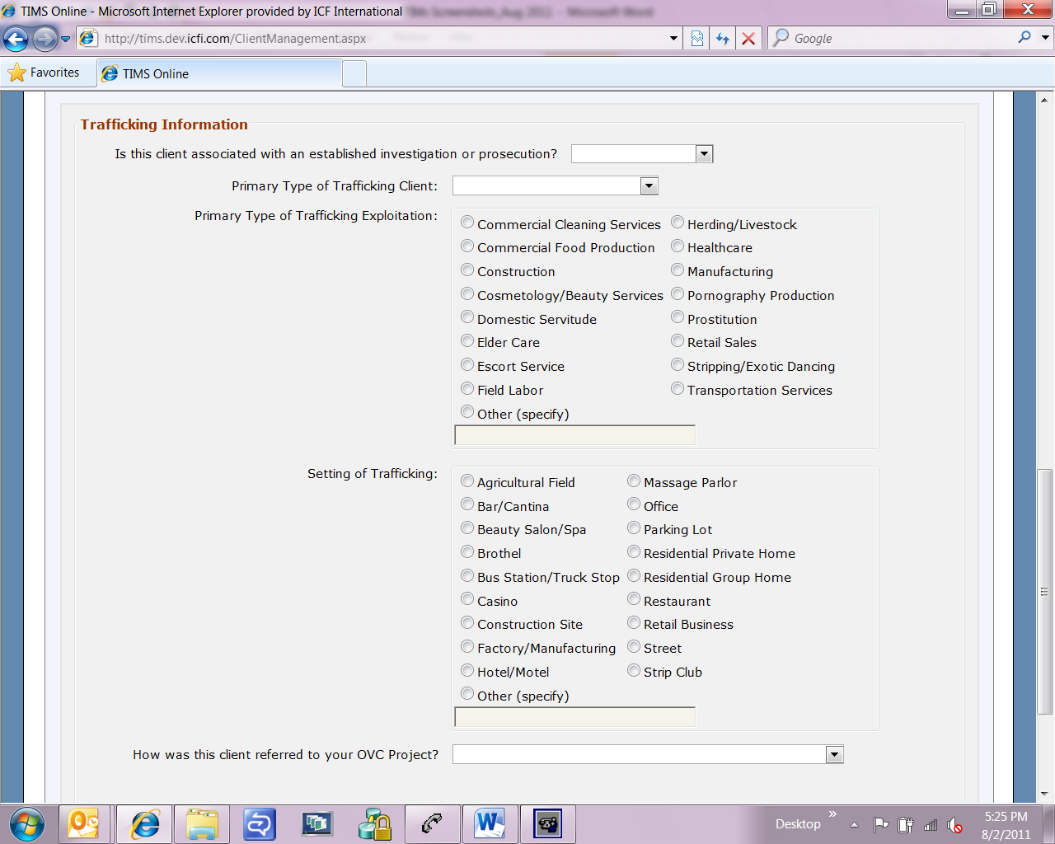

Client Management Funding (screen 1 of 4)
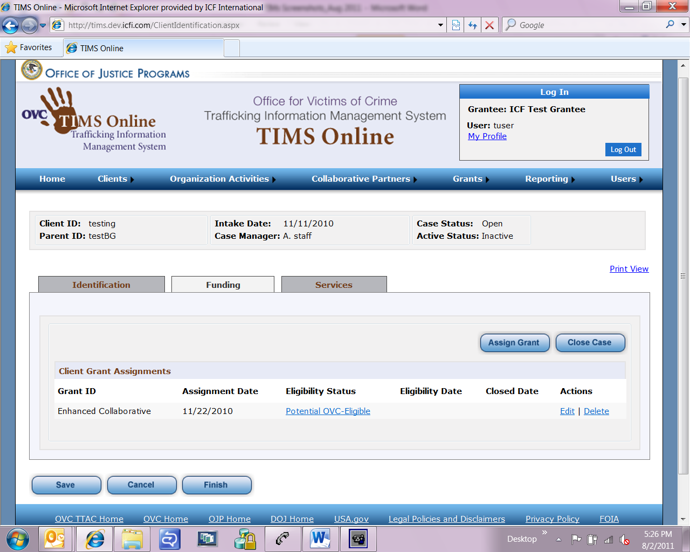

Client Management Funding (screen 2 of 4)
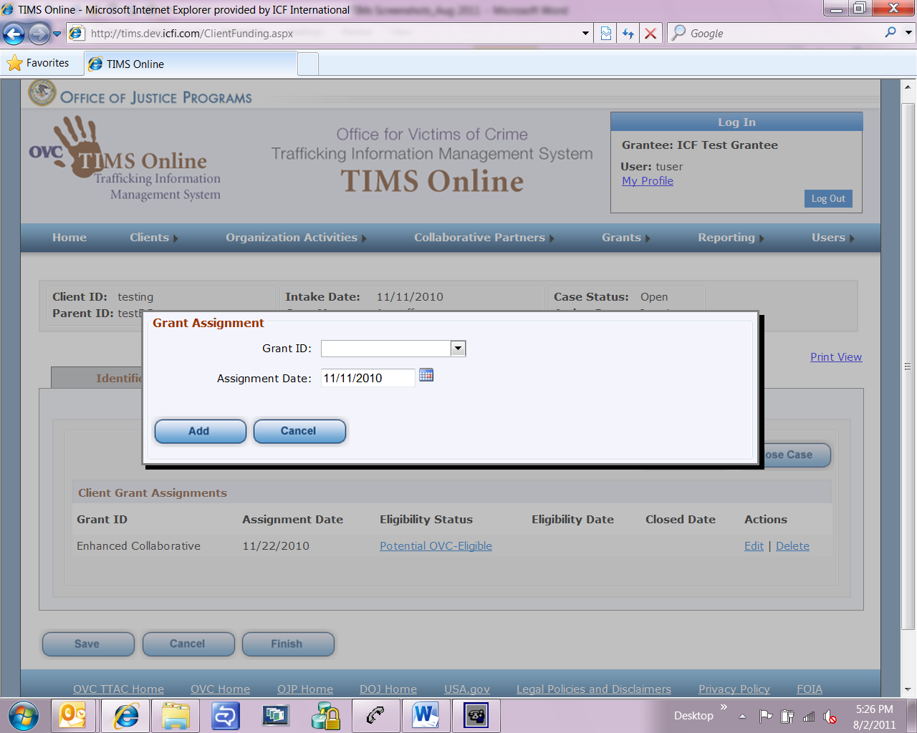

Client Management Funding (screen 3 of 4)
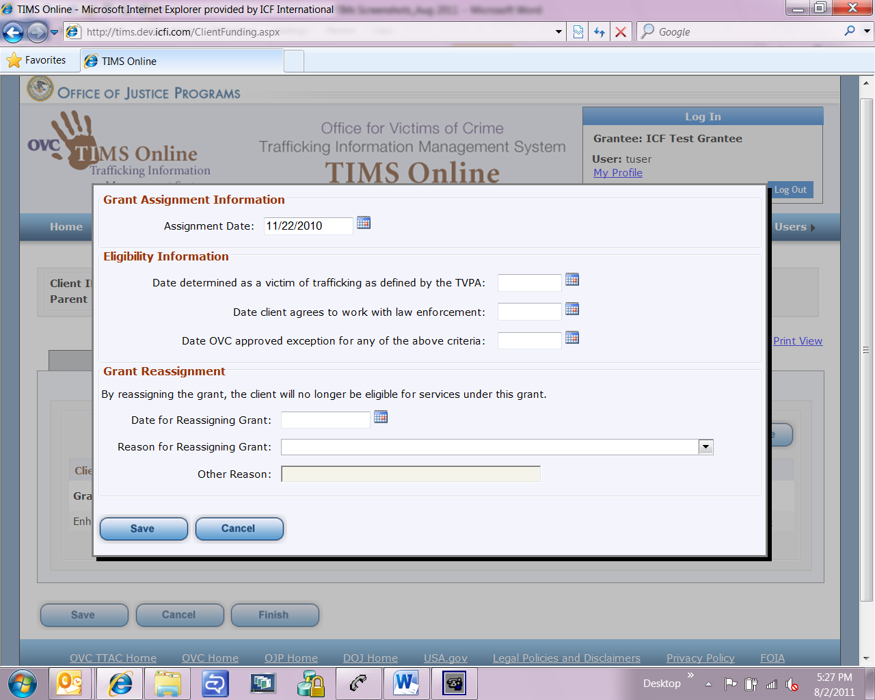

Client Management Funding (screen 4 of 4)
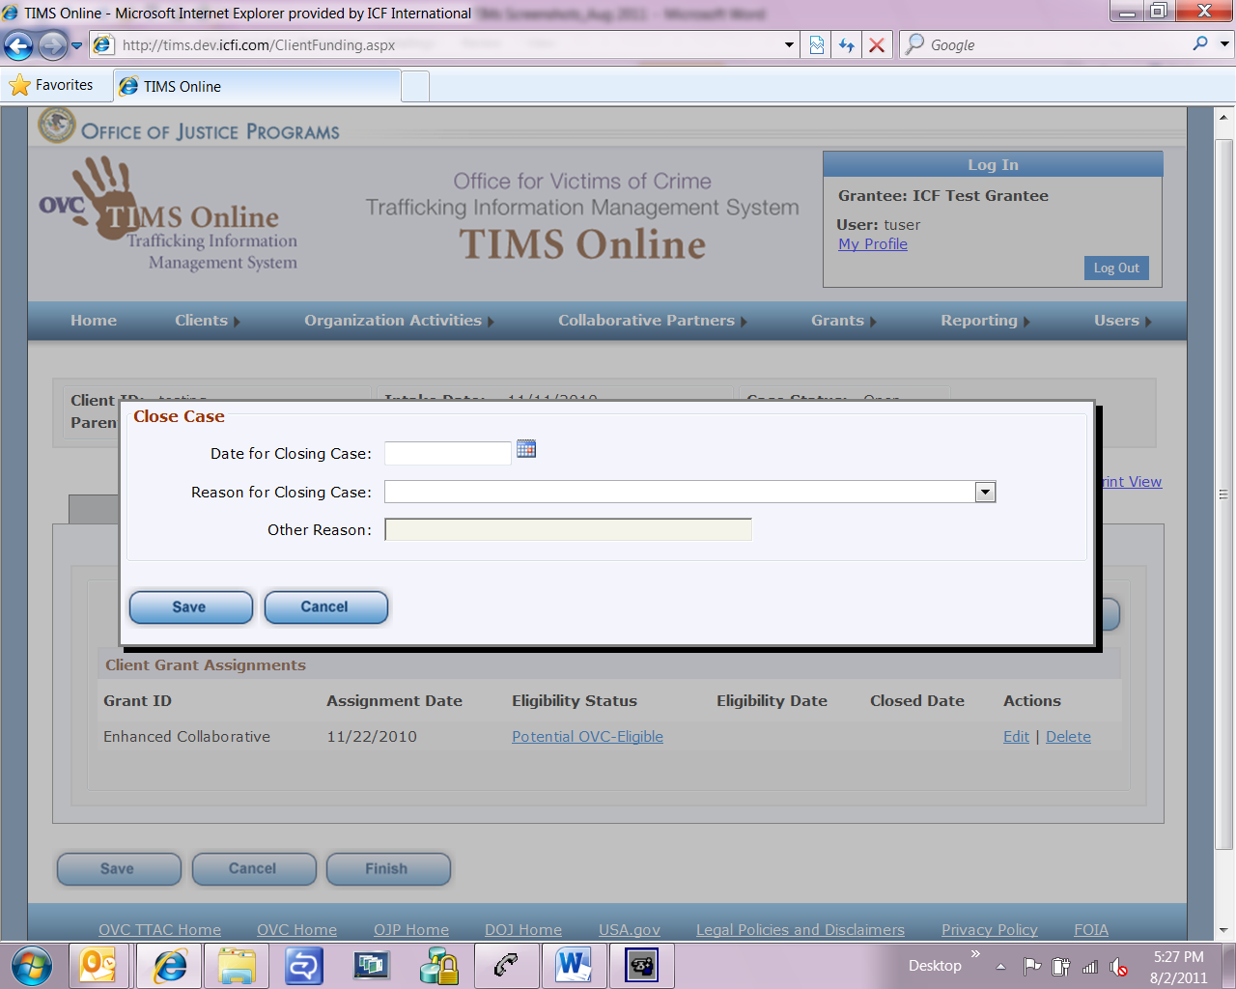

Client Management Services Service Provision (screen 1 of 2)
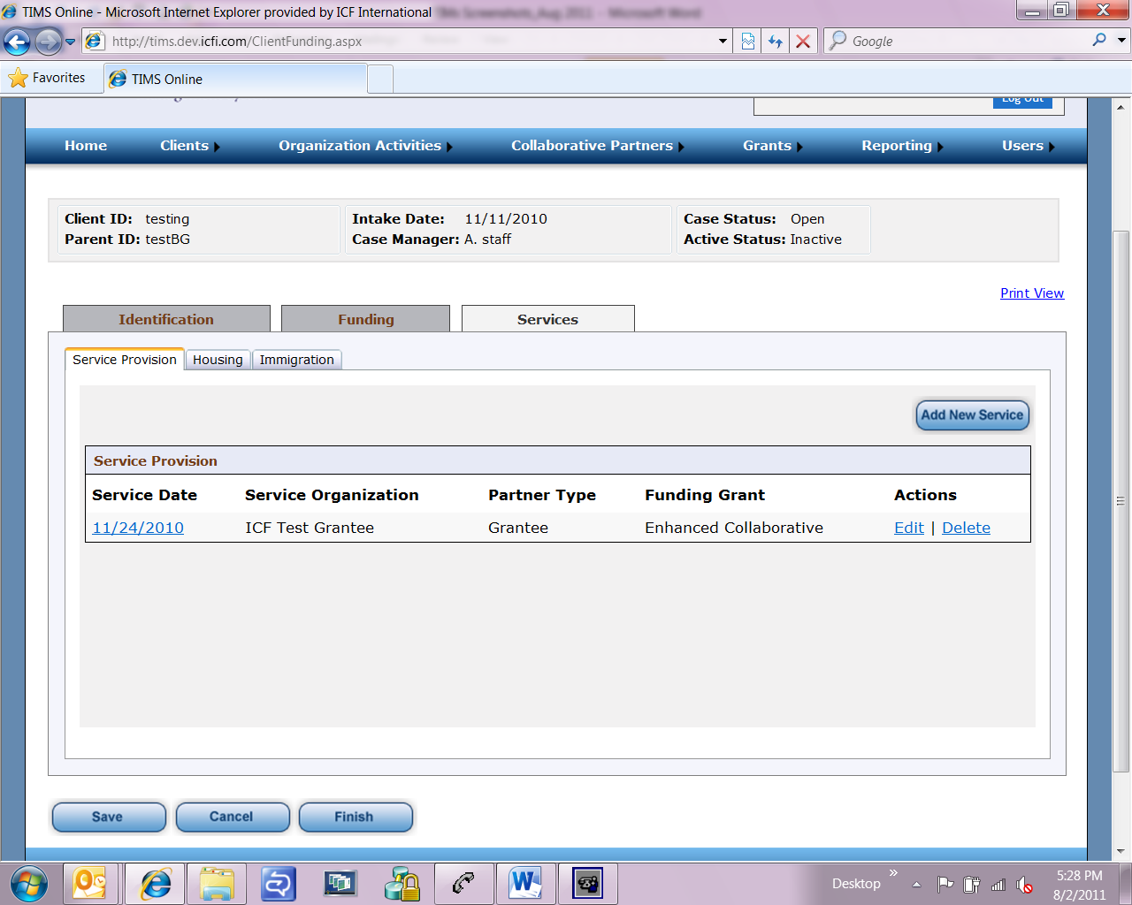

Client Management Services Service Provision (screen 2 of 2)
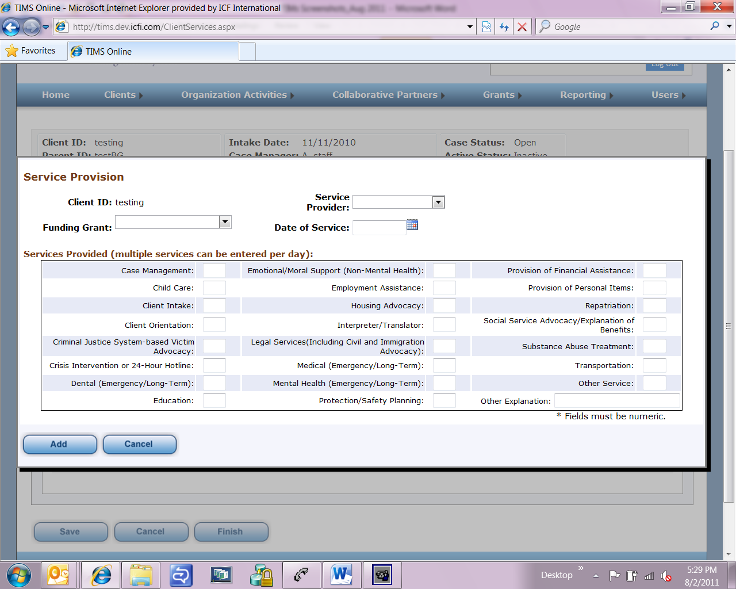

Client Management Services Housing (screen 1 of 2)
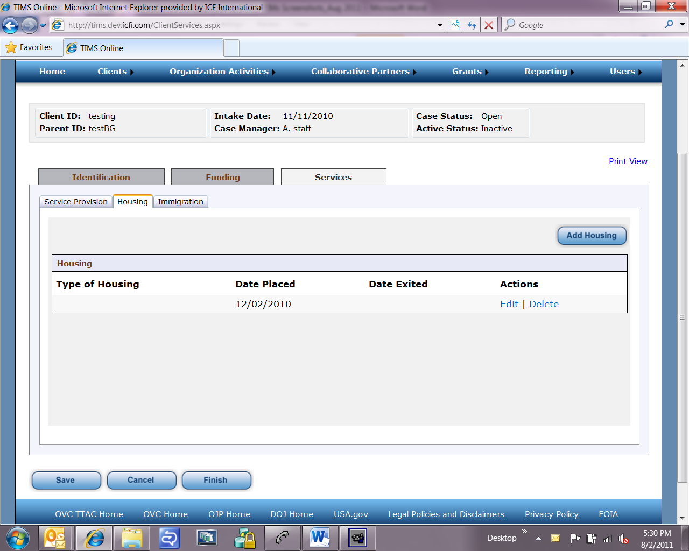

Client Management Services Housing (screen 2 of 2)
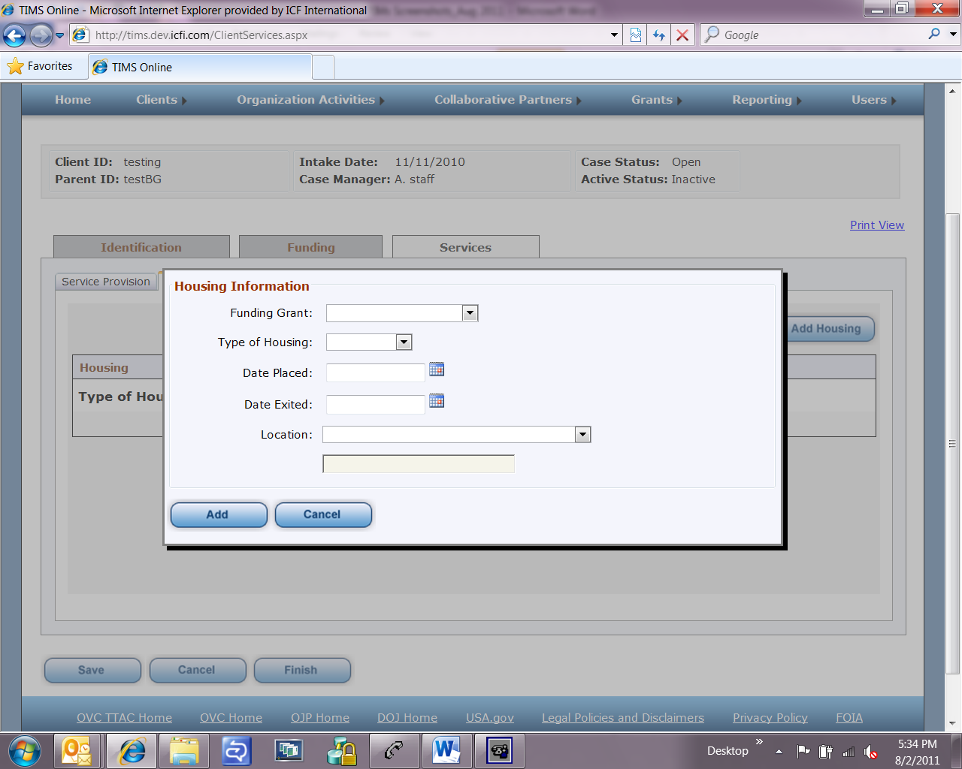

Client Management Services Immigration
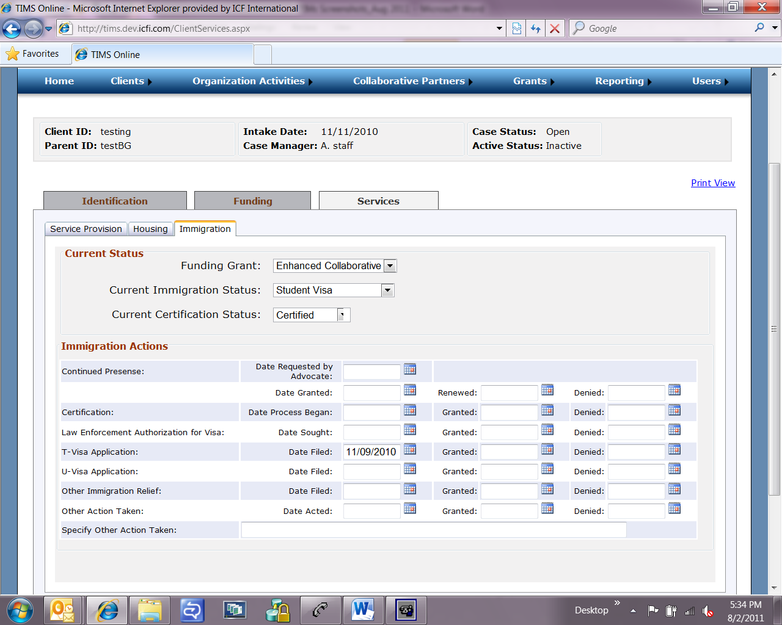

Organization Activities Training (screen 1 of 3)
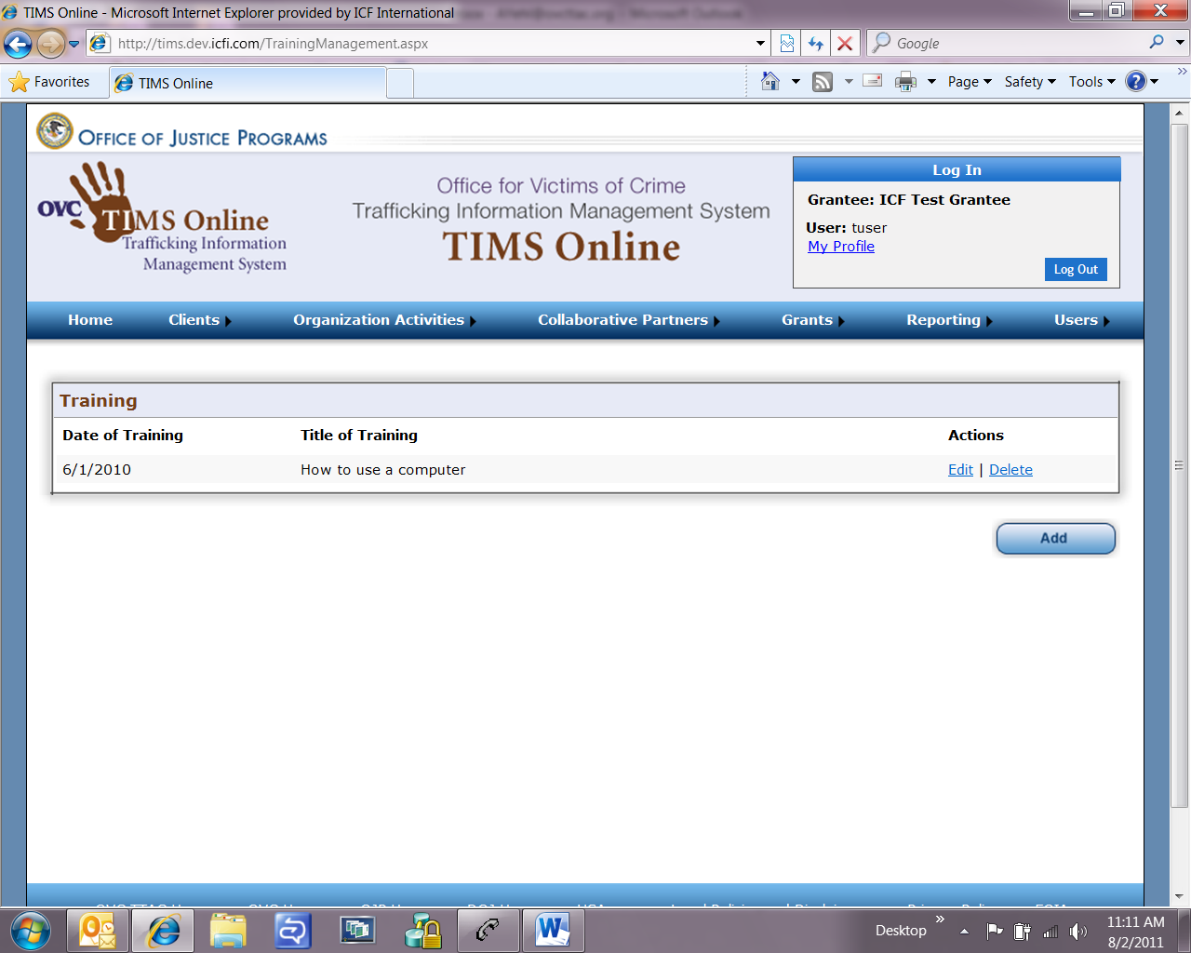

Organization Activities Training (screen 2 of 3)
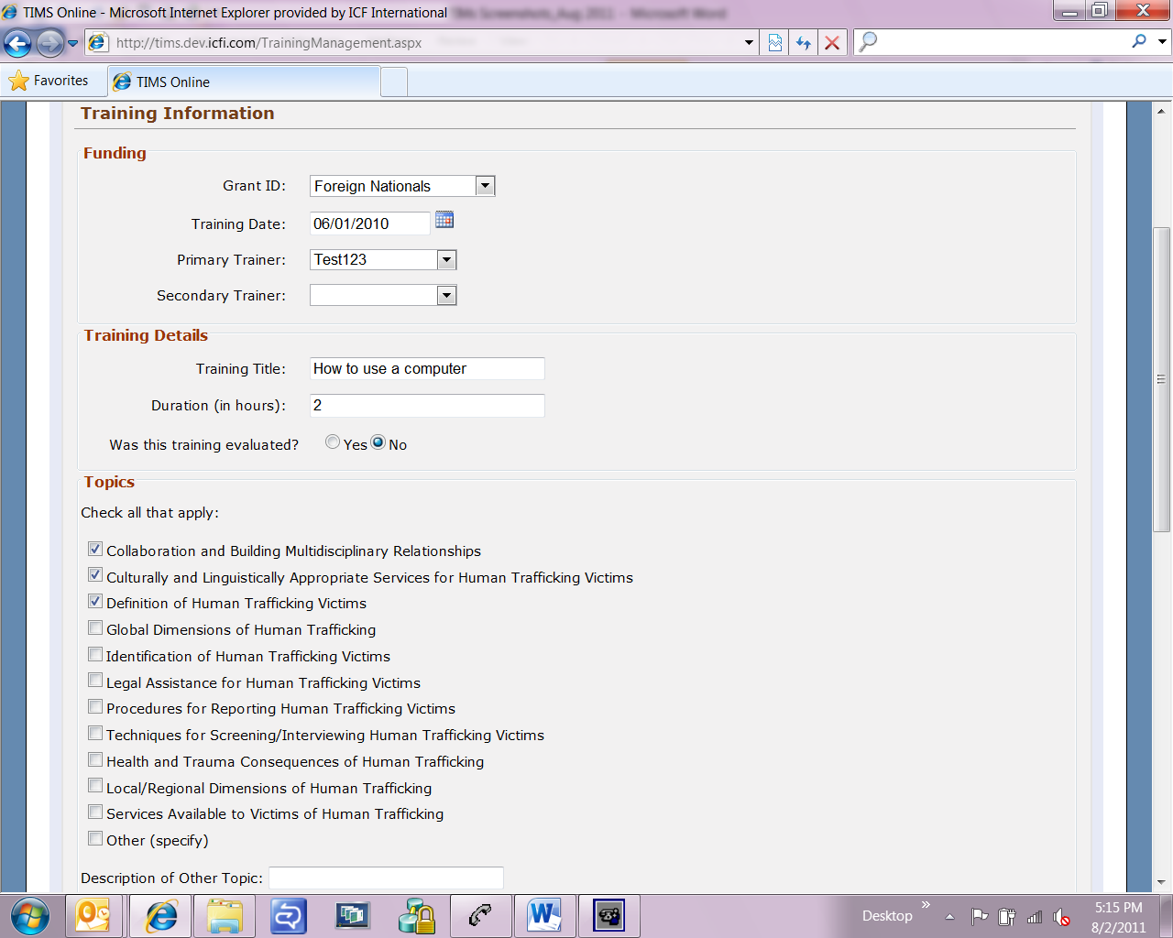

Organization Activities Training (screen 3 of 3)
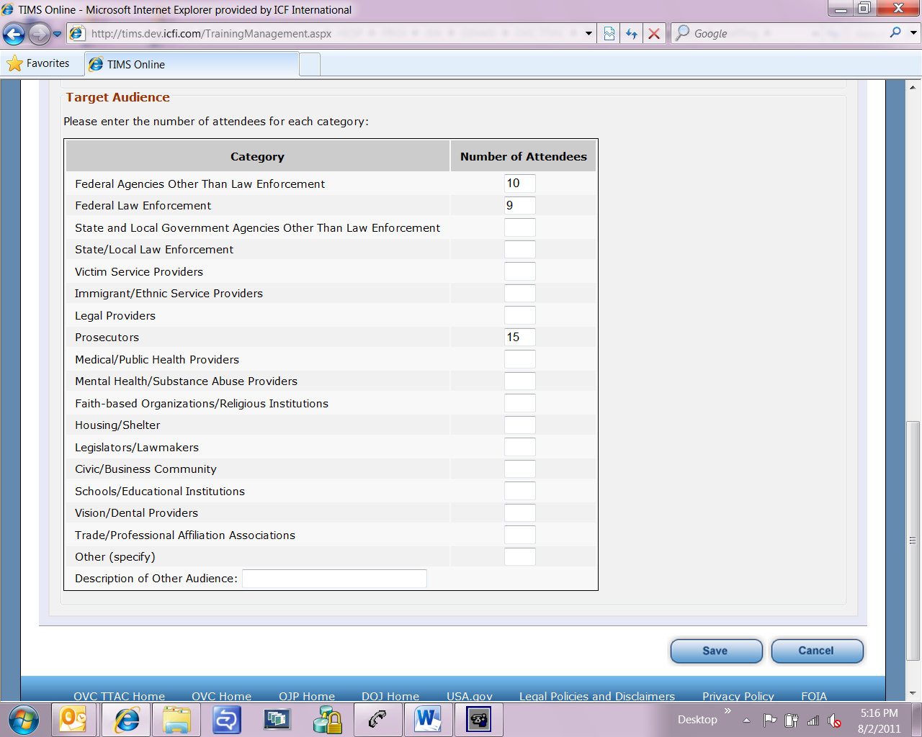

Organization Activities Community Outreach (screen 1 of 2)
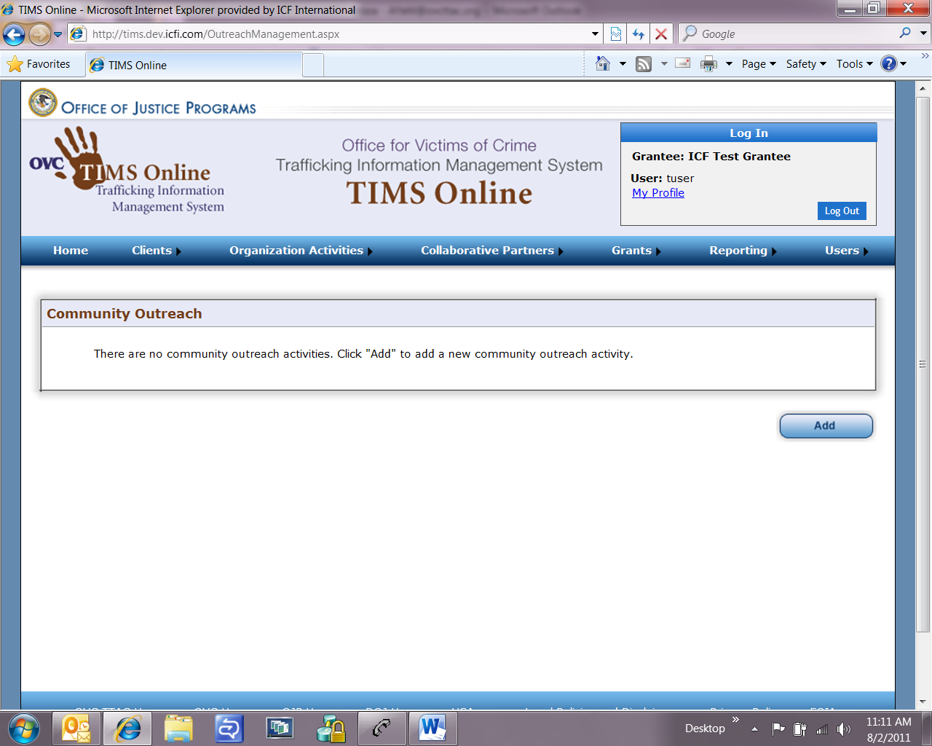

Organization Activities Community Outreach
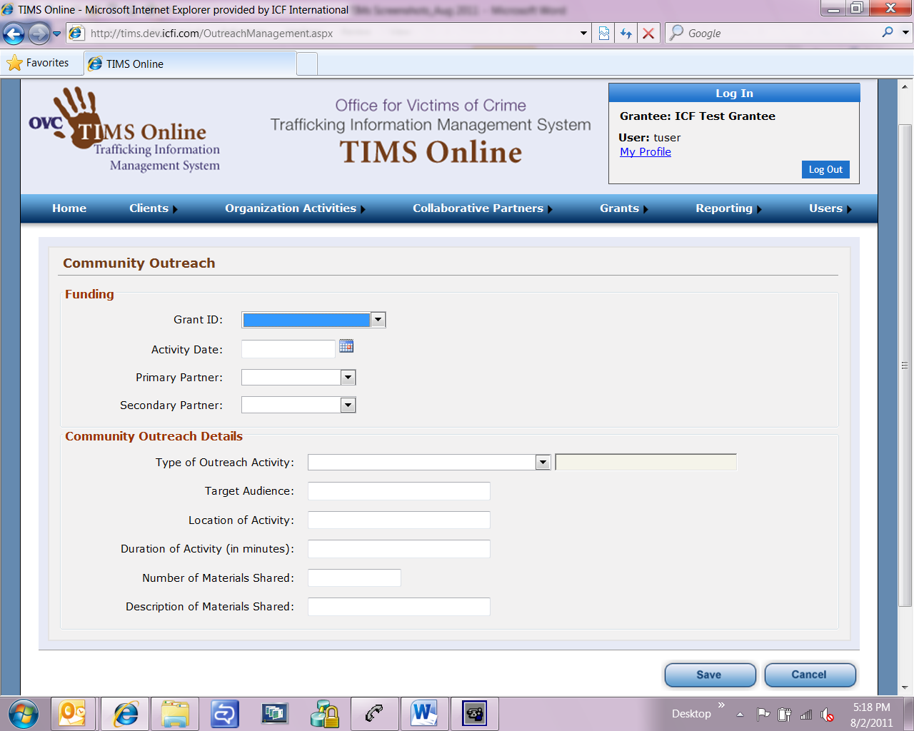

Organization Activities Technical Assistance (screen 1 of 2)
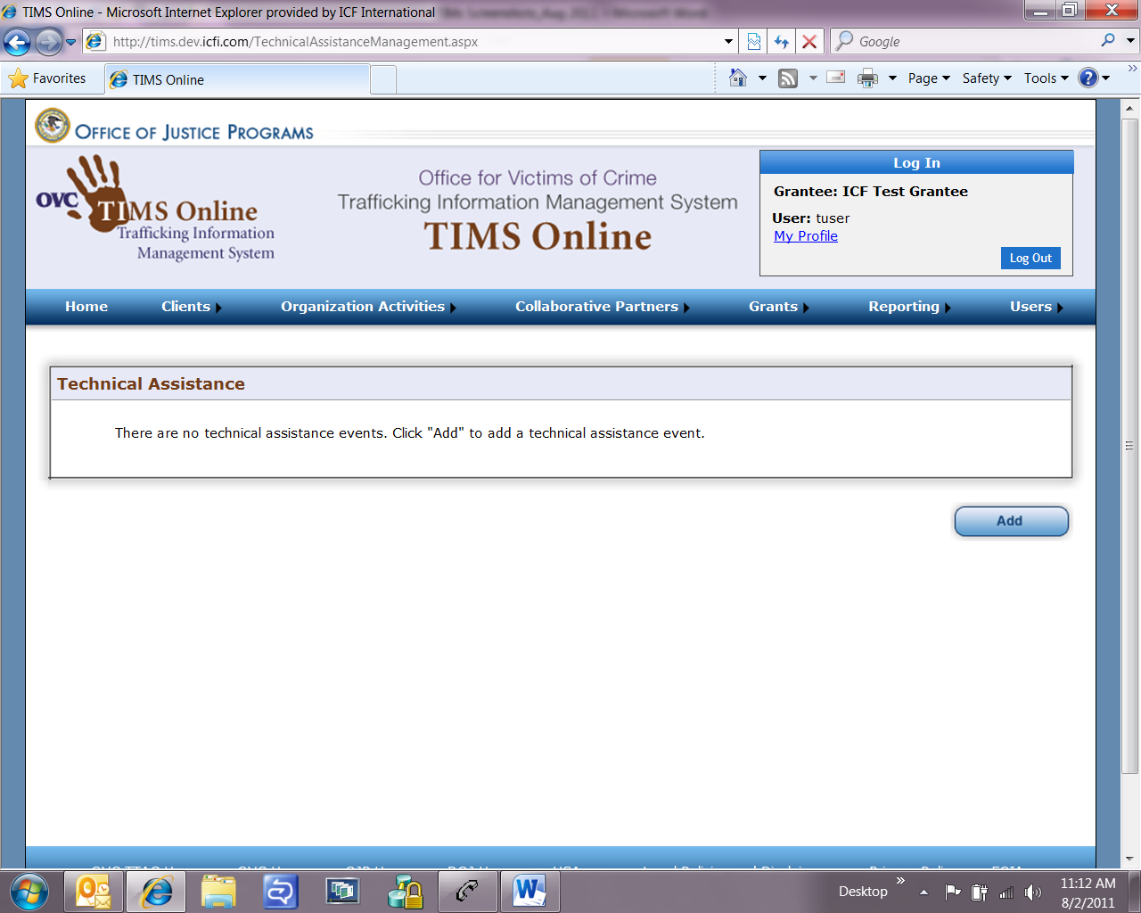

Organization Activities Technical Assistance (screen 2 of 2)
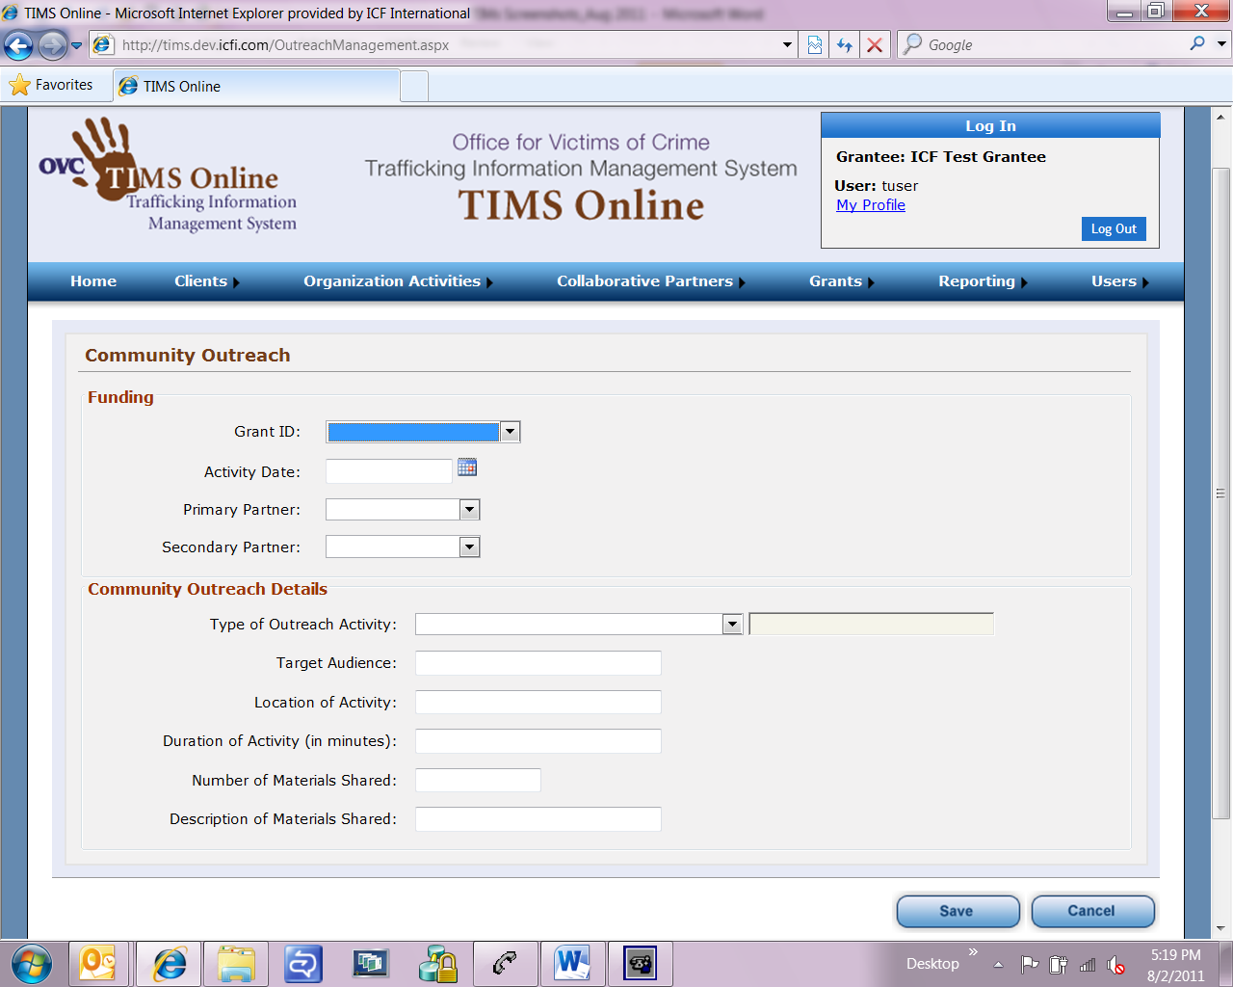

Collaborative Partners Partner Management (screen 1 of 2)
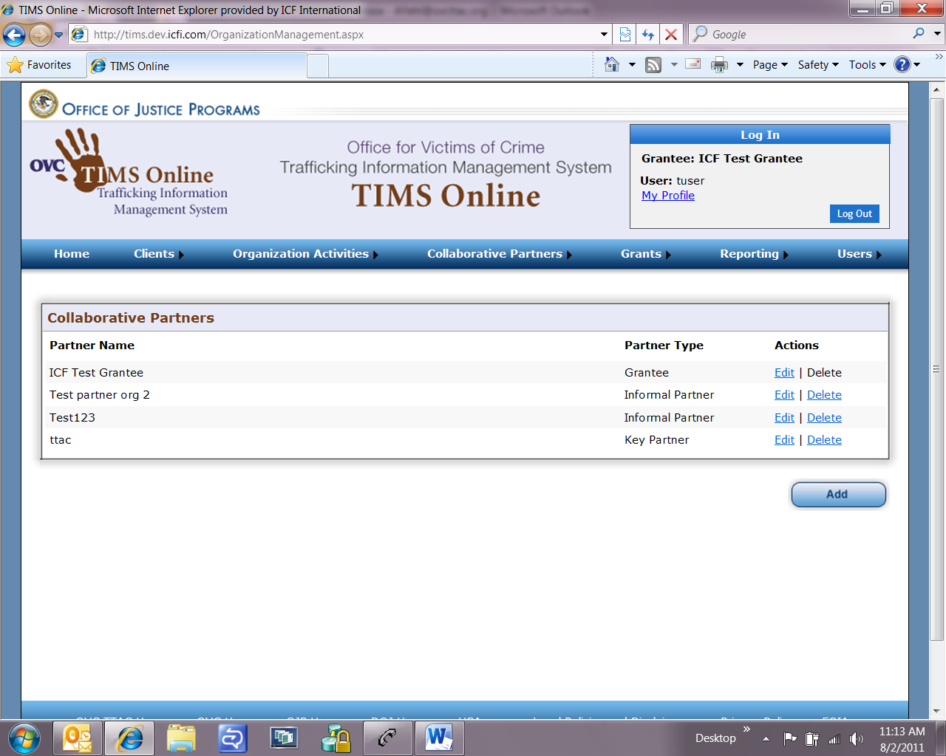

Collaborative Partners Partner Management (screen 2 of 2)
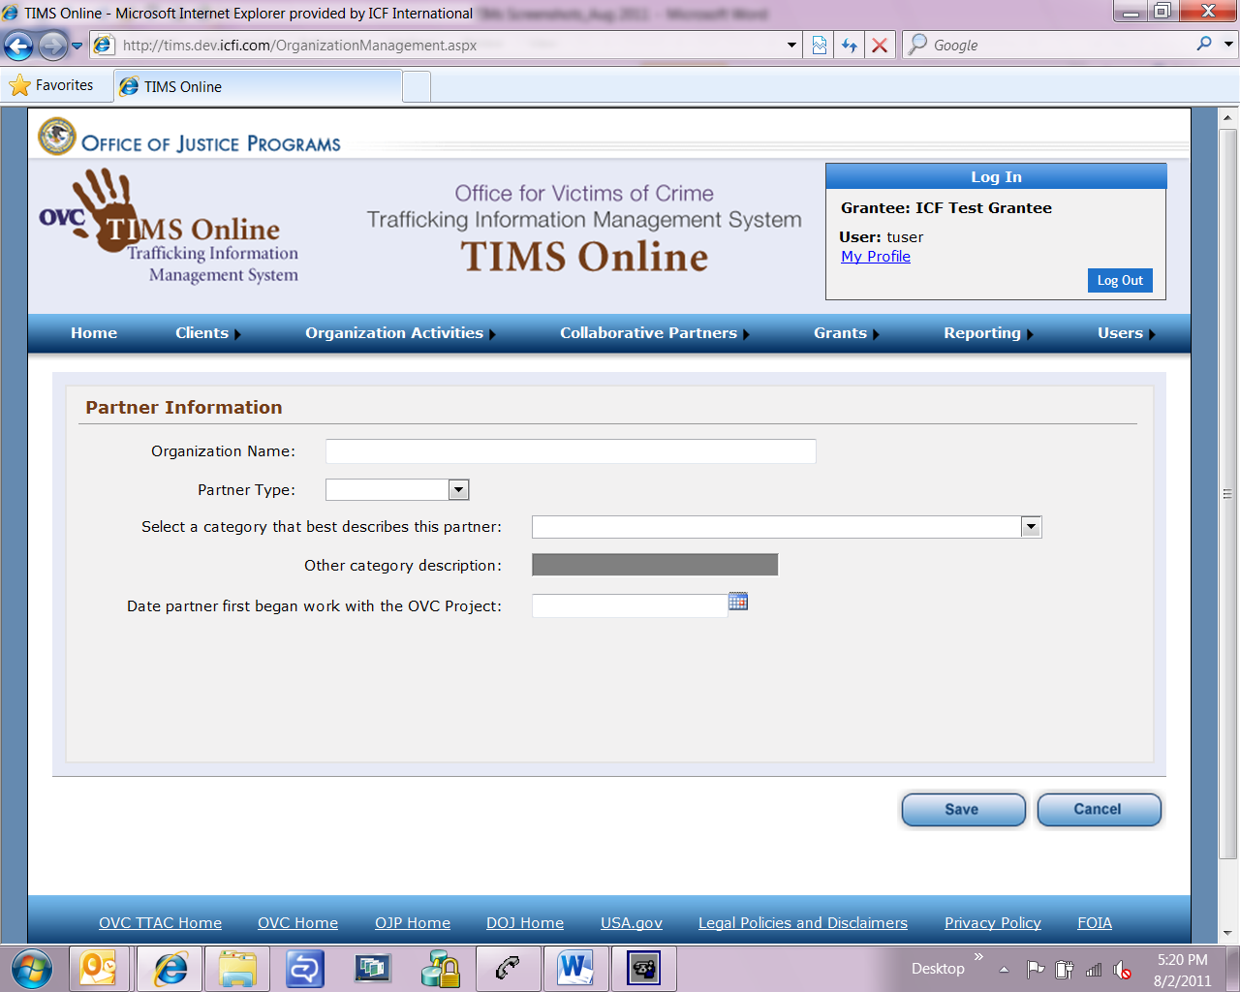

Grants Grant Management (screen 1 of 2)
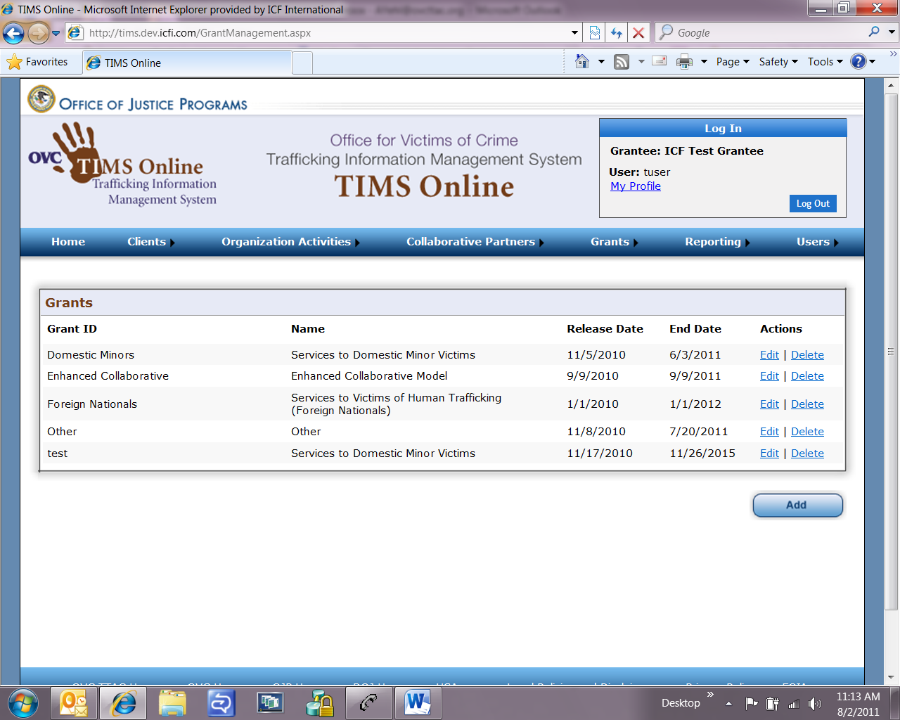

Grants Grant Management (screen 2 of 2)
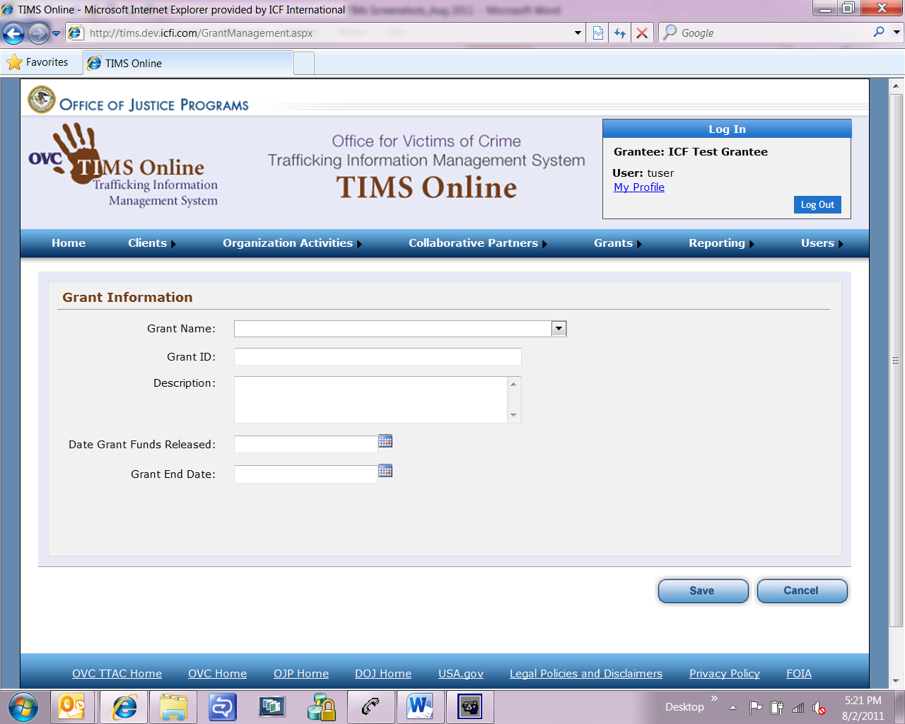

Users Case Manager Management (screen 1 of 2)

Users Case Manager Management (screen 2 of 2)
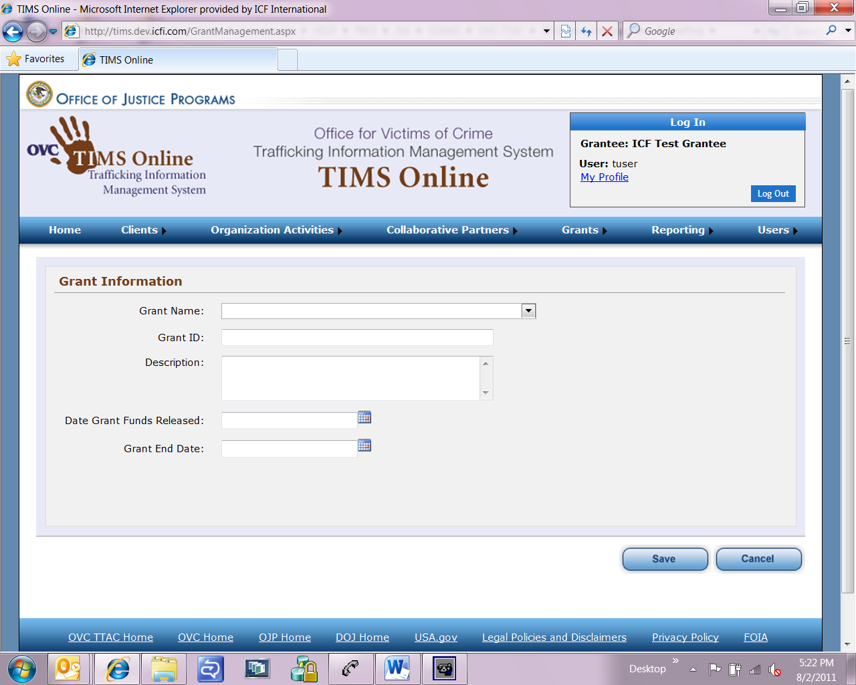

My Profile
