Online TAA Petition, per October 2011 Amendments

I. General Instructions
The changes marked on this document are based on the 2009 Version of the TAA petition. All references to public agencies will be removed, with very few other changes.

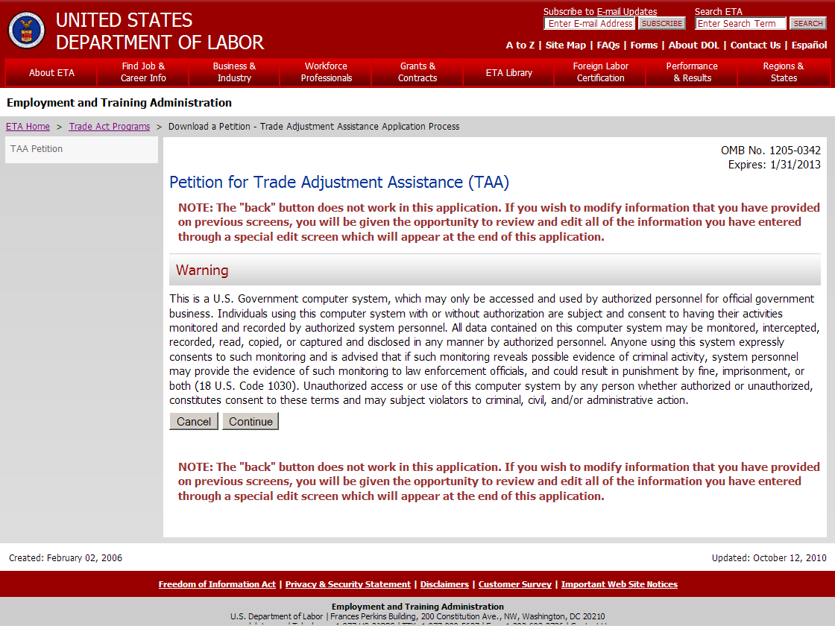

Instructions – How to Submit an Online Petition
Delete sentence which makes reference to public agencies. Change text to the following:

About the Trade Adjustment Assistance (TAA) Program
The Trade Act of 1974 (19 USC § 2271 et seq.), as amended, established Trade Adjustment Assistance (TAA) to provide assistance to workers in firms hurt by foreign trade. Program benefits include long-term training while receiving income support. TAA provides both rapid and early assistance. Filing this petition is the first step in qualifying for benefits and assistance. After the petition is filed, the U.S. Department of Labor will determine whether a significant number or proportion of the workers of the firm have become total or partially separated or are threatened to become totally or partially separated, and whether imports or a shift in production or services to a foreign country contributed importantly to these actual or threatened separations and to a decline in sales or in production of articles or supply of services. Workers in public agencies may also qualify for assistance where an agency has acquired from a foreign country services like or directly competitive with the services the agency supplies. If a petition is approved and the workers are certified as eligible to participate in the TAA program, workers covered by a certification may contact their state workforce agency to apply for benefits. These benefits are provided at no expense to employers.

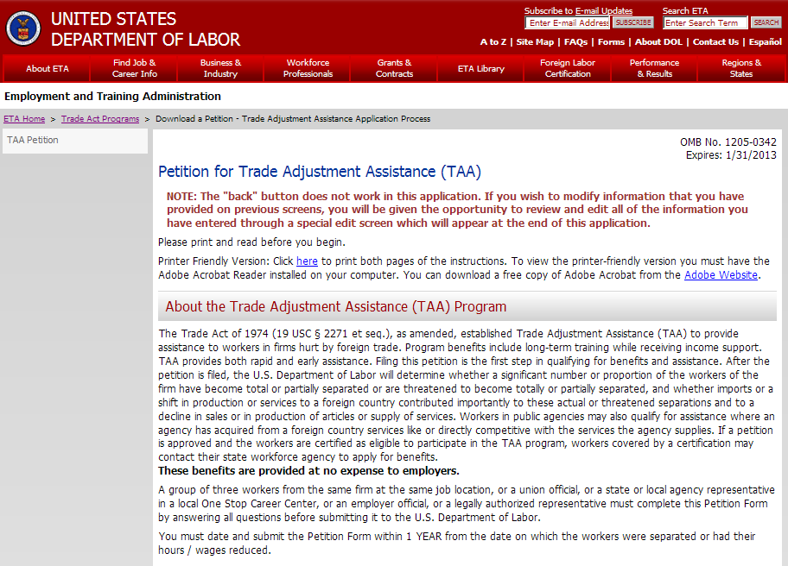
Instruction – Helpful Tips for Online Filing

No changes to this screen.

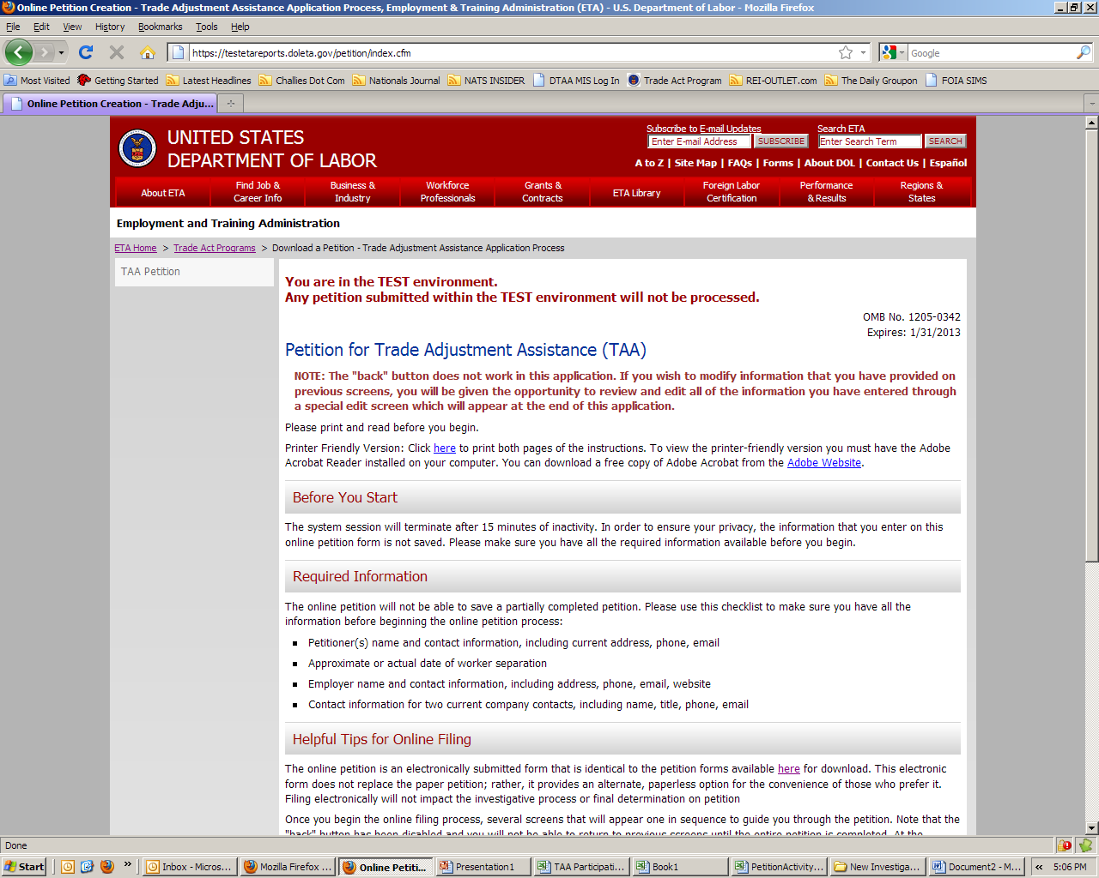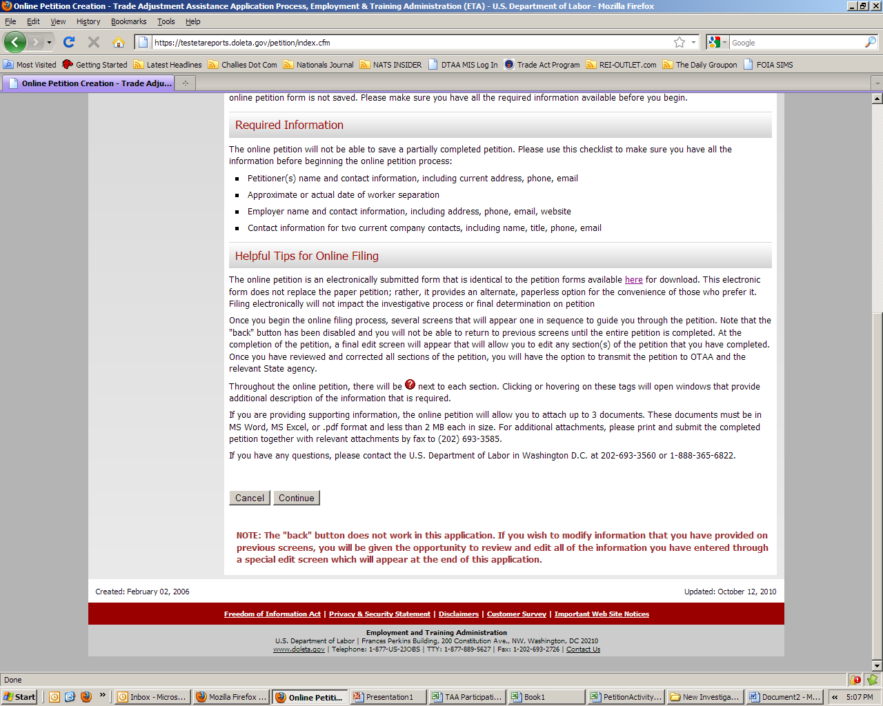

II. Section One. Petitioner Information

No changes to this screen.

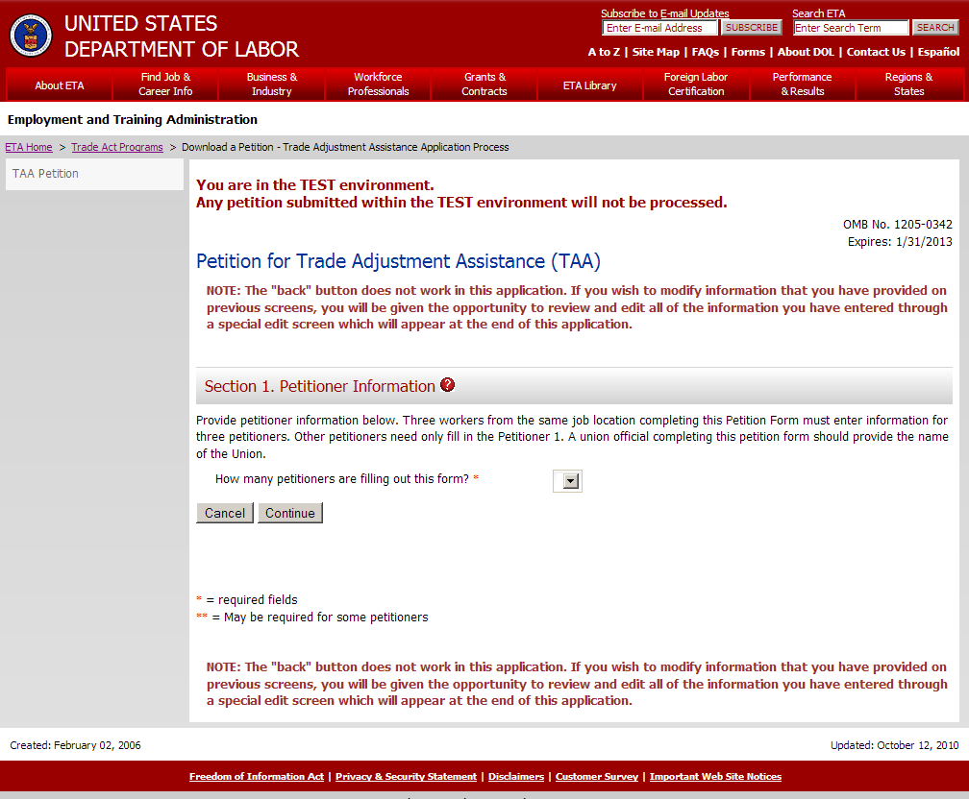
III. Section 2. Firm/Public Agency Information

Remove all references to Public Agency in the headers. New text for headers reads:
Section 2. Workers’ Firm/Public Agency Information

New text for paragraph one reads:
Provide information on the firm or public agency employing the worker group. Complete items (a) – (h) regarding the employing firm or public agency. If the workers are doing work at a location that is different than the worker’s employer (e.g., the petitioning workers are employed by a staffing agency but work at a manufacturing firm), also complete items (i) – (m) regarding the firm or public agency at which the workers perform their jobs.

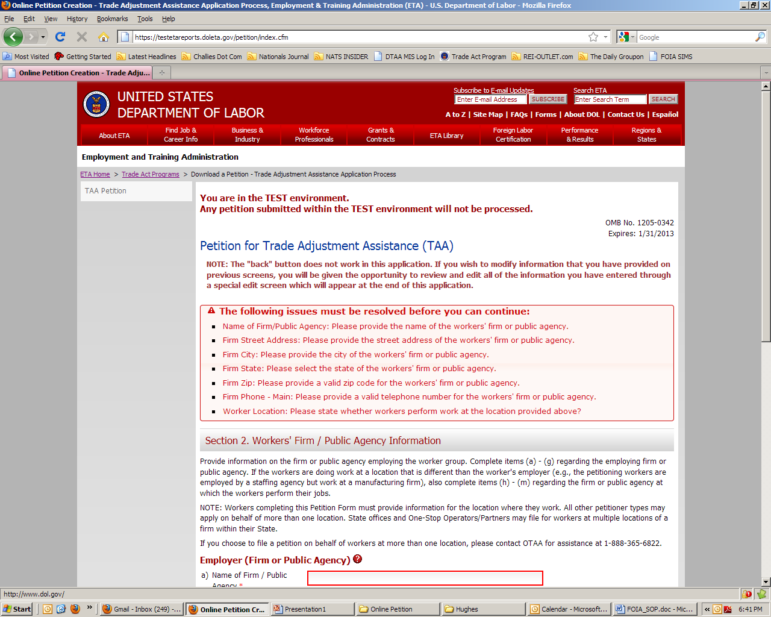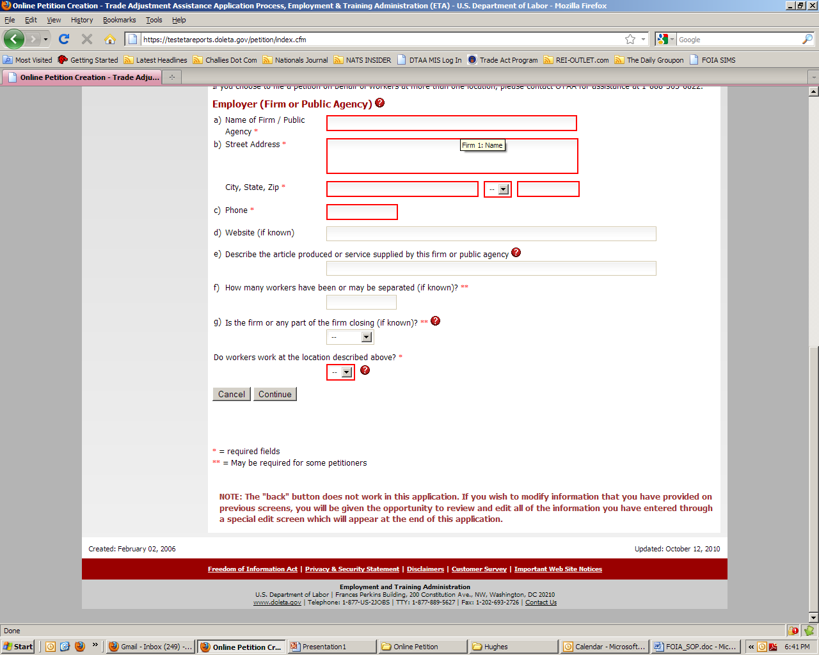
IV. Section 3. Firm/Public Agency Information

Remove reference to public agencies. New text for Paragraph 1 reads:
1. To the best of your knowledge, provide reasons why you believe that separations that have occurred or may be threatened at the workers’ firm or public agency are due to foreign trade. (Example: Production has been / is being shifted to a foreign country, services are being outsourced to a foreign country, increased imports of articles or services, loss of business with a TAA-certified firm.)

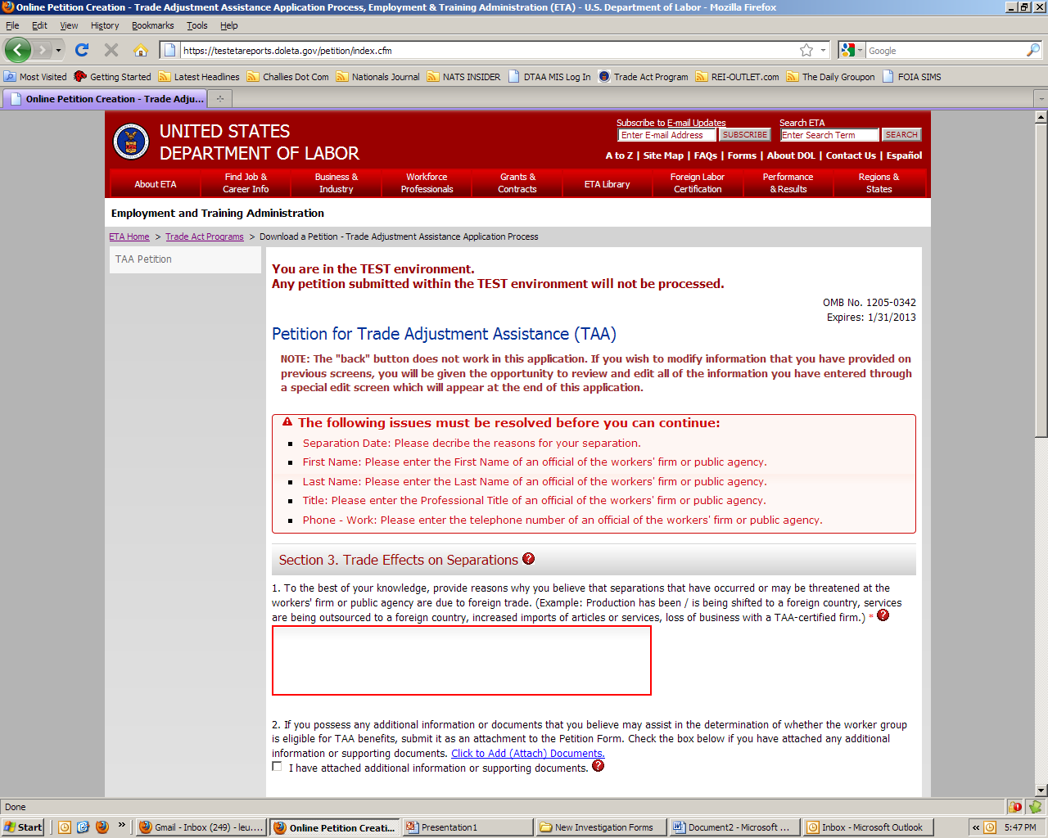
V. Petition Review and Edit Information

No changes to this screen.

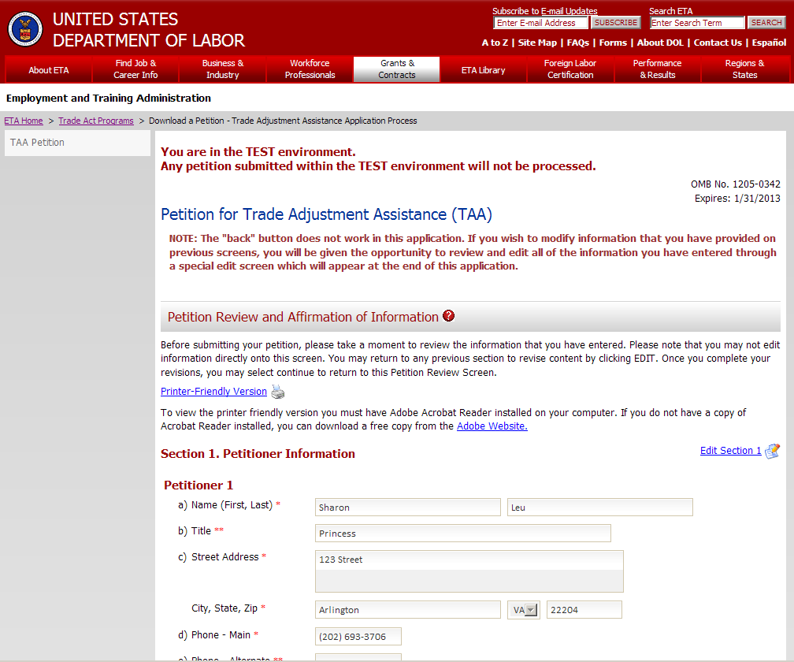

VI. Section 4. Affirmation of Information

No changes to this screen.

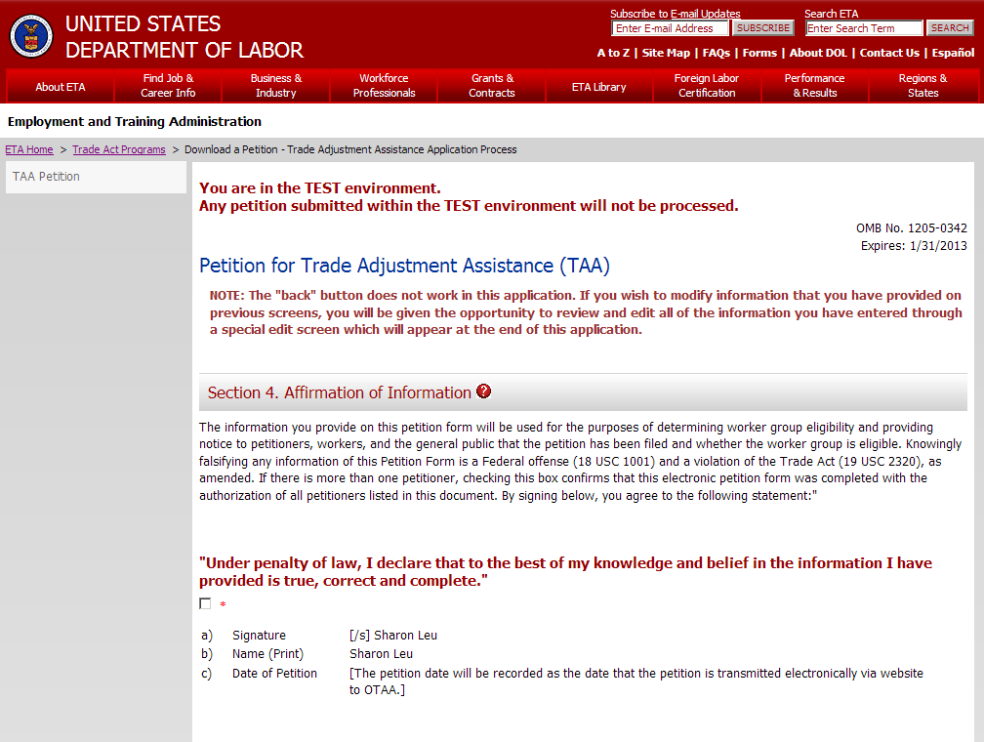

Emailing Petition
No changes to this screen.

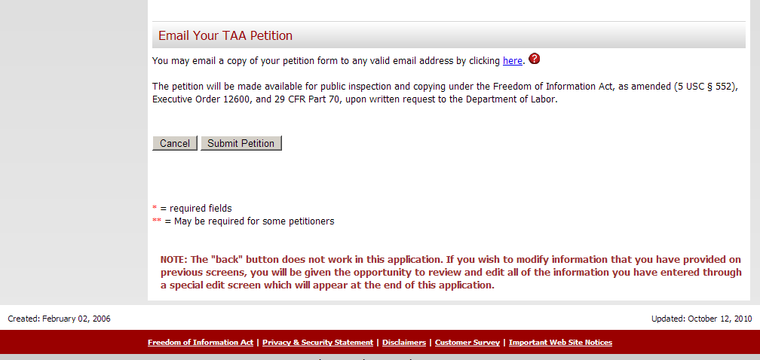
VII. Thank You Screen

No changes to this screen.

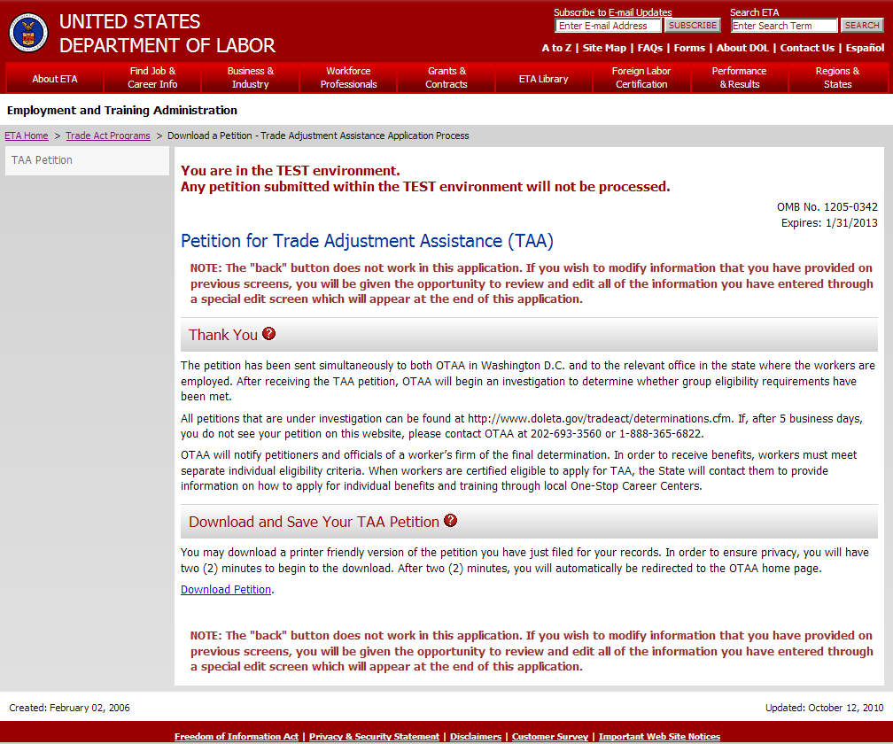

VIII. Help Tags
Section Two Help Tags
Remove all references to Public Agencies.

Firm/Public Agency Information
Petitioners must provide information about the firm or public agency where the workers are employed. Contact information must be provided for at least two knowledgeable officials of that company in order for the Department to initiate the investigative process.

Name of Firm
The name of the company that employs the workers covered by the petition.

Section Three Help Tags
Remove all reference to Public Agencies.

Information Regarding Trade Effects
A trade effect may include a shift in production, outsourcing of services, increased imports, loss of business with a TAA certified firm, or affirmative finding of injury by the US International Trade Commission.

Please provide as much information as possible. Once a petition is filed, the Office of Trade Adjustment Assistance will conduct an investigation to determine whether foreign trade has contributed importantly to worker separations. This investigation may include collection of information from the company, customers of the company, and aggregate trade data as needed. Petitioners should still be as specific as possible about their reasons for believing layoffs are related to foreign trade. Any information provided in this section will help the Office of Trade Adjustment Assistance to conduct its investigation.

Section Four Help Tags
Remove all reference to Public Agencies.

Add New Firm/Public Agency
Clicking this link will add a new firm/Public Agency to your petition.
IX. Error Messages
Section Two Error Messages
Remove all reference to Public Agencies.

 | Field Name | Length | Required | Edit/Validation | Comments | Error Message
(a) | Name of Firm/Public Agency | 100 | Y |  |  | Please provide the name of the workers' firm or public agency
(b) | Street Address | 50 | Y |  |  | Please provide the street address of the workers' firm or public agency
(b) | City | 50 | Y |  |  | Please provide the city of the workers' firm or public agency
(b) | State | 2 | Y | 2-letter abbreviation; DROP DOWN MENU | Disaggregate State and Zip [OMB form aggregates] | Please select the state of the workers' firm or public agency
(b) | Zip | 9 | Y | 5 -digit required 4-digit optional | Disaggregate into 5+4; 4-digits are stored but not required [MIS currently stores 5] | Please provide a valid zip code for the workers' firm or public agency
(c) | Phone - Main | 10 | Y | 10-digit format | Visual mask on display; International numbers tabled for future release | Please provide a valid telephone number for the workers' firm or public agency

Section Three Error Messages
Remove all reference to Public Agencies.

 | Field Name | Length | Required | Edit/Validation | Comments | Error Message
 | First Name | 30 | Y |  | Text | Please enter the First Name of an official of the workers' firm or public agency
 | Last Name | 30 | Y |  | Text | Please enter the Last Name of an official of the workers' firm or public agency
(b) | Title | 50 | Y |  |  | Please enter the Professional Title of an official of the workers' firm or public agency
(c) | Phone - Work | 10 | Y | 10-digit format | Visual mask on display; International numbers tabled for future release | Please enter the telephone number of an official of the workers' firm or public agency

About the Trade Adjustment Assistance (TAA) Program
The Trade Act of 1974 (19 USC § 2271 et seq.), as amended, established Trade Adjustment Assistance (TAA) to provide assistance to workers in firms hurt by foreign trade. Program benefits include long-term training while receiving income support. TAA provides both rapid and early assistance. Filing this petition is the first step in qualifying for benefits and assistance. After the petition is filed, the U.S. Department of Labor will determine whether a significant number or proportion of the workers of the firm have become total or partially separated or are threatened to become totally or partially separated, and whether imports or a shift in production or services to a foreign country contributed importantly to these actual or threatened separations and to a decline in sales or in production of articles or supply of services. Workers in public agencies may also qualify for assistance where an agency has acquired from a foreign country services like or directly competitive with the services the agency supplies. If a petition is approved and the workers are certified as eligible to participate in the TAA program, workers covered by a certification may contact their state workforce agency to apply for benefits. These benefits are provided at no expense to employers.

Filing Instructions
- A group of three workers from the same firm at the same job location, or a union official, or a state or local agency representative in a local One Stop Career Center, or an employer official, or a legally authorized representative must complete this Petition Form by answering all questions before submitting it to the U.S. Department of Labor.
- You must date and submit the Petition Form within 1 YEAR from the date on which the workers were separated or had their hours / wages reduced.
- You must file the Petition Form with both the U.S. Department of Labor in Washington, DC and the TAA coordinator or the dislocated worker office of the state where the firm or public agency is located.
- To file with the U.S. Department of Labor, use one of the methods below (electronically submit or fax for quicker processing):
Electronically submit the Petition Form online at http://www.doleta.gov/tradeact/petitions.cfm OR
Fax the completed Petition Form to 202-693-3585, OR
Mail the completed Petition Form to the U.S. Department of Labor at:
U.S. Department of Labor
Office of Trade Adjustment Assistance
200 Constitution Ave NW, Room N-5428
Washington, DC 20210

- To file with the TAA coordinator or the dislocated worker office of the state:
Use the contact information below to find the appropriate filing address. If this Petition Form includes firms in different states, copies of this completed Petition Form must be filed in each state where firms or public agencies are located.
Toll-Free Helpline: 1-877-US2-JOBS (TTY) 1-877-889-5627
Internet: http://www.servicelocator.org
For assistance in preparing a petition
Petitioners may request assistance in preparing the petition at their local One-Stop Career Center, by contacting the U.S. Department of Labor in Washington, D.C. at 202-693-3560 (Main Number), or by contacting their State Dislocated Worker Unit or Employment Security Agency through the telephone numbers or internet addresses provided above.
To check the status of your petition go to:
http://www.doleta.gov/tradeact/taa/taa_search_form.cfm
Public Burden Statement
Persons are not required to respond to this collection of information unless it displays a currently valid Office of Management and Budget (OMB) control number. Responding is required to obtain or maintain benefits (19 USC 2321). Public reporting burden for this collection is estimated to average 20 minutes per response, including the time for reviewing instructions, searching existing data sources, gathering and maintaining the data needed, completing and reviewing the collection of information, and a state review. Send comments regarding this burden estimate or any other aspect of this collection of information, including suggestions for reducing this burden, to the Department of Labor at the address provided above (Paperwork Reduction Project 1205-0342).
Section 1. Petitioner Information
Provide petitioner information below. Three workers from the same job location completing this Petition Form must fill in all three columns. Other petitioners need only fill in the Petitioner 1 column. A union official completing this petition form should provide the name of the Union.
 |  | Petitioner 1 |  | Petitioner 2 |  |  | Petitioner 3
a) | Name
b) | Title
c) | Street Address
 | City
 | State, Zip
d) | Phone – Main
e) | Phone – Alternate
f) | E-mail
g) | Worker Separation Date
h) Petitioner Type: Three Workers  Company Official  Union Official  (Union Name _______________ )
(please check one) State Workforce Office  One-Stop Operator/Partner  Other Authorized Representative 
i) | Describe the worker group on whose behalf this petition is being filed:
Section 2. Workers’ Firm / Public Agency Information

Provide information on the firm or public agency employing the worker group. Complete items (a) – (h) regarding the employing firm or public agency. If the workers are doing work at a location that is different than the worker’s employer (e.g., the petitioning workers are employed by a staffing agency but work at a manufacturing firm), also complete items (i) – (m) regarding the firm or public agency at which the workers perform their jobs.
NOTE: Workers completing this Petition Form must provide information for the location where they work. All other petitioner types may apply on behalf of more than one location. State offices and One-Stop Operators/Partners may file for workers at multiple locations of a firm within their State. If you choose to file on behalf of workers at more than one location, please attach additional sheets as necessary.
Employer (Firm or public agency)
a) | Name of Firm / Public Agency
b) | Street Address
 | City
 | State, Zip
c) | Phone
d) | Website (if known)
e) | Describe the article produced or service supplied by this firm or public agency
f) | How many workers have been or may be separated (if known)?
g) | Is the firm or any part of the firm closing (if known)? If yes, when?
If the workers work at a location that is different from that listed in item a) and b), then fill out items h) through m) for that location:
h) | Name of Firm / Public Agency
i) | Street Address
 | City
 | State, Zip
j) | Phone
k) | Describe the article produced or service supplied by this firm or public agency
l) | How many workers have been or may be separated (if known)?
m) | Is the firm or any part of the firm closing (if known)? If yes, when?

Section 3. Trade Effects on Separations
1. To the best of your knowledge, provide reasons why you believe that separations that have occurred or may be threatened at the workers’ firm or public agency are due to foreign trade. (Example: Production has been / is being shifted to a foreign country, services are being outsourced to a foreign country, increased imports of articles or services, loss of business with a TAA-certified firm.)
2. If you possess any additional information or documents that you believe may assist in the determination of whether the worker group is eligible for TAA benefits, submit it as an attachment to the Petition Form. Check the box below if you have attached any additional information or supporting documents.
I have attached additional information or supporting documents.
3. Provide contact information for two company officials. Either separately or together, these officials should be familiar with all of the following: employment, job functions, and sales or production at each job location.
 |  | Official 1 |  | Official 2
a) a) | Name
b) | Title
c) | Phone – Work
d) | Phone – Alternate
e) | Fax
f) | E-mail

Section 4. Affirmation of Information

The information you provide on this petition form will be used for the purposes of determining worker group eligibility and providing notice to petitioners, workers, and the general public that the petition has been filed and whether the worker group is eligible. Knowingly falsifying any information on this Petition Form is a Federal offense (18 USC § 1001) and a violation of the Trade Act (19 USC § 2316). For this petition to be valid, each of the petitioners listed in Question 1 must sign below, and the Petition Form must be dated. By signing below, you agree to the following statements:

“I declare that to the best of my knowledge and belief the information I have provided is true, correct, and complete.”
a) | Signature
b) | Name (Print)
c) | Date of Petition

The Petition Form will be made available for public inspection and copying under the Freedom of Information Act, as amended (5 USC § 552), Executive Order 12600, and 29 CFR Part 70, upon written request to the U.S. Department of Labor.

