# Appendix D: Online Survey

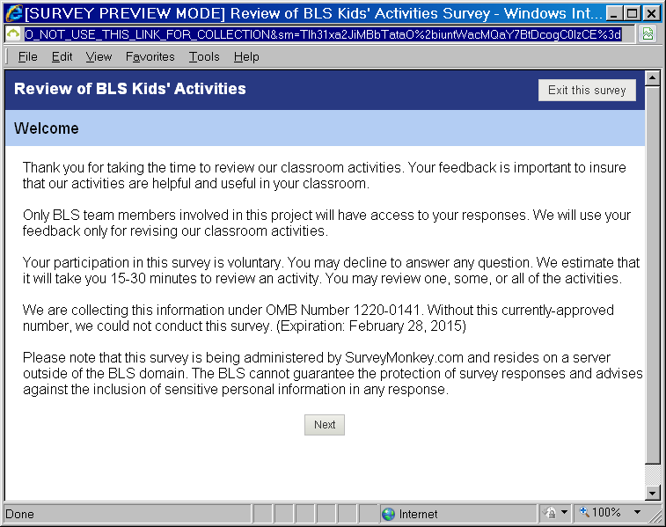

Page 1

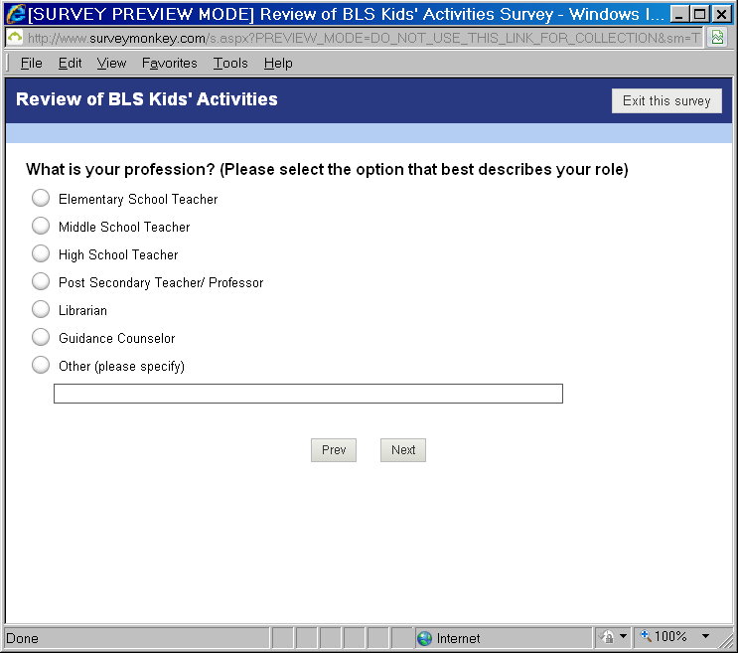

Page 2. Skip to page 4 if the response is Librarian, Guidance Counselor, or Other.

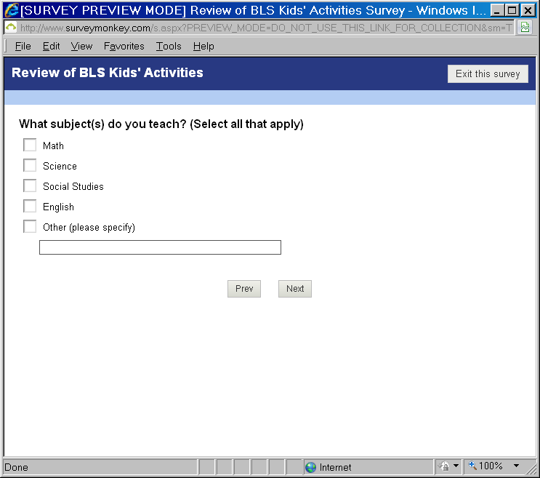

Page 3.

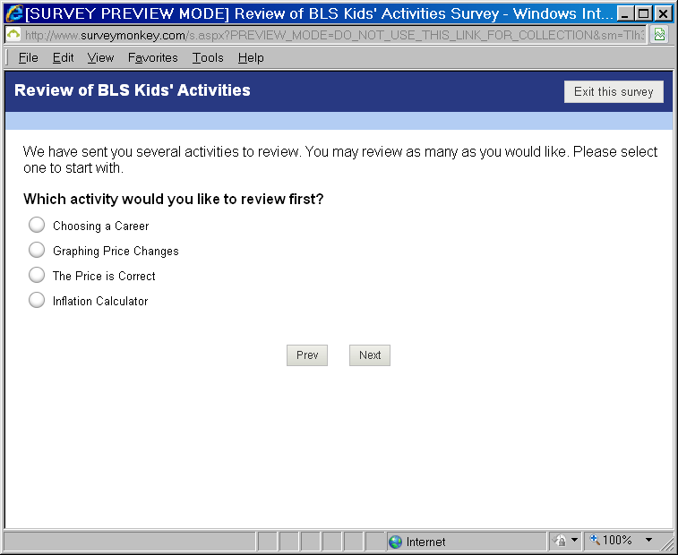Page 4.

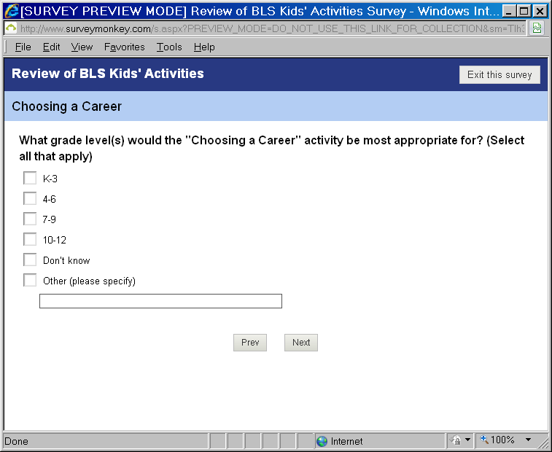Page 5. (Note: Pages 5 – 12 are shown for the “Choosing a Career” activity. The same items will be presented for each activity.)

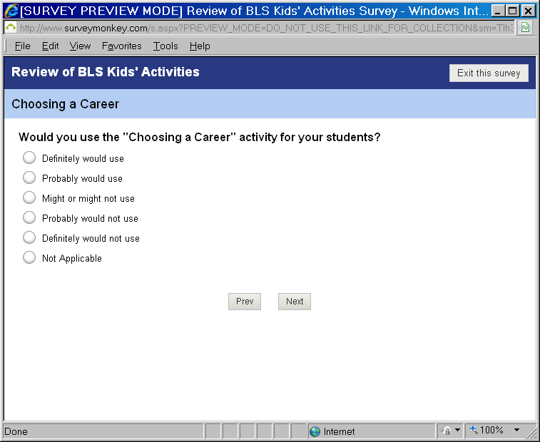

Page 6. Skip to Page 8 for all except for “Probably” and “Definitely” would not use.

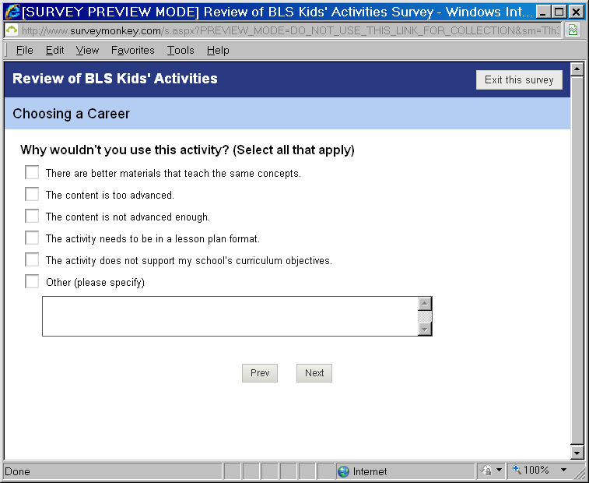

Page 7.

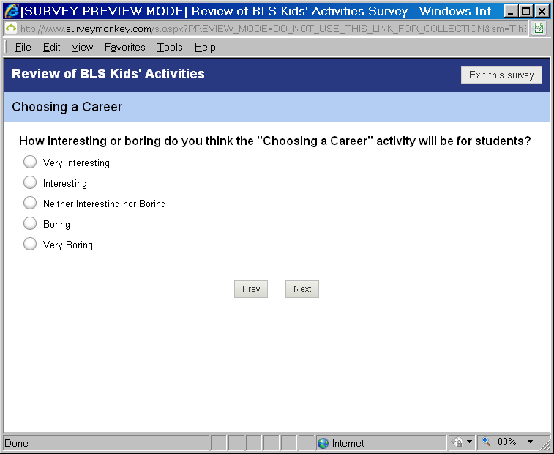

Page 8.

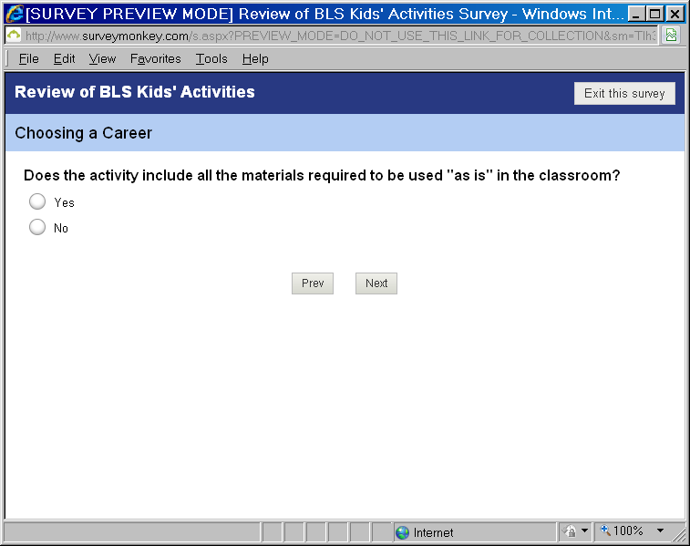

Page 9. For “Yes,” Skip to Page 11.

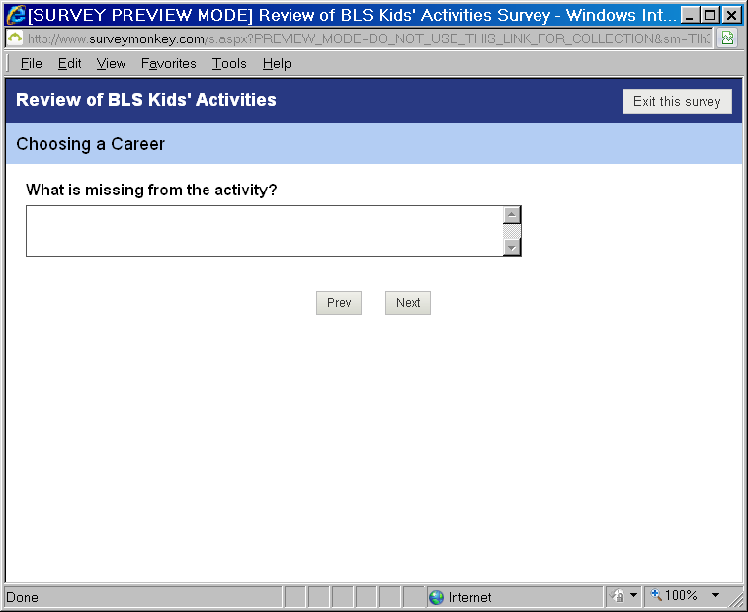

Page 10.

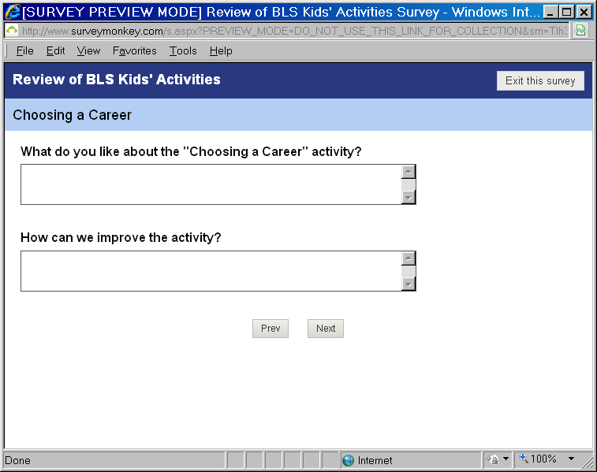

Page 11.

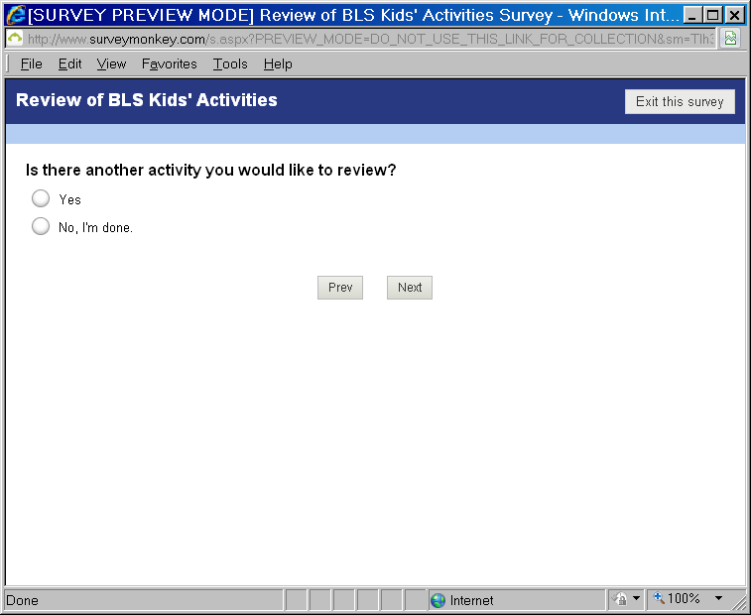

Page 12. For “Yes,” go back to Page 4.

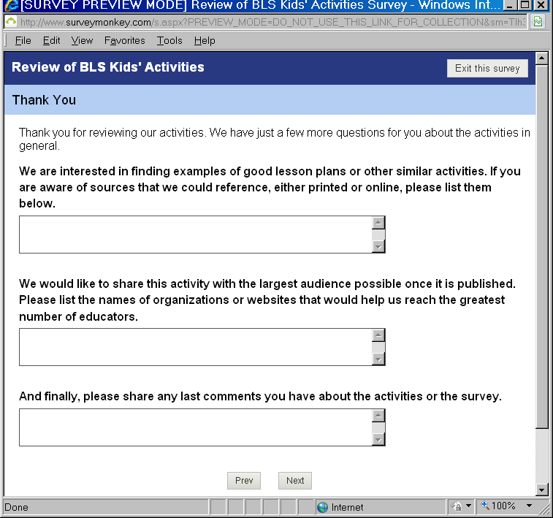

Page 13.

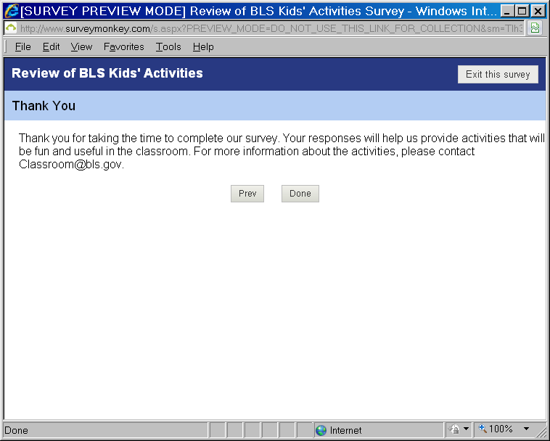

Page 14.

# Appendix E: Print Survey

Thank you for taking the time to review our classroom activities. Your feedback is important to insure that our activities are helpful and useful in your classroom.

Only BLS team members involved in this project will have access to your responses. We will use your feedback only for revising our classroom activities.

Your participation in this survey is voluntary. You may decline to answer any question. We estimate that it will take you 15-30 minutes to review each activity. You may review one, some, or all of the activities.

We are collecting this information under OMB Number 1220-0141. Without this currently-approved number, we could not conduct this survey. (Expiration: February 28, 2015)

If you have any questions about the activities or the survey, please contact Classroom@bls.gov.

**Which activity did you review?**

Choosing a Career

Graphing Price Changes

The Price is Correct

Inflation Calculator

**What grade level(s) would this activity be most appropriate for? (Select all that apply)**

K-3

4-6

7-9

10-12

Don’t know

**Would you use this activity for your students?**

http://www.surveymonkey.com/i/t.gif Definitely would use (*skip to question 5*)

http://www.surveymonkey.com/i/t.gif Probably would use (*skip to question 5*)

Might or might not use (*skip to question 5*)

http://www.surveymonkey.com/i/t.gif Probably would not use

Definitely would not use

Not Applicable (*skip to question 5*)

**Why wouldn't you use the activity? (Select all that apply)**

There are better materials that teach the same concepts.

The content is too advanced.

The content is not advanced enough.

The activity needs to be in a lesson plan format.

The activity does not support my school’s curriculum objectives.

Other (please specify):

**How interesting or boring do you think this activity will be for students?**

Very Interesting

Interesting

Neither Interesting nor Boring

Boring

Very Boring

**Does the activity include all the materials required to be used as is in the classroom?**

Yes

No. If no, please specify what is missing:

**What do you like about the activity?**

**How can we improve the activity?**

**Please share any additional comments you have about the activity.**

[Thank you for taking the time for your review. Your responses will help us provide activities that will be fun and useful in the classroom.](http://www.surveymonkey.com/MySurvey_EditPage.aspx?sm=v5mTVql1WaAFaIUfZp06nZ7TM6YWEhQWhjLTDeDw5nazUgpduo5CMZjONm%2fMOBHl&TB_iframe=true&height=450&width=650)

**1. What is your profession? (Please select the option that best describes your role)**

Elementary School Teacher

Middle School Teacher

High School Teacher

Post Secondary Teacher/ Professor

Librarian (*skip to question 3*)

Guidance Counselor (*skip to question 3*)

Other (please specify) (*skip to question 3*)

**2. If you are a teacher, what subject(s) do you teach? (Select all that apply)**

Math

Science

Social Studies

English

Other (please specify)

**3. We are interested in finding examples of good lesson plans or other similar activities. If you are aware of sources that we could reference, either printed or online, please list them below.**

**4. We would like to share this activity with the largest audience possible once it is published. Please list the names of organizations or websites that would help us reach the greatest number of educators.**