January 24, 2014

NOTE TO THE  REVIEWER OF: | OMB CLEARANCE 1220-0141  “Cognitive and Psychological Research”
FROM: | Brandon Kopp  Research Psychologist  Office of Survey Methods Research
SUBJECT: | Submission of Materials for the Pretesting of proposed changes for the CE Quarterly 2015

Please accept the enclosed materials for approval under the OMB clearance package 1220-0141 “Cognitive and Psychological Research.” In accordance with our agreement with OMB, we are submitting a brief description of the study.

The total estimated respondent burden hours for this study is 43.2 hours.

If there are any questions regarding this project, please contact Brandon Kopp at
202-691-7514.

- Introduction and Purpose
The Bureau of Labor Statistics has completed several projects with the goal of improving the Consumer Expenditure Quarterly Interview Survey (CEQ). One of the main goals of these improvements is to keep the market basket of goods and services, which provides item weights for the Consumer Price Index (CPI), current. Given the rapid changes in the marketplace, changes need to be made to the CEQ to ensure that the data accurately reflect the state of consumer buying habits. Based on input from CPI commodity analysts and economists, a few areas of the survey were identified as needing attention to maintain the most up-to-date market basket possible. In a parallel effort to improve CEQ data quality, economists from the Branch of Production and Control (P&C) identified changes that need to be addressed for reasons of respondent burden, outdated questions, and general instrument issues.
In addition to these recommendations, independent teams within the Bureau of Labor Statistics (BLS) evaluated products and services which are becoming more common and made recommendations for changes to the questionnaire to improve reporting for these areas.

2. Research Design
The purpose of this study is to ensure that proposed changes to the 2015 CE Quarterly Interview instrument and information booklet are clear and understandable to respondents, and are interpreted by respondents as intended. To accomplish this goal, question variations will be tested using cognitive interviewing. The set of questions presented to each participant will vary, with each set covering multiple topics. Participants will be assigned topics based on their experience with and knowledge of the subject matter. A complete list of the changes to be tested is included in Appendix A.
As noted, cognitive interviewing will be used to gain insight into the topics addressed in the changes. Cognitive interviews provide an in-depth understanding of the respondent’s thought processes and reactions to the questions. These interviews will be done one-on-one in the Office of Survey Methods Research (OSMR) laboratory, and will be audiotaped. Interviews will be conducted by staff from the OSMR who are experienced in conducting these types of interviews. The testing protocol is included in Appendix B.

3. Participants
Participants will be recruited from a participant database maintained by OSMR. Efforts will be made to select participants with varying levels of education, income, and occupation, based on self-reported information provided during the initial recruitment process.

4. Burden Hours
The number of participants is dependent upon the results and the point at which saturation is reached and no further information is being gained from additional interviews. Given that, our goal is to obtain no more than 40 participants in the OSMR lab. We anticipate that each session will average 45 minutes and last no longer than one hour (or 40 burden hours). Participants will be compensated $40 for their time. Participants will not be asked additional screening questions as part of recruitment. Scheduling an appointment is expected to take no longer than 5 minutes and participants will not be compensated for time spent on scheduling. This will add an additional 3.2 burden hours (40 participants X .08 hours) to the study, for a total of 43.2 burden hours.

5. Data Confidentiality
Participants will be informed as to the voluntary nature of the study. Participants will also be informed that the study will be used for internal purposes to improve the design of a national Consumer Expenditure interview survey. Participants will be given a consent form to read and sign (See Appendix C). Information related to this study will not be released to the public in any way that would allow identification of individuals except as prescribed under the conditions of the Privacy Act Notice.
Appendix A: List of Changes to be Tested

Each of the following proposed changes to the CEQ will be tested using cognitive interviews. The goal is to identify the associations participants have with various terms, how they interpret question meanings, and to identify the most effective wording for questions and response choices. Below is a list of changes to be tested.
Question Additions or Modifications
- Add business expense screener question to CE Introduction
- Add questions to health insurance section to capture information on health care exchange policies
- Update health insurance type question to pick up Tricare policies and replace other health insurance plan questions with new questions for other government health programs
- Add question to screen out non-deeded timeshare properties
- Reword total owed for property after last payment question, inputting month names as necessary
- Reword loan question to "Line of credit home equity loans"
- Change vacation home property question to include "not rented out"
- Remove "for non-business use" from computer software expense question
- Delete “Room-size” from rugs or other non-permanent floor coverings question
- Modify wording of tire repair expense question to exclude new tire purchase
- Reword "food and beverages for catered affairs" to "catering"

Remove Question
- Remove ALCOHOL screener from alcohol questions

Modifications to the CE Information Booklet (Infobook)
- Update Infobook examples for sport or recreational equipment repairs
- Modify Infobook examples for fees for participating in sports by removing 'golf' and adding other examples
- Update Infobook examples for dental care
- Modify the Infobook examples for travel items including luggage
- Add examples to closet storage items in Infobook.
- Add examples to water sports equipment in Infobook
- Modify Infobook examples for clothing accessories by changing “purse” to “hand bag”
- Modify the Infobook examples for costumes
- Modify the Infobook examples for uniforms
- Update Infobook examples for coats, jackets, or furs

Appendix B: Cognitive Testing Protocol

The protocol includes the question that will be tested, additional questions that provide context for the tested question, and debriefing questions. The interviewer may ask unscripted follow-up questions if a participant’s answer suggests additional, pertinent information can be gained.

Introductory Material
- Hi! Thank you for coming in today.
- I am …... [This is my colleague ( ) who will be taking notes for us today]
- Have you participated in any of our studies before? (if yes, Which ones?)
- [Sign Consent Form/Permission to audiotape] (see Appendix C)
- Explanation:
  - We are going to be working with some questions from the Consumer Expenditure Survey, an ongoing survey that provides information about the buying habits of American consumers. This information is used for a lot of things but its primary purpose is to help calculate inflation. Are you familiar with the inflation rate?
  - What we are going to do today is go through a few questions from the survey and get your reactions to them. The purpose of this session is to help us find out more about how people respond to these questions. Basically, we’re trying to find out what you think a question is asking and how hard it is to answer. We are not here to evaluate you, we are looking to improve the questions, so there are no wrong answers. All the information you give us will be kept completely confidential, and will be used to improve the survey questions.
- Any questions before we begin?
Question Additions and Modifications
- Add business expense screener question to CE Introduction
As we start, please understand that we ask the same topics of everybody we talk to. I realize some of these questions may not apply to your household.

Most questions that I will be asking refer to a specific time period.
During this interview, the time period, unless I state otherwise is for the past three months, that is, from the 1st day of "reference month" to today.

Most of my questions are about expenses your household had or bills you’ve received. You will find it helpful to have your checkbook register, credit card statements and other records as you answer the questions.

Before we get started, do you deduct or plan to deduct any of your expenses as business expenses?
- Yes
- No
- IF REPORTS - What kinds of expenses did you have – can you tell me some examples?
- Can you rephrase the question in your own words? [probe to understand if they understand we mean even just one deductible business expense, rather than a routine behavior]
- Can you name some examples of things that you would consider a ‘deductible business expense’?
- Take a look at this list of expenses – which of these would count as deductible business expenses?
- What does ‘deduct’ mean to you? [probe to understand whether they understand we mean tax deductible]
- Did you consider the other people in your household when answering this question? [probe to understand whether anyone else in the household has even just one relevant expense]
- Who might answer ‘yes, they will deduct business expenses’ – can you name some examples? [probe to understand whether they would include non-business owners but not employees who get reimbursed]
- Why do you think we ask this question about whether you have a deductible business expenses? [probe to understand whether they think answering a certain way will shorten the interview]

Examples
Use of your car for work | Home insurance since your office is at home | Airfare that your company paid for | Rent payments for a store
Landline phone service at your business | Payment of your employee’s wages | Storage costs for your store’s stock | Fixing a display window in your store

- Add questions to health insurance section to capture information on health care exchange policies
- Update health insurance type question to pick up Tricare policies and replace other health insurance plan questions with new questions for other government health programs
NOTE: Highlights show new questions and new skip patterns in this section.
Existing Question IHB_ITEM
Do you or any members of your household have any hospitalization or health insurance plans or belong to a plan that pays all or part of your medical expenses? Include policies paid for someone outside your household and please consider any special purpose plans you may have, such as dental, vision, or prescription drug insurance.”
1. Yes
2. No

Skip instructions:
1: Goto HINSCMP
2: Goto Debriefing Questions

Existing Question HINSCMP
What is the name of the insurance company for this policy?
__________________

Existing Question HHICOVQ
How many household members are covered by this policy?
________________

Existing Question HHICODE
What type of insurance plan is it?
* Do not collect Medicare prescription drug plans in Commercial Medicare Supplements. Medicare prescription drug plans are collected in Part C.
1. Health Maintenance Organization
2. Fee for Service Plan
3. Commercial Medicare Supplement
4. Tricare, all types including dental
5. Other special purpose plan

Skip instructions:
1: Goto HHIPOS
2-4: Goto HHIGROUP
5: Goto HHISPECT

Existing Question HHIPOS

Under normal circumstances, if you go to a doctor who is not part of your plan without a referral, will your insurance company pay for the cost?
1. Yes
2. No

Skip instructions:
goto HHIGROUP

Existing Question HHISPECT

Is this special purpose insurance plan -
1. Dental insurance?
2. Vision insurance?
3. Prescription drug insurance?
4. Other type of special purpose health insurance? - Specify

Skip instructions:
goto HHIGROUP

Existing Question HHIGROUP
Was the policy obtained on an individual or group basis?
1. Individually Obtained
2. Group through place of employment
3. Group through other organization

Skip instructions:
1, 3, DK, RF: Goto PORTAL
2: Goto HHIPRYOU

new question PORTAL:
Was the policy obtained through [fill: healthcare.gov/state exchange name]?
1. Yes
2. No

Skip instructions:
1: goto PORTPLAN
2, DK, RF: goto HHIPRYOU

new question PORTPLAN:
Is this policy a platinum, gold, silver, bronze, or catastrophic plan?
- Platinum plan
- Gold plan
- Silver plan
- Bronze plan
- Catastrophic plan

Skip instructions:
goto HHIPRYOU

Existing Question HHIPRYOU

Do you or any member of your household pay ANY portion of the premiums for this policy?
1. Yes
2. No

Skip instructions:
1: goto HHIPRDED
2, DK, RF: goto HHIPROUT

Existing Question HHIPRDED

Are any premiums paid through payroll deductions?
1. Yes
2. No

Skip instructions:
goto HHIRPMXB

Existing Question HHIPROUT:

Who pays the policy premiums?
1. An employer or union?
2. Another group or persons outside your household?

Skip instructions:
If PORTAL=1 goto PREMSUBS else goto HHIMORE

Existing Question HHIRPMXB

How much [do you/does your household] currently spend for this plan [including payroll deductions]?
______________ per [Time Period: HHIRPMPD]

Skip Instructions for HHIRPMPD:
1-9: If PORTAL=1 goto PREMSUBS else goto HHIMORE
10,DK,RF: Goto HHIIRGXB

new question PREMSUBS:
Is the cost of the premium subsidized based on [fill: your/your household's] income?
* Subsidized health coverage is insurance with a reduced premium. Low and middle income families are eligible to receive tax credits that allow them to pay lower premiums for insurance bought through healthcare exchanges or marketplaces.
1. Yes
2. No

Skip instructions:
1: goto HHISUBSPD
2, DK, RF: goto HHIMORE

new question HHISUBPD:
Is the subsidy paid directly to the health insurance company?
1. Yes
2. No

Skip instructions:
go to HHIMORE

new question OTHMED:
Are ^YOU_ANYMEM covered by a plan such as VA Medical, CHAMPVA, CHIP[fill:/stateCHIPname], or Indian Health Service (IHS)?
1. Yes
2. No

Skip instructions:
1: if NUMHOUSE gt 1 go to OTHMDCOV else goto S14C_END
2, DK, RF: goto S14C_END

new question OTHMDCOV:
How many members of your household are covered by these plans?

Skip instructions: Goto S14C_END
ACA Exchange Questions:
- Have you heard of DC Health Link, Maryland Health Connection, or Healthcare.gov?
  - (if “Yes”) What are they for?
  - (if “No”) Have you heard of Affordable Care Act or Obamacare health insurance exchanges?
    - (if “No”) The exchanges are organizations set up to allow people to purchase health insurance. Exchanges provide a set of standardized health care plans from which individuals may purchase health insurance eligible for federal subsidies.
- Have you purchased health insurance through any of these groups or websites?
- These health insurance exchanges have different categories of plans, different levels. Can you tell me what those levels are?
- (if “No”) [Show list of alternatives] Which of these is the correct names for the categories?
  - Bronze, Silver, Gold, Platinum, Catastrophic
  - Good, Better, Best, Premium, Emergency
  - Individual, Family, Business, Emergency, Out-of-Pocket
- “Bronze, Silver, Gold, Platinum, Catastrophic” are the names of the levels. Can you tell me what those levels mean?
- Please describe what a “Catastrophic” plan is.

- Add question to screen out non-deeded timeshare properties
Is this a time-sharing arrangement where you or any member of your household has use of the property only for a specified length of time each year?
1. Yes
2. No

Is this a deeded or right-to-use timeshare?
1. Deeded
2. Right-to-use

H_DEEDED (help screen for DEEDED):
Deeded timeshares
-Use of the resort is usually sold into fractional ownership.
-The ownership of the property does not expire
-The owner is liable for his portion of real estate taxes, which are usually collected with the maintenance fees.

Right-to-use timeshares
-When the contract ends, all rights return to the property owner.
-Often called a “club membership” or right to use the reservation system.
-Rights to use the property expire after a certain number of years, typically 15-30 years.

- For this question, we need to know whether a set of instructions for the interviewer makes sense. Sometimes, respondents don’t use the same terms that we do and when they answer a question, the interviewer must figure out what it all means. On this sheet of paper, there is an interview question and below that is some information for you to use in answering that question. First is information about an imaginary timeshare. Then are ‘help’ instructions that you can look at if you need help answering the question. Once you choose your answer, mark it on the sheet and let me know.
  - Hand to the respondent a pencil and the question paper
  - Scenario Information:
    - You have a time-sharing arrangement.
    - You pay maintenance fees once per year.
    - You report the timeshare on your taxes.
    - You get points that you can use toward stays at other vacation destinations.
    - The property was owned by your parents and passed on to you 20 years ago.
  - If they hesitate, instruct them to use the help information also included on the question sheet. The goal is to see if they can classify your response into deeded or right-to-use.
- How did you go about answering this question? What information did you use?
- What kind of information would have been helpful for answering this question?

- Reword total owed for property after last payment question, inputting month names as necessary
- Reword loan question to "Line of credit home equity loans"
In-Lab Screener Questions
Do you own your home?
- Yes
- No

Do you have a home equity line of credit?
- Yes
- No

(if “No” Then) Give participant scenario
Please read this scenario and I will ask you a couple questions about it.

Two years ago, you took out a home equity line of credit on your home for $30,000 to do some remodeling. You have been paying the loan back at $500 per month. The last time you checked in [THE REFERENCE MONTH] you still owed $18,000. You paid the $500 toward the loan in [THE REFERENCE MONTH] and [TWO MONTH] but did not make a payment in [LAST MONTH].

(if “Yes” Then) PAIDLOAN
I'd like to ask you some questions about you and your household’s home equity line of credit.

Since the first of [THE REFERENCE MONTH], have/has you or your household made any payments for your/your household's loan?
1. Yes
2. No

PDAMTX1
What was the total amount paid in [THE REFERENCE MONTH]? ______

PDAMTX2
What was the total amount paid in [TWO MONTH]? ______

PDAMTX3
What was the total amount paid in [LAST MONTH]? ______

TOTOWED
^TOTOWED_FILL

IF PAIDLOAN= 2, DK, RF, fill "How much was owed at the end of [LAST MONTH]?"
ELSEIF PDAMTX3 ne 0, fill "How much was owed at the end of [TWO MONTH] before the payment made in [LAST MONTH]?"
ELSEIF PDAMTX2 ne 0, fill "How much was owed at the end of [THE REFERENCE MONTH] before the payment made in [TWO MONTH]?"
ELSEIF PDAMTX1 ne 0, fill, "How much was owed at the end of [PRE - REFERENCE MONTH] before the payment made in [THE REFERENCE MONTH]?"
- (if “Homeowner” and “No Line of Credit”) Have you ever taken out a home equity line of credit?
- Could you please describe what a “home equity line of credit” is?
- I’ve heard the terms “home equity line of credit” and “line of credit home equity loan” used interchangeably. Which do you use?

- Change vacation home property question to include "not rented out"
Do you own this home?
1. Yes
2. No

- (IF “NO”) – For this question, I want you to imagine that you own a property. The property was empty for a while but a new renter signed a contract for December 1st and moved in on January 1st.

Since the first [THE REFERENCE MONTH], how much time did you occupy this timeshare/property?
* Enter quantity and select period (Days Weeks Months Percent Other)
Since the first of [THE REFERENCE MONTH], was this property either rented by someone outside your household or available to be rented?
1. Yes
2. No

Since the first of [THE REFERENCE MONTH], how much time was this property rented by someone outside your household?
* Enter quantity and select period (Days Weeks Months Percent Other)

Since the first of [THE REFERENCE MONTH], how much time was this property available to be rented, but not rented out?
* Enter quantity and select period (Days Weeks Months Percent Other)

- Ask preceding question about home ownership status; provide additional instruction if necessary.
- Ask remaining questions including the target question.
- Please rephrase this last question in your own words.
- How would you go about answering this question? What sort of information would you use?
- What does ‘rented out’ mean to you? [probe to understand whether include non-paying guests]
- IF OWN HOME – Can you tell me the exact dates that the property was available to be rented? [draw out a calendar or other device to probe calculation strategy]

- Remove "for non-business use" from computer software expense question
Have you or any members of your household purchased or rented any --
- GPS devices, calculators, and fax machines
- Digital book readers or tablets
- Computers, computer systems, or related hardware
- Computer software, including computer games

What did you purchase or rent? ________

Was this item
- Purchased for someone inside the household?
- Rented?
- Purchased for someone outside the household?

When did you purchase it? ________

What did it cost? (Include delivery charges, exclude installation charges.) _______

What was the total rental expense since the first of the reference month not including the current month? ______

Was this purchase combined with any other expense? _______

- Can you name 5 examples of the types of computer software that you think should definitely be included?
- Take a look at this list – what on this list should definitely be included? Definitely excluded?
- IF REPORTS – Do you plan to deduct any of the expenses you told me about as business expenses? [probe to match up with their business screener response]

Examples List
TurboTax Personal used for everyone in your household | Microsoft Office used for work and home | Monthly access to professional software online
Call of Duty game you purchased for a friend | QuickBooks for small businesses | Anti-virus software for the laptop used for work and home

- Delete “Room-size” from rugs or other non-permanent floor coverings question
Since the first of [THE REFERENCE MONTH], have you or any member of your household purchased any -
- Read each item on list
26. Rugs or other non-permanent floor coverings, including carpet squares?
1. Yes
2. No

What did you purchase? _________________

What did it cost? __________
- Earlier, I asked you if you purchased “Rugs or other non-permanent floor coverings, including carpet squares?” How would you define the word “rug?”
- How large is a typical rug?
- Is there a maximum size where you would no longer think of it as a rug, but something else?
- What are some examples of “other non-permanent floor coverings?”

- Modify wording of tire repair expense question to exclude new tire purchase
I will now ask about expenses for vehicle services, parts, and equipment. Please do not include expenses for vehicles used entirely for business.

Since the first of [THE REFERENCE MONTH], have you or any members of your household had expenses for any of the following?
* Read each item on list
1. Oil change, lubrication, or oil filter
2. Motor tune-up
3. Battery purchases or installation
4. Tire purchases or mounting
5. Tire repair

What was the expense for? ______

Did this expense include labor?
1. Yes
2. No

In what month did you have this expense? ______

What was the total cost? ______

Was this expense combined with any other expenses? ______

- Can you name 5 examples of things that should definitely be included in ‘tire purchases or mounting’?
- Can you name 5 examples of things that should definitely be included in ‘tire repair’?
- IF ERROR – can you tell me a bit more about that? [probe to understand why they made the error]
- We are deciding between a few different names for these categories – and we’d like your help to decide which is best. Which do you think works best – ‘tire purchases or mounting’ or ‘new or used tires or mounting’? And which – ‘tire repair’ or ‘patches, plugs, or other repairs for flat tires’?
- Have you ever purchased or repaired a tire? [probe to understand their familiarity with tires]

- Reword "food and beverages for catered affairs" to "catering"
Now I am going to ask about miscellaneous expenses which have not been collected anywhere else in this survey. Please remember to include any payments you made online or had automatically deducted. Also, please include any shipping and handling charges with the cost of any item that was shipped.
Since the first of [THE REFERENCE MONTH], have you or any members of your household had expenses for any of the following, either for you or any members of your household or for someone outside your household?
- Sewing, knitting, or quilting materials and items?
- Purchase of pets, pet supplies, or medicine for pets?
- Pet services
- Veterinarian expenses for pets
- Catering?

What was the expense for? _______

In what month did you have this expense? (can be same for every month) _______

Was this expense for someone inside or outside your household? _______
- What does the term ‘catering’ mean to you?
- Can you name 5 examples of events that people might get catering for?
- Can you name 5 examples of things that should definitely be included in ‘catering’?
- IF ERROR – can you tell me a bit more about that? [probe to understand why made the error]
- We provide this list [Show Infobook List] to show respondents what we mean when we ask about ‘catering’. Does this list remind you of any expenses that your household had that you haven’t already told me about?
- Here’s another list of examples of things related to catering [examples list]. Take a look at this list and mark which ones you think should definitely be included and which should definitely be excluded.

Infobook List:
Catering, including –
Bridal showers | Weddings | Parties | Graduations
Bar/Bat Mitzvahs | Anniversaries | Quinceaneras | Confirmations

Examples list
Appetizers | Waiters to serve food | Alcohol | Ice
License for serving alcohol at an event | Rental of chairs | Venue Rental fees | Canned sodas

Remove Question
- Remove ALCOHOL screener from alcohol questions
(ALCOHOL – Question To be Removed) Since the first of [THE REFERENCE MONTH] have you or any members of your household purchased alcohol, including beer and wine?
- Yes
- No

What has been you or your household's usual MONTHLY expense for alcohol, including beer and wine to be served at home? __________
- Earlier, I asked you the question “What has been your or your household's usual MONTHLY expense for alcohol, including beer and wine to be served at home?” Could you tell me what that question is asking, in your own words?
- Another question we often ask is “Since the first of the reference month have you or any members of your household purchased alcohol, including beer and wine?” Can you tell me what this question is asking, in your own words?
- I asked about your “usual monthly expense for alcohol.” What does “usual” mean in this question?
- How did you go about answering this questions?
- If you don’t mind me asking, what types of alcohol do you/members of your household usually drink?
- Did you include alcohol purchases made by other members of your household?
- Did you include drinks purchased at bars, restaurants, concerts, sporting events, places like that? Why or why not?
  - (If “no”) If you did include them, how would that change your answer?

Modifications to the CE Information Booklet
- Update Infobook examples for sport or recreational equipment repairs
Since the first of [THE REFERENCE MONTH], did you or any members of your household have any expenses for service contracts, maintenance, or repairs for –
9. Sport or recreational equipment

What did the service contract or repair cover? _____________
What was the total cost? _____________

Infobook List:
Sport or recreational equipment
bicycle repair | outdoor sports equipment repairs
golf club or gun repair | exercise equipment repairs

- I asked you about “sport and recreational equipment repairs.” Please give me some examples of sports equipment that may need to be repaired.
- [Show Infobook List] Is there anything that should be included in this list?
- Does looking at the list remind you of any sports equipment repairs you’ve had done since the beginning of [THE REFERENCE MONTH]?

- Modify Infobook examples for fees for participating in sports by removing 'golf' and adding other examples
Since the first of [THE REFERENCE MONTH] have you or any member of your household had any membership costs or other expenses related to any of the following?
1. Golf courses or country clubs
2. Health clubs, fitness centers, swimming pools, weight loss centers, or other sports and recreational organizations
3. Fees for participating in sports such as bowling, biking, hockey, football, or swimming

What was the total amount of this expense? / What is your monthly expense? ______

Infobook List:
Fees for participating in sports such as bowling, biking, hockey, football, or swimming, including –
tennis | club sports | bowling | hunting and fishing licenses
billiards | swimming | biking | hockey
running races | triathlons | youth sports | basketball
baseball | gymnastics

- I asked you about “fees for participating in sports.” What are some examples of sports where someone might have to pay a fee?
- Do you participate in any sports that require a fee?
  - (if “Yes”) What sports are those?
- Do you have children that participate in sports?
  - (if “Yes”) Are there any fees associated with those sports?
- [Show Infobook List] Looking at this list, are there any items that definitely don’t belong? Why does it not belong? What category would you put that item in?
- Is there anything that should be included in this list?
- Does looking at the list remind you of any fees that you’ve paid since the beginning of [THE REFERENCE MONTH]?
- Do you golf?
- (if “Yes”) [Show List of Item Codes] Where would you put expenses for driving ranges?
1. Golf courses or country clubs
2. Health clubs, fitness centers, swimming pools, weight loss centers, or other sports and recreational organizations
3. Fees for participating in sports such as bowling, biking, hockey, football, or swimming

- Update Infobook examples for dental care
Now I am going to ask some questions about medical payments and reimbursements. I will begin with your payments.

By payments I mean any co-pays and out-of-pocket expenses. Include all payments, even those for persons who are outside of your household.

Since the first of [THE REFERENCE MONTH], have you or any members of your household made any payments for the following?
* Read each item on list
- Eye examinations, treatment, or surgery
- Purchase of eye glasses or contact lenses
- Dental care
…

Describe the care/service/item.

Was this a purchase or rental?

Was/were the care/service/item for a member of your household or someone outside of your household?

In what month was(were) the payment(s) made? (can be the same amount each month)
What was the total amount paid in the above month?/ What is your monthly expense?

Was this expense combined with any other expenses?

- Thinking about dental care generally, what are some examples of dental care that you think should definitely be included?
- What are some examples of things you think should definitely be excluded?
- Take a look at this list [Show Infobook List] - what about these?
- What does ‘professional teeth whitening’ mean to you? [probe to understand whether they include at-home kits]
- We want this list to remind respondents of all kinds of dental care. Are there any kinds of dental care that you can think of that are not listed here, that we ought to include?

Infobook List:
Dental care, such as -
cleanings  dentures  bridges  braces/invisalign  caps or crowns | root canals  X-rays  fillings  professional whitening  cosmetic dentistry

- Modify the Infobook examples for travel items including luggage
- Add examples to closet storage items in Infobook.
Since the first of [THE REFERENCE MONTH], have you or any members of your household purchased for you or your household or for someone outside of your household any -
15. Lamps, lighting fixtures, or ceiling fans?
16. Other household decorative items
17. Closet storage items?
18. Travel items including luggage?

What did you purchase? _______

What was the purchase price? ________

Infobook Lists:
Closet Storage items, including -
garment bag | underbed storage | hanging bags | garment racks
shoe bag | hampers | drawers | shelf organizers
shoe rack | drawer organizers | hangers

Travel items including luggage, also including –
travel garment bags | briefcases | backpack
trunk | messenger bag | tote bag

Closet Storage Items:
- I asked you about “closet storage items.” Please give me 5 examples of closet storage items.
- [Show Infobook List] Looking at this list, are there any items that definitely don’t belong? Why does it not belong? What category would you put that item in?
- Is there anything that should be included in this list?
- Does looking at the list remind you of any purchases that you’ve made since the beginning of [THE REFERENCE MONTH]?
- When was the last time you purchased any closet storage items? What did you purchase?

Travel items including luggage:
- I asked you about “travel items including luggage.” Please give me 5 examples of travel items.
- [Show Infobook List] Looking at this list, are there any items that definitely don’t belong? Why does it not belong? What category would you put that item in?
- Is there anything that should be included in this list?
- Does looking at the list remind you of any purchases that you’ve made since the beginning of [THE REFERENCE MONTH]?
- When was the last time you purchased any travel items? What did you purchase?

- Add examples to water sports equipment in Infobook
Since the first of [THE REFERENCE MONTH], have you or any members of your household purchased or rented any of the following items?
27. General sports equipment (exclude athletic shoes for sports related use, such as football, baseball, soccer or bowling)
28. Health and exercise equipment
30. Hunting and fishing equipment, including all guns
32. Water sports equipment
33. Outboard motors

What did you purchase or rent? _______

Was this item
1. Purchased for someone inside the household?
2. [Rented?/BLANK]
3. Purchased for someone outside the household?

What did it cost? _______

Infobook List:
Water sports equipment, including –
water skis | snorkel | surf board | diving equipment
life jacket | water ski vest | raft | wake board
wind/paddle board | surf board | boogie board | skim board

- I asked you about “water sports equipment.” What are some examples of water sports?
- Please give me 5 examples of water sports equipment.
- [Show Infobook List] Looking at this list, are there any items that definitely don’t belong? Why does it not belong? What category would you put that item in?
- Is there anything that should be included in this list?
- Does looking at the list remind you of any purchases that you’ve made since the beginning of [THE REFERENCE MONTH]?
- Do you boat, ski, surf, or participate in any other water sports?
  - (if “Yes”) What equipment do you own?

- Modify Infobook examples for clothing accessories by changing “purse” to “hand bag”
- Modify the Infobook examples for costumes
- Modify the Infobook examples for uniforms
- Update Infobook examples for coats, jackets, or furs
Now I am going to ask about clothing and footwear, for infants, children, and adults. Please include any shipping and handling charges with the cost of any item that was shipped.

Since the first of [THE REFERENCE MONTH], have you or has any member of your household purchased any of the following items, either for members of your household or for someone outside your household?

- Coats, jackets or furs
- Sport coats or tailored jackets
- Suits
- Vests
- Shirts, sweaters, blouses, or tops
- Pants, jeans, or shorts
- Dresses
- Skirts
- Undergarments
- Hosiery
- Nightwear or loungewear
- Accessories
- Swimsuits or warm-up or ski suits
- Uniforms, for which the cost is not reimbursed
- Costumes
Mention all categories; only ask for detail for bolded categories of interest.

What did you buy? _______

For whom was it purchased? (name) ______

For whom was this purchased?
- Male 16 and over
- Female 16 and over
- Male 2-15
- Female 2-15
- Children under 2 years old

When did you purchase it? (can be same amount each month) _______

What is your monthly expense/How much did it cost? ______

Was this purchase combined with anything else? _______

Coats, jackets, or furs
- Can you name 5 examples of items that you think we are interested in for this question?
- We provide this list [Show Infobook List] to show respondents what we mean when we ask about ‘coats, jackets, or furs’. How does this description compare to the kinds of items you had originally thought about? Does the list remind you of any expenses your household had that you haven’t already told me about?
- Now, take a look at this list [Examples List] and mark which ones you think should definitely be included and which should definitely be excluded.

Infobook List:
Coats, jackets, or furs, including -
shawl/stole
raincoat
down vest

List of examples Coats Jackets or Furs:
Fur gloves | Windbreaker | Blazer
Fur coat | Sweater vest | Winter coat
Sports coat | Scarf | Hoodie

Accessories
- Can you name 5 examples of items that you think we are interested in for this question?
- We provide this list [Show Infobook List] to show respondents what we mean when we ask about ‘accessories’. Does this list remind you of any expenses that your household has had that you haven’t already told me about?
- Which of these items [Show Accessories Picture Array] pictured do you think should definitely be included? Which should definitely be excluded? [probe if they exclude ‘purses’]
- Take another look at these pictures. Did you or anyone in your household have any expenses for items like these?
- And what would you call an item that looked like this? [point to purse] and this? [handbag] [probe to understand if they distinguish between purses and handbags in a meaningful way]

Infobook List:
Accessories, including -
umbrellas  belts  ties  scarves  gloves  mittens | hand bag  wallet  apron  ear muffs  handkerchiefs  bridal headpiece |  | fold-up rain accessories  bandannas  hair accessories  non-prescription sunglasses
Uniforms
- Can you name 5 examples of items that you think we are interested in for this question?
- What does ‘for which the cost is not reimbursed’ mean to you?
- We provide this list [Show Infobook List] to show respondents what we mean when we ask about ‘uniforms, for which the cost is not reimbursed’. Does this list remind you of any expenses that your household has had that you haven’t already told me about?
- Which of these items [Examples List] do you think should definitely be included? Which should definitely be excluded?

Infobook List:
Uniforms, other than sport, for which the cost is not reimbursed, including -
school uniforms  scout uniforms  work uniforms  medical scrubs |  | barber smocks  lab smocks  military uniforms
List of examples Uniforms:
Polo shirt in school colors | Khaki pants that you bought for yourself but can also be worn at work | School football team jersey
Mechanic’s jumpsuit | Socks with school logo | Waiter’s apparel
Boy scout outfit | Black shirt and pants worn for work | Doctor’s white coat provided by the hospital

Costumes
- Can you name 5 examples of ‘costumes’ that you think should definitely be included?
- We provide this list [Show Infobook List] to show respondents what we mean when we ask about ‘costumes’. Does this list remind you of any expenses that your household had that you haven’t already told me about?
- Take a look at these pictures [Show Costumes Picture Array]. Which items do you think should definitely be included? Which should be definitely excluded? [probe to understand whether they include ‘practice’ outfits (like ballet leotards)]
- IF ERROR – What would you call this group of items? What words would you use?

Infobook List:
Costumes, including -
dance
ballet performances
Halloween

Costumes Picture Array
 |  | 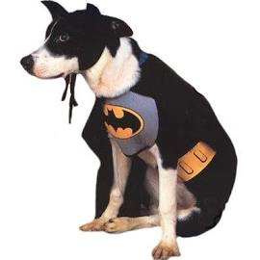 |  | 
 |  | 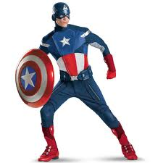 |  | 
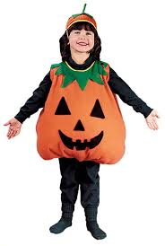 |  |  |  | 
Accessories Picture Array
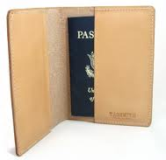 | 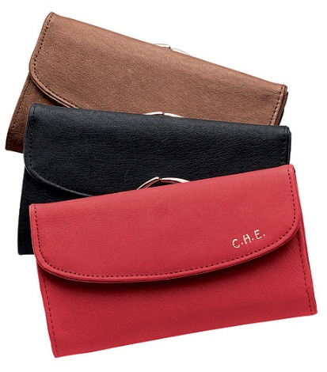 |  | 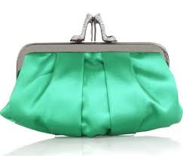 |  | 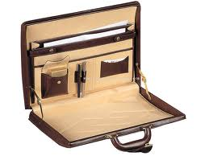
 | 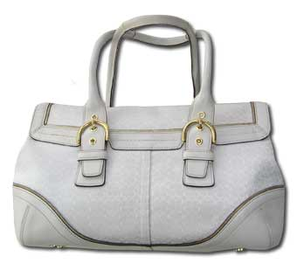 |  | 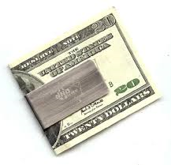 |  | 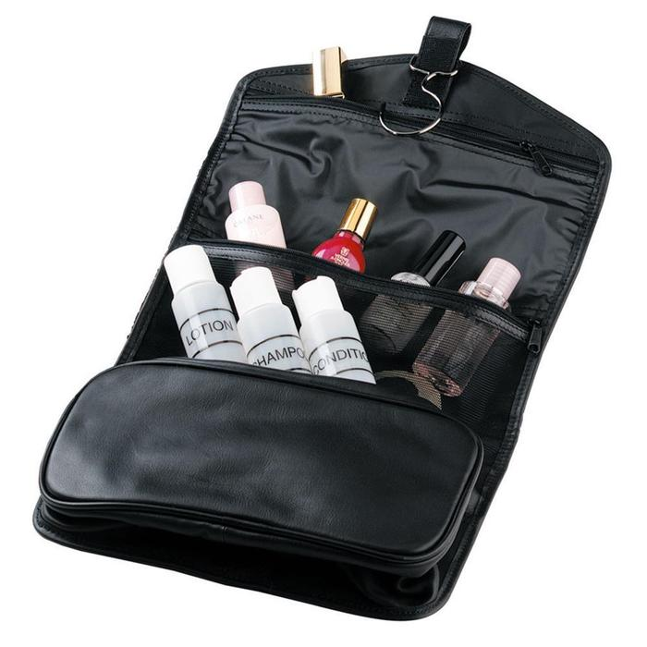
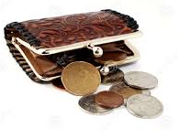 | 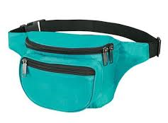 |  | 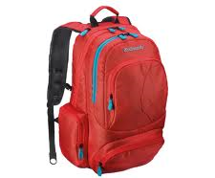 |  | 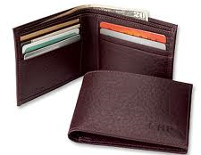

Appendix C: Consent Form

Consent Form

The Bureau of Labor Statistics (BLS) is conducting research to increase the quality of BLS surveys. This study is intended to suggest ways to improve the procedures the BLS uses to collect survey data.

The BLS, its employees, agents, and partner statistical agencies, will use the information you provide for statistical purposes only and will hold the information in confidence to the full extent permitted by law. In accordance with the Confidential Information Protection and Statistical Efficiency Act of 2002 (Title 5 of Public Law 107-347) and other applicable Federal laws, your responses will not be disclosed in identifiable form without your informed consent. The Privacy Act notice on the back of this form describes the conditions under which information related to this study will be used by BLS employees and agents.

During this research you may be audio and/or videotaped, or you may be observed. If you do not wish to be taped, you still may participate in this research.

We estimate it will take you an average of 45 minutes to participate in this research (ranging from 30 minutes to 60 minutes).

Your participation in this research project is voluntary, and you have the right to stop at any time. If you agree to participate, please sign below.

Persons are not required to respond to the collection of information unless it displays a currently valid OMB control number. OMB control number is 1220-0141, and expires February 28, 2015.

------------------------------------------------------------------------------------------------------------
I have read and understand the statements above. I consent to participate in this study.

___________________________________ ___________________________
Participant's signature Date

___________________________________
Participant's printed name

___________________________________
Researcher's signature

OMB Control Number: 1220-0141
Expiration Date: [02-28-2015]

PRIVACY ACT STATEMENT
In accordance with the Privacy Act of 1974, as amended (5 U.S.C. 552a), you are hereby notified that this study is sponsored by the U.S. Department of Labor, Bureau of Labor Statistics (BLS), under authority of 29 U.S.C. 2. Your voluntary participation is important to the success of this study and will enable the BLS to better understand the behavioral and psychological processes of individuals, as they reflect on the accuracy of BLS information collections. The BLS, its employees, agents, and partner statistical agencies, will use the information you provide for statistical purposes only and will hold the information in confidence to the full extent permitted by law. In accordance with the Confidential Information Protection and Statistical Efficiency Act of 2002 (Title 5 of Public Law 107-347) and other applicable Federal laws, your responses will not be disclosed in identifiable form without your informed consent.

